Supporting Information

Anthraquinone-Based Silicate Covalent Organic Frameworks as Solid Electrolyte Interphase for High-Performance Lithium-Metal Batteries

Chen Li¹, Dan-dong Wang², Gerald Siu Hang Poon Ho¹, Zhengyang Zhang², Jun Huang¹, Ki-Taek Bang¹, Chun Yin Lau³, Shao-Yuan Leu³, Yanming Wang², and Yoonseob Kim^{1,}*
¹Department of Chemical and Biological Engineering, The Hong Kong University of Science and Technology, Hong Kong SAR, P. R. China
²University of Michigan - Shanghai Jiao Tong University Joint Institute, Shanghai Jiao Tong University, Shanghai 200240, P. R. China
³Department of Civil and Environmental Engineering, The Hong Kong Polytechnic University, Hong Kong SAR, P. R. China
*To whom correspondence should be addressed: yoonseobkim@ust.hk

Chemicals and materials. 1,2-dimethoxybenzene (Energy Chemical, ACS reagent, 99%), acetaldehyde (Sigma-Aldrich, ACS reagent, ≥99.5%), sulfuric acid (Honeywell, ACS reagent, 95%-97%), 1.0M BBr₃ solution in anhydrous dichloromethane (Energy Chemical, ACS reagent), lithium methoxide (Energy Chemical, ACS reagent, 98%), silica gel (for column chromatography, pore size 60 Å, 230-400 mesh ASTM, Merck/Millipore), sodium dichromate (Sigma-Aldrich, ACS reagent, ≥99.5%), glacial acetic acid (VWR, ACS reagent, 99.8-100.5%), HBr (Energy Chemical, ACS reagent, 48wt.% in H₂O), Chloroform-d (Sigma-Aldrich, 99.8 atom % D, contains 1 % (v/v) TMS), Dimethyl Sulfoxide-d₆ (Sigma-Aldrich, 99.96 atom % D).

Detailed experiment:
Synthesis of monomers
Scheme S1. Synthetic route of 9,10-Dimethyl-2,3,6,7-tetrahydroxyanthracene (2).

9,10-Dimethyl-2,3,6,7-tetramethoxyanthracene (1). A mixture of 1,2-dimethoxybenzene (13.82 g, 0.1 mol), acetaldehyde (5.6 mL, 0.1 mol), and acetonitrile (5.2 mL, 0.1 mol) was cooled to 0 °C and added dropwise to 100 mL of concentrated sulfuric acid over 10 minutes. The purple reaction mixture was stirred at 0 °C for 2 h and then poured over ice. The formed precipitate was filtered, washed with deionized water, and recrystallized from acetone to give 1 as a grey solid (5.43 g, 17 %). ¹H NMR (400 MHz, CDCl₃): δ = 7.41 (s, 4H), 4.09 (s, 12H), 2.95 (s, 6H). ¹³C NMR (100 MHz, CDCl₃): δ = 148.83, 125.93, 124.02, 102.73, 55.82, 14.92. HRMS (ESI-TOF): m/z Calcd for C₂₀H₂₂O₄: [M]⁺ 326.1518, found 326.1516 [M+Na]⁺ 349.1416, found 349.1416.
9,10-Dimethyl-2,3,6,7-tetrahydroxyanthracene (2). To a flame dried round-bottomed flask equipped with a stir bar was added 9,10-dimethyl-2,3,6,7-tetramethoxyanthracene 1 (1.6 g, 4.9 mmol) under nitrogen atmosphere. Anhydrous dichloromethane (40 mL) was then added, and 21.6 mL of a 1.0 M BBr₃ solution in anhydrous dichloromethane (5.412 g, 21.6 mmol) was injected quickly into the suspension. The reaction mixture was stirred at room temperature for 2 h. turned brown/yellow. The solution was filtered, washed with deionized water, and dried at 80 °C overnight to yield yellow powder 2 (1.08g, 82 %). ¹H NMR (400 MHz, DMSO-d₆): δ = 9.47 (s,4H), 7.32 (s, 4H), 2.68 (s, 6H). ¹³C NMR (100 MHz, DMSO-d₆): δ =145.98, 125.32, 121.07, 105.66, 14.25. HRMS (ESI-TOF): m/z Calcd for C₁₆H₁₄O₄: [M]⁻ 269.0814, found 269.0812.
Figure S1. 400 MHz ¹H NMR spectrum of 9,10-Dimethyl-2,3,6,7-tetramethoxyanthracene (1) in CDCl₃.
Figure S2. 100 MHz ¹³C NMR spectrum of 9,10-Dimethyl-2,3,6,7-tetramethoxyanthracene (1) in CDCl₃.

Figure S3. 400 MHz ¹H NMR spectrum of 9,10-Dimethyl-2,3,6,7-tetrahydroxyanthracene (2) in DMSO-d₆.
Figure S4. 100 MHz ¹³C NMR spectrum of 9,10-Dimethyl-2,3,6,7-tetrahydroxyanthracene (2) in DMSO-d₆.

Scheme S2. Synthetic route of 2,3,6,7-Tetrahydroxy-9,10-anthraquinone (4).

2,3,6,7-Tetramethoxy-9,10-anthraquinone (3). A mixture of finely powdered 9,10-Dimethyl-2,3,6,7-tetramethoxyanthracene 1 (5.0 g, 15 mmol), sodium dichromate (25 g, 95 mmol) and 250 mL acetic acid were refluxed for 60 min. After the solvent was cooled to room temperature, the precipitate filter washed with water and dried to give yellow powder 3 was obtained (3g, 60%). ¹H NMR (400 MHz, CDCl₃): δ = 7.68 (s, 4H), 4.05 (s, 12H). ¹³C NMR (100 MHz, CDCl₃): δ = 182.15, 153.59, 128.59, 108.53, 56.69. HRMS (ESI-TOF): m/z Calcd for C₂₀H₂₂O₄: [M+Na]⁺ 351.0845, found 351.0852.
2,3,6,7-Tetrahydroxy-9,10-anthraquinone (4). 2,3,6,7-Tetramethoxy-9,10-anthraquinone 3 (2.5 g, 7.63 mmol) and 48% HBr were heated under reflux (oil bath temp. 150℃) for 3 days. After the first 24 h, more 48% HBr (5 ml) was added through the reflux condenser to wash down some unreacted starting material that had collected there due to intense foaming and to its poor wettability. After 48 h, the yellow color had turned completely to ochre, and the foaming had stopped. After cooling, the precipitate was collected by filtration, and washed to neutral pH with dist. H₂O, and air-dried to yield brown powder 4 (2.1g, quantitative). ¹H-NMR (400MHz, DMSO-d₆): δ = 10.45(s, 4H); 7.43 (s, 4H); 3.93 (residual H, MeO of some contaminating unhydrolyzed product). ¹³C NMR (100 MHz, DMSO-d₆): δ = 181.17, 150.86, 127.11, 112.95. HRMS (ESI-TOF): m/z Calcd for C₁₄H₈O₆: [M]⁻ 271.0243, found 271.0241.

Figure S5. 400 MHz ¹H NMR spectrum of 2,3,6,7-Tetramethoxy-9,10-anthraquinone (3) in CDCl₃.
Figure S6. 100 MHz ¹³C NMR spectrum of 2,3,6,7-Tetramethoxy-9,10-anthraquinone (3) in CDCl₃.

Figure S7. 400 MHz ¹H NMR spectrum of 2,3,6,7-Tetrahydroxy-9,10-anthraquinone (4) in DMSO-d₆.
Figure S8. 100 MHz ¹³C NMR spectrum of 2,3,6,7-Tetrahydroxy-9,10-anthraquinone (4) in DMSO-d₆.

Synthesis of DMA-Si-COFs from silica gel.
9,10-dimethyl-2,3,6,7-tetrahydroxyanthracene (DMA) (100 mg, 0.37 mmol), anhydrous methanol (9.5 ml), 0.55 ml of 1.0 M lithium methoxide solution in anhydrous methanol (21 mg, 0.55 mmol) and silica gel (15 mg, 0.25 mmol) were charged into a 35mL Schlenk pressure tube. Then the Schlenk pressure tube was sonicated for around 10 min to ensure homogeneity, degassed with three cycles of freeze−pump−thaw, and then sealed. Finally, the reaction mixture was heated at 180 °C for 4 days yielding dark brown powders which were collected by filtration and washed with anhydrous acetone. The sample was dried in a vacuum oven at 80 °C for 24 h, yielding DMA-Si-COFs as black powders (0.0829g, 84%). ICP Found: 2.89 wt% (Calcd: 3.14).
Synthesis of AQ-Si-COFs from silica gel. 2,3,6,7-tetrahydroxyanthracene-9,10-dione (THAQ) (100 mg, 0.37 mmol), anhydrous methanol (9.5 ml), 0.55 ml of 1.0 M lithium methoxide solution in anhydrous methanol (21 mg, 0.55 mmol) and silica gel (45 mg, 0.75 mmol) were charged into a 35 mL Schlenk pressure tube. Then the Schlenk pressure tube was sonically treated for around 10 min to ensure homogeneity, degassed with three cycles of freeze−pump−thaw, and then sealed. Finally, the reaction mixture was heated at 180 °C for 4 days yielding reddish-brown powders, which was collected by filtration, and washed with anhydrous acetone. The sample was dried in a vacuum oven at 80 °C for 24 h, yielding AQ-Si-COFs as dark brown powders (0.0943g, 96%). ICP Found: 3.45 wt% (Calcd: 3.13).

General Characterization Methods. ¹H and ¹³C NMR spectra were recorded on a Bruker AVII 400 MHz NMR Spectrometer (400 MHz for ¹H and 100 MHz for ¹³C), Chemical shifts are reported in delta (δ) units, expressed in parts per million (ppm) relative to the residual solvent as an internal standard (CDCl₃, ¹H: 7.26 ppm and ¹³C 77.16 ppm; DMSO-d₆, ¹H: 2.50 ppm and ¹³C 39.52 ppm). Abbreviations associated with the peak assignment are as follows: s, singlet. High-resolution mass spectra were obtained from Water's Xevo G2-XS Tof mass spectrometer with an Electrospray source. Powder X-ray diffraction (XRD) data were collected by PANalytical X-ray Diffractometer, Model X’pert Pro. The scanning rate was 2-degree min^{–1} from 3 to 50 2-theta degrees. Scanning electron microscope (SEM) was measured with a JSM-6700F. The samples were coated with gold before SEM measurement. The Fourier-transform infrared spectroscopy (FTIR) was recorded by a Bruker FTIR with an attenuated total reflectance (ATR) setup using a Vertex 70 FTIR spectrometer. X-ray photoelectron spectroscopy (XPS) measurements were performed on Surface analysis Kratos Axis Ultra. Thermal gravimetric analysis (TGA) tests were performed on Perkin Elmer UNIX/TGA7 instrument under an N₂ atmosphere, ranging from 30 °C to 800 °C by a heating rate of 10 °C min^{–1}. Solid state NMR spectra were recorded with a Jeol ECZ500R 500 MHz Solid-State NMR spectrometer in the Hong Kong polytechnic university. N₂ adsorption/desorption measurements were conducted using a MICROTRAC (BELSORP mini X) at 77 K. Before the measurement, the Si-COFs sample was degassed at 180 °C for 12h.

Procedure for Li Content Analysis by ICP-OES: ICP-OES was performed by PwekinElmer /7300DV. 5 mg of sample was placed in a 10 mL glass vial and digested with 1.5 mL 5% HNO₃ in deionized water in a microwave at 150 °C. Then, this solution was then added to 10mL and diluted by 10 times with deionized water. 50 ppb, 100 ppb, and 200 ppb of standard solutions of Li were prepared for calibration.

Electrochemical measurements
Li⁺ conductivity ($σ_{{Li}^{+}}$)
Si-COFs were soaked with 1.0 M LiClO₄ in Ethylene carbonate/Diethyl carbonate (EC/DEC) =50/50 (v/v) (denoted as: Li@Si-COFs) and dried for 48h under vacuum to remove the solvent. After that, the dry samples were mechanically pressed into solid pellets under the pressure of 10 MPa for 120 s. Then the pellet was fixed between two stainless-steel electrodes by a CR2032 coin-type cell in an argon-filled glovebox, and the EIS test was performed over the frequency ranging from 1 Hz to 10⁶ Hz with an amplitude of 100 mV. The Li⁺ transference number (t_{Li}⁺) was measured using the Si-COFs/Li|Si-COFs/Li symmetric cell by potentiostatic polarization method (DC voltage: 20mV). The temperature-dependent $σ_{{Li}^{+}}$ (S cm^{–1}) was calculated based on the following equation:
$$σ=\frac{l}{R×A}$$
where l is the thickness of the pellet (cm), R is the interfacial resistance of the pellet (Ω) , and A is the area (cm²) in contact with the stainless-steel electrodes. To ensure that the battery reaches thermodynamic equilibrium, test was conducted after the cell reached the target temperature and maintained for at least half an hour. The thermal activation energy was derived from the Arrhenius relationship.

Bruce−Vincent−Evans technique
The most common experimental method for measuring $t_{{Li}^{+}}$ in a polymer electrolyte is the so-called Bruce-Vincent method, named for the work done by Colin Vincent and Peter Bruce on this subject, published in 1987.¹ The method involves the polarization of a symmetrical cell by a small potential difference, to induce a small concentration gradient, until the system reaches a steady state, with a concentration gradient that does not change further with time.

The $t_{{Li}^{+}}$ was calculated by the following equation:
$$t_{{Li}^{+}}=\frac{i_{ss}\left(∆V-i_{0}R_{0}\right)}{i_{0}\left(∆V-i_{ss}R_{ss}\right)}$$
where $∆$V is the DC voltage, i₀ and i_{SS} are the values of the measured initial and steady-state current. The steady-state current is determined once the change is less than 1% for 10 minutes. R₀ and R_{SS} are initial and steady-state resistance measured by EIS.
Cyclic voltammetry
Analyses were performed in a standard three-electrode setup: a modified working, an Ag/AgCl reference, and a Pt foil (1cm×1cm) counter held in the 50mL electrolytic cell. Before analyses, the electrolyte (1.5 M LiOH in deionized water) was purged with N₂ for 20 minutes. The base electrodes were prepared by cutting stainless steel cloth (350 × 350, wire diameter: 0.035mm) into a dimension of 2 cm × 2 cm. The composite electrodes were prepared by drop casting method. Si-COFs or monomer slurries that were prepared by grinding active material (72 wt.%), polyvinylidene difluoride (PVDF) (14 wt.%), and carbon black (14 wt.%) with 0.4 mL of N-methyl-2-pyrrolidone (NMP) for 30 minutes in an agate mortar and pestle. For the coating of active material, the base electrodes were dropped by the final slurries and left to dry at 100℃ overnight. The final loading was 0.01 g Si-COFs or monomers per electrode. The cyclic voltammetry (CV) measurements were performed on Autolab PGSTAT204 (Metrohm, Switzerland). The cutoff voltage of the CV test was –0.5－0.7V, and different scan rates (1, 2, 3, 4, 5 mV s^{–1}) were applied.
Figure S9. FTIR spectrum of DMA (red curve), Silica gel (black curve), and DMA-Si-COFs (blue curve).

Figure S10. CV curves of DMA-Si-COF at at multiple scan rates from 0.1 to 0.3 mV/s.

Figure S11. CV curves of monomer THAQ at multiple scan rates from 0.001 to 0.005 V/s.
Figure S12. CV curves of stainless steel mesh substrate at 0.005 V/s for multiple cycles.

Figure S13. Experimental, simulated and Rietveld refined PXRD patterns of DMA-Si-COFs.

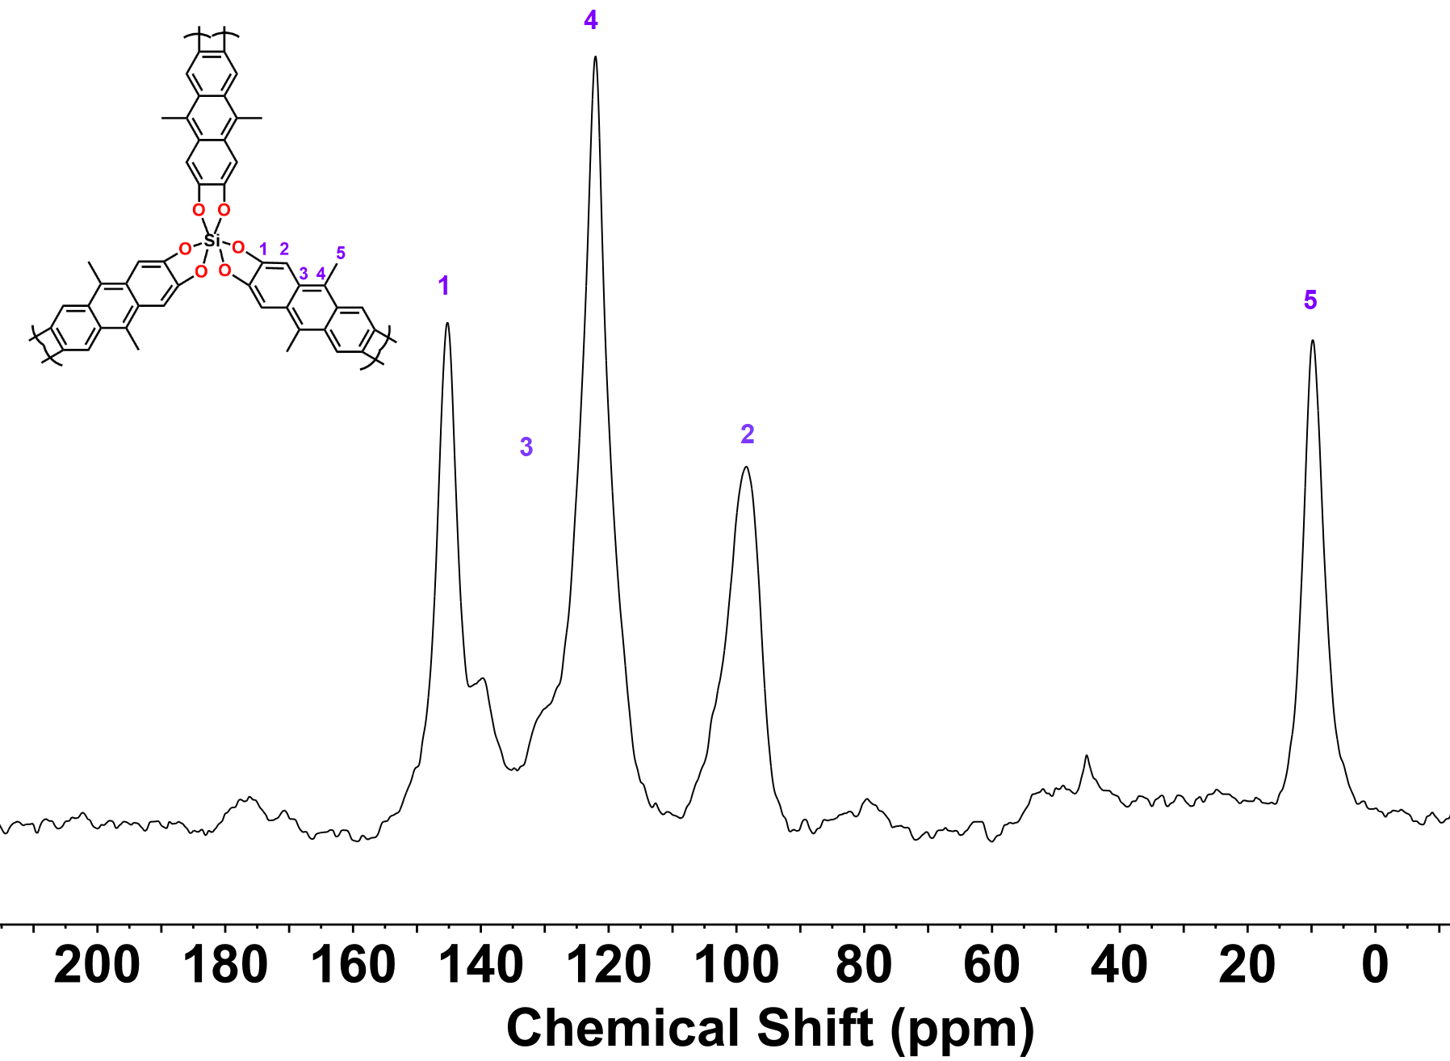
Figure S14. Solid-state ¹³C NMR spectrum of DMA-Si-COFs (101 MHz).

(a) | 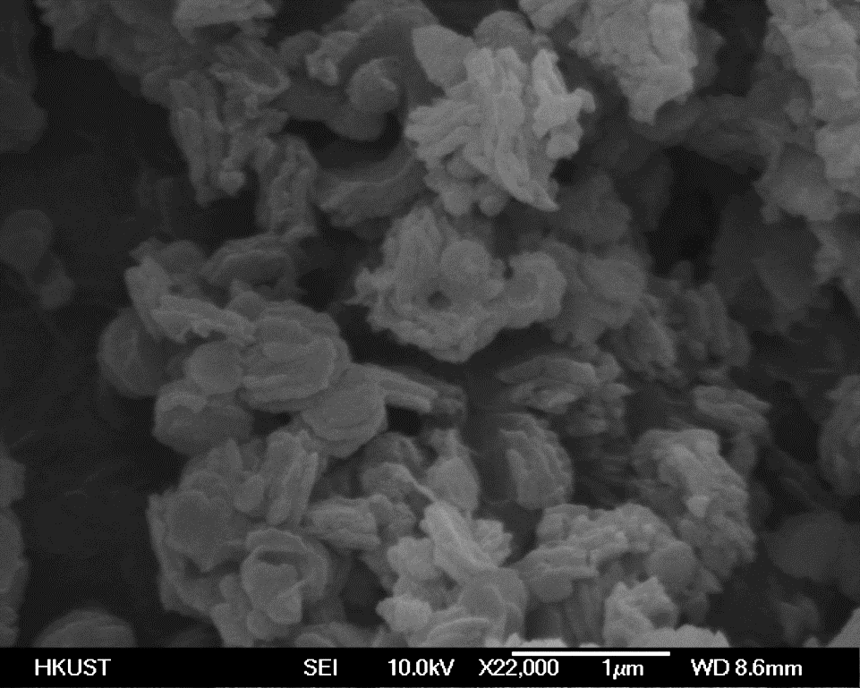
(b) | 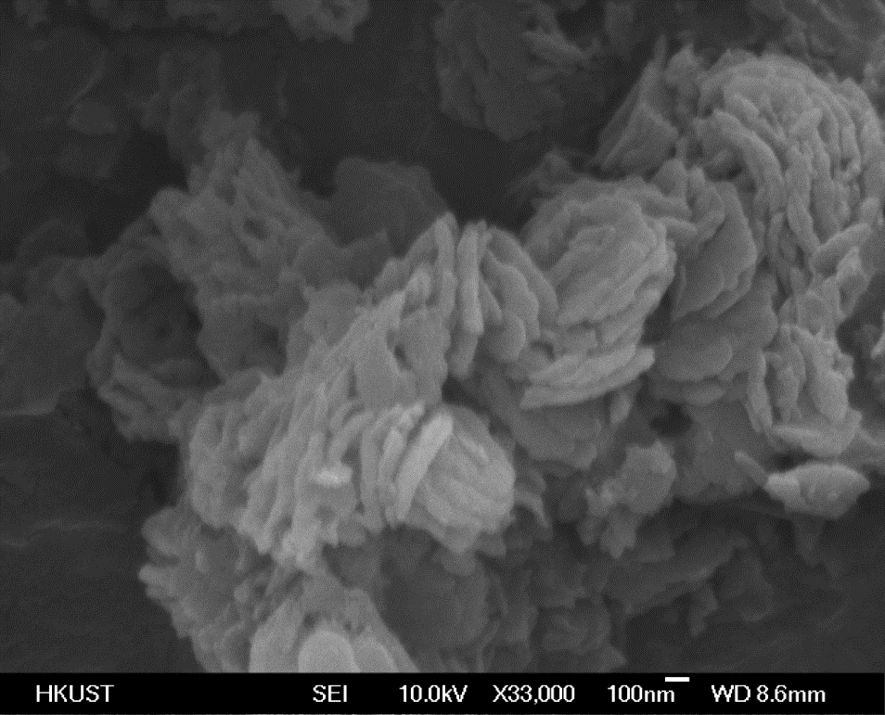
Figure S15. SEM image of DMA-Si-COFs at (a)×22,000 and (b)×33,000 showing the formation of uniform platelets.

Table S1. Elemental analysis and ICP-OES result for DMA-Si-COFs and AQ-Si-COFs

Figure S16. XPS analysis of (a) total elements (b)Si 2p and (c) Li 1s species on AQ-Si-COFs.

Figure S17. XPS analysis of (a) total elements (b)Si 2p and (c) Li 1s species on DMA-Si-COFs.

Figure S18. TGA curve for AQ-Si-COFs.

Figure S19. Arrhenius plot for $σ_{{Li}^{+}}$ of AQ-Si-COFs at various temperatures, the corresponding linear line was fitted to result the R² > 0.99.

Figure S20. Nyquist plots of Li@ DMA-Si-COFs at various temperatures. (Li: 1.0 M LiClO₄ in EC/DEC=50/50 (v/v)).

Figure S21. Arrhenius plot for $σ_{{Li}^{+}}$ of DMA-Si-COFs at various temperatures, the corresponding linear line was fitted to result in the R² > 0.99.

Figure S22. $t_{{Li}^{+}}$ of DMA-Si-COFs calculated using the Bruce−Vincent−Evans technique.

Calculation method
The Vienna Ab initio simulation package (VASP) was used to perform all the density functional theory (DFT) calculations. The projected augmented wave (PAW) pseudopotentials by Kresse and Joubert ²⁻³ was adopted throughout the work, with the Perdew-Burke-Ernzerhof (PBE) functional developed by Perdew, Burke, and Ernzerhof.⁴ The van der Waals interactions were taken into consideration by introducing the zero damping DFT-D3 method of Grimme.⁵ A vacuum space with a thickness of 32.37 angstroms was inserted to prevent unphysical self-interactions of the molecules due to the periodic boundary condition. A 400-eV cut-off energy for the plane wave basis set was set for all calculations. A force tolerance of −0.01 was used as the convergence criterion for geometry optimizations. The electrostatic potential maps were generated by Avogadro software.⁶

Bader charge analysis and structures
Table S2. Bader charge analysis of AQ-Si-COFs of the unstripped Li⁺. The number of transferred electrons listed in this table is greater than 0.65. The first column is the atomic species. The second column is the number of valence electrons per atom. The third column is the initial number of valence electrons per atom. The fourth column is the number of electrons transferred. The number of transferred electrons listed in this table is greater than 0.65. The first column is the atomic species. The second column is the number of valence electrons per atom. The third column is the initial number of valence electrons per atom. The fourth column is the number of electrons transferred. The positive value represents the number of electrons gained by the atom. The negative value represents the number of electrons the atom has lost.

Unstripped Li⁺
Atom | CHARGE | ZVAL | δe
Si | 0.90 | 4 | -3.10
O1 | 7.29 | 6 | 1.29
O2 | 7.29 | 6 | 1.29
O3 | 7.28 | 6 | 1.28
O4 | 7.30 | 6 | 1.30
O5 | 7.28 | 6 | 1.28
O6 | 7.28 | 6 | 1.28
O7 | 7.33 | 6 | 1.33
O8 | 7.34 | 6 | 1.34
O9 | 7.32 | 6 | 1.32
O10 | 7.32 | 6 | 1.32
O11 | 7.32 | 6 | 1.32
O12 | 7.33 | 6 | 1.33
C19 | 3.35 | 4 | -0.65
C20 | 3.30 | 4 | -0.70
C21 | 3.33 | 4 | -0.67
C22 | 3.34 | 4 | -0.66
C24 | 3.32 | 4 | -0.68
Li1 | 0.12 | 1 | -0.88
Li2 | 0.12 | 1 | -0.88
Li3 | 0.12 | 1 | -0.88
Li4 | 0.26 | 1 | -0.74
Li5 | 0.28 | 1 | -0.72
Li6 | 0.25 | 1 | -0.75
Li7 | 0.24 | 1 | -0.76
Li8 | 0.25 | 1 | -0.75
Li9 | 0.25 | 1 | -0.75
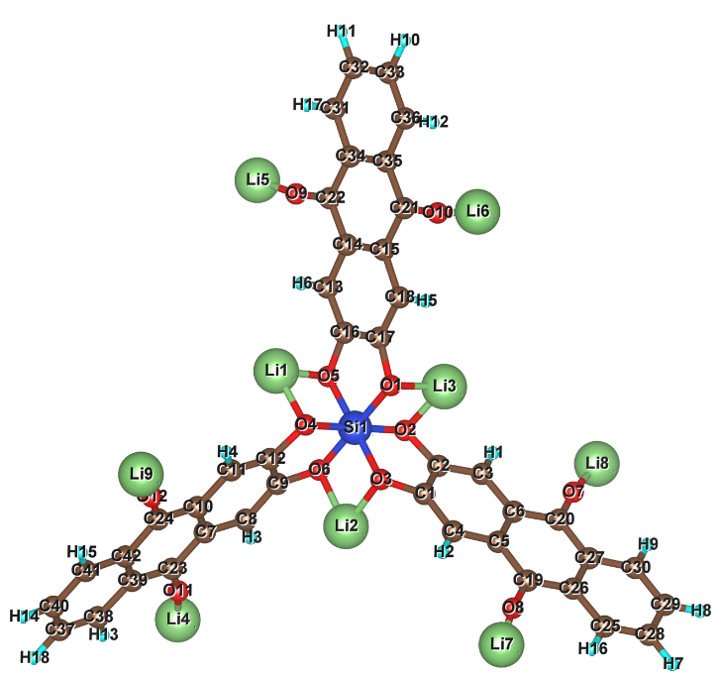
Fig S23. The structure of AQ-Si-COFs of the unstripped Li⁺.

Table S3. Bader charge analysis of AQ-Si-COFs of one Li⁺ stripped. The number of transferred electrons listed in this table is greater than 0.65. The first column is the atomic species. The second column is the number of valence electrons per atom. The third column is the initial number of valence electrons per atom. The fourth column is the number of electrons transferred. The number of transferred electrons listed in this table is greater than 0.65. The first column is the atomic species. The second column is the number of valence electrons per atom. The third column is the initial number of valence electrons per atom. The fourth column is the number of electrons transferred. The positive value represents the number of electrons gained by the atom. The negative value represents the number of electrons the atom has lost.

One Li⁺ stripped
Atom | CHARGE | ZVAL | δe
Si | 0.90 | 4 | -3.10
O1 | 7.29 | 6 | 1.29
O2 | 7.30 | 6 | 1.30
O3 | 7.29 | 6 | 1.29
O4 | 7.29 | 6 | 1.29
O5 | 7.28 | 6 | 1.28
O6 | 7.27 | 6 | 1.27
O7 | 7.14 | 6 | 1.14
O8 | 7.33 | 6 | 1.33
O9 | 7.31 | 6 | 1.31
O10 | 7.32 | 6 | 1.32
O11 | 7.31 | 6 | 1.31
O12 | 7.33 | 6 | 1.33
C20 | 3.16 | 4 | -0.84
C22 | 3.35 | 4 | -0.65
C24 | 3.32 | 4 | -0.68
Li1 | 0.12 | 1 | -0.88
Li2 | 0.12 | 1 | -0.88
Li3 | 0.12 | 1 | -0.88
Li4 | 0.12 | 1 | -0.88
Li5 | 0.23 | 1 | -0.77
Li6 | 0.12 | 1 | -0.88
Li7 | 0.13 | 1 | -0.87
Li8 | 0.21 | 1 | -0.79
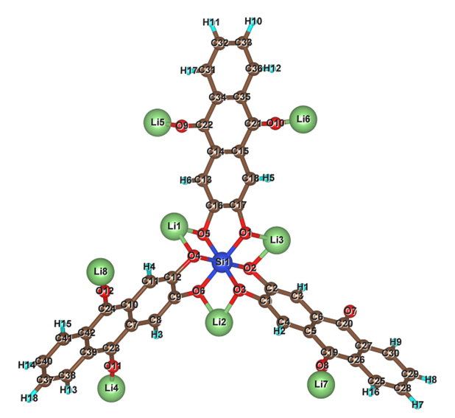
Fig S24. The structure of AQ-Si-COFs of one Li⁺ stripped.

Table S4. Bader charge analysis of AQ-Si-COFs of six Li⁺ stripped. The number of transferred electrons listed in this table is greater than 0.65. The first column is the atomic species. The second column is the number of valence electrons per atom. The third column is the initial number of valence electrons per atom. The fourth column is the number of electrons transferred. The number of transferred electrons listed in this table is greater than 0.65. The first column is the atomic species. The second column is the number of valence electrons per atom. The third column is the initial number of valence electrons per atom. The fourth column is the number of electrons transferred. The positive value represents the number of electrons gained by the atom. The negative value represents the number of electrons the atom has lost.

Six Li⁺ stripped
Atom | CHARGE | ZVAL | δe
Si | 0.89 | 4 | -3.11
O1 | 7.29 | 6 | 1.29
O2 | 7.28 | 6 | 1.28
O3 | 7.28 | 6 | 1.28
O4 | 7.30 | 6 | 1.30
O5 | 7.28 | 6 | 1.28
O6 | 7.27 | 6 | 1.27
O7 | 7.06 | 6 | 1.06
O8 | 7.07 | 6 | 1.07
O9 | 7.04 | 6 | 1.04
O10 | 7.06 | 6 | 1.06
O11 | 7.07 | 6 | 1.07
O12 | 7.07 | 6 | 1.07
C19 | 3.10 | 4 | -0.90
C20 | 3.10 | 4 | -0.90
C21 | 3.15 | 4 | -0.85
C22 | 3.13 | 4 | -0.87
C23 | 3.11 | 4 | -0.89
C24 | 3.13 | 4 | -0.87
Li1 | 0.11 | 1 | -0.89
Li2 | 0.11 | 1 | -0.89
Li3 | 0.11 | 1 | -0.89
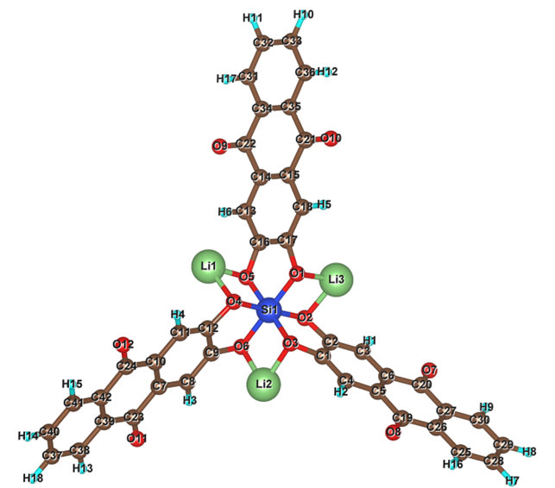
Fig S25. The structure of AQ-Si-COFs of six Li⁺ stripped.

Table S5. Bader charge analysis of AQ-Si-COFs of seven Li⁺ stripped. The number of transferred electrons listed in this table is greater than 0.65. The first column is the atomic species. The second column is the number of valence electrons per atom. The third column is the initial number of valence electrons per atom. The fourth column is the number of electrons transferred. The number of transferred electrons listed in this table is greater than 0.65. The first column is the atomic species. The second column is the number of valence electrons per atom. The third column is the initial number of valence electrons per atom. The fourth column is the number of electrons transferred. The positive value represents the number of electrons gained by the atom. The negative value represents the number of electrons the atom has lost.

Seven Li⁺ stripped
Atom | CHARGE | ZVAL | δe
Si | 0.91 | 4 | -3.09
O1 | 7.28 | 6 | 1.28
O2 | 7.28 | 6 | 1.28
O3 | 7.27 | 6 | 1.27
O4 | 7.25 | 6 | 1.25
O5 | 7.25 | 6 | 1.25
O6 | 7.26 | 6 | 1.26
O7 | 7.04 | 6 | 1.04
O8 | 7.05 | 6 | 1.05
O9 | 7.05 | 6 | 1.05
O10 | 7.07 | 6 | 1.07
O11 | 7.05 | 6 | 1.05
O12 | 7.06 | 6 | 1.06
C19 | 3.08 | 4 | -0.92
C20 | 3.09 | 4 | -0.91
C21 | 3.09 | 4 | -0.91
C22 | 3.04 | 4 | -0.96
C23 | 3.11 | 4 | -0.89
C24 | 3.10 | 4 | -0.90
Li1 | 0.11 | 1 | -0.89
Li2 | 0.11 | 1 | -0.89
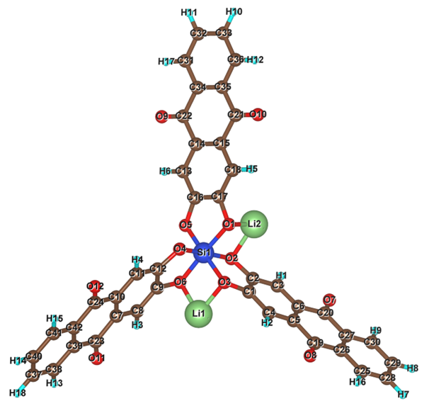
Fig S26. The structure of AQ-Si-COFs of seven Li⁺ stripped.

Table S6. Bader charge analysis of AQ-Si-COFs of eight Li⁺ stripped. The number of transferred electrons listed in this table is greater than 0.65. The first column is the atomic species. The second column is the number of valence electrons per atom. The third column is the initial number of valence electrons per atom. The fourth column is the number of electrons transferred. The number of transferred electrons listed in this table is greater than 0.65. The first column is the atomic species. The second column is the number of valence electrons per atom. The third column is the initial number of valence electrons per atom. The fourth column is the number of electrons transferred. The positive value represents the number of electrons gained by the atom. The negative value represents the number of electrons the atom has lost.

Eight Li⁺ stripped
Atom | CHARGE | ZVAL | δe
Si | 0.90 | 4 | -3.10
O1 | 7.18 | 6 | 1.18
O2 | 7.23 | 6 | 1.23
O3 | 7.27 | 6 | 1.27
O4 | 7.24 | 6 | 1.24
O5 | 7.18 | 6 | 1.18
O6 | 7.27 | 6 | 1.27
O7 | 7.04 | 6 | 1.04
O8 | 7.04 | 6 | 1.04
O9 | 7.06 | 6 | 1.06
O10 | 7.06 | 6 | 1.06
O11 | 7.05 | 6 | 1.05
O12 | 7.06 | 6 | 1.06
C19 | 3.12 | 4 | -0.88
C20 | 3.07 | 4 | -0.93
C21 | 3.03 | 4 | -0.97
C22 | 3.07 | 4 | -0.93
C23 | 3.11 | 4 | -0.89
C24 | 3.07 | 4 | -0.93
Li1 | 0.11 | 1 | -0.89
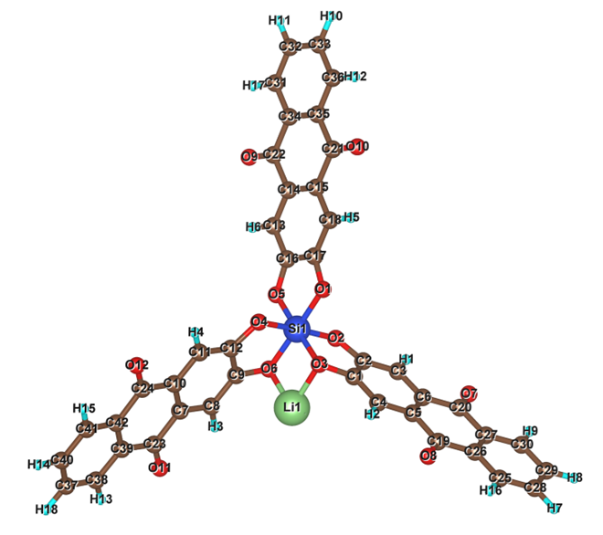
Fig S27. The structure of AQ-Si-COFs of eight Li⁺ stripped.

Table S7. Bader charge analysis of AQ-Si-COFs of nine Li⁺ stripped. The number of transferred electrons listed in this table is greater than 0.65. The first column is the atomic species. The second column is the number of valence electrons per atom. The third column is the initial number of valence electrons per atom. The fourth column is the number of electrons transferred. The number of transferred electrons listed in this table is greater than 0.65. The first column is the atomic species. The second column is the number of valence electrons per atom. The third column is the initial number of valence electrons per atom. The fourth column is the number of electrons transferred. The positive value represents the number of electrons gained by the atom. The negative value represents the number of electrons the atom has lost.

Nine Li⁺ stripped
Atom | CHARGE | ZVAL | δe
Si | 0.91 | 4 | -3.09
O1 | 7.19 | 6 | 1.19
O2 | 7.20 | 6 | 1.20
O3 | 7.19 | 6 | 1.19
O4 | 7.19 | 6 | 1.19
O5 | 7.18 | 6 | 1.18
O6 | 7.18 | 6 | 1.18
O7 | 7.05 | 6 | 1.05
O8 | 7.03 | 6 | 1.03
O9 | 7.07 | 6 | 1.07
O10 | 7.05 | 6 | 1.05
O11 | 7.04 | 6 | 1.04
O12 | 7.04 | 6 | 1.04
C19 | 3.08 | 4 | -0.92
C20 | 3.05 | 4 | -0.95
C21 | 3.08 | 4 | -0.92
C22 | 3.02 | 4 | -0.98
C23 | 3.06 | 4 | -0.94
C24 | 3.11 | 4 | -0.89
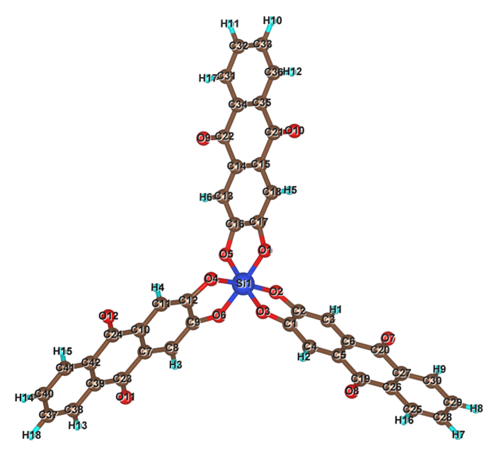
Fig S28. The structure of AQ-Si-COFs of nine Li⁺ stripped.

Coin cell fabrication.
Preparation of Si-COFs|Li anode (Electrolyte interphase)
2 mg Si-COFs particles were dispersed into 1 mL anhydrous 1,3-dioxolane (in an Argon-filled glove box). The resulting brown suspension was ultrasonicated for 20 min to achieve homogeneity. Afterward, 50 µL, 100 µL, and 800 µL of the suspension was transferred on a Li chip (15.6 mm in diameter). Finally, the Li chip was dried in the glovebox at 65°C overnight to form a conformal coating with a thickness of ∼15 µm, ∼35 µm, and ∼100 µm, which corresponds to ∼0.2 mg cm⁻², ∼0.4 mg cm⁻² and ∼3.2 mg cm⁻² mass loading of Si-COFs.

Preparation of LiCoO₂ Cathode
The LiCoO₂ electrodes were prepared by the drop-casting method. LiCoO₂ slurries were designed by grinding active material LiCoO₂ powder (85 wt.%), PVDF (7.5 wt.%), and carbon black (7.5 wt.%) with 1 mL of NMP for 30 minutes in an agate mortar and pestle. For the active material coating, the base electrodes were dropped by the final slurries on the aluminum foil substrate. (Diameter: 14mm) and left to dry at 100 ℃ overnight. The last loading was 0.002 g LiCoO₂ per electrode.

Preparation of Si-COFs Cathode
The base electrodes were prepared by cutting stainless steel cloth (350×350, wire diameter: 0.035mm) into a diameter of 14mm. The composite electrodes were prepared by the drop-casting method. Si-COFs slurries were prepared by grinding active material (72 wt.%), PVDF (14 wt.%), and carbon black (14 wt.%) with 0.4 mL of NMP for 30 minutes in an agate mortar and pestle. For the coating of active material, the base electrodes were dropped by the final slurries and left to dry at 100 ℃ overnight. The final loading was 0.001 g Si-COFs per cathode.
Measurements

The specific capacity of AQ-Si-COFs and DMA-Si-COFs
The Li metal cells were made by Li foil anodes (15.6mm, 0.45 mm) and AQ-Si-COFs or DMA-Si-COFs composite cathodes. Polypropylene membrane (Celgard, 25 μm) was used as a separator, and 60 μL of 1.0 M LiPF₆ in EC/DEC (Sigma Aldrich) was used as an electrolyte for all cell tests. The voltage window for the cells with composite cathodes was set from 0.01 to 4.5 V. All cells were assembled in an argon-filled glove box, and the tests were conducted at ambient temperature. The performances of Si-COFs on the different substrates showed that the stainless steel mesh was much better than the aluminum foil with a more homogeneous and stable surface, on which Si-COFs did not fall off during the cycles (Fig. S31). In addition, the pure stainless steel mesh substrate showed no activity for galvanostatic charge-discharge response (Fig. S32).

AQ-Si-COFs and DMA-Si-COFs as the electrolyte interphase on the Li anode
The Li metal cells were made by Li foil anodes (15.6mm, 0.45 mm) with or without Si-COFs coating and LiCoO₂ cathodes. Polypropylene membrane (Celgard, 25 μm) was used as a separator, and 60 μL of 1.0 M LiPF₆ in EC/DEC (Sigma Aldrich) was used as an electrolyte for all cell tests. The voltage window for the cells with LiCoO₂ cathodes was set from 3.0 to 4.5 V. All cells were assembled in an argon-filled glove box, and the tests were conducted at ambient temperature.

Theoretical Specific Capacity Calculation
Theoretical capacity was calculated by the following equation:
Capacitance = ($\frac{mAh}{g}$)($\frac{nF}{Mw(3.6)}$)($\frac{\frac{c}{mol}}{\frac{g}{mol}}$)$×\frac{1mAh}{3.6C}$
where n is the number of electrons transferred per redox reaction. F is the Faraday constant, and Mw is the molar weight of the repeat unit of the organic component.

The repeating unit in AQ-Si-COFs consists of 1/2 of an AQ unit and 1/3 of a Silicate unit. Hence, the molecular weight of the repeating unit cell in AQ-Si-COFs is 145.3 g/mol (C₇H₄Si_{1/3}O₃). The number of electrons (n) involved in the repeating unit is equal to 1.67; therefore, using Equation, the theoretical capacity of AQ-Si-COFs is calculated to be 369.0 mAh g⁻¹.
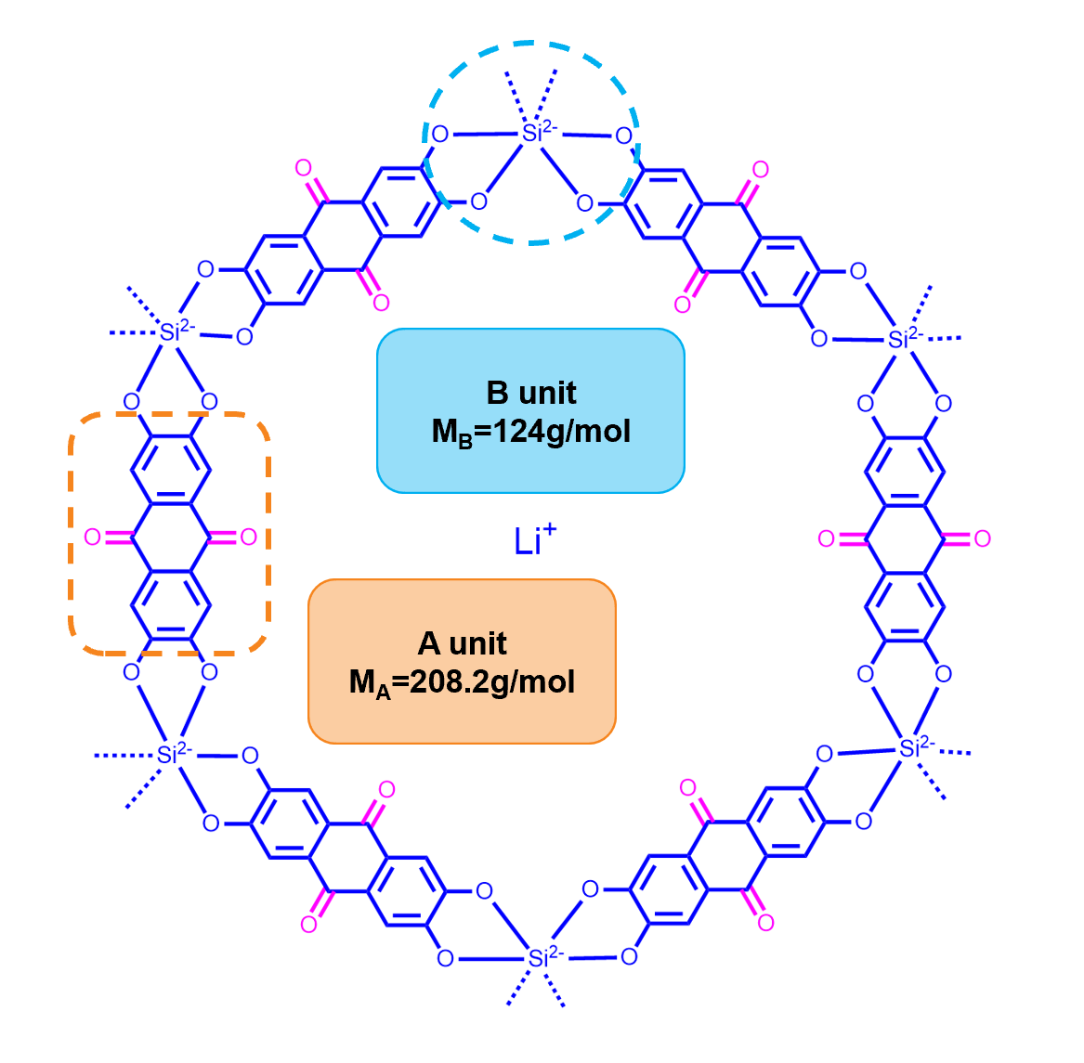
Figure S29. Chemical structure of AQ-Si-COFs and molecular weight analysis of the repeating units.
The repeating unit in DMA-Si-COFs consists of 1/2 of a DMA unit and 1/3 of a Silicate unit. Hence, the molecular weight of the repeating unit cell in DMA-Si-COFs is 144.4 g/mol (C₈H₇Si_{1/3}O₂). The number of electrons (n) involved in the repeating unit is equal to 0.67; therefore, using Equation, the theoretical capacity of AQ-Si-COFs is calculated to be 123.8 mAh g⁻¹.
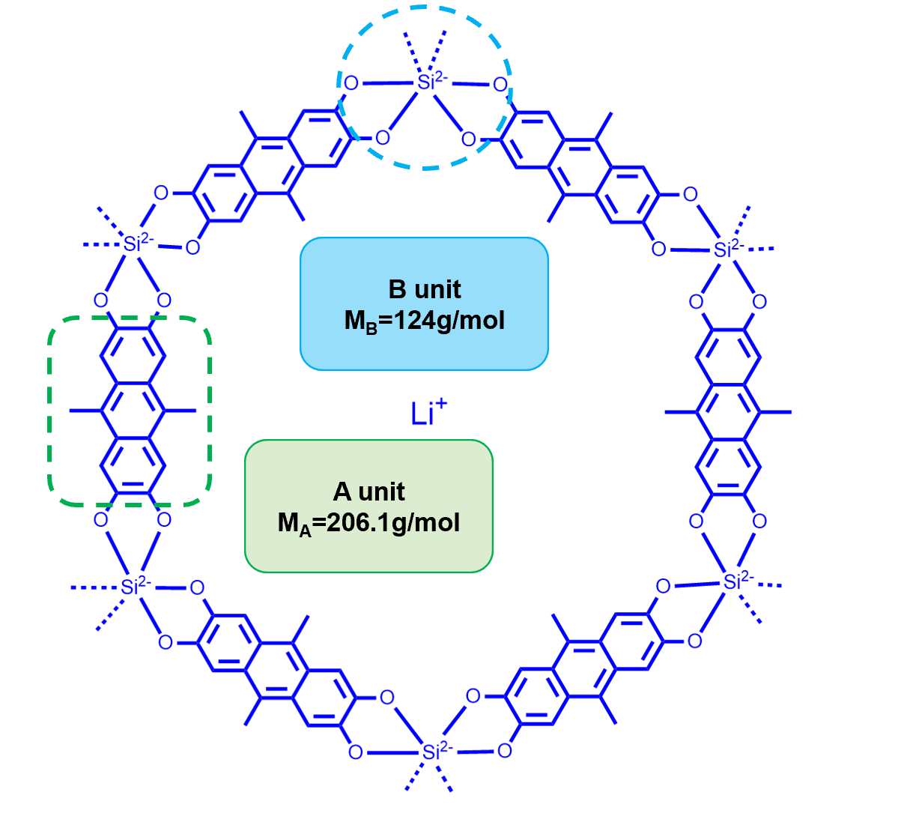
Figure S30. Chemical structure of DMA-Si-COFs and molecular weight analysis of the repeating units.

Figure S31. Galvanostatic charge−discharge response for AQ-Si-COFs on the aluminum foil substrate.
Figure S32. Galvanostatic charge−discharge response for stainless steel mesh substrate.

Figure S33. Cycle performance for DMA-Si-COFs|Li at the current density of 100 mA g⁻¹ (DMA-Si-COFs|Li: the DMA-Si-COFs as cathode; Li metal as the anode; 1.0 M LiPF₆ in EC/DEC as an electrolyte).

Figure S34. Voltage profiles for AQ-Si-COFs|Li at the current density of 400 mA g⁻¹. (AQ-Si-COFs|Li: the AQ-Si-COFs as cathode; Li metal as the anode; 1.0 M LiPF₆ in EC/DEC as an electrolyte).

Figure S35. Rate voltage profiles for AQ-Si-COFs|Li in the current density range of 100 mA g⁻¹ to 500 mA g⁻¹. (AQ-Si-COFs|Li: the AQ-Si-COFs as cathode; Li metal as the anode; 1.0 M LiPF₆ in EC/DEC as an electrolyte).
Figure S36. Rate voltage profiles for DMA-Si-COFs|Li in the current density range of 100 mA g⁻¹ to 500 mA g⁻¹. (DMA-Si-COFs|Li: the DMA-Si-COFs as cathode; Li metal as the anode; 1.0 M LiPF₆ in EC/DEC as an electrolyte).

Figure S37. Voltage profiles for LiCoO₂|DMA-Si-COFs/Li at 0.25C. (LiCoO₂|DMA-Si-COFs/Li: The LiCoO₂ as cathode; Li metal with DMA-Si-COFs SEI as the anode; 1.0 M LiPF₆ in EC/DEC as an electrolyte).

Figure S38. Voltage profiles for LiCoO₂|Li at 0.25C. (LiCoO₂| Li: The LiCoO₂ as cathode; Li metal as the anode; 1.0 M LiPF₆ in EC/DEC as an electrolyte).

Figure S39. Cycle performance for LiCoO₂|15µm-AQ-Si-COFs/Li at 0.25 C.

Figure S40. Comparison of rate performance at 0.25, 2, 4 and 6 C.

Figure S41. The SEM images of the Li anode of the cells without (a, b) and with (c, d) the 15 μm AQ-Si-COFs coating as an SEI after 100 cycles.

Figure S42. The SEM images of the Li anode of the cells with different thickness of the AQ-Si-COFs coating as an SEI after 100 cycles. (a) The cross and (b) surface-section of 35 µm SEI sample. (c) The cross and (d) surface-section of 100 µm SEI sample.

References
1. Evans, J.; Vincent, C. A.; Bruce, P. G., Electrochemical measurement of transference numbers in polymer electrolytes. Polymer 1987, 28 (13), 2324-2328.
2. Blöchl, P. E., Projector augmented-wave method. Physical Review B 1994, 50 (24), 17953-17979.
3. Kresse, G.; Joubert, D., From ultrasoft pseudopotentials to the projector augmented-wave method. Physical Review B 1999, 59 (3), 1758-1775.
4. Perdew, J. P.; Burke, K.; Ernzerhof, M., Generalized Gradient Approximation Made Simple. Physical Review Letters 1996, 77 (18), 3865-3868.
5. Grimme, S.; Antony, J.; Ehrlich, S.; Krieg, H., A consistent and accurate ab initio parametrization of density functional dispersion correction (DFT-D) for the 94 elements H-Pu. J Chem Phys 2010, 132 (15), 154104.
6. Hanwell, M. D.; Curtis, D. E.; Lonie, D. C.; Vandermeersch, T.; Zurek, E.; Hutchison, G. R., Avogadro: an advanced semantic chemical editor, visualization, and analysis platform. Journal of Cheminformatics 2012, 4 (1), 17.

