Frequency distribution for the number of recorded sessions attended by patients completing the programme

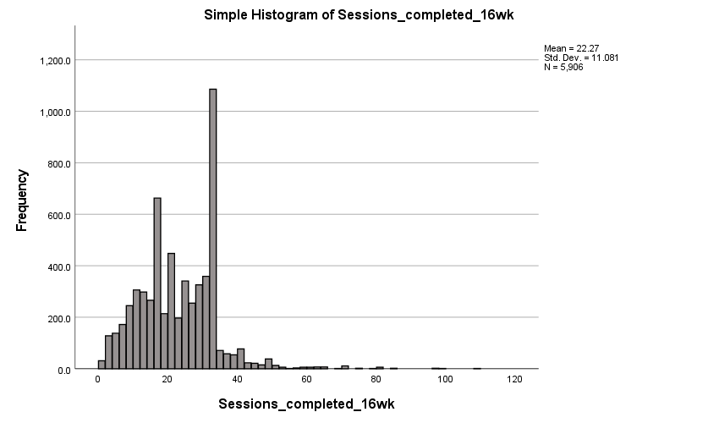

Peaks are observed at 16 weeks and 32 weeks which likely reflect groups of patients choosing to attend once and twice per week respectively over the 16-week programme.

