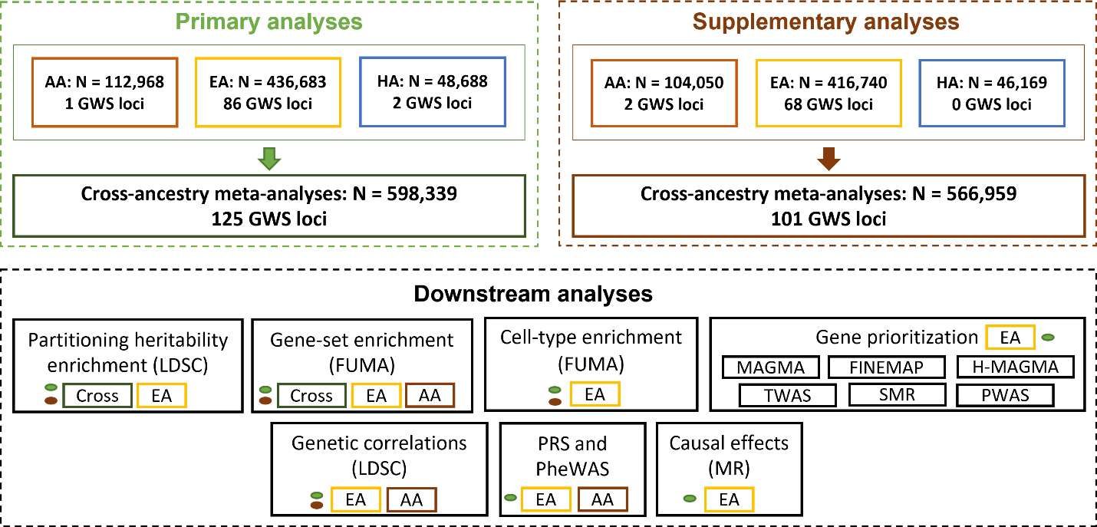
Supplementary Figure 1. Overview of the study. Top left: Primary GWAS analyses for pain intensity. Within ancestry GWAS for African American (AA), European American (EA) and Hispanic American (HA) followed by cross-ancestry meta-analysis. These results were used for all downstream analyses. Top right: Supplementary GWAS analyses for pain intensity. Bottom: Downstream analyses were conducted using the cross-ancestry, AA and EA GWAS results as indicated by color shadings: primary GWAS (green) and supplementary GWAS (brown)

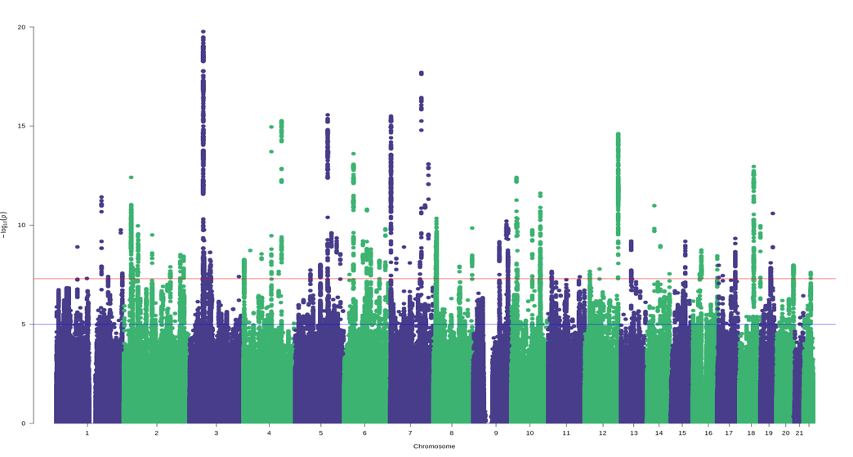
Supplementary Figure 2. Manhattan plot for the pain intensity in European American GWAS analysis. Identified 86 independent risk loci. The red line indicates GWS after correction for multiple testing (P < 5 × 10⁻⁸)

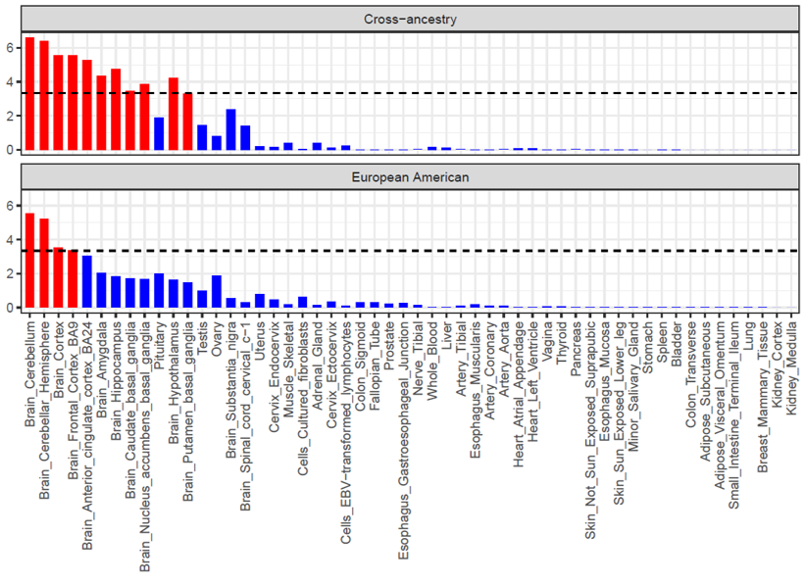
Supplementary Figure 3. MAGMA tissue enrichment for the pain intensity in cross-ancestry and European American GWAS results. Tissue enrichment analyses were conducted using FUMA. Bonferroni correction threshold (represented by the black dashed line) = 9.25 × 10⁻⁴ (0.05/54)

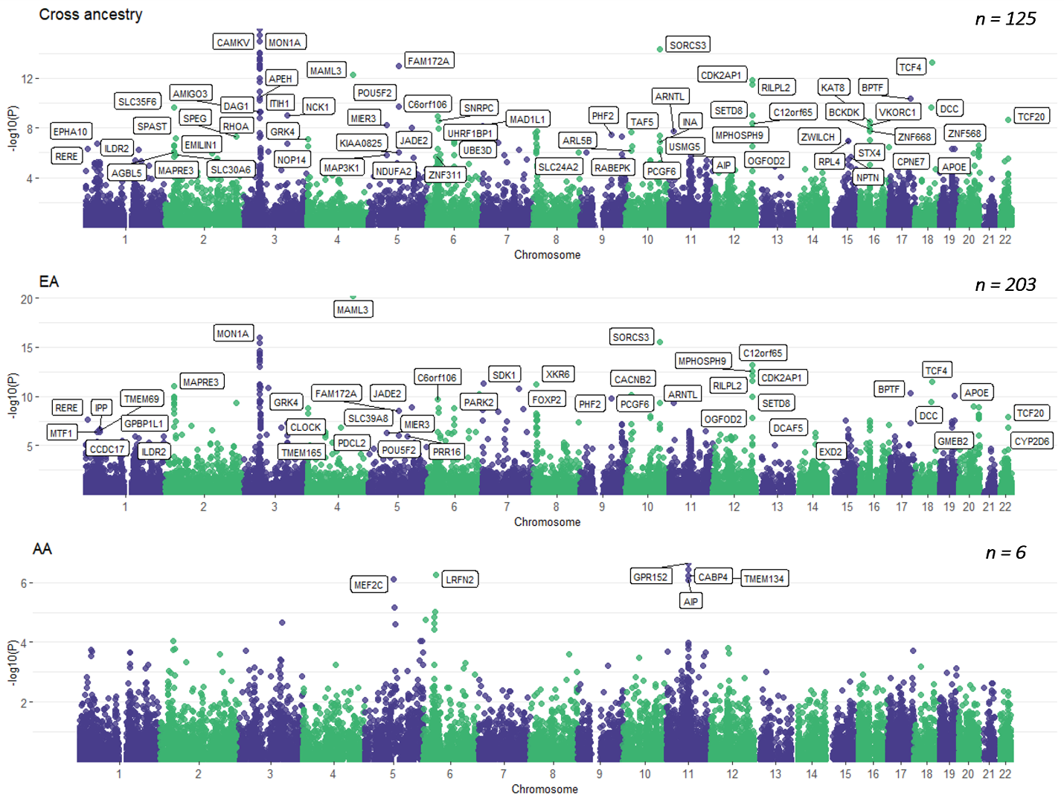
Supplementary Figure 4. Gene-based Manhattan plots for cross-ancestry, European American and African American GWAS. Gene-based association analyses were conducted using FUMA and genes that survive multiple correction are annotated. (Bonferroni p = 2.67 × 10⁻⁶ [0.05/18,702]).

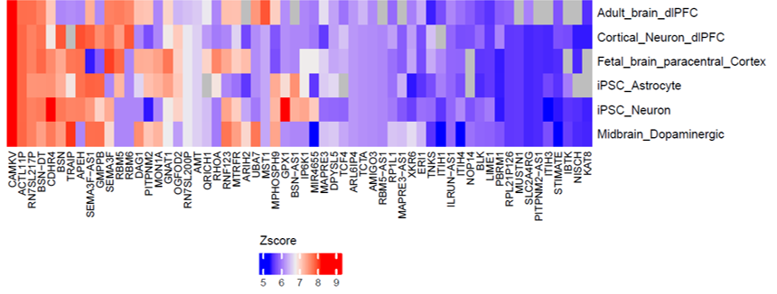
Supplementary Figure 5. H-MAGMA Gene-Tissue pairs for pain intensity. Genes that survive multiple correction across six tissues are annotated. (Bonferroni p = 2.84 × 10⁻⁸)

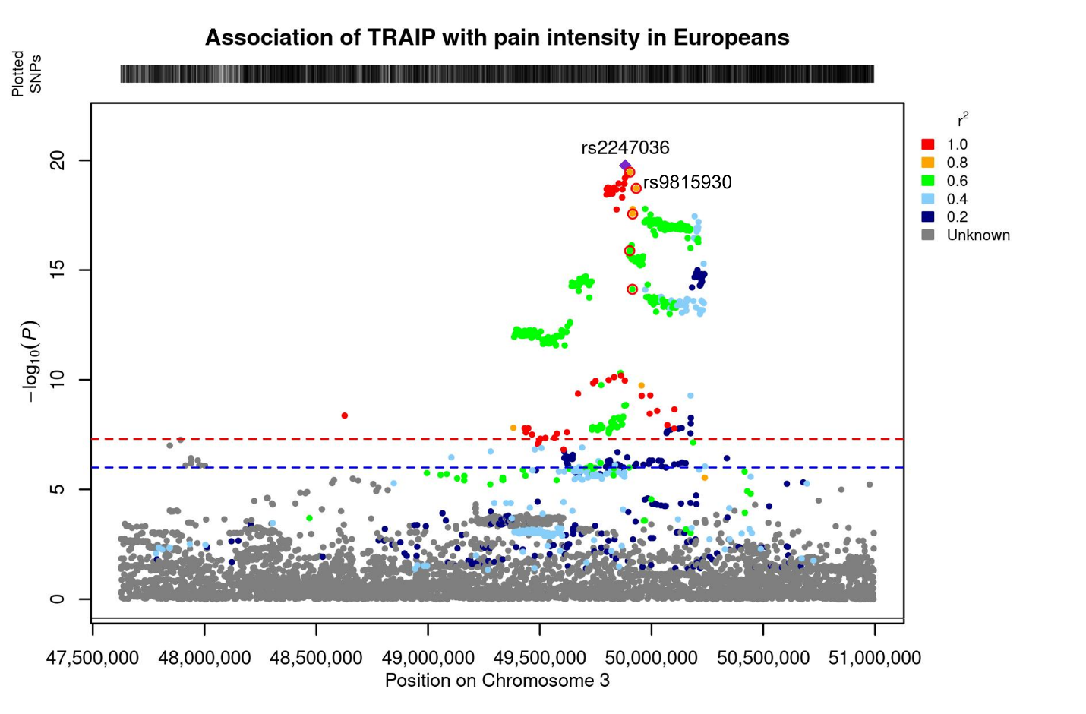
Supplementary Figure 6. Regional plot for TRAIP*rs2247036 and MSTR1*rs9815930 on chromosome 3. Credible locus prioritized by FINEMAP (PP > 0.5) are annotated with red rings. The MSTR1*rs9815930 locus is in high LD (r2 > 0.8) with the lead variant TRAIP*rs2247036.

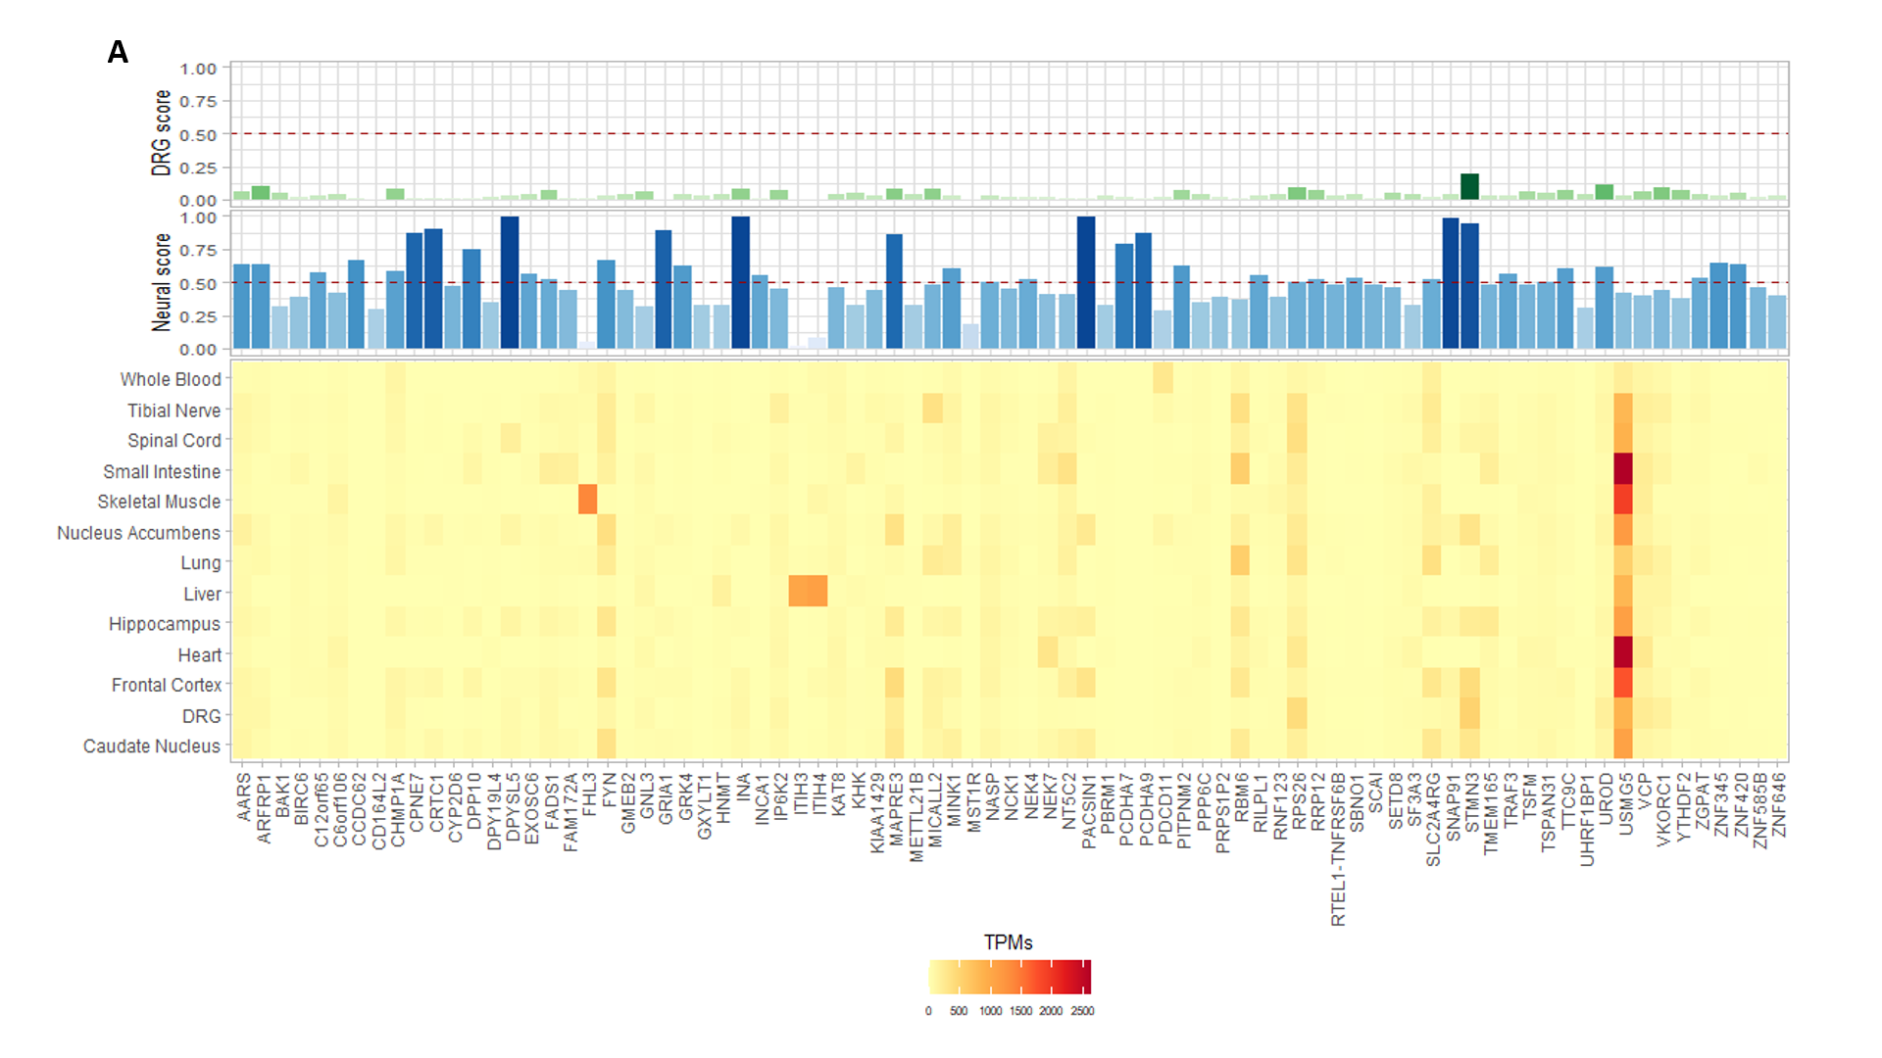
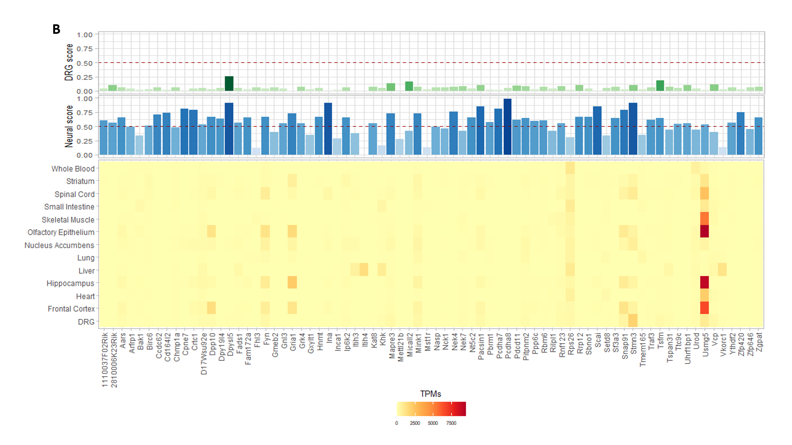
Supplementary Figure 7. Identification of tissue enrichment gene expression patterns. Causal genes and proteins that are differentially expressed in CNS and DRG in (A) humans and (B) mouse. DRG, dorsal root ganglia; TPM, transcripts per million.

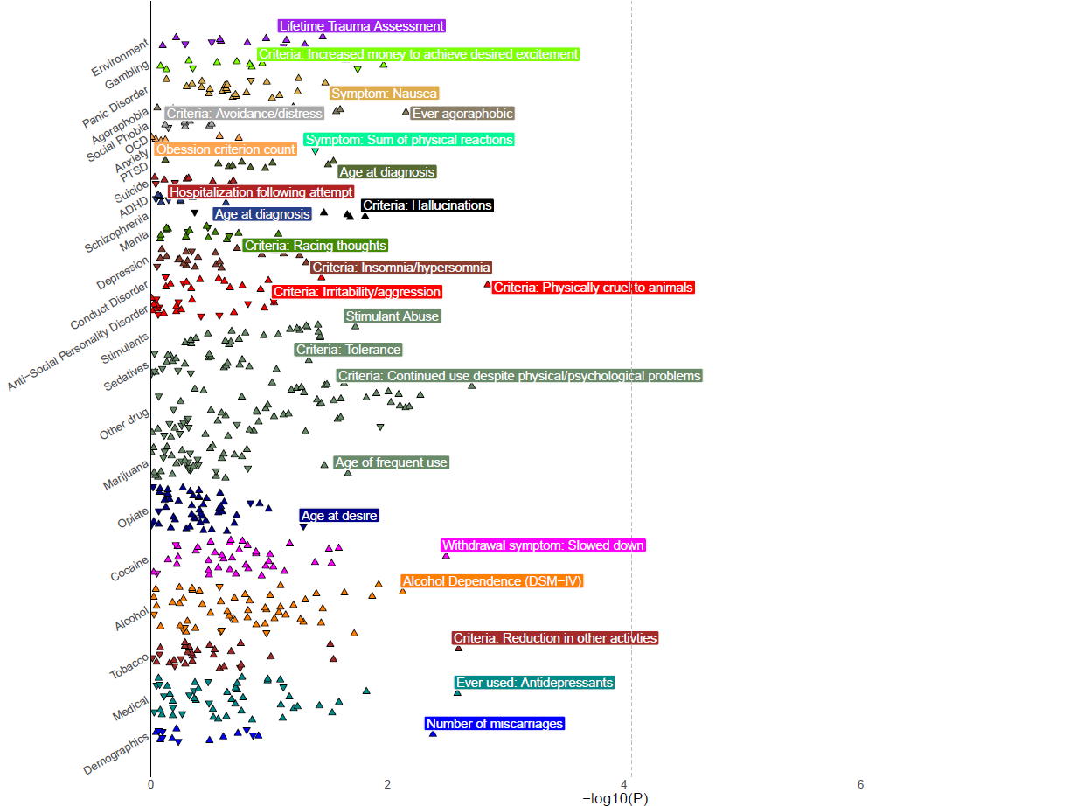
Supplementary Figure 8. PheWAS in Yale-Penn AA individuals. PheWAS plot for pain intensity PRS in EA individuals from Yale-Penn. No phenotypes passed Bonferroni correction (Bonferroni correction threshold = P < 7.83 × 10⁻⁵ (0.05/638).

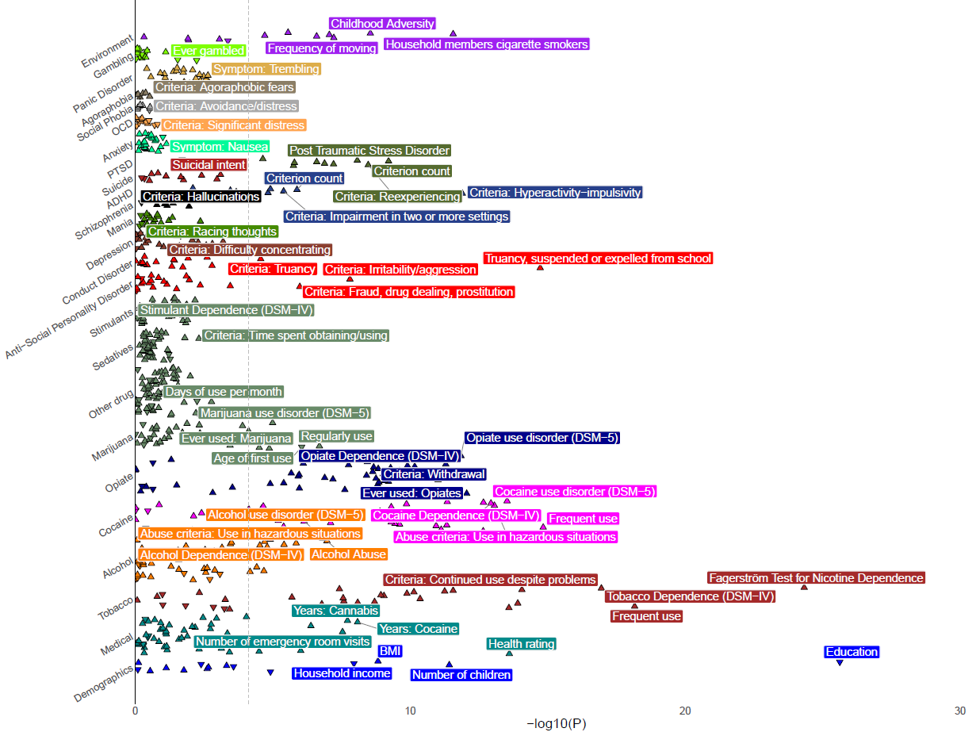
Supplementary Figure 9. PheWAS in Yale-Penn EA individuals. PheWAS plot for pain intensity PRS in EA individuals from Yale-Penn. Phenotypes that pass Bonferroni correction are annotated (Bonferroni correction threshold = P < 7.83 × 10⁻⁵ (0.05/638).

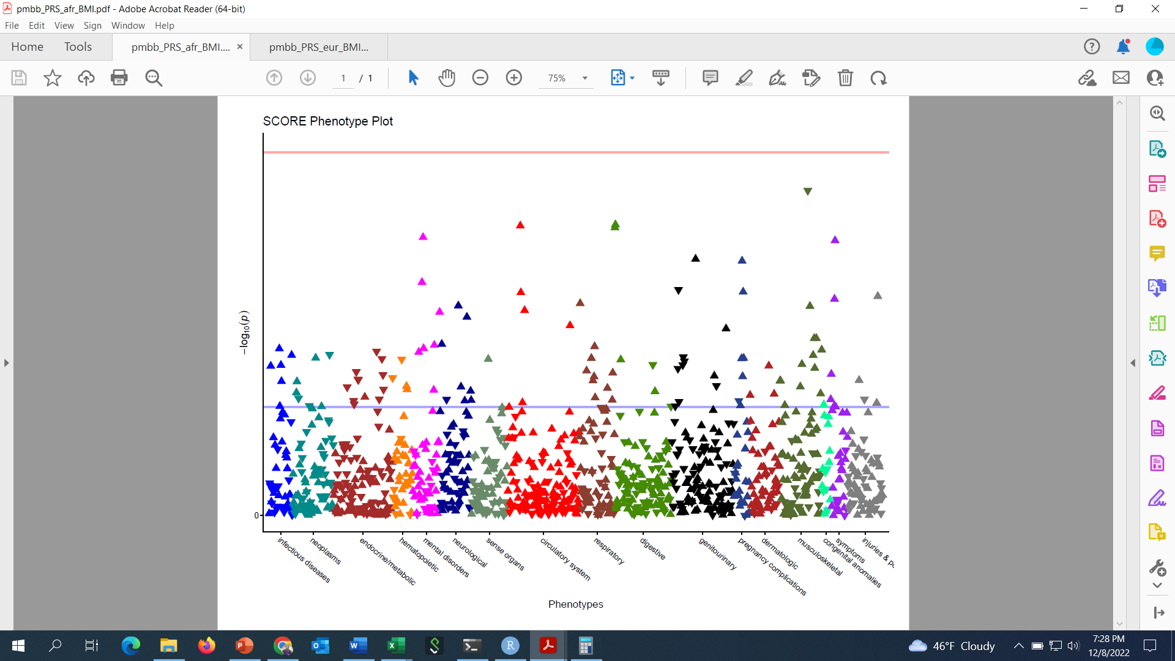
Supplementary Figure 10. PheWAS in PMBB AA individuals. PheWAS plot for pain intensity PRS in AA individuals from PMBB. No phenotypes pass Bonferroni correction are annotated (Bonferroni correction threshold = P < 3.68 × 10⁻⁵ (0.05/1360).

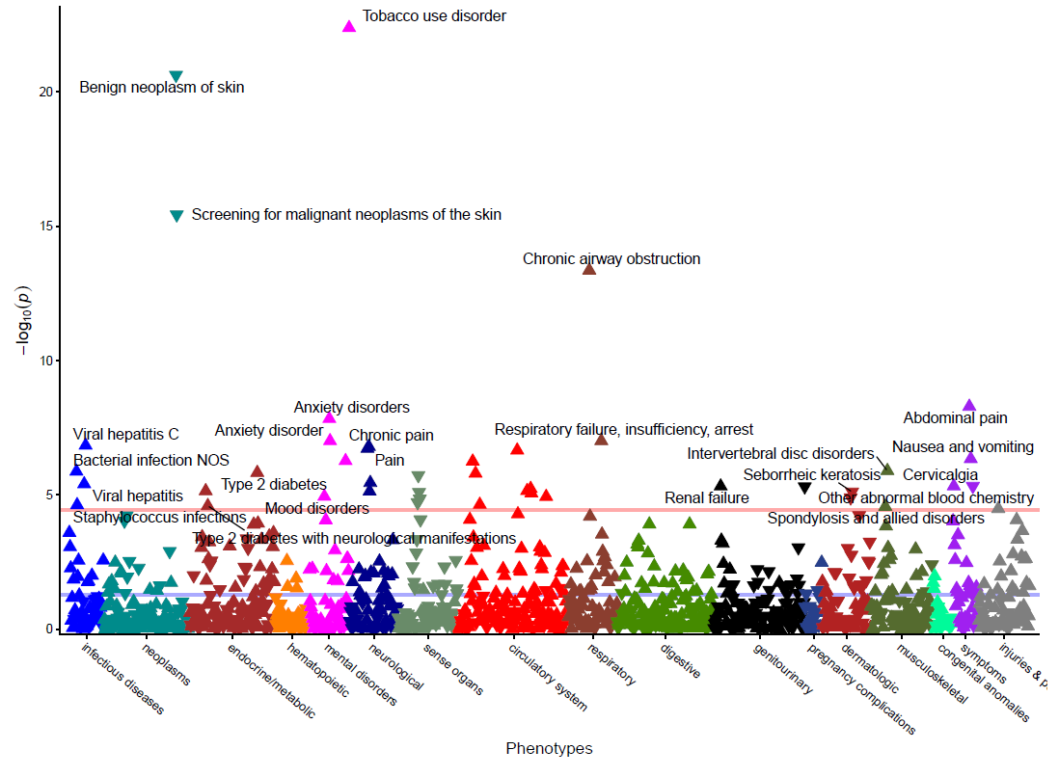
Supplementary Figure 11. PheWAS in PMBB EA individuals. PheWAS plot for pain intensity PRS in EA individuals from PMBB. Phenotypes that pass Bonferroni correction are annotated (Bonferroni correction threshold = P < 3.68 × 10⁻⁵ (0.05/1360).

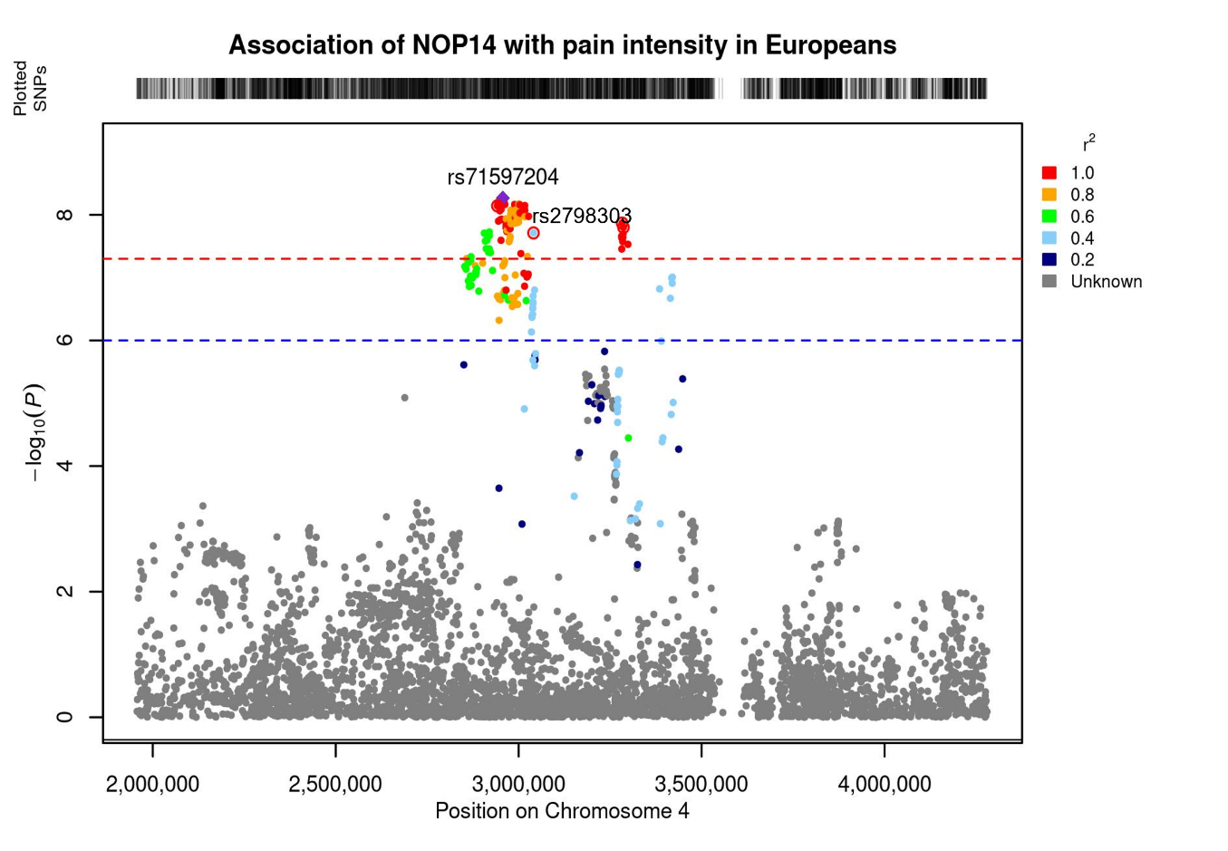
Supplementary Figure 12. Regional plot for NOP14*rs71597204 and GRK4*rs2798303 on chromosome 4. Credible locus prioritized by FINEMAP (PP > 0.5) are annotated with red rings. The GRK4*rs2798303 locus is in moderate LD (r2 > 0.4) with the lead variant NOP14*rs71597204.

