Supplementary data
Adding to the family of resistance factors against last resort antibiotics: Identification and characterization of a novel carbapenemase, CIM-1

Yu Wang^{1,2}, Sylvia A Sapula¹, Jonathan J. Whittall¹, Jack M. Blaikie¹, Olga Lomovskaya³ and Henrietta Venter^{1*}
¹Health and Biomedical Innovation, Clinical and Health Sciences, University of South Australia, Adelaide, Australia
²School of Biomedical Science, University of Adelaide, Adelaide, Australia
³ Qpex Biopharma, Inc., San Diego, California, United States
*Corresponding author: Henrietta Venter (rietie.venter@unisa.edu.au)

Supplementary Figure 1. The top protein selected by SWISS-MODEL during modelling of CIM-1 3D structure, MYO-1, has a high amino acid similarity comparing to CIM-1. Non-canonical lipobox (FISC) was also observed from MYO-1 amino acid sequence at position 15 to 18. MYO-1 was predicted by SignalP6.0 to be a lipoprotein at a likelihood of 0.8233. Sequence identity and similarity was determined using Sequence Manipulation Suit (SMS): identical residues: 132; similar residues: 46; percent identity:48.89; percent similarity: 65.93. Amino acid sequence alignment of CIM-1 with NDM-1 was generated by ESPript 3.0.

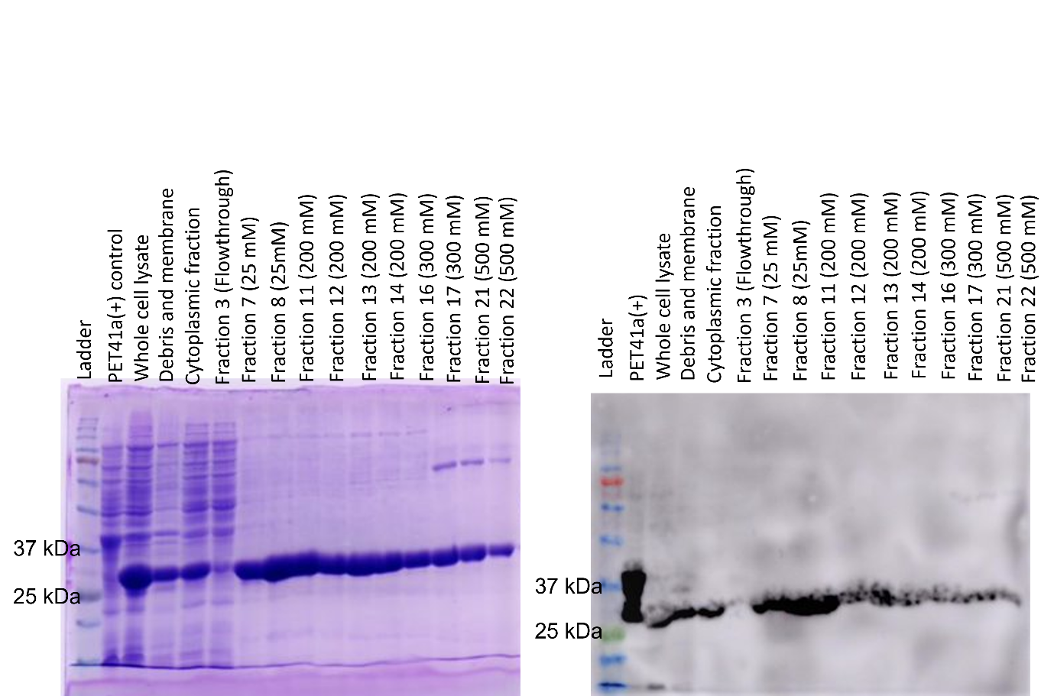

Supplementary Figure 2. SDS-PAGE analysis of His-tagged CIM-1ΔSig protein purification.
E. coli BL21(DE3) was transformed with pET41a(+)-bla_{CIM-1ΔSig} and grown in LB at 25 °C for 20 hours. The protein was purified from the supernatant after ultra-centrifugation of disrupted cells using an ÄKTA pure FPLC and Nickel-affinity column chromatography. All fractions were loaded onto 15% SDS-PAGE gel. Proteins were visualized via gel staining with Coomassie® Brilliant Blue R-250 (Bio-Rad). High purity of CIM-1ΔSig was observed across most fractions due to its high expression level (left panel). A Western blot (right panel) was used to confirm His-tagged CIM-1ΔSig at approximately 27 kDa (Theoretical weight of His-tagged CIM-1ΔSig is 26908.49 Da, calculated using Expasy pl tool: https://web.expasy.org/cgi-bin/compute_pi/pi_tool)

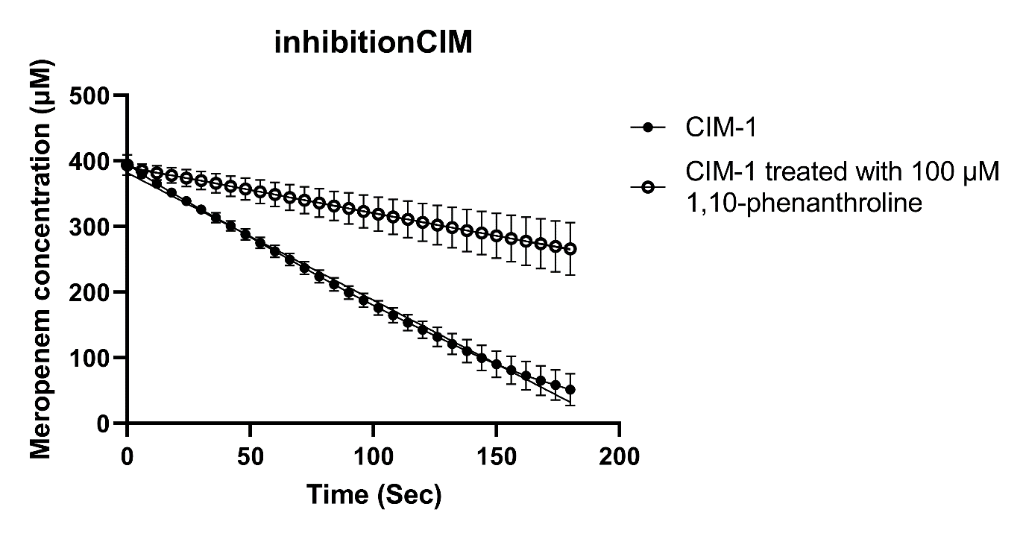
Supplementary Figure 3. The rate of hydrolysis of CIM-1 was significantly reduced in the presence of the zinc metal ion chelator, 1,10-phenanthroline. CIM-1 (250 nM) was incubated with 100 µM of 1, 10-phenanthroline for 20 minutes. The absorbance of the unhydrolyzed meropenem substrate was measured at 320 nm and converted to meropenem concentration by using a standard curve of known meropenem concentrations versus meropenem absorbance. Slope was calculated and compared between treated and untreated CIM-1.

Two homologs from Pedobacter sp.
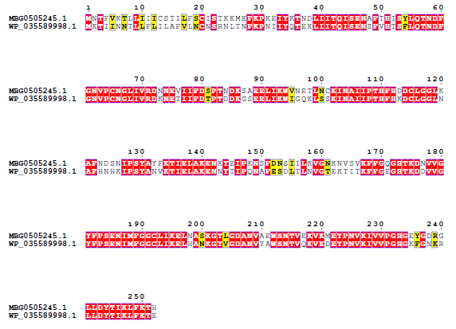
Two homologs from Elizabethkingia anophelis.
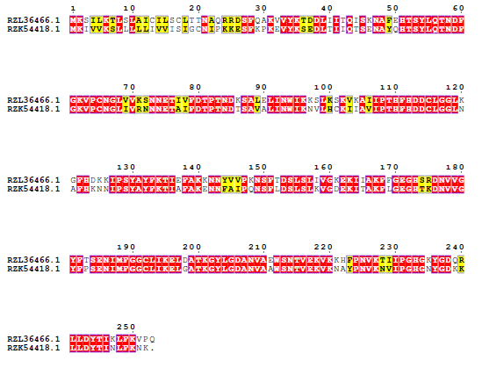
Supplementary Figure 4. Lower amino acid similarity in the signal peptides as comparison to the mature protein sequences was observed between the homologs, where ones are predicted to be lipidated (MBG0505245.1 and RZK54418.1), the others are not.
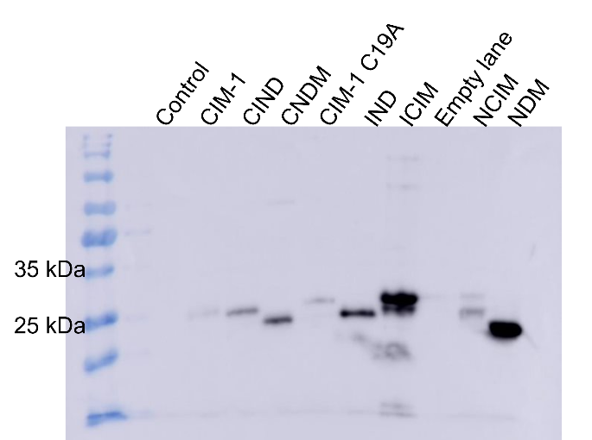
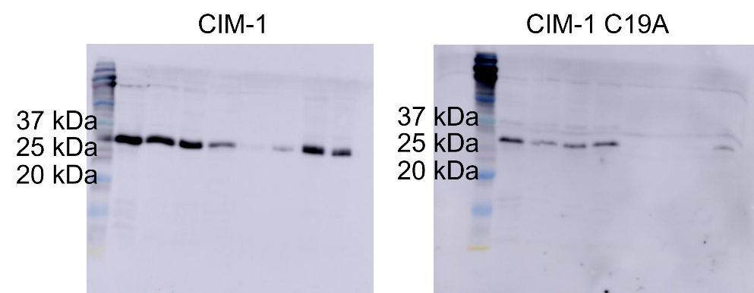
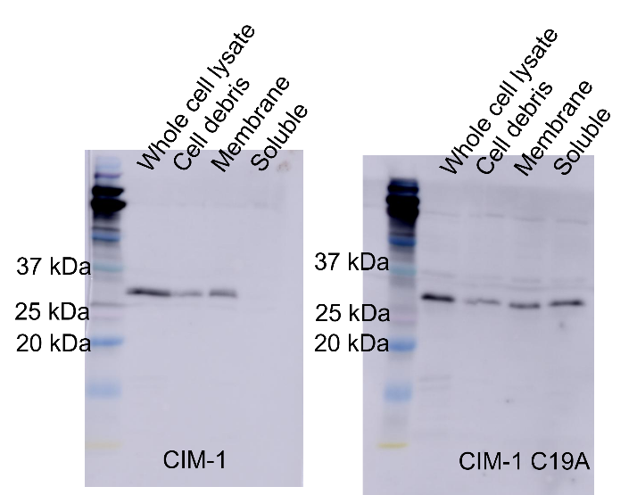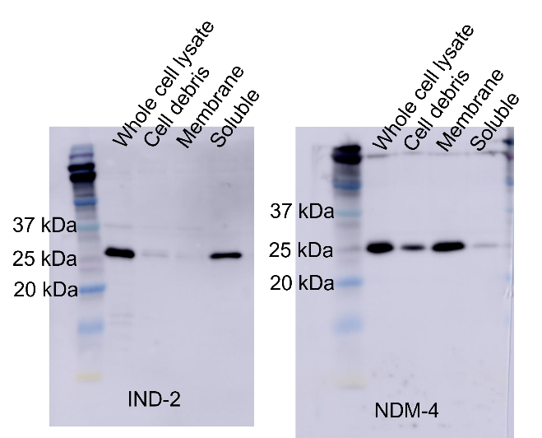
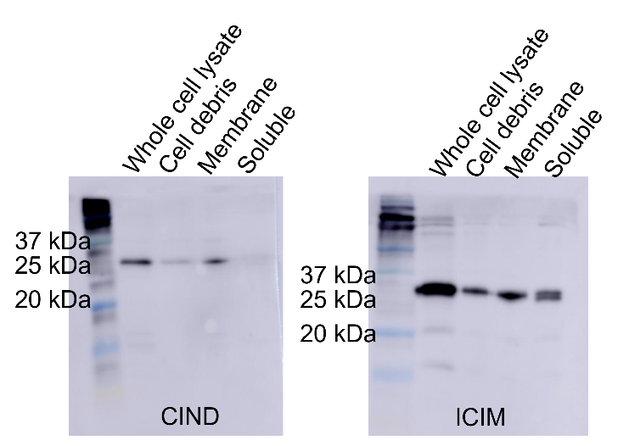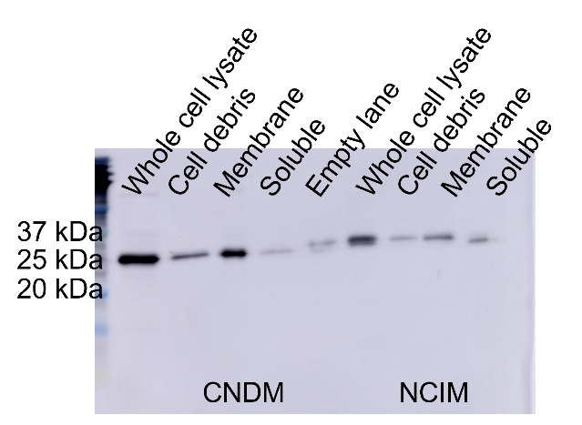
Supplementary Figure 5. Full gel image for Figures 2 and 3.

