Supplementary Figure (SF)

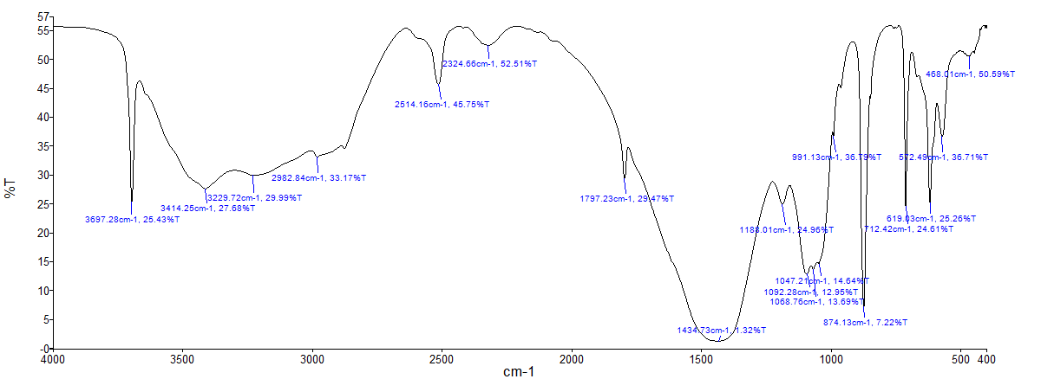
a

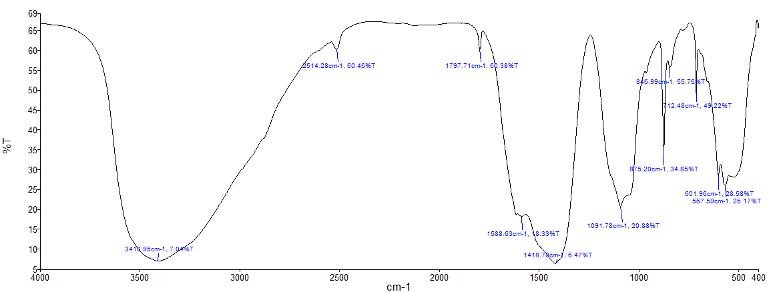
b

SF1. FTIR analyses of thermally activated (TA) adsorbent (a) before chromium adsorption and (b) after chromium adsorption

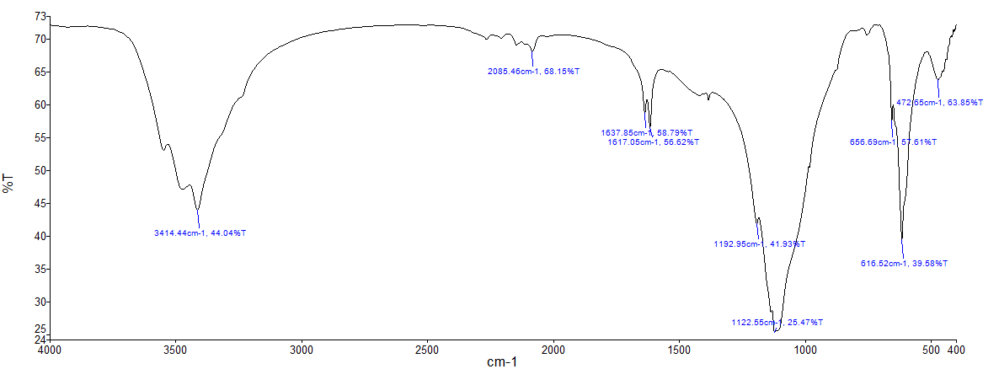
c

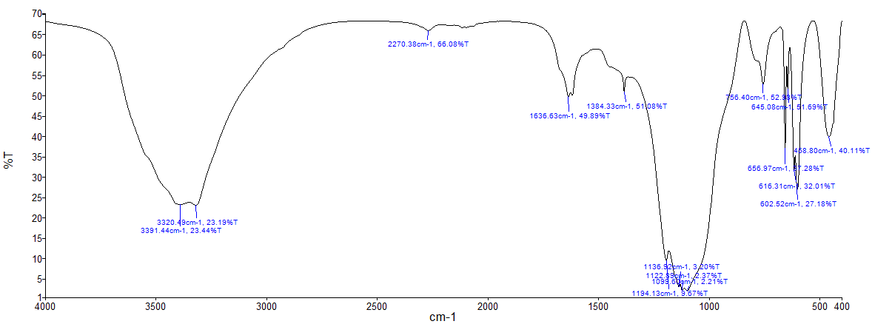
d

SF2. FTIR analyses of zinc chloride activated (ZA) adsorbent (c) before chromium adsorption and (d) after chromium adsorption

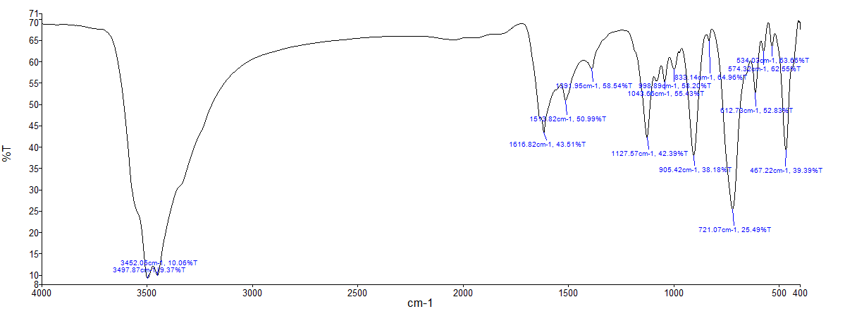
e

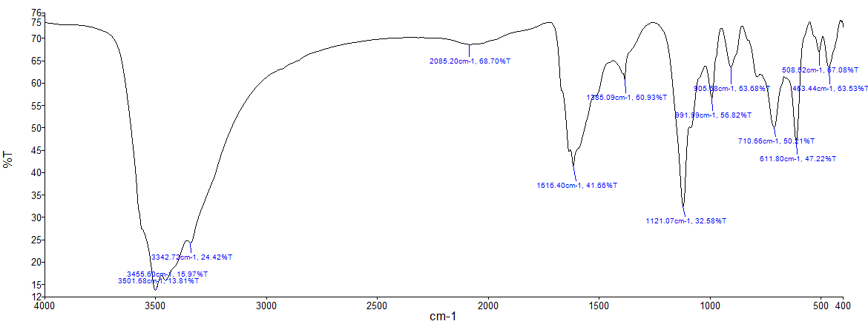
f

SF3. FTIR analyses of potassium hydroxide activated (KA) adsorbent (e) before chromium adsorption and (f) after chromium adsorption

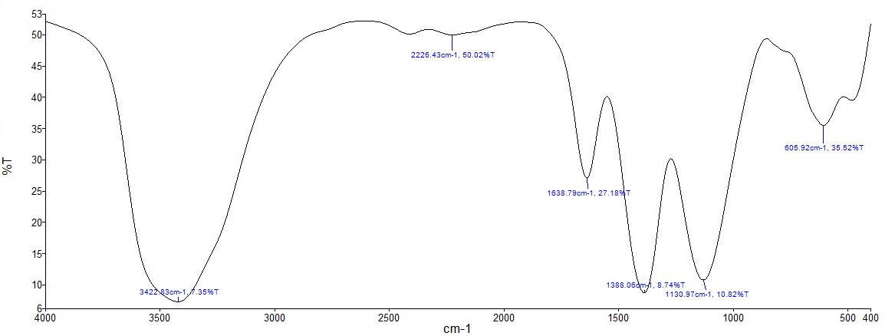
g

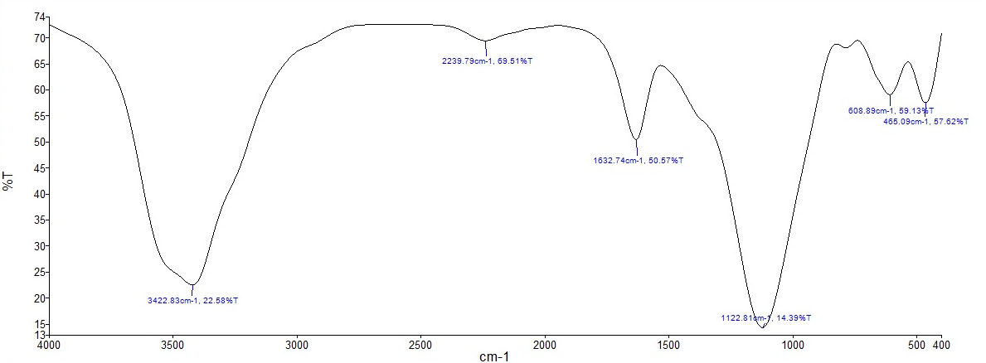
h

SF4. FTIR analyses of nitric acid activated (NA) adsorbent (g) before chromium adsorption and (h) after chromium adsorption

