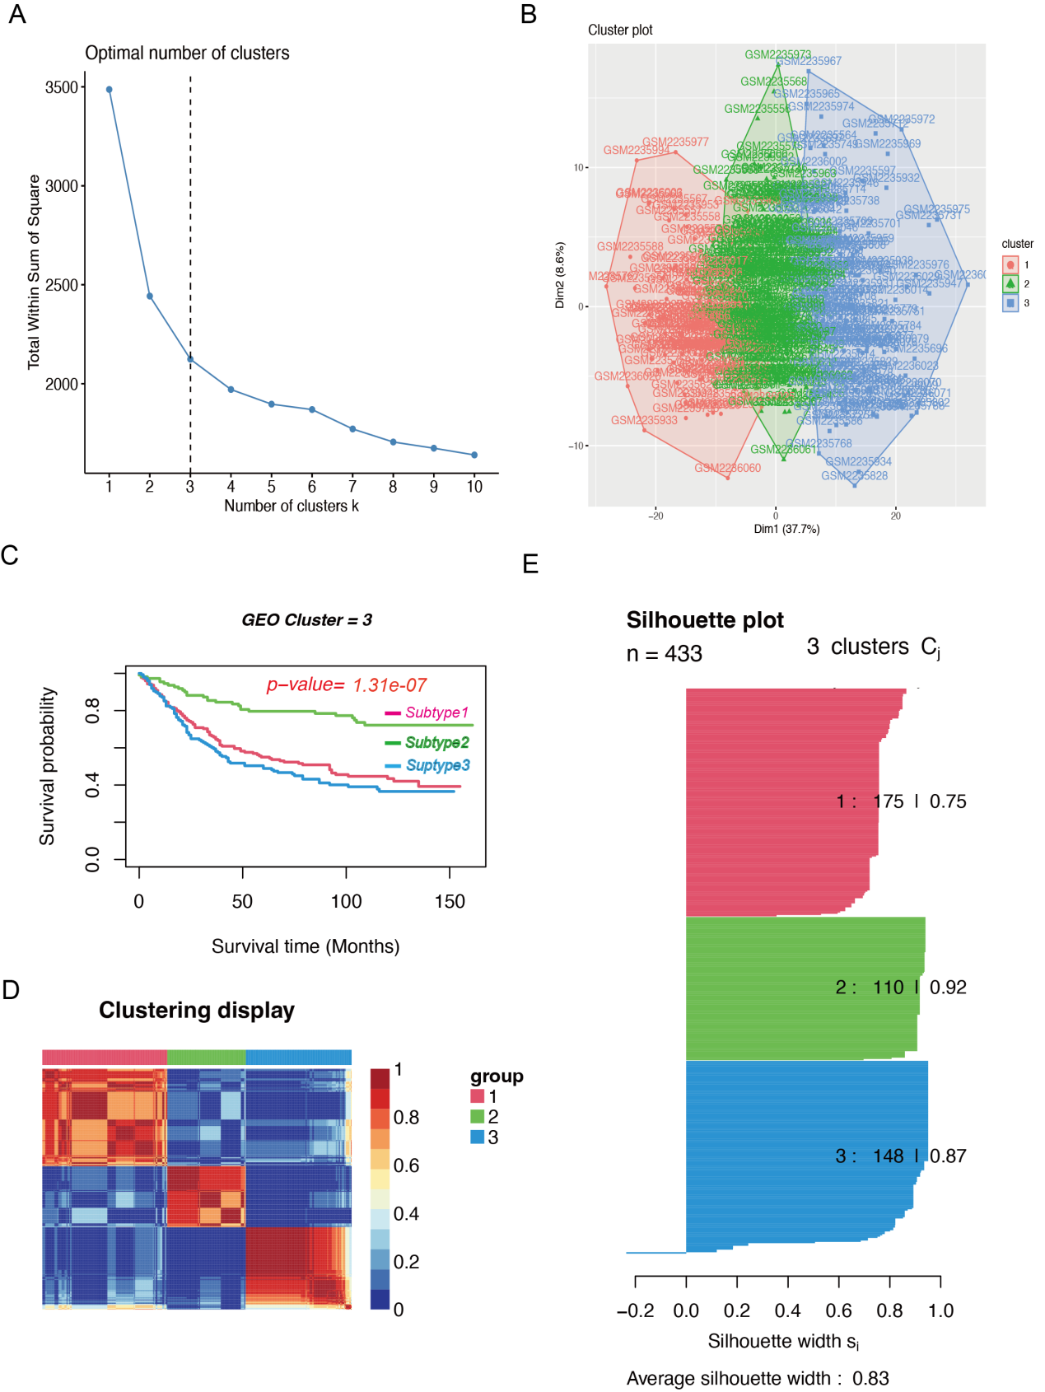
Supplement 1: Molecular typing of the GEO samples. (A) Calculation of the optimal k value. (B) Cluster diagram of the three molecular typing. (C) The prognosis of different typing. (D) Heat map of different typing. (E) Calculation of the profile coefficients of the typing.
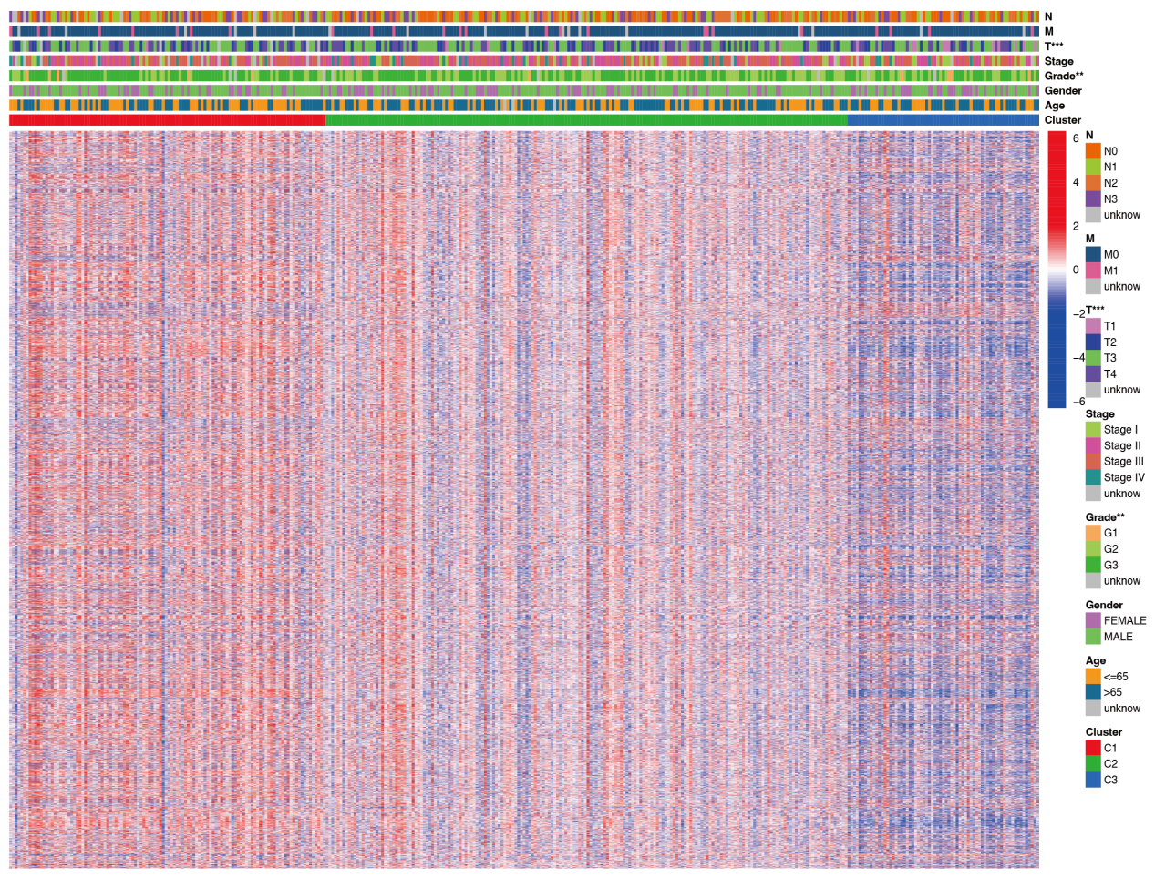
Supplement 2: A cluster analysis on gene sets: these gene sets shown high expression in subtype C1 and low expression levels in subtype C3.

