Additional file 1
A 31-bp Indel in the 5' UTR region of the GNB1L gene is significantly associated with chicken body weight and carcass traits
Tuanhui Ren^{1,2}, Ying Yang¹, Wujian Lin^{1,2}, Wangyu Li^{1,2}, Rong Fu^{1,2}, Mingjian Xian^{1,2}, Zihao Zhang^{1,2}, Wen Luo^{1,2}, Xiquan Zhang^{1,2*}

Figure S1. DNA sequencing files of the GNB1L 31-bp Indel. (a) Partial sequence of the D allele. (b) The partial sequence of the I allele.

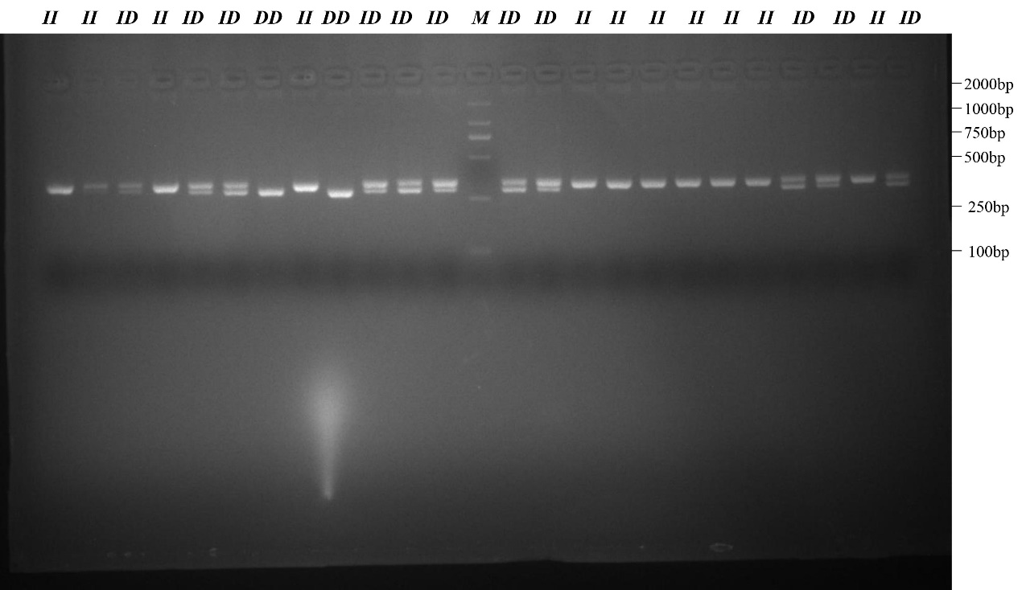

Figure S2. Electrophoresis (3.0%) patterns showing the amplification results for GNB1L gene. DD, ID and II are the three different genotypes, and M represents DL2000. Because the gel has not melted enough, there is a white stain in the picture.

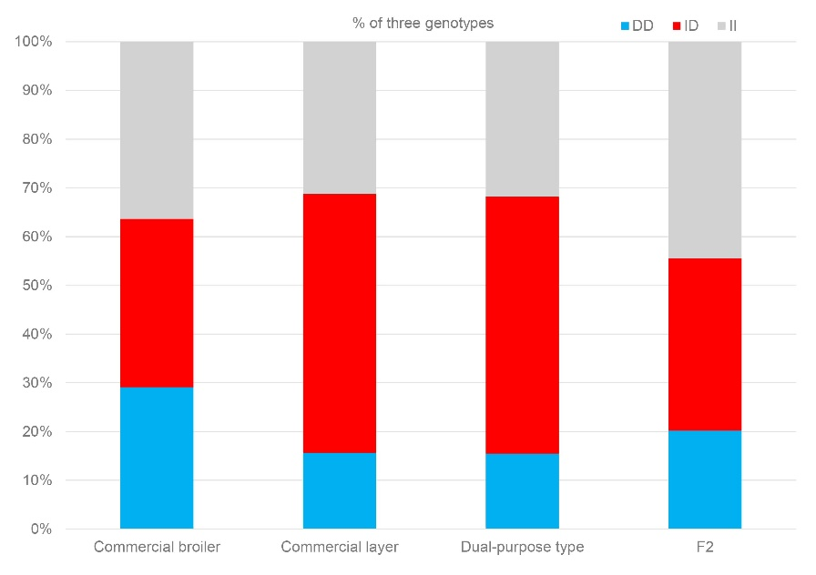
Figure S3. Percentages of the DD (blue), ID (red), and II (gray) genotypes in four types.
Figure S4. Transcription factor binding sites predicted in the GNB1L 31-bp Indel. The AliBaba 2.1 online website parameters such as cons = 75% and classification level K = 4.

Table S1. Pairwise fixation index (Fst) of GNB1L gene in different chickens.

 | F2 | WC | LS | RW | QY | ND | ISA
WC | 0.003
LS | 0.023 | 0.027
RW | 0.004 | 0.000 | 0.022
QY | 0.000 | 0.005 | 0.055 | 0.008
ND | 0.000 | 0.003 | 0.042 | 0.005 | 0.000
ISA | 0.001 | 0.001 | 0.035 | 0.002 | 0.002 | 0.001
GX | 0.000 | 0.008 | 0.061 | 0.011 | 0.000 | 0.001 | 0.004
Note: F2: F2 resource population (F2, n = 360), ND: Ningdu chickens, RW: Recessive white Rock chickens, ISA: ISA brown laying hen, GX: Guangxi chickens, WC: Wenchang chickens, QY: Qingyuan chickens, LS: Lushi chickens.

Table S2. Association analysis of the GNB1L 31-bp indel with meat traits in the Xinghua × Recessive White Rock F2 populations.
Traits | Mean±SE |  |  | P-value
Traits | DD | ID | II | P-value
LMSF | 78.4±3.3 | 74.6±2.5 | 72.6±2.2 | 0.338
BMSF | 33.7±1.2 | 32.4±0.9 | 33.3±0.8 | 0.648
RWL (%) | 17.9±1.7 | 20.34±1.8 | 18.6±1.4 | 0.592
CLMF | 19635.4±516.5 | 19845.5±367.7 | 19680.7±376.1 | 0.93
CBMF | 22018.7±579.2 | 21320.0±412.3 | 21831.4±421.7 | 0.547
BMDC (%) | 26.0±0.2 | 26.1±0.2 | 26.2±0.2 | 0.681
BMDC (%) | 25.0±0.3ab | 24.9±0.3a | 25.3±0.3b | 0.046
BMFC (%) | 0.9±0.1 | 0.9±0.1 | 0.9±0.1 | 0.764
LMFC (%) | 3.6±0.3 | 3.3±0.3 | 3.8±0.3 | 0.05

Note: SE = standard error of the mean; BMSF = Breast muscle shear force; LMSF = Leg muscle shear force; RWL = Rate of water loss; CLMF = Cross-sectional area of leg muscle fibers; CBMF = Cross-sectional area of breast muscle fibers; BMDC = Breast muscle dry matter content; BMDC = Leg muscle dry matter content; BMFC = Breast muscle fat content; LMFC = Leg muscle fat content.

Table S3. Details of primer pairs.

Primers (5'-3') | Sizes (bp) | Tm (℃) | Genotype (bp)
GNB1L-F: TGCTGCACTGGAGCTAACAA | 332 | 61 | DD: 332, ID: 332+301, II: 301
GNB1L-R: GCTCAGCCAGTCAGTGGTAG | 332 | 61 | DD: 332, ID: 332+301, II: 301
GNB1L-DF: GGATCTGCCTGTGGGATTTA | 158 | 60 | -
GNB1L-DR: CAAAACCTGAACCTCCTCCA | 158 | 60 | -
actin-F: GACTGACCGCGTTACTCCCA | 166 | 60 | -
actin-R: CCAACCATCACACCCTGATGTC | 166 | 60 | -
Note: “–” represents a primer that is not used for genotyping.

