Supplementary material: Chip Scale, CMOS-compatible, high energy passively Q-switched laser
Neetesh Singh^{1*}, Jan Lorenzen¹, Milan Sinobad¹, Kai Wang², Andreas C. Liapis³, Henry Frankis⁴, Mahmoud A. Gaafar¹, Stefanie Haugg⁵, Henry Francis⁶, Jose Carreira⁶, Michael Geiselmann⁶, Tobias Herr¹, Jonathan Bradley⁴, Zhipei Sun³, Sonia M Garcia-Blanco², and Franz X. Kärtner^{1,7}
¹Center for Free-Electron Laser Science CFEL, Deutsches Elektronen-Synchrotron DESY, Germany
²Integrated Optical Systems, MESA+ Institute for Nanotechnology, University of Twente, 7500AE, Enschede, The Netherlands
³Department of Electronic and Nanoengineering, Aalto University, Espoo 05140, Finland
⁴Department of Engineering Physics, McMaster University, 1280 Main Street West, Hamilton, Ontario L8S 4L7, Canada
⁵Centre for hybrid Nanostructures, University of Hamburg, Luruper Chaussee 149,, 22761, Hamburg, Germany
⁶LIGENTEC SA, EPFL Innovation Par L, Chemin de la Dent-d’Oche 1B, Switzerland CH-1024 Ecublens, Switzerland.
⁷Department of Physics, Universität Hamburg, Jungiusstr. 9, 20355 Hamburg, Germany
*neetesh.singh@desy.de

Table of content
- Passive and active component testing
- Passive components (Loop mirror (LM), Pump and signal combiner (PSC) and directional coupler of NLI)
- Measurement of the 3-dB point of the DC of the LM and insertion loss
- Bend loss measurements
- NLI modulation depth
- Gain film deposition
- Doping concentration measurement
- Refractive index of Al₂O₃ film
- Simulations of the LMA waveguide and Q-switching

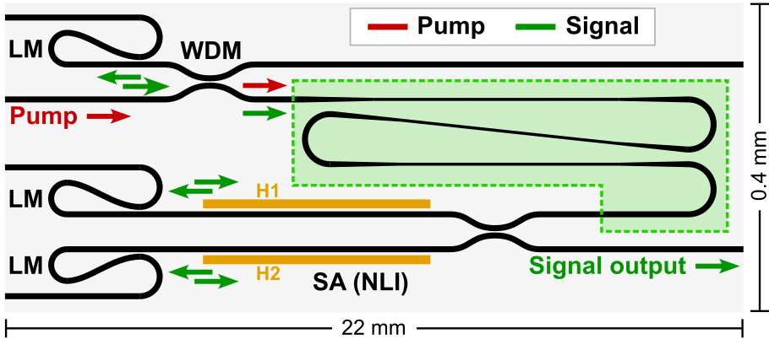
- Passive and active component testing: As is shown in the manuscript and below in Fig.S1, the laser cavity consists essentially of a passive section – reflectors and a saturable absorber, and a gain section. In the passive section the laser has a pump and signal combining device (which is a wavelength division multiplexer (WDM)), loop mirrors to reflect the signal and an artificial saturable absorber, based on nonlinear interferometer (NLI) for pulse generation. The gain section consist of a Tm³⁺:Al₂O₃ film on top of silicon nitride waveguide with a 300 nm thick silica layer sandwiched in between. The pump light is coupled into the gain section (green box) through the WDM, and at the output end of the gain section the signal is adiabatically coupled into a wide SiN waveguide which leads to the integrated saturable absorber (NLI-SA). Here in the supplementary, we discuss the characterization of these components.

Fig. S1. Schematic of a compact integrated LMA pulsed laser. WDM – wavelength division multiplexer; LM – loop mirror; SA – saturable absorber; H1,2 – high and low power arm heaters. The pump is coupled into the gain section through a WDM towards the serpentine waveguide. Within the green dashed box region, the black lines indicate SiN waveguide where the LMA region is in the straight SiN section and confined mode in the bent section to achieve tighter bends for compact footprint. The integrated SA is a nonlinear Michelson interferometer (NLI) which splits the pulse into two arms through a directional coupler and back reflects them with the help of LMs.

- Passive components (Loop mirror (LM), Pump and signal combiner (PSC) and directional coupler of NLI):

PSC: The pump and signal combiner is a WDM based on directional coupler. It was fabricated in the passive SiN layer, with a waveguide width of 0.9 µm, length of 570 µm and the separation of 1.5 µm between the two waveguides in the coupling region. The directional coupler (DC) was fabricated on the same chip as the laser as a test structure, the spectral response is shown in Fig. S2a. Here we observe that the signal has a maximum around 1.89 µm (cross port of the WDM) with a bandwidth of 130 nm @ 1dB level. The pump at 1.61 µm has a transmission over 90% to the through port of the WDM. We note a chip to chip variation in the spectral response on the same wafer is measured to be ±5 nm and from wafer to wafer it is close to ±10 nm.
a)
b)
c)
d)

Fig. S2. Response of the passive components. a) Measured pump and signal combiner which is a WDM. b) Measured directional coupler’s through and cross port of the loop mirror from which the, c) reflectivity is extracted. Measured directional coupler of the NLI-SA with a split ratio of 80:20 at 1.9 μm.
A loop mirror consists of two components – a DC and a 180° circular bend and is defined in the SiN layer covered entirely in silica. Its DC had a waveguide width of 0.9 µm, length of 250 µm and the separation between the two waveguides was 1.3 µm in the coupling region. The spectral response is shown in Fig. S2b, where we observe the 3-dB crossing point is at 1890 nm, which can be calculated to give maximum reflectivity at 1890 nm (as shown in Fig. S2c). Next, we measured the response of the directional coupler which determines the modulation depth of the saturable absorber [1]. The spectral response of the directional is shown in Fig. S2d, where we see that around 1.89 µm the DC power splitting factor is ~ 80:20, i.e. 80% power to the through port and 20% power to the cross port which are both terminated with loop mirrors (Fig. S1). The 80:20 split ratio gives a modulation depth of more than 50% which is tunable with the help of integrated heaters (by applying thermal phase shift).
- Measurement of the 3-dB point of the DC of the LM and insertion loss:
Above we measured, the DC of the loop mirror and found out its strong reflection wavelength (the 3-dB point). However, from such a measurement it’s hard to distinguish the insertion loss of the device. To measure the insertion loss, we took measurements similar to a cutback measurement with the DCs. In that, we fabricated a cascaded DC device as shown in Fig.S3a. In that, unlike a traditional cutback, there is only one input signal port, thus removing the uncertainty in the measurement from different input ports for different cutback lengths. The input signal is launched from the top left port which goes through several top ports of the cascaded DCs, and collected as shown in Fig.S3a. The separation between the output ports is only 30 µm, which ensures that the output couplers should have similar coupling loss. The measured signal for different ports is shown in Fig. S3b. Here we see that the two neighboring output channels have a ~ 3 dB difference in signal strength around 1890 nm, which suggest that the 3-dB point (as determined in Fig. S2b) has negligible insertion loss, otherwise the difference would be higher at 1890 nm. The wavelength dependent power difference between the two neighboring ports is given as ~ 10(log₁₀(1-t) + log₁₀(I)), where t is the split ratio which is 0.5 for the 3-dB point at 1890 nm and I is any additional insertion loss (here we assume the output ports have similar coupling losses).
a)
b)
3
In
1
2
4

Fig. S3. a) The cascade DC tree for the insertion loss measurement. b) The measured signal at the four output ports. Here the 3-dB point is at 1890 nm where the difference between the signal strengths between the neighboring ports is ~ 3 dB.
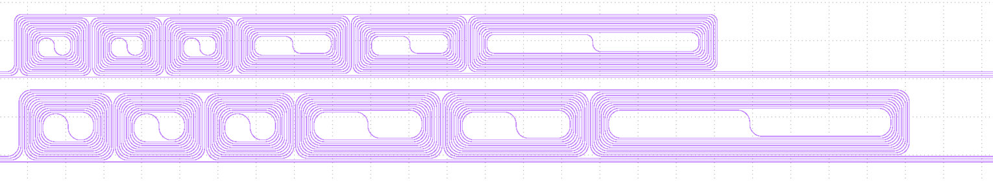
A negligible insertion loss from the DC of the loop mirror is expected because the separation between the two waveguides in the coupling region is 1.3 µm, which is large enough to cause any etching dependent roughness loss (with 200 nm node CMOS based stepper lithography). Here we also note that the measured signal becomes noisier as we go down in port number from the input, that is mainly because of the drop in signal strength and approaching the noise limit of the measurement tool (Yokogawa AQ6376) due to injecting a low power signal at the input from the broadband source (NKT).
150 bends
100 bends
50 bends
R=50 µm
R=80 µm

Fig. S4 Spiral waveguides with 50, 100 and 150 bends for two different radii 50 µm and 80 µm.
- Bend loss measurements:
To achieving a low loss cavity the bends should suffer low propagation loss. Here we measured the loss of the bends over 50 nm bandwidth around 1900 nm with cutback method. We fabricated waveguides with three different number of bends (50, 100 and 150) while the straight waveguide sections remained of the same length for all the waveguides. Here we utilized 90° bends instead of 180° bends as the former takes less space on the reticle and gives an upper limit on the loss experienced by the later. In other words, two 90° bends give higher loss (~ 2x) than one 180° bend. This is because two 90° bends have two additional interface loss (bent to straight waveguide section) where the mode mismatch is the dominant loss mechanism, this is especially true for larger radii bends [2, 3].
For the loss measurement spiral waveguides were fabricated as shown in Fig.S4. Two different bend radii were tested 50 µm and 80 µm over the spectral range from 1870 nm to 1920 nm. The loss measurement is shown in Fig. S5. The loss for R=50 µm remained around 0.004 dB/bend, and for R= 80 µm the bend loss was 0.0008 dB/bend. As mentioned above the 90° bends give an upper limit of the loss experience by an 180° bend (which is usually 2x smaller than the two 90° bends) so we can safely assume that the loss incurred by the bends in the laser cavity is <0.0008 dB/180° around the signal wavelength.
R=50 µm
R=80 µm
90° bend

Fig.S5 Two radii were used 50 µm and 80 µm. b) The measured transmission data spanning from 1870 nm to 1920 nm. Inset: a cartoon showing a 90° bend.

- NLI modulation depth:
We have measured the response of the as-fabricated saturable absorbers (NLI) in the laser cavity [Fig. 3 in the manuscript]. In that, we launched a very weak broadband signal (supercontinuum source, NKT) due to the lack of a narrow band source around the signal wavelength, and used integrated heater to trace out the as-fabricated NLI reflection curve. There we observe that the modulation depth is less than 40%, when it should have been more than 50% for an NLI with a 80:20 DC power splitter. This can be understood as follows. The NLI reflectivity at a very low power (in the linear regime) can be given as, $R=S{.N}_{t}^{2}L_{m}$, here S is the signal from the source (supercontinuum source) $N_{t}$ is the wavelength dependent NLI’s through port response (Fig.S2d) and $L_{m}$ is the wavelength dependent loop mirror’s reflectivity (Fig.S2c). The square over the $N_{t}$ is due to the fact that signal passes twice the DC of the NLI on reflection.
The reflected signal response is shown in Fig. S6b. Here we see the maximum reflection is <1840 nm. Since we are using a broadband source (1780 nm to 2000 nm, supercontinuum filtered with a bandpass filter, Thorlab FB 1900-200) the output collected back is dominated mainly by signal at 1840 nm where NLI’s DC has more than 85% signal transmitted to the through port, which in turn results into a less than 40% modulation depth. By using a narrow laser around 1890 nm the modulation depth over 50% can be extracted. We note that even though the overall reflectivity of the NLI is strongest at 1840 nm, for a saturable absorber what is crucial is that the DC of the NLI has a large split ratio so that the modulation depth of the NLI is strong which helps in Q-switching a laser and in forming pulses in general [1, 4, 5].
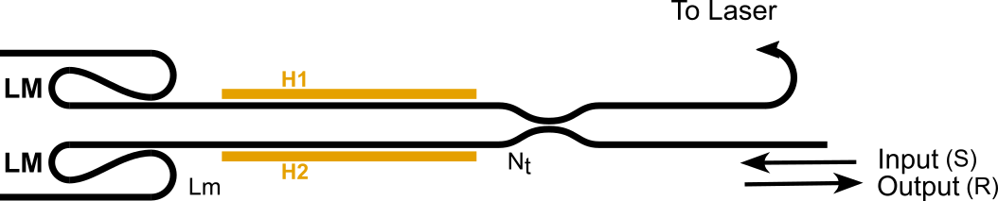
a)
b)
Fig. S6 a) The schematic of the NLI with the input and output port to measure the NLI reflection curve. b) The overall reflectivity response (R) of the NLI with the maximum reflectivity at <1840 nm (green). Blue is the through port response of the NLI ($N_{t}$), and red is the reflectivity of the loop mirror ($L_{m}$).

- Gain film deposition:

Once the passive part of the chip is fabricated (Ligentec), it needs to be deposited with a gain film. Such a deposition can be done with BEOL (back end of the line) process. Here we deposit the gain film at MESA+ Institute for Nanotechnology, University of Twente. We use an RF sputtering machine for the deposition of thulium doped Al₂O₃ layer (AJA ATC 15000 RF reactive co-sputtering system), Fig. S7a. Before the deposition on the actual sample with devices, a long witness sample (a rectangular ~10x0.7 cm piece of thermally oxidized silicon) is deposited with gain film until a good quality film is obtained.
The sample is mounted in the holder (back and front plates of the holder is shown in Fig. S7b) and introduced into the camber through a loadlock and is placed on a rotating heated holder mount. Two targets, aluminum (Al) and thulium (Tm), are powered with their own RF power source. Subsequently the chamber is pre-evacuated to a base
pressure of 0.1 µTorr using a turbomolecular pump to remove OH ions, the presence of which can cause severe quenching of the gain ions. The Al-target is powered with 200W and argon gas is flowed in at rate of 25.0 sccm. Oxygen is also flowed in at a rate of 3 sccm to obtain aluminum oxide on the samples. The distance between the target and the samples is close to 6 inches. The sample is usually deposited at a substrate temperature and the process pressure of ~ 400C and 4 mTorr, respectively. An important aspect of the deposition is to avoid the oxidation of the target (also known as target poisoning) for which the bias voltage between the target (cathode) and the chamber (anode) is continuously monitored as a function of O₂ flow rate (while the sample is still in the loadlock chamber), which gives a bias curve [6]. The substrate containing the sample is introduced into the chamber while making sure the bias voltage is stable and subsequently the deposition is carried out. After one hour of deposition the witness sample is characterized with a prism coupling method (Metricon 2010/M). In this a laser excites guided slab modes with the help of a prism into the Tm³⁺:Al₂O₃ deposited witness sample (8 µm thick silica on silicon). Information about the film thickness and refractive index can be obtained as the light launching angle determines a set of excited modes which can indicate the index and the thickness of the film [7].
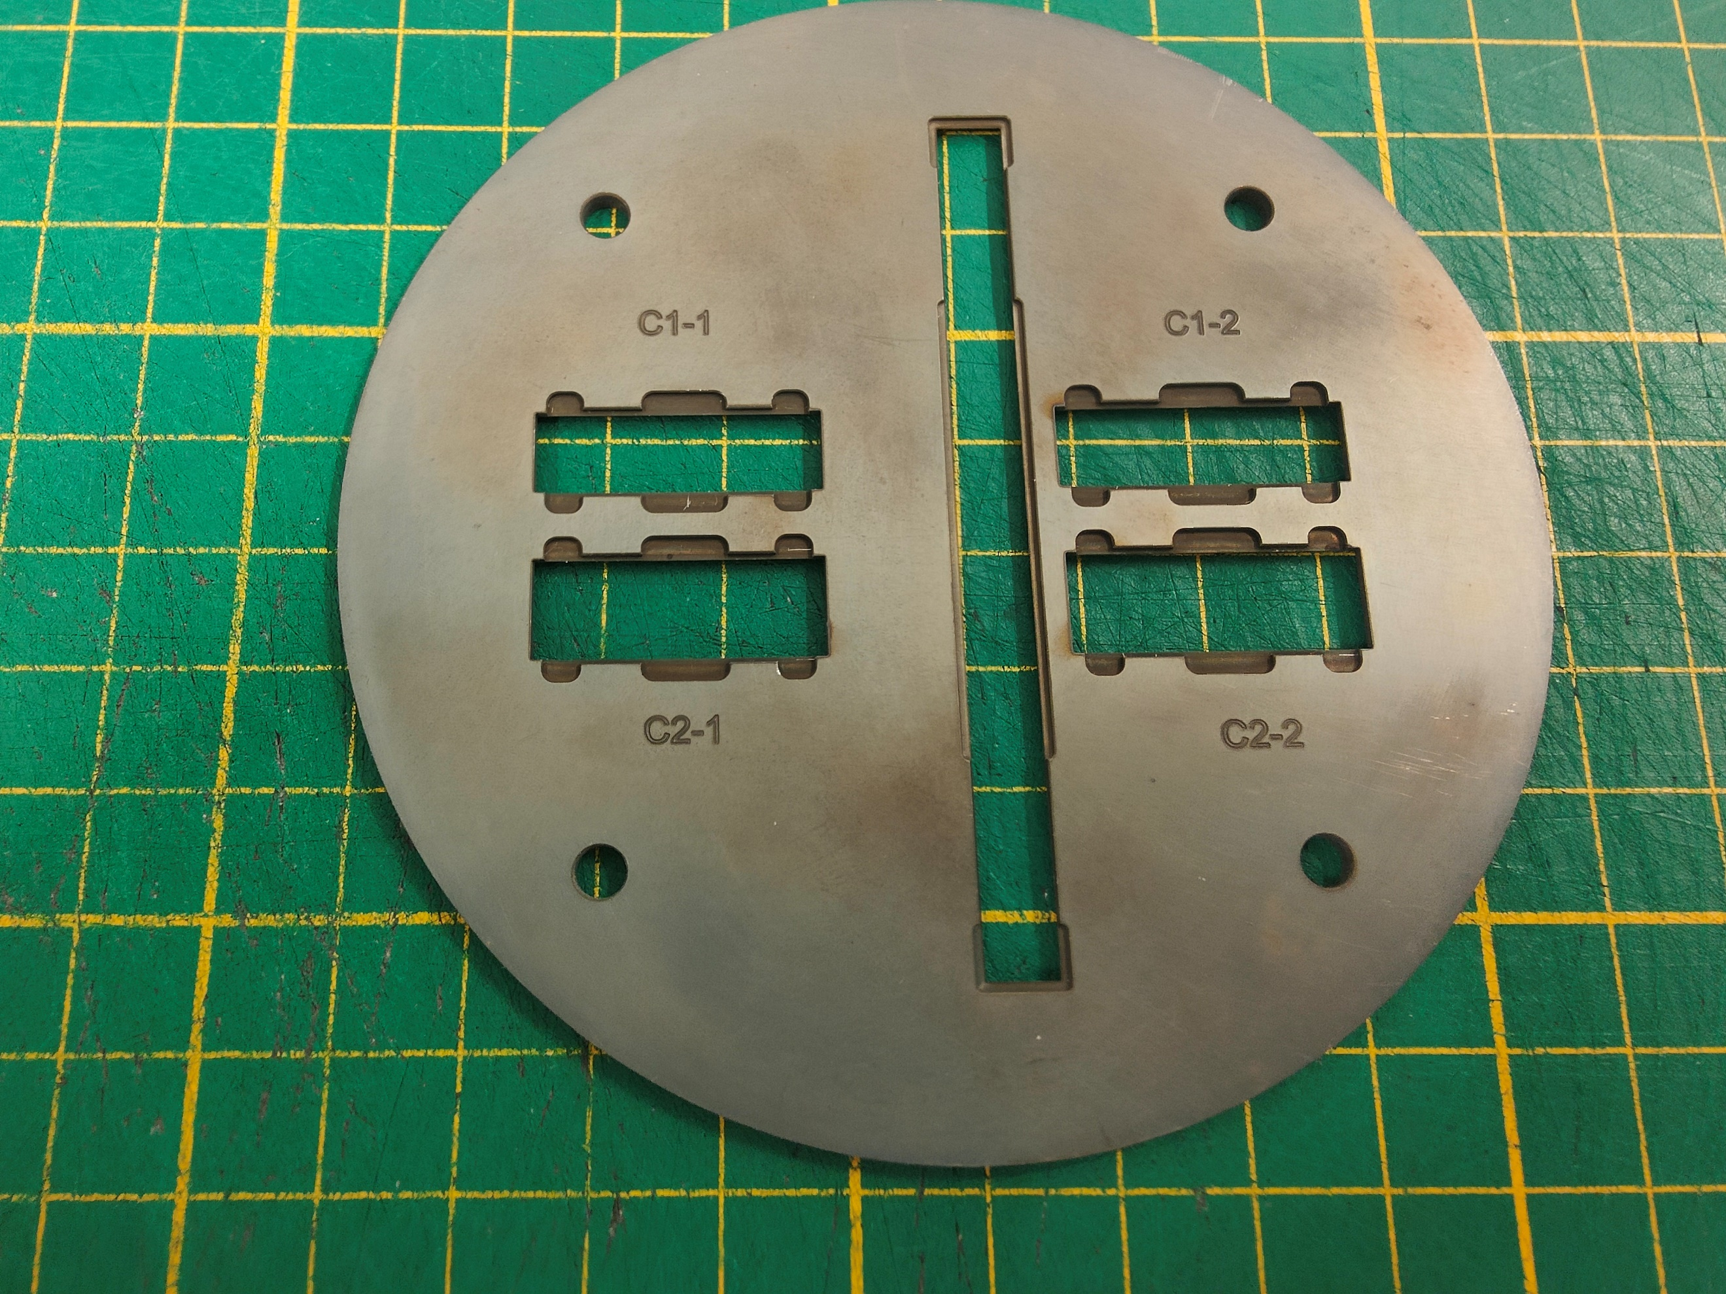
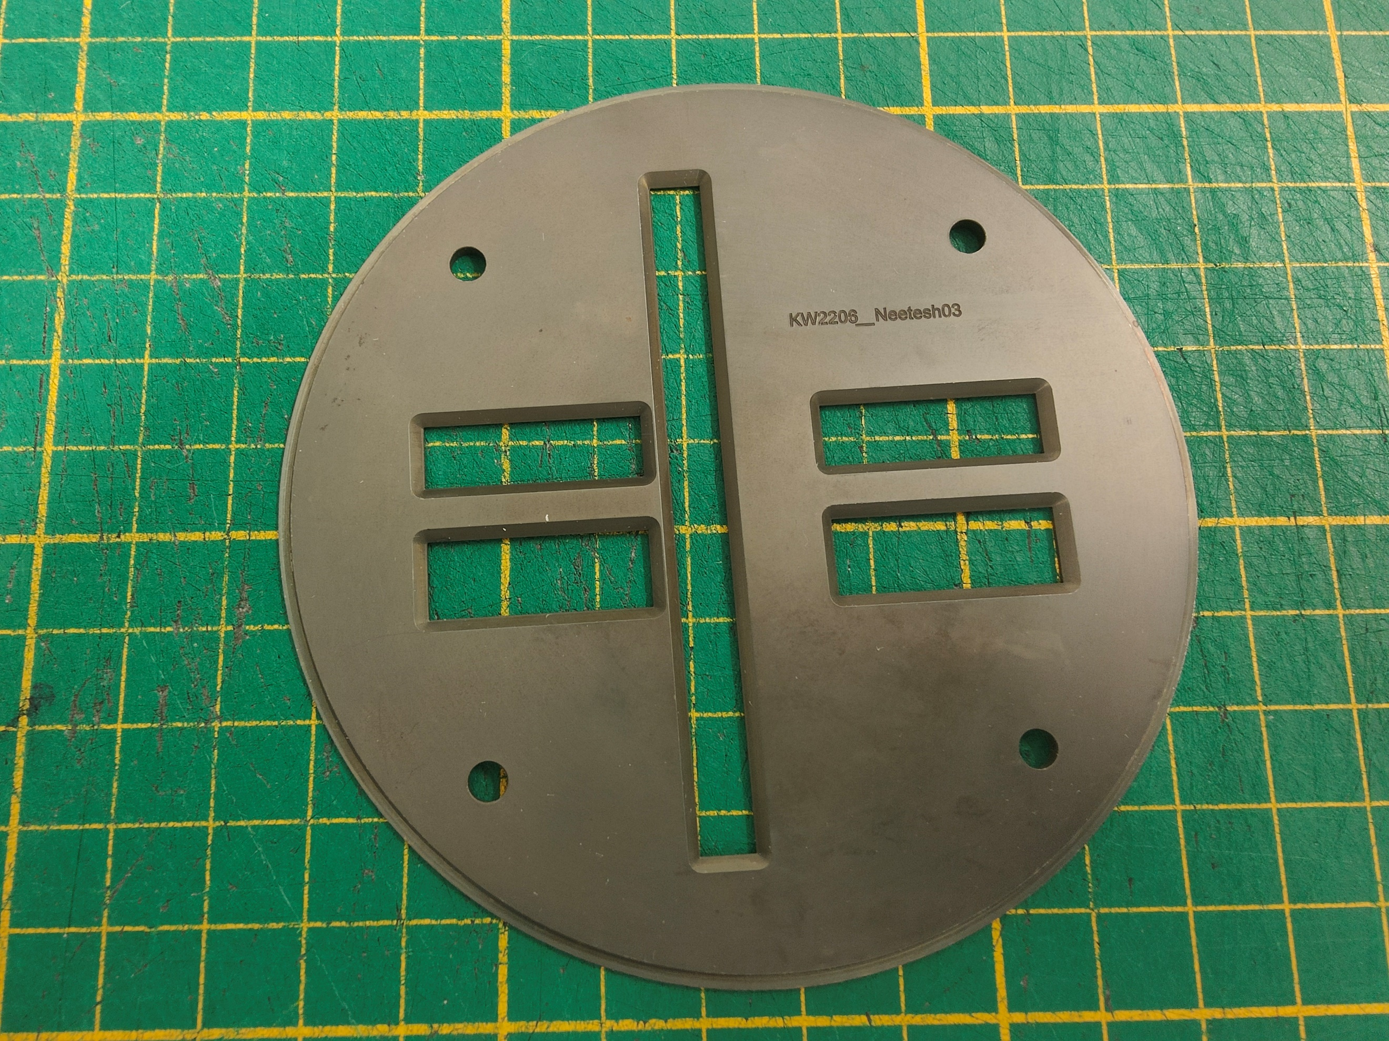
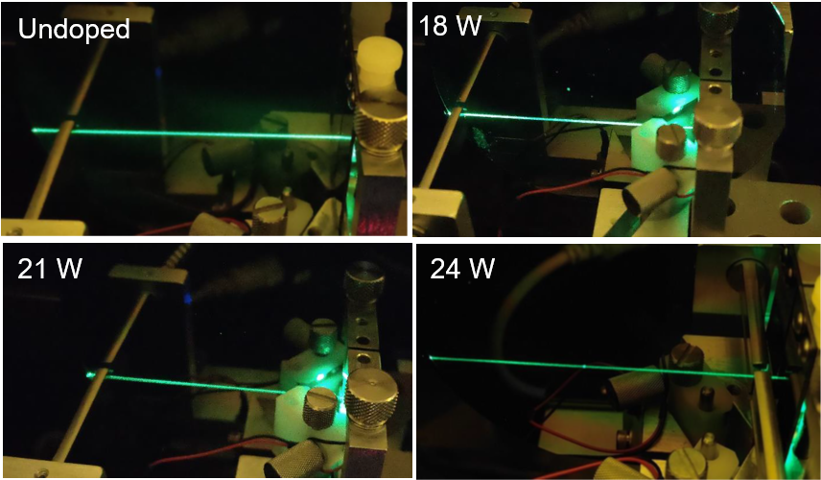
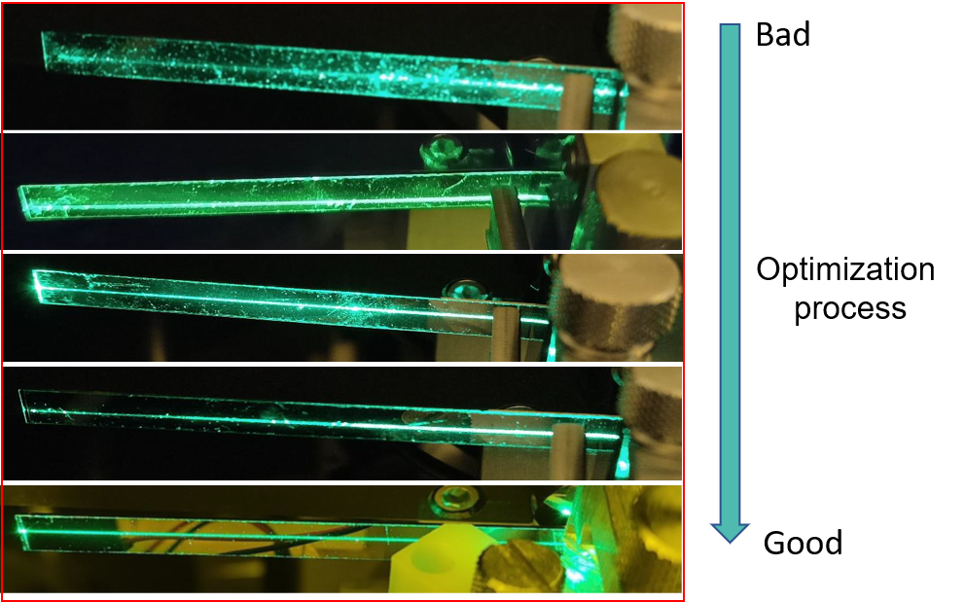
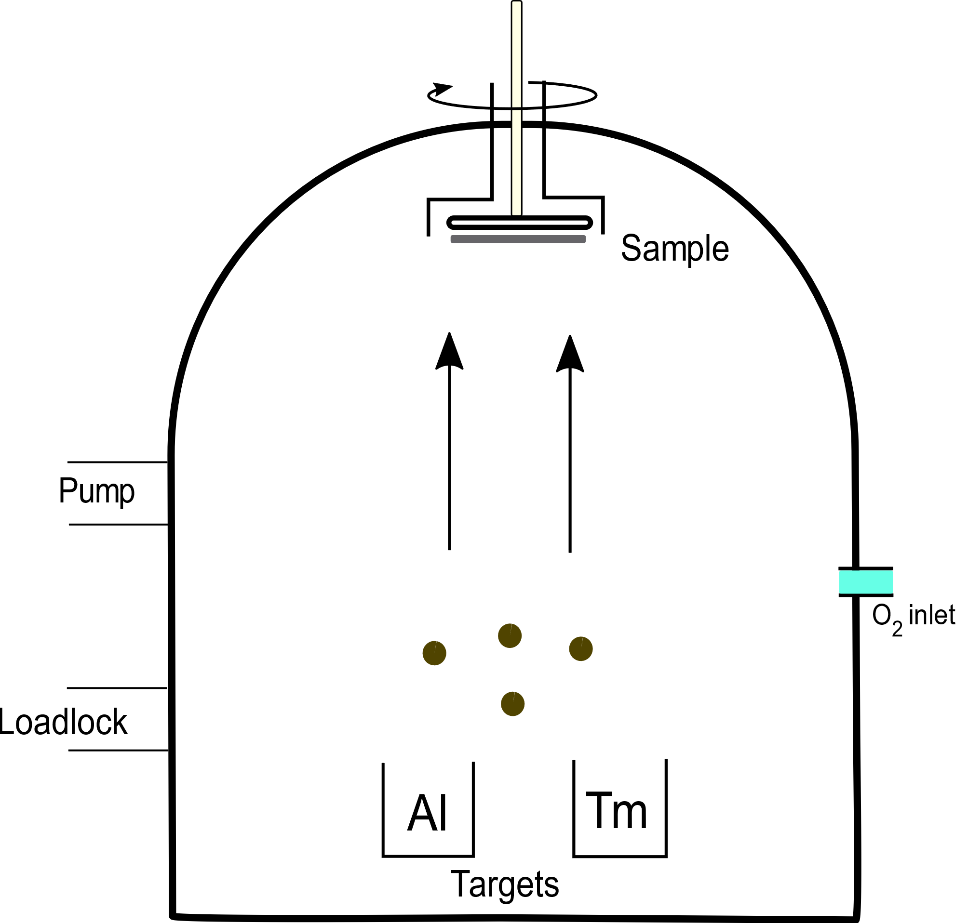
Front
Back
Sample slots
Witness piece slot
a)
b)
c)
d)
Fig. S7. a) A schematic of the AJA system with Aluminum (Al) and Thulium (Tm) target loaded. b) The front and back of the chip holder, the front part is the side from where the chip gets the film deposited, while back part is for mounting the chip in the holder. c) The scattering streak of witness test sample measured during the optimization process. d) The scattering streak of several doped films along with an undoped alumina film. The scattering streak measurement are done with 520 nm laser.

Information on the propagation loss can also be qualitatively obtained from the decay in the strength of the scattering streak measured with an inbuilt detector (however, this requires a careful measurement to make sure the right slab modes are excited). A slow decay indicates a good quality film whereas a fast drop indicates a bad film. Several witness samples are tested with optimized deposition parameters until a good quality film is obtained (see Fig.S7c). Scattering streak measured at 520 nm for films with different concentration and undoped film is shown in Fig. S7d. Once a good film is obtained the machine can be used to deposit gain films on many laser samples until another round of optimization is required (usually if the machine is occupied by a single user/material then the optimization routine is several months apart).

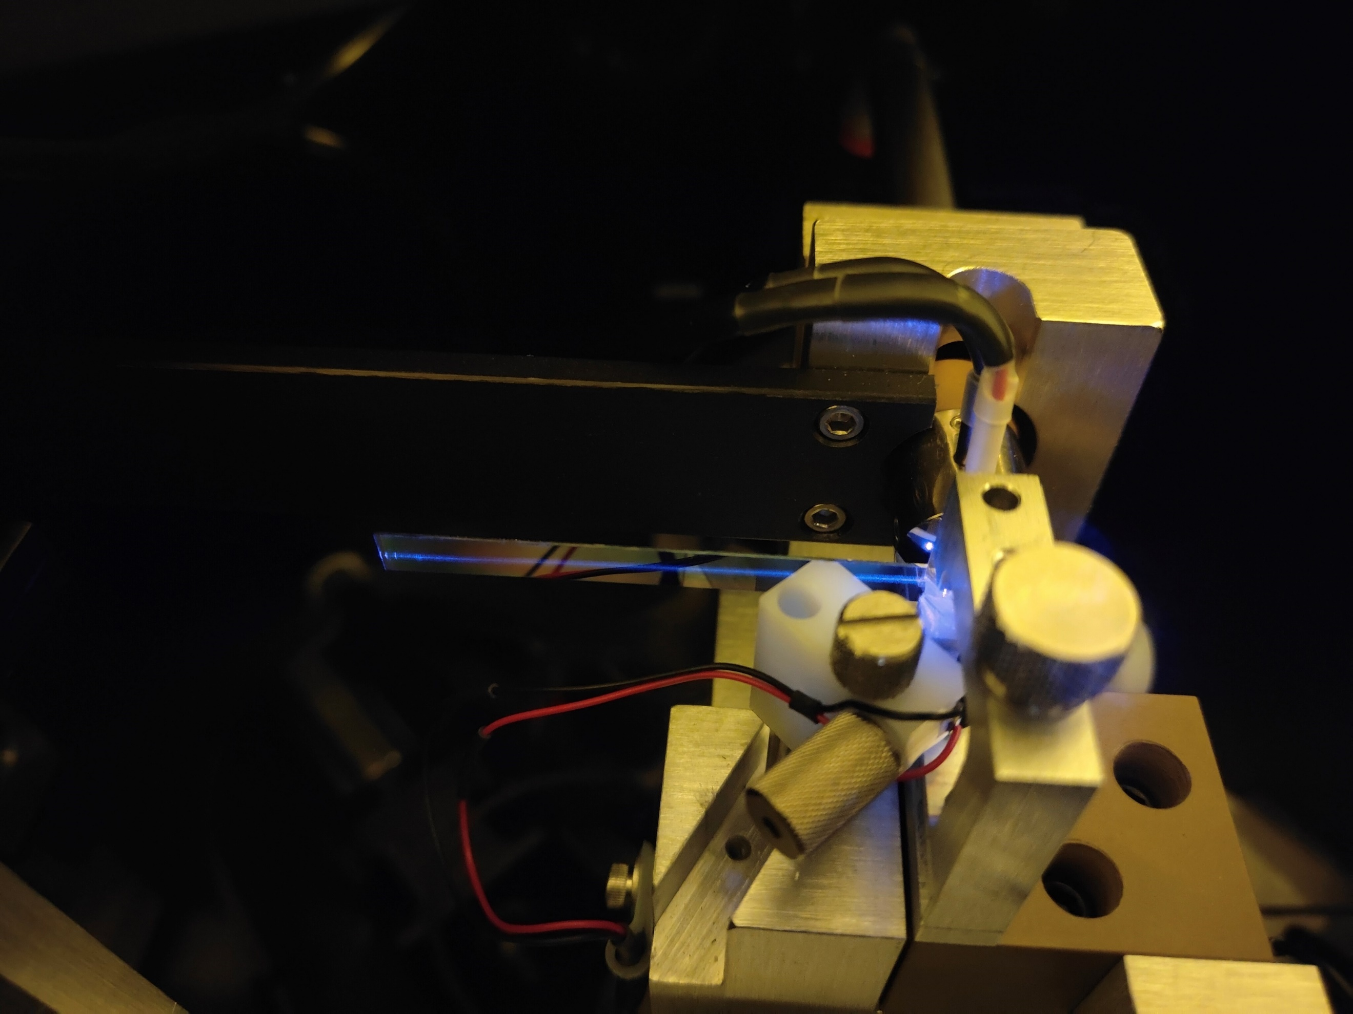
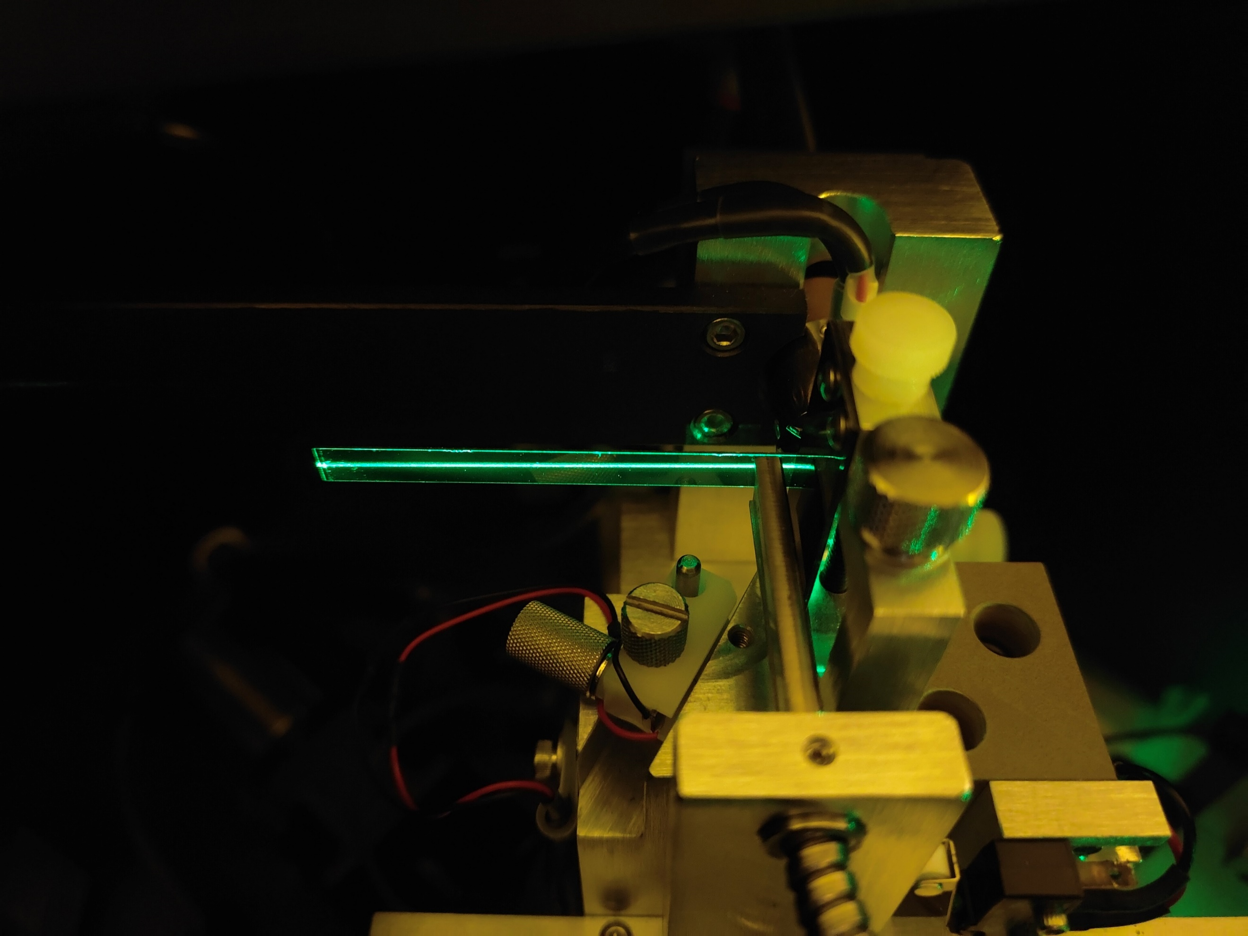
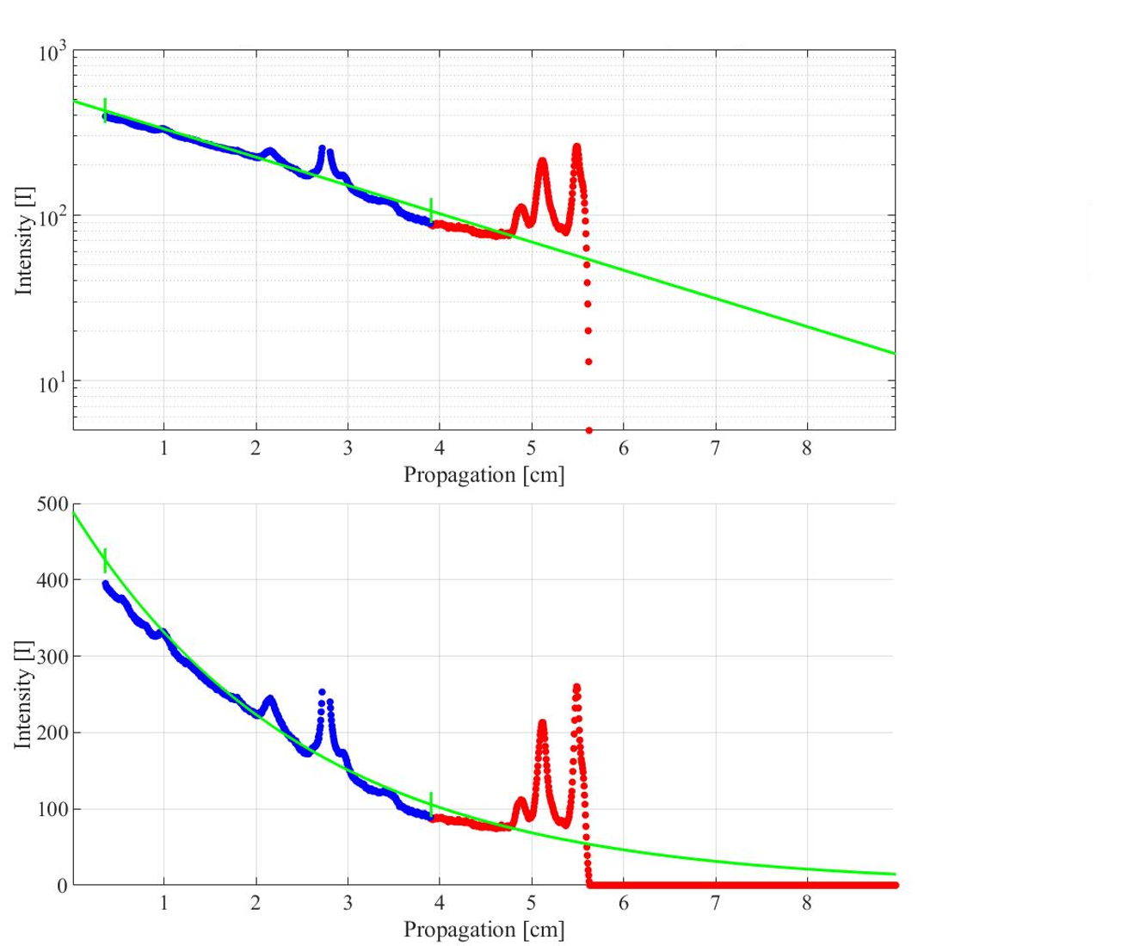
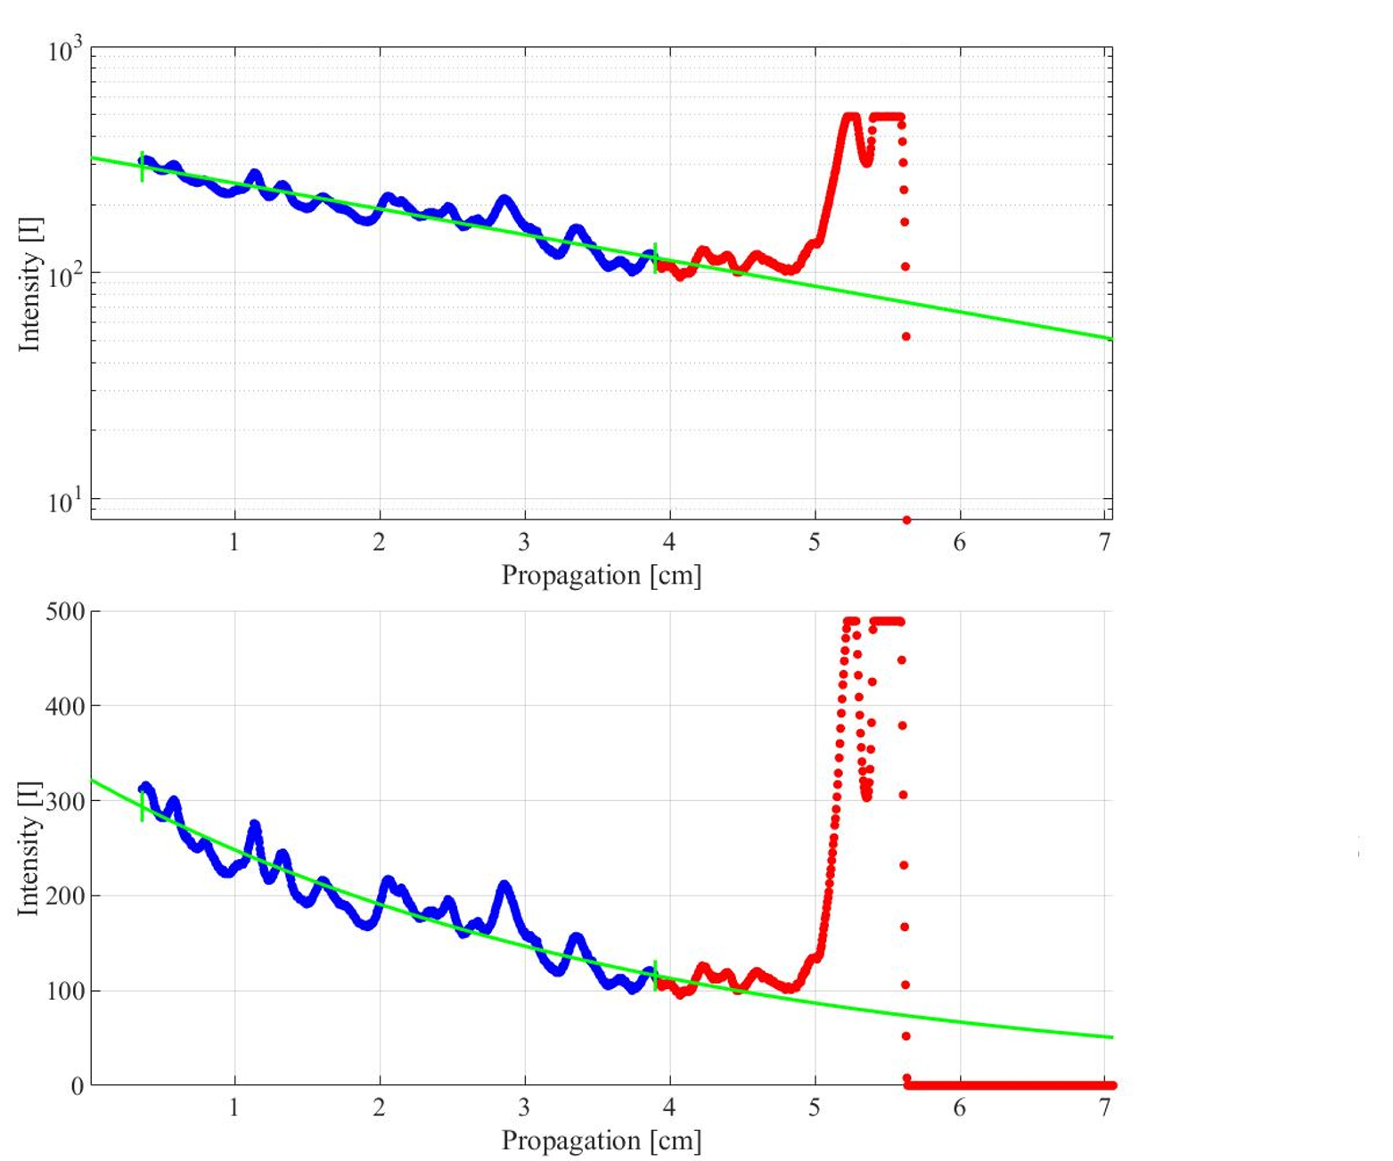
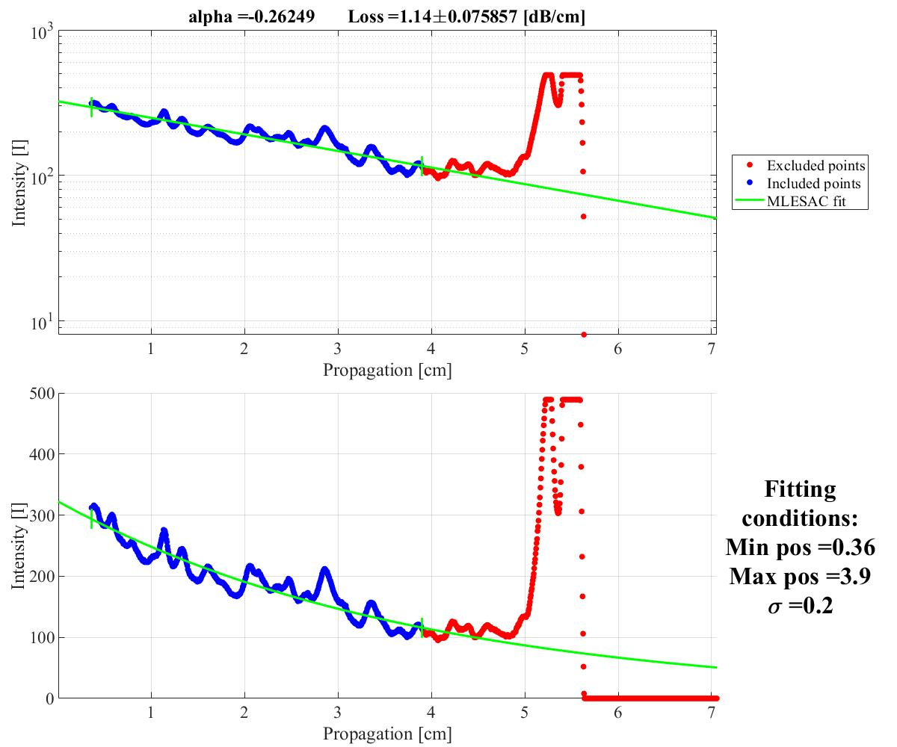
a)
b)
a1)
a2)
b1)
b2)
Fig. S8. a) Scattering streak measurement of a doped witness sample at 403 nm and b) 520 nm. The concentration of the film is around 3.2x10²⁰/cm3. The a1), a2) and b1), b2) are the traces in logarithmic and linear scale at 403 nm and 520 nm laser testing, respectively. The loss at 403 nm is >1.5 dB/cm and at 520 >1 dB/cm.
Once the deposition is optimized, actual devices along with a witness sample are loaded into the chamber. Film deposition rate is usually between 4 to 5 nm/min and can take up to 3 hrs for the deposition to finish (depending on the film thickness). Metricon loss measurement data of doped film measured with lasers at 403 nm and 521 nm is shown in Fig. S8. The fitting gives a loss of >1.5 dB/cm (@ 403 nm) and >1 dB/cm (@ 521 nm), which is high due to the presence of the dopants in the film and also due to the fact that higher order modes may have been excited which tend to have higher loss as they scan the surface of the film many more times than the fundamental mode [7].
- Doping concentration measurement:
It is challenging to determine the ion concentration in a particular device on a chip with the traditional Rutherford Back Scattering method due to the non-planar surface of the chip containing lasers [8]. Therefore, we employ a different method in which the saturation of the loss due to gain ions at high intensity is exploited. The ion concentration can be given as [9-12]:
$$N=\frac{α_{abs}}{Γσ_{abs}}$$
Here the $Γ$ is confinement factor of mode in the gain film, $σ_{abs}$ is the absorption crossection and N is concentration. By knowing the $α_{abs}$ (ion absorption loss) one can get an estimate of the concentration, N. To measure the absorption due to the rare-earth ions we need to isolate the ion absorption loss from any other linear losses such as coupling loss and the waveguide loss. To estimate $α_{abs}$ we can exploit the fact that ions absorption loss is nonlinear with signal power, that is the loss saturates to the lowest value at high signal power by exciting the ions to the upper state. Beyond the saturation power the ratio of the output (P_{o}) and input power (P_{in}) is constant i.e. the loss is saturated [11,12] and is dominated only by linear losses - waveguide passive loss and coupling loss. Below the saturation power the P_{o}/P_{in} drops as the number of ions in the ground state starts to remain high causing a gradually increasing loss with lower signal power which reaches its maximum at very low input power (small-signal loss). To measure such a nonlinear curve of our device we launch the signal (1.61 µm) into a 1.67 cm long gain waveguide and extract the nonlinear loss curve as shown in Fig. S9. Here we observe in Fig.S9a the transmission reaches its maximum beyond 200 mW of off-chip power, whereas below 150 µW of off-chip power the loss reaches its maximum, Fig.S9b (small-signal loss), which is dominated by the ion absorption.
a)
b)
Fig.S9 Nonlinear loss measurement of the gain waveguide. Here the P_{in} is the off-chip input power and P_{o} is the output power. The coupling loss and the linear propagation loss has been taken out of the curve to show only ion-based absorption loss. a) Loss in linear scale showing the saturation of the loss at high power, and b) the same curve as a) with horizontal axis in log scale showing the small-signal loss reaching its maximum around 150 µW, dominated by ion absorption.
The difference between the maximum and the minimum of P_{o}/P_{in} is approximately 5 dB which is the loss due to ion absorption, $α_{abs}$. For the estimated confinement factor of 75% and the absorption cross-section of 3x10⁻²¹ cm² at 1.61 µm [13] we estimate the concentration to be 3.2x10²⁰/cm³ with 10% uncertainty. We note that these values can vary by a ± 20% since an RF sputtered aluminum oxide host can modify the cross-section coefficients, which will be reported in future.
- Refractive index measurement of the Al₂O₃ film:

Fig. S10. Index of refraction and the absorption coefficient of Al₂O₃ film measured from 246 nm to 11780 nm.
To determine the optical properties of the alumina film we measured the Al₂O₃ with an ellipsometer. A 240 nm Al₂O₃ film was deposited on top of an oxidized silicon test sample. The thickness of the SiO₂ was 500 nm. We measured the optical properties of Al₂O₃ film with VASE ellipsometer (J.A. Woollam Co. and McMaster University). To isolate the influence due to the silicon and silica substrates, samples with only oxidized silicon and bare silicon were also measured. The data taken from 246 nm to 11780 nm is shown in Fig.S10. Samples lightly doped with thulium (2 – 2.5x10²⁰ /cm³) were also measured, however the changes in the index were not significant.

- Simulations of the LMA waveguide and Q-switching:
LMA waveguide (flexible mode size variation):
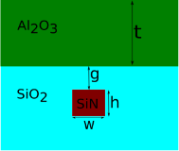
As mentioned in the manuscript, even larger mode can be achieved with relative ease by modifying the thickness of the gain layer (t) or the inter layer oxide thickness (g) (Fig S10a). The mode area at the pump wavelength (1.61 µm) as a function of t and g is shown in Fig.S10b (simulation with Lumerical mode solver). Here we see that for small g one has to deposit relatively thicker gain layer. That is because, for a thin g the requirement on gain layer thickness increase since the mode is very close to the SiN waveguide and it takes a thicker alumina to pull the mode up into the alumina. However, deposition of a thick layer in practice becomes time consuming, because the deposition time increases therefore one would like to keep the thickness small. To counter that limitation, one can instead increase the g which is fairly easy to fabricate. Therefore, our LMA design is quite robust against fabrication limits and tolerances.
Mode area at pump wavelength (w = 0.34 μm, h = 800 nm)
A_{eff}
a)
b)

Fig.S11. a) Gain waveguide crossection. b) Mode area as a function of interlayer oxide thickness and gain layer thickness.
We must emphasize that even larger mode area can be achieved reaching an area associated with LMA fibers, without having to grow very thick Al₂O₃ layer. This feature of our LMA device makes the integrated photonics on par with fiber-based photonics (passive or active) and therefore augers well for the future of high energy integrated photonics devices.
LMA waveguide for broadband operation:
It is important that the LMA devices have a very wide bandwidth operation, i.e. if such an LMA structure can support large mode area of different wavelengths (spectrally far apart) while having a high mode overlap. This can be important for future technologies such as high-energy nonlinear integrated photonics where nonlinear processes such as four-wave-mixing may require high signal and idler mode overlap to have high conversion efficiency where signal and idler and pump can be spanning over an octave. More importantly a wide bandwidth operation is crucial for laser application where the pump is usually spectrally far apart from the signal. For example, in the instances where a thulium laser is pumped at the wavelength of 780 nm for signal generation at 1.9 µm and an erbium laser is pumped at the wavelength of 980 nm for signal generation at 1.55 µm. We have simulated the signal and pump mode area at these wavelength as shown in Fig.S11, for a fixed gain film thickness of 1 µm with a top cladding of silica and a SiN thickness of 800 nm.
We see in Fig.S11a1, with g = 100, for a higher pump and signal mode overlap in thulium laser (i.e. similar mode area size) requires narrow SiN width, whereas for g =200 the pump mode is usually larger and the signal and pump mode reach a similar size at around 245 nm of SiN width. With larger g the area of pump and signal only match for very large mode area, which may be useful for only larger mode area applications. For the erbium laser a similar trend is seen as for the thulium laser, however the requirements are little relaxed as the spectral separation between the pump and the signal is not as large as in the case of thulium. It seems, however, keeping the interlayer oxide thickness (g) not too high (<400nm) will be a more reliable choice.
790 nm
1880 nm
980 nm
1550 nm
a1)
b1)
c1)
a2)
b2)
c2)

Fig.S11. Mode area as a function of SiN wg width (w) and the inter-layer oxide (g). a1,b1,c1. Mode area at the pump (0.79 µm) and the signal (1.88 µm) wavelength for thulium lasers. a2,b2,c2, Mode area of pump (0.98 µm) and signal (1.55 µm) for erbium lasers.
In the simulation we have usually kept the SiN width within the range of CMOS 200 nm node, but nowadays it’s routine to have photonics fabrication in 65 nm node, therefore SiN width will not be a challenge, which will be more relaxed with thin SiN layers that are routinely used in CMOS facilities. With this study we learn that wavelengths more than an octave apart can still have very high mode overlap, which bodes well for broadband operation. In fact, in some case the shorter wavelength has a larger mode area than the signal, that is mainly because at shorter wavelength the mode is mainly in the alumina layer whereas the long wavelength signal mode still interacts with the SiN layer underneath keeping the mode size slightly smaller.
Q-switching simulations:
We can solve the dynamics of the gain, loss and signal in a laser cavity with a simplified rate equation for a two level model and a single cavity mode. We assume that the changes in the laser power, gain and saturable absorption are small on a time scale of the round trip time, $Tr$, less than 20% [14, 15].
$$Tr\frac{dP}{dt}=2\left(g-l-q\left(P\right)\right)P \left(1\right)$$
$$Tr\frac{dg}{dt}=\frac{g-g_{0}}{Tl}- \frac{gTrP}{El} \left(2\right)$$
$$\left.q=qo (u+2t\left(1-t\right)(1+\cos\left(yPL+ φ_{t}\right)\right) (3)$$
Here $Tr$ is the rountrip time, P is the power and $g$ is the gain, $g_{0}$ is the small signal gain, and $El$ is saturation energy. $Tl$ = τ/$Tr$, where τ is upper state life time. The $q$ is the saturable absorber’s loss (NLI-SA). $qo$ is the saturable loss, u is the unsaturable loss (mainly due to the waveguide loss) t is the split ratio of the NLI’s directional coupler, $y$ is the Kerr factor, P is the power, L is the length of the waveguide and the $φ_{t}$ the thermal phase shift. In the simulation we used El = 6 uJ, τ = 600 us, $Tr$ = 1 ns and power loss less than 10%. $qo$= 0.03, $u$ = 0.04, t = 0.8, $yL$ = 0.015, $φ_{t}$ = 0.8π. In the simulation the time step is 100 ps and the total simulation window is 400 µs. The time domain data is shown in the manuscript (manuscript Fig.3 d).

Fig.S12. The saturable loss as a function of intracavity power
The saturable loss due to the NLI-SA is shown in Fig.S12, where we see the loss saturates around 40 W and follows a cosine response. The small unsaturable loss $qo$, is due to the fact that we tune the NLI-SA to operate near the peak of the reflectivity curve (on the positive slope), Fig. 3b in the manuscript. This results in a weak saturable absorption modulation and therefore small gain modulation leading to a long pulse generation. This is unlike the case with a strong saturable absorption which causes a strong change in the saturable loss, thus a strong modulation in gain, and a strong signal build up and shut off leading to shorter pulses with high peak power, which can also lead to optical damage in a material with a low damage threshold.
Reference:
- N. Singh et.al. “Towards CW modelocked laser on chip – a large mode area and NLI for stretched pulse mode locking”, Opt. Express, 28, 15 (2020).
- F. Vogelbacher, et. al. “Analysis of silicon nitride partial Euler waveguide bends,” Opt. Express, 27, (2019).
- M. Bahadori, et. al. “Universal Design of Waveguide Bends in Silicon-on-Insulator Photonics Platform,” J. Light. Techn. 37 (2019).
- U. Keller, et. al. , “Semiconductor saturable absorber mirrors (SESAM's) for femtosecond to nanosecond pulse generation in solid-state lasers,” IEEE J. Sel. Top. Quantum Electron. 2(3), 435–453 (1996).
- C. Aguergaray, et. al. “Mode-locked femtosecond all-normal all-PM Yb-doped fiber laser using a nonlinear amplifying loop mirror,” Opt. Express, 20 (2012).
- C. I. van. Emmerik, et. al. “Relative oxidation state of the target as guideline for depositing optical quality RF reactive magnetron sputtered Al₂O₃ layers,” Opt. Mat. Express, 10, (2020).
- P. K. Tien, “Light waves in thin films and integrated optics,” Appl. Optics, 10, (1971).
- S. U. Campisano, et. al. “Determination of concentration profile in thin metallic films: Applications and limitations of He⁺ backscattering,” Thin Solid Films, 25 (1975).
- J. Bradley “Al2O3:Er3+ as a gain platform for integrated optics,” PhD Thesis, (2012)
- L. Agazzi “Spectroscopic Excitation and Quenching Processes in Rare-Earth-Ion-Doped Al2O3 and their Impact on Amplifier and Laser Performance” PhD Thesis (2012).
- Z. Burshtein, et. al. “Excited-state absorption studies of Cr⁴⁺ ions in several garnet host crystals,” IEEE J. Quant. Electron. 34, 1998.
- L. M. Frantz and J. S. Nodvik, "Theory of pulse propagation in a laser amplifier", J. Appl. Phys., vol. 34, pp. 2346-2349, 1963.
- S. D. Agger, et. al. “Emission and absorption cross-section of thulium doped silica fibers,” Opt. Express, 14 (2006).
- H. A. Haus, “Parameter ranges for CW passive mode locking,” IEEE J. Quantum. Elec., QE-12, 1976.
- F. X. Kärtner, et. al. “Control of solid state laser dynamics by semiconductor devices,” Optical. Eng. 34, (1995)

