Clinical and prognostic profile of SRSF2 and related spliceosome mutations in patients with acute myeloid leukemia

Wenbo Jia#, Xiaodong Guo#, Yihong Wei, Jinting Liu, Can Can, Ruiqing Wang, Xinyu Yang, Chunyan Ji, Daoxin Ma*

Department of Hematology, Qilu Hospital of Shandong University, Jinan, Shandong 250012, P.R. China;

# These authors contribute equally to this work.

Corresponding author: Daoxin Ma, Professor
Address: Department of Hematology, Qilu Hospital of Shandong University, Jinan, Shandong 250012, P.R. China
Phone: 86-0531-82169887 Fax: 86-0531-86927544
E-mail address: daoxinma@sdu.edu.cn

Running head: spliceosome mutations in AML

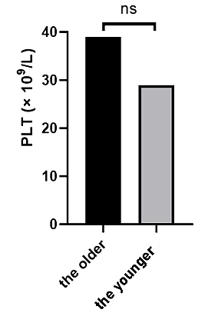
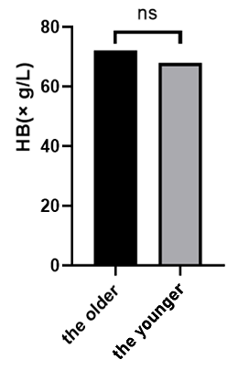
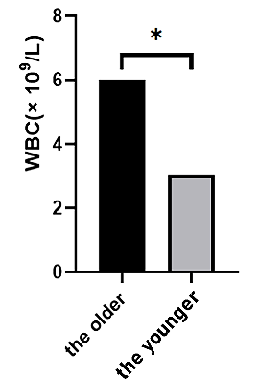
a b c
f
d
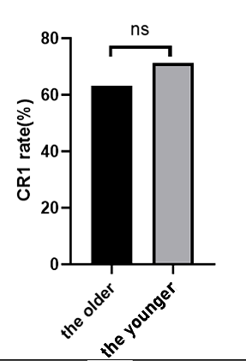
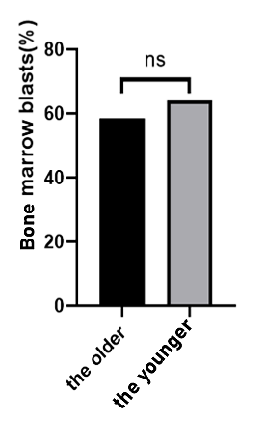
e
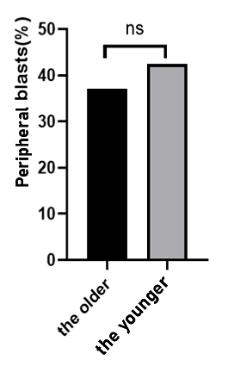
Figure S1 Clinical relevance in relation to SF mutations in AML patients. a The WBC count between the older and younger patients. b The HB between the older and younger patients. c The PLT count between the older and younger patients. d The peripheral blasts between the older and younger patients. e The bone marrow blasts between the older and younger patients. f The CR1 rate between the older and younger patients

Characteristics HR 95%CI P value
Male | 2.921 | 1.016-8.397 | 0.047
Kit^{mut} | 20.856 | 2.101-207.016 | 0.009
ZRSR2^{mut} | 4.795 | 1.046-21.980 | 0.044
Table S1a Multivariate analysis of OS in patients with SF mutation

Demographics | SRSF2 mutation(n=33) | Other SF mutation(n=31) | P value
Male, n (%） | 24(72.7) | 24(77.4) | 0.665
Age, median(range), y | 64(51-87) | 61(15-80) | 0.015
Median WBC (range), × 10⁹/L | 7.16(0.53-300.79) | 3.31(0.15-175.97) | 0.171
Median HB (range), × g/L | 67(7.0-113.0) | 66.0(38.0-124.0) | 0.357
Median PLT (range), × 10⁹/L | 33(9 -543) | 42(1-270) | 0.432
FAB classification  n, M0/M1/M2/M4/M5/M6/unknown | 1/1/1/4/22/0/4 | 0/0/0/4/16/0/11 | 0.126
Median peripheral blasts % (range) | 47.5(0.0-98.0) | 14.0(0.0-89.0) | 0.028
Median bone marrow blasts % (range) | 57.0(0.0-98.0) | 39.5(0.0-93.0) | 0.183
Median abnormal cells by FMC % (range) (%)  range（%） | 48.0(8.0-95.0) | 23.3(4.0-75.9) | 0.014
MRD%, median (range) | 5.51(0.08-95.0) | 2.02(0.00-23.75) | 0.291
CR1 rate (%) | 47.8(11/23) | 47.8(11/23) | 1.000
Table S1b Characteristics of the cohort of patients with SRSF2 and other SF mutation AML

