Construction and application of multipurpose MOF-based hydrogen sulfide probe
Xinyi Liu, Xiaosong Wang, Yuliang Jiang*
Jiangsu Collaborative Innovation Center of Biomedical Functional Materials, Jiangsu Key Laboratory of Bio-functional Materials, School of Chemistry and Materials Science, Nanjing Normal University, Nanjing 210023, Jiangsu, Peoples R China
List of contents
1. SEM of UiO-66-NH₂
2. FT-IR spectra of UiO-66-NH₂ and UiO-66-NH₂@BDC
3. C 1s XPS spectra of UiO-66-NH₂@BDC
4. The high-resolution spectra of O 1s of UiO-66-NH₂@BDC
5. Zr 3d XPS spectra of UiO-66-NH₂@BDC
6. High-resolution XPS response of N 1s spectra for the UiO-66-NH₂@BDC
7. Fluorescence titration spectrum to S²⁻(a)and Plot of curve(b)
8. UiO-66-NH₂@BDC relative fluorescence intensity
9. The comparison of MOF-based probe with the reported probes for sensing of S²⁻
10. Interference experiment
11. (A)UV absorption spectrum, the high-resolution XPS spectra of (B)O 1s and (C)N 1s of UiO-66-NH₂@BDC before and after S²⁻ treatment
12. Water sample detection

1. SEM of UiO-66-NH₂
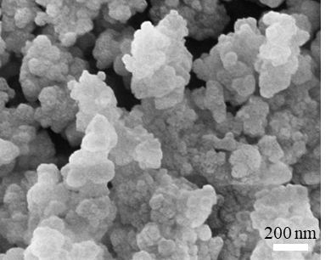
Fig.S1 SEM of UiO-66-NH₂.
2. FT-IR spectra of UiO-66-NH₂ and UiO-66-NH₂@BDC
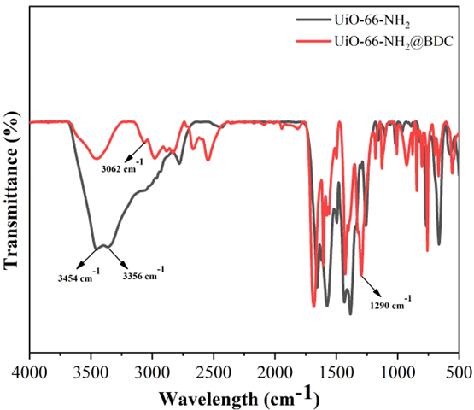
Fig.S2 FT-IR spectra of UiO-66-NH₂ and UiO-66-NH₂@BDC.
3. C 1s XPS spectra of UiO-66-NH₂@BDC
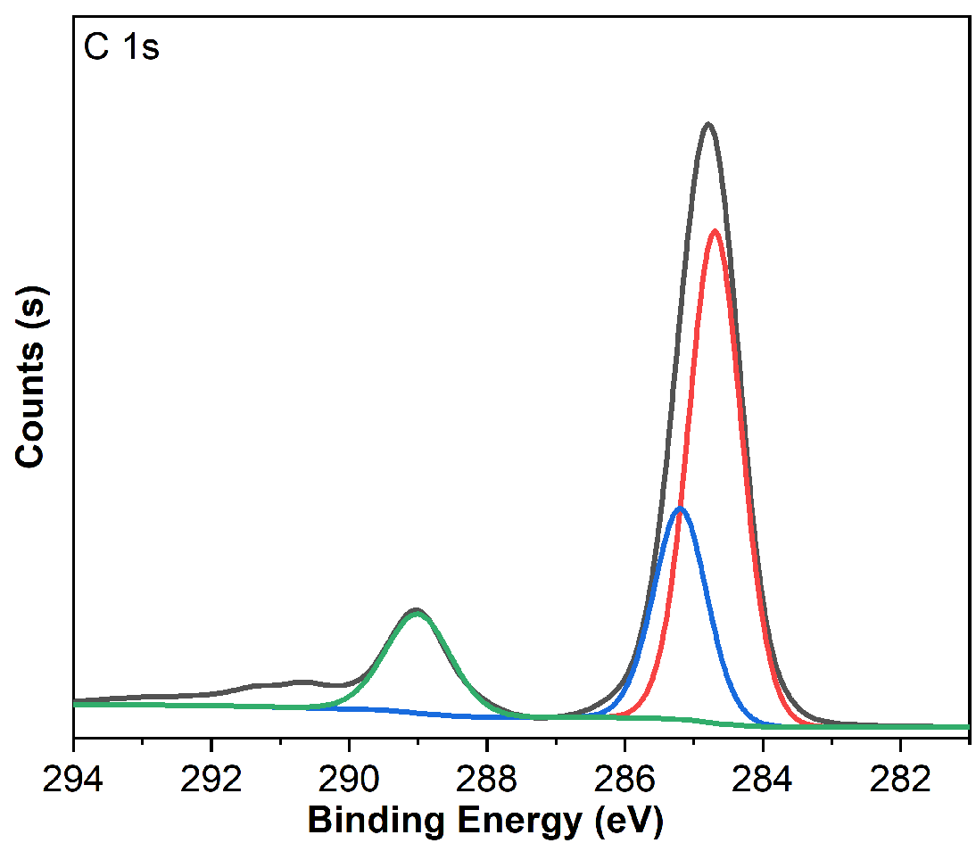
Fig.S3 C 1s XPS spectra of UiO-66-NH₂@BDC.
4. The high-resolution spectra of O 1s of UiO-66-NH₂@BDC
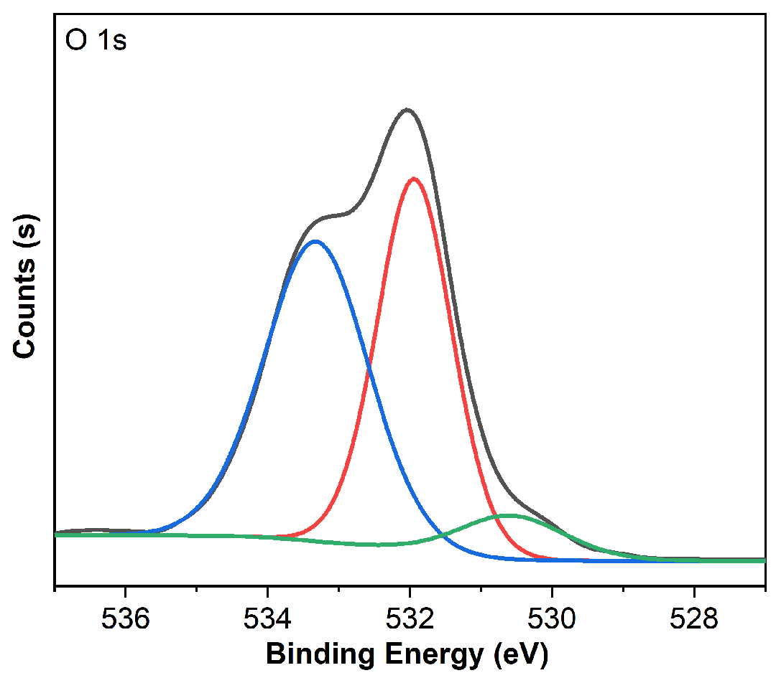
Fig.S4 The high-resolution spectra of O 1s of UiO-66-NH₂@BDC.
5. Zr 3d XPS spectra of UiO-66-NH₂@BDC
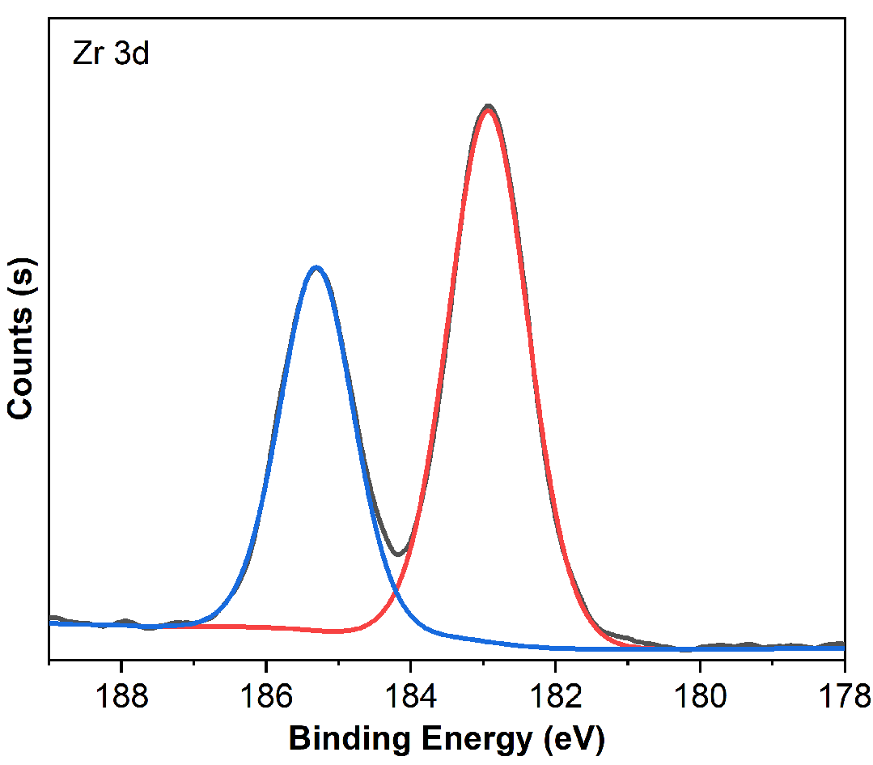
Fig.S5 Zr 3d XPS spectra of UiO-66-NH₂@BDC.
6. High-resolution XPS response of N 1s spectra for the UiO-66-NH₂@BDC
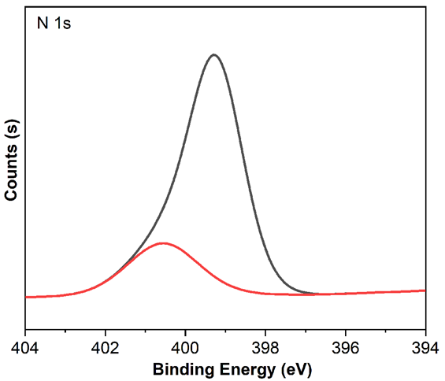
Fig.S6 High-resolution XPS response of N 1s spectra for the UiO-66-NH₂@BDC.
7. (A)Fluorescence emission spectra of UiO-66-NH₂ at different concentrations of S²⁻. (B)Plot of I/I₀ versus S²⁻ concentration
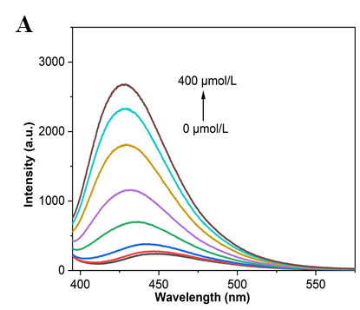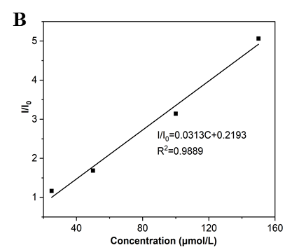
Fig.S7 (A)Fluorescence emission spectra of UiO-66-NH₂ at different concentrations of S²⁻. (B)Plot of I/I₀ versus S²⁻ concentration.
8. UiO-66-NH₂@BDC relative fluorescence intensity
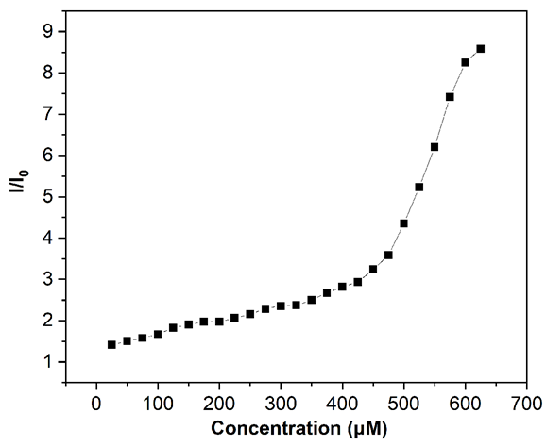
Fig.S8 UiO-66-NH₂@BDC relative fluorescence intensity.
9. Table S1 The comparison of MOF-based probe with the reported probes for sensing of S²⁻
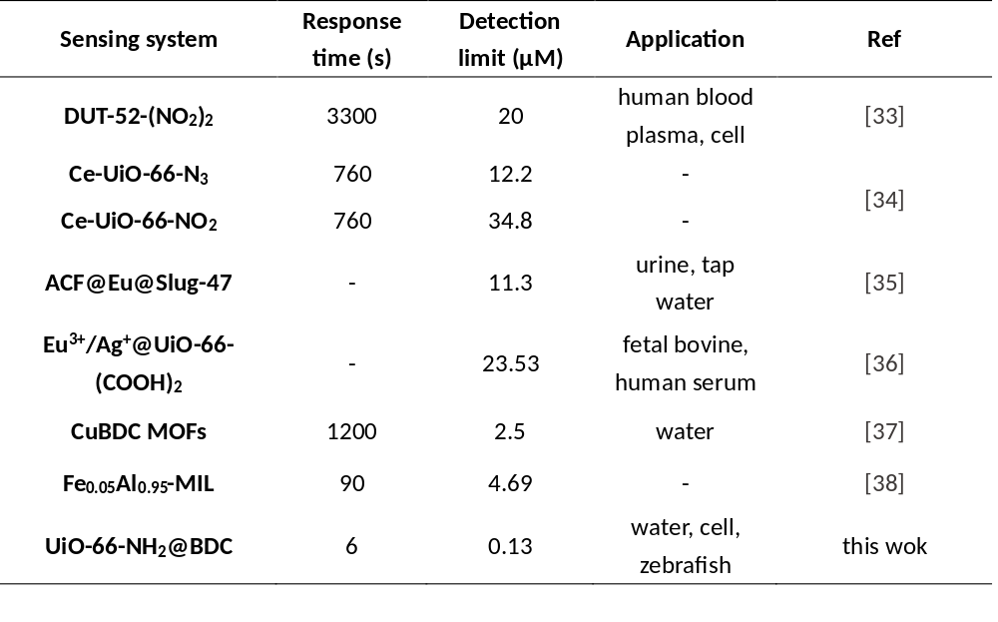
10. Interference experiment
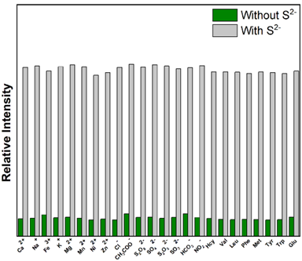
Fig.S9 In the absence of (green column) and the presence of (grey column) S²⁻, UiO-66-NH₂@BDC fluorescence response in the presence of interfering metal ions (interfering ions concentration 600 μM, S²⁻ concentration 500 μM).
11. (A)UV absorption spectrum, the high-resolution spectra of (B)O 1s and (C)N 1s of UiO-66-NH₂@BDC before and after S²⁻ treatment

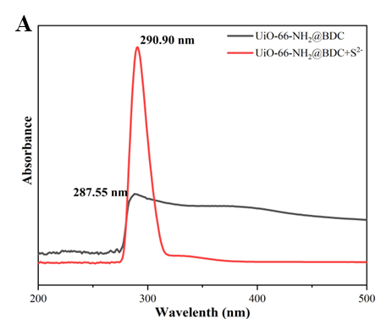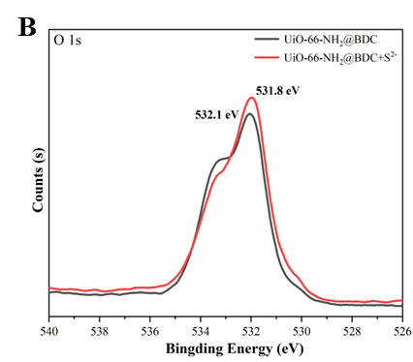
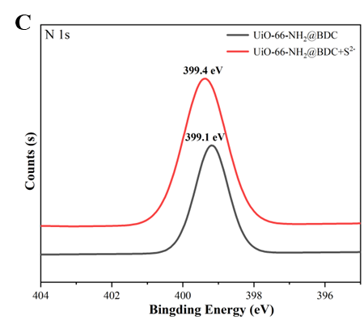
Fig.S10 (A)UV absorption spectrum, the high-resolution spectra of (B)O 1s and (C)N 1s of UiO-66-NH₂@BDC before and after S²⁻ treatment.
12. Table S2 Water sample detection
