Supporting Information

Bioinspired self-driven ultra-long-distance anti-gravity water transport device with core-shell and twofold hierarchical structure

Qixin Lu, Yu Guan*, Shaohai Fu

Jiangsu Engineering Research Centre for Digital Textile Inkjet Printing, Key Laboratory of Eco-Textile, Jiangnan University, Ministry of Education, Wuxi 214122, China
E-mail: guanyu2013@foxmail.com (Yu Guan)

1 Experimental section
1.1 Materials and chemicals
Cellulose acetate (CA, Mw= 30,000, acetyl content 39.8%, hydroxyl content 3.5 wt %, Shanghai Aladdin Biochemical Technology Co., Ltd.), N, N-dimethylacetamide (DMAc, Sinopharm Chemical Reagent Co., Ltd., China), and acetone (Sinopharm Chemical Reagent Co., Ltd., China) were used as received. Carbon nanotubes (CNTs, multiwall, 5-15 μm, -COOH content 3.86 wt%) with a purity of over 95% were purchased from Nanjing XFNANO Materials Tech Co., Ltd. Transparent glass tube (length: 1.5 m; inner diameter: 2 mm; outer diameter: 5 mm) was purchased from Dongkai Chuang Kai GENKAYI Co., Ltd.
1.2 Preparation of core-shell structure unit (CS unit).
Electrostatic spinning: 17wt% CA powder was added into a DMAc/acetone (1:2, w/w) solution, continuously stirring for 3 h until it was completely dissolved. Afterward, the electrospinning machine (LSP02-2B lab syringe pump and roller collector, Qingdao Nuokang Environmental Protection Technology Co., Ltd., China; P303-1ACA1 high voltage power supply, Tianjin Dongwen High Voltage Power Supply Co., Ltd., China; roller collector) was applied to prepare CA nanofiber films (CANF). The as-prepared 17wt% CA solution was transferred into a 10 mL plastic syringe with blunt metal needles of 0.34 mm inner diameter. The as-spun CANF were deposited on tinfoil wrapped on the roller collector rotating at 100 rpm with 25 kV applied voltage, 15 cm needle tip-collector distance, and 1 mL/h flow rate. In addition, the ambient temperature and relative humidity (RH) were maintained at 25±5°C and 50%, respectively. After successful electrospinning, the collected CANFs were dried in an oven at 50°C for 3 h to take the residual solvent out.
The water flow-assisted twist: A rectangular banded CA film (BCA) with a 1 cm width and a 28 cm length was prepared by cutting the CA nanofiber film along the direction of roller motion. Then, BCA was scoured with a tiny water flow (350 mL·min⁻¹) along its length direction. Immediately, one end of the scoured BCA was fixed to the tip of an electric motor and the other was fixed to a piece of cardboard. The entire BCA was suspended between the motor and the cardboard. Subsequently, the fixed BCA was rotated into a one-dimensional twisted CA fiber bundle with a diameter of about 2 mm after the motor rotated 30 turns, obtaining a twist of 10.71 turns per 10 cm. Next, the CA fiber bundle was dried in an oven at 50°C for 1 h to take the residual water out and hold the twisted shape.
Low-temperature plasma (LTP) treatment and encapsulation: CA fiber bundle was treated with LTP on the condition of 30 W for 3 min to prepare the hydrophilic CA fiber bundle. And LTP treatment can also be performed before the water flow-assisted twist. The hydrophilic CA fiber bundle as a core was encapsulated in a glass tube to form a core-shell structure unit (CS unit).
1.3 Preparation of water transport device with twofold hierarchical structure and core-shell structure (TH@CS).
By the same electrospinning methods, a series of CANF with different fiber diameters were prepared at the 17wt%, 15wt%, and 13wt% CA solutions, which were treated by water flow-assisted twist, and LTP hydrophilic treatment to obtain CA nanofiber bundles with highly aligned fiber structures and hydrophilicity. Finally, using a head-to-tail way, the CA nanofiber bundles were assembled from bottom to top and encapsulated to obtain a hierarchical structure of fiber diameters (HS_{pore}). In the HS_{pore}, the length of each CA nanofiber bundle was equal to 33.3 cm.
CA nanofiber film with 2wt% CNTs in CA solution was prepared using the same electrospinning parameters and methods and was treated by water flow-assisted twisting, LTP hydrophilic treatment, and encapsulation to obtain CS-CNTs. Then, the HS_{pore} and CS-CNTs were assembled from bottom to top to obtain a water transport device with a hierarchical structure of fiber diameter and photothermal ability (TH@CS).
1.4 Preparation of bionic leaves.
Firstly, green CANF was fabricated by incorporating the 2wt% disperse dyes (B-291: Y-114: O-30=1:10:3, w/w/w) relative to the mass of CA into the CA solution. Then, the bionic leaves were prepared by encapsulating green CANF with transparent plastic wraps and then adhering them to viscose fabrics. Finally, the bionic leaves and TH@CS as a bionic stem were assembled to form a bionic tree, where the petiole part of the bionic leaves penetrated the interior of TH@CS and made full contact with the internal CA nanofiber bundle core.
1.5 Characterization of TH@CS.
The morphologies and structures of the sample were characterized by a scanning electron microscope (SEM, su1510, Hitachi, Japan). The diameter and overall orientation of fibers were computed via Image J software from the corresponding SEM images. The pore diameter of samples was tested by Mercury porosimetry (AUTOPORE 9600, Micromeritics, USA). The contact angle of samples was characterized by a contact angle measuring instrument (JC2000DM, Shanghai POWEREACH Digital Equipment Co., Ltd., China). A testo 871 IR camera (Testo SE & Co. KGaA, Germany) was used to record the surface temperature of CA/CNTs nanofiber films. The night vision image of samples was obtained by a night vision device (SAGA-NV0535, Suzhou SAGA, China). Absorptivity (%) of samples in 400-2500 nm was calculated by subtracting reflectance (%) and transmittance (%) by 100. The reflectance (%) and transmittance (%) of samples were obtained by the UV-VIS-NIR spectrophotometer (Lamda 950, PerkinElmer, USA).
1.6 Water transport performance.
Vertical wicking measurement was analyzed according to modified FZ/T 01071. The length of the sample under the water surface was 1 cm. The height and time of water rising on the sample were recorded. The wicking height under 1 sun illumination (1 kW·m⁻²) was measured in the same way as above, with a xenon lamp (ULTRA VITALUX 300W 230 V E27, OSRAM GmbH., Germany) as the light source.
1.7 Vis-NIR spectral simulating performance.
The reflectance spectra of samples were determined by a UV-VIS-NIR spectrophotometer (Lamda 950, PerkinElmer, USA). The spectral correlation coefficient (r_{m}) was calculated by equation (1) as follows.
$${\text{r}}_{\text{m}}\text{=}\frac{\sum_{\text{λ=λa}}^{{\text{λ}}_{\text{b}}}{\left({\text{R}}_{\text{r}\left(\text{λ}\right)}\text{-}{\overline{\text{R}}}_{\text{r}}\right)\left({\text{R}}_{\text{t}\left(\text{λ}\right)}\text{-}\overline{{\text{R}}_{\text{t}}}\right)}}{\sqrt{\sum_{\text{λ=}{\text{λ}}_{\text{a}}}^{{\text{λ}}_{\text{b}}}{{\left({\text{R}}_{\text{r}\left(\text{λ}\right)}\text{-}\overline{{\text{R}}_{\text{r}}}\right)}^{\text{2}}}}\sqrt{\sum_{\text{λ=}{\text{λ}}_{\text{a}}}^{{\text{λ}}_{\text{b}}}{{\left({\text{R}}_{\text{t}\left(\text{λ}\right)}\text{-}\overline{{\text{R}}_{\text{t}}}\right)}^{\text{2}}}}}$$
(1)

where R_{r(λ)} and R_{t(λ)} are the reflectance of the reference (natural Osmanthus fragrant leaves) and test sample at a certain wavelength (λ), respectively. ‾R_{r} and‾R_{t} is the average reflectance of the reference and test samples in the measured spectral range (λ_{a}-λ_{b}, 380-2500 nm). The range of r_{m} is [-1, 1], and the larger the absolute value of r_{m} presents the more spectral similarity between the reference and the test sample. The test bandwidths are 10 nm.

2 Figures
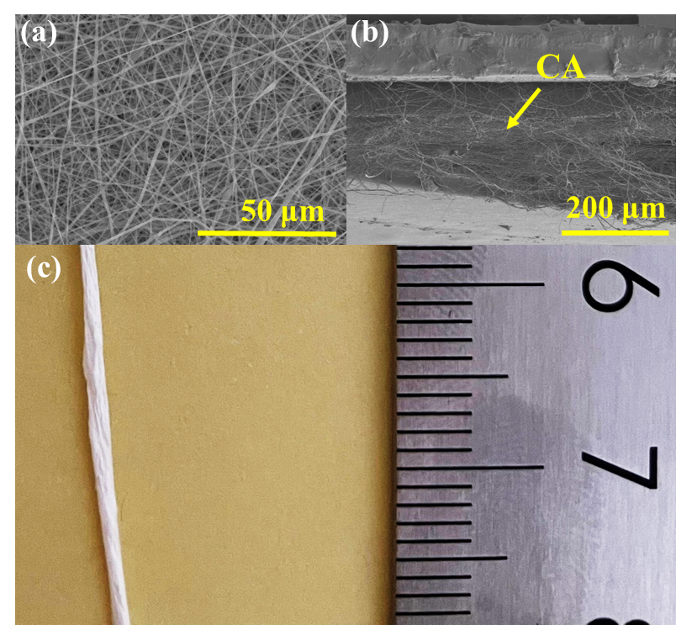
Figure S1 SEM images of CANF a) cross-section and b) surface. c) Optical image of o-CANB

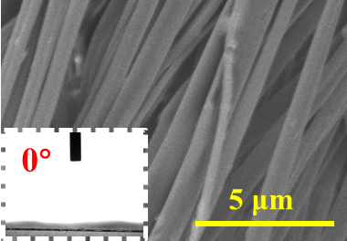
Figure S2 SEM image and The water contact angle of CS-CNTs.

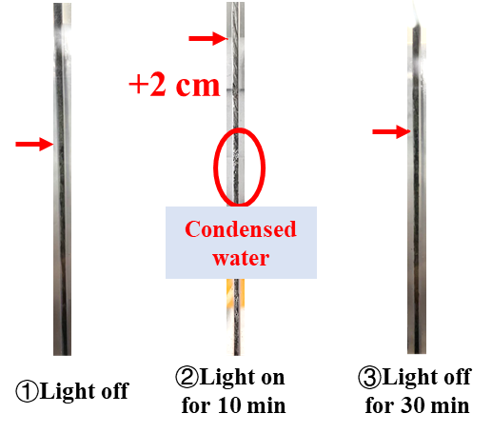
Figure S3 Optical images of TH@CS at light on/off. The arrow pointed to the position of the water transport forefront.

