Supplementary Table 1. Molecular and pathological information of five DIPG cells.

Supplementary Table 2. IC50 value of DIPG cells treated with palbociclib or YF-PRJ8-1011.

Supplementary Table 3. The data on the pharmacokinetics of palbociclib in BALB/c mice.
Time Point (hr) | Average Conc. in Plasma (ng/mL) | Average Conc. in Brain (ng/g) | Average Conc. in CSF (ng/mL) | Average Brain/Plasma Ratio | Average CSF/Plasma Ratio
0.5 | 5785 | 354 | 24.6 | 0.0615 | 0.00422
1 | 3660 | 363 | 17.7 | 0.0919 | 0.00451
2 | 4780 | 568 | 11.6 | 0.119 | 0.00254
4 | 2880 | 421 | 12.0 | 0.146 | 0.00414
8 | 2670 | 325 | 7.19 | 0.122 | 0.00266
24 | 865 | 165 | 2.62 | 0.197 | 0.00175

Supplementary Figure 1. ¹H nuclear magnetic resonance (1H-NMR) spectrum of YF-PRJ8-1011.
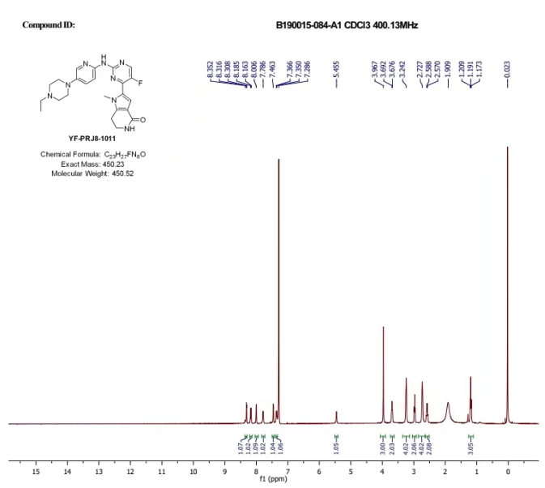

Supplementary Figure 2. Safety test of YF-PRJ8-1011 in BALB/c mice.

(a) Changes in body weight of four female B6 mice in 14 days of YF-PRJ8-1011 treatment at a dose of 50mg/kg, 100 mg/kg, 250 mg/kg and 500 mg/kg (b) H&E staining of heart, spleen, brain, liver, lung and kidney in B6 mice treated with 500mg/kg YF-PRJ8-1011 and no acute organ damage found.

Supplementary Figure 3. H&E staining and immunohistochemical (IHC) staining for p-Rb of the tumor.

(a) H&E staining of the brainstem of YF-PRJ8-1011 or vehicle treated mice at the end of 14-day treatment (b) The performance of the immunohistochemical (IHC) p-Rb staining on vehicle-treated or YF-PRJ8-1011-treated mice at the end of 14-day treatment (H&E and IHC, ×400).

