Supplementary Information

3,4-dihydroxyphenylacetaldehyde synthase evolved an ordered and distinct active site to promote elastic cuticle formation and blood intake in Aedes aegypti
Jin Chen, Christopher J. Vavricka, Shuangshuang Wei, Huaqing Chen, Yu Tang, Tomohisa Hasunuma, Huai Guan, Jianyong Li, Chenghong Liao, and Qian Han

Table S1. Data collection and refinement statistics of DHPASS
Crystal Data
Space Group | C222₁
Unit Cell
a (Å) | 72.5
a = b (Å) | 117.3
c (Å) | 139.8
α=β=γ (°) | 90.0
Data collection
X-ray source | BNLª-X29
Wavelength (Å) | 1.075
Resolution (Å) ^{b} | 2.20 (2.28-2.20)
Total number of reflections | 446,804
Number of unique reflections | 30,527
R-merge ^{b} | 0.082(0.577)
Mean I/sigma(I) | 32.9 (4.7)
Redundancy ^{b} | 14.5 (14.1)
Completeness (%)^{b} | 100 (100)
Refinement statistics
R-work (%) | 22.0
R-free (%) | 26.7
RMS Bond lengths (Å) | 0.009
RMS Bond angles (°) | 1.306
No. of water molecules | 141
Average B overall (Å²) | 45.8
Statistics on Ramachandran plot (%)
Ramachandran favored (%) | 97.6
Ramachandran allowed (%) | 2.2
Ramachandran outliers (%) | 0.2
ª Brookhaven National Laboratory
^{b} Values in parentheses refer to the highest resolution shell

Fig. S1 Mortality of adult mosquitoes after oviposition. The abscissa represents different treatment groups. Abbreviations: DEPC, adult mosquitoes treated with DEPC water; GUS, adult mosquitoes treated with gus‑dsRNA; DS, adult mosquitoes treated with DHPASS‑dsRNA; **** P < 0.0001; ns, not significant.

Fig. S2 Overall structure and schematic view of DHPASS. (A) Schematic representation of the DHPASS dimer. (B) View of a DHPASS monomer. The LLP cofactor is shown in stick representation. The large domain (green), small domain (red) and N-terminal part (blue) are labeled.

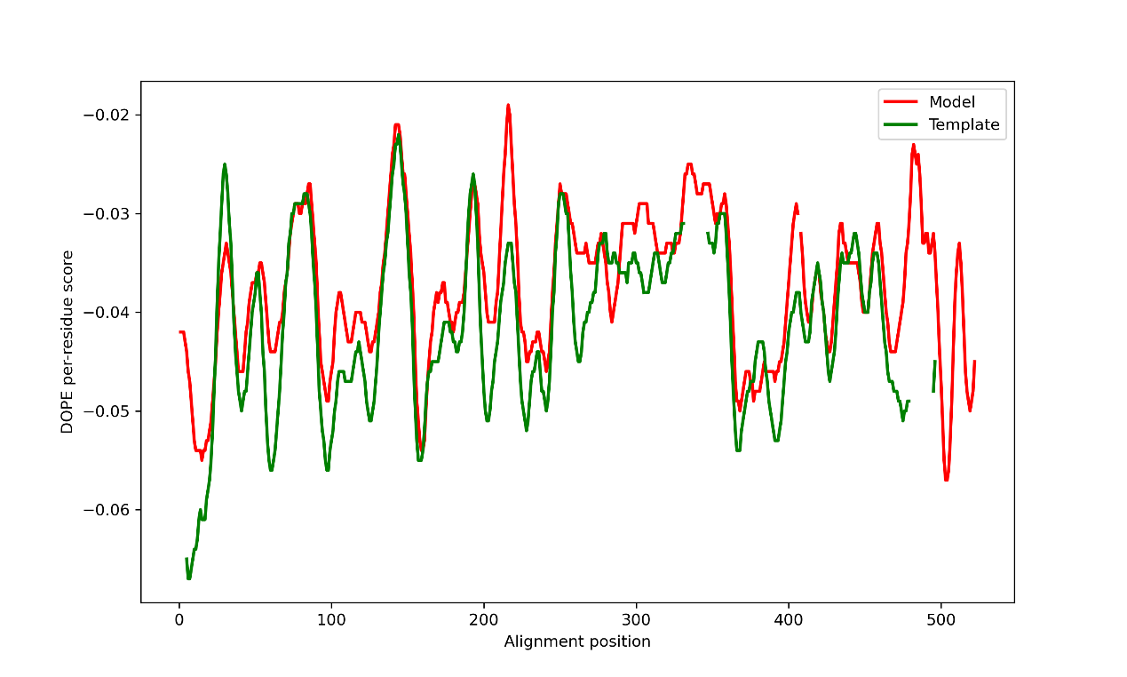
Fig. S3 DOPE score for each residue of the AeDHPASS model and template.

Fig. S4 Ramachandran plot of the AeDHPASS model.

