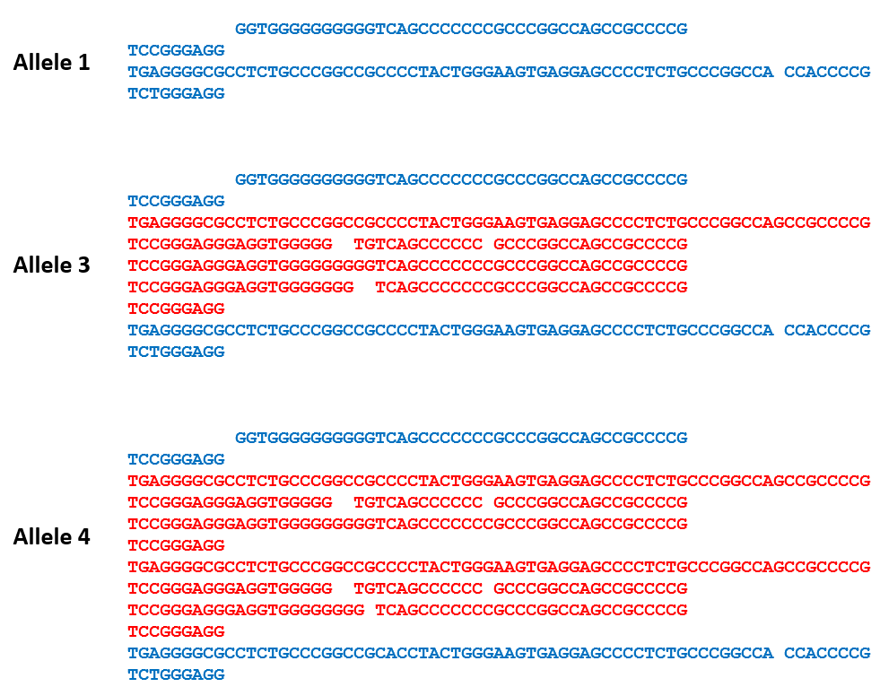

Supplementary Figure 1: Alignment of SVA_67 VNTR allele sequences. Four alleles of SVA_67 were identified by genotyping PCR. Excluding the SINE-R and poly-A tail, the different VNTR domains have a length of 128 bp (allele 1), 357 bp (allele 3) 485 bp (allele 4). Allele 2 was excluded from analysis.

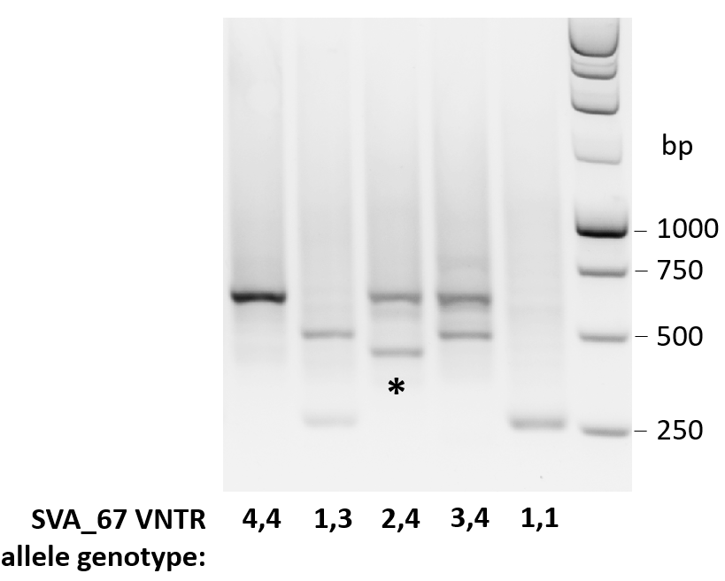
Supplementary Figure 2: PCR and gel electrophoresis of SVA_67 from a subset of the PPMI cohort. Representative gel image with expected amplicon size for SVA_67 alleles and corresponding SVA_67 genotypes are shown. Four SVA_67 alleles were identified (numbered 1–4 to reflect increasing length). Allele 2 is indicated by an asterisk.

a
b
c

Supplementary Figure 3
d
e
f

Supplementary Figure 3
g
Supplementary Figure 3: Association of SVA_67 allele genotype with expression of KANSL1 (a), PLEKHM1 (b), MAPT (c), CRHR1 (d), ARL17A (e), ARL17B (f) and NSF (g) using datapoints from Baseline (0 months). Statistically significant differences between SVA_67 allele genotypes were calculated using the non-parametric Kruskal-Wallis test. The Wilcoxon test was applied to calculate pairwise comparisons between group levels with corrections for multiple testing (FDR correction) indicated as asterisks. *P<0.05, **P<0.01, ***P<0.001.

