A holistically 3D-printed flexible millimeter-wave Doppler radar for self-driving vehicles: Towards fully printed high-frequency multilayer flexible hybrid electronic systems: Supplementary Information

Hong Tang1, Yingjie Zhang2, Bowen Zheng1, Sensong An1, Mohammad Haerinia1, Yunxi Dong1, Yi Huang1, Wei Guo2, and Hualiang Zhang1
1Department of Electrical and Computer Engineering, University of Massachusetts, Lowell, MA, USA
2Department of Physics and Applied Physics, University of Massachusetts, Lowell, MA, USA

Supplementary Figure 1. 2D DXF design files for each printed layer. a) C1 layer. b) C2 layer. c) C3 layer. d) C4 layer. e) Fiducial holes. f) C1-C2 vias. g) C1-C3 vias. h) C1-C4 vias.

Supplementary Figure 2. Geometries of the mmWave patch antenna array.

The geometries of the proposed mmWave patch antenna array are illustrated in Supplementary Figure 2. The design parameters are all labeled in this figure. Moreover, the comparisons between the designed and fabricated parameters are shown in Supplementary Table 1.
Supplementary Table 1 | Comparisons between the designed and fabricated parameters (labeled in Supplementary Figure 2) of the mmWave patch antenna array.
Item Name | Designed Value (mm) | Manufactured  Value (mm) | Error Rate | Item  Name | Designed Value (mm) | Manufactured  Value (mm) | Error Rate
w1 | 0.51 | 0.50 | 2.00% | l1 | 3.12 | 3.10 | 0.64%
w2 | 4.1 | 4.13 | 0.73% | l2 | 3.44 | 3.32 | 3.49%
w3 | 0.2 | 0.18 | 10.00% | l3 | 3.12 | 3.14 | 0.64%
w4 | 4.1 | 4.11 | 0.24% | l4 | 3.44 | 3.26 | 5.23%
w5 | 0.2 | 0.19 | 5.00% | l5 | 3.12 | 3.11 | 0.32%
w6 | 4.1 | 4.08 | 0.49% | l6 | 3.44 | 3.26 | 5.23%
w7 | 0.2 | 0.19 | 5.00% | l7 | 3.12 | 3.14 | 0.64%
w8 | 4.1 | 4.08 | 0.49% | l8 | 3.44 | 3.29 | 4.36%
w9 | 0.2 | 0.21 | 5.00% | l9 | 3.12 | 3.11 | 0.32%
w10 | 4.1 | 4.11 | 0.24% | l10 | 3.44 | 3.32 | 3.49%
w11 | 0.2 | 0.18 | 10.00% | l11 | 3.12 | 3.12 | 0.00%
w12 | 4.1 | 4.09 | 0.24% | l12 | 3.44 | 3.29 | 4.36%
w13 | 0.2 | 0.21 | 5.00% | l13 | 3.12 | 3.09 | 0.96%
w14 | 4.1 | 4.13 | 0.73% | l14 | 3.44 | 3.31 | 3.78%
w15 | 0.2 | 0.18 | 10.00% | l15 | 3.12 | 3.11 | 0.32%
w16 | 4.1 | 4.10 | 0.00%

Supplementary Figure 3. Velocity diagram for the moving vehicle under test.

The velocity diagram for the moving vehicle is shown in Supplementary Figure 3. For vehicle1, it is approaching the radar main beam. Since the moving direction is not in parallel with the radar radiation direction, the velocity needs to be decomposed into two components, the parallel component V// and the perpendicular component V⊥. However, only the parallel component V// can be detected by the radar. It can be observed that the detectable velocity component V// is opposite to the radar radiation direction. Thus, the detected velocity is negative. When the vehicle is right in front of the radar main beam (i.e., vehicle2 shown in the figure), the detected velocity is zero since there is no parallel velocity component V//. When the vehicle departs from the radar (i.e., vehicle3 shown in the figure), the detectable velocity component V// is in the same direction as the radar radiation direction. Thus, the detected velocity is positive in this case.
Supplementary Figure 4. a) Simulation model of the un-bent antenna array. b) Simulation model of the bent antenna array. c, d) Simulated reflection coefficients and realized gains of the bent and un-bent antenna arrays.

In Supplementary Figure 4b, the antenna array is bent with a radius of 84.1 mm (the size is identical to the radius of the PVB tube during the bending tests) and simulated in CST with a discrete port. Simulated responses of the bent and un-bent antenna arrays are presented in Supplementary Figure 4c and Supplementary Figure 4d, respectively. It can be observed that the radiation performance of the antenna array will change when it is bent. The reflection coefficient will become worse when the antenna is bent, resulting in poor impedance matching at 24 GHz. Correspondingly, the realized gain will decrease by 3 dBi when the array is bent. As a result, decrease in realized gain results in a decrease in the magnitude of the output spectrum (i.e., presented in Fig. 4d in the main manuscript).
Supplementary Figure 5. Photos of the printed flexible radar which is conformally integrated with a vehicle rear bumper.

The photo of a rigid Doppler radar is shown in Supplementary Figure 6. It follows almost the same design as our proposed 3D printed Doppler radar, except for the customized shapes of the insulation layers I2 and I3 shown in Fig. 1b of the main manuscript. Additionally, all the vias are designed as through vias to save the cost for this rigid board. This rigid board is manufactured to validate the design concept of our radar board. The performance of this rigid Doppler radar is presented in Supplementary Figure 7.
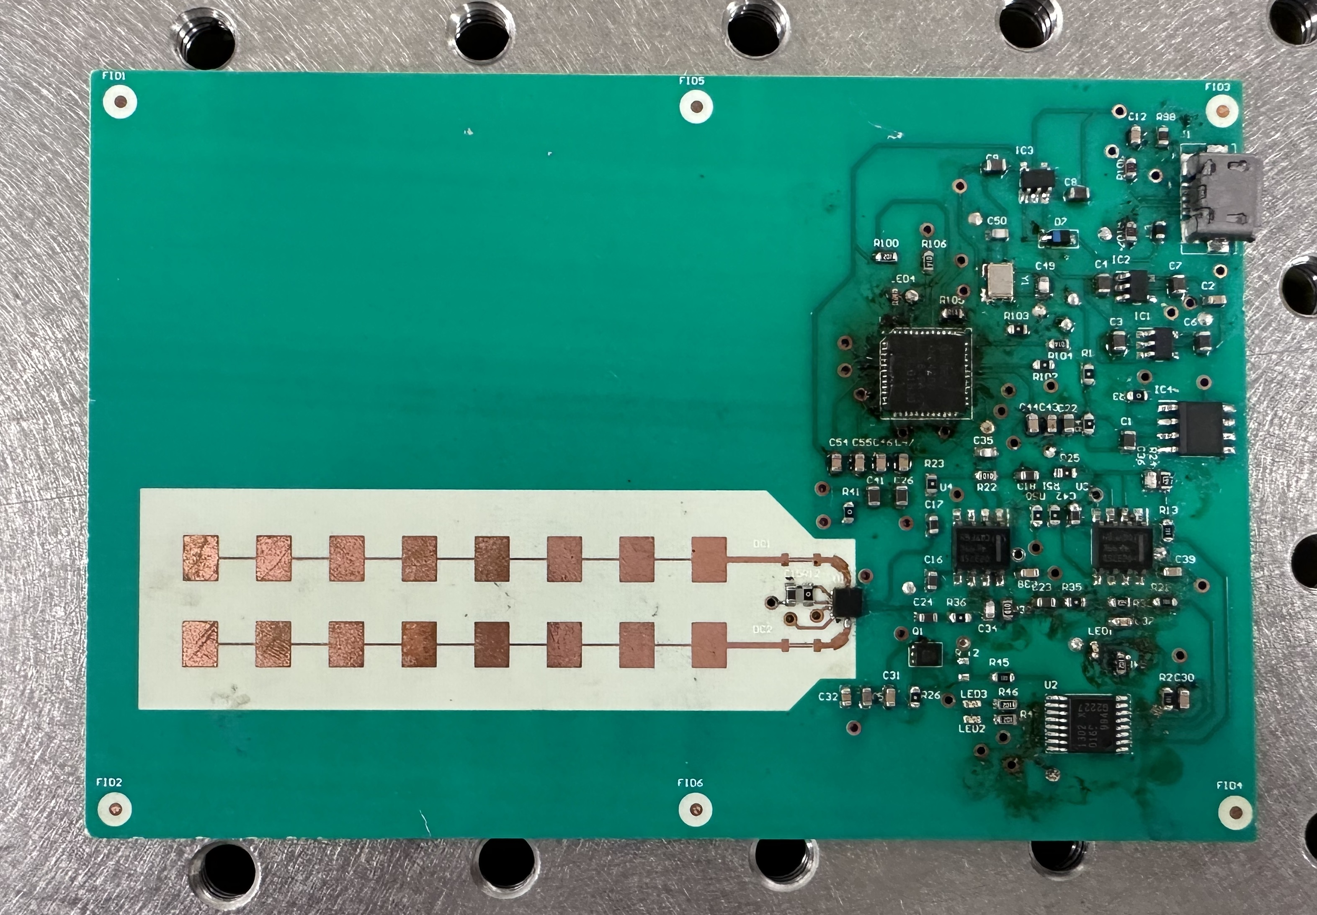
Supplementary Figure 6. A photo of the rigid Doppler radar manufactured by conventional PCB technologies.

The experimental setups are identical to the tests for 3D-printed radar. The output spectrum of the RF module is shown in Supplementary Figure 7a. It can be seen that the output frequency of the rigid radar is 24.05 GHz, and the detected output power at that frequency is -23.6737 dBm. It is worth to mention that the measured output amplitude is 3.31dBm larger than that of the printed radar. We believe that it is mainly because the conductivity of the commercial silver ink, which is around 2M S/m, is smaller than that of the copper, which is 58M S/m. Compared with copper, the lower conductivity of commercial silver ink leads to lower efficiency, lower realized gain, and lower output spectrum magnitude. Simulated realized gains with different values of conductivities are presented in Supplementary Figure 7b. It can be observed that a lower conductivity will lead to a lower gain. Indoor field tests were conducted to characterize performance of the rigid radar. The processed 2D velocity mapping is shown in Supplementary Figure 7c.
Supplementary Figure 7. Performance of the rigid Doppler radar. a) Measured output spectrum of the rigid radar. b) Simulated realized gain with different conductivities. c) Field tests results of the rigid radar.

Supplementary Figure 8. Diagram for melt high-heat epoxy mixed with printed TPC layer.

The Diagram for the melted high-heat epoxy mixed with the printed TPC layer is shown in Supplementary Figure. 8. Since temperature of the printing nozzle is much higher than melting point of the high-heat epoxy, the top part of the epoxy layer (e.g., high heat epoxy2) will be melted and mixed with the extruded TPC layer to increase bonding strength between the TPC layer and the epoxy layer. A video is available in supplementary videos to further illustrate the mixing processes.
Supplementary Figure 9. The microphotographs of the SMD chips/components with high-heat epoxy to increase the reliability of the radar system. a) CMOS switch. b) LDO. c) MCU. d) mmWave transceiver. e) LDO. f) LDO.

The major SMD chips, such as CMOS switch (shown in Supplementary Figure 9a), LDOs (shown in Supplementary Figure 9b, Supplementary Figure 9e, and Supplementary Figure 9f), MCU (shown in Supplementary Figure 9c), 24 GHz transceiver (shown in Supplementary Figure 9d), are all coated with transparent high-heat epoxy to further enhance the reliability. Without high-heat epoxy, the electrical connection may fail since the mechanical strength of the cured conductive epoxy is not strong enough to maintain good connections, especially when the printed radar is bent. When the high-heat epoxy is applied, the chips will be attached to the board tightly and maintain a good electrical connection, even if the board is bent or under other scenarios.

Supplementary Figure 10. Microphotograph of the vias. a-c) Vias filled with high-heat epoxy. d) Vias without high-heat epoxy.

The vias filled with high-heat epoxy are displayed in Supplementary Figure 10a-c, while a via without high-heat epoxy is shown in Supplement Figure 10d. In Supplementary Figure 10a-c, the vias filled with conductive epoxy are cured at 90°C for 60 minutes, then filled with high-heat epoxy. Since the viscosity of the epoxy is low before curing, the high-heat epoxy can fill the inner holes of the vias quickly, resulting in a more robust via connection when the high-heat epoxy is fully cured. The cured high-heat epoxy is highlighted in the figure.
Supplementary Figure 11. An example of the raw IF data before and after processing. a) The received raw IF data. b) The spectrum of the IF data. c) The processed velocity spectrum.

