Supplementary Information for:

Uncovering Unique Screening Effects in 2D Perovskites: Implications for Exciton and Band Gap Engineering

Kameron R. Hansen*^{,1}, Cindy Y. Wong^{2,6}, C. Emma McClure^{3,4,6}, Blake Romrell³, Laura Flannery², Daniel Powell¹, Kelsey Garden¹, Alex Berzansky¹, Michele Eggleston³, Daniel J. King³, Carter M. Shirley³, Matthew C. Beard⁴, Wanyi Nie⁵, André Schleife², John S. Colton³, Luisa Whittaker-Brooks¹

¹Department of Chemistry, University of Utah, Salt Lake City, Utah 84112, United States
²Department of Materials Science and Engineering and Materials Research Laboratory, University of Illinois at Urbana-Champaign, Urbana, Illinois 61801, USA
³Department of Physics and Astronomy, Brigham Young University, Provo, Utah 84602, USA
⁴National Renewable Energy Laboratory, Golden, Colorado 80401, USA
⁵Los Alamos National Laboratory, Los Alamos, NM, USA
⁶These authors contributed equally to this work

*To whom correspondence should be addressed. E-mail: kameron.hansen@utah.edu

Supplementary Information Guide

1. Simulation of 2D and 3D Wannier exciton in an electric field 4
2. Measuring E_{g} from the mid-point of the absorption step feature 5
3. Effect of morphology on E_{b} 6
4. Effect of octahedral tilt on µ and E_{b} 6
5. Effect of temperature on E_{b} 9
6. Consistency of absorption and EA between various studies 9
7. Effect of barrier screening, superlattice screening, and phonon screening on E_{g} and E_{b} 10
8. Production of Fig. 3a 11
9. Measuring the dielectric function of thin films using IDE impedance spectroscopy 11
10. Effective masses 13
11. Dielectric constants 13
11.1 Bulk dielectric constants 13
11.2 Barrier and well dielectric constants 13
12. Modeling 2D HP exciton properties 15
12.1 Superlattice model 15
12.1.1 Single particle wavefunctions 16
12.2 Isolated quantum well model 17
12.3 Input parameters 18
13. Disentangling quantum and dielectric confinement effects 18
14. Standard error of E_{b} calculations and implications for phonon screening 20
14.1 Interpretation of disagreement between theory and experiment 20
14.2 Comparison to recent phonon screening model 20
15. Phonon screening efficiency 21
16. E_{b} and E_{g} of 3D HPs and n > 1 2D HPs 21
16.1 3D HPs 21
16.2 n > 1 2D HPs 23
17. E_{b} vs. fundamental material parameters (ε_{w}, ε_{b}, and µ) 24
18. Linear tunability of E_{b} by alloying B-site and X-site atoms 25
19. Structural characterization 25
21. Additional figures 29
References 31

Table S1: Exciton binding energies, radii, masses, dielectric constants, and structural parameters
 | d₀₀₂ (Å) | β−β’ (°) | ε∞ | ε₀ | ε(MHz) | µ | E_{1s} (eV) | E_{g} (eV) | E_{b} (meV) | $〈r〉$(Å)
BA₂PbI₄ (I) | 13.81 | 13 | 3.19 | 7.06 |  | 0.111 | 2.398 ± 0.002 | 2.626 ± 0.004 | 228 ± 5 | 13.9
BA₂PbI₄ (II) | 13.04 | 36 | 3.30 | 6.70 | 11.2 | 0.139 | 2.575 ± 0.003 | 2.831 ± 0.002 | 256 ± 4 | 13.2
(C₅)₂PbI₄ (II) | 14.52 | 39 |  |  |  |  | 2.573 ± 0.005 | 2.845 ± 0.002 | 272 ± 5 | 12.8
(C₆)₂PbI₄ (I)¶ | 16.35 | 13 |  |  |  |  | 2.344 ± 0.004 | 2.579 ± 0.004 | 235 ± 6 | 13.7
(C₇)₂PbI₄ (I) | 18.31 | 14 |  |  | 10.1 |  | 2.381 ± 0.004 | 2.627 ± 0.008 | 246 ± 9 | 13.4
(C₇)₂PbI₄ (II) | 17.12 | 39 | 2.99 | 6.69 |  | 0.147 | 2.567 ± 0.004 | 2.844 ± 0.002 | 277 ± 4 | 12.7
(C₁₀)₂PbI₄ (II) | 21.21 | 38 | 2.77 | 5.11 |  | 0.141 | 2.580 ± 0.002 | 2.878 ± 0.003 | 298 ± 4 | 12.3
(C₁₂)₂PbI₄ (II) | 24.51 | 33 |  |  |  |  | 2.577 ± 0.002 | 2.869 ± 0.002 | 292 ± 3 | 12.4
(C₁₄)₂PbI₄ (II) | 27.08 | 33 | 2.42 |  | 8.2 | 0.135 | 2.585 ± 0.003 | 2.882 ± 0.003 | 297 ± 4 | 12.3
(C₁₆)₂PbI₄ (II) | 29.65 | 33 |  |  |  |  | 2.577 ± 0.002 | 2.877 ± 0.003 | 300 ± 4 | 12.2
PEA₂PbI₄ | 16.34 | 0 | 3.29 | 6.18 | 10.5 | 0.108* | 2.366 ± 0.002 | 2.589 ± 0.004 | 223 ± 4 | 14.1
EOA₂PbI₄ | 10.05 | 17 | 3.94 | 13.61 |  | 0.122 | 2.323 ± 0.005 | 2.378 ± 0.005 | 55 ± 7 | 30.1
TEA₂PbI₄ | 15.75 |  |  |  |  |  | 2.389 ± 0.002 | 2.607 ± 0.004 | 218 ± 4 | 14.2
5F-PEPI | 16.82 | 0 | 3.03 |  |  |  | 2.485 ± 0.002 | 2.759 ± 0.002 | 274 ± 3 | 12.7
HDAPbI₄ | 25.96 |  |  |  |  |  | 2.569 ± 0.004 | 2.817 ± 0.003 | 248 ± 5 | 13.4
BA₂SnI₄ | 13.06 | 35 | 3.47 | 10.04 |  | 0.097 | 2.181 ± 0.004 | 2.35 ± 0.02 | 170 ± 20 | 16.2
PEA₂SnI₄ | 16.35 | 0 | 3.49†† |  |  | 0.075* | 1.982 ± 0.004 | 2.11 ± 0.015 | 128 ± 16 | 19.1
PEA₂SnBr₄ | 16.61 |  |  |  |  |  | 2.875 ± 0.002 | 3.151 ± 0.006 | 276 ± 6 | 12.7
BA₂PbBr₄ | 13.81 | 11 | 2.61 | 6.31 |  | 0.132 | 3.04 ± 0.003 | 3.392 ± 0.002 | 352 ± 4 | 11.4
PEA₂PbBr₄ | 16.67 | 0 | 2.74 | 5.86 | 6.1 | 0.1 | 3.076 ± 0.003 | 3.425 ± 0.003 | 349 ± 4 | 11.4
PEA₂PbBr_{3.3}Cl_{0.6} | 16.75 |  |  |  |  |  | 3.132 ± 0.005 | 3.512 ± 0.006 | 380 ± 8 | 10.9
PEA₂PbBr_{2.6}Cl_{1.3} | 16.90 |  |  |  |  |  | 3.234 ± 0.005 | 3.639 ± 0.008 | 405 ± 9 | 10.6
PEA₂PbBr₂Cl₂ | 16.65 |  |  |  |  |  | 3.388 ± 0.005 | 3.837 ± 0.006 | 449 ± 8 | 10.0
PEA₂PbBr₁Cl₃ | 16.74 |  |  |  |  |  | 3.540 ± 0.004 | 4.005 ± 0.005 | 465 ± 6 | 9.9
PEA₂PbCl₄ | 16.89 | 0 | 2.48 | 5.62 |  | 0.118 | 3.643 ± 0.004 | 4.13 ± 0.008 | 487 ± 9 | 9.6
BA₂PbCl₄ | 13.99 | 7 | 2.27 | 5.90 | 6.9
BA₂MAPb₂I₇ | 19.67 | 28 | 3.33 | 9.84 |  |  | 2.190 ± 0.006 | 2.325 ± 0.015 | 135 ± 16 | 18.5
(C₆)₂MAPb₂I₇¶ |  |  |  |  |  |  | 2.158 ± 0.005 | 2.272 ± 0.015 | 114 ± 16 | 19.3
BA₂MA₂Pb₃I₁₀ | 25.98 | 16 | 3.97 |  |  |  | 2.043 ± 0.015 | 2.12 ± 0.02 | 77 ± 25 | 25.6
(C₆)₂MA₂Pb₃I₁₀¶ |  |  |  |  |  |  | 2.023 ± 0.008 | 2.120 ± 0.015 | 97 ± 17 | 22.3
MAPbI₃ |  |  | 4.53§ |  | 36 | 0.104¶¶ | 1.652¶¶ | 1.636¶¶ | 16 ± 2¶¶ | 43.0
MAPbBr₃ |  |  | 3.55§ |  | 26§§ | 0.117† | 2.289 ± 0.002 | 2.317 ± 0.006 | 28 ± 6 | 38.2
MAPbCl₃ |  |  | 2.87§ |  | 24§§ | 0.18** | 3.021 ± 0.003 | 3.088 ± 0.008 | 67 ± 9 | 27.5
*Ref ¹
†Ref. ²
§Ref. ³
¶ E_{1s}, E_{g} , and E_{b} assignments are based on our interpretation of EA spectra reported in reference⁴
**Ref. ⁵
††From Eq. (21)
§§ Ref. ⁶
¶¶ Ref. ⁷

Table S2: Abbreviations of organic cations
Abbreviation | Molecule name | Molecular formula
BA or C₄ | Butylammonium | CH₃(CH₂)₃NH₃
C₅ | Amylammonium | CH₃(CH₂)₄NH₃
C₆ | Hexylammonium | CH₃(CH₂)₅NH₃
C₇ | Heptylammonium | CH₃(CH₂)₆NH₃
C₈ | Octylammonium | CH₃(CH₂)₇NH₃
C₁₀ | Decylammonium | CH₃(CH₂)₉NH₃
C₁₂ | Dodecylammonium | CH₃(CH₂)₁₁NH₃
C₁₄ | Tetradecylammonium | CH₃(CH₂)₁₃NH₃
C₁₆ | Hexadecylammonium | CH₃(CH₂)₁₅NH₃
EOA | Ethanolammonium | HOCH₂CH₂NH₃
HDA | Hexamethylenediammonium | H₃N(CH₂)₆NH₃
MA | Methylammonium | CH₃NH₃
PEA | Phenethylammonium | C₆H₅CH₂CH₂NH₃
5F-PEA | 5-fluoro-phenethylammonium | C₈H₆F₅N
TEA | Thiopheneethylammonium | C₆H₉NS

1. Simulation of 2D and 3D Wannier exciton in an electric field
We implement the numerical procedure outlined in Ref. ⁸, Ref.⁹, Ref.¹⁰, and Ref. ¹¹ to simulate the 2D and 3D Wannier exciton electroabsorption (EA) spectrum and gain key insights into the expected EA response for 2D and 3D halide perovskites (HP). The procedure begins with Elliot’s formula for the absorption of a direct-gap semiconductor:^{12,13}

$ε_{i}\left(E\right)=C\sum_{n}{{\left|ψ_{n}\left(r=0\right)\right|}^{2}}δ(E-E_{g}-E_{n})$ (1)

where $ε_{i}$ is the imaginary part of the dielectric constant (directly proportional to the absorption coefficient using a small frequency range assumption¹³), $C$ is a constant proportional to the dipole matrix element^{9,11}, $E$ is the photon energy, $ψ_{n}\left(r=0\right)$ is the exciton wavefunction as a function with energy $E_{n}$, and $r$ is the electron-hole relative position. Thus, the problem of simulating the absorption reduces to finding the wavefunction solutions $ψ_{n}(r)$ to the electron-hole Schrodinger equation at $|r|=0$. For a 3D Wannier exciton in a uniform field, in dimensionless units this Schrodinger equation is as follows:

$\left(-{∇_{x,y,z}}^{2}-\frac{2}{r}+fz\right)ψ_{3D,n}\left(r\right)=E_{n}ψ_{3D,n}(r)$ (2)

And for a 2D Wannier exciton with an in-plane electric field:

$\left(-∇_{x,y}^{2}-\frac{2}{r}+fx\right)ψ_{2D,n}\left(r\right)=E_{n}ψ_{2D,n}(r)$ (3)

where $f$ is a dimensionless parameter representing the electric field strength, and the label $n$ represents a quantum state with energy $E_{n}$, azimuthal quantum number $m$, and a separation parameter $t_{n}$. The potential in Eq. (2) and (3) is general for a Wannier exciton in an electric field and is not material-specific. However, to simulate the EA of a Wannier exciton with a mass and binding energy that best represents excitons in 2D HPs at our experimental applied fields (11 kV/cm < $F$ < 156 kV/cm), we select a range of dimensionless field of 0 < $f$ < 0.7, where $f$ is defined as:

$f=\frac{ea_{0}}{R}F'$ (4)

Here $F'$ is the field strength felt by the exciton, $a_{0}$ is the exciton’s 3D Bohr radius, $R$ is the Rydberg energy, as follows:

$F'=\frac{ΔV_{AC}/d}{ε\left(f_{AC}\right)}$ (5)

$a_{0}=\frac{4π{ℏ^{2}ε}_{0}ε_{r,eff}}{e^{2}{ m}^{*}}$ (6)

$R=\frac{ℏ^{2}}{2a_{0 }^{2}m^{*}}$ (7)

Here, $d$ is the spacing between our interdigitated electrodes (45 $μm$), $ΔV_{AC}$ is the applied voltage (50 – 700 V) at frequency $f_{AC}$ (983 Hz for us), and $ε\left(f_{AC}\right)$ is the dielectric constant at that frequency which screens the applied field. By contrast, $ε_{r,eff}$ is the dielectric constant at the much higher frequency relevant to the screening of the electron-hole interaction (discussed in the text). Since excitons in 2D HPs are not ideal Wannier excitons, estimations for $a_{0}$ and $R$ (and by extension $f$) will differ depending on whether $a_{0}$ and $R$ are computed using estimates of $ε_{r,eff}$ and $m^{*}$ substituted into Eq. (6) and (7), or instead, taken to be the experimentally-measured exciton radii ($r$) and binding energies ($E_{b}$). Nevertheless, the fact that 2D HPs don’t neatly feat into the Wannier model doesn’t impede our overall goal of simulating the EA in a regime that roughly mimics the experimental EA. The key result of the simulation, as it pertains to this study, is the location of $E_{g}$ within the Franz-Keldysh feature, and this result is rather insensitive to $f$ over a wide field range (e.g., all $f<1$). Using the experimentally-determined values of $r$ and $E_{b}$ ($r_{3D}=$ 46 Å and $E_{b,3D}=$ 16 meV for MAPbI₃⁷; $r_{2D}=$ 17 Å and $E_{b,2D}=$ 260 meV for BA₂PbI₄), $ΔV_{AC,max}=700$ V, and values of 25 and 6 for $ε(f_{AC})$ of MAPbI₃ and BA₂PbI₄, respectively, we arrive at dimensionless fields of $f_{max,3D}$ = 0.18 and $f_{max,2D}$ = 0.017. However, due to numerical instabilities that occur for very low $f$, we simulate the EA in a slightly higher field range, but one that still captures the low-field, low-broadening behavior of the 2D HPs. To move forward with solving Eq. (1) and Eq. (2), a transformation to parabolic coordinates is needed, which with the following separation of variables ansatz,

$ψ_{n}\left(r\right)=\frac{χ_{1}\left(ξ\right)χ_{2}(ζ)}{{\left(ξζ\right)}^{1/4}}$ , (8)

results in these two parabolic quasi-Schrodinger equations for both the 2D and 3D case:

$χ_{1}{\left(ξ\right)}^{''}+\left(\frac{1-m^{2}}{4ξ^{2}}+\frac{t_{n}}{ξ}+\frac{E}{4}-\frac{fξ}{8}\right)χ_{1}\left(ξ\right)=0$ (9)

$χ_{2}{\left(ζ\right)}^{''}+\left(\frac{1-m^{2}}{4ζ^{2}}+\frac{1-t_{n}}{ζ}+\frac{E}{4}-\frac{fζ}{8}\right)χ_{2}\left(ζ\right)=0$. (10)

Here the variables $ξ$ and $ζ$ are equal to r ± z (or x, for 2D), respectively, $m$ is the azimuthal quantum number, $t_{n}$ represents the separation parameter which must be numerically solved for, and $J$ is a parameter that determines whether Coulomb interactions are included ($J=1$) or ignored ($J=0$). From here, the problem of solving for $ψ_{n}$ reduces to solving for $χ_{1}(ξ)$ and $χ_{2}\left(ζ\right)$, and the only difference in the 2D and 3D cases is the selection of the azimuthal quantum number, that is, $m =±0.5$ in two-dimensions and $m = 0$in three dimensions for s-state excitons. We set the Coulomb parameter to unity ($J=1$) and implement the Numerov procedure, explained in detail in Ref. ⁸, Ref. ¹⁰, and Ref. ¹¹ to solve for $t_{n}$, $χ_{1}\left(ξ\right)$, $χ_{2}\left(ζ\right)$, and then relate these solutions to the field-shifted absorption spectrum, $α_{2D}(E,f)$ and $α_{3D}\left(E,f\right)$. The corresponding zero-field absorption spectra are as follows:⁹

$ε_{i,2D}(E,0)=\frac{1}{π}\sum_{n=1}^{∞}{\frac{1}{{\left(n-\frac{1}{2}\right)}^{3}}δ\left(E-E_{g}+\frac{R}{{\left(n-\frac{1}{2}\right)}^{2}}\right)}+\frac{1}{2π}\frac{Θ\left(E-E_{g}\right)}{1+e^{-2π/\sqrt{E-E_{g}}}}$ (11)

$ε_{i,3D}\left(E,0\right)=\frac{1}{π}\sum_{n=1}^{∞}{\frac{1}{n^{3}}δ\left(E-E_{g}+\frac{R}{n^{2}}\right)}+\frac{1}{2π}\frac{Θ\left(E-E_{g}\right)}{1-e^{-2π/\sqrt{E-E_{g}}}}$ (12)

The simulated EA is computed as follows:

$Δε_{i}=ε_{i}\left(E,f\right)*L\left(E\right)-ε_{i}\left(E,0\right)*L\left(E\right)$ (13)

where $L\left(E\right)$ is a Lorentzian function with half-width-half-maximum (HWHM) of $Γ$, and the convolution with $L\left(E\right)$ mimics the homogenous broadening of the material. This produces the simulated 2D Wannier exciton EA shown in Fig. 1 and the simulated 3D Wannier exciton EA in Fig. S17.

2. Measuring E_{g} from the mid-point of the absorption step feature
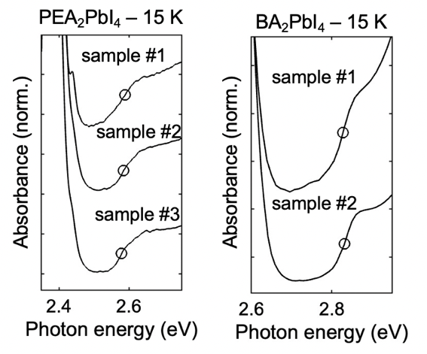
Fig. S1: A zoom-in on the step-like absorption feature of three PEA₂PbI₄ thin films (left) and two BA₂PbI₄ thin films (right). The open circle marks the FK zero-crossing observed in each film’s EA spectrum.

The step-like absorption feature for three PEA₂PbI₄ thin films and two BA₂PbI₄ are shown in Fig. S1. For each of these thin films, corresponding EA spectra were acquired and the open circles in Fig. S1 mark the zero-crossing position of each film’s FK feature, i.e. the band gap energy. In a situation where the 2s, 3s, etc. exciton states contribute to the absorption, one would expect enhanced absorption at the base of the step and for E_{g} to be located closer to the top of the step. However, this is not what we observe. Instead, E_{g} bisects the step-feature in each case. No evidence of $n$ > 1 exciton absorption was observed in any of the ~50 thin films investigated in this study, forcing us to conclude that the absorption of these states is very weak and is buried beneath broad, neighboring features. It is a simple, yet nonetheless oftentimes overlooked fact that Elliot theory predicts that E_{g} is located at the midpoint of this step-like feature according to Eq. (11). Thus, the FK signal verifies the interband origin of the absorption step feature, and vice versa. In cases where both are detected, two independent and corroborating measurements of $E_{g}$ are obtained. In the case only the step-feature is resolved, E_{g} (and by extension E_{b}) can be measured with a precision of ~10 - 25 meV depending on the clarity of the step.

3. Effect of morphology on E_{b}
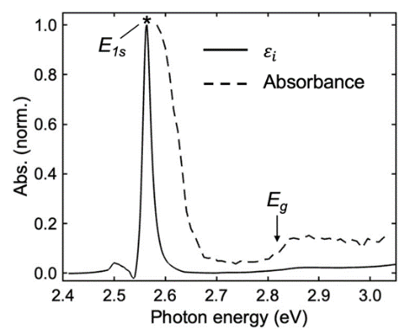
Fig. S2: The imaginary part of the dielectric function (solid line) and the absorbance (dashed line) for a BA₂PbI₄ single crystal flake at 15 K.

In order to compare E_{b} of thin film samples to that of a single crystal (SC), SC flakes of BA₂PbI₄ were synthesized (see Methods), filtered, and mounted in a cryostat for low-temperature reflection and transmission experiments. Due to their small size, the SC flakes were incompatible with our EA experiments. We opted instead to resolve the step-like feature in the absorption spectrum in order to determine E_{g} and, by extension, E_{b} as well (Supplementary Section 2). As shown in Fig. S2, the absorbance of the SC flake shows a step-like feature at the interband transition, and this allows for a measurement of E_{g} = 2.831 ± 0.02 meV. Meanwhile, a Kramers–Kronig transformation of the reflectance data (using the software of Ref. ¹⁴) yields the imaginary part of the dielectric function ($ε_{i}$), and this allows us to measure the energy of the 1s absorption peak, E_{1s} = 2.565 ± 0.002 eV, resulting in E_{b} = 266 ± 20 meV. This agrees with our multiple E_{b} measurements obtained using EA on BA₂PbI₄ thin films. Results in the main text (Fig. 2a) and Supplementary Section 6 further corroborate that polycrystalline thin films and SC flakes share the same value of $E_{b}$.
To further test the effect of sample morphology on E_{b}, we synthesized ordered and disordered PEA₂PbI₄ thin films and measured E_{b} using absorption and EA spectroscopy. The variable of temperature in the spin-coating procedure was leveraged in order to create thin films with varying degrees of static disorder, i.e. with varying grain sizes, homogeneity of grain orientation, defect density, etc. The width of the absorption features at 15 K is a straightforward measurement of the thin film’s static disorder from the perspective of the band-edge electronic states¹⁵, and we determine these widths by fitting hyperbolic secant functions to the exciton absorption peaks and extracting the HWHM (Γ). We find Γ ranges from 18 meV in the most ordered thin film to 36 meV in the least ordered (Fig. S3a). Interestingly, we find the size of Γ is correlated with E_{g} and E_{1s}, as the films of greater crystallinity (low Γ) redshift to a greater degree upon cooling to 15 K. The exciton binding energy, however, is uncorrelated with Γ and is consistent at approximately 222 meV for each of the samples (Fig. S3b). This is a clear negation of the hypothesis that E_{b} depends on morphology and microstructure in HP systems^{16,17}. The samples in Fig. S3 are listed as 1-5 from most ordered (1) to least ordered (5). The thin films were processed as follows: 1 = post-annealed at 100 °C, 2 = post-annealed at 100 °C, 3 = hotcast with a solution at 65 °C and a substrate at 210 °C, 4 = hotcast with a solution at 65 °C and a substrate at 160 °C then subsequently post-annealed at 100 °C, and 5 = hotcast with a solution at 65 °C and a substrate at 260 °C.

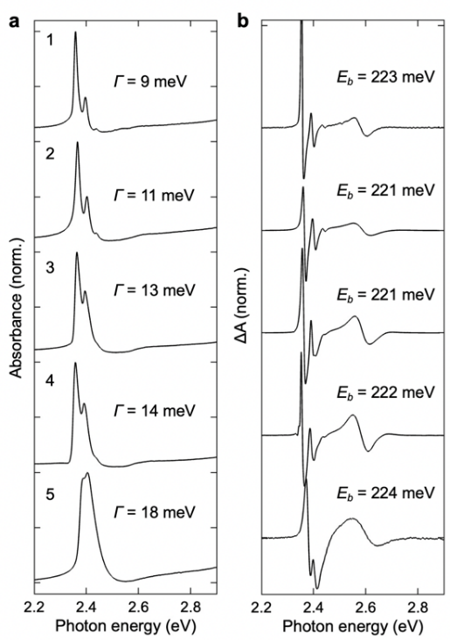
Fig. S3: (a) The absorbance and (b) EA of several PEA₂PbI₄ thin films at 15 K. The films were spin-coated at various temperatures resulting in varying degrees of static disorder, and are presented from most ordered (1) to least ordered (5).

4. Effect of octahedral tilt on µ and E_{b}
The varying degrees of tilting within the (C_{m})₂PbI₄ structures is a confounding variable that must be accounted for to determine $E_{b}$ as a function of $l_{b}$. Not only does the degree of tilting vary between (C_{m})₂PbI₄ compositions, but additionally, the degree of tilting also varies between the different phases of a single (C_{m})₂PbI₄ composition (each composition undergoes 1 – 3 phase transitions between 200 K and 400 K ¹⁸⁻²²). Thanks to the work of Billing and Lemmerer²⁰⁻²², a detailed record exists of the crystallographic structures and phase transition temperatures for each phase of each composition. We verified that our room-temperature XRD yielded a d₀₀₂ distance in agreement with that of Billing and Lemmerer (Table S3), and then quantified the degree of tilting in both the room temperature (293 K) and low temperature phases (< 200 K) via a simple metric: $|β-β'|$, where $β$ and $β'$ are the I-I-I angles shown in the bottom-right inset of Fig. S4a. We found the (C_{m})₂PbI₄ structures follow a tightly-segregated bimodal distribution with either a small tilt ($|β-β'|$ = 13 ± 4°; common at room temperature), which we label as phase I, or a large tilt ($|β-β'|$ = 36 ± 3°; common at low temperature), which we label as phase II (Table S3).
Upon calculating $μ$ via DFT for various (C_{m})₂PbI₄ members, we found a strong correlation between $μ$ and the octahdedral tilt angle $|β-β'|$. Indeed, we find $μ$ is largely determined by two factors, octahedral tilting and composition of the metal-halide layer. A complete list of DFT-calculated masses is provided in Table S3, and the values are plotted as a function of $|β-β^{'}|$ in Fig. S4a. The positive correlation between $μ$ and $|β-β^{'}|$ is very obvious and is observed for each metal-halide composition (PbI, SnI, PbBr). Our results demonstrate tin-based HPs have lower effective masses which is in agreement with previous studies^{1,23,24}. The change is $μ$ is smaller and less clear for X-site substitutions, which is logical considering that the B-site plays a larger role in determining the band structure than the X-site^{25,26}. These results (and others^{2,27}) suggest there may be a slight increase in $μ$ moving from I Br Cl; however, a larger sample size is needed to test this hypothesis more thoroughly.
Seeing as $E_{b}∝μ$, we expect a similar correlation between $E_{b}$ and $|β-β^{'}|$. On two occurrences, once for BA₂PbI₄ (where BA = C₄) and another time for (C₇)₂PbI₄, the thin film retained a portion of crystallites in the phase I structure upon cooling to low temperature, and this allowed

for simultaneous $E_{b}$ measurements of phase I and II structures with all other factors held constant. In both cases, $E_{b}$ was larger in the phase II structure where $|β-β^{'}|$ was greater, as hypothesized. The BA₂PbI₄ thin film is shown in Fig. 2c of the main text while that of (C₇)₂PbI₄ is shown in Fig. S4b-c. In the latter case, we measured $E_{b}=$ 246 meV for the phase I crystal structure, and $E_{b}=$ 275 meV for the phase II structure. The octahedral-tilt-induced changes in $μ$ between various (C_{m})₂PbI₄ members were sufficient to explain the octahedral-tilt-induced changes in $E_{b}$. This is demonstrated in Fig. 4f of the main text, where $E_{b}$ was calculated using the superlattice model using both the average phase I mass ($μ=$ 0.111 $m_{0}$) and the average phase II mass ($μ=$ 0.140 $m_{0}$) and these values are in agreement with our experimental $E_{b}$ measurements.

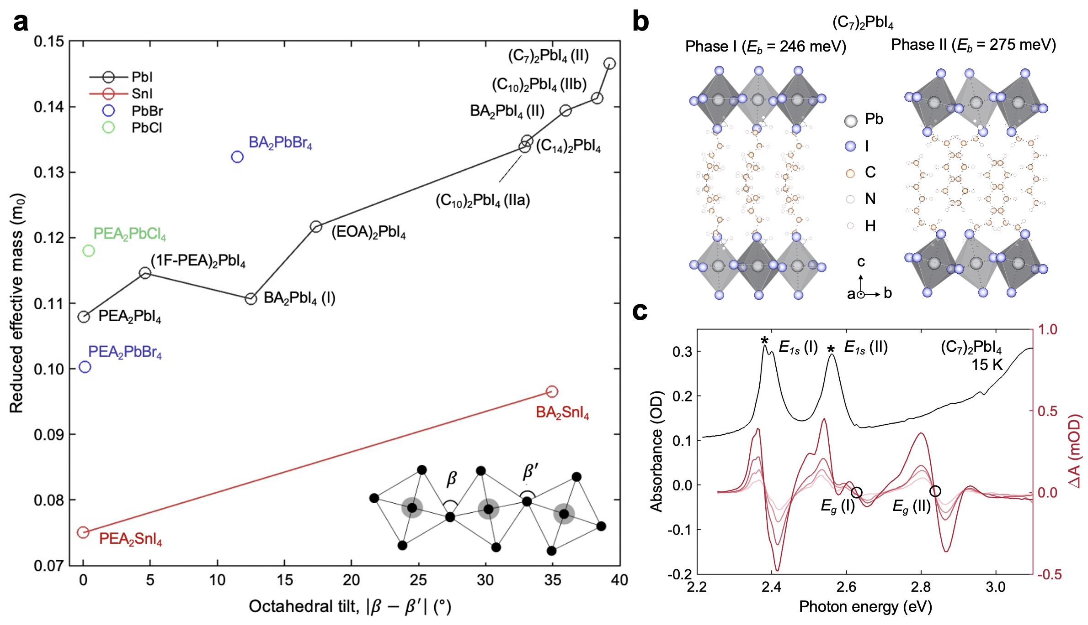
Fig. S4: (a) The exciton’s reduced effective mass (µ) as a function of octahedral tilting within the static structure. Structural data was obtained from single-crystal XRD in the literature (see Table S3), and the octahedral tilt was measured as $|β-β^{'}|$ where $β$ and $β'$ are angles between neighboring triads of X-site halide atoms, defined in the bottom-right inset.(b) Phase I (left) and phase II (right) crystal structures of (C₇)₂PbI₄, with a greater degree of octahedral tilt in the latter (structure from Ref. ²²) (c) Absorption (black; left-hand y-axis) and EA (red; right-hand y-axis) of a (C₇)₂PbI₄ thin film wherein a portion of crystallites retained their room temperature (phase I) structure after cooling to 15 K, allowing for simultaneous $E_{b}$ measurements of phases I and II.

Table S3: Structural parameters for (C_{m})₂PbI₄ structures
Composition | Temp* (K) | $|β-β^{'}|$* | $μ$ (m₀) | d₀₀₂ (Å)* | d₀₀₂ (Å) – this study | $l_{b,0}$ (Å) | $E_{b}$ (meV)
(C₄)₂PbI₄ (II) | 173 | 36.0° | 0.111§ | 13.12 |  | 6.72 | 256 ± 4
(C₄)₂PbI₄ (I) | 293 | 12.5° | 0.139§ | 13.80 | 13.79 | 7.40 | 228 ± 4
(C₅)₂PbI₄ (II) | 173 | 38.5° | 0.146¶ | 14.52 |  | 8.12 | 272 ± 5
(C₅)₂PbI₄ (II) | 293 | 36.6° | 0.140¶ | 14.64 | 14.77 | 8.24
(C₆)₂PbI₄ (I) | 173 | 10.3° | 0.110¶ | 16.04 |  | 9.64 | 238 ± 5†
(C₇)₂PbI₄ (II) | 253 | 39.2° | 0.147§ | 17.12 |  | 10.72 | 276 ± 6
(C₇)₂PbI₄ (I) | 293 | 13.5° | 0.113¶ | 18.31 | 18.42 | 11.91 | 246 ± 9
(C₁₀)₂PbI₄ (IIb) | 243 | 38.3° | 0.146¶ | 21.21 |  | 14.81 | 298 ± 4
(C₁₀)₂PbI₄ (IIa) | 268 | 32.9° | 0.134§ | 21.97
(C₁₀)₂PbI₄ (I) | 293 | 14.1° | 0.119¶ | 21.27 | 21.11 | 14.87
(C₁₂)₂PbI₄ (II) | 293 | 33.1° | 0.135¶ | 24.51 | 24.48 | 18.11 | 292 ± 3
(C₁₄)₂PbI₄ (II) | 293 | 33.1° | 0.135§ | 27.08 | 27.04 | 20.68 | 297 ± 4
(C₁₆)₂PbI₄ (II) | 293 | 33.0° | 0.135¶ | 29.65 | 29.61 | 23.25 | 300 ± 4
*From single crystal XRD of Billing and Lemmerer ²⁰⁻²², acquired at the temperature specified in column 1
†Our interpretation of EA data from Tanaka et al ⁴
§ Calculated from DFT
¶ Interpolated from $μ$ vs $|β-β^{'}|$ relationship in Fig. S4a.

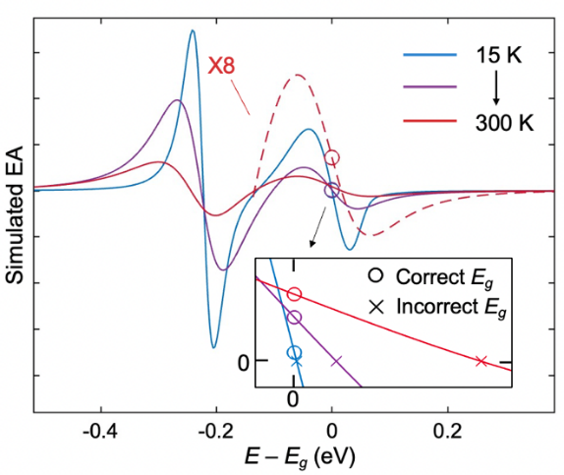
Fig. S5: Simulated temperature-dependent EA signal for PEA₂PbI₄. The Stark and FK features begin to overlap as the homogenous broadening increases, resulting in an asymmetric FK feature. This is clearest for the 300 K simulated EA, where the asymmetric FK feature is plotted with a 8× increase in magnitude (dashed red line).

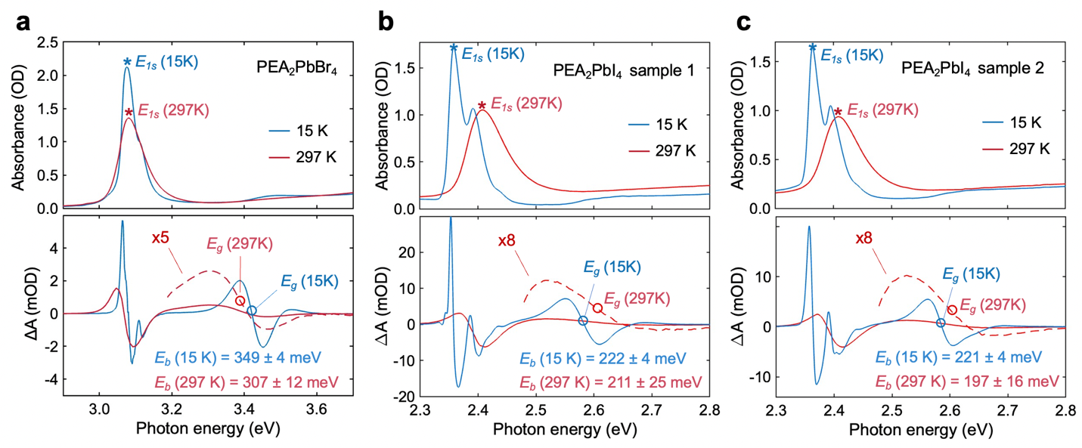
Fig. S6: (a) Absorbance of a PEA₂PbBr₄ thin film at 15K and 297K (top) along with the corresponding EA spectra (bottom). These measurements are repeated for (b) PEA₂PbI₄ sample 1 and (c) PEA₂PbI₄ sample 2.

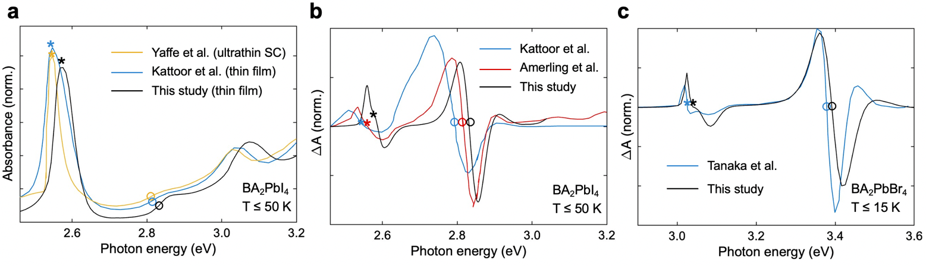
Fig. S7: (a) Low temperature absorbance spectrum of an ultrathin single crystal of BA₂PbI₄ (thickness = 2.4 ± 0.3 nm) from Ref. ¹⁹ compared to that of a thin film from Ref. ²⁸ and this study. (b) Low temperature EA of three BA₂PbI₄ thin films, from Ref. ²⁸ (blue), Ref. ²⁹ (red) and this study (black). (c) Low temperature EA of a BA₂PbBr₄ thin film from Ref. ³⁰ compared to a thin film in this study.

5. Effect of temperature on E_{b}
Moving from 15 K to room temperature, the exciton’s EA lineshape transitions from mostly first derivative to mostly second derivative¹⁰. Due to the increased broadening at room temperature, the last positive peak of the exciton’s second derivative EA signal overlaps somewhat with the first positive peak of the FK feature. As a result, the oscillation corresponding the FK feature is asymmetric at room temperature and this makes its zero-crossing point a less precise indicator of $E_{g}$. To understand where $E_{g}$is located in an FK feature of this nature, we simulated the overlap effect using first and second derivatives of a hyperbolic secant function (with a peak centered at $E_{1s}$) to represent the exciton’s Stark shift and an Airy function (with zero-crossing centered at $E_{g}$) to represent the FK oscillation. In order to simulate the effect of increasing temperature on EA, the sum of these two functions (i.e., the total EA signal) was convolved with hyperbolic secants of increasing HWHM ($Γ$). Additionally, the excitonic portion of the EA was altered from mostly first derivative to mostly second derivative moving from 15 300 K in the simulation; this latter effect is important to account for because the exciton’s lineshape affects its FK counterpart when the broadening is large. We measured the homogenous broadening as a function of temperature ($Γ(T)$) for PEA₂PbI₄ in a previous study¹⁸, and we also measured the first to second derivative transition in the exciton’s EA in a previous study³¹. Thus, using this information along with $E_{1s}$ and $E_{g}$, we are able to simulate the temperature-dependent EA of PEA₂PbI₄ in a realistic manner. The result of the simulation are shown in Fig. S5, and confirm our hypothesis that the zero-crossing point of an asymmetric FK feature is not a precise indicator of $E_{g}$; instead, a far better indicator is the midpoint energy between positive (left) and negative (right) peaks in the main FK feature; these points are indicated by circles in the inset of Fig. S5.
In Fig. S6, the experimental EA at 15K is compared to that at room temperature for three samples. Due to its large exciton binding energy, the PEA₂PbBr₄ sample in Fig. S6a has very separated Stark and FK features. As a result, the overlap effect is small and the FK feature is only slightly asymmetric, even at room temperature. By comparison, the overlap effect is larger in the PEA₂PbI₄ samples and the room temperature FK feature is very asymmetric as a result. These data are shown in Fig. S6b (sample 1), Fig. S6c (sample 2), and Fig. 2d of the main text (sample 3). Using the insight gained from the simulation, the midpoint energy between the positive and negative peaks in the asymmetric FK feature is assigned to $E_{g}$. Measuring $E_{g}$ in this manner is less precise than at low temperature due to the possibility of complex, inhomogeneous broadening mechanisms that differ from the homogenous broadening assumed by the simulation. Nevertheless, the similarity between the experimental and simulated temperature-dependent EA provides confidence that the primary effects underlying the asymmetry have been accounted for, and we estimate this measurement of $E_{g}$ is accurate to within 10 – 25 meV depending on the sample.
As shown in Fig. S6, we find $E_{b}$ decreases by a small margin moving from 15 K to room temperature for each of the 2D HPs. The decrease is largest and most clear for the PEA₂PbBr₄ sample, where $E_{b}$ decreases from 349 ± 4 meV at 15 K to 307 ± 12 meV at room temperature. Averaging across these three samples and the PEA₂PbI₄ sample shown in main article, we find $E_{b}$ is reduced by 9 ± 3 % upon warming to room temperature. Seeing as none of these PEA-based 2D HPs undergo structural phase transitions between 15 K and 300 K, it is likely a safe assumption that µ is temperature-independent and the small reduction of E_{b} moving to 300 K is caused by an increase in the dielectric screening of the electron-hole interaction.

6. Consistency of absorption and EA between various studies
To determine the consistency in E_{b} of 2D HP samples prepared according to different methods and across different studies, we digitized several figures from the literature (using the software of Ref. ³²) and compared the results to the absorbance and EA of this study. First, in Fig. S7a, the absorbance of a thin single crystal flake (thickness = 2.4 nm) on an SiO₂/Si substrate from Ref. ¹⁹ is compared to our thin film absorbance and that from Ref. ²⁸. The E_{1s} and E_{g} vary slightly due to different temperatures and morphologies (as is shown in Supplementary Section 3, 2D HP samples can redshift by slightly different amounts when cooled to the same temperature). At a thickness of only 2.4 nm, the exfoliated single crystal likely only contains two inorganic and two organic layers. As such, a blueshifting of $E_{g}$ and an increase of $E_{b}$ would not be surprising. Nevertheless, the absorbance lineshape is remarkably consistent for all three samples, and we observe no measurable difference in E_{b}. Even for exfoliated, ultrathin 2D HP single crystals, the inorganic layers are tethered to at least one cation layer (van der Waals plane is between A'-site cations) and this insulates the inorganic layer from the dielectric environment of the substrate and air. Thus, exfoliated 2D HPs are not as sensitive to their surrounding as are TMDC monolayers (although small shifts in $E_{b}$ are expected in the monolayer limit³³). Furthermore, the SiO₂ substrate has a high-frequency dielectric constant similar to that of BA₂PbI₄; for these reasons, the absorption properties of the sample are not affected by the low sample thickness, nor is E_{b}. By comparing EA on BA₂PbI₄ from Ref. ⁸ (blue line in Fig. S7b) to that of Ref. ²⁹ (red) and this study (black), it is clear just how consistent the EA features are study-to-study. Again, only slight variations in E_{1s} and E_{g} are noticed, but there is no discernible change in E_{b} to within the measurement resolution. The same in the case for the BA₂PbBr₄ thin film of Ref. ³⁰ (blue) and that of this study (black) in Fig. S7c. This further corroborates our finding that E_{b} is robust parameter that is intrinsic to a given crystal structure, and EA probes the critical point E_{g} in an extremely consistent and reliable manner. Although the EA signal is consistent study-to-study, measurements of E_{g} and E_{b} have varied widely due to differing interpretations of the interband feature. Thus, the simulation of the 2D Wannier exciton (Supplementary Section 1) is critical for verifying the lineshape and field-dependence of this feature are unambiguously in agreement with Elliott and Franz-Keldysh theory, respectively, and to identify E_{g} as the midpoint of the feature.

7. Effect of barrier screening, superlattice screening, and phonon screening on E_{g} and E_{b}
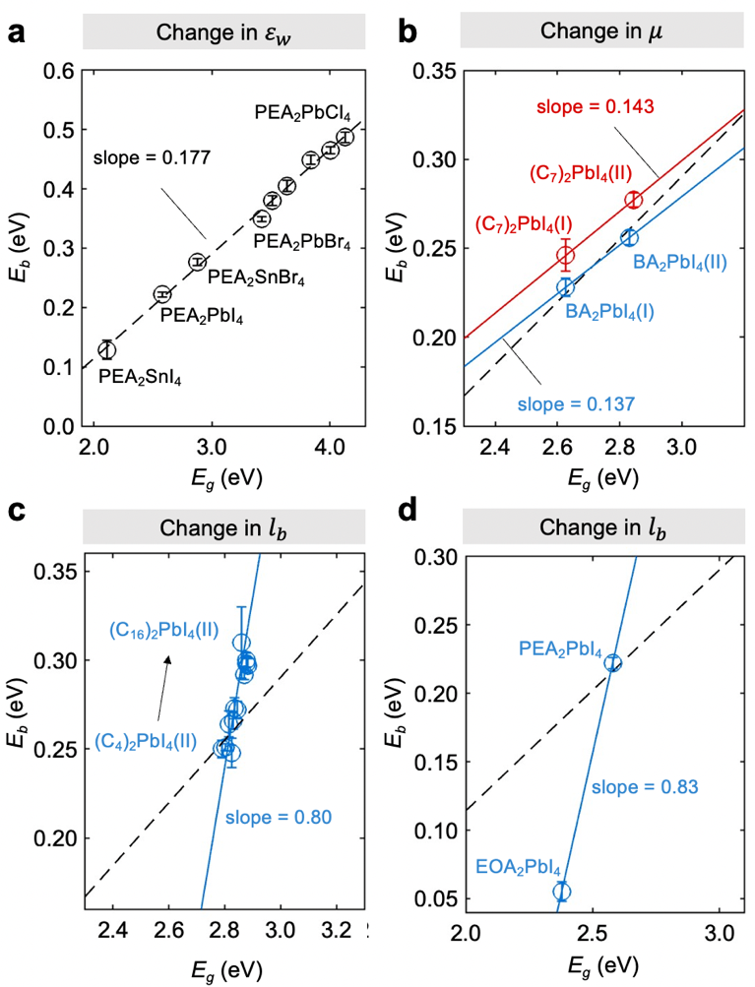
Fig. S8: (a) $E_{b}$ vs. $E_{g}$ for multiple PEA₂BX₄ structures. The data points between PEA₂PbBr₄ and PEA₂PbCl₄ are Br-Cl alloys. (b) $E_{b}$ vs. $E_{g}$ for phase I and phase II structures of (C₇)₂PbI₄ (red) as well as phase I and phase II structures of BA₂PbI₄ (blue). (c) $E_{b}$ vs. $E_{g}$ for multiple (C_{m})₂PbI₄ members. (d) $E_{b}$ vs. $E_{g}$ for PEA₂PbI₄ and EOA₂PbI₄.
As described in the main text, the primary difference between PEA₂BX₄ structures moving from SnI₄ PbI₄ PbBr₄ PbCl₄ is a decrease in $ε_{w}$. This parameter is proportional to the in-plane polarizability which Jiang et al. show is the source of the $E_{b}$ vs. $E_{g}$ correlation in their derivation of E_{g} = 0.25E_{b}.³⁴ As shown in Fig. S8a, when varying $ε_{w}$ in this manner for PEA-based structures we measure a trendline with a shallower slope than Jiang et al.’s slope of 0.25 as well as a negative y-axis intercept (E_{g} = 0.177E_{b} – 0.238). In this section, we show the reason for this discrepancy is that there are additional screening mechanisms in 2D HPs, not included in Jiang et al.’s derivation.
First, however, we begin pointing out the effect that other parameters such as $μ$ and $l_{b}$ have on the $E_{g}$. The effects $μ$ and $l_{b}$ on $E_{b}$ are well-understood within the superlattice model (and plotted in Fig. 4f and Fig. S23c, respectively), and their effects on $E_{g}$ can be determined experimentally by careful comparison of $E_{g}$ for select 2D HP structures.
To determine the effect of $μ$ on $E_{g}$, it is most instructive to compare band gaps of phase I and phase II (C_{m})₂PbI₄ members, as the primary change moving from phase I II is an increase in $μ$ and all other material parameters remain relatively constant. For both BA₂PbI₄ (where BA = C₄) and (C₇)₂PbI₄, the increase in $μ$ causes a moderate changes in $E_{b}$ (~32 meV) and an even larger change in $E_{g}$ (~220 meV). As shown in Fig. S8b, this means changes in $μ$ allow for tunability along lines with slope ≈ 0.14.
Although excitons are confined to inorganic [BX₄]²⁺ layers, the field between the electron-hole pair extends outside the well and is partially screened by both barrier molecules and neighboring inorganic layers. Thus, the degree of “barrier screening” can be modified both by the dielectric constant of the barrier molecule ($ε_{b}$) and the spacing between inorganic sheets ($l_{b}$). While we aren’t able to clearly measure the effect of $ε_{b}$ on $E_{g}$, the effect is likely similar to the effect of $l_{b}$ which we were able to measure (Fig. S8c). Here, the $E_{b}$ vs $E_{g}$ relationship is plotted for multiple (C_{m})₂PbI₄ members and the change in barrier screening allows for tunability along the fit line $E_{b}=0.80E_{g}-$ 1.99 eV, where the slope of 0.80 is much steeper than that obtained for inorganic-layer substitutions (slope $≈$ 0.18). Meanwhile, a very similar effect is demonstrated in Fig. S8d, where $E_{g}$ is plotted as a function of $E_{b}$ for PEA₂PbI₄ ($l_{b,0}=$9.94 Å; $ε_{b,∞}=$ 2.40) and EOA₂PbI₄ ($l_{b,0}=$3.65 Å; $ε_{b,∞}=$ 2.45) where the primary difference between the two structures is an increase in $l_{b}$ moving from EOA PEA. This results in a similar fit line of $0.83E_{g}-$ 1.92 eV. While changes to the barrier screening have a large effect on $E_{b}$, the effect on $E_{g}$ is non-negligible as evidenced by the fact these fit lines do not have infinite slopes. Instead the slopes are $≈$ 1, meaning the blueshift of $E_{g}$ and the increase in $E_{b}$ are approximately equal in magnitude. This leaves $E_{1s}$ largely unaffected, since $E_{1s}=E_{g}-E_{b}$. This phenomenon of a decrease in barrier screening causing equal shifts for $E_{g}$ and $E_{b}$ is commonly observed for transition metal dichalcogenide (TMDC) monolayers³⁵⁻³⁷, although in the TMDC literature this is referred to as “substrate screening”. In the case of 2D HPs, the phenomenon was recently predicted in the theoretical calculations of Cho and Berkelbach³³, and it is experimentally demonstrated here.
With this understanding of how barrier screening impacts both $E_{g}$ and $E_{b}$, we can proceed to calculate the $E_{b}$ vs $E_{g}$relationship for [BX₄]²⁻ layers suspended in a vacuum. As far as $E_{b}$ is concerned, this can be accomplished by setting $ε_{b}=1$ and $l_{b}→∞$ in the superlattice model (Supplementary Section 12). Naturally, removing the barrier screening increases $E_{b}$, and we know from the results in Fig. S8 (and theoretical results in Ref. ³³) that $E_{g}$ increases by an equivalent magnitude. When these calculations are performed using the $ε_{w,∞}$ values, the {$E_{g}$, $E_{b}$} data points follow the universal relationship for 2D semiconductors that was recently derived, namely, $E_{b}=0.25E_{g}$.³⁴ However, all three additional sources of screening must be removed (phonon, barrier layers, and neighboring well layers) in order for this to be the case. To demonstrate this fact, we show in $E_{b}$ vs $E_{g}$ in Fig. S9 where only phonon screening effects are removed and $E_{b}$ is calculated using $ε_{w,∞}$ and $ε_{b,∞}$ (red data points). These are the same as the red points labeled “Theory, $ε_{∞}$” in Fig. 4b of the main text, and are still much lower than the $E_{b}=0.25E_{g}$ trend line. Repeating these calculations using $ε_{b}=$ 1 brings the values closer (blue data points); however, it isn’t until superlattice effects are also removed ($l_{b}→∞$), that the calculated $E_{b}$ and $E_{g}$ fall on the trend line (purple data points); these are purple circles plotted in the upper inset of Fig. 2g of the main text. All three additional sources of screening must be removed in order for 2D HPs to satisfy the assumptions used by Jiang et al. in their derivation of $E_{b}={0.25E}_{g}$, namely, the theory assumes a 2D semiconductor suspended in infinite vacuum where $E_{g}$ and $E_{b}$ are correlated through their mutual dependence on the in-plane polarizability. The agreement with Jiang et al.’s derived trendline, upon removal of these additional screening sources, provides another point of validation for the superlattice model and our values of $ε_{w,∞}$.

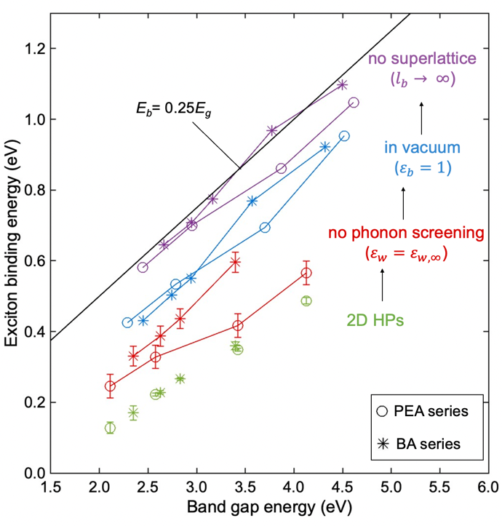
Fig. S9: E_{b} vs E_{g} for several 2D HP compounds. All three additional sources of screening must be removed in order for 2D HPs to satisfy the assumptions inherent to the derivation of $E_{b}=0.25E_{g}$ from Ref. ³⁴ When these screening effects are systematically removed, $E_{g}$ vs $E_{b}$ agrees with the universal relation for 2D semiconductors. The green data points are experimentally measured $E_{b}$ and $E_{g}$ for the following compounds, in order of increasing $E_{g}$: PEA₂SnI₄, BA₂SnI₄, PEA₂PbI₄, BA₂PbI₄ (I), BA₂PbI₄ (II), BA₂PbBr₄, PEA₂PbBr₄, and PEA₂PbCl₄. The red data points have $E_{b}$ determined by superlattice calculations using $ε_{w,∞}$ and $ε_{b,∞}$ values (i.e. no phonon screening), and $E_{g}$ determined by experiment. The blue datapoints have $E_{b}$ determined from are superlattice calculations using $ε_{w,∞}$ and $ε_{b}=1$ (i.e. no phonon or barrier molecule screening). The purple data points are superlattice calculations using $ε_{w,∞}$, $ε_{b}=1$, and $l_{b}→∞$ (i.e. no phonon, barrier screening, superlattice).

8. Production of Fig. 3a
The schematic of $ε(f)$ for 2D and 3D HPs, shown in Fig. 3a of the main text, was produced by considering many dielectric constant measurements in the literature, as well as those in this study. For 2D HPs, the increase of ~3.5 ~6 ~10 moving from $ε_{∞}$ $ε_{0}$ $ε(MHz)$ is based on measurements in this study. For 3D HPs, the increase from ~4.5 ~25 ~35 moving from $ε_{∞}$ $ε_{0}$ $ε(MHz)$ is based on those in this study and multiple others^{3,6,38-42}. To our knowledge, $ε(f)$ has not actually been measured across the frequency range wherein the dipolar rotation of MA⁺ is resonant; however, MD simulations show the rotation of the MA cation has a resonance near 10¹⁰ Hz⁴³. The dielectric constants obtained in this study along with the MD simulations in Ref. ⁴⁴ indicate that A’-site molecules in the A’₂BX₄ structures contribute to $ε$ in a similar manner.

9. Measuring the dielectric function of thin films using IDE impedance spectroscopy

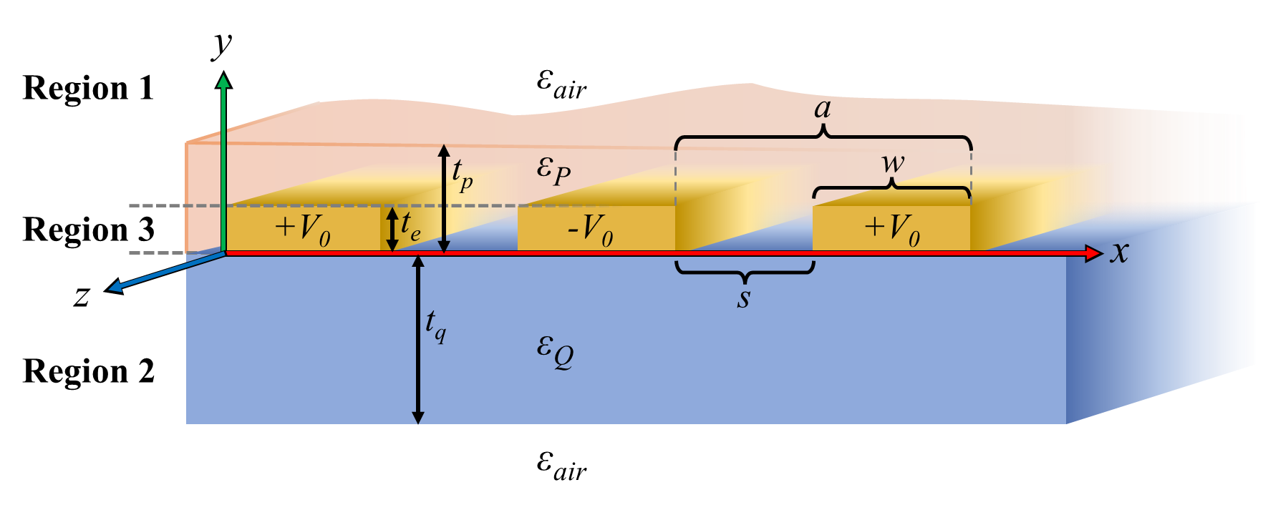
Fig. S10: Schematic of the IDE on quartz substrate with deposited HP film. Region 1 contains air and HP above the electrodes’ top surface, Region 2 contains quartz and air below the electrodes, and Region 3 contains HP only between the electrodes. The HP film occupies an overall area A in the x-z plane (not shown). For our IDEs, typical dimension are approximately the following: s = 50 μm, w = 30 μm, a = 80 μm, t_{q} = 500 μm, t_{e} = 120 nm, and t_{p} = 200–1000 nm.

Since knowledge of the dielectric function $ε(f)$ at radio frequencies in most HP films is quite limited, we developed a new method to experimentally measure these values from interdigitated electrode (IDE) capacitance measurements. Although the typical approach to measuring $ε(f)$ in this frequency domain utilizes a parallel-plate electrode configuration and a simple conversion from capacitance via $C=ε_{0}εA/d,$that technique cannot be used unless relatively large volumes of test material such as single crystals or compressed wafers can be produced. However, as per our method below, the same IDE structure that is used to produce the in-plane electric field in our EA experiments can be employed as an alternative electrode schema to sense capacitance in thin films and measure $ε_{r}(f)$ using a different set of mathematical relations which connect capacitance to geometry and dielectric constant(s). As long as the physical details such as electrode dimensions and film thicknesses are known, this method allows accurate measurements even with very low volumes of HP material.
We extend den Otter’s work⁴⁵ which characterizes and approximates the capacitance of a 2D IDE surrounded by a homogeneous dielectric material on each side, to a 3D situation with several distinct dielectric materials in three regions of space, as depicted in Fig. S10.
The method of den Otter models the surface potential of the IDE using separation of variables for the 2D Laplace equation in x and y, assuming infinitely thin electrodes and no z-dependence. A Fourier expansion represents the potential of the electrodes in the $y=0$ plane, and equations for the electric field in space above and below the IDE can be found: for $y>0$ in Region 1,

$E_{1}=\sum_{n=1}^{∞}{B_{n}\frac{\left(2n-1\right)π}{a}}\exp\left(-\frac{\left(2n-1\right)πy}{a}\right)$ $\left[\cos\left(-\frac{\left(2n-1\right)πx}{a}\right)\hat{x}-\sin\left(\frac{\left(2n-1\right)πx}{a}\right)\hat{y} \right]$ (14)

and for $y<0$ in Region 2,

$E_{2}=\sum_{n=1}^{∞}{B_{n}\frac{\left(2n-1\right)π}{a}}\exp\left(\frac{\left(2n-1\right)πy}{a}\right)$ $\left[\cos\left(\frac{\left(2n-1\right)πx}{a}\right)\hat{x}+\sin\left(\frac{\left(2n-1\right)πx}{a}\right)\hat{y} \right]$. (15)

The Fourier coefficients $B_{n}$ depend on the IDE dimensions s and a, and are taken from Ref. ⁴⁵. These equations apply to the situation where each region is filled with a uniform material. In our case, however, Regions 1 and 2 each contain two materials. For Region 2, Eq. (2) may be used with the bottom air ignored because the longest length scale for penetration into the quartz is set by the n = 1 term which has a characteristic length of $a/π$. Region 1 with no HP film, as is the case for a bare IDE substrate which we sometimes measure, is similar. However, Region 1 when there is a HP film requires substantial modification in order to account for the change in boundary conditions in Region 1 due to the small thickness of HP extending above the electrodes (distance $t_{p}-t_{e}$); these details are presented in an upcoming manuscript Ref. ⁴⁶
Additionally, since the IDEs used in this study are 120 nm thick, which is not negligible compared to the thickness of our HP films, the region of space between the electrodes must be considered as a third region which we model by supposing only in-plane field exists, given by the x-component of the gradient of the in-plane potential:

$E_{3}=\sum_{n=1}^{∞}{B_{n}\frac{\left(2n-1\right)π}{a}}\cos\left(\frac{\left(2n-1\right)πx}{a}\right)\hat{x}$ (16)

We then equate the energy stored in the electric fields in these three regions to the energy stored in a capacitor using:

$U=\frac{1}{2}C{\left(2V_{0}\right)}^{2}=\frac{1}{2}\int{D⋅E dV}= \frac{ε_{0}}{2}\left(\int_{mater.A}{ε_{A}E_{A}^{2} dV}+\int_{mater.B}{ε_{B}E_{B}^{2} dV}+…\right)$, (17)

where $2V_{0}$ is the voltage difference between capacitor “plates”. In this manner, the capacitance becomes a function of many materials’ dielectric constants along with the geometry of the situation. These equations can then be solved to find $ε_{P}\left(f\right)$, the dielectric function of the HP film. To do so, first we use Eq. (18) and capacitance measurements of IDEs with no film deposited to calculate $ε_{Q}\left(f\right)$, the dielectric function of the quartz substrate at the frequencies of interest; then we use those values along Eq. (19) and capacitance measurements of IDEs with HP films added to find $ε_{P}\left(f\right)$.

$C_{quartz}=\frac{ε_{0}A}{a}\left(\frac{π}{8V_{0}^{2}}\sum_{n=1}^{∞}{B_{n}^{2}\left[\left(1+ε_{Q}\right)\left(2n-1\right)+\left(\frac{πt_{e}}{a}\right){\left(2n-1\right)}^{2}\right]}\right)$ (18)

$C_{P}=\frac{ε_{0}A}{a}\left(\frac{π}{8V_{0}^{2}}\sum_{n=1}^{∞}{B_{n}^{2}\left[\left(ε_{Q}+\frac{ε_{P}\exp\left(\frac{-2π\left(\left(2n+5\right)t_{p}+2t_{e}\right)}{a}\right)\left({\left(ε_{P}+1\right)}^{2}\exp\left(\frac{2π\left(6nt_{p}+2t_{e}+3t_{p}\right)}{a}\right)-{\left(ε_{P}-1\right)}^{2}\exp\left(\frac{2π\left(2n\left(2t_{e}+t_{p}\right)+5t_{p}\right)}{a}\right)\right)}{{\left((ε_{P}-1)\exp\left(\frac{2\left(2n-1\right)t_{e}π}{a}\right)+(ε_{P}+1)\exp\left(\frac{2\left(2n-1\right)t_{p}π}{a}\right) \right)}^{2}}\right)\left(2n-1\right)+\left(ε_{P}\left(\frac{πt_{e}}{a}\right)\right){\left(2n-1\right)}^{2}\right]}\right)$ (19)

Eq. (16) actually overpredicts the strength of the electric field in Region 3, due to the relaxation of the potential function that will occur when Region 3 has finite thickness, so we additionally performed calculations using a modified Eq. (19) in which the final term (representing Region 3) is replaced with a simpler contribution from a constant field, E₃ = 2V₀/s between the electrodes; then averaged the two capacitances thus obtained and used their difference as part of the overall uncertainty estimate. The summations are carried out to 10,000 (HP) or 50,000 terms (quartz). We have tested against known values for quartz and water (Milli-Q); the resulting $ε\left(f\right)$ functions are depicted in Fig. 3c of the main paper and show excellent agreement with accepted values in literature⁴⁷⁻⁵⁰. New results for several HP films are shown in Fig. 3d and Fig. 3e of the main paper. Additional procedures and results are detailed more extensively in Ref. ⁴⁶.

10. Effective masses
Reports of the effective mass for 2D HPs, both calculated and measured, generally range from 0.07 – 0.15$m_{0}$^{1,10,51-53}. Previous theorical calculations of $E_{b}$ in 2D MHPs have used values of 0.17$m_{0}$⁵⁴ and 0.221 $m_{0}$⁵⁵. The decision of whether to use $μ ≈$ 0.2$m_{0}$ or $μ ≈$0.1$m_{0}$ largely reduces to whether to trust low-field or high-field magnetoabsorption as a measurement technique. As recently pointed out by Baranowski and Plochocka⁵⁶, the latter is more accurate as it requires far fewer assumptions when applied in HPs. High-field magnetoabsorption measurements have yielded $μ=$ 0.091 for PEA₂PbI₄ and $μ=$ 0.104 for MAPbI₃^{1,7,51}. These values are in agreement (± 20%) with DFT-calculated values using both HSE and PBE + SOC functionals^{1,57}. Indeed, the DFT-calculated effective masses of 2D MHPs are consistent study-to-study; for example, three studies have independently calculated that $μ$ increases from ~0.11 $m_{0}$ to ~0.14 $m_{0}$ as BA₂PbI₄ moves from the LT to RT phase (this study, Dyksik et al.¹, and Ziegler et al.⁵⁸). In this study, the effective mass tensor at the CBM/VBM was calculated via the finite difference method using the effective mass calculator code in Ref. ⁵⁹, and the resulting $μ$ values (Table S4) are in good agreement with previous DFT studies^{1,27}. Albeit, the DFT-calculated $μ$ for PEA₂PbI₄ (0.108$m_{0}$) is higher than the high-field magnetoabsorption value (0.091$m_{0}$)¹; as such, we estimate a relative uncertainty of 18% for our DFT-calculated $μ$. Our choice not to add a correction factor to our DFT-calculated $μ$ is based on the fact $μ$ of MAPbI₃ is 0.104 $m_{0}$⁷, and we expect $μ$ to increase moving from 3D 2D as this is the typical trend due to quantum confinement and is also predicted by DFT calculations (see Table S4 and ref.²⁷).

11. Dielectric constants

11.1 Bulk dielectric constants

In order to meaningful compare experimental vs theoretical $E_{b}$ values, the input parameters to the theory must be trustworthy. Specifically, in the context of this study, the high-frequency dielectric constant ($ε_{∞}$) is the most important value to accurately determine for two reasons: (1) one of our main conclusions is that the experimental $E_{b}$ does not agree with theoretical calculations using $ε_{∞}$ and (2) the calculation of $E_{b}$ is more sensitive to $ε$ than any other input parameter. We take a joint experimental-theoretical approach for the determination of both $ε_{∞}$ and $ε_{0}$, as explained in the main text, and consider our results in the context of the extensive body of dielectric constants in the literature.
The electronic and phonon contributions to the dielectric tensor were calculated using DFT at the PBE + $Δ$ level (see Methods) using structures experimentally determined from single crystal XRD (list of reference structures are provided in Table S5). These calculations were run for a wide range of 2D MHP compositions and we found all materials to have uniaxial dielectric tensors, as expected from previous studies^{60,61}. In order to compare the DFT calculations to experiment, we averaged the $ε_{xx}$ and $ε_{yy}$ elements which were nearly identical (varied by 2% on average) to obtain the in-plane permittivity, $ε_{∥}$; the uniaxial dielectric tensor then takes the following form:

$ε=\left(\begin{matrix}ε_{∥} & 0 & 0 \\ 0 & ε_{∥} & 0 \\ 0 & 0 & ε_{⊥}\end{matrix}\right)$ (20)

where $ε_{∥}=(ε_{xx}+ε_{yy})/2$ and $ε_{⊥}=ε_{zz}$. A tensor in the form of Eq. (20) was obtained for both the full electronic contribution ($ε_{e}$) and the full phonon contribution ($ε_{p}$); the calculated electronic contribution does not include the phonon contribution, and vice versa. The high-frequency and low-frequency dielectric constants are then defined as $ε_{∞}=ε_{e}$ and $ε_{0}=ε_{e}+ε_{p}$. The anisotropy in the $ε_{∞}$ tensor is small for all compositions ($ε_{⊥}=0.95ε_{∥}$ on average) but moderate for the $ε_{0}$ tensor ($ε_{⊥}=0.5ε_{∥}$ on average; see Table S5). Figs. 3e and 3f of the main text displays orientationally-averaged dielectric constants, computed as $ε^{*}=(ε_{∥}+ε_{∥}+ε_{⊥})/3$. Here, and in Table S5, we use an asterisk to indicate the spatially averaged value; for simplicity in the main paper we simply call it $ε$ (e.g. in Fig. 3e and 3f).
At optical frequencies, the precise values obtained by DeCrescent et al.⁶¹ for PEA₂PbI₄ and BA₂PbI₄ serve as a critical test of the accuracy of our calculated $ε_{∥,∞}$ and $ε_{⊥,∞}$ values. DeCrescent et al. employed a self-consistent combination of ellipsometry and momentum-resolved reflectometry, which removes many uncertainties inherit to traditional ellipsometry fit procedures, and produces dielectric constants with <10% error at 1500 nm (200 THz). We find the calculated and measured values are in very close agreement without any correction factors (Table S5). On average, our DFT-calculated $ε_{∥,∞}$ values are 4% smaller than those measured by DeCrescent et al. while our $ε_{⊥,∞}$ values are 7% larger. This discrepancy was predicted by DeCrescent et al., as the authors commented that their measured ratio of $ε_{∥,∞}/ε_{⊥,∞}$is likely slightly overestimated⁶¹. Additional confidence in these values is gained by comparing our value of $ε_{∞}\sim$3.5 for PEA₂PbI₄ and BA₂PbI₄ to the known value for MAPbI₃ of $ε_{∞}\sim$4.5^{3,38}; a decrease of approximately this magnitude has been measured moving from 3D 2D⁶², which is expected since organic matter occupies a larger portion of the 2D HP unit cell. For these many reasons, it is determined that the computed $ε_{e}$ tensor is trustworthy, and the phonon contribution is added to obtain the low-frequency dielectric tensor ($ε_{0}=ε_{e}+ε_{p}$) without any correction factor to $ε_{e}.$

11.2 Barrier and well dielectric constants

Modeling the image-charge effect requires knowledge of the barrier and well dielectric constants ($ε_{b}$ and $ε_{w}$), distinct from that of the bulk. Previous studies have estimated $ε_{b}$ and $ε_{w}$ either with the dielectric constant of analogous materials (e.g. using PbI₂ as a surrogate for the [PbI₄]²⁻ layer, resulting in the values of $ε_{b,∞}=$ 2.44 and $ε_{w,∞}=$ 6.1 for (C_{m})₂PbI₄)^{54,63} (which we note are inconsistent with bulk $ε_{∞}$ values; Table S5), or by calculating the dielectric profile across the stacking axis using DFT, resulting in $ε_{b}=$ 4.00 and $ε_{w}=$ 2.1 for BA₂PbI₄^{64,65}. Seeing as no method for calculating $ε_{b}$ and $ε_{w}$ is free of assumptions, we opted to develop a new method based on the spatially-averaged dielectric constant of a layered material (explained below) using assumptions that could be verified statistically. We find the results to be in good agreement with the dielectric profile method developed by Even and Katan⁶⁴.
Our values of $ε_{b}$ and $ε_{w}$ are calculated from the bulk dielectric tensors for several members of the C_{m} series. For any two members of the C_{m} series with composition (C_{m})₂PbI₄, the barrier and well dielectric constants can be calculated algebraically using the equations for the spatially-averaged dielectric constant of a layered material:⁵⁴

$ε_{bulk}=\frac{\left(ε_{w}l_{w}+ε_{b}l_{b}\right)}{l_{w}+l_{b}}$ (21)

where $l_{w,b}$ are the well and barrier lengths (i.e. the nominal well/barrier length adjusted by the atomic radius of the halide atom according to Eq. (36) and Eq. (37)). Our DFT calculations combined with the measurements by DeCrescent et al. provide a sample size of N = 8 unique C_{m} structures and, under the assumption that due to the similarities of the molecules the dielectric constants for the [(C_{m})₂]²⁺ layers do not change with length, linear regression fits according to Eq. (2) yields the dielectric constants for the [PbI₄]²⁻ and the [(C_{m})₂]²⁺ layers. The results (Table S6) are in close agreement with calculations of the dielectric profile by Blancon et al.⁵⁵, but our well-to-barrier ratio is slightly greater (we obtain $ε_{w,∞}/ε_{b,∞}=$ 4.68/1.78 whereas Blancon et al. obtained 4.00/2.1). Fortunately, the $E_{b}$ calculation is far more sensitive to the magnitude of the spatially averaged dielectric constant than it is the ratio of $ε_{w}/ε_{b}$, and the former was rigorously verified by experiment, as previously discussed. As mentioned, the fit procedure assumes that $ε_{b}$ and for that matter also $ε_{w}$ are independent of the number of carbons in the C_{m} alkyl chain, and the low standard errors of the $ε_{∞}$ fit values for [PbI₄]²⁻ and [(C_{m})₂]²⁺ (Table S6) serve to verify that this is a valid assumption.
Having obtained the dielectric constants of [PbI₄]²⁻ and [(C_{m})₂]²⁺ layers, it becomes algebraically possible to solve for the remaining barrier layers ([PEA₂]²⁺, [1F-PEA₂]²⁺, [5F-PEA₂]²⁺, [EOA₂]²⁺) and well layers ([SnI₄]²⁻, [PbBr₄]²⁻, [PbCl₄]²⁻). This is possible when a 2D HP shares a common layer with (C_{m})₂PbI₄ structures, and its bulk dielectric constant (either high or low frequency, known from DFT) is combined with the now known $ε_{w}$ of [PbI₄]²⁻ (or the now known $ε_{b}$ of [(C_{m})₂]²⁺) in Eq. (21), leaving only one unknown. This type of process was carried out to obtain the various barrier and well dielectric constants reported in Table S6, with errors determined by propagating standard error of the known dielectric constants in Eq. (21). Finally, as pointed out by Even and Katan, when adding additional octahedral layers to the inorganic section, the n > 1 compounds should not be classified as merely thicker versions of the n = 1 compound, due to the introduction of a new MA molecule moving from n = 1 n = 2.⁶⁶ Therefore, the dielectric constants of the MA_{n-1}Pb_{n}I_{3n+1} layer were computed independently, using $l_{w}$ = 12.54 for BA₂MAPb₂I₇ and $l_{w}$ = 18.91 for BA₂MA₂Pb₃I₁₀.

Table S4: Electron, hole, and reduced effective masses, as determined from the DFT band structure
 | Structure | $m_{h,∥}$ ($m_{0}$) | $m_{e,∥}$ ($m_{0}$) | $μ$ ($m_{0}$)
BA₂PbI₄ | Ref. ⁶⁷ (100 K) | 0.365 | 0.226 | 0.139
BA₂PbI₄ | Ref. ⁶⁷ (RT) | 0.241 | 0.205 | 0.111
(C₇)₂PbI₄ | Ref. ²² (173 K) | 0.340 | 0.258 | 0.147
(C₁₀)₂PbI₄ | Ref. ²² (173 K) | 0.322 | 0.252 | 0.141
(C₁₀)₂PbI₄ | Ref. ²² (268 K) | 0.300 | 0.242 | 0.134
(C₁₄)₂PbI₄ | Ref. ²¹ (RT) | 0.305 | 0.242 | 0.135
PEA₂PbI₄ | Ref. ¹ | 0.25* | 0.19* | 0.108*
(1F-PEA)₂PbI₄ | Ref. ⁶⁸ (RT) | 0.248 | 0.213 | 0.115
EOA₂PbI₄ | Ref. ⁶⁹ (RT) | 0.324 | 0.195 | 0.122
BA₂SnI₄ | Ref. ⁷⁰ (RT) | 0.199 | 0.188 | 0.097
PEA₂SnI₄ | Ref. ¹ | 0.15* | 0.15* | 0.075*
BA₂PbBr₄ | Ref. ⁷¹ (RT) | 0.280 | 0.251 | 0.132
PEA₂PbBr₄ | Ref. ⁷² (RT) | 0.305 | 0.150 | 0.100
PEA₂PbCl₄ | Ref. ⁷³ (RT) | 0.363 | 0.175 | 0.118
BA₂MAPb₂I₇ | Ref. ⁷⁴ (RT) | 0.169 | 0.157 | 0.081
BA₂MA₂Pb₃I₁₀ | Ref. ⁷⁴ (RT) | 0.161 | 0.160 | 0.080
*Values from Ref. ¹
Table S5: Comparison of experimental and DFT-computed dielectric constants.
 |  |  |  | Theor. (DFT) |  |  | Exp. (mR)*. Ref. ⁶¹ |  |  | Theor. (DFT) |  |  | Exp. (IDE)†
Composition | Structure | k-point grid | d₀₀₂ (Å) | $$ε_{∥,∞}$$ | $$ε_{⊥,∞}$$ | $ε_{∥,∞}$ |  | $$ε_{⊥,∞}$$ | $$ε_{∥,0}$$ |  | $$ε_{⊥,0}$$ | $$ε_{0}^{*}$$ | $ε$(3 MHz)
BA₂PbI₄ | Ref. ⁶⁷(100 K) | 3x3x1 | 13.04 | 3.349 | 3.204 |  |  |  | 7.790 |  | 4.528 | 6.70
BA₂PbI₄ | Ref. ⁶⁷ (RT) | 3x3x1 | 13.81 | 3.293 | 2.973 | 3.46 |  | 2.68 | 8.565 |  | 4.062 | 7.06 | 11.2± 1.3
(C₆)₂PbI₄ | Ref. ²⁰(RT) |  | 16.35 |  |  | 3.31 |  | 2.84
(C₇)₂PbI₄ | Ref. ²²(173 K) | 2x2x1 | 17.12 | 3.021 | 2.928 |  |  |  | 8.107 |  | 3.870 | 6.69
(C₇)₂PbI₄ | Ref. ²² (RT) |  | 18.31 |  |  |  |  |  |  |  |  |  | 10.1±1.1
(C₈)₂PbI₄ | Ref. ²² (RT) |  | 18.74 |  |  | 3.11 |  | 2.78
(C₁₀)₂PbI₄ | Ref. ²² (173 K) | 3x2x1 | 21.21 | 2.784 | 2.733 |  |  |  | 5.936 |  | 3.471 | 5.11
(C₁₀)₂PbI₄ | Ref. ²² (268 K) | 5x5x1 | 21.98 | 2.691 | 2.621
(C₁₀)₂PbI₄ | Ref. ²² (RT) |  | 21.28 |  |  |  |  |  |  |  |  |  | 8.2 ± 1.3
(C₁₄)₂PbI₄ | Ref. ²¹ (RT) | 7x7x1 | 27.08 | 2.420 | 2.405
PEA₂PbI₄ | Ref. ¹ (RT) | 4x4x2 | 16.34 | 3.396 | 3.079 | 3.53 |  | 2.96 | 7.295 |  | 3.936 | 6.18 | 10.5±1.5
(1F-PEA)₂PbI₄ | Ref. ⁶⁸ (RT) | 2x2x4 | 16.53 | 3.361 | 3.109
(5F-PEA)₂PbI₄ | Ref. ⁷⁵ (RT) | 4x4x3 | 16.82 | 3.172 | 2.736
EOA₂PbI₄ | Ref. ⁶⁹ (RT) | 4x4x4 | 10.05 | 4.037 | 3.750 |  |  |  | 16.35 |  | 8.140 | 13.61
BA₂SnI₄ | Ref. ⁷⁰ (RT) | 4x4x1 | 13.06 | 3.604 | 3.190 |  |  |  | 12.67 |  | 4.769 | 10.04
BA₂PbBr₄ | Ref. ⁷¹(RT) | 4x4x1 | 13.81 | 2.649 | 2.533 |  |  |  | 7.467 |  | 3.989 | 6.31
PEA₂PbBr₄ | Ref. ⁷² (RT) | 2x2x1 | 16.67 | 2.815 | 2.598 |  |  |  | 7.036 |  | 3.503 | 5.86 | 6.1±0.6
BA₂PbCl₄ | Ref. ⁷¹(RT) | 1x4x4 | 13.99 | 2.283 | 2.233 |  |  |  | 6.952 |  | 3.795 | 5.90
PEA₂PbCl₄ | Ref. ⁷³ (RT) | 2x2x1 | 16.89 | 2.524 | 2.380 |  |  |  | 6.694 |  | 3.465 | 5.62 | 6.9±1.5
BA₂MAPb₂I₇ | Ref. ⁷⁴ (RT) | 5x1x5 | 19.67 | 3.372 | 3.257 |  |  |  | 12.10 |  | 5.323 | 9.84
BA₂MA₂Pb₃I₁₀ | Ref. ⁷⁶ (RT) | 6x1x6 | 25.98 | 4.043 | 3.814
*values measured at 2×10¹⁴ Hz
†values measured at 3×10⁶ Hz
Table S6: Barrier and well dielectric constants
Well layers
 | $$ε_{∞}$$ | $$ε_{0}$$
[PbI₄]²⁻ | 4.68 ± 0.19 | 11.4 ± 2.3
[PbBr₄]²⁻ | 3.45 ± 0.13 | 10.1 ± 2.1
[PbCl₄]²⁻ | 2.79 ± 0.13 | 9.4 ± 2.1
[SnI₄]²⁻ | 4.95 ± 0.11 | 16.7 ± 2.0
[MA_{n-1}Pb_{n}I_{3n-1}]²⁻ | 4.12 ± 0.50 | 13.6 ± 1.6
Barrier layers
 | $$ε_{∞}$$ | $$ε_{0}$$
[(C_{m})₂]²⁺ | 1.75 ± 0.13 | 3.0 ± 1.6
[PEA₂]²⁺ | 2.40 ± 0.15 | 4.23 ± 1.2
[EOA₂]²⁺ | 2.45 ± 0.45 | 27.7 ± 4.7
[1F-PEA₂]²⁺ | 2.36 ± 0.14
[5F-PEA₂]²⁺ | 2.06 ± 0.14

12. Modeling 2D HP exciton properties
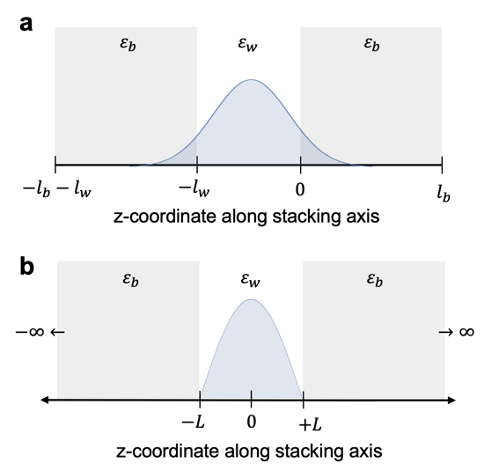
Fig. S11: (a) Z-coordinates in the superlattice model of Muljarov⁵⁴ (b) Z-coordinates in the isolated QW model of Hanamura⁷⁷. In Muljarov’s theory, the single particle electron/hole wavefunction (blue shaded area) is allowed to extend into the barrier whereas it is confined to the well in the theory of Hanamura.

First principal calculations of $E_{b}$ and the mean exciton radius $a=〈r〉$ were obtained using the theory of Hanamura et al.⁷⁷ an exciton confined to a single dielectric and quantum well (QW); and also the theory of Gusienov⁷⁸ and Muljarov⁵⁴ for an exciton within a periodically-repeating superlattice of dielectric and quantum wells. We refer to the former as the “isolated QW” model, and the latter as the “superlattice” model. The superlattice model is more accurate since it accounts for the finite barrier length ($l_{b}$), the coupling between wells, and the excitonic wave function extending into the barrier. As such, that model was used for the theoretical calculations of $E_{b}$ in the main text and $〈r〉$ in Supplementary Table 1. The purpose of our isolated QW calculations is to verify our numerical results of the superlattice— the two methods ought to agree in the limit $l_{b}→∞$ and when the single-particle electron/hole wavefunctions are confined to the well (required in the Hanamura model). Under these conditions, we find $E_{b}$ agrees to within 0 - 5% using the two models, and this serves as helpful validation of our numerical methods. To maintain consistency with the original sources, we use the same coordinate systems as the authors in their respective articles. Namely we define $z_{e}$ ($z_{h}$) as the electron (hole) out-of-plane coordinate (these are shown in Fig. S11), and $r_{e}$ ($r_{h}$) as the electron (hole) in-plane coordinate. For the superlattice model (Fig. S11a) the origin of the z-coordinate is taken to be the interface between well and barrier; for the isolated QW model (Fig. S11b) the origin is taken to be the center of the well.

12.1 Superlattice model

The following theory is based on the work of Gusienov⁷⁸ and Muljarov⁵⁴; we present an overview of the theory and describe our numerical approach to obtaining $E_{b}$ and $a$. The calculations were run using atomic units, with lengths in terms of hydrogen’s Bohr radius $a_{0,H}$ (1$a_{0,H}$ = 0.529177 Å) and energy in terms of Hartree (1 Hartree = 27.2114 eV). We first obtain out-of-plane single particle wavefunctions for electron and hole by solving the 1D Schrödinger equation for the z-dimension then use those wavefunctions to construct a potential which is used in a 2D (in-plane) combined electron-hole Schrödinger equation. The absolute values of the energy eigenvalues of that 2D equation are the exciton binding energies. More specifically, the 2D Schrödinger equation for the relative motion of the e-h pair is the following:^{54,78}

$-\frac{ℏ^{2}}{2μ}\left(\frac{d^{2}}{dr^{2}}+\frac{1}{r}\frac{d}{dr}-\frac{m^{2}}{r^{2}}\right)R\left(r\right)+V\left(r\right)R\left(r\right)=E_{b,n}R\left(r\right)$ (22)

Here, $μ$ denotes the exciton’s reduced effective mass ($μ^{-1}=m_{e,∥}^{-1}+m_{h,∥}^{-1}$), $r$ is the e-h in-plane separation (or 2D radial coordinate) $r=|r_{e}-r_{h}|$, and $m$ is the angular momentum quantum number. We set $m=0$ to solve for the $s$-state binding energies $E_{b,n}$, and the primary task of the procedure is the calculation of the potential $V(r)$, given by ⁵⁴:

$V\left(r\right)=4\int_{-l_{w}/2}^{l_{b}/2}{dz_{e}\int_{-l_{w}/2}^{l_{b}/2}{dz_{h}{\left|ψ_{e}\left(z_{e}\right)\right|}^{2}{\left|ψ_{h}\left(z_{h}\right)\right|}^{2}V(z_{e},z_{h},r)}}$ (23)

Here, $ψ_{e}$ ($ψ_{h}$) denotes the ground state one-electron (hole) wavefunction perpendicular to the quantum well, and the procedure for solving for these wavefunctions is given in Supplementary Section 12.1.1. Due to the symmetry in $ψ_{e,h}\left(z_{e,h}\right)$ and $V(z_{e},z_{h},r)$, we only integrate over one quadrant of {$z_{e},z_{h}$} (coordinates defined in Fig. S11a) and multiply by four. The potential energy term $V(z_{e},z_{h},r)$ is given by:

$V\left(z_{e},z_{h},r\right)=-\frac{e}{2π}\int_{0}^{∞}{ϕ\left(z_{e},z_{h},q\right)J_{0}(qr)qdq}$ (24)

where $J_{0}$ denotes the Bessel function of the first kind, and $ϕ\left(z_{e},z_{h},q\right)$ is the Fourier-transform of the electrostatic potential $ϕ\left(z_{e},z_{h},r=|r_{e}-r_{h}|\right)$ at an observation point ($r_{e},z_{e}$), caused by the presence of a charge $+e$ at point $(r_{h},z_{h})$. The expression for $ϕ\left(z_{e},z_{h},q\right)$ varies depending on which layer the charge and observation point reside in. If both the charge and observation point are inside the well ($-l_{w}<\{z_{e},z_{h}\}<0$), then the potential is:⁵⁴

$ϕ\left(z_{e},z_{h},q\right)=-\frac{2πe}{ε_{w}q}\sinh\left(q\left|z_{e}-z_{h}\right|\right)+\frac{2πe}{ε_{b}q\sinh\left(q_{0}\right)}\left[2αβ\sinh\left(ql_{b}\right)\cosh{(q\left(z_{e}+z_{h}+l_{w}\right))}+\left\{α^{2}\sinh{(q\left(l_{b}+l_{w}\right))}+β^{2}\sinh{(q\left(l_{b}-l_{w}\right))}\right\}\cosh{(q\left(z_{e}-z_{h}\right))}\right]$,

(25)

where

$η=ε_{b}/ε_{w}$; $α=(1+η)/2$; $β=(1-η)/2$; (26)

$q_{0}=\operatorname{arccosh}\left[\frac{α^{2}}{η}\cosh\left(q\left(l_{b}+l_{w}\right)\right)-{\frac{β}{η}}^{2}\cosh\left(q\left(l_{b}-l_{w}\right)\right)\right]$ (27)

To obtain the analogous expression for the case that the charge and observation point are both inside the barrier ($0<\{z_{e},z_{h}\}<l_{b}$), one makes the following substitutions within Eq. (25): $ε_{w}↔ε_{b}$, $l_{b}↔l_{w}$, $z_{e}↔-z_{e}$ , $z_{h}↔-z_{h}$. For the case wherein the charge and observation point are in neighboring layers ($-l_{w}<z_{e}<0$ and $0<z_{h}<l_{b}$) or ($-l_{w}<z_{h}<0$ and $0<z_{e}<l_{b}$), the potential is given by:

$ϕ\left(z_{e},z_{h},q\right)=\frac{2πe}{ε_{b}q\sinh\left(q_{0}\right)}[α\sinh\left(q\left(l_{w}+l_{b}\right)\right)\cosh{(q(z_{e}-z_{h}))}+β\sinh\left(q\left(l_{b}-l_{w}\right)\right)\cosh{(q(z_{e}+z_{h}))}+β\sinh\left(q\left(z_{e}+z_{h}\right)\right)\left\{2α^{2}\sinh\left(ql_{b}\right)\sinh\left(ql_{w}\right)-\sinh\left(q_{0}\right)\right\}+α sinh(q(|z_{e}-z_{h}|)\{2β^{2}\sinh\left(ql_{b}\right)\sinh\left(ql_{w}\right)-sinh⁡(q_{0})\}$ (28)

The integrand in Eq. (24) oscillates with a magnitude that diminishes at small $q$ and rapidly increases at large $q$. We used a numerical procedure to identify the turning point (minima in the magnitude of the peak oscillations) at each value of {$z_{e}$, $z_{h}$} and then used this value ($q_{upper}$) as the upper bound to the integral. When the charge and observation point are in the same layer, i.e., Eq. (25), we found the value of $q_{upper}$ can be satisfactorily approximated as $q_{upper}=16.05{\left|z_{e}-z_{h}\right|}^{-0.9481}$. However, we did not obtain an analogous approximation for the case of $ϕ(z_{e},z_{h},q)$ in Eq. (28) since $q_{upper}$ is not a simple function of $\left|z_{e}-z_{h}\right|$ when the charge and observation points are in different layers. Instead, for a given $r$, we used the $q$ value which minimizes $Ω\left(q\right)$, where $Ω\left(q\right)=qϕ(z,z_{0},q)/\sqrt{qr}$ is a function that represents the amplitude of the integrand ( since the Bessel function magnitude decays according to 1/$\sqrt{qr}$). Upon calculating $V(r)$, Eq. (22) was solved using the finite element method (via the NDEigensystem function in Mathematica) to yield the 1s, 2s, 3s, etc. exciton energies $E_{n}$ and radial wavefunctions $R(r)$. The theoretical $E_{b}$ values are computed as $E_{b}=-E_{1s}$ and the exciton radii are computed from the expectation value of the radial position $〈r〉=2π\int_{0}^{∞}{R\left(r\right)rR\left(r\right)rdr}$. This method reproduced the $V(r)$ functions reported by Muljarov⁵⁴ and Zahra⁷⁹ and yielded $E_{b}$ values in agreement with their studies.

12.1.1 Single particle wavefunctions

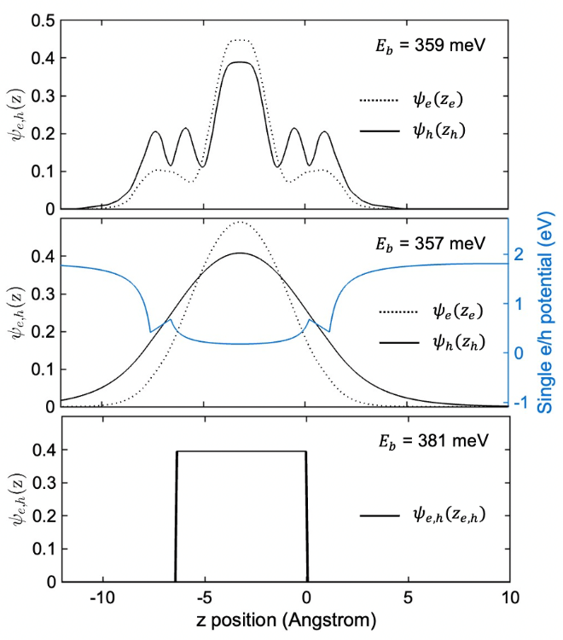
Fig. S12: Single-particle e/h out-of-plane wavefunctions as calculated by Blancon et al.⁵⁵ (top), Muljarov et al.⁵⁴ (middle) and Tanaka et al.⁸⁰ (bottom), and corresponding $E_{b}$ values using Eq. (22).

The superlattice model requires knowledge of the single particle wavefunctions $ψ_{e}\left(z_{e}\right)$ and $ψ_{h}\left(z_{h}\right)$ perpendicular to the well. By experimenting with various wavefunctions, we find that the computed values $E_{b}$ and $r$ are actually quite insensitive to the shape of the single particle wavefunctions $ψ_{e}\left(z_{e}\right)$ and $ψ_{h}\left(z_{h}\right)$^{54,80}, so long as they roughly resembles the “1D particle in a well” ground state, but the values are moderately sensitive to the fraction of the electron/hole wavefunction outside of the well:

$Λ_{e,h}=1-\int_{-l_{w}}^{0}{{\left|ψ_{e,h}\left(z_{e,h}\right)\right|}^{2}dz}$ (29)

These observations are demonstrated in Fig. S12, where three functional forms of $ψ_{e,h}(z_{e,h})$ from previous 2D HP studies are featured. The $ψ_{e}(z_{e})$ and $ψ_{h}(z_{h}$) in the top panel are the most accurate, as they were calculated by Blancon et al.⁵⁵ using DFT-computed Bloch functions at the Brillouin zone center for BA₂PbI₄. As such, these are the single particle wavefunctions that were used to calculate $E_{b}$ in this study. Only a small portion of the electron and hole are outside of the well, with $Λ_{e}=$ 6.7% and $Λ_{h}=$ 19.4%. For comparison, we calculated $ψ_{e,h}\left(z_{e,h}\right)$ according to the method of Muljarov⁵⁴ and these results are shown below in the middle panel. In Muljarov’s method, a potential well is built from quantum-confinement and image-charge effects (blue line in Fig. S12) and a 1D Schrödinger equation is solved to obtain the wavefunctions. From a strictly physical perspective, this method is inferior since the 1D Schrodinger equation requires effective masses in the z-direction ($m_{e,⊥}$ and $m_{h,⊥}$) and the effective mass approximation is invalid for n = 1 2D HPs⁶⁶. Moreover, the Muljarov potential (blue line) is somewhat arbitrarily stitched together between the well and barrier to avoid a singularity at the interface. However, $E_{b}$ calculations using Muljarov’s and Blancon’s wavefunctions are in close agreement as long as $Λ_{e}$ and $Λ_{h}$ are in agreement. In this case, we used masses of $m_{e,⊥}=$ 5.1$m_{0}$ and $m_{h,⊥}=$ 0.93$m_{0}$ in order to make the fraction of wavefunctions in the well, $Λ_{e}$ and $Λ_{h}$, match the values of Blancon et al. (6.7% and 19.4%, respectively), and the resulting $E_{b}=$ 357 meV is close to the value of $E_{b}=$ 359 meV that was obtained using the Blancon wavefunctions. By way of comparison, the same calculation using $m_{e,⊥}=m_{h,⊥}=$ 0.5 $m_{0}$ results in $Λ_{e}=Λ_{h}=$ 26.5% and $E_{b}=$ 335 meV. Meanwhile, $m_{e,⊥}=m_{h,⊥}=$ 10 $m_{0}$ results in $Λ_{e}=Λ_{h}=$ 3.8% and $E_{b}=$ 376 meV.
For additional comparison, we also used the rather crude approximation made by Tanaka et al.⁸⁰ where $ψ_{e,h}\left(z_{e,h}\right)=1/\sqrt{l_{w}}$ inside the well and $ψ_{e,h}\left(z_{e,h}\right)=0$ outside the well (bottom panel of Fig. S12). Surprisingly, the resulting $E_{b}=$ 381 meV is not too far off from the more accurate calculations. This further demonstrates that $E_{b}$ is rather insensitive to the single-particle electron/hole wavefunctions.

12.2 Isolated quantum well model

The isolated QW well model is simpler to implement than its superlattice counterpart due in large part to two additional assumptions that simplify the calculation and allow for $E_{b}$ and $a$ to be determined using the variational method. The most consequential additional assumptions are: (1) the single-particle electron particle is confined within the well and (2) the barrier length is infinite so Coulomb effects do not extend to neighboring wells. These are somewhat reasonable assumptions as only ~10% of the electron/hole lies outside the well (Supplementary Section 12.1.1) and the experimentally observed coupling between wells is rather small ($E_{b}$ increases from 256 to 300 meV as $l_{b}$ increases from 6.64 to 23.25), but nevertheless, the assumptions lead to an overprediction of $E_{b}$ of ~5 – 50% depending on the HP system. The two approximations can be implemented in superlattice model by setting $l_{b}→∞$ and choosing a $ψ_{e,h}\left(z_{e,h}\right)$ confined to the well, but Hanamura et al.⁷⁷ developed a potentially easier procedure to implement based on the variational method, which was subsequently applied to 2D HPs by Hong et al.⁶³, and which we describe here. The two implementations yield results in agreement to within 5% of each other, which is a helpful validation of our numerical procedures.
To model the quasi-2D exciton in an isolated QW, we begin with the following Hamiltonian:

$H={\frac{-ℏ^{2}}{2μ}∇}_{r}^{2}-\frac{ℏ^{2}}{2m_{⊥e}}\frac{∂^{2}}{∂z_{e}^{2}}-\frac{ℏ^{2}}{2m_{⊥h}}\frac{∂^{2}}{∂z_{h}^{2}}+V_{eh}+V_{si}$ (30)

where $m_{⊥e}$ ($m_{⊥h}$) is the out-of-plane electron (hole) mass, $z_{e}$ ($z_{h}$) is the out-of-plane electron (hole) coordinate, $μ$ is the exciton’s in-plane reduced effective mass, $r$ is the e-h in-plane separation (or 2D radial coordinate), $r=|r_{e}-r_{h}|$. The term $V_{si}$ accounts for the self-image potential of a single particle, i.e., the interaction between an electron (or hole) and its own image.

$V_{si}=\frac{1}{2}\frac{e^{2}}{ε_{w}}\sum_{n≠0}{{\left(\frac{ε_{w}-ε_{b}}{ε_{w}+ε_{b}}\right)}^{|n|}\left\{{\left|z_{e}-{\left(-1\right)}^{\left|n\right|}z_{e}-2nL\right|}^{-1}+{\left|z_{h}-{\left(-1\right)}^{\left|n\right|}z_{h}-2nL\right|}^{-1}\right\}}$ (31)

where $L=l_{w}/2$. The potential $V_{eh}$ is the electron-hole interaction mediated by the image-charge effect:

$V_{eh}=\frac{-e^{2}}{ε_{w}}\sum_{n≠0}{{\left(\frac{ε_{w}-ε_{b}}{ε_{w}+ε_{b}}\right)}^{|n|} {\left\{r^{2}+{\left(z_{e}-{\left(-1\right)}^{\left|n\right|}z_{h}-2nL\right)}^{2}\right\}}^{-1/2}}$ (32)

The following trial wavefunction is used:

$ψ\left(r,z_{e},z_{h}\right)=\frac{1}{La}{\left(\frac{2}{π}\right)}^{1/2}\cos\left(\frac{πz_{e}}{2L}\right)\cos\left(\frac{πz_{h}}{2L}\right)e^{-r/a}$ (33)

where $a$ is the variational parameter representing the exciton radius. The energy:

$$\left\langle ψ | H | ψ\right\rangle =2π\int_{0}^{∞}{\int_{-L}^{L}{\int_{-L}^{L}{ψ{\left(r,z_{e},z_{h}\right)}^{2}×\left\{\frac{ℏ^{2}[4aL^{2}(m_{⊥e}m_{⊥h})-4L^{2}{(m}_{⊥e}m_{⊥h})r+a^{2}π^{2}μ(m_{⊥e}+m_{⊥h})r]}{8a^{2}L^{2}μ{(m}_{⊥e}m_{⊥h})r}+V_{eh}+V_{si}\right\}r dz_{e}dz_{h}dr}}}$$
(34)

is then variationally minimized with respect to $a$. Upon obtaining $a$, the exciton binding energy ($E_{b}$) can be calculated from:

$E_{b}=E\left(a=∞\right)-E\left(a\right)=-\left\langle ψ | {\frac{-ℏ^{2}}{2μ}∇}_{r}^{2}+V_{eh} | ψ\right\rangle =2π\int_{0}^{∞}{\int_{-L}^{L}{\int_{-L}^{L}{ψ{\left(r,z_{e},z_{h}\right)}^{2}\left\{\frac{ℏ^{2}(a-r)}{2a^{2}rμ}+V_{eh}\right\}r dz_{e}dz_{h}dr}}}$ (35)

The summations in Eq (31) and (32) run from $-∞$ to $∞$, however we found that numerically only the first 10 terms are needed. Using in-house code written on MATLAB, the integral in Eq. (34) was solved for a range of exciton radii ($a$), and the value of $a$ that minimized the integral was then used to calculate the binding energy according to Eq. (35).

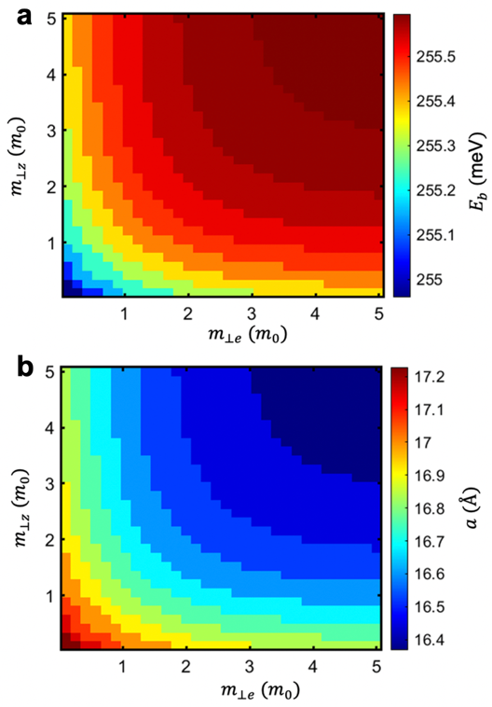
Fig. S13: (a) The exciton binding energy, as determined by the isolated QW model for a wide range of perpendicular electron/hole masses. (b) The exciton radius, as determined by the isolated QW model for a wide range of perpendicular e/h masses. Note the small dependence of both variables on $m_{⊥e}$ and $m_{⊥h}$.

The shortcomings of the effective-mass approximation (EMA) in the case of n = 1 2D MHPs have been discussed extensively by Even, Katan, and others ^{66,81}. In particular it has been shown that the CBM and VBM along the c-axis (perpendicular to the layer) are nonparabolic and thus the effective masses $m_{⊥,e}$ and $m_{⊥,h}$ are not well defined. Therefore, the effectiveness of the isolated QW model, which depends on the EMA, is somewhat surprising. We attribute this to the model’s lack of sensitivity to the perpendicular masses. In Fig. 13, the predictions of $E_{b}$ and $a$ are shown for a grid of perpendicular masses covering the space of {$0.1m_{0} <m_{⊥,e}<0.5m_{0}$, $0.1m_{0} <m_{⊥,h}<0.5m_{0}$}. We find that the binding energy is particularly insensitive to the selection of mass, only varying between 255 and 255.5 meV; the prediction of the radius varies a bit more, between 16.4 and 17.2 Å. This lack of sensitivity is good, as it shows the model does not strongly depend on the poorly-defined $m_{⊥e}$ and $m_{⊥h}$ parameters.

12.3 Input parameters

Our method for obtaining $μ$ is explained in Supplementary Section 10 and our method for obtaining $ε_{w}$ and $ε_{b}$ is explained in Supplementary Section 11. The values for $l_{w}$ and $l_{b}$ were obtained by increasing the nominal well length by the twice the radius of the halide atom that extends into the barrier, $R_{X}$ (one extra radius on each side of the well):

$l_{w}=l_{w,0}+{2R}_{X}$ (36)
$l_{b}=l_{b,0}-2R_{X}$ (37)

where $l_{w,0}$ and $l_{b,0}$ are the nominal well and barrier lengths, respectively. We take $l_{w,0}$ as distance between the nuclei of opposing halide atoms within a [BX₆]⁴⁻ octahedra. Surveying dozens of experimentally-determined crystals structures in literature, we determine $l_{w,0}=$ 6.4 ± 0.1 Å for all n = 1 2D HPs in this study and we use a single value (6.4 Å) for each structure. The barrier length is then determined as $l_{b,0}=$ d₀₀₂ − $l_{w,0}$ (d₀₀₂ values in Table S1). Reasonable estimates for $R_{X}$ fall between 0 Å and half of the atomic radius of iodine, 0.7Å⁸². We selected a value between the two extremes, namely $R_{X}$ = 0.3 Å. To propagate the uncertainty of $R_{X}$ in our $E_{b}$ calculations, we carried out the numerical procedure starting with the $ε_{w}$ and $ε_{b}$ fitting (Supplementary Section 11.2) and ending with the solving of Eq. (22). Calculations using the lower bound of $R_{X}=$ 0 and upper bound $R_{X}=$ 0.7 resulted in 2.7% lower and 2.9% larger $E_{b}$ values, respectively, in comparison to calculations using $R_{X}=$ 0.3 Å.

13. Disentangling quantum and dielectric confinement effects
Significant efforts have been devoted to tuning $E_{b}$ in 2D HPs through the dielectric mismatch of barrier and well layers^{64,65,81,83-88}, often referred to as “dielectric confinement” or the “image charge effect”, with a particular focus on the mismatch in dielectric constants, e.g. the ratio $ε_{w}$/$ε_{b}$^{83,89} or the ratio ($ε_{w}-ε_{b}$)/ ($ε_{w}+ε_{b}$)^{90,91}. The idea that the image charge effect strongly influences E_{b} began in early studies on 2D HPs by Muljarov⁵⁴ and Tanaka⁸⁰, where it was reported that the image charge effect increases $E_{b}$ by a factor of ~3 for n = 1 HPs. Although Tanaka and Muljarov arrived at their conclusion through different means—experiment in the case of Tanaka and theory in the case of Muljarov— both studies grouped two distinct effects into their factors of 3. The first effect is the dielectric mismatch which creates image charges, and the second is the overall reduction in dielectric constant when moving from 3D HPs to 2D HPs that results from the addition of smaller dielectric constant organic molecules in between the larger dielectric constant inorganic layers. Here we attempt to disentangle the quantum and dielectric confinement effects by using our superlattice model for several relevant situations. In the following, we show the overall reduction in dielectric constant is actually the dominant effect, accounting for most of the factor of 3. Contrary to popular belief, the enhancement to $E_{b}$ caused by dielectric mismatch is quite small in 2D HPs.
In the situations that follow we have three distinct dielectric constants that we consider, namely that of the well, $ε_{w}$, that of the barrier, $ε_{b}$, and then also the spatially-averaged value of the overall material, $ε_{bulk}=(ε_{w}l_{w}+ε_{b}l_{b})/(l_{w}+l_{b})$. As in the main paper we use the symbol $γ$ to indicate the enhancement in binding energy as compared to that of a Wannier exciton in the hydrogenic model:

$E_{b}=γ\left(\frac{μ}{m_{0}}\right)\left(\frac{1}{ε^{2}}\right)$× 13.6 eV (38)

Here $E_{b}$ is the actual measured binding energy of the HP, $μ$ is the reduced mass of the exciton, and $ε$ is the dielectric constant which screens the electron-hole Coulomb interaction. The symbol $γ$ can be decomposed into a product of quantum and dielectric confinement effects, which we label $γ_{QC}$ and $γ_{DC}$, respectively: $γ=γ_{QC}γ_{DC}$.
The question of which dielectric constant to use in Eq. (38) can be and has been interpreted different ways. One is to use the spatially-averaged dielectric constant, $ε_{bulk}$. Another is to use the dielectric constant of the 3D counterpart material, which we assume to be equivalent to $ε_{w}$; this assumption is justified based on the similarity between $ε_{∞}$ of MABX₃ structures and $ε_{w,∞}$ of the [BX₄]²⁻ inorganic layers obtained in this study (4.53 vs 4.68 for PbI; 3.55 vs 3.45 for PbBr; 2.87 vs 2.79 for PbCl, as given in Table S1 and Table S6). We therefore use the symbols $γ_{DC}^{'}$ and $γ_{DC}^{''}$ to distinguish between the dielectric confinement described using those two differing conventions:

$E_{b}=γ_{QC}γ_{DC}^{'}\left(\frac{μ}{m_{0}}\right)\left(\frac{1}{ε_{bulk}^{2}}\right)$× 13.6 eV (39)

$E_{b}=γ_{QC}γ_{DC}^{''}\left(\frac{μ}{m_{0}}\right)\left(\frac{1}{ε_{w}^{2}}\right)$× 13.6 eV (40)

Although the difference in definition is subtle, the difference in the respective values ($γ_{DC}^{'}$ vs $γ_{DC}^{''}$) is significant for 2D HPs. As is apparent from their definitions, the two are related through

$γ_{DC}^{''}=γ_{DC}^{'}{\left(ε_{w}/ε_{bulk}\right)}^{2}$, (41)

where the factor of ${\left(ε_{w}/ε_{bulk}\right)}^{2}$ can be thought of as ${\left(ε_{3D,bulk}/ε_{2D,bulk}\right)}^{2}$, namely the reduction in $E_{b}$ due to the decrease in the bulk dielectric constant moving from 3D to 2D HPs. Its value is significant for HPs as a larger portion of the 2D HP unit cell is organic (low $ε$) by volume. The formulation of Eq. (40) groups both the “dielectric reduction” and “dielectric mismatch” effects into $γ_{DC}^{''}$, whereas Eq. (39) considers the two to be separate effects and only the dielectric mismatch enters into $γ_{DC}^{'}$ (since the overall dielectric reduction is accounted for by using $ε_{bulk}$ in the denominator). In early papers studying the image charge effect in 2D HPs, the entire factor $γ_{DC}^{''}$ was referred to as the reduction in $E_{b}$ due to the image charge effect^{54,80}. We take the opposite approach, namely that$γ=γ_{QC}γ_{DC}^{'}$, as the factor $γ_{DC}^{'}$ is a more accurate definition for the reduction of $E_{b}$ due to dielectric mismatch that is widely referred to throughout the literature in discussions of dielectric confinement^{63,81,83-85}.
In order to decompose $γ$ into the three factors, $γ_{QC}$, $γ_{DC}^{'}$, and $γ_{DC}^{''}$, we consider five scenarios which are schematically depicted in Figure S14 (left hand side). The numerical results of our calculations are depicted in Figure S14 (right hand side) for a range of $ε_{b}$ and $ε_{w}$ values. Parameters representative of standard 2D HPs such as BA₂BX₄ or PEA₂BX₄ were used in these calculations; specifically, $l_{b,0}=$ 8.6 Å, $l_{w,0}=$ 6.4 Å, and $μ=$ 0.12 $m_{0}$.
Scenario 1 represents an exciton in a typical 2D HP system, where $ε_{b}<ε_{w}$ and the electron/hole is confined to a single layer. This is the situation outlined in our actual superlattice calculations (Supplementary Section 12) so by definition $E_{b,1}$ is equivalent to $E_{b}$ in Eqs. (38) – (40). Scenario 2 represents a 2D HP with no dielectric mismatch but still exhibiting quantum confinement; these $E_{b}$ were calculated by setting $ε_{b}=ε_{w}$ in the superlattice model. Scenario 3 is similar to 2, but using the lower, spatially-averaged dielectric constant $ε_{bulk}$ for both barrier and well in the superlattice model calculations. Scenario 4 is simply a Wannier exciton in the hydrogenic model using the dielectric constant of the well, i.e., $E_{b,4}=\left(μ/m_{0}\right)\left(1/ε_{w}^{2}\right)$× 13.6 eV. Scenario 5 is similar to 4, but using the spatially-averaged dielectric constant in the hydrogenic model, i.e., $E_{b,5}=\left(μ/m_{0}\right)\left(1/ε_{bulk}^{2}\right)$× 13.6 eV.

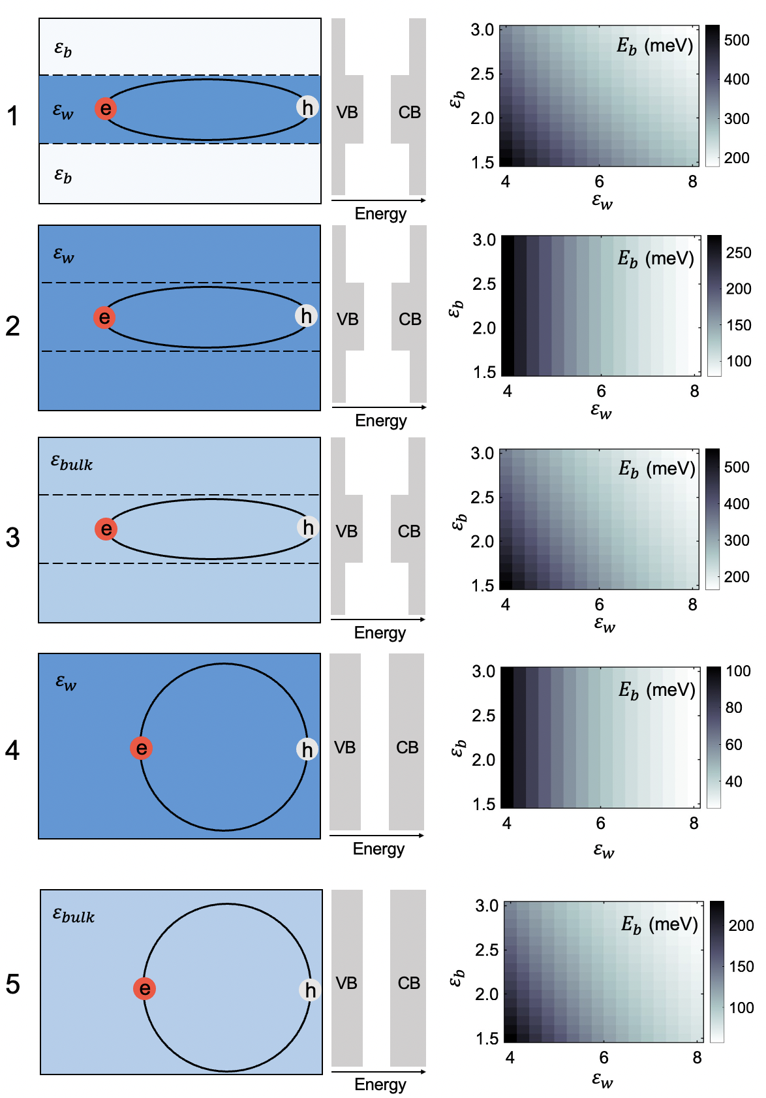
Fig. S14: An exciton in five hypothetical HP systems (1) A quantum and dielectric well with ${ε_{b}<ε}_{w}$, (2) a quantum well where well and barrier dielectric constants are both set equal to the 3D bulk value, $ε_{w}$, (3) a quantum well where well and barrier dielectric constants are both set equal to the 2D bulk value, $ε_{bulk}$, (4) a 3D semiconductor with a simple hydrogenic exciton, dielectric constant set equal to the 3D bulk value, $ε_{w}$, and (5) a 3D semiconductor with simple hydrogenic exciton, dielectric constant set equal to the 2D bulk value, $ε_{bulk}$.

Now we can identify $γ_{QC}$, $γ_{DC}^{'}$, and $γ_{DC}^{''}$ as follows. The only change moving from scenario 4 → 2 (and 5 → 3), is the addition of quantum confinement (with no dielectric confinement). Thus, we have:

$γ_{QC}=\frac{E_{b,2}}{E_{b,4}}=\frac{E_{b,3}}{E_{b,5}}$ (42)

By contrast, moving from scenario 2 → 1, or from 3 → 1 adds dielectric confinement, with no additional quantum confinement. Since scenario 2 involves the 3D bulk value of dielectric constant, approximated as $ε_{w}$, and scenario 3 involves the 2D bulk value of dielectric constant, namely the spatially-averaged value $ε_{bulk}$, we therefore also have:

$γ_{DC}^{'}=\frac{E_{b,1}}{E_{b,3}}$ (43)

$γ_{DC}^{''}=\frac{E_{b,1}}{E_{b,2}}$ (44)

The results for $γ_{QC}$, $γ_{DC}^{'}$, $γ_{DC}^{''}$ calculated this way are presented in Fig. S15. As mentioned above, the factor $γ_{DC}^{'}$ is more accurate than $γ_{DC}^{''}$ when talking about the reduction of $E_{b}$ due to dielectric mismatch; and it is quite small, ranging between 1 and 1.2 (Figure S15c). The apparent dielectric confinement effect expressed by $γ_{DC}^{''}$ is significantly larger than that only because of the additional factor of ${\left(ε_{w}/ε_{bulk}\right)}^{2}$, which is not actually a result of dielectric confinement at all but rather a lowering of the overall dielectric constant which is accounted for within the Wannier model.

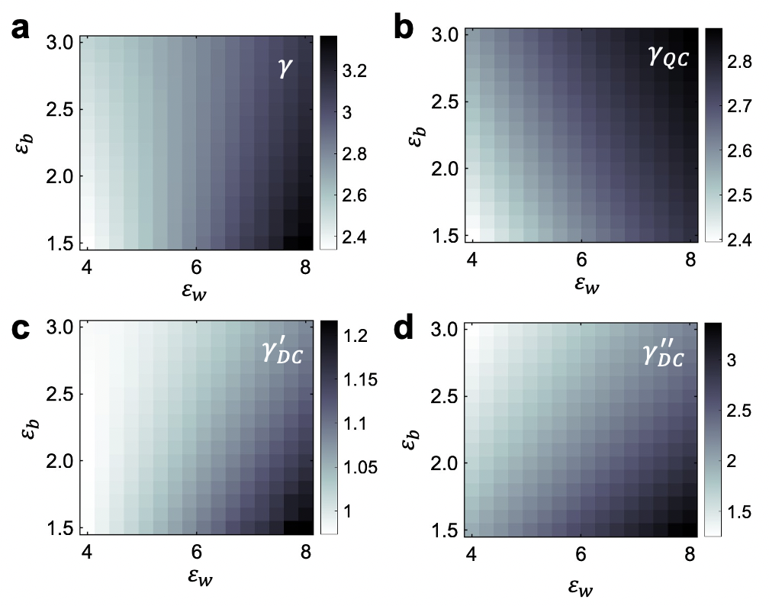
Fig. S15: (a) The total enhancement to $E_{b}$ discussed in the main text ($γ$) obtained by comparing the 2D HP exciton binding energy ($E_{b,1}$) to that predicted from the Wannier model using the bulk 2D dielectric constant ($E_{b,5}$); or equivalently, $γ_{QC}γ_{DC}^{'}$. (b) The enhancement to $E_{b}$ as a result of quantum confinement, $γ_{QC}$. (c) The enhancement of $E_{b}$ due to dielectric mismatch, $γ_{DC}^{'}$. Using our convention that $γ=γ_{QC}γ_{DC}^{'}$, the values from (a) equal the values from (b) multiplied by the values from (c). (d) The enhancement to $E_{b}$ as a result of dielectric mismatch and also the overall dielectric reduction due to incorporating lower dielectric constant material into the structure, $γ_{DC}^{''}=γ_{DC}^{'}{\left(ε_{w}/ε_{bulk}\right)}^{2}$.

Lastly, it is helpful to place these calculations in the context of the main study where we focus on the total factor that enhances $E_{b}$ in 2D HPs beyond the Wannier model ($γ=γ_{QC}γ_{DC}^{'}$), which we measure to be $γ≈$ 1.6 using $ε_{∞}$ values and $γ≈$ 8.4 using $ε_{0}$ values. Our calculations (Fig. S15a) show an expected value of γ between 2.4 and 3.2, which gives rise to an $ε$ value significantly between the $ε_{∞}$ and $ε_{0}$ measurements.

14. Standard error of E_{b} calculations and implications for phonon screening

14.1 Interpretation of disagreement between theory and experiment

As is demonstrated throughout the main text, theoretical predictions of $E_{b}$ are greater than measured values when high-frequency dielectric constants ($ε_{∞}$) are used as input parameters to the theory. To determine the statistical significance of this discrepancy, we calculated the standard error of our theoretical calculations (superlattice model) by propagating the uncertainties (σ) from all of our input parameters: $μ$, $ε_{w,∞}$, $ε_{b,∞}$, $l_{w}$, and $l_{b}$. Averaging across nineteen 2D HP structures, these relative uncertainties are: $σ_{μ}/μ$ = 0.18, $σ_{εw∞}/ε_{w,∞}$ = 0.04, $σ_{εb∞}/ε_{b,∞}$ = 0.08, $σ_{lw}/l_{w}$ = 0.11, and $σ_{lb}/l_{b}$ = 0.15 (reported as one standard deviation). These uncertainties were propagated for three structures with input parameters that span a diverse range— (C₁₀)₂PbI₄, BA₂PbI₄, and EOA₂PbI₄—by generating normal distributions of $μ$, $ε_{w,∞}$, and $ε_{b,∞}$ according to their respective standard errors, randomly sampling the normal distributions to create 300 combinations of parameters, calculating $E_{b}$ for each set of parameters, and then fitting the resulting $E_{b}$ to a normal distribution to determine $σ_{Eb}$. This produced $E_{b}$ = 507 ± 75 meV for (C₁₀)₂PbI₄, $E_{b}$ = 436 ± 65 meV for BA₂PbI₄, and $E_{b}$ = 303 ± 52 meV for EOA₂PbI₄. The three materials have relative uncertainties of 0.15, 0.15, and 0.17, respectively, and we take their average of 0.16 to be the relative uncertainty in our calculations due to $σ_{μ}$, $σ_{εw∞}$ and $σ_{εb∞}$. The analogous uncertainty due to $σ_{lw}$ and $σ_{lb}$ is small, equal to 0.03 (Supplementary Section 14), and can be neglected to within two sig figs; we therefore take 0.16 to be the total relative uncertainty ($σ_{Eb}/E_{b}$) of the exciton binding energies calculated using $ε_{∞}$. The known values from EA are, on average, 2.6$σ$ away from the calculated value in the superlattice model when using $ε_{∞}$ (see Table S7). And as pointed out in the main text, this discrepancy between theory and experiment is largest in 2D HPs with low exciton binding energies, for example EOA₂PbI₄ where the difference is 5.1$σ$. The statistical significance, along with that trend, is consistent with phonon screening playing a role that increases in efficiency for materials in which $E_{b}/ℏ$ approaches $ω_{LO}$.
While the errors reported above represent the explicit error in our $E_{b}$ calculations, there may also be errors implicit to the model. For example, the superlattice model may not accurately represent excitons in 2D HPs due to unfriendly and unnoticed assumptions. However, we believe this is unlikely since the theory robustly agrees with experiment when a small degree of additional screening is assumed (as demonstrated in Figure 4 of the main text). Additionally, we note that sophisticated theoretical approaches involving the GW approximation and the Bethe-Salpeter equation also consistently overestimate $E_{b}$ by a serious margin when high-frequency dielectric constants are used^{33,55,92,93}. Lastly, similar exciton models based on Rytova and Keldysh theory accurately predict $E_{b}$ for covalently-bonded TMDC systems where phonon screening effects can be ignored^{35,94,95}. For these reasons, we choose to not interpret the overprediction of $E_{b}$ as an indictment of the model, but rather as evidence that the optical dielectric constants are inconsistent with the low $E_{b}$ values that we measured.

14.2 Comparison to recent phonon screening model

Phonon screening of the electron-hole interaction in 3D HPs was recently predicted by Umari et al.⁹⁶, and a generalized model for phonon screening based on fully ab initio calculations was subsequently developed by Filip et al.⁹³ The change in exciton binding energy, due to the additional phonon screening, is expected to be:⁹³

$ΔE_{b}=-2ω_{LO}\left(1-\frac{ε_{∞}}{ε_{0}}\right)\frac{\sqrt{1+ω_{LO}/E_{b}} + 3}{{\left(1 + \sqrt{1+ω_{LO}/E_{b}}\right)}^{3}}$ (45)

where $ω_{LO}$ is the phonon resonant frequency. This equation predicts a very small shift of $ΔE_{b}$= –2.3 meV for PEA₂PbI₄, much smaller than the $ΔE_{b}$ = –106 meV that we determine from difference in $E_{b,exp}$ and $E_{b,theor}(ε_{∞})$ (values in Table S7). The isotropic dielectric tensor and isotropic mass tensor approximations inherent to Eq. (45) may explain some (but likely not all) of the discrepancy between the $ΔE_{b}$ in this study, and that predicted by Eq. (45). Thus, further theoretical modeling of exciton-phonon interactions is needed to fully understand the results in this study

Table S7: Theoretical and measured $E_{b}$ values and their differences
 | $E_{b,theor}(ε_{0})$ (meV) | $E_{b,theor}(ε_{∞})$ (meV) | $E_{b,exp}$ (meV) | ${ΔE}_{b}$ (meV)* | Difference (σ)†
BA₂PbI₄ (II) | 147 | 436 | 256 | -180 | 2.6σ
BA₂PbI₄ (I) | 132 | 387 | 228 | -159 | 2.6σ
(C₆)₂PbI₄ (I) | 146 | 407 | 235 | -172 | 2.6σ
(C₇)₂PbI₄ (II) | 178 | 487 | 273 | -214 | 2.7σ
(C₇)₂PbI₄ (I) | 157 | 424 | 246 | -178 | 2.6σ
(C₁₀)₂PbI₄ (II) | 195 | 507 | 298 | -209 | 2.6σ
(C₁₄)₂PbI₄ (II) | 206 | 513 | 297 | -216 | 2.6σ
PEA₂PbI₄ | 96 | 328 | 222 | -106 | 2.0σ
1F-PEPI |  | 347
5F-PEPI |  | 383 | 274 | -109 | 1.8σ
EOA₂PbI₄ | 26 | 303 | 55 | -248 | 5.1σ
BA₂SnI₄ | 78 | 330 | 170 | -160 | 3.0σ
PEA₂SnI₄ | 51 | 245 | 128 | -117 | 3.0σ
BA₂PbBr₄ | 167 | 596 | 352 | -244 | 2.6σ
PEA₂PbBr₄ | 102 | 417 | 349 | -68 | 1.0σ
BA₂PbCl₄ | 170 | 699
PEA₂PbCl₄ | 123 | 566 | 487 | -79 | 0.9σ
BA₂MAPb₂I₇ | 59 | 253 | 130 | -123 | 3.0σ
BA₂MA₂Pb₃I₁₀ | 45 | 207 | 70 | -137 | 4.1σ
*the lowering of $E_{b}$ due to phonon screening ($ΔE_{b}=E_{b,theor}\left(ε_{∞}\right)-E_{b,exp}$)
†the number of standard deviations that $E_{b,exp}$ is away from $E_{b,theor}\left(ε_{∞}\right)$.

15. Phonon screening efficiency
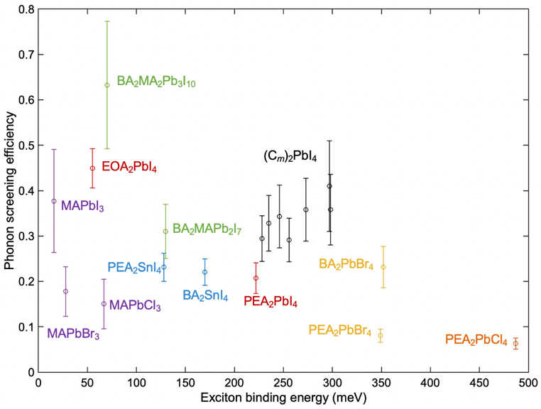
Fig. S16: Phonon screening efficiency ($α$) as a function of $E_{b}$.

Phonon screening efficiency (α) is expected to be larger for materials in which E_{b}/ℏ is closer to ω_{LO}. To investigate whether such a correlation exists in our data, we determined α for 16 structures with known $E_{b}$ values (from EA) and known $l_{b}$, $l_{w}$, $ε_{w}$, $ε_{b}$, and $μ$ parameters. Using the latter five parameters, $E_{b}$ was simulated according to the superlattice model as a function of $ε^{'}=β\left(\frac{ε_{w}l_{w}+ε_{b}l_{b}}{l_{w}+l_{b}}\right)$ where $β$ was varied to make $ε^{'}$ range from $ε_{0}$ and $ε_{∞}$. The $E_{b}(ε^{'})$ curves were interpolated and the point matching the experimental $E_{b}$ from was taken as $ε^{'}$. From $ε^{'}$, the phonon screening efficiency was defined as $α=(ε^{'}-ε_{∞})/(ε_{0}-ε_{∞})$, i.e. the fraction of the way $ε'$ is from $ε_{∞}$ to $ε_{0}$. The correlation between $α$ and $E_{b}$ for these 16 2D HP structures is shown in Fig. S16, along with MAPbI₃, MAPbBr₃, MAPbCl₃. In the latter, $α$ was determined in a similar fashion except that the 3D Wannier model (Eq. (38)) was used in place of the superlattice model.

16. E_{b} and E_{g} of 3D HPs and n > 1 2D HPs

16.1 3D HPs

In 3D systems, µ takes on a larger role in determining${ E}_{b}$ in comparison to 2D system. As a result, correlations between${ E}_{b}$ and $E_{g}$ are less common in 3D systems, and no universal correlation across all 3D semiconductors is observed³⁴. Despite the increased $μ$-dependence, $ε$ is still the primary factor that determines $E_{b}$ in 3D systems and correlations between $E_{b}$ and $E_{g}$ are sometimes seen. For 3D HPs in particular, we expect a correlation because both $ε$ and $μ$ evolve in a manner so as to increase $E_{b}$ moving from MASnI₃ MAPbI₃ MAPbBr₃ MAPbCl₃,^{5,97-99} and $E_{g}$ also increases in this direction (Table S1).
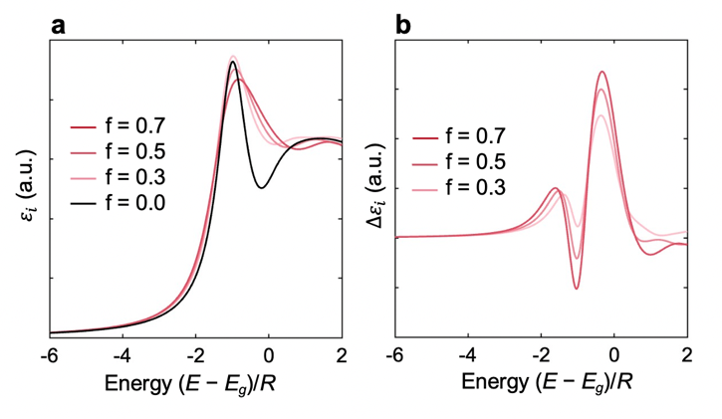
Fig. S17: (a) Simulated $ε_{i}$ spectrum (proportion to the absorption) for a 3D Wannier exciton in an electric field and corresponding (b) simulated EA. A broadening parameter of $Γ=1R$ was used for the convolution.

In order to explore whether the $E_{g}$-$E_{b}$ correlation exists in 3D HPs we sought to measure $E_{g}$ and $E_{b}$ for MASnI₃, MAPbI₃, MAPbBr₃, and MAPbCl₃ using low temperature EA and absorption. We were unsuccessful in acquiring EA on MASnI₃ due to the sample’s high conductivity. On other hand, EA spectra were collected for MAPbI₃, MAPbBr₃, and MAPbCl₃, and these are shown in Fig S19. The EA spectra of the 3D HPs have clear differences from their 2D counterparts in that the Stark and FK features are no long distinct, but instead blend into one feature. To understand where $E_{g}$ lies within this feature, we simulated the EA of a 3D Wannier exciton (Supplementary Section 1). The simulation results are shown in Fig. S17, where the FK and Stark features overlap significantly due to the small exciton binding energy of 3D systems. Unlike the 2D Wannier exciton where $E_{b}≫Γ$, these features cannot be interpreted as independent of one another at the band-edge— each point within the band-edge spectrum ($E_{1s}<E<E_{g}$) contains contribution of both effects after the convolution with the broadening function with a HWHM of $Γ$. When $Γ>E_{b}$, the information regarding the precise energy levels E_{1s} and E_{g} is somewhat buried beneath the broadening function and the numerical simulation may differ from a material’s EA response due to complex, inhomogeneous broadening mechanisms in the material that aren’t accounted for in the simulation^{100,101}. The 3D HPs at low temperature are on the boundary of this condition, with $Γ \sim { E}_{b}$. Simulating the EA under these conditions with $Γ={ E}_{b}$, we see that ${ E}_{g}$ (“0” on the horizontal axis of Fig. S17b) occurs between the peak and the zero-crossing of the interband feature, unlike the 2D systems where a zero-crossing is expected at $E_{g}$.
In fact, this difference in the location of $E_{g}$ in the standard 2D and 3D FK effects without any Coulomb interaction between the electron and hole (i.e. no exciton effects). When exciton effects are ignored, the problem of solving for the absorption of a 2D and 3D semiconductor under an electric field is greatly simplified and analytical solutions for the 2D and 3D FK features can be obtained. These analytical solutions are shown in Fig. S18 (the method for their calculation is given in Ref. ⁹, Ref. ¹⁰², and Ref. ¹⁰³). The well-known step function absorption for a 2D semiconductor leads to a situation where the first zero-crossing of the FK feature occurs at${ E}_{g}$. In contrast, the square root dependence of the 3D semiconductor’s absorption results in $E_{g}$ coinciding with the first peak of the FK feature. After convolving these EA spectra with a broadening function to represent experimental conditions, the position of $E_{g}$ within the EA spectrum shifts very slightly in the 3D case to fall between the first peak and zero-crossing in the 3D case, albeit still closer to the peak. This is the same result that we see in our numerical simulation which includes the ionization and Stark effects of the exciton (Fig. S17b).

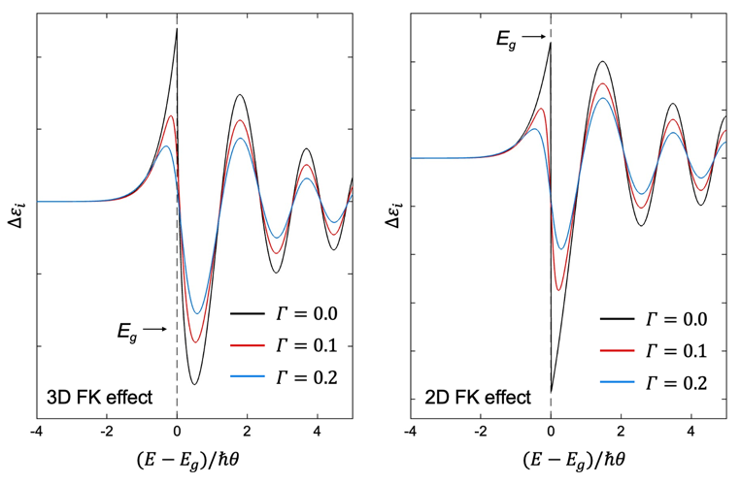
Fig. S18: (a) Simulated $ε_{i}$ spectrum (proportion to the absorption) for the 3D FK effect when exciton effects are excluded. (b) Simulated $ε_{i}$ spectrum for the 2D FK effect when exciton effects are excluded.

Our EA measurements at low temperature (T ≤ 50 K) correspond to the orthorhombic phases of each structure. At these low temperatures, distinct exciton peaks are resolved at the band-edge absorption and the EA lineshape is qualitatively similar between all three structures. As previously discussed, the insights gained in the numerical simulation regarding the positions of $E_{1s}$ and $E_{g}$ are only valid when $Γ<E_{b}$. From the width of the exciton peak, we measure $Γ$to be 14 meV 10 meV 23 meV moving from MAPbI₃ MAPbBr₃ MAPbCl₃. The exciton binding energies the former two structures, MAPbI₃ and MAPbBr₃ have been determined via high-field magnetoabsorption to be 16 meV and 25 meV, respectively, in their low-temperature orthorhombic phase. Meanwhile E_{b} for MAPbCl₃ is estimated to be much higher than MAPbBr₃ due to its lower $ε$ and higher $μ$ (Table S1). Thus, we suspect that MAPbBr₃ and MAPbCl₃ satisfy the $Γ<E_{b}$ condition. Interpreting the EA according to the simulation of a 3D Wannier exciton, E_{1s} is assigned to the exciton absorption peak and E_{g} to the first FK peak— these are marked asterisks and open circles, respectively, in Fig. S19. We measure $E_{b}$ = 28 ± 6 for MAPbBr₃ and $E_{b}$ = 67 ± 9 meV for MAPbCl₃. The asterisk and open circle (with separation of 29 meV for MAPbI₃) are a guide to the eye; since the $Γ<E_{b}$ condition is not met we don’t report an $E_{b}$ for this structure.
As shown in Fig. S19d, a correlation between $E_{b}$ and $E_{g}$ also exists for 3D HPs. Performing a linear fit, we obtain $E_{b}=0.0334E_{g}-0.0406$ eV, which has a much smaller slope than the fit line obtained for 2D HPs (slope ≈ 0.18). While this correlation is derived for MABX₃ structures, substitutions of various A-site cations (e.g., Cs, FA, etc.) in place of MA are not likely to affect the result by more than a few meV². Meanwhile, the effect of alloying B-site and X-site atoms on E_{b} and E_{g} is likely accurately captured by the correlation, as this is the case for the 2D HPs in this study (Supplementary Section 18).

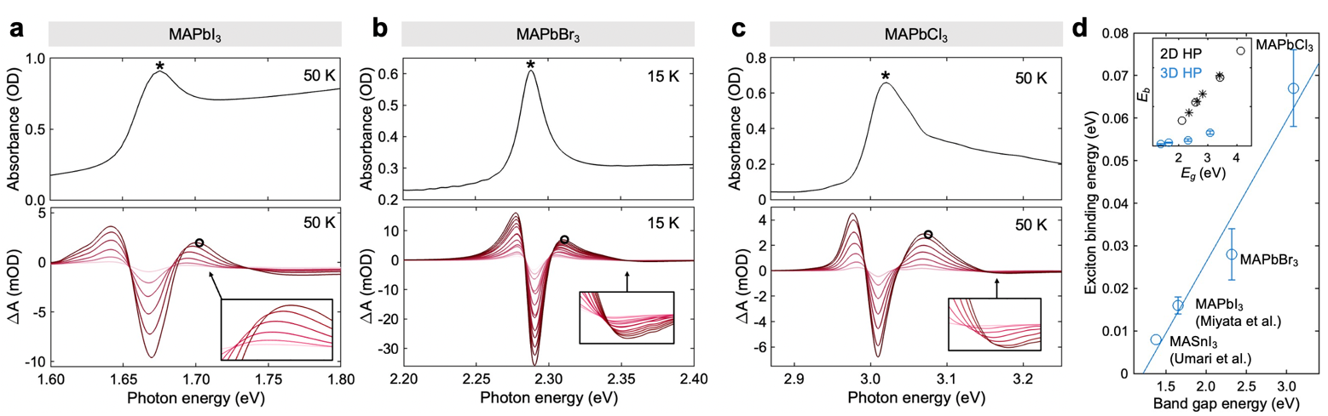
Fig. S19: (a) Absorption (top) and EA (bottom) of MAPbCl₃ at 50 K. The inset shows the onset of the field-broadening caused by the FK effect. (b) Absorption (top) and EA (bottom) of MAPbBr₃ at 50 K. (c) Absorption (top) and EA (bottom) of MAPbI₃ at 50 K. (d) Relationship between $E_{b}$ and $E_{g}$ for 3D HPs along with the fit line of $E_{b}=0.0334E_{g}-0.0406$ eV. The inset shows the comparison to 2D HPs, The MAPbI₃ datapoint is from Ref. ⁷ and the MASnI₃ datapoint is from Ref. ⁹⁶.

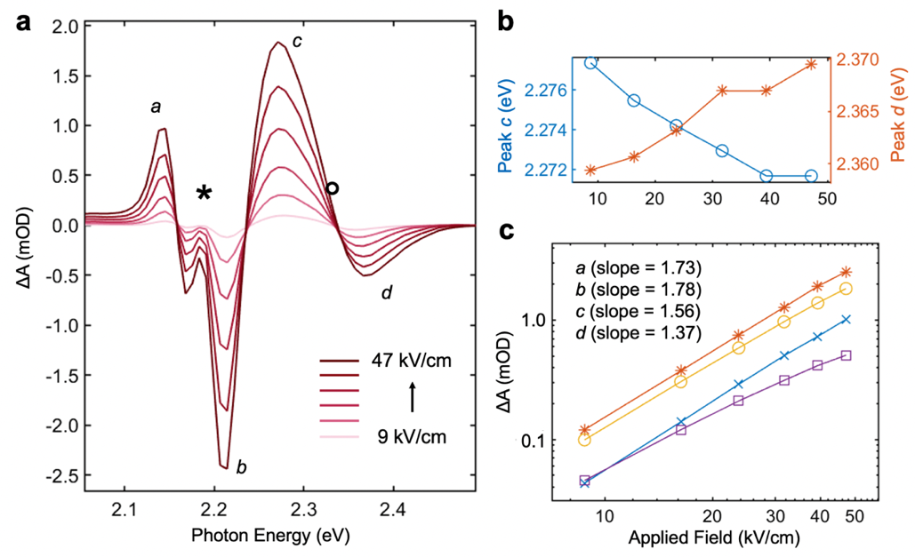
Fig. S20: High-field FK effect observed for n=2 phase (BA₂MAPb₂I₇). (a) EA spectrum at 45 K. The asterisks (*) marks $E_{1s}$ measured from the linear absorption while the circle (◦) marks $E_{g}$. (b) Peaks c and d as a function of applied field. (c) Amplitudes of peaks a, b, c, and d as a function of applied field.

16.2 n > 1 2D HPs

In order to determine $E_{b}$ as a function of $l_{w}$, we saught to measure $E_{g}$ and $E_{b}$ for BA₂MAPb₂I₇ (n=2), BA₂MA₂Pb₃I₁₀ (n=3), and BA₂MA₃Pb₄I₁₃ (n=4). In attempt to synthesize pure phase thin films, single crystal flakes were prepared by precipitation in HI, and then dissolved in a 4:1 DMF: DMSO mixture for spin-coating (see Methods). The phase purity of the resulting films was judged from absorption and XRD measurements. While the n=2 films were >90% pure-phase, the n = 3 and n= 4 formed mixed-phase thin films wherein a coexistence of all three phases were present within a single thin film.
High-field FK character near the band edge was observed for both of the n = 2 films allowing for a trustworthy assignment of $E_{g}$. The EA spectrum of an n = 2 film is shown in Fig. S20a, where the EA features a and b result from the Stark shifting of the exciton below the band gap. Peak c is sum of final Stark-shift peak and the first FK peak, while d is purely from the FK effect. The redshifting of c and blueshifting of d with applied field (shown in Fig. S20b) is a clear indication that these latter two peaks have partial high-field FK character and result from the continuum wavefunction leaking into the band gap¹⁰. Accordingly, the amplitudes of c and d show sub-quadratic scaling with applied field (Fig. S20c) further confirming their high-field FK character. This allows the zero-crossing of the FK feature to be taken as a trustworthy upper bound for band gap; we find $E_{g}$ = 2.33 ± 0.015 eV, where the large uncertainty originates from the dimensionality of the n=2 phase. As previously discussed, $E_{g}$ corresponds to the zero-crossing of the FK feature¹⁰ in 2D semiconductor, whereas in a 3D semiconductor $E_{g}$ is closer to the first peak. Moving from n = 1 to n = 4, the band structure becomes more 3D-like and as such, $E_{g}$ lies closer to the first peak of the FK feature; however, the exact dimensionality of the 2 ≤ n ≤ 4 phases and the location of $E_{g}$ within the FK feature for a quasi-2D semiconductor are both unknown. Thus, we take the peak as a lower-bound and the zero-crossing as an upper bound and estimate the band gap accordingly. The absorption and EA spectra of the mixed-phase thin film are shown in Fig. S21. The $E_{1s}$ positions (asterisks) are taken from the peaks in the linear absorption. The vertical tick marks indicate the first FK peak and are taken as a lower bound for $E_{g}$. The subsequent zero-crossing of the FK feature is not resolved in all cases; however, its position can be estimated from the downward slope—this provides an upper bound for $E_{g}$. The $E_{g}$ assignments are accordingly made between the lower and upper bounds and are indicated by the open circles in Fig. S21. The $E_{1s}$ and $E_{g}$ markings for n = 4 in Fig. S21 are meant to serve as a guide to the eye—since the FK feature is poorly resolved in the n = 4 case, we don’t report an $E_{b}$ measurement for this structure.

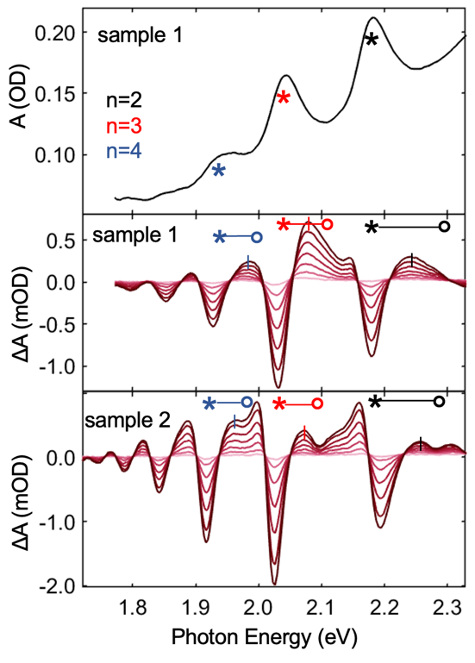
Fig. S21: The absorption and EA spectra of a mixed phase (n = {1,2,3,4}) thin film (sample 1; top) and EA spectra of an additional film (sample 2; bottom). The intersecting vertical lines mark the first peak of the FK feature and are a lower bound for $E_{g}$.

17. E_{b} vs. fundamental material parameters (ε_{w}, ε_{b}, and µ)
The $E_{b}$ vs. $l_{b}$ and $E_{b}$ vs. $l_{w}$ relationships are given in Fig. 4f and Fig. 4j in the main text, respectively. The relationship between $E_{b}$ and the other paramters (e.g. $ε_{w}$, $ε_{b}$, and $μ$) are more challenging to experimentally determine, as these parameters are difficult to systematically manipulate while holding the other parameters constant. For example, moving from PEA₂PbCl₄ PEA₂PbBr₄ PEA₂PbI₄ PEA₂SnI₄ is an effective way to alter $ε_{w}$ while holding $l_{w}$, $l_{b}$, and $ε_{b}$ constant; however, $μ$ also changes somewhat between these compositions. This is evident in Fig. S22a, where we plot $E_{b}$ vs. $ε_{w}$. While $μ$ remains relative constant near ~0.11 $m_{0}$ for PEA₂PbCl₄, PEA₂PbBr₄, PEA₂PbI₄ and a consistent downward trend is observed, the mass decreases abruptly to 0.075 $m_{0}$ for PEA₂SnI₄ resulting in a substantially lower $E_{b}$. Here, the solid line in Fig. S22a was calculated using fixed values for $l_{b}, l_{w}$, $ε_{b},$ and $μ$ while varying $ε_{w}$. The experimental datapoints correspond to $E_{b}$ values determined by EA and effective $ε_{w}^{'}$ values are determined by multiplying $ε_{w,∞}$ (Table S6) by 1.38 to account for an average enhancement due to phonon screening. A steeper slope is observed in the experimental trend, which we interpret as an increase in phonon screening efficiency moving from PbClSnI, exactly analogous to the discrepancy between theory and experiment in Fig. 4j of the main text. Turning to the $E_{b}$ vs. $ε_{b}$ relationship plotted in Fig. S22b, the experimental trend is disturbed by even more confounding variables as there are substantial deviations in $l_{b}$ and $μ$ between these structures. Nevertheless, $l_{w}$ and $ε_{w}$ are held constant and a downward-slopping trend is observed as $ε_{b}$ increases. Finally, increase in octahedral tilt (and by extension $μ$ as well) as BA₂PbI₄ transitions from phase I II allows for comparison of $E_{b}$ between two structures where $μ$ increases, but all other parameters are held constant. The ${ΔE}_{b}$ moving from phase I II is measured via EA and $Δμ$ is obtained from DFT. Inputting the different $μ$ into the supperlattice model, a thoertical value for $ΔE_{b}$ is obtained that is in good agreement with experiment (Fig. S22c). No fit parameters were used in the production of Fig. S22.

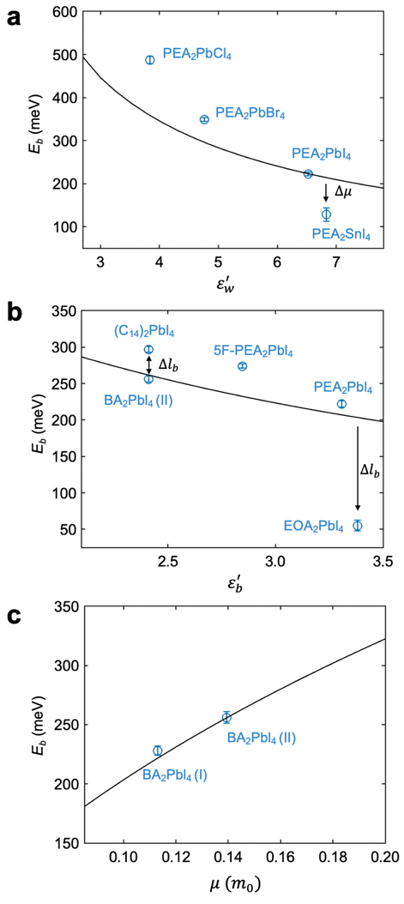
Fig. S22: (a) $E_{b}$ as a function of $ε_{w}^{'}$. The solid line was calculated by varying $ε_{w}$ in the superlattice model using $ε_{b}=$ 2.8, $l_{b,0}=$ 10.26 Å, $l_{w,0}=$ 6.4 Å, and $μ=$ 0.11 $m_{0}$. (b) $E_{b}$ as a function of $ε_{b}^{'}$. The solid line was calculated by varying $ε_{b}$ in the superlattice model using $ε_{w}=$ 6.15, $l_{b,0}=$ 10.26 Å, $l_{w,0}=$ 6.4 Å, and $μ=$ 0.11 $m_{0}$. (c) $E_{b}$ as a function of $μ$. The solid line was calculated by varying $ε_{b}$ in the superlattice model using $ε_{w}=$ 6.15, $l_{b,0}=$ 10.26 Å, $l_{w,0}=$ 6.4 Å, and $μ=$ 0.11 $m_{0}$. (c) $E_{b}$ as a function of $μ$. The solid line was calculated by varying $μ$ in the superlattice model using $ε_{w}=$ 6.15, $ε_{b}=$ 2.8, $l_{b,0}=$ 6.72 Å, and $l_{w,0}=$ 6.4 Å.

18. Linear tunability of E_{b} by alloying B-site and X-site atoms
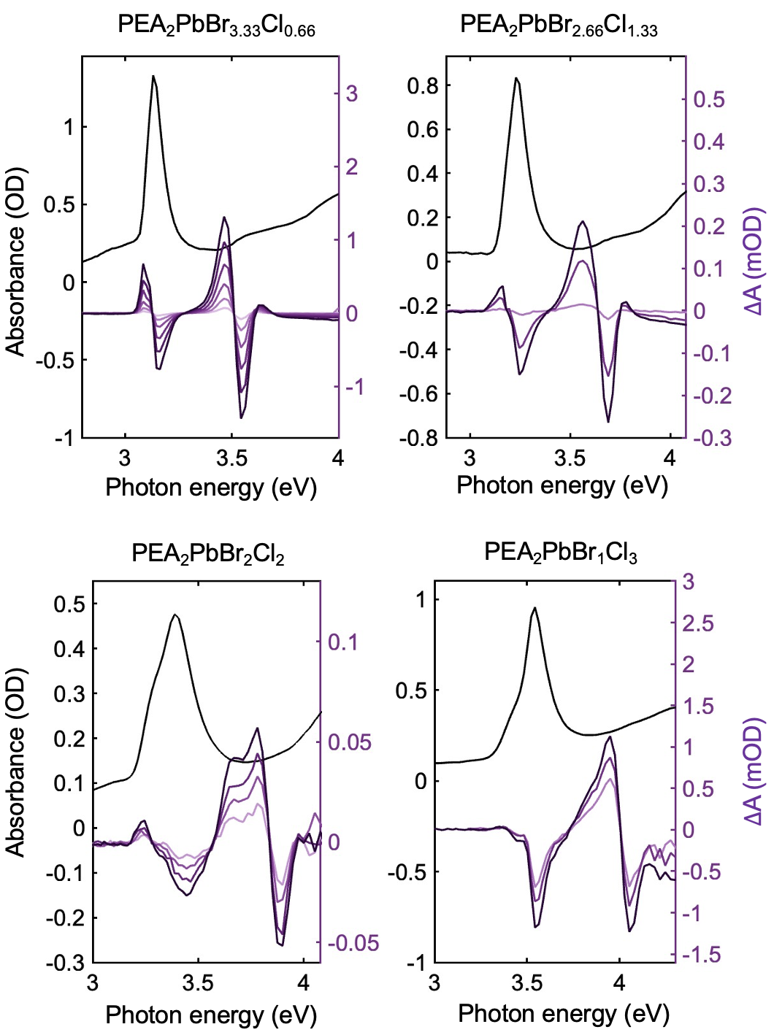
Fig. S23: Low-temperature absorbance spectra (black; left-hand y-axis) and electroabsorption (purple; right-hand y-axis) for PEA₂PbBr_{x}Cl_{4-x} structures where x = {3.33, 2.66, 2, 1}.

Our EA results on the PEA₂PbBr_{x}Cl_{4-x} series for x = {0, 1, 2, 2.66, 3.33, 4}, show that $E_{b}$ can be linearly tuned by alloying different ratios of the X-site anion. The absorption and EA for these alloyed compositions are shown in Fig. S23, while the $E_{b}$ and $E_{g}$ values are given in Table S1. We attempted to replicate these results for the B-site cation by preparing films with mixed ratios of Pb and Sn, but found the crystallites within the film segregated into Pb and Sn-rich domains, and a similar result occurred for mixed Br and I films. Computational results by Umari et al. on MASn_{0.5}Pb_{0.5}I₃ indicate $E_{b}$ is also tunable by B-site alloying⁹⁶. Naturally, however, homogenous mixing of the B-site atoms within the sample will have to be achieved for this to be realized experimentally. From a fundamental perspective, if the alloyed atoms are homogenously mixed, then $E_{b}$ will be continuously and linearly tunable via the alloyed ratio due to the fact E_{b} primarily depends on $ε$ which in turn primarily depends on the valance electron polarizability. If the mixing of atoms is homogenous within the film, then the exciton radius will encompass a mixture of atoms and be screened accordingly. This line of reasoning is most applicable for 2D HPs, but slightly less applicable in 3D HPs where $μ$ takes on a larger role in determining E_{b}.³⁴ Therefore, the formula to predict E_{b} of any dimensionality (see main text) is least appropriate in situations where the HP is three-dimensional, very alloyed, and a high degree of accuracy in E_{b} is desired.

19. Structural characterization
The anisotropy of the electronic structure in quantum well systems results in different EA responses for electric fields parallel vs perpendicular to the quantum well layers. For parallel fields, exciton states are redshifted by the quadratic and linear Stark effects and continuum states respond via the FK effect. In contrast, perpendicular fields redshift exciton states due to the quantum-confined Stark effect¹⁰⁴ and the band-edge is affected by the quantum-confined FK effect¹⁰³. As such, it is necessary to determine the quantum well orientation relative to the applied field in order to know the physical origin of the EA signal. In this study, we did so by acquiring grazing-incidence wide-angle X-ray scattering (GIWAXS) patterns for n = 1, n = 2, and the mixed phase n = {1,2,3,4} thin films (Fig. S23) and calculating mosacisity factors (MF) from the $ϕ$ dependence of the [002] diffraction peak, according to the procedure outlined in Ref. ¹⁰⁵ MF values fall on a linear scale from 1 (homogenous crystallite orientation parallel to the substrate) to -1 (homogenous crystallite orientation perpendicular to the substrate). We obtained MF = 0.987, MF = 0.964, and MF = 0.956 for the n=1, n=2, and the mixed-phase thin film (n=3 portion of the mixed-phase film), respectively, indicating that in each case the quantum wells have a very homogenous orientation relative to the substrate, and by extension, to the applied electric field as well.

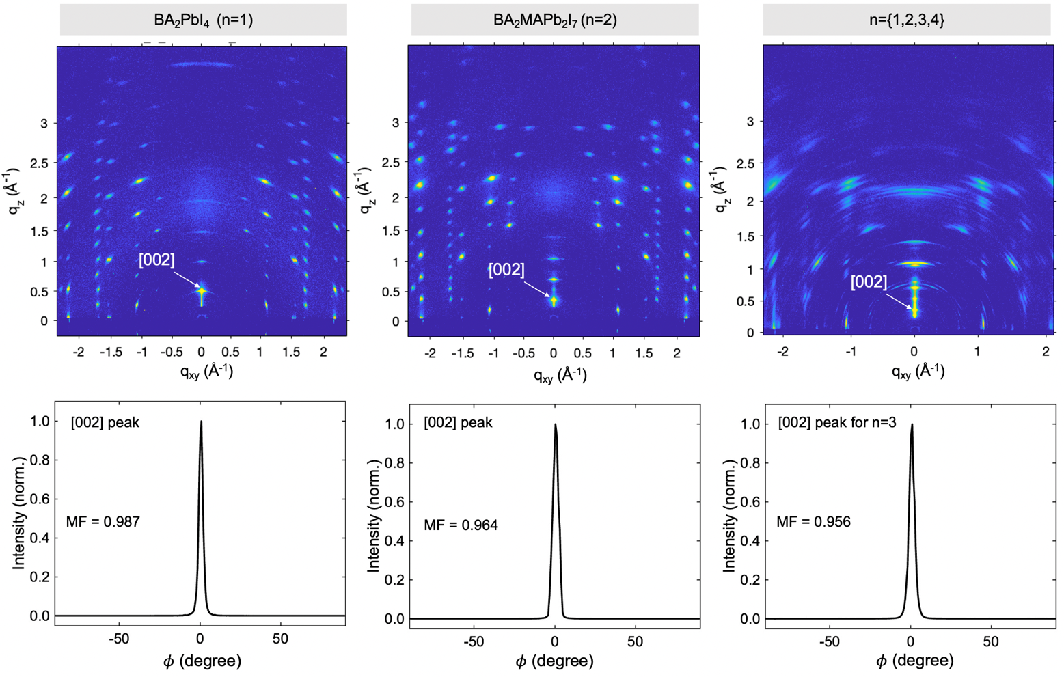
Fig. S24: (Top) GIWAXS patterns of BA₂PbI₄, BA₂MAPb₂I₇, and BA₂MA₂Pb₃I₁₀ thin films and (bottom) corresponding $ϕ$ line cuts of the [002] diffraction peak. The intensity is tightly centered at $ϕ$ = 0° where q_{xy} is zero, indicating that the orientation of the quantum well layers—parallel to the substrate—is very homogenous throughout the thin film.

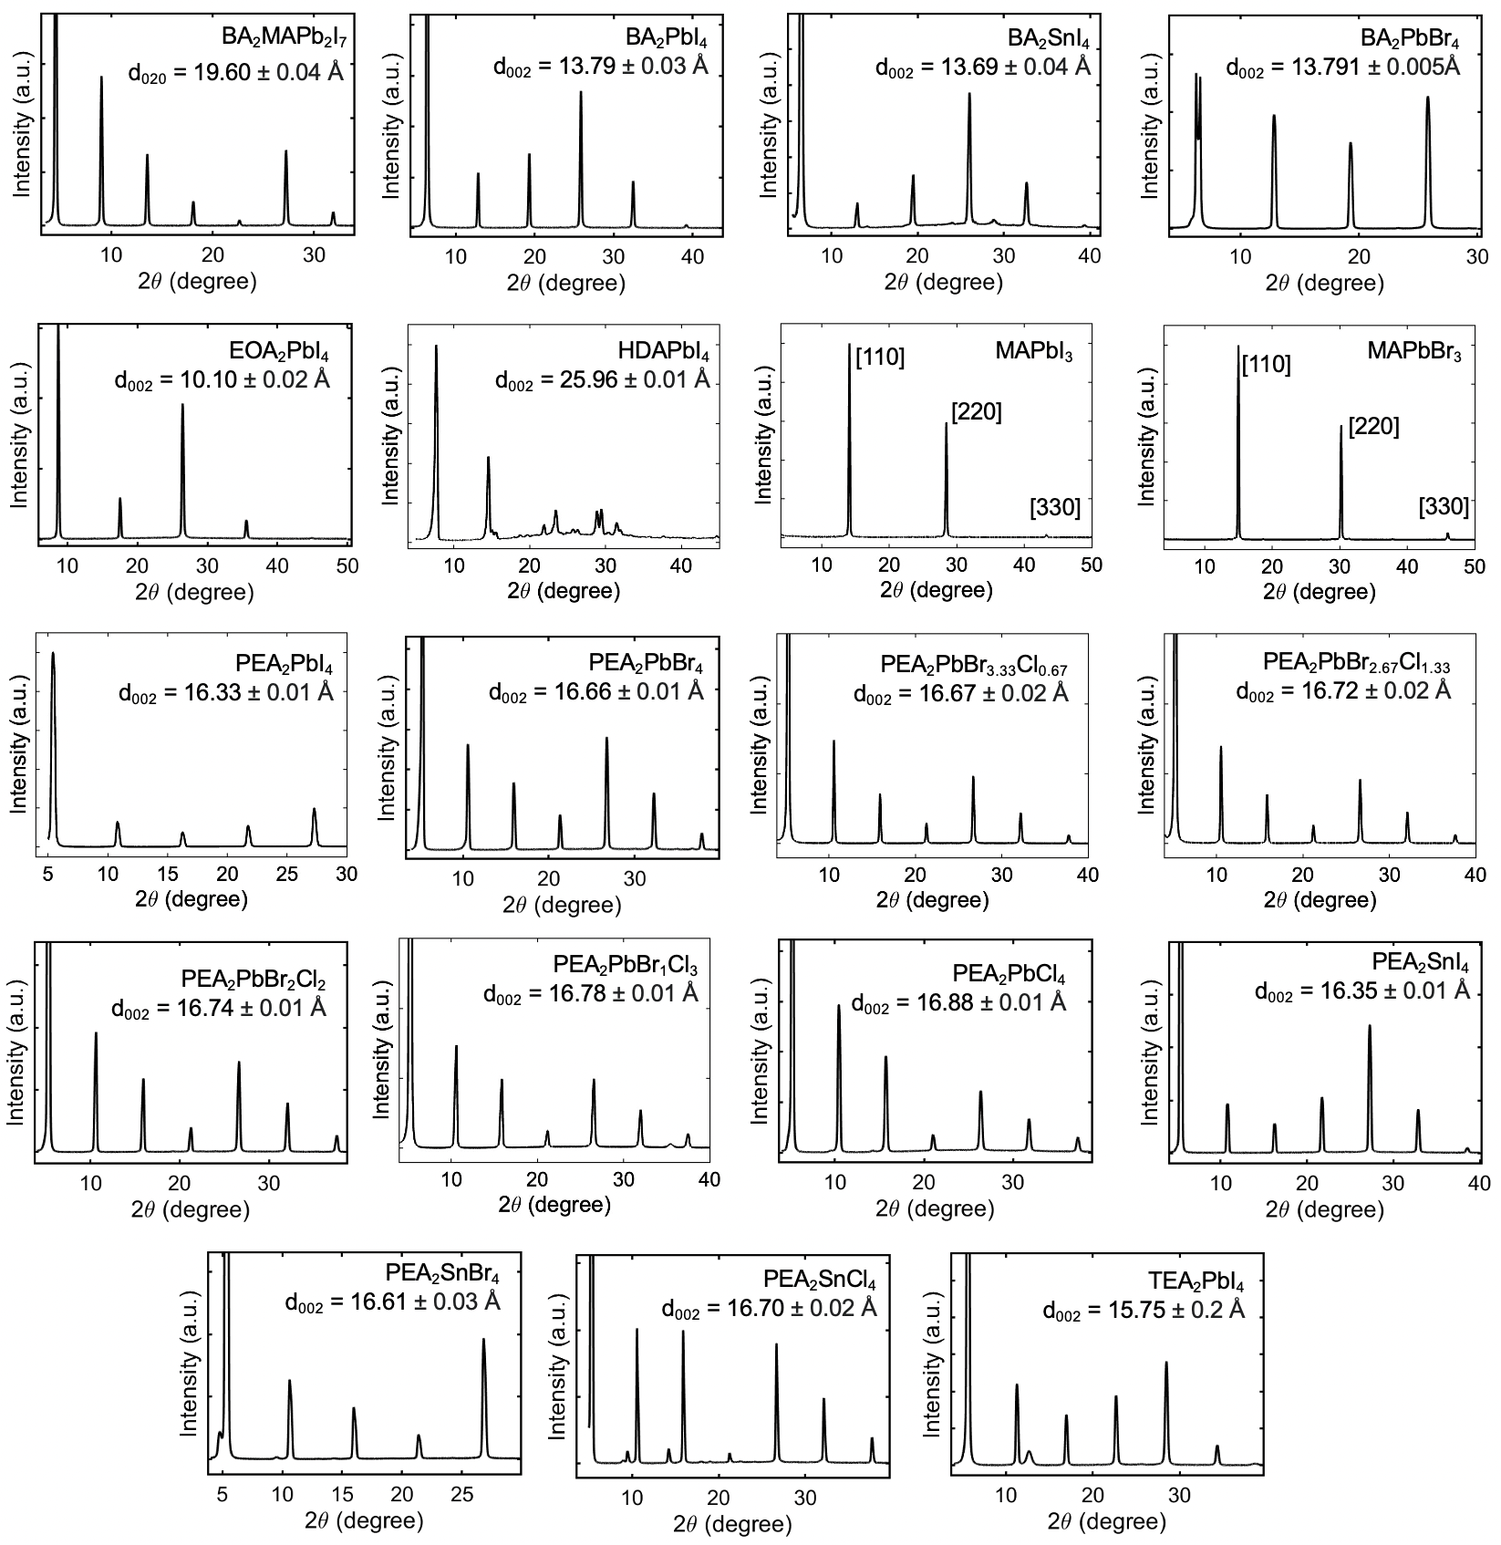
Fig. S25: XRD patterns for several of the 2D and 3D HP thin films in this study. The XRD and d₀₀₂ values for the (C_{m})₂PbI₄ series values are given in Fig. 4c and Table S1, respectively.

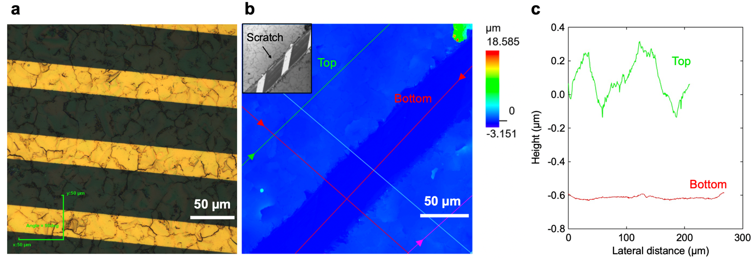Fig. S26: Representative profilometry data used to measure the film thickness for dielectric function measurements. (a) Optical micrograph of a PEA₂PbI₄ thin film. (b) Height profile of a different region on the same thin film. The inset shows a microscope image of the region. Metal tweezers were used to apply a scratch across the film surface and expose the substrate surface which consists of gold strips in an interdigitated geometry on a quartz wafer. Linescans were acquired in order to measure the average height of the film surface (labeled “top”) and substrate surface (labeled “bottom”). (c) Heights of the film (green, “top”) and substrate (red, “bottom”) surfaces with an average difference of 702 nm.

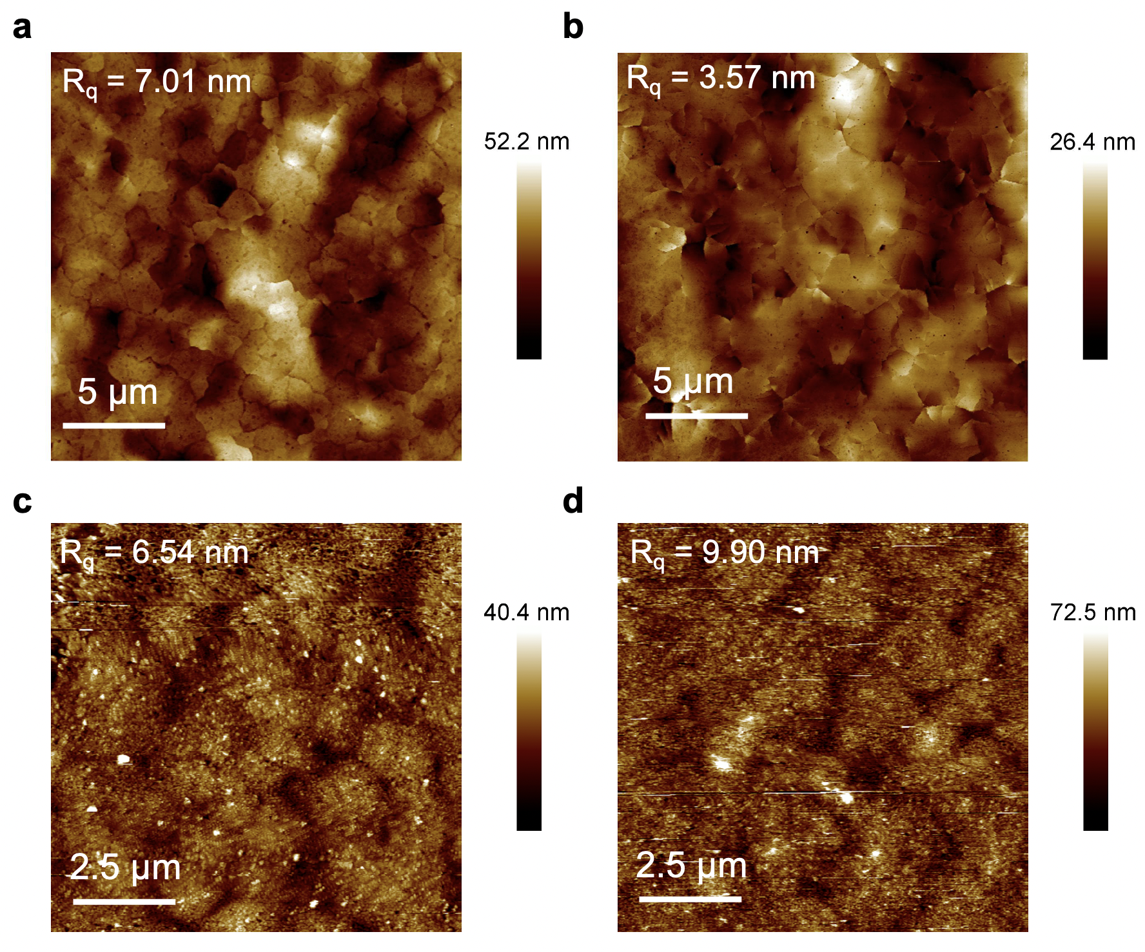
Fig. S27: AFM images of (a) a representative PEA₂PbI₄ thin film used for impedance spectroscopy (t~300 nm), (b) a second PEA₂PbI₄ film, (c) a PEA₂PbI₄ thin film used for EA spectroscopy (t~ 100 nm), and (d) a PEA₂PbBr₄ thin film used for EA spectroscopy (t~ 100 nm).

21. Additional figures

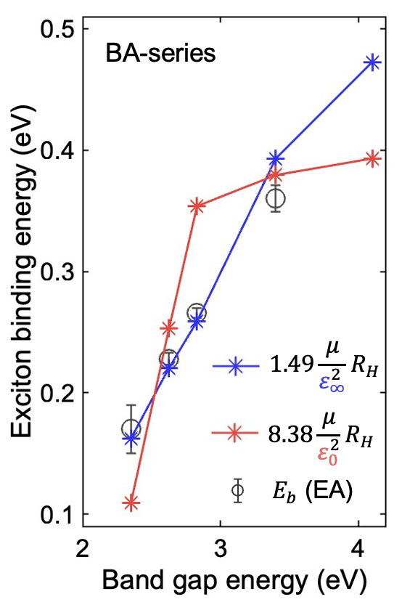
Fig. S28: E_{b} as a function of E_{g} for BA-based 2D HPs, fit to a modified Wannier exciton model using ε₀ (red) and ε∞ (blue) values.

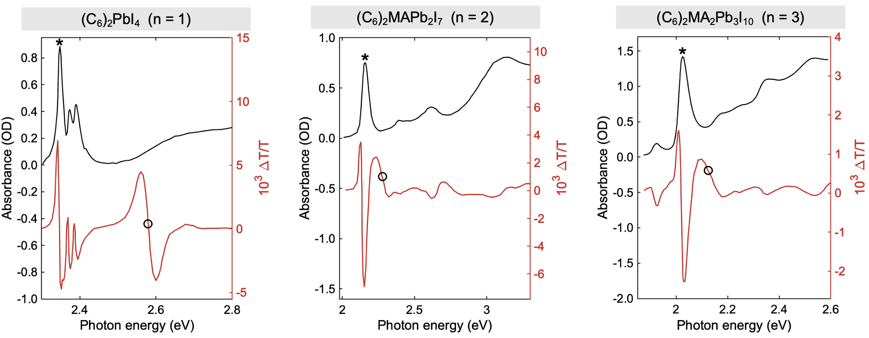
Fig. S29: EA spectra by reported by Tanaka et al. in ref. ⁴, digitized using the software in ref. ³². Our E_{1s} and E_{g} assignments are informed by simulations of 2D and 3D Wannier exciton EA spectra and are marked as asterisks and open circles, respectively, which lead to the E_{b} values listed in Supplementary Table S1.

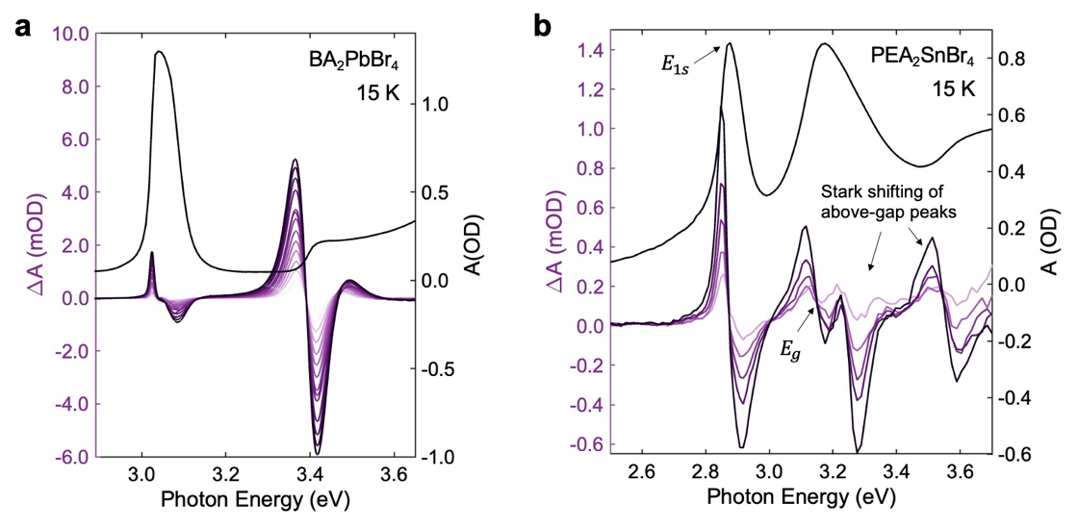
Fig. S30: Absorption (black; right-hand y-axis) and EA (purple; left-hand y-axis) for (a) BA₂PbBr₄ and (b) PEA₂SnBr₄.

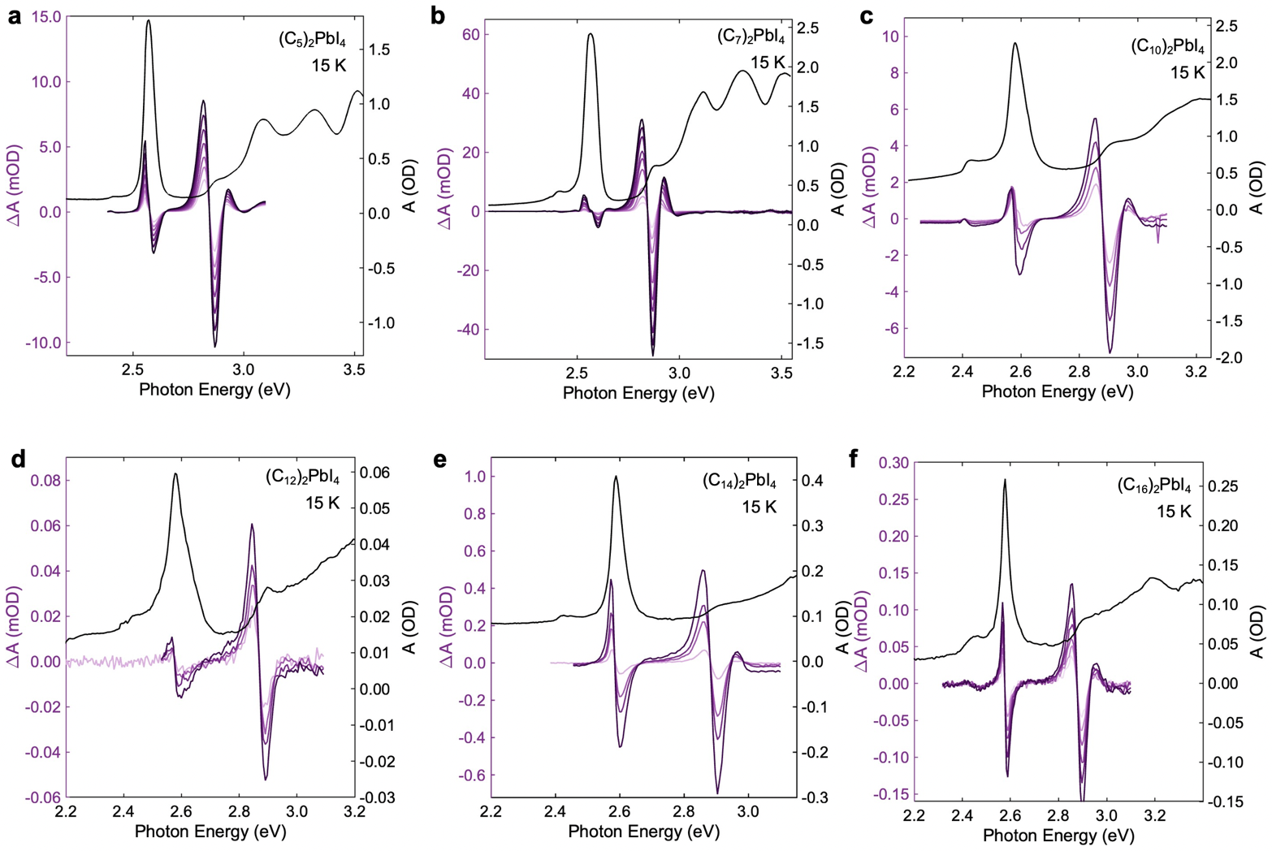
Fig. S31: Absorption (black; right-hand y-axis) and EA (purple; left-hand y-axis) for (a) (C₅)₂PbI₄ (b) (C₇)₂PbI₄ (c) (C₁₀)₂PbI₄ (d) (C₁₂)₂PbI₄ (e) (C₁₄)₂PbI₄ (f) (C₁₆)₂PbI₄.

References

1 Dyksik, M. et al. Broad tunability of carrier effective masses in two-dimensional halide perovskites. ACS Energy Lett. 5, 3609-3616 (2020).
2 Galkowski, K. et al. Determination of the exciton binding energy and effective masses for methylammonium and formamidinium lead tri-halide perovskite semiconductors. Energy Environ. Sci. 9, 962-970 (2016).
3 Leguy, A. M. A. et al. Experimental and theoretical optical properties of methylammonium lead halide perovskites. Nanoscale 8, 6317-6327 (2016). https://doi.org:10.1039/C5NR05435D
4 Tanaka, K. & Kondo, T. Bandgap and exciton binding energies in lead-iodide-based natural quantum-well crystals. Sci. Technol. Adv. Mater. 4, 599-604 (2003).
5 Bokdam, M. et al. Role of Polar Phonons in the Photo Excited State of Metal Halide Perovskites. Scientific Reports 6, 28618 (2016). https://doi.org:10.1038/srep28618
6 Poglitsch, A. & Weber, D. Dynamic disorder in methylammoniumtrihalogenoplumbates (II) observed by millimeter‐wave spectroscopy. The Journal of Chemical Physics 87, 6373-6378 (1987). https://doi.org:10.1063/1.453467
7 Miyata, A. et al. Direct measurement of the exciton binding energy and effective masses for charge carriers in organic–inorganic tri-halide perovskites. Nat. Phys. 11, 582-587 (2015).
8 Zhang, X. A Planar Violet Electroabsorption Modulator and Modeling of Electric Effects on Zinc Oxide Excitons PhD thesis, North Carolina State University, (2006).
9 Lederman, F. L. & Dow, J. D. Theory of electroabsorption by anisotropic and layered semiconductors. I. Two-dimensional excitons in a uniform electric field. Phys. Rev. B. 13, 1633-1642 (1976). https://doi.org:10.1103/PhysRevB.13.1633
10 Hansen, K. R., McClure, C. E., Colton, J. S. & Whittaker-Brooks, L. Franz-Keldysh and Stark Effects in Two-Dimensional Metal Halide Perovskites. PRX Energy 1, 013001 (2022).
11 Dow, J. D. & Redfield, D. Electroabsorption in Semiconductors: The Excitonic Absorption Edge. Phys. Rev. B. 1, 3358-3371 (1970). https://doi.org:10.1103/PhysRevB.1.3358
12 Elliott, R. Intensity of optical absorption by excitons. Phys. Rev. 108, 1384 (1957).
13 Galbraith, I. Excitonic electroabsorption and electrorefraction in semiconductors. Phys. Rev. B. 48, 5105 (1993).
14 Kuzmenko, A. B. Kramers–Kronig constrained variational analysis of optical spectra. Rev. Sci. Instrum. 76, 083108 (2005). https://doi.org:10.1063/1.1979470
15 Sun, H. D. et al. Temperature dependence of excitonic absorption spectra in ZnO/Zn0.88Mg0.12O multiquantum wells grown on lattice-matched substrates. Appl. Phys. Lett. 78, 2464-2466 (2001). https://doi.org:10.1063/1.1367300
16 Grancini, G. et al. Role of microstructure in the electron–hole interaction of hybrid lead halide perovskites. Nat. Photonics 9, 695-701 (2015). https://doi.org:10.1038/nphoton.2015.151
17 Lei, Y. et al. Perovskite superlattices with efficient carrier dynamics. Nature 608, 317-323 (2022). https://doi.org:10.1038/s41586-022-04961-1
18 Hansen, K. R. et al. Low Exciton Binding Energies and Localized Exciton–Polaron States in 2D Tin Halide Perovskites. Advanced Optical Materials, 2102698 (2022).
19 Yaffe, O. et al. Excitons in ultrathin organic-inorganic perovskite crystals. Phys. Rev. B. 92, 045414 (2015). https://doi.org:10.1103/PhysRevB.92.045414
20 Billing, D. G. & Lemmerer, A. Synthesis, characterization and phase transitions in the inorganic–organic layered perovskite-type hybrids [(CnH2n+ 1NH3) 2PbI4], n= 4, 5 and 6. Acta Crystallogr. Sect. B: Struct. Sci. 63, 735-747 (2007).
21 Billing, D. G. & Lemmerer, A. Synthesis, characterization and phase transitions of the inorganic–organic layered perovskite-type hybrids [(C n H 2n+ 1 NH 3) 2 PbI 4](n= 12, 14, 16 and 18). New J. Chem. 32, 1736-1746 (2008).
22 Lemmerer, A. & Billing, D. G. Synthesis, characterization and phase transitions of the inorganic–organic layered perovskite-type hybrids [(C n H 2n+ 1 NH 3) 2 PbI 4], n= 7, 8, 9 and 10. Dalton Transactions 41, 1146-1157 (2012).
23 Sa, R., Zha, W., Ma, Z., Yuan, R. & Liu, D. Stable lead-free perovskite solar cells: A first-principles investigation. Spectrochimica Acta Part A: Molecular and Biomolecular Spectroscopy 239, 118493 (2020). https://doi.org:https://doi.org/10.1016/j.saa.2020.118493
24 Feng, J. & Xiao, B. Effective Masses and Electronic and Optical Properties of Nontoxic MASnX3 (X = Cl, Br, and I) Perovskite Structures as Solar Cell Absorber: A Theoretical Study Using HSE06. J. Phys. Chem. C 118, 19655-19660 (2014). https://doi.org:10.1021/jp506498k
25 Leveillee, J. et al. Influence of $\ensuremath{\pi}$-conjugated cations and halogen substitution on the optoelectronic and excitonic properties of layered hybrid perovskites. Phys. Rev. Mater. 2, 105406 (2018). https://doi.org:10.1103/PhysRevMaterials.2.105406
26 Papavassiliou, G. C., Koutselas, I. B., Terzis, A. & Whangbo, M. H. Structural and electronic properties of the natural quantum-well system (C6H5CH2CH2NH3)2SnI4. Solid State Commun. 91, 695-698 (1994). https://doi.org:https://doi.org/10.1016/0038-1098(94)00435-8
27 Traore, B., Even, J., Pedesseau, L., Képénekian, M. & Katan, C. Band gap, effective masses, and energy level alignment of 2D and 3D halide perovskites and heterostructures using DFT-1/2. Phys. Rev. Mater. 6, 014604 (2022). https://doi.org:10.1103/PhysRevMaterials.6.014604
28 Kattoor, V., Awasthi, K., Jokar, E., Diau, E. W.-G. & Ohta, N. Integral Method Analysis of Electroabsorption Spectra and Electrophotoluminescence Study of (C4H9NH3)2Pbl4 Organic–Inorganic Quantum Well. J. Phys. Chem. C 122, 26623-26634 (2018). https://doi.org:10.1021/acs.jpcc.8b08116
29 Amerling, E. et al. Electroabsorption Spectroscopy Studies of (C₄H₉NH₃)₂PbI₄ Organic–Inorganic Hybrid Perovskite Multiple Quantum Wells. J. Phys. Chem. Lett. 8, 4557-4564 (2017). https://doi.org:10.1021/acs.jpclett.7b01741
30 Tanaka, K. et al. Electronic and Excitonic Structures of Inorganic–Organic Perovskite-Type Quantum-Well Crystal (C4H9NH3)2PbBr4. Jpn. J. Appl. Phys. 44, 5923-5932 (2005). https://doi.org:10.1143/jjap.44.5923
31 Powell, D., Hansen, K. R., Flannery, L. & Whittaker-Brooks, L. Traversing Excitonic and Ionic Landscapes: Reduced-Dimensionality-Inspired Design of Organometal Halide Semiconductors for Energy Applications. Acc. Chem. Res. 54, 4371-4382 (2021). https://doi.org:10.1021/acs.accounts.1c00492
32 Rohatgi, A. WebPlotDigitizer, <https://automeris.io/WebPlotDigitizer> (2022).
33 Cho, Y. & Berkelbach, T. C. Optical Properties of Layered Hybrid Organic–Inorganic Halide Perovskites: A Tight-Binding GW-BSE Study. J. Phys. Chem. Lett. 10, 6189-6196 (2019). https://doi.org:10.1021/acs.jpclett.9b02491
34 Jiang, Z., Liu, Z., Li, Y. & Duan, W. Scaling universality between band gap and exciton binding energy of two-dimensional semiconductors. Phys. Rev. Lett. 118, 266401 (2017).
35 Stier, A. V., Wilson, N. P., Clark, G., Xu, X. & Crooker, S. A. Probing the influence of dielectric environment on excitons in monolayer WSe2: insight from high magnetic fields. Nano Lett. 16, 7054-7060 (2016).
36 Andersen, K., Latini, S. & Thygesen, K. S. Dielectric Genome of van der Waals Heterostructures. Nano Lett. 15, 4616-4621 (2015). https://doi.org:10.1021/acs.nanolett.5b01251
37 Komsa, H.-P. & Krasheninnikov, A. V. Electronic structures and optical properties of realistic transition metal dichalcogenide heterostructures from first principles. Phys. Rev. B. 88, 085318 (2013). https://doi.org:10.1103/PhysRevB.88.085318
38 Brivio, F., Butler, K. T., Walsh, A. & van Schilfgaarde, M. Relativistic quasiparticle self-consistent electronic structure of hybrid halide perovskite photovoltaic absorbers. Phys. Rev. B. 89, 155204 (2014). https://doi.org:10.1103/PhysRevB.89.155204
39 Onoda-Yamamuro, N., Matsuo, T. & Suga, H. Dielectric study of CH3NH3PbX3 (X = Cl, Br, I). J. Phys. Chem. Solids 53, 935-939 (1992). https://doi.org:https://doi.org/10.1016/0022-3697(92)90121-S
40 Lin, Q., Armin, A., Nagiri, R. C. R., Burn, P. L. & Meredith, P. Electro-optics of perovskite solar cells. Nat. Photonics 9, 106-112 (2015). https://doi.org:10.1038/nphoton.2014.284
41 Zhao, D. et al. Low-frequency optical phonon modes and carrier mobility in the halide perovskite CH3NH3PbBr3 using terahertz time-domain spectroscopy. Appl. Phys. Lett. 111, 201903 (2017). https://doi.org:10.1063/1.4993524
42 Wilson, J. N., Frost, J. M., Wallace, S. K. & Walsh, A. Dielectric and ferroic properties of metal halide perovskites. APL Materials 7, 010901 (2019). https://doi.org:10.1063/1.5079633
43 Caselli, V. M. et al. Charge Carriers Are Not Affected by the Relatively Slow-Rotating Methylammonium Cations in Lead Halide Perovskite Thin Films. J. Phys. Chem. Lett. 10, 5128-5134 (2019).
44 Kang, J. & Wang, L.-W. Dynamic Disorder and Potential Fluctuation in Two-Dimensional Perovskite. J. Phys. Chem. Lett. 8, 3875-3880 (2017). https://doi.org:10.1021/acs.jpclett.7b01501
45 den Otter, M. W. Approximate expressions for the capacitance and electrostatic potential of interdigitated electrodes. Sens. Actuators, A 96, 140-144 (2002).
46 McClure, C. E., Hansen, K. R., Whittaker-Brooks, L. & Colton, J. S. Dielectric Spectroscopy on 2D and 3D Metal Halide Perovskites Using an Interdigitated Electrode Geometry To be published (2021).
47 De, A. & Rao, K. Dielectric properties of synthetic quartz crystals. Journal of materials science 23, 661-664 (1988).
48 Krupka, J., Derzakowski, K., Tobar, M., Hartnett, J. & Geyer, R. G. Complex permittivity of some ultralow loss dielectric crystals at cryogenic temperatures. Meas. Sci. Technol. 10, 387-392 (1999). https://doi.org:10.1088/0957-0233/10/5/308
49 Batalioto, F., Duarte, A. R., Barbero, G. & Neto, A. M. F. Dielectric Dispersion of Water in the Frequency Range from 10 mHz to 30 MHz. The Journal of Physical Chemistry B 114, 3467-3471 (2010). https://doi.org:10.1021/jp910114y
50 Angulo-Sherman, A. & Mercado-Uribe, H. Dielectric spectroscopy of water at low frequencies: The existence of an isopermitive point. Chem. Phys. Lett. 503, 327-330 (2011). https://doi.org:https://doi.org/10.1016/j.cplett.2011.01.027
51 Dyksik, M. et al. Tuning the Excitonic Properties of the 2D (PEA)₂(MA)_{n−1}Pb_{n}I_{3n+1} Perovskite Family via Quantum Confinement. J. Phys. Chem. Lett. 12, 1638-1643 (2021).
52 Zibouche, N. & Islam, M. S. Structure–Electronic Property Relationships of 2D Ruddlesden–Popper Tin- and Lead-based Iodide Perovskites. ACS Appl. Mater. Interfaces 12, 15328-15337 (2020). https://doi.org:10.1021/acsami.0c03061
53 Yao, Q., Fang, H., Deng, K., Kan, E. & Jena, P. Superhalogens as building blocks of two-dimensional organic–inorganic hybrid perovskites for optoelectronics applications. Nanoscale 8, 17836-17842 (2016). https://doi.org:10.1039/C6NR05573G
54 Muljarov, E. A., Tikhodeev, S., Gippius, N. & Ishihara, T. Excitons in self-organized semiconductor/insulator superlattices: PbI-based perovskite compounds. Phys. Rev. B. 51, 14370 (1995).
55 Blancon, J. C. et al. Scaling law for excitons in 2D perovskite quantum wells. Nat. Commun. 9, 2254 (2018). https://doi.org:10.1038/s41467-018-04659-x
56 Baranowski, M. & Plochocka, P. Excitons in metal‐halide perovskites. Adv. Energy Mater. 10, 1903659 (2020).
57 Zhang, L. & Liang, W. How the Structures and Properties of Two-Dimensional Layered Perovskites MAPbI3 and CsPbI3 Vary with the Number of Layers. J. Phys. Chem. Lett. 8, 1517-1523 (2017). https://doi.org:10.1021/acs.jpclett.6b03005
58 Ziegler, J. D. et al. Excitons at the Phase Transition of 2D Hybrid Perovskites. ACS Photonics (2022). https://doi.org:10.1021/acsphotonics.2c01035
59 Fonari, A. & Sutton, C. Effective Mass Calculator for Semiconductors. GitHub: San Francisco, CA, USA (2015).
60 Fieramosca, A. et al. Tunable Out-of-Plane Excitons in 2D Single-Crystal Perovskites. ACS Photonics 5, 4179-4185 (2018). https://doi.org:10.1021/acsphotonics.8b00984
61 DeCrescent, R. A. et al. Optical Constants and Effective-Medium Origins of Large Optical Anisotropies in Layered Hybrid Organic/Inorganic Perovskites. ACS Nano 13, 10745-10753 (2019). https://doi.org:10.1021/acsnano.9b05504
62 Song, B. et al. Determination of Dielectric Functions and Exciton Oscillator Strength of Two-Dimensional Hybrid Perovskites. ACS Materials Letters 3, 148-159 (2021). https://doi.org:10.1021/acsmaterialslett.0c00505
63 Hong, X., Ishihara, T. & Nurmikko, A. Dielectric confinement effect on excitons in PbI 4-based layered semiconductors. Phys. Rev. B. 45, 6961 (1992).
64 Sapori, D., Kepenekian, M., Pedesseau, L., Katan, C. & Even, J. Quantum confinement and dielectric profiles of colloidal nanoplatelets of halide inorganic and hybrid organic–inorganic perovskites. Nanoscale 8, 6369-6378 (2016). https://doi.org:10.1039/C5NR07175E
65 Traore, B. et al. Composite Nature of Layered Hybrid Perovskites: Assessment on Quantum and Dielectric Confinements and Band Alignment. ACS Nano 12, 3321-3332 (2018). https://doi.org:10.1021/acsnano.7b08202
66 Even, J., Pedesseau, L. & Katan, C. Understanding quantum confinement of charge carriers in layered 2D hybrid perovskites. ChemPhysChem 15, 3733–3741 (2014).
67 Menahem, M. et al. Strongly Anharmonic Octahedral Tilting in Two-Dimensional Hybrid Halide Perovskites. ACS Nano 15, 10153-10162 (2021). https://doi.org:10.1021/acsnano.1c02022
68 Hu, J. et al. Synthetic control over orientational degeneracy of spacer cations enhances solar cell efficiency in two-dimensional perovskites. Nat. Commun. 10, 1276 (2019). https://doi.org:10.1038/s41467-019-08980-x
69 Mercier, N., Poiroux, S., Riou, A. & Batail, P. Unique Hydrogen Bonding Correlating with a Reduced Band Gap and Phase Transition in the Hybrid Perovskites (HO(CH2)2NH3)2PbX4 (X = I, Br). Inorg. Chem. 43, 8361-8366 (2004). https://doi.org:10.1021/ic048814u
70 Wong, M. K. et al. Synthesis of Lead-Free Perovskite Films by Combinatorial Evaporation: Fast Processes for Screening Different Precursor Combinations. Chem. Mater. 29, 9946-9953 (2017). https://doi.org:10.1021/acs.chemmater.7b03293
71 Tu, Q. et al. Exploring the Factors Affecting the Mechanical Properties of 2D Hybrid Organic–Inorganic Perovskites. ACS Appl. Mater. Interfaces 12, 20440-20447 (2020). https://doi.org:10.1021/acsami.0c02313
72 Shibuya, K., Koshimizu, M., Nishikido, F., Saito, H. & Kishimoto, S. Poly[bis(phenethylammonium) [dibromidoplumbate(II)]-di-[mu]-bromido]]. Acta Crystallographica Section E 65, m1323-m1324 (2009). https://doi.org:doi:10.1107/S160053680903712X
73 Mitzi, D. B. A Layered Solution Crystal Growth Technique and the Crystal Structure of (C6H5C2H4NH3)2PbCl4. J. Solid State Chem. 145, 694-704 (1999). https://doi.org:https://doi.org/10.1006/jssc.1999.8281
74 Stoumpos, C. C. et al. Ruddlesden–Popper hybrid lead iodide perovskite 2D homologous semiconductors. Chem. Mater. 28, 2852-2867 (2016).
75 Hu, J. et al. Aryl-Perfluoroaryl Interaction in Two-Dimensional Organic–Inorganic Hybrid Perovskites Boosts Stability and Photovoltaic Efficiency. ACS Materials Letters 1, 171-176 (2019). https://doi.org:10.1021/acsmaterialslett.9b00102
76 Cao, D. H., Stoumpos, C. C., Farha, O. K., Hupp, J. T. & Kanatzidis, M. G. 2D Homologous Perovskites as Light-Absorbing Materials for Solar Cell Applications. J. Am. Chem. Soc. 137, 7843-7850 (2015). https://doi.org:10.1021/jacs.5b03796
77 Hanamura, E., Nagaosa, N., Kumagai, M. & Takagahara, T. Quantum wells with enhanced exciton effects and optical non-linearity. Materials Science and Engineering: B 1, 255-258 (1988).
78 Guseinov, R. R. Coulomb Interaction and Excitons in a Superlattice. physica status solidi (b) 125, 237-243 (1984). https://doi.org:https://doi.org/10.1002/pssb.2221250128
79 Zahra, H., Hichri, A. & Jaziri, S. Comparative study of the exciton binding energies of thin and ultrathin organic-inorganic perovskites due to dielectric mismatch effects. J. Appl. Phys. 122, 015701 (2017). https://doi.org:10.1063/1.4989838
80 Tanaka, K. et al. Image charge effect on two-dimensional excitons in an inorganic-organic quantum-well crystal. Phys. Rev. B. 71, 045312 (2005). https://doi.org:10.1103/PhysRevB.71.045312
81 Katan, C., Mercier, N. & Even, J. Quantum and dielectric confinement effects in lower-dimensional hybrid perovskite semiconductors. Chem. Rev. 119, 3140-3192 (2019).
82 Slater, J. C. Atomic radii in crystals. The Journal of Chemical Physics 41, 3199-3204 (1964).
83 Chakraborty, R. & Nag, A. Correlation of dielectric confinement and excitonic binding energy in 2D layered hybrid perovskites using temperature dependent photoluminescence. J. Phys. Chem. C 124, 16177-16185 (2020).
84 Mauck, C. M. & Tisdale, W. A. Excitons in 2D Organic–Inorganic Halide Perovskites. Trends Chem. 1, 380-393 (2019). https://doi.org:https://doi.org/10.1016/j.trechm.2019.04.003
85 Cheng, B. et al. Extremely reduced dielectric confinement in two-dimensional hybrid perovskites with large polar organics. Communications Physics 1, 80 (2018). https://doi.org:10.1038/s42005-018-0082-8
86 Lin, J.-T. et al. Harnessing Dielectric Confinement on Tin Perovskites to Achieve Emission Quantum Yield up to 21%. J. Am. Chem. Soc. 141, 10324-10330 (2019). https://doi.org:10.1021/jacs.9b03148
87 Li, H. et al. Layered Ruddlesden–Popper Efficient Perovskite Solar Cells with Controlled Quantum and Dielectric Confinement Introduced via Doping. Adv. Funct. Mater. 29, 1903293 (2019). https://doi.org:https://doi.org/10.1002/adfm.201903293
88 Yin, J. et al. Tuning Hot Carrier Cooling Dynamics by Dielectric Confinement in Two-Dimensional Hybrid Perovskite Crystals. ACS Nano 13, 12621-12629 (2019). https://doi.org:10.1021/acsnano.9b04085
89 Takagi, H., Kunugita, H. & Ema, K. Influence of the image charge effect on excitonic energy structure in organic-inorganic multiple quantum well crystals. Phys. Rev. B. 87, 125421 (2013). https://doi.org:10.1103/PhysRevB.87.125421
90 Straus, D. B. & Kagan, C. R. Electrons, excitons, and phonons in two-dimensional hybrid perovskites: connecting structural, optical, and electronic properties. J. Phys. Chem. Lett. 9, 1434-1447 (2018).
91 Mathieu, H., Lefebvre, P. & Christol, P. Simple analytical method for calculating exciton binding energies in semiconductor quantum wells. Phys. Rev. B. 46, 4092-4101 (1992). https://doi.org:10.1103/PhysRevB.46.4092
92 Molina-Sánchez, A. Excitonic States in Semiconducting Two-Dimensional Perovskites. ACS Applied Energy Materials 1, 6361-6367 (2018). https://doi.org:10.1021/acsaem.8b01326
93 Filip, M. R., Qiu, D. Y., Del Ben, M. & Neaton, J. B. Screening of Excitons by Organic Cations in Quasi-Two-Dimensional Organic–Inorganic Lead-Halide Perovskites. Nano Letters 22, 4870-4878 (2022). https://doi.org:10.1021/acs.nanolett.2c01306
94 Stier, A. V. et al. Magnetooptics of Exciton Rydberg States in a Monolayer Semiconductor. Phys. Rev. Lett. 120, 057405 (2018). https://doi.org:10.1103/PhysRevLett.120.057405
95 Wang, G. et al. Colloquium: Excitons in atomically thin transition metal dichalcogenides. Reviews of Modern Physics 90, 021001 (2018). https://doi.org:10.1103/RevModPhys.90.021001
96 Umari, P., Mosconi, E. & De Angelis, F. Infrared Dielectric Screening Determines the Low Exciton Binding Energy of Metal-Halide Perovskites. J. Phys. Chem. Lett. 9, 620-627 (2018). https://doi.org:10.1021/acs.jpclett.7b03286
97 Laamari, M. E., Cheknane, A., Benghia, A. & Hilal, H. S. Optimized opto-electronic and mechanical properties of orthorhombic methylamunium lead halides (MAPbX3) (X = I, Br and Cl) for photovoltaic applications. Solar Energy 182, 9-15 (2019). https://doi.org:https://doi.org/10.1016/j.solener.2019.02.035
98 Mehdizadeh, A., Akhtarianfar, S. F. & Shojaei, S. Role of Methylammonium Rotation in Hybrid Halide MAPbX3 (X = I, Br, and Cl) Perovskites by a Density Functional Theory Approach: Optical and Electronic Properties. J. Phys. Chem. C 123, 6725-6734 (2019). https://doi.org:10.1021/acs.jpcc.8b11422
99 Mosconi, E., Umari, P. & De Angelis, F. Electronic and optical properties of MAPbX3 perovskites (X = I, Br, Cl): a unified DFT and GW theoretical analysis. Physical Chemistry Chemical Physics 18, 27158-27164 (2016). https://doi.org:10.1039/C6CP03969C
100 Dow, J. D. Effects of final-state interactions on modulation spectra of semiconductors. Surf. Sci. 37, 787-803 (1973). https://doi.org:https://doi.org/10.1016/0039-6028(73)90368-3
101 Rudin, S., Reinecke, T. & Segall, B. Temperature-dependent exciton linewidths in semiconductors. Phys. Rev. B. 42, 11218 (1990).
102 Hamakawa, Y., Germano, F. A. & Handler, P. Interband Electro-Optical Properties of Germanium. I. Electroabsorption. Phys. Rev. 167, 703-709 (1968). https://doi.org:10.1103/PhysRev.167.703
103 Haug, H. & Koch, S. W. Quantum theory of the optical and electronic properties of semiconductors. (World Scientific Publishing Company, 2009).
104 Miller, D. A. B. et al. Band-Edge Electroabsorption in Quantum Well Structures: The Quantum-Confined Stark Effect. Phys. Rev. Lett. 53, 2173-2176 (1984). https://doi.org:10.1103/PhysRevLett.53.2173
105 Ogle, J., Powell, D., Amerling, E., Smilgies, D.-M. & Whittaker-Brooks, L. Quantifying multiple crystallite orientations and crystal heterogeneities in complex thin film materials. CrystEngComm 21, 5707-5720 (2019). https://doi.org:10.1039/C9CE01010F

