Appendix Table 2: Groups per medication that were omitted from the analysis due to small sample sizes
Medication | Age | Sex
Antidepressants
Citalopram | 10-14 | Female
Citalopram | 10-14 | Male
Citalopram | 15-19 | Male
Escitalopram | 10-14 | Female
Escitalopram | 10-14 | Male
Antipsychotics
Olanzapine | 10-14 | Female
Olanzapine | 10-14 | Male
Quetiapine | 10-14 | Female
Quetiapine | 10-14 | Male
Aripiprazole | 10-14 | Female
Benzodiazepines
Diazepam | 10-14 | Female
Diazepam | 10-14 | Male
Diazepam | 15-19 | Female
Diazepam | 15-19 | Male
These groups have an average of less than 100 patients per quarter in the respective age, sex and medication group combination. An average of 100 patients per quarter between the first quarter of 2013 and the second quarter of 2020 was defined as the minimum sample requirement for the inclusion in the analysis.

Appendix Table 3: Number of Patients per quarter
Medication | Age | Sex | 2013 Q1 | 2013 Q2 | 2013 Q3 | 2013 Q4 | 2014 Q1 | 2014 Q2 | 2014 Q3 | 2014 Q4 | 2015 Q1 | 2015 Q2 | 2015 Q3 | 2015 Q4 | 2016 Q1 | 2016 Q2 | 2016 Q3 | 2016 Q4 | 2017 Q1 | 2017 Q2 | 2017 Q3 | 2017 Q4 | 2018 Q1 | 2018 Q2 | 2018 Q3 | 2018 Q4 | 2019 Q1 | 2019 Q2 | 2019 Q3 | 2019 Q4 | 2020 Q1 | 2020 Q2 | 2020 Q3 | 2020 Q4 | 2021 Q1 | 2021 Q2 | 2021 Q3 | 2021 Q4
Antidepressants
Antidepressants | 10-14 | Female | 464 | 502 | 446 | 591 | 493 | 544 | 551 | 655 | 523 | 598 | 581 | 697 | 546 | 665 | 625 | 760 | 348 | 395 | 413 | 561 | 376 | 451 | 462 | 596 | 388 | 473 | 502 | 640 | 442 | 472 | 562 | 801 | 550 | 787 | 869 | 1162
Antidepressants | 10-14 | Male | 549 | 593 | 527 | 620 | 533 | 556 | 517 | 614 | 527 | 544 | 514 | 582 | 514 | 588 | 544 | 629 | 429 | 465 | 430 | 548 | 437 | 482 | 442 | 537 | 436 | 477 | 428 | 534 | 402 | 408 | 425 | 531 | 429 | 532 | 499 | 585
Antidepressants | 15-19 | Female | 2977 | 3042 | 2901 | 3192 | 2933 | 3060 | 2956 | 3324 | 2996 | 3093 | 3020 | 3395 | 3170 | 3415 | 3279 | 3616 | 2853 | 3059 | 2961 | 3451 | 3324 | 3406 | 3326 | 3754 | 3521 | 3664 | 3603 | 4031 | 3764 | 3701 | 3948 | 4697 | 4616 | 5293 | 5300 | 6007
Antidepressants | 15-19 | Male | 1942 | 1999 | 1901 | 2081 | 1889 | 1909 | 1909 | 2113 | 2013 | 2047 | 2027 | 2300 | 2120 | 2266 | 2260 | 2527 | 2003 | 2013 | 1968 | 2248 | 1981 | 2005 | 1980 | 2216 | 1978 | 2034 | 1971 | 2227 | 1907 | 1837 | 1976 | 2208 | 2049 | 2254 | 2286 | 2505
Antidepressants | All ages | Female | 382917 | 383891 | 380199 | 394888 | 388131 | 388518 | 388144 | 398503 | 387487 | 386536 | 383254 | 396339 | 386511 | 389730 | 385992 | 396954 | 388652 | 388275 | 385234 | 395542 | 388105 | 388381 | 384475 | 397437 | 389693 | 388196 | 387142 | 398142 | 392306 | 378085 | 387373 | 399749 | 390884 | 394796 | 393172 | 397238
Antidepressants | All ages | Male | 181439 | 181141 | 179427 | 187525 | 186035 | 185647 | 185515 | 192148 | 188770 | 188370 | 186611 | 193885 | 190871 | 192042 | 190410 | 196529 | 195060 | 193844 | 192255 | 198527 | 196901 | 195547 | 193914 | 201084 | 198503 | 197125 | 195865 | 202330 | 199779 | 191105 | 195690 | 201933 | 199203 | 200511 | 199916 | 202621
Antipsychotics
Antipsychotics | 10-14 | Female | 312 | 338 | 307 | 366 | 308 | 336 | 335 | 394 | 309 | 338 | 346 | 387 | 303 | 364 | 343 | 387 | 217 | 261 | 267 | 304 | 255 | 314 | 285 | 342 | 276 | 304 | 338 | 361 | 283 | 285 | 335 | 448 | 349 | 432 | 465 | 593
Antipsychotics | 10-14 | Male | 816 | 813 | 745 | 840 | 796 | 822 | 766 | 797 | 775 | 767 | 743 | 781 | 759 | 815 | 741 | 824 | 714 | 739 | 692 | 762 | 720 | 782 | 721 | 788 | 804 | 809 | 768 | 835 | 799 | 796 | 786 | 883 | 814 | 911 | 839 | 922
Antipsychotics | 15-19 | Female | 933 | 1009 | 960 | 1030 | 928 | 952 | 953 | 1026 | 986 | 1009 | 974 | 1057 | 963 | 1068 | 1021 | 1071 | 955 | 1018 | 1052 | 1129 | 1058 | 1070 | 1051 | 1186 | 1178 | 1211 | 1176 | 1270 | 1266 | 1225 | 1278 | 1501 | 1581 | 1846 | 1820 | 1996
Antipsychotics | 15-19 | Male | 1276 | 1266 | 1267 | 1298 | 1227 | 1222 | 1275 | 1323 | 1244 | 1285 | 1249 | 1311 | 1260 | 1298 | 1301 | 1417 | 1220 | 1233 | 1182 | 1271 | 1186 | 1217 | 1202 | 1292 | 1235 | 1245 | 1228 | 1335 | 1181 | 1117 | 1184 | 1270 | 1198 | 1299 | 1297 | 1407
Antipsychotics | All ages | Female | 90818 | 92612 | 94300 | 99124 | 92585 | 95805 | 98403 | 102470 | 95248 | 96517 | 97866 | 102292 | 95616 | 98465 | 99709 | 103840 | 97988 | 99313 | 100746 | 102915 | 96250 | 97561 | 99293 | 104237 | 97642 | 99092 | 101192 | 105842 | 100276 | 97889 | 102025 | 106781 | 100166 | 102775 | 103929 | 108638
Antipsychotics | All ages | Male | 64694 | 65651 | 66469 | 69771 | 66557 | 68144 | 69886 | 72688 | 69091 | 70011 | 70597 | 73887 | 70377 | 71876 | 72541 | 75508 | 72621 | 72910 | 73855 | 75134 | 71946 | 72240 | 72815 | 76293 | 72808 | 73361 | 74583 | 77906 | 75132 | 72860 | 75586 | 78874 | 75070 | 76630 | 77382 | 81003
Benzodiazepines
Benzodiazepines | 10-14 | Female | 90 | 89 | 122 | 97 | 95 | 109 | 123 | 97 | 97 | 109 | 119 | 97 | 83 | 88 | 102 | 95 | 110 | 112 | 126 | 94 | 94 | 106 | 134 | 99 | 95 | 105 | 105 | 77 | 87 | 63 | 82 | 74 | 68 | 69 | 145 | 91
Benzodiazepines | 10-14 | Male | 107 | 118 | 143 | 86 | 95 | 113 | 124 | 99 | 102 | 95 | 138 | 119 | 126 | 118 | 136 | 114 | 132 | 129 | 137 | 114 | 122 | 138 | 157 | 117 | 119 | 144 | 160 | 106 | 106 | 88 | 113 | 106 | 101 | 122 | 167 | 115
Benzodiazepines | 15-19 | Female | 152 | 170 | 191 | 212 | 148 | 180 | 173 | 170 | 141 | 144 | 159 | 165 | 128 | 141 | 140 | 136 | 94 | 115 | 105 | 109 | 153 | 152 | 172 | 167 | 100 | 133 | 152 | 149 | 67 | 75 | 93 | 125 | 91 | 102 | 141 | 145
Benzodiazepines | 15-19 | Male | 161 | 215 | 237 | 215 | 166 | 178 | 190 | 179 | 154 | 171 | 186 | 187 | 172 | 190 | 206 | 206 | 143 | 131 | 148 | 143 | 154 | 128 | 182 | 167 | 134 | 142 | 158 | 146 | 96 | 99 | 100 | 106 | 87 | 103 | 123 | 160
Benzodiazepines | All ages | Female | 48517 | 51421 | 61171 | 73684 | 48537 | 56287 | 66198 | 74570 | 46438 | 49740 | 57007 | 69487 | 43941 | 48548 | 56863 | 66549 | 44082 | 47994 | 54136 | 63696 | 51104 | 53313 | 59467 | 68473 | 46708 | 48203 | 53260 | 60458 | 32292 | 33850 | 40813 | 48729 | 30490 | 33265 | 38643 | 46477
Benzodiazepines | All ages | Male | 27536 | 28545 | 32378 | 36924 | 28070 | 30757 | 34669 | 37945 | 27596 | 28714 | 31814 | 36572 | 26991 | 28645 | 31699 | 35697 | 27196 | 28625 | 30960 | 34601 | 30892 | 31197 | 33947 | 37566 | 28931 | 29235 | 31376 | 34426 | 20874 | 20961 | 23756 | 27483 | 19513 | 20930 | 23579 | 26995
Note 1: The absolute number of patients per quarter in each age and sex group for Antidepressants, Antipsychotics and Benzodiazepines to illustrate developments.
Note 2: Patients Rates are used for modelling to account for underlying changes in demographics, here absolute numbers are portrayed to set the developments into perspective.

Appendix Table 4: Relative change in the total number of patients for all evaluated Medications between Q4 2019 and Q4 2021
Medication | Age | Sex | Change in Percent
Antidepressants
Antidepressants | 10-14 | Female | 81.56%
Antidepressants | 10-14 | Male | 9.55%
Antidepressants | 15-19 | Female | 49.02%
Antidepressants | 15-19 | Male | 12.48%
Antidepressants | All ages | Female | -0.23%
Antidepressants | All ages | Male | 0.14%
Antidepressants - Subgroups
Fluoxetine | 10-14 | Female | 62.25%
Fluoxetine | 10-14 | Male | 12.29%
Fluoxetine | 15-19 | Female | 52.79%
Fluoxetine | 15-19 | Male | 21.01%
Fluoxetine | All ages | Female | 5.41%
Fluoxetine | All ages | Male | 1.21%
Citalopram | 15-19 | Female | 32.26%
Citalopram | All ages | Female | -9.97%
Citalopram | All ages | Male | -10.23%
Sertraline | 10-14 | Female | 114.09%
Sertraline | 10-14 | Male | 17.37%
Sertraline | 15-19 | Female | 66.95%
Sertraline | 15-19 | Male | 25.35%
Sertraline | All ages | Female | 12.63%
Sertraline | All ages | Male | 10.37%
Escitalopram | 15-19 | Female | 30.37%
Escitalopram | 15-19 | Male | 1.30%
Escitalopram | All ages | Female | 2.85%
Escitalopram | All ages | Male | 3.21%
Antipsychotics
Antipsychotics | 10-14 | Female | 64.27%
Antipsychotics | 10-14 | Male | 10.42%
Antipsychotics | 15-19 | Female | 57.17%
Antipsychotics | 15-19 | Male | 5.39%
Antipsychotics | All ages | Female | 2.64%
Antipsychotics | All ages | Male | 3.98%
Antipsychotics - Subgroups
Olanzapine | 15-19 | Female | 47.95%
Olanzapine | 15-19 | Male | -13.04%
Olanzapine | All ages | Female | 6.18%
Olanzapine | All ages | Male | 5.14%
Quetiapine | 15-19 | Female | 86.18%
Quetiapine | 15-19 | Male | 16.56%
Quetiapine | All ages | Female | 8.16%
Quetiapine | All ages | Male | 10.02%
Risperidone | 10-14 | Female | 26.03%
Risperidone | 10-14 | Male | 9.93%
Risperidone | 15-19 | Female | 3.74%
Risperidone | 15-19 | Male | 7.01%
Risperidone | All ages | Female | -0.64%
Risperidone | All ages | Male | 2.46%
Aripiprazole | 10-14 | Male | 12.29%
Aripiprazole | 15-19 | Female | 29.12%
Aripiprazole | 15-19 | Male | 6.65%
Aripiprazole | All ages | Female | 7.52%
Aripiprazole | All ages | Male | 7.37%
Benzodiazepines
Benzodiazepines | 10-14 | Female | 18.18%
Benzodiazepines | 10-14 | Male | 8.49%
Benzodiazepines | 15-19 | Female | -2.68%
Benzodiazepines | 15-19 | Male | 9.59%
Benzodiazepines | All ages | Female | -23.13%
Benzodiazepines | All ages | Male | -21.59%
Benzodiazepines - Subgroups
Diazepam | All ages | Female | -40.24%
Diazepam | All ages | Male | -29.26%
Note 1: This table displays the change between the fourth quarter of 2019 and the fourth quarter of 2021. While we estimate the effect to start in the third quarter in our models, this table includes the fourth quarter of 2019 to compare the patient rates at the end of our observation period to a time before the start of the pandemic. The fourth quarter was chosen as a comparison to eliminate the influence of seasonal effects.
Note2: Total Numbers for individual Medications could not be published due to data protection reasons, hence only relative changes are displayed at this level.
Note 3: Age groups below our minimum sample size of 100 patients per quarter on average were not displayed.

Appendix graph 4: Results of significance tests for Antidepressants
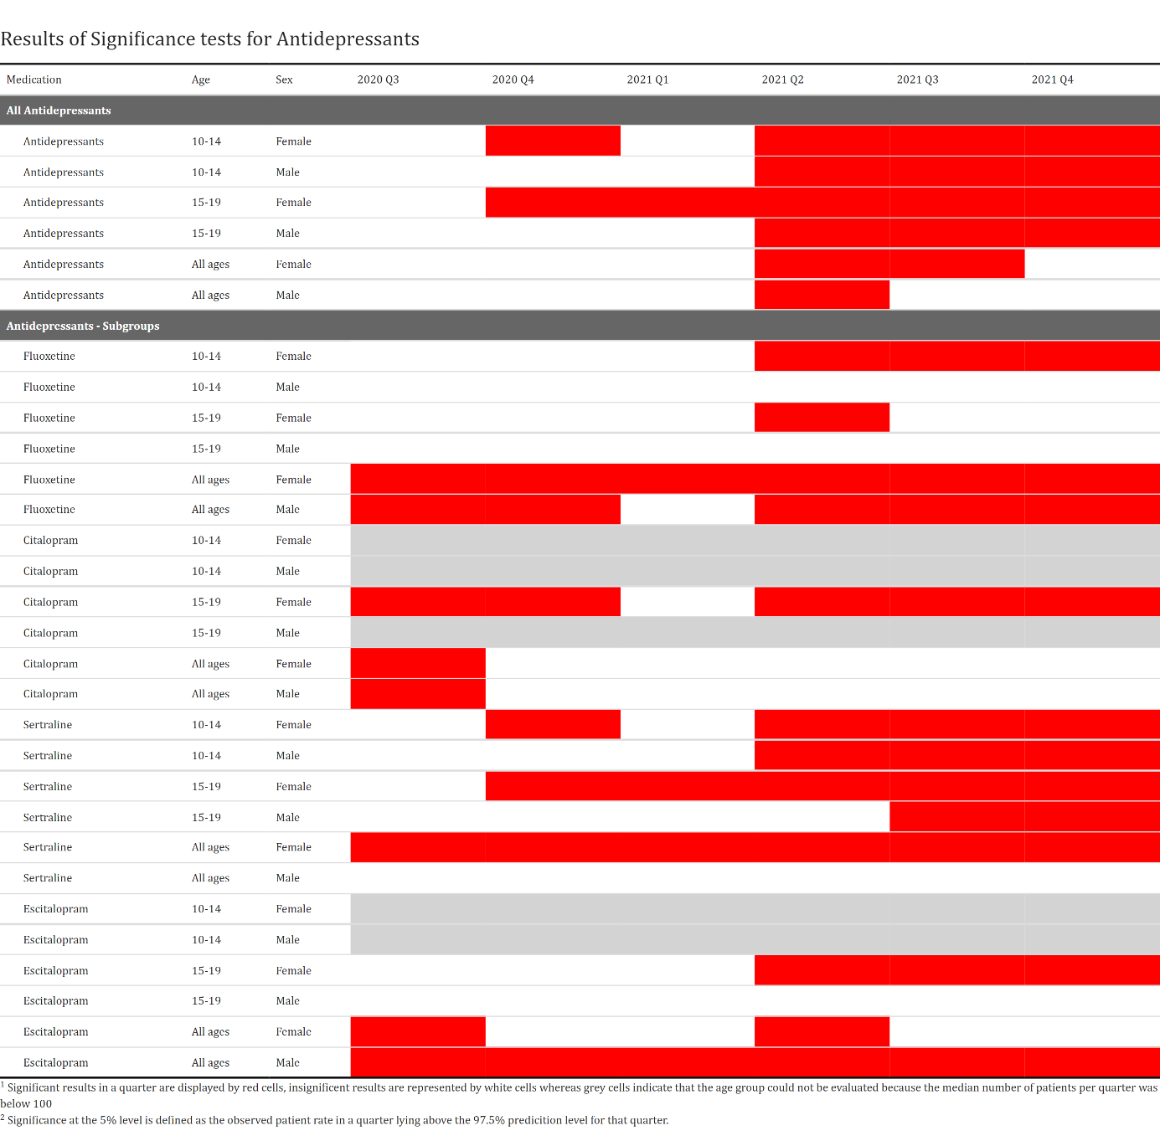
Appendix graph 5: Results of significance tests for Antipsychotics
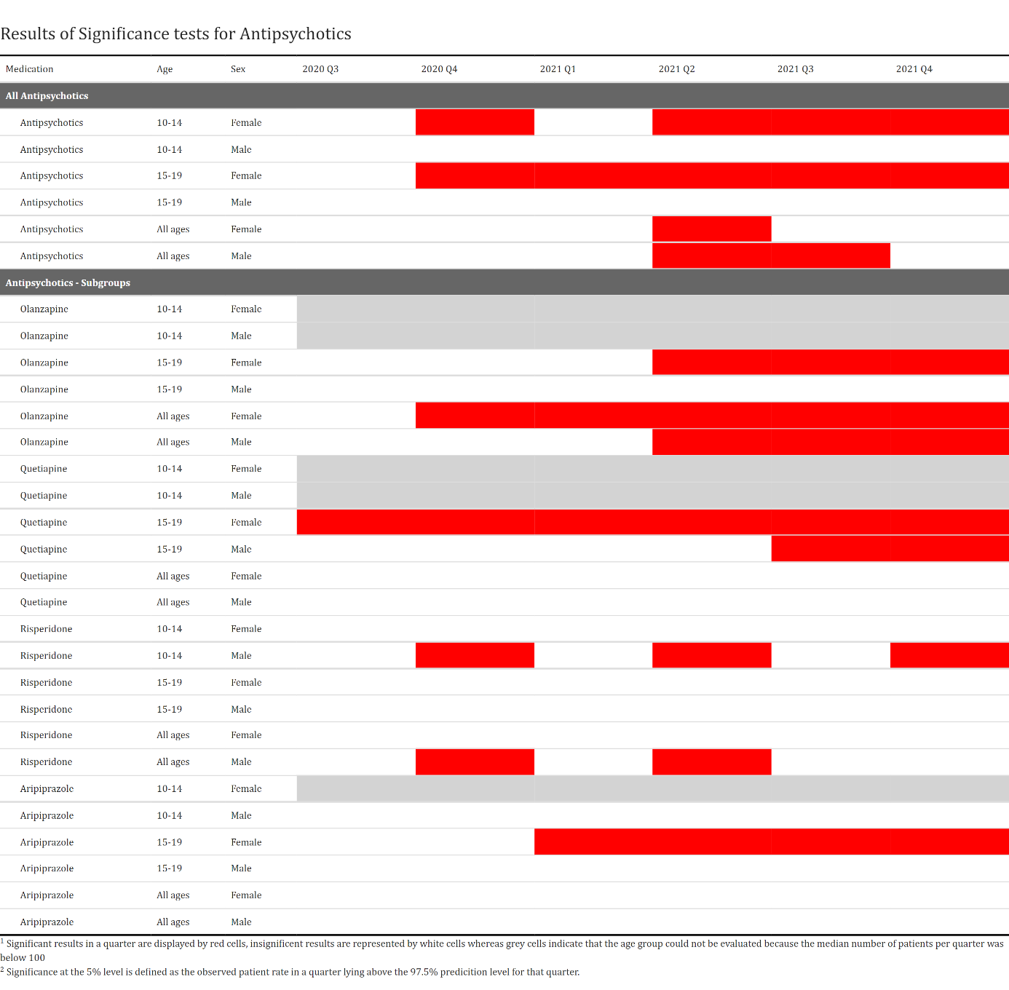
Appendix graph 6: Results of significance tests for Benzodiazepines
