Supplementary materials for
Resting-state EEG measures cognitive impairment in Parkinson’s disease

Supplementary Table S1: Performance summary of the LEAPD in 5-fold and 10-fold cross-validation
 |  | 100 x 5-fold CV |  |  | 100 x 10-fold CV
 |  | All participants | Parkinson’s disease only | Controls  only | All participants | Parkinson’s disease only | Controls  only
Spearman’s-rho correlation with cognitive measures | MoCA | 0.67*** | 0.64*** | 0.46*** | 0.68*** | 0.66*** | 0.46***
Spearman’s-rho correlation with cognitive measures | NIH PVT | 0.63*** | 0.68*** | 0.51*** | 0.64*** | 0.69*** | 0.52***
Spearman’s-rho correlation with cognitive measures | NIH PCPST | 0.58*** | 0.57*** | 0.09*** | 0.58*** | 0.57*** | 0.11***
Spearman’s-rho correlation with cognitive measures | NIH DCCST | 0.66*** | 0.66*** | 0.64*** | 0.68*** | 0.69*** | 0.67***
Spearman’s-rho correlation with cognitive measures | NIH FICAT | 0.60*** | 0.59*** | 0.46*** | 0.61*** | 0.60*** | 0.47***
Spearman’s-rho correlation with cognitive measures | NIH PSMT | 0.55*** | 0.53*** | 0.03** | 0.56*** | 0.54*** | 0.03**
Linear  regression  model for MoCA | $$R^{2}$$ | 0.37 | 0.34 | 0.31 | 0.38 | 0.35 | 0.32
Linear  regression  model for MoCA | RMSE | 0.12 | 0.12 | 0.10 | 0.12 | 0.12 | 0.10
Linear  regression  model for MoCA | F-statistic | 8800.46*** | 5043.47*** | 2175.08*** | 9315.00*** | 5361.56*** | 2348.82***
Linear  regression  model for MoCA | AIC | -21768.18 | -14125.02 | -8799.03 | -21829.22 | -14231.11 | -8802.15
Linear  regression  model for MoCA | Log-likelihood | 10887.09 | 7065.51 | 4402.51 | 10917.61 | 7118.56 | 4404.08
Quadratic  regression model for MoCA | $$R^{2}$$ | 0.44 | 0.42 | 0.34 | 0.45 | 0.44 | 0.36
Quadratic  regression model for MoCA | RMSE | 0.11 | 0.11 | 0.10 | 0.11 | 0.11 | 0.10
Quadratic  regression model for MoCA | F-statistic | 5828.74*** | 3654.98*** | 1284.82*** | 6202.83*** | 3899.21*** | 1383.83***
Quadratic  regression model for MoCA | AIC | -23462.63 | -15527.00 | -9063.35 | -23617.64 | -15702.14 | -9075.83
Quadratic  regression model for MoCA | Log-likelihood | 11735.31 | 7767.50 | 4535.68 | 11812.82 | 7855.07 | 4541.92
Detection of MoCA-based cognitive impairment | Accuracy % | 80.50 | 78.88 | 83.80 | 80.97 | 78.82 | 85.35
Detection of MoCA-based cognitive impairment | AUC | 0.89 | 0.89 | 0.83 | 0.90 | 0.89 | 0.84
Detection of MoCA-based cognitive impairment | Sensitivity % | 78.80 | 82.00 | 63.36 | 80.06 | 82.85 | 66.64
Detection of MoCA-based cognitive impairment | Specificity % | 81.78 | 75.36 | 89.71 | 81.65 | 74.28 | 90.76
Detection of MoCA-based cognitive impairment | PPV % | 76.50 | 78.96 | 64.06 | 76.66 | 78.41 | 67.62
Detection of MoCA-based cognitive impairment | NPV % | 83.67 | 78.78 | 89.43 | 84.47 | 79.34 | 90.38
Detection of MoCA-based cognitive impairment | Odds ratio | 16.68 | 13.93 | 15.06 | 17.86 | 13.94 | 19.60

Abbreviations: CV = Cross-validation; RMSE = root mean squared error; PPV = Positive predictive value; NPV = Negative Predictive value; AIC = Akaike information criterion; AUC = Area under the receiver operating characteristic curve; MoCA = Montreal Cognitive Assessment; NIH = National Institutes of Health; PVT = Picture vocabulary test; FICAT = Flanker inhibitory control and attention test; DCCST = Dimensional change card sorting test; PCPST = Pattern comparison processing speed test; PSMT = Picture sequence memory test. All cross-validations were repeated 100 times with data shuffling and results were averaged. For the regression models, p values show the statistical significance of the predictor variable (combined LEAPD index). In all cases, p value <0.001***, <0.01**.
Supplementary Table S2: LEAPD performance for leave-one-out cross-validation after shuffling scores of cognitive measures

 |  | All participants | Parkinson’s disease only | Controls  only
Spearman’s-rho correlation with cognitive measures | MoCA | 0.02 | 0.05 | -0.07
Spearman’s-rho correlation with cognitive measures | NIH PVT | 0.06 | 0.12 | -0.05
Spearman’s-rho correlation with cognitive measures | NIH PCPST | -0.1 | -0.12 | -0.09
Spearman’s-rho correlation with cognitive measures | NIH DCCST | -0.05 | -0.01 | -0.07
Spearman’s-rho correlation with cognitive measures | NIH FICAT | 0.08 | 0.21* | -0.11
Spearman’s-rho correlation with cognitive measures | NIH PSMT | 0.04 | 0.09 | -0.06
Linear  regression  model for MoCA | $$R^{2}$$ | 0.01 | 0.02 | <0.01
Linear  regression  model for MoCA | RMSE | 0.09 | 0.09 | 0.08
Linear  regression  model for MoCA | F-statistic | 1.40 | 1.63 | 0.01
Linear  regression  model for MoCA | AIC | -293.35 | -189.11 | -103.08
Linear  regression  model for MoCA | Log-likelihood | 149.68 | 97.56 | 54.54
Quadratic  regression model for MoCA | $$R^{2}$$ | 0.02 | 0.03 | 0.01
Quadratic  regression model for MoCA | RMSE | 0.09 | 0.09 | 0.08
Quadratic  regression model for MoCA | F-statistic | 1.16 | 1.26 | 0.21
Quadratic  regression model for MoCA | AIC | -292.29 | -188.02 | -102.51
Quadratic  regression model for MoCA | Log-likelihood | 150.14 | 98.01 | 54.75
Detection of MoCA-based cognitive impairment | Accuracy % | 50.34 | 50.00 | 51.02
Detection of MoCA-based cognitive impairment | AUC | 0.49 | 0.51 | 0.51
Detection of MoCA-based cognitive impairment | Sensitivity % | 54.69 | 50.00 | 63.64
Detection of MoCA-based cognitive impairment | Specificity % | 47.06 | 50.00 | 40.74
Detection of MoCA-based cognitive impairment | PPV % | 43.75 | 42.00 | 46.67
Detection of MoCA-based cognitive impairment | NPV % | 57.97 | 58.00 | 57.89
Detection of MoCA-based cognitive impairment | Odds ratio | 1.07 | 1.00 | 1.20

Abbreviations: RMSE = root mean squared error; AUC = Area under the receiver operating characteristic curve; AIC = Akaike information criterion; PPV = positive predictive value; NPV = negative predictive value; MoCA = Montreal Cognitive Assessment; NIH = National Institutes of Health; PVT = Picture vocabulary test; FICAT = Flanker inhibitory control and attention test; DCCST = Dimensional change card sorting test; PCPST = Pattern comparison processing speed test; PSMT = Picture sequence memory test. Statistical test p value <0.05*.

Supplementary Figure S3
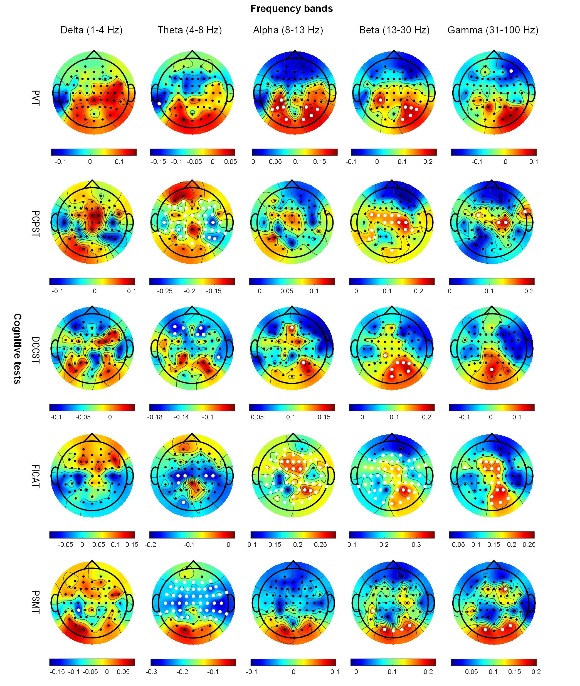
Correlation between EEG spectral powers and cognitive tests from NIH-Toolbox. Topographic plots show age-adjusted spearman’s rho correlation between delta, theta, alpha, beta and gamma power of EEG and five cognitive tests from NIH-Toolbox. Electrodes with statistically significant correlations (p-value< 0.05) are marked with white dots. PVT = Picture vocabulary test; FICAT = Flanker inhibitory control and attention test; DCCST = Dimensional change card sorting test; PCPST = Pattern comparison processing speed test; PSMT = Picture sequence memory test
Supplementary Figure S4
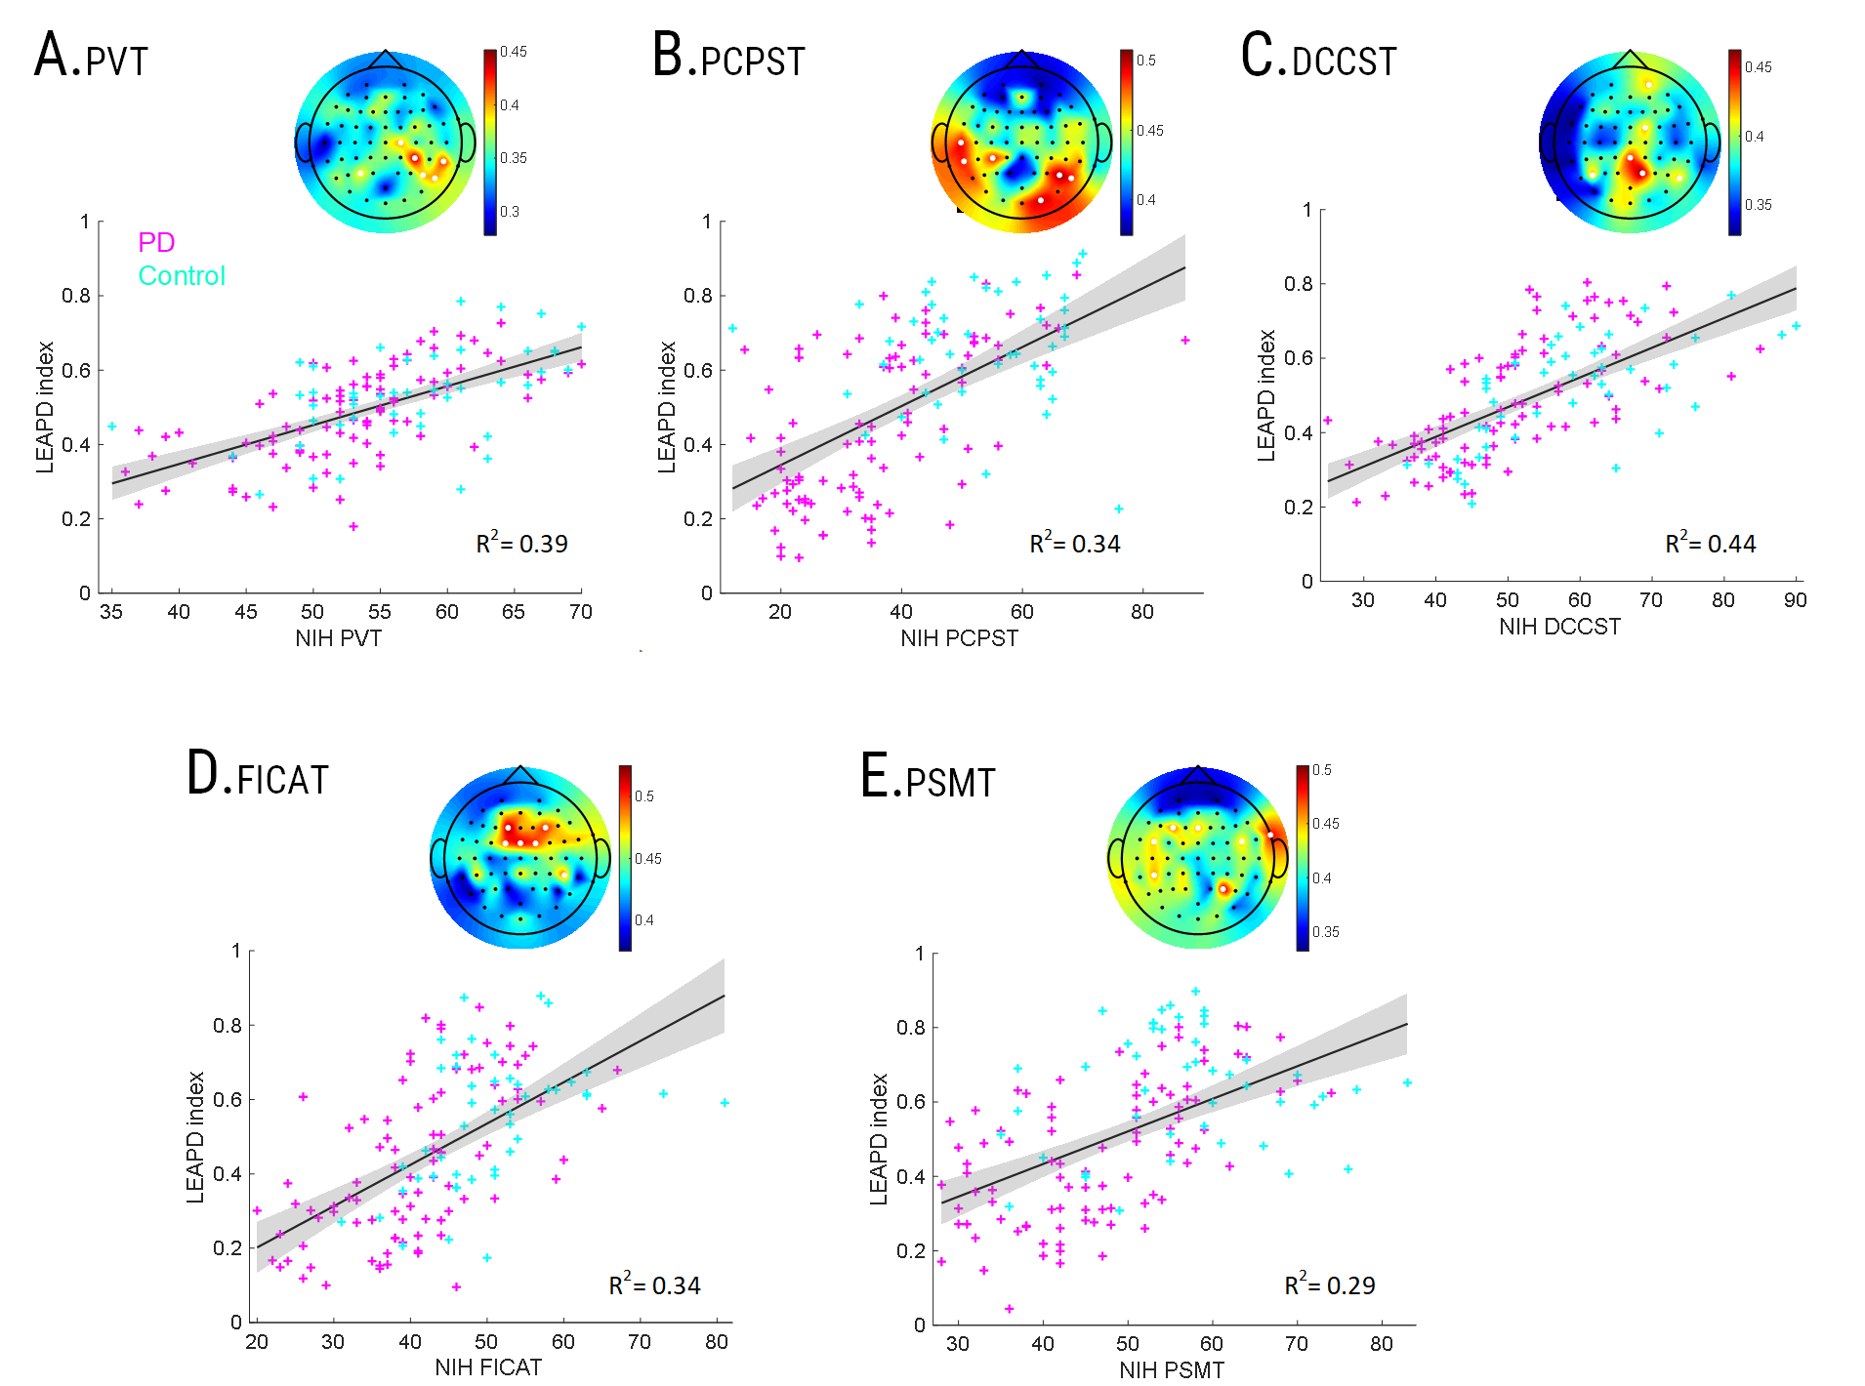
Performance of LEAPD for cognitive tests from NIH-Toolbox in leave-one-out cross-validation. Scatter plots for the linear regression models between the cognitive test scores and LEAPD indices for all participants ( n=149) with (pink) and without PD (cyan). The solid line shows a linear fit to the data with 95% confidence intervals (shaded regions). LEAPD was trained individually for each case and hyperparameters were optimized. The topographic plots show correlations between single-electrode LEAPD indices and cognitive test scores during optimal parameter selection and the selected electrodes (marked as white dots) for generating the combined LEAPD index for each case. PD = Parkinson’s disease, PVT = Picture vocabulary test; FICAT = Flanker inhibitory control and attention test; DCCST = Dimensional change card sorting test; PCPST = Pattern comparison processing speed test; PSMT = Picture sequence memory test

Supplementary Video S5
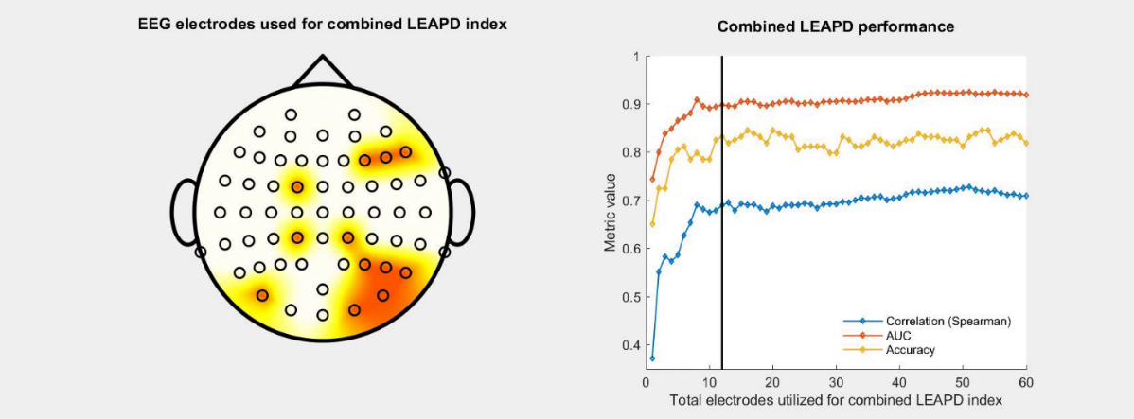
Performance of LEAPD with varying EEG electrodes. Effect of the total number of selected EEG electrodes for the combined LEAPD index on performance during leave-one-out cross-validations with 149 participants. The topographical plot on the left panel highlights the selected EEG electrodes utilized for generating the combined LEAPD index. Selected EEG electrodes are marked in orange. The order of the selected electrodes was determined by their individual performances of the single-electrode LEAPD index in 10-fold cross-validation (Fig. 2B). Concurrently, the right panel shows the performance of the combined LEAPD index (generated by the selected EEG electrodes) in Spearman’s rho correlation with MoCA scores (blue), classifier accuracy (yellow), and AUC (red). The black vertical marker shows the current performance corresponding to the left panel. Abbreviation: AUC = Area under the receiver operating characteristic curve.

Supplementary Figure S6
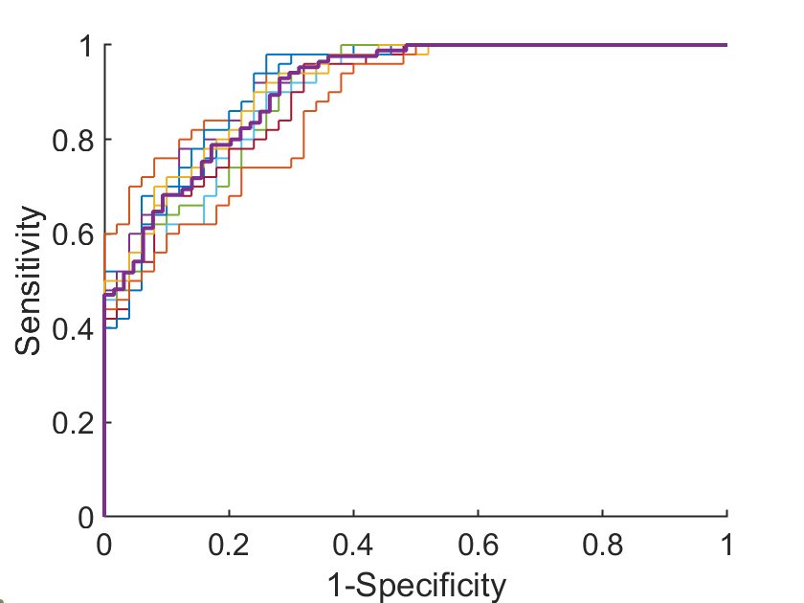
Performance of LEAPD in balanced groups during leave-one-out cross-validation: Light lines (n=10) show receiver operative characteristic (ROC) curves of LEAPD after randomly sub-sampling the dataset with 50 cognitively impaired and 50 cognitively normal participants after leave-one-out cross-validation. The thick line shows ROC curve for the full dataset.

Appendix A1: LEAPD approach for indexing cognitive function
Linear predictive coding rapidly encodes EEG time series by modeling each EEG data using preceding samples. The number of preceding samples used to model EEG data (the LPC order) dictates the level of detail captured for spectral profiles. Fundamentally, LPC fits an autoregressive model to a time series. Suppose, one has a time series with $N$ samples: $x\left(0\right),x\left(1\right),….x\left(N-1\right)$. Then, in $K$-th order LPC model, $x(n)$ is approximated by $n$ preceding data samples
$$x\left(n\right)=e\left(n\right)-\sum_{i=1}^{K}{a_{i}x\left(n-i\right)} (1)$$
where $a_{i} (i=1,2,…K)$ are the $K$ model parameters which are also known as LPC coefficients and $e(n)$ is the LPC model’s prediction error. Thus, given an EEG time series $x\left(0\right),x\left(1\right),….x\left(N-1\right)$ with N samples, LPC of order K generates $K$ number of LPC coefficients, ($a_{1}, a_{2},.., a_{K})$. These LPC coefficients (model parameters) represent a compressed encoding of the spectral density of the time series. The LPC vectors were created using the LPC coefficients $(a={\left[a_{1}, a_{2}… a_{K}\right]}^{T})$ in the LEAPD approach. In the multidimensional space of these model parameters, separate distinct affine subspaces are formed by EEG data from PD and control participants. LEAPD was originally designed to provide a diagnostic index for PD using the ratio of normalized distances from these affine subspaces¹.
Principal component analysis was used to identify these affine subspaces for each EEG electrode, and each single-electrode LEAPD index was calculated by taking the normalized distances from these subspaces. In particular, suppose the LPC order is K and the number of desired principal components is n. Assuming that there is a total $S$ number of participants with normal cognition and with cognitive impairment in the training dataset, the set for the vectors of LPC coefficients from S cognitively impaired subjects is $V_{1}$ with a dimension of $S×K$. The $i^{th}$ row of$V_{1}$ is the LPC vector $a_{1,i} ;i∈\{1,2,..,S\}$ for $i^{th}$ subject with cognitive impairment. Similarly, let $V_{2}$ be the set for the vectors of LPC coefficients from $S$ subjects with normal cognition where the $i^{th}$ row of$V_{2}$ is the feature vector $a_{2,i};i∈\{1,2,..,S\}$ for the $i^{th}$ subject. Let $m_{1}∈ R^{1×K}$ and $m_{2}∈ R^{1×K}$ be the bias vectors of $V_{1}$ and $V_{2}$ respectively where each element $m_{c,i}$ is the mean of the $i^{th}$ column of $V_{c}$ where $c∈\{1,2\}$. Now, let $W_{1}$ and $W_{2}$ be the scaled and unbiased form of $V_{1}$ and $V_{2}$. Therefore,
$$W_{c}=\frac{V_{c}-{\left(D_{c} Q\right)}^{T}}{\sqrt{S-1}} ;c∈\{1,2\} (2)$$
where,
$$D_{c}=\left[\begin{matrix}m_{c,1} & ⋯ & 0 \\ ⋮ & ⋱ & ⋮ \\ 0 & ⋯ & m_{c,K}\end{matrix}\right] ;c∈\left\{1,2\right\} (3)$$
and $Q∈ R^{K×S}$ with $Q_{ij}=1 ∀i,j$. Finally, by performing singular value decomposition on $W_{1}$ and $W_{2}$ we get,
$$W_{c}=U_{c}Σ_{c}P_{c}^{T} ;c∈\left\{1,2\right\} (4)$$
where the matrices $U_{c}, P_{c} ;c∈\{1,2\}$ are left and right matrices with orthonormal basis vectors and $Σ_{1}$and $Σ_{2}$ are diagonal matrices containing the singular values of $W_{1}$and $W_{2}$. Thus, the basis vectors forming $n$ dimensional affine subspace for cognitive impairment are the first $n$ columns of $P_{1}$corresponding to the $n$ most significant singular values. We denote these orthonormal vectors by $p_{1,1},p_{1,2},⋯,p_{1,n}$. Similarly, from $P_{2}$ we can obtain the $n$ orthonormal basis vectors for the affine subspace for normal cognition which are denoted by $p_{2,1},,p_{2,2},⋯,p_{2,n}$. Now, suppose the vector of LPC coefficients from a new participant is $a$. Then, LEAPD determines the normalized distance $D_{1}$ and $D_{2}$ from point $a$ to the respective affine subspaces for cognitive impairment and normal cognition. These distances are calculated by:
$$D_{c}={\left\|(a-m_{c}) -\sum_{i=1}^{n}{\frac{p_{c,i}^{T}(a-m_{c})}{p_{c,i}^{T} p_{c,i}} }p_{c,i}\right\|}_{2} ;c∈\left\{1,2\right\}. (5)$$
Finally, the LEAPD index ($ρ$) was calculated by taking the ratio of these normalized distances:
$$ρ= \frac{D_{2}}{D_{2}+D_{1}}. (6)$$
LEAPD indices ($ρ$) ranged between 0 and 1, with high values corresponding to high MoCA scores. In particular, if $ρ<0.5$, then the vector $a$ is closer to the subspace with cognitive impairment, and when $ρ>0.5$, it is closer to the subspace for normal cognition. We specified a LEAPD index value cut-off of <0.5 to represent cognitive impairment which was determined principally by the relative distances from the affine subspaces of normal cognition and cognitive impairment. Before calculating the index, a zero phase, 6th order, Butterworth bandpass filter was applied to control the frequency region of the spectral profiling. After independently obtaining the single-electrode LEAPD index from multiple EEG electrodes, the indices were combined using their geometric mean to obtain a combined LEAPD index. In particular, after obtaining single-electrode LEAPD indices from $L$ electrodes $ρ_{i};i∈\{1,2,…,L\}$, they were combined into a combined LEAPD index using geometric mean:
$$ρ_{combined}=\frac{1}{L}\prod_{i=1}^{L}{ρ_{i}}. (7)$$
To optimize cognitively impaired and cognitively normal affine subspaces, we explored four key parameters: a) frequency range of the bandpass filter between 2-34 Hz, b) order of linear predictive coding between 2 and 10, c) affine subspace dimensions and d) optimal EEG electrodes for the combined LEAPD index. The first three parameters were optimized for each EEG electrode by conducting an exhaustive search and maximizing Spearman’s rho correlation of the single-electrode LEAPD indices with MoCA scores using a single round of 10-fold cross-validation. After optimizing these three parameters for all EEG electrodes, we selected the optimal EEG electrodes based on their best individual performance during the exhaustive search.
Similarly to the MoCA score, utilizing LEAPD for cognitive tests from NIH-Toolbox was achieved by identifying affine subspaces for high cognitive scores and low cognitive scores. For each of the cognitive tests from NIH-Toolbox, the median of the cognitive scores across all participants was used as a cutoff to divide participants into high and low-score cognitive groups.

Appendix A2: Performance evaluation
We calculated spectral power in the delta (1−4 Hz), theta (4−8 Hz), alpha (8−13 Hz), beta (13−30 Hz), and gamma (31−100 Hz) bands for our traditional EEG spectral analyses. The spectral powers were calculated for each participant using all individual EEG electrodes. There were 300 spectral features for each participant and 44,700 measurements from the whole dataset, with the dimensions of 5 bands × 149 participants × 60 electrodes. We also calculated the log spectral ratio of alpha and theta band power. We calculated age-adjusted partial Spearman’s rho correlations between cognitive scores and these spectral features which we compared with the correlation between the cognitive score and the combined LEAPD index.
LEAPD performance was quantified using nonparametric Age-adjusted Spearman’s rho partial correlation. To further explore LEAPD’s relationship with MoCA, we used regression analysis, in which we considered linear and quadratic models. We inspected six metrics during regression: R²; root-mean-square error of the combined LEAPD index; F-test on the regression model; Akaike information criterion; and log-likelihood. To quantify classification results, we used sensitivity, specificity, classifier accuracy rate, area under the receiver operating characteristic curve (AUC), positive predictive value, negative predictive value, and odds ratio. To validate our results, we performed leave-one-out cross-validations using all participants with 1) their true cognitive scores and 2) after randomly shuffling cognitive scores among participants (randomization test). We also performed 5-fold and 10-fold cross-validations in 100 independent rounds of data shuffling.
For investigating how the total number of selected EEG electrodes for the combined LEAPD index influenced performance, we utilized leave-one-out cross-validation and calculated Spearman’s rho correlation coefficient, classifier accuracy rate, and AUC. The electrodes were selected based on the order (high to low) of their individual single-electrode LEAPD performances of MoCA correlations (Fig 2C). In addition, we investigated how the total number of selected EEG electrodes for the combined LEAPD index influenced performance and the robustness of the LEAPD approach by using truncation analysis to quantify the effect of EEG signal length (i.e., duration of EEG data) on performance. For investigating the robustness of the LEAPD approach in truncation analysis, we started with the full EEG dataset (average EEG length: 2.7 min), gradually truncated the dataset up to 10% with 5% increments, and quantified performance for each case using leave-one-out cross-validation. Truncation was applied to the EEG data from all participants starting from the end of EEG recordings. We repeated the same procedure to the MoCA-shuffled dataset and compared the performance.

Appendix A3: Statistical analysis
Because some of our data didn’t follow normal distributions and there were statistically significant differences in the age of the participants at group-level, we used non-parametric Spearman (rank) partial correlation (controlling for the age) for correlations (‘partialcorr’ function in Matlab and ‘pcor’ command in R) and two-sided non-parametric Wilcoxon rank-sum tests. We also tested whether PD had any statistically significant impact on the correlation between the combined LEAPD index and MoCA score using linear mixed-effect models. To compare regression models, we used the likelihood ratio test. All statistical procedures were performed using MATLAB 2021b and R (version 4.1.2). All data and statistical analyses were reviewed by the Biostatistics and Research Design Core in the Institute for Clinical and Translational Science at the University of Iowa.

Reference:
1 Anjum, M. F. et al. Linear predictive coding distinguishes spectral EEG features of Parkinson's disease. Parkinsonism & Related Disorders 79, 79-85, doi:10.1016/j.parkreldis.2020.08.001 (2020).

