SUPPLEMENTARY INFORMATION

Sponge-derived matter is assimilated by coral holobionts

Authors: Reigel, A.M.¹, Easson, C.G.², Apprill, A.³, Freeman, C.J.⁴, Bartley, M.M.¹, Fiore, C.L.¹

Institutions:
¹Department of Biology, Appalachian State University
²Department of Biology, Middle Tennessee State University
³Marine Chemistry and Geochemistry, Woods Hole Oceanographic Institution
⁴Department of Biology, College of Charleston

Corresponding Author:
Name: Alicia M. Reigel
Current Affiliation: Department of Biology, Appalachian State University
Mailing Address: 572 Rivers St., Boone, NC 28607
Email: reige012@gmail.com

Table of Contents
SUPPLEMENTARY METHODS 3
Processing of Enriched Water Samples 3
Coral and Symbiodiniaceae Separations 3
Coral Surface Area Measurements 4
Symbiodiniaceae Density 5
Stable isotope analysis equations 5
SUPPLEMENTARY TABLES 7
Supplementary Table S1. Total counts of sponge, coral and Symbiodiniaceae samples 7
Supplementary Table S2. Mean δ¹³C and δ¹⁵N for sponge, coral, and Symbiodiniaceae tissues. 8
Supplementary Table S3. Incorporation of¹³C & ¹⁵N by coral and Symbiodiniaceae tissues. 9
Supplementary Table S4. PERMANOVA Test Results 10
SUPPLEMENTARY FIGURES 14
Supplementary Figure S1. ‘Pulse-chase’ experimental setup visualization 14
Supplementary Figure S2. Surface area (cm²) of coral fragments 15
Supplementary Figure S3. DOC & TN concentrations in ‘pulse’ seawater samples 15
Supplementary Figure S4. Molar C:N ratio of non-enriched coral & Symbiodiniaceae tissues. 16
Supplementary Figure S5. Symbiodiniaceae density in coral tissues. 17
SUPPLEMENTARY RESULTS 18
Pairwise PERMANOVA Test Results 18
REFERENCES 22

SUPPLEMENTARY METHODS

Processing of Enriched Water Samples

During the ‘pulse-chase’ experiment, six 500 ml enriched water samples (n=3 from the ‘pulse’ and n=3 from a subset of the sponge-containing aquaria ~1.5 hrs into the ‘chase’) were collected in acid-washed polycarbonate bottles for bulk dissolved organic carbon (DOC) and total nitrogen (TN) analysis. Note that the tank water used for the ‘pulse’ was 0.22 µm filtered and the labeled bicarbonate provided is inorganic, thus, the DOC was composed of both background from the seawater and sponge-derived DOC. For the ‘chase’ samples, the water in the aquaria was not pre-filtered, so DOC sources include tank seawater, sponge- and coral-derived DOC, and possibly a small contribution from microbial production. TN includes both organic and inorganic nitrogen compounds, and for the ‘pulse’ was composed of background nitrogen, the labeled inorganic compounds, and sponge-derived NDM. For the ‘chase’ the labeled compounds are replaced with possible microbe- and coral-produced NDM, though we expect this contribution was minimal.

Each enriched water sample was individually passed through a polytetrafluoroethylene (PTFE) 0.22 µm, 47 mm filter (Omnipore, EMD Millipore Corporation, Billerica, MA, USA) encased in an acid-washed in-line perfluoroalkoxy alkane (PFA) filter holder (Advantec, Cole-Parmer, Vernon Hills, IL, USA) using peristalsis (MasterFlex L/S pump and pump heads, Cole-Parmer, Vernon Hills, IL, USA). All filter tubing (Masterflex® L/S® Precision Pump Tubing, PharMed® BPT, L/S 25, Radnor, PA, USA) was acid-washed. Filtering rates were kept slow to avoid the bursting of microbial cells on the filter membrane which could cause sample contamination. Subsamples of the filtrate (25 ml) were collected in acid-washed, combusted 40ml amber EPA vials and acidified to pH 3 with 12M trace metal grade hydrochloric acid (HCL, OptimaTM, Fisher Chemical, Fisher Scientific, Hampton, NH, USA). EPA vials were wrapped in tinfoil to limit light exposure and stored at 4 ºC. The acidified samples were sent to Woods Hole Oceanographic Institute for dissolved organic carbon (DOC) and total dissolved nitrogen (TN) analysis using a Shimadzu TOC-V_{CSH}TOC analyzer¹.

Coral and Symbiodiniaceae Separations
To prepare for downstream analyses, the coral fractions, host and symbiotic micro-algae (family Symbiodiniaceae), were manually separated. Symbiodiniaceae encompasses a diverse set of unicellular dinoflagellates² and corals are largely associated with those belonging to seven genera³. We did not genotype the dinoflagellates recovered in this study, so the terms ‘symbiotic micro-algae’ and ‘Symbiodiniaceae’ are used to refer to any species of dinoflagellate that separated out during this process. Scleractinian fragments were thawed and airbrushed with an aerosolized jet of 0.22 µm filtered seawater to physically separate the coral tissue and skeleton and suspend the coral tissue material into a homogenate. To separate host tissue from Symbiodiniaceae cells, the homogenate was centrifuged at 2000 x g for 3-5 minutes. Centrifugation formed a pellet comprised of Symbiodiniaceae cells and a homogenate of host material. The host homogenate was pipetted into a separate sterile 50 ml Falcon tube. The homogenate, Symbiodiniaceae pellet, and skeletal fragments were frozen and transported to Appalachian State University where they were stored at -20 C until further processing. At Appalachian State, host homogenates and Symbiodiniaceae pellets were thawed and checked for purity. Impure fractions were recombined, homogenized with a tissue homogenizer (maximum speed for ~15 sec) to physically separate Symbiodiniaceae cells from host tissue, and centrifuged (3000 x g, 6 min.) to pellet the Symbiodiniaceae cells. Following centrifuging, fractions were checked for purity under the microscope, and the process was repeated until at least 80% purity was reached.
E. flexuosa fractions were separated using a different process. First, the frozen coral fragments were lyophilized (Labconco™ FreeZone™ Bulk Tray Dryer) for 22-24 hours, until they were completely dry. Following lyopholization, the axial skeleton was removed, and the tissue was ground up using a mortar and pestle. Separate mortar and pestle sets were used for control and enriched samples. The ground tissue was weighed and then rehydrated in 10 ml of MilliQ water in a sterile 15 ml Falcon tube. Very quickly following rehydration, the sclerites (skeletal fragments) sank to the bottom of the tube and the remaining host homogenate was pipetted into a new tube taking care not to transfer the sclerites. The host homogenate was homogenized further using a tissue homogenizer for ~15 sec at maximum speed and centrifuged at 4000 x g for 5 minutes to separate the fractions. The centrifugation step was repeated as necessary until the host homogenate and Symbiodiniaceae pellets were at least 80% pure.
Following fraction separations, 50 ml of the Symbiodiniaceae fraction from each sample was transferred to a cryovial with 50 ml of 10% paraformaldehyde (PFA) to fix the cells for Symbiodiniaceae density estimates. Fixed Symbiodiniaceae samples were stored in the 4°C refrigerator. The pure host homogenates and remaining Symbiodiniaceae pellets were stored in the -20°C freezer.

Coral Surface Area Measurements
Surface area was calculated for coral fragments following two well-documented methods: Image J measurements and the aluminum foil method⁴. ImageJ coral surface area measurements were completed utilizing planar photography and ImageJ software⁵. For A. cervicornis and O. faveolata, fragment surface area was measured using the frozen, airbrushed skeleton for each sample, while for E. flexuosa, the entire fragment, prior to lypopholization as detailed above, was used. To obtain images of A. cervicornis and E. flexuosa, the fragments were held at an upright position, similar to their natural growth direction, and photographed from four sides (rotated 90°). O. faveolata are dome-shaped mounding corals, so photographs were only taken from above. A ruler was held in alignment with the fragments for scaling purposes. Photographs were individually uploaded to ImageJ and pixel dimensions were set using the straight-line tool and ‘set scale’ option. Using the polygon tool to drag an outline around the perimeter of the fragment, the enclosed area was calculated with the ‘measure’ function (in cm²). The area of all four sides was summed to estimate the surface area of the skeletal fragment.
The aluminum foil method was completed based on published methods⁴, but briefly, small pieces of aluminum foil were cut and carefully measured (cm²) and weighed (g) to obtain a standard weight per unit of area (g/cm²) for the foil. The foil used in this study had a standard weight per unit of area of 0.00618 g/cm². Coral fragments were carefully covered with aluminum foil and all excess foil was trimmed until there was no overlap. Each foil wrapping was carefully removed from the fragment, and weighed. The fragment surface area was calculated using the standard weight per unit area of the aluminum foil (Surface area of coral fragment = mass of coral fragment foil*0.006180525794 g/cm²). All surface measurement data is publicly available at https://www.bco-dmo.org/dataset/880711⁶.

Symbiodiniaceae Density
Symbiodiniaceae density (cells/cm²) was estimated for each coral fragment using the following procedure. First, 20 μl of the PFA-fixed Symbiodiniaceae cells from each sample were stained with either 2 μl (E. flexuosa) or 5 μl (A. cervicornis and O. faveolata) of Trypan Blue to increase their visibility under the microscope. If the cells were too numerous to be counted accurately, they were further diluted with 175 μl of MilliQ water. A subsample (10 μl) of the dilution was then placed into the cell counting chamber of a hemocytometer (Marienfeld Superior Neubauer Improved Chamber) and cells were counted in 4 quadrants following the standard Neubauer protocol as suggested by Electron Microscopy Sciences (https://www.emsdiasum.com/microscopy/technical/datasheet/68052-14.aspx). Cell counts from all quadrants were summed. Symbiodiniaceae abundance in the dilution (cells/ml dilution) for each fragment was obtained by multiplying the total cell count by the dilution factor and the standard cell abundance for the hemocytometer (10,000 cells/ml per manufacturer) and dividing by the number of quadrants counted (4).
$$Dilution Abundance \left(cells/ml dilution\right)=\frac{cell count*Dilution Factor*10,000}{4}$$
Total Symbiodiniaceae abundance (cells/ml) per fragment was estimated by standardizing the dilution abundance to the total volume of its host homogenate (ml).

$Symbiodiniaceae Abundance (cells/ml)=Dilution Abundance*Volume host homogenate$

Finally, the Symbiodiniaceae density for each fragment was calculated by standardizing the Symbiodiniaceae abundance to the total surface area of the fragment (cm²) as determined by the ImageJ method detailed above.

$$Symbiodiniaceae Density \left(cell/{cm}^{2}\right)=Symbiodiniaceae Abundance*fragment surface area ({cm}^{2})$$

All data associated with the calculation of Symbiodiniaceae densities in the coral fragments is publicly available at https://www.bco-dmo.org/dataset/880711⁶.

Stable isotope analysis equations
Carbon and nitrogen stable isotope ratios are expressed in standard delta notation and calculated using the equation from Fry⁷ as follows:

$δ{}_{ }^{13}C or δ{}_{ }^{15}N=\left[\left(\frac{R_{sample}}{\left(R_{standard}-1\right)}\right)* 1000\right]$,

where R_{sample} is the ratio of ¹³C/¹²C or ¹⁵N/¹⁴N in the sample material (sponge, coral, or Symbiodiniaceae), and R_{standard} is the known ratio of the isotopes in a standard reference material (Vienna Pee Dee Belemnite (VPDB) for C; R_{standard} = 0.011180, and for N; R_{standard}= 0.0036765). The final multiplication by 1000 is meant to amplify any small differences between samples and reference values. Values for δ are reported in permil units (⁰/₀₀), and high δ values indicate enrichment of the heavy isotope while negative δ value indicate a sample depleted in heavy isotopes relative to the standard material.

Then, following the process outlined in Fry⁷, we used the δ values to calculate fractional abundance (F), which is preferred over δ for downstream calculations of enriched samples as it generates less errors. We start by rearranging the definition of δ as:

$R_{sample}=\left[\left(\frac{δ}{1000}\right)+1\right]$ * $R_{standard}$,

where, R_{standard} is the same as previously noted for C and N,

Next, we use R_{sample} to calculate fractional abundance (F_{sample}) of ¹³C or ¹⁵N as follows:

$$F_{sample}=\frac{ δ+1000}{\left(δ+1000\right)+\left(\frac{1000}{R_{standard}}\right)}$$

where δ is the δ¹³C or δ¹⁵N for the sample and the corresponding C or N R_{standard} is used.

We then use F to calculate excess fractional abundance for an enriched sample (E_{sample}) as the difference between the fractional abundance of the enriched sample (F_{sample}) and the average fractional abundance of the background samples (F_{bkgd}), where background samples are all T₀ (i.e., initial) samples for each species and fraction.

$E_{sample}=F_{sample}-F_{bkgd}$.

Next, we used slightly modified versions of the equations put forth in Rix et al.⁸ to calculate total ¹³C or ¹⁵N incorporation and incorporation rate. To calculate total incorporation (I) we multiplied the excess fractional abundance (E_{sample}) by the total C or N content (µmol) of the sample (A_{sample}):

$I=E_{sample}*A_{sample}$.

Lastly, we normalized the ¹³C or ¹⁵N incorporation (I) of each sample to its total C or N content (A_{sample}) and the number of hours the sample was exposed to the isotope (T) during the ‘chase’ (3 or 6 hrs) to obtain a biomass-specific incorporation rate of heavy isotope (IR_{Tracer}) into the tissue of each sample.

${IR}_{Tracer}=\frac{I}{{(A}_{sample}* T)}$.

IR_{Tracer} is reported in the text results, Fig. 3, and Supplementary Table S4 as ‘Incorporation Rate (µmol of ¹³C or ¹⁵N mmol of C or N_{coral or Symbiodiniaceae}⁻¹ hr⁻¹).’ Values of δ13C, δ15N, total carbon and total nitrogen content (µmol of C or N) used in the above calculation are publicly available at https://www.bco-dmo.org/dataset/889857⁹.

SUPPLEMENTARY TABLES

Supplementary Table S1. Total counts of sponge, coral and Symbiodiniaceae samples included at each point during the ‘pulse-chase’ experiment. Black cells indicate that no samples were collected at that time point. Note: There were a total of 8 experimental tanks (3 control, 5 enriched), but several coral and Symbiodiniaceae samples with abnormal ¹³C or ¹⁵N values (high or low depending on expected values for each treatment) were removed in an abundance of caution and this is reflected in the ‘chase’ sample counts.
Species | Total Experimental Samples | Initial  Control Samples  (T=0) | ‘pulse’ Samples | 3-hr ‘chase’ Samples  (T₃) |  |  | 6-hr ‘chase’ Samples  (T₆)
 |  |  |  | CONTROL |  | ENRICHED | CONTROL | ENRICHED
A. cauliformis | 10 | 2 | 3 |  |  |  |  | 5
A. fulva | 9 | 2 | 2 |  |  |  |  | 5
V. rigida | 9 | 2 | 2 |  |  |  |  | 5
N. digitalis | 8 | 2 | 1 |  |  |  |  | 5
C. aculeata | 8 | 2 | 1 |  |  |  |  | 5
I. birotulata | 9 | 2 | 2 |  |  |  |  | 5
A. cervicornis | 19 | 5 |  | 2 | 5 |  | 2 | 5
A. cervicornis Symbiodiniaceae | 19 | 5 |  | 2 | 5 |  | 2 | 5
O. faveolata | 19 | 4 |  | 3 | 5 |  | 2 | 5
O. faveolata Symbiodiniaceae | 19 | 4 |  | 3 | 5 |  | 2 | 5
E. flexuosa | 18 | 5 |  | 2 | 4 |  | 2 | 5
E. flexuosa Symbiodiniaceae | 19 | 5 |  | 3 | 5 |  | 2 | 4

Supplementary Table S2. Mean δ¹³C and δ¹⁵N for sponge, coral, and Symbiodiniaceae tissues throughout the 6-hr ‘pulse-chase’ experiment. ‘Pulse’ column values are from sponge samples collected at the end of the 3-hr ‘pulse.’ T₀, indicates the initial samples taken prior to the start of the experiment, while T₃, and T₆ denote the two sampling times at the mid-point and the end of the ‘chase,’ respectively. Labeled isotopes provided to sponges via dissolved organic bicarbonate (¹³C), ammonia and nitrate (¹⁵N). Bolded red text in the “Change in δ¹³C” and “Change in δ¹⁵N” columns denotes a net loss of the heavy isotope during the ‘chase,’ while bolded blue text denotes a net gain of the heavy isotope during the ‘chase.’ Note that releases and gains are not necessarily significant. ‘ND’ is used to denote an experimental time point where samples were not collected for the indicated group.
 | Tissue Type | δ¹³C (‰) |  |  |  |  | δ¹⁵N (‰)
 | Tissue Type | T₀ | ‘Pulse’ | T₃ | T₆ | Change in δ¹³C  (T₆ - ‘Pulse’) | T₀ | ‘Pulse’ | T₃ | T₆ | Change in δ¹⁵N  (T₆ - ‘Pulse’)
A. cauliformis | Sponge | -18.6 | 10.1 | ND | 0.08 | -10.02 | 3.15 | 661 | ND | 546 | -115
A. fulva | Sponge | -18.3 | 1.55 | ND | 2.96 | 1.41 | 4.3 | 473 | ND | 442 | -31
V. rigida | Sponge | -17.6 | 0.15 | ND | -2.46 | -2.61 | 4.75 | 1274 | ND | 442 | -832
N. digitalis | Sponge | -17.2 | -17.0 | ND | -16.6 | 0.40 | 5.05 | 988 | ND | 137 | -851
C. aculeata | Sponge | -17.4 | -16.8 | ND | -17.4 | -0.60 | 4.05 | 1049 | ND | 121 | -928
I. birotulata | Sponge | -17.6 | -17.4 | ND | -17.9 | -0.50 | 5.65 | 570 | ND | 371 | -199
 |  | T₀ | ‘Pulse’ | T₃ | T₆ | Change in δ¹³C  (T₆ – T₀) | T₀ | ‘Pulse’ | T₃ | T₆ | Change in δ¹⁵N  (T₆ – T₀)
A. cervicornis | Coral | -18.5 | ND | -16.6 | -16.7 | 1.8 | 4.16 | ND | 154 | 273 | 268.84
O. faveolata | Coral | -25.2 | ND | -26.7 | -26.2 | -1 | 5.05 | ND | 110 | 165 | 159.95
E. flexuosa | Coral | -19.4 | ND | -18.6 | -18.0 | 1.4 | 6.38 | ND | 126 | 123 | 129.38
A. cervicornis Symbiodiniaceae | Symbiodiniaceae | -18.4 | ND | -14.8 | -14.4 | 4 | 2.94 | ND | 756 | 1829 | 1826.06
O. faveolata Symbiodiniaceae | Symbiodiniaceae | -26.9 | ND | -22.7 | -23.7 | 3.2 | -1.95 | ND | 102 | 181 | 182.95
E. flexuosa Symbiodiniaceae | Symbiodiniaceae | -17.8 | ND | -16.8 | -15.9 | 1.9 | 6.07 | ND | 80.6 | 104 | 97.93

Supplementary Table S3. Total incorporation (µmol) and incorporation rates (heavy isotope (µmol)/total isotope in tissue (mmol) per hour) of ¹³C and ¹⁵N in sponge-derived dissolved matter by coral and Symbiodiniaceae during the 6-hr ‘chase.’ Data is given for both sampling time points (T₃ and T₆). Bolded blue text in T₆ columns denotes a value that is higher than its T₃ counterpart, conversely, bolded red text denotes a T₆ value that is lower than its T₃ counterpart. For total incorporation a blue value at T₆ would suggest a net gain of the heavy isotope in the tissue, and a red value a loss of the heavy isotope, between hours 3-6 of the ‘chase.’ For incorporation rate, a red value in T₆ indicates that the heavy isotope was assimilated into the coral or Symbiodiniaceae tissue faster in the first half of the ‘chase,’ while a blue value indicates a faster rate in the last half of the ‘chase.’ A bolded black value in either column indicates no difference across ‘chase’ time points. Note differences are not necessarily significant.
Species and Fraction | Carbon (¹³C) Incorporation |  |  |  | Nitrogen (¹⁵N) Incorporation
Species and Fraction | T₃ |  | T₆ |  | T₃ |  | T₆
Species and Fraction | Incorporation (µmol) | Incorporation Rate  (µmol ¹³C mmol C_{coral or Sym}⁻¹ hr⁻¹) | Incorporation (µmol) | Incorporation Rate  (µmol ¹³C mmol C_{coral or Sym}⁻¹ hr⁻¹) | Incorporation (µmol) | Incorporation Rate  (µmol ¹⁵N mmol N N_{coral or Sym}⁻¹ hr⁻¹) | Incorporation (µmol) | Incorporation Rate  (µmol ¹⁵N mmol N N_{coral or Sym}⁻¹ hr⁻¹)
A. cervicornis | 0.0021 | 0.0069 | 0.0019 | 0.0032 | 0.0066 | 0.1828 | 0.0119 | 0.1633
O. faveolata | -0.0008 | -0.0056 | -0.0004 | -0.0018 | 0.0023 | 0.1281 | 0.0028 | 0.0973
E. flexuosa | 0.0002 | 0.0032 | 0.0003 | 0.0027 | 0.0012 | 0.1454 | 0.0013 | 0.0711
A. cervicornis Symbiodiniaceae | 0.0026 | 0.0132 | 0.0029 | 0.0072 | 0.0288 | 0.9139 | 0.0778 | 1.104
O. faveolata Symbiodiniaceae | 0.0025 | 0.0154 | 0.0019 | 0.0058 | 0.0039 | 0.1267 | 0.0065 | 0.1115
E. flexuosa Symbiodiniaceae | 0.0002 | 0.0035 | 0.0003 | 0.0035 | 0.0009 | 0.0907 | 0.0007 | 0.0746

Supplementary Table S4. PERMANOVA results of multivariate tests reported in the text. Significance was obtained from p-values calculated by permutations of the residuals under a reduced model using 999 unique permutations. Associated post-hoc pairwise PERMANOVAS were completed with Bonferroni corrections and are detailed in the Supplementary Results (pgs. 18-21). Asterisks denote significant differences (p<0.05).
Factor(s) | df | SS | R² | Pseudo-F | P(perm)
a. δ ¹³C for T₀ & enriched coral & Symbiodiniaceae from sampling points T₃ & T₆
Species | 2 | 1234.20 | 0.7373 | 161.9887 | 0.001 *
Fraction | 1 | 60.05 | 0.0389 | 15.7642 | 0.001 *
Time | 2 | 61.76 | 0.0369 | 8.1055 | 0.004 *
Species:Fraction | 2 | 0.91 | 0.0005 | 0.1191 | 0.884
Species:Time | 4 | 12.89 | 0.0077 | 0.8460 | 0.517
Fraction:Time | 2 | 25.06 | 0.0150 | 3.2892 | 0.045 *
Time:Fraction:Species | 4 | 20.14 | 0.0120 | 1.3216 | 0.293
Residual | 68 | 259.05 | 0.1547
Total | 85 | 1674.06
b. δ ¹³C for control coral & Symbiodiniaceae tissues from ‘chase’ sampling points T₀, T₃ & T₆
Species | 2 | 896.05 | 0.9720 | 1314.4441 | 0.001 *
Fraction | 1 | 5.95 | 0.0065 | 17.4657 | 0.001 *
Species:Fraction | 2 | 3.81 | 0.0041 | 5.5848 | 0.011 *
Residual | 47 | 16.02 | 0.0174
Total | 52 | 921.83
c. δ ¹³C for control A. cervicornis coral tissues from ‘chase’ sampling points T₀, T₃ & T₆
Time | 2 | 0.3657 | 0.4175 | 2.1503 | 0.184
Residual | 6 | 0.5100 | 0.5825
Total | 8 | 0.8756
d. δ ¹³C for control A. cervicornis Symbiodiniaceae tissues from ‘chase’ sampling points T₀, T₃ & T₆
Time | 2 | 0.3706 | 0.3961 | 1.9676 | 0.278
Residual | 6 | 0.5650 | 0.6039
Total | 8 | 0.9656
e. δ ¹³C for control O. faveolata coral tissues from ‘chase’ sampling points T₀, T₃ & T₆
Time | 2 | 0.1304 | 0.1028 | 0.2864 | 0.789
Residual | 5 | 1.1383 | 0.8972
Total | 7 | 1.2688
f. δ ¹³C for control O. faveolata Symbiodiniaceae tissues from ‘chase’ sampling points T₀, T₃ & T₆
Time | 2 | 0.1097 | 0.0215 | 0.0659
Residual | 6 | 4.9925 | 0.9785
Total | 8 | 5.1022
g. δ ¹³C for control E. flexuosa coral tissues from ‘chase’ sampling points T₀, T₃ & T₆
Time | 2 | 2.8039 | 0.4877 | 2.8563
Residual | 6 | 2.9450 | 0.5123
Total | 8 | 5.7489
h. δ ¹³C for control E. flexuosa Symbiodiniaceae tissues from ‘chase’ sampling points T₀, T₃ & T₆
Time | 2 | 0.3519 | 0.1685 | 0.6078 | 0.593
Residual | 6 | 1.7370 | 0.8315
Total | 8 | 2.0889
i. ¹³C incorporation (umol) of enriched coral & Symbiodiniaceae fractions
Fraction | 1 | 2.3e-05 | 0.1360 | 8.8165 | 0.007 *
Residual | 56 | 1.5e-04 | 0.8640
Total | 57 | 1.7e-04
j. ¹³C incorporation (umol) of enriched coral tissues only
Species | 2 | 3.4329e-05 | 0.6984 | 27.5052 | 0.001 *
Supplementary Table S4 continued on pg. 11
Supplementary Table S4 continued from pg. 10
Factor(s) | df | SS | R² | Pseudo-F | P(perm)
Time | 1 | 6.8000e-08 | 0.0014 | 0.1091 | 0.756
Species:Time | 1 | 4.0400e-07 | 0.0082 | 0.3239 | 0.738
Residual | 23 | 1.4353e-05 | 0.2920
Total | 28 | 4.9155e-05
k. ¹³C incorporation (umol) of enriched Symbiodiniaceae tissues only
Host Species | 2 | 3.3058e-05 | 0.3427 | 6.1103 | 0.011 *
Time | 1 | 9.0000e-08 | 0.0009 | 0.0334 | 0.859
Host Species:Time | 2 | 1.0910e-06 | 0.01131 | 0.2016 | 0.828
Residual | 23 | 6.2217e-05 | 0.64503
Total | 28 | 9.6456e-05
l. ¹³C incorporation rate (µmol of ¹³C mmol of C_{coral or Symbiodiniaceae}⁻¹ hr⁻¹) of enriched coral and Symbiodiniaceae tissues
Fraction | 1 | 0.0007 | 0.2141 | 15.255 | 0.001 *
Residual | 56 | 0.0025 | 0.7860
Total | 57 | 0.0032
m. ¹³C incorporation rate (µmol of ¹³C mmol of C_{coral}⁻¹ hr⁻¹) of enriched coral tissues from ‘chase’ exposure intervals T₀-T₃ & T₀-T₆
Species | 2 | 0.0004 | 0.6421 | 29.7461 | 0.001 *
Time Interval | 1 | 0.0000 | 0.0001 | 0.0118 | 0.908
Species:Time Interval | 2 | 0.0001 | 0.1096 | 5.0754 | 0.021 *
Residual | 23 | 0.0002 | 0.2482
Total | 28 | 0.0007
n. ¹³C incorporation rate (µmol of ¹³C mmol of C _{Symbiodiniaceae}⁻¹ hr⁻¹) of enriched Symbiodiniaceae tissues from ‘chase’ exposure intervals T₀-T₃ & T₀-T₆
Host Species | 2 | 0.0003 | 0.1610 | 2.7675 | 0.072
Time Interval | 1 | 0.0002 | 0.1121 | 3.8563 | 0.061
Host Species:Time Interval | 2 | 0.0001 | 0.0581 | 0.9981 | 0.396
Residual | 23 | 0.0012 | 0.6689
Total | 28 | 0.0018
o. δ ¹⁵N for T₀ & enriched coral & Symbiodiniaceae from sampling points T₃ & T₆
Species | 2 | 3414557 | 0.19753 | 98.057 | 0.001 *
Fraction | 1 | 1280488 | 0.07407 | 73.544 | 0.001 *
Time | 2 | 3048922 | 0.17638 | 87.557 | 0.001 *
Species:Fraction | 2 | 2537777 | 0.14681 | 72.878 | 0.001 *
Species:Time | 4 | 2731825 | 0.15803 | 39.225 | 0.001 *
Fraction:Time | 2 | 1098499 | 0.06355 | 31.546 | 0.001 *
Time:Fraction:Species | 4 | 1990549 | 0.11515 | 28.581 | 0.001 *
Residual | 68 | 1183958 | 0.06849
Total | 85 | 17286575
p. δ ¹⁵N for control coral & Symbiodiniaceae tissues from ‘chase’ sampling points T₀, T₃ & T₆
Species | 2 | 162.3 | 0.0248 | 0.6727 | 0.597
Fraction | 1 | 421.0 | 0.0644 | 3.4894 | 0.049 *
Species:Fraction | 2 | 287.5 | 0.04395 | 1.1914 | 0.348
Residual | 47 | 5670.8 | 0.2669
Total | 52 | 6541.6
q. δ ¹⁵N for control A. cervicornis coral tissues from ‘chase’ sampling points T₀, T₃ & T₆
Time | 2 | 9.0036 | 0.7646 | 9.7441 | 0.011 *
Residual | 6 | 2.7720 | 0.2354
Total | 8 | 11.7756
r. δ ¹⁵N for control E. flexuosa coral tissues from ‘chase’ sampling points T₀, T₃ & T₆
Time | 2 | 644.30 | 0.5838 | 4.2073 | 0.047 *
Residual | 6 | 459.41 | 0.4162
Total | 8 | 1103.72
Supplementary Table S4 continued on pg. 12
Supplementary Table S4 continued from pg. 11
Factor(s) | df | SS | R² | Pseudo-F | P(perm)
s. δ ¹⁵N for control O. faveolata coral tissues from ‘chase’ sampling points T₀, T₃ & T₆
Time | 2 | 0.1304 | 0.1028 | 0.2864 | 0.789
Residual | 5 | 1.1383 | 0.8972
Total | 7 | 1.2688
t. δ ¹⁵N for control A. cervicornis Symbiodiniaceae tissues from ‘chase’ sampling points T₀, T₃ & T₆
Time | 2 | 26.088 | 0.7454 | 8.7819 | 0.057
Residual | 6 | 8.912 | 0.2546
Total | 8 | 35.00
u. δ ¹⁵N for control E. flexuosa Symbiodiniaceae tissues from ‘chase’ sampling points T₀, T₃ & T₆
Time | 2 | 4.0036 | 0.2372 | 0.9331 | 0.435
Residual | 6 | 12.8720 | 0.4763
Total | 8 | 16.8756
v. δ ¹⁵N for control O. faveolata Symbiodiniaceae tissues from ‘chase’ sampling points T₀, T₃ & T₆
Time | 2 | 417.72 | 0.3190 | 4.4054 | 0.263
Residual | 6 | 891.68 | 0.6810
Total | 8 | 1309.40
w. ¹⁵N incorporation (umol) of enriched coral & Symbiodiniaceae fractions
Fraction | 1 | 0.8780 | 0.0734 | 4.4375 | 0.013 *
Residual | 56 | 11.0800 | 0.9266
Total | 57 | 11.958
x. ¹⁵N incorporation (umol) of enriched coral tissues only
Species | 2 | 2.6303 | 0.6859 | 30.4456 | 0.001 *
Time | 1 | 0.1039 | 0.0271 | 2.4063 | 0.105
Species:Time | 1 | 0.1073 | 0.0280 | 1.2417 | 0.293
Residual | 23 | 0.9935 | 0.2591
Total | 28 | 3.8351
y. ¹⁵N incorporation (umol) of enriched Symbiodiniaceae tissues only
Host Species | 2 | 5.5951 | 0.7722 | 66.9491 | 0.001 *
Time | 1 | 0.1972 | 0.0272 | 4.7185 | 0.008 *
Host Species:Time | 1 | 0.4919 | 0.0679 | 5.8862 | 0.001 *
Residual | 23 | 0.9611 | 0.1327
Total | 28 | 7.2452
z. ¹⁵N incorporation rate (µmol of ¹⁵N mmol of N_{coral or Symbiodiniaceae}⁻¹ hr⁻¹) of enriched coral and Symbiodiniaceae tissues
Fraction | 1 | 0.7732 | 0.1030 | 6.4299 | 0.008 *
Residual | 56 | 6.7344 | 0.8970
Total | 57 | 7.5076
aa. ¹⁵N incorporation rate (µmol of ¹⁵N mmol of N_{coral}⁻¹ hr⁻¹) of enriched coral tissues from ‘chase’ exposure intervals T₀-T₃ & T₀-T₆
Species | 2 | 0.4382 | 0.2799 | 5.6072 | 0.006 *
Time Interval | 1 | 0.1255 | 0.0802 | 3.2124 | 0.061
Species:Time Interval | 2 | 0.1031 | 0.0659 | 1.3193 | 0.254
Residual | 23 | 0.8986 | 0.5741
Total | 28 | 1.5654
bb. ¹⁵N incorporation rate (µmol of ¹⁵N mmol of N _{Symbiodiniaceae}⁻¹ hr⁻¹) of enriched Symbiodiniaceae tissues from ‘chase’ exposure intervals T₀-T₃ & T₀-T₆
Host Species | 2 | 4.1261 | 0.7982 | 50.1907 | 0.001 *
Time Interval | 1 | 0.0446 | 0.0086 | 1.0849 | 0.315
Host Species:Time Interval | 2 | 0.0530 | 0.0103 | 0.6443 | 0.580
Residual | 23 | 0.9454 | 0.1829
Total | 28 | 5.1691
Supplementary Table S4 continued on pg. 13
Supplementary Table S4 continued from pg. 12
Factor(s) | df | SS | R² | Pseudo-F | P(perm)
cc. Molar C:N Ratio for T₀ coral & Symbiodiniaceae tissues only
Species | 2 | 0.0206 | 0.2127 | 8.2689 | 0.003 *
Fraction | 1 | 0.0101 | 0.1038 | 0.0667 | 0.016 *
Species:Fraction | 2 | 0.0401 | 0.4134 | 16.0717 | 0.001 *
Residual | 21 | 0.0262 | 0.2701
Total | 26 | 0.0971
dd. Symbiodiniaceae density (cells/cm²) in all coral fragments
Host Species | 2 | 9.8206 | 0.7744 | 131.4812 | 0.001 *
Treatment | 1 | 0.0838 | 0.0066 | 2.2443 | 0.133
Time | 2 | 0.2999 | 0.0237 | 4.0157 | 0.012 *
Host Species:Treatment | 2 | 0.2072 | 0.0163 | 2.7742 | 0.051
Host Species: Time | 4 | 0.4592 | 0.0362 | 3.0743 | 0.010 *
Treatment:Time | 1 | 0.0652 | 0.0051 | 1.7449 | 0.198
Host Species:Treatment:Time | 2 | 0.1026 | 0.0081 | 1.3738 | 0.265
Residual | 44 | 1.6432 | 0.1296
Total | 58 | 12.6818
ee. Symbiodiniaceae density (cells/cm²) in A. cervicornis coral fragments
Time | 2 | 0.0315 | 0.0691 | 0.631 | 0.576
Residual | 17 | 0.4238 | 0.9309
Total | 19 | 0.4553
ff. Symbiodiniaceae density (cells/cm²) in O. faveolata coral fragments
Time | 2 | 0.0975 | 0.2065 | 2.2115 | 0.108
Residual | 17 | 0.3748 | 0.7935
Total | 19 | 0.4723
gg. Symbiodiniaceae density (cells/cm²) in E. flexuosa coral fragments
Time | 2 | 0.7517 | 0.3887 | 5.0877 | 0.006 *
Residual | 16 | 1.1820 | 0.6113
Total | 18 | 1.9337

SUPPLEMENTARY FIGURES

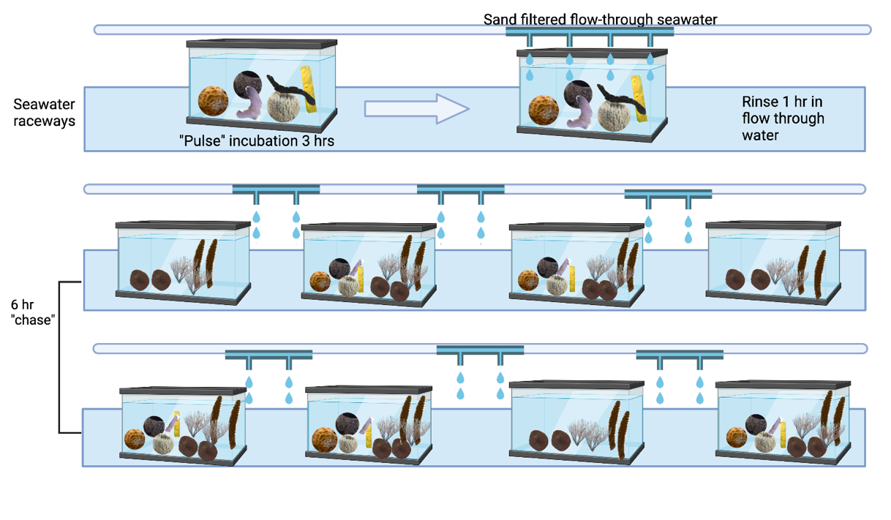

Supplementary Figure S1. ‘Pulse-chase’ experimental setup visualization. Following a 24-hr acclimation period, individuals of six species of emergent Caribbean sponges (n=6-8 each) were placed in a single aquarium with dissolved isotopically-labeled inorganic nutrients (bicarbonate containing ¹³C, and nitrate and ammonium both containing ¹⁵N) for a 3-hr ‘pulse’ (top left). Following the pulse, five enriched sponges from each species were moved to a new sand-filtered flow-through seawater tank for a 1-hr rinse (top right) and remaining individuals (n=1-3) were destructively sampled, hereby known as ‘pulse’ sponge samples. Following the rinse, enriched sponges were separated into 5 randomly assigned 20-gal tanks contained in two larger mesocosms without flow-through, for the 6-hr ‘chase’ (Bottom). Each ‘chase’ tank also contained fragments of three coral species (Acropora cervicornis, Orbicella faveolata, Eunicea flexuosa, n=2 per species), none of which were initially enriched. The ‘chase’ setup resulted in five experimental tanks containing corals and enriched sponges, and three control tanks containing only corals. At 3-hrs into the ‘chase’ (T₃), a single fragment of each coral species was destructively sampled from each tank. At the end of the 6-hr ‘chase’ (T₆) all remaining corals and sponges (n=1 per species per tank) were destructively sampled. Visualization was made using BioRender.

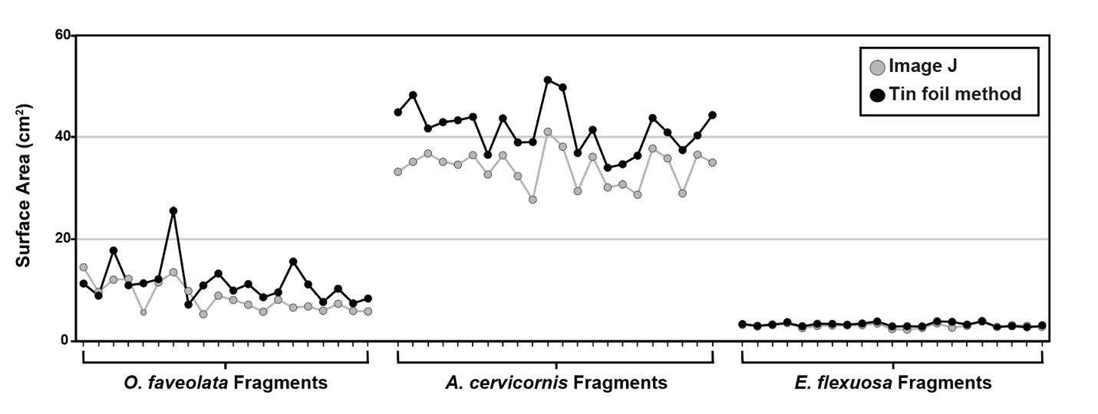

Supplementary Figure S2. Surface area (cm²) comparison of coral fragments using two different measurement methods: Image J (gray line) and Tin Foil Method (black line). Fragments are grouped by coral species, Orbicella faveolata (n=20), Acropora cervicornis (n=22) and Eunicea flexuosa (n=20), and each dashed line within the species group indicates one individual fragment that has been measure with both methods.

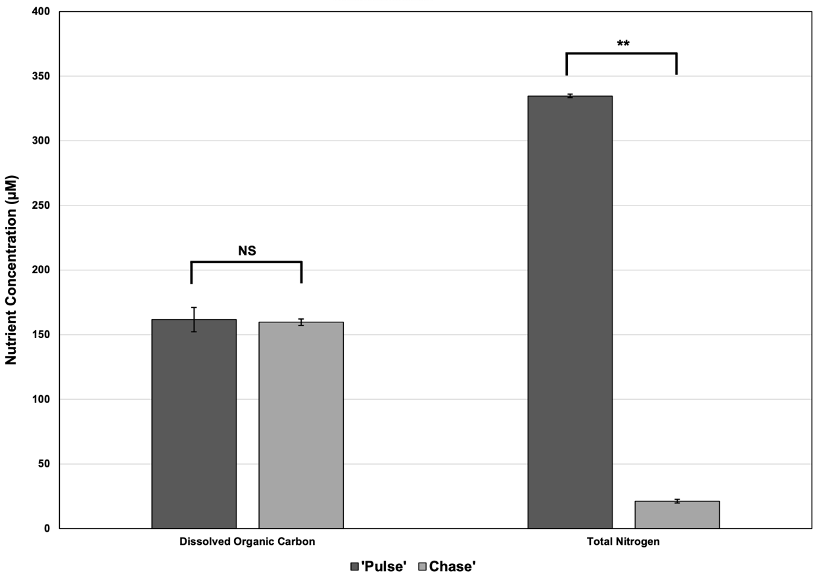
Supplementary Figure S3. Concentration (µM + SD) of dissolved organic matter (DOC) and total nitrogen in the aquaria water samples from the end of the ‘pulse’ (dark gray; n=3) and a subset of the tanks containing coral fragments during the ‘chase’ (light gray; n=3). NS denotes no significant difference in DOC concentration between the two time points, while two asterisks denote a significant difference (p<0.0001) in total nitrogen between the two time points.
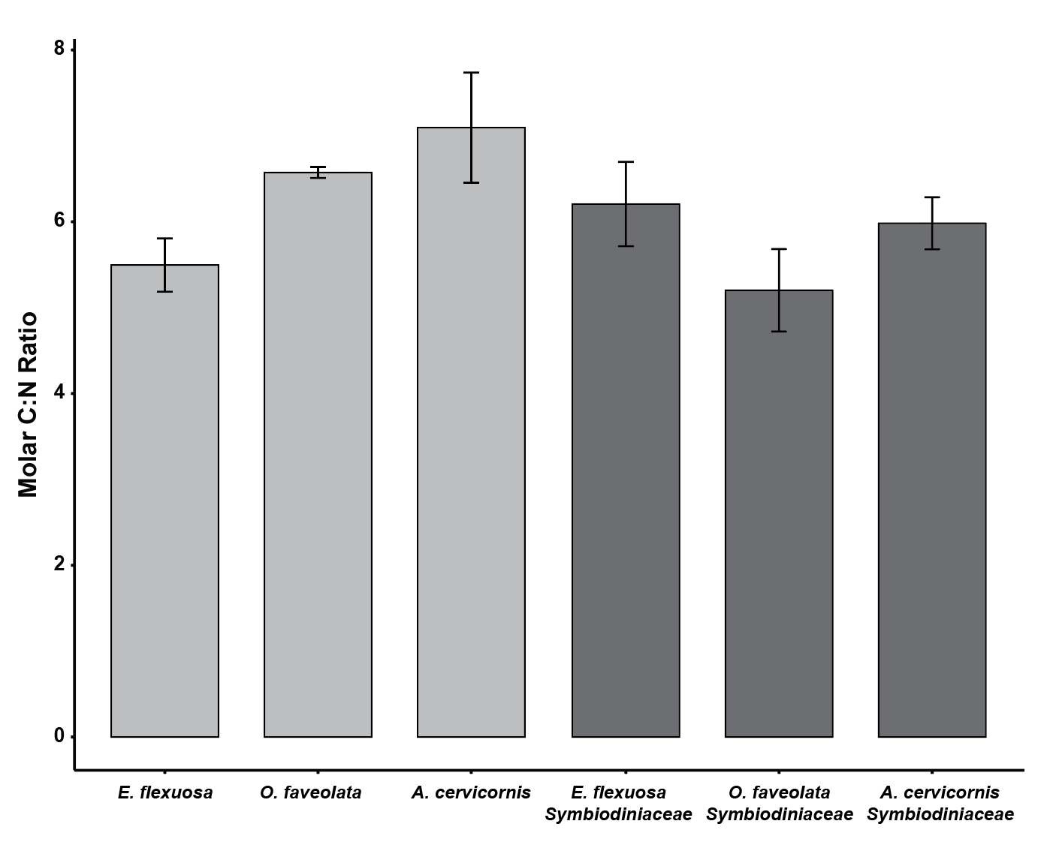

Supplementary Figure S4. Molar C:N ratio (± SD) of coral (light gray) and Symbiodiniaceae tissue (dark gray) for all non-enriched T₀ (i.e., initial) samples.

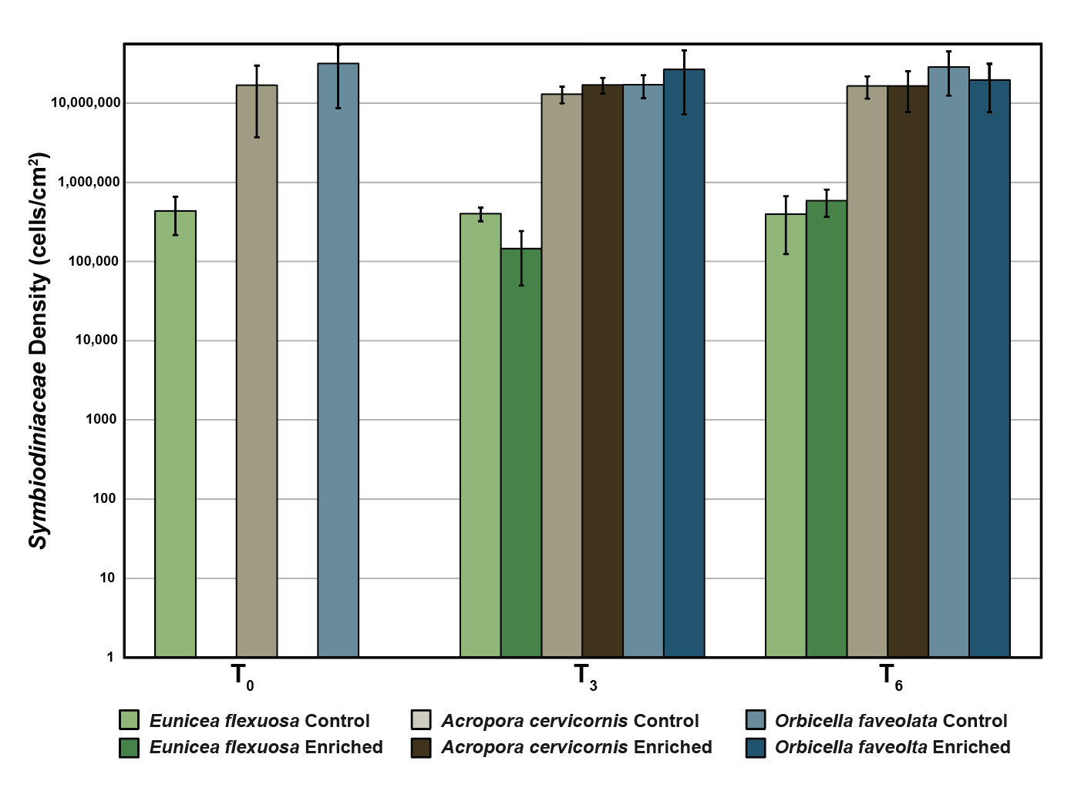

Supplementary Figure S5. Symbiodiniaceae density (cells/cm² ± SD) in tissues from Eunicea flexuosa (brown) Acropora cervicornis (blue), and Orbicella faveolata (yellow). The lighter shaded bar for each coral species indicates Symbiodiniaceae abundance in control samples and the darker shaded bar denotes abundance in enriched samples (i.e., exposed to labeled isotopes via sponge-derived DM during the ‘chase’). Abundance is shown for three time-points including initial, 3-hrs, and 6-hrs into the ‘chase’ (T₀, T₃, and T₆, respectively). Note that Symbiodiniaceae density is shown on a log¹⁰ scale.

SUPPLEMENTARY RESULTS

Pairwise PERMANOVA Test Results
Here we report the results from the post-hoc pairwise tests associated with the PERMANOVA tests reported in Supplementary Table S4. All post-hoc tests were completed using the ‘pairwiseadonis’ package in R with 999 permutations and Bonferroni corrections. Only pairwise results that are reported in text are included here. For access to unreported pairwise tests please contact the corresponding author. Asterisks denote significant (p<0.05) differences.

Pairwise tests for Supplementary Table S4j – ¹³C Incorporation for Enriched Coral Tissue
Ofav_vs_Eflex Df SumOfSqs R2 F Pr(>F)
Species 1 3.4655e-06 0.60753 27.8247 0.002 *
Time 1 3.0800e-07 0.05399 2.4728 0.149
Species:Time 1 6.2500e-08 0.01096 0.5020 0.470
Residual 15 1.8682e-06 0.32751
Total 18 5.7043e-06 1.00000
---
Ofav_vs_Acer Df SumOfSqs R2 F Pr(>F)
Species 1 3.3169e-05 0.69305 37.2230 0.001 *
Time 1 3.3000e-08 0.00069 0.0368 0.847
Species:Time 1 4.0000e-07 0.00836 0.4490 0.478
Residual 16 1.4257e-05 0.29790
Total 19 4.7859e-05 1.00000
---
Eflex_vs_Acer Df SumOfSqs R2 F Pr(>F)
Species 1 1.4018e-05 0.52422 16.7129 0.001 *
Time 1 9.2000e-09 0.00034 0.0110 0.914
Species:Time 1 1.3220e-07 0.00494 0.1576 0.686
Residual 15 1.2581e-05 0.47049
Total 18 2.6740e-05 1.00000

Pairwise tests for Supplementary Table S4m – ¹³C Incorporation Rates for Enriched Coral Tissue
Ofav_vs_Eflex Df SumOfSqs R2 F Pr(>F)
Species 1 0.00020664 0.64368 40.1740 0.001 *
Time 1 0.00001506 0.04691 2.9280 0.121
Species:Time 1 0.00002217 0.06907 4.3107 0.055
Residual 15 0.00007715 0.24034
Total 18 0.00032102 1.00000
---
Ofav_vs_Acer Df SumOfSqs R2 F Pr(>F)
Species 1 0.00038609 0.64350 43.0957 0.001 *
Time 1 0.00000003 0.00004 0.0030 0.962
Species:Time 1 0.00007053 0.11755 7.8722 0.010 *
Residual 16 0.00014334 0.23891
Total 19 0.00059999 1.00000
---
Eflex_vs_Acer Df SumOfSqs R2 F Pr(>F)
Species 1 2.2565e-05 0.14232 3.3348 0.082
Time 1 2.2664e-05 0.14295 3.3494 0.089
Species:Time 1 1.1823e-05 0.07457 1.7473 0.219
Residual 15 1.0150e-04 0.64016
Total 18 1.5855e-04 1.00000

Pairwise tests for Supplementary Table S4o – δ ¹⁵N for T₀ & Enriched Coral & Symbiodiniaceae Tissue
Ofav_vs_Eflex Df SumOfSqs R2 F Pr(>F)
Species 1 11580 0.03964 6.7291 0.012 *
HolobiontFraction 1 1505 0.00515 0.8744 0.365
Time 2 187377 0.64145 54.4397 0.001 *
Species:HolobiontFraction 1 1348 0.00462 0.7835 0.388
Species:Time 2 11277 0.03861 3.2765 0.046 *
HolobiontFraction:Time 2 1900 0.00650 0.5519 0.558
Species:HolobiontFraction:Time 2 1405 0.00481 0.4083 0.680
Residual 44 75722 0.25922
Total 55 292115 1.00000
---
Ofav_vs_Acer Df SumOfSqs R2 F Pr(>F)
Species 1 2352041 0.14613 95.924 0.001 *
HolobiontFraction 1 2009917 0.12487 81.972 0.001 *
Time 2 3802555 0.23625 77.541 0.001 *
Species:HolobiontFraction 1 1866721 0.11598 76.132 0.001 *
Species:Time 2 1849750 0.11492 37.720 0.001 *
HolobiontFraction:Time 2 1665632 0.10348 33.965 0.001 *
Species:HolobiontFraction:Time 2 1421029 0.08829 28.977 0.001 *
Residual 46 1127906 0.07008
Total 57 16095551 1.00000
---
Eflex_vs_Acer Df SumOfSqs R2 F Pr(>F)
Species 1 2699741 0.16442 106.664 0.001 *
HolobiontFraction 1 1894026 0.11535 74.831 0.001 *
Time 2 3532477 0.21514 69.783 0.001 *
Species:HolobiontFraction 1 1861432 0.11337 73.544 0.001 *
Species:Time 2 2179639 0.13275 43.058 0.001 *
HolobiontFraction:Time 2 1569993 0.09562 31.015 0.001 *
Species:HolobiontFraction:Time 2 1518138 0.09246 29.990 0.001 *
Residual 46 1164288 0.07091
Total 57 16419733 1.00000

Pairwise tests for Supplementary Table S4q – δ ¹⁵N for Control A. cervicornis Coral Tissue
T=0 vs T=3 Df SumOfSqs R2 F Pr(>F)
Time 1 7.8223 0.76135 15.951 0.041 *
Residual 5 2.4520 0.23865
Total 6 10.2743 1.00000
---
T=0 vs T=6 Df SumOfSqs R2 F Pr(>F)
Time 1 3.388 0.58014 6.9086 0.104
Residual 5 2.452 0.41986
Total 6 5.840 1.00000
--
T=3 vs T=6 Df SumOfSqs R2 F Pr(>F)
Time 1 0.64 0.5 2 0.6667
Residual 2 0.64 0.5
Total 3 1.28 1.0

Pairwise tests for Supplementary Table S4r – δ ¹⁵N for Control E. flexuosa Coral Tissue
T=0 vs T=3 Df SumOfSqs R2 F Pr(>F)
Time 1 586.96 0.56122 6.3951 0.041 *
Residual 5 458.91 0.43878
Total 6 1045.87 1.00000

T=0 vs T=6 Df SumOfSqs R2 F Pr(>F)
Time 1 0.112 0.01718 0.0874 0.824
Residual 5 6.408 0.98282
Total 6 6.520 1.00000
---
T=3 vs T=6 Df SumOfSqs R2 F Pr(>F)
Time 1 422.30 0.48219 1.8624 0.3333
Residual 2 453.51 0.51781
Total 3 875.81 1.00000

Pairwise tests for Supplementary Table S4x – ¹⁵N Incorporation for Enriched Coral Tissue
Ofav_vs_Eflex Df SumOfSqs R2 F Pr(>F)
Species 1 0.42585 0.33646 7.7705 0.010 *
Time 1 0.01499 0.01185 0.2736 0.697
Species:Time 1 0.00280 0.00221 0.0511 0.944
Residual 15 0.82205 0.64949
Total 18 1.26569 1.00000
---
Ofav_vs_Acer Df SumOfSqs R2 F Pr(>F)
Species 1 1.25985 0.61634 34.9720 0.001 *
Time 1 0.13249 0.06482 3.6778 0.049 *
Species:Time 1 0.07536 0.03687 2.0919 0.136
Residual 16 0.57639 0.28198
Total 19 2.04410 1.00000
---
Eflex_vs_Acer Df SumOfSqs R2 F Pr(>F)
Species 1 2.26269 0.74233 57.6610 0.001 *
Time 1 0.11532 0.03783 2.9387 0.088
Species:Time 1 0.08147 0.02673 2.0762 0.161
Residual 15 0.58862 0.19311
Total 18 3.04809 1.00000

Pairwise tests for Supplementary Table S4y – ¹⁵N Incorporation for Enriched Symbiodiniaceae Tissue
Acer_vs_Ofav Df SumOfSqs R2 F Pr(>F)
Species 1 2.5761 0.72417 129.126 0.001 *
Time 1 0.2394 0.06731 12.002 0.002 *
Species:Time 1 0.4226 0.11879 21.181 0.001 *
Residual 16 0.3192 0.08973
Total 19 3.5573 1.00000
---
Acer_vs_Eflex Df SumOfSqs R2 F Pr(>F)
Species 1 3.6851 0.72937 66.6652 0.001 *
Time 1 0.3032 0.06001 5.4847 0.018 *
Species:Time 1 0.2350 0.04651 4.2509 0.028 *
Residual 15 0.8292 0.16411
Total 18 5.0524 1.00000
---
Ofav_vs_Eflex Df SumOfSqs R2 F Pr(>F)
Species 1 2.14304 0.69246 41.5435 0.001 *
Time 1 0.10806 0.03492 2.0948 0.157
Species:Time 1 0.06995 0.02260 1.3560 0.269
Residual 15 0.77378 0.25002
Total 18 3.09484 1.00000

Pairwise tests for Supplementary Table S4cc – Molar C:N Ratio for T₀ coral & Symbiodiniaceae Tissue
Ofav_vs_Acer Df SumOfSqs R2 F Pr(>F)
Species 1 0.015377 0.20786 11.5117 0.006 *
HolobiontFraction 1 0.039718 0.53687 29.7333 0.001 *
Species:HolobiontFraction 1 0.001520 0.02055 1.1379 0.296
Residual 13 0.017365 0.23473
Total 16 0.073981 1.00000
---
Ofav_vs_Eflex Df SumOfSqs R2 F Pr(>F)
Species 1 0.000281 0.00584 0.2406 0.644
HolobiontFraction 1 0.000647 0.01345 0.5542 0.467
Species:HolobiontFraction 1 0.032024 0.66524 27.4128 0.001 *
Residual 13 0.015187 0.31548
Total 16 0.048139 1.00000
---
Acer_vs_Eflex Df SumOfSqs R2 F Pr(>F)
Species 1 0.014560 0.23902 11.7203 0.007 *
HolobiontFraction 1 0.000870 0.01429 0.7006 0.423
Species:HolobiontFraction 1 0.025609 0.42040 20.6147 0.002 *
Residual 16 0.019876 0.32629
Total 19 0.060916 1.00000

Pairwise tests for Supplementary Table S4dd – Symbiodiniaceae density in all coral fragments
Eflex_vs_Acer Df SumOfSqs R2 F Pr(>F)
Species 1 7.4167 0.75637 114.87 0.001 *
Residual 37 2.3889 0.24363
Total 38 9.8057 1.00000
---
Eflex_vs_Ofav Df SumOfSqs R2 F Pr(>F)
Species 1 6.7213 0.7364 103.36 0.001 *
Residual 37 2.4059 0.2636
Total 38 9.1273 1.0000
---
Acer_vs_Ofav Df SumOfSqs R2 F Pr(>F)
Species 1 0.70074 0.43036 28.709 0.001 *
Residual 38 0.92754 0.56964
Total 39 1.62828 1.00000

Pairwise tests for Supplementary Table S4gg – Symbiodiniaceae density in E. flexuosa coral fragments
T0_vs_T3 Df SumOfSqs R2 F Pr(>F)
Time 1 0.28165 0.20847 2.6338 0.083
Residual 10 1.06936 0.79153
Total 11 1.35101 1.00000
---
T0_vs_T6 Df SumOfSqs R2 F Pr(>F)
Time 1 0.07615 0.16681 2.0021 0.144
Residual 10 0.38036 0.83319
Total 11 0.45651 1.00000
---
T3_vs_T6 Df SumOfSqs R2 F Pr(>F)
Time 1 0.71347 0.43833 9.3648 0.001 ***
Residual 12 0.91424 0.56167
Total 13 1.62770 1.00000

REFERENCES
1. Hansell, D. & Carlson, C. Marine Dissolved Organic Matter and the Carbon Cycle. Oceanography 14, (2001).
2. LaJeunesse, T. C. Zooxanthellae. Curr. Biol. 30, R1110–R1113 (2020).
3. LaJeunesse, T. C. et al. Systematic revision of Symbiodiniaceae highlights the antiquity and diversity of coral endosymbionts. Curr. Biol. 28, 2570-2580.e6 (2018).
4. Marsh, J. A. Primary Productivity of Reef-Building Calcareous Red Algae. Ecology 51, 255–263 (1970).
5. Schneider, C. A., Rasband, W. S. & Eliceiri, K. W. NIH image to ImageJ: 25 years of image analysis. Nat. Methods 9, 671–675 (2012).
6. Reigel, A. M. et al. Coral fragment surface area calculations utilizing two methods (tin foil and Image J) and corresponding zooxanthellae count data. (2022) doi:10.26008/1912/BCO-DMO.880711.1.
7. Fry, B. Stable isotope ecology. (Springer, 2006). doi:10.1007/0-387-33745-8.
8. Rix, L. et al. Differential recycling of coral and algal dissolved organic matter via the sponge loop. Funct. Ecol. 31, 778–789 (2017).
9. Reigel, A. M. et al. Isotopic analysis of ¹³C and ¹⁵N for sponges, coral, and zooxanthellae (family Symbiodiniaceae) used in a ‘pulse-chase’ experiment to examine the uptake of sponge-derived nutrients by the coral holobiont. (2023) doi:10.26008/1912/BCO-DMO.889857.1.

