Supplementary Materials for

Deep history of cultural and linguistic evolution among Central African hunter-gatherers

Padilla-Iglesias et al.

Corresponding author emails: cecilia.padillaiglesias@uzh.ch , andrea.migliano@uzh.ch

This PDF file includes:

Text S1to S2
Figs. S1 to S21
Tables S1 to S22
Legends to Datasets S1 to S2

Other Supplementary Materials for this manuscript include the following:
Dataset S1
Dataset S2

Supplementary text 1: Extended explanation of fractioning of genetic sample and IBD analyses

After removing Bantu-associated genomic regions using the local ancestry inference and masking procedure described in Materials and Methods in the main text, we introduced a new procedure to split the remaining genetic data (associated exclusively with CAHG ancestry) into fractions representing distinct temporal depths.
IBD analysis allows the identification of genetic sequences that two individuals share due to a recent common ancestor (a recent relative). In other words, an IBD fragment represents a DNA sequence found in individuals 1 and 2, which is too similar (or too long), to have evolved independently. For this reason, most IBD fragments will be identified in individuals from the same population, as they are more likely to have a common recent ancestral relative. However, if the two individuals 1 and 2 were sampled from two distinct populations (for example, from two CAHG groups), they must also have inherited the similar sequence from a recent common progenitor. We can therefore infer that a recent migrant between the two populations introduced the sequence from one population into the other. Note that despite the misleading name, an IBD fragment found between two populations is identical by descent from a recent migrant or progenitor (a parent, in the case of siblings), not from a remote member of the ancestral population prior to the split between the two populations. Moreover, although IBD fragments between populations contributed to our measure of ‘genetic distance’ between CAHG populations (as they were included in some genetic sets), strictly speaking they only provide a measure of recent genetic flow or admixture. Hence, IBD analysis provides no information on the genetic distance between populations since their split, or divergence dates from an ancestral population. It only provides evidence for recent gene flow resulting in sequence similarities not compatible with observed levels of genetic differentiation between populations.
The other feature of IBD fragments is that they do not last indefinitely. Every generation, due to crossing-over and recombination, the chromosomes introduced by a migrant will incorporate fragments from the local background, and the size of sequences (IBD length) similar between the individual descending from the migrant in population 1, and individuals in the source population 2, continuously decreases. The longer the time since the migration event, the shorter the shared IBD fragments become, until it is no longer possible to tell that the sequence was derived from a recent migration event. For this reason, IBD analysis can only inform us of recent but not remote gene flow. However, this also means that the size of the IBD is inversely proportional to how long ago the migration/admixture event happened: a long shared IBD sequence means very recent migration, while smaller sequences mean a more remote migration event. In addition, a migration date also provides an estimated rate of migration: an identified migration 1,000 years ago suggests a rate of one migration event per 1,000 years, as the more recent event may have been preceded by others no longer identifiable.
In our study, we proposed an extension of the IBD technique. As discussed, we first excluded genomic regions of Bantu origin based on the masking procedure in the main text. Hence, the remaining distribution of genetic similarities reflected only genetic admixture between CAHG groups (before or after the Bantu arrival), but not between CAHG and Bantu groups. Finally, we also excluded IBD fragments exchanged between CAHG groups. What is left were short IBD fragments unlikely to represent recent migration, or corresponding to older migrations that cannot be dated. In parallel, we assessed shared musical instruments between the same CAHG populations, obtaining a measure of cultural similarity. We then tested for a correlation between cultural and genetic similarities. We ran the analyses for each set of genetic data: full set, set with CAHG-derived IBDs only (after masking of Bantu-derived ancestry fragments), and set excluding all recent IBD fragments. We repeated the procedure for cultural distances based on subsistence tools.

Supplementary text 2: Extended explanation of the assessment of the sharing of terms to design musical instruments and subsistence tools.
To judge whether words used to designate the same objects were sufficiently similar to suggest borrowing or common origins, for each word, first we checked whether our recorded terms appeared in the language descriptions of the corresponding group and that they had consistent meanings. When available, we worked with the assumption that diverging terms between pairs of languages could be partly explained by differences in the words’ morphology. In the case of Bantu languages, a prevalent feature is the noun class prefix system which can differ between languages without impact on the similarity of the root. For example, the differences between the word for arrow used by the Bakoya (di.banzika¹) and the Aka (mbànzà²) could be attributed to the fact the in these two languages the Bantu singular / plural noun class system differs (See Jacquot³ for a description of the Bakoya noun class and Bouquiaux & Thomas⁴ for that of the Aka). If the noun class prefixes are disregarded, similarities between the roots become more transparent (banz).
We also considered orthographic conventions that might have led to different representations of terms due to differences in linguists’ backgrounds rather than real differences in the meaning or origins of the terms. For instance, Bantu voiceless alveolar affricates can be either transcribed as ts or as tch as a result of French influence, and homorganic nasals preceding labiodental fricatives can also vary in the way they are transcribed (e.g.: mf/nf or mv/nv)⁵.
Importantly, surface differences between terms can also reflect regular phonological processes, either diachronic or synchronic, such as the vowel shifts between sòkò (Aka) and sàkà (Baka), or lìgbégbé (Baka) and li.gbo:gbo (Efe)⁶. Such differences point to a shared origin. When words are borrowed, however, phonological processes can also be idiosyncratic. As a general rule we posit such processes and therefore shared vocabulary only when the processes reflects a phonetically natural process or superficial variation. Transcriptions of tones are unreliable in many sources, making it impossible to establish similarity when tones differ. After compiling the final list of shared musical instrument and subsistence tool terminology between CAHG groups, we also noted whether the objects denoted by the terms were unique to CAHGs (as opposed to present in other African non-hunter-gatherer groups) as well as whether the terms themselves were unique to CAHGs (see Dataset S2 for notes). After doing so, we created two datasets of shared specialized vocabulary: one including all shared terms between CAHG groups, and one including only those terms that were unique to CAHG, and where evidence of common origin/ borrowing was clear.
References:
1. Soengas, B. La subsistance des Pygmées Bakoya à l’épreuve de l’agriculture: dynamique des savoirs ethnobotaniques et des pratiques (Département de la Zadié, Ogooué-Ivindo, Gabon). (Museum national d’histoire naturelle-MNHN PARIS, 2010).
2. Kilian-Hatz, C. The Linguistic Link between (Western) baMbenga and (Eastern) baMbuti Pygmies. (Academia-Verlag, 2019).
3. Jacquot, A. Les classes nominales dans les langues bantoues des groupes B. 10, B. 20, B. 30 (Gabon-Congo). vol. 157 (IRD Editions, 1983).
4. Bouquiaux, L. & Thomas, J. M. Quelques problèmes comparatifs de langues bantoues C10 des confins oubanguiens: le cas du mbati, du ngando et de l’aka. Sprachen und Sprachzeugnisse in Afrika: eine Sammlung philologischer Beiträge Wilhelm JG Möhlig zum 60, 87–106 (1994).
5. Schroeder, L. Bantu orthography manual. E-book. SIL International. Retrieved March 15, 2015 (2008).
6. Nurse, D. Toward a typology of diachronic phonological change in Bantu languages. Linguistica Atlantica 100–122 (1987).

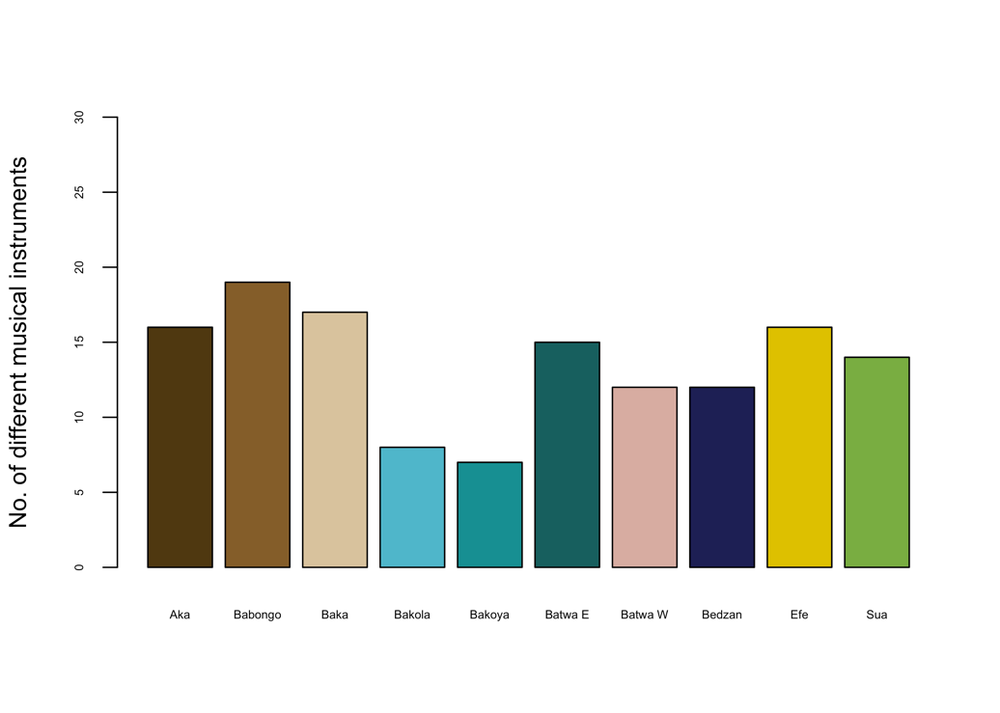
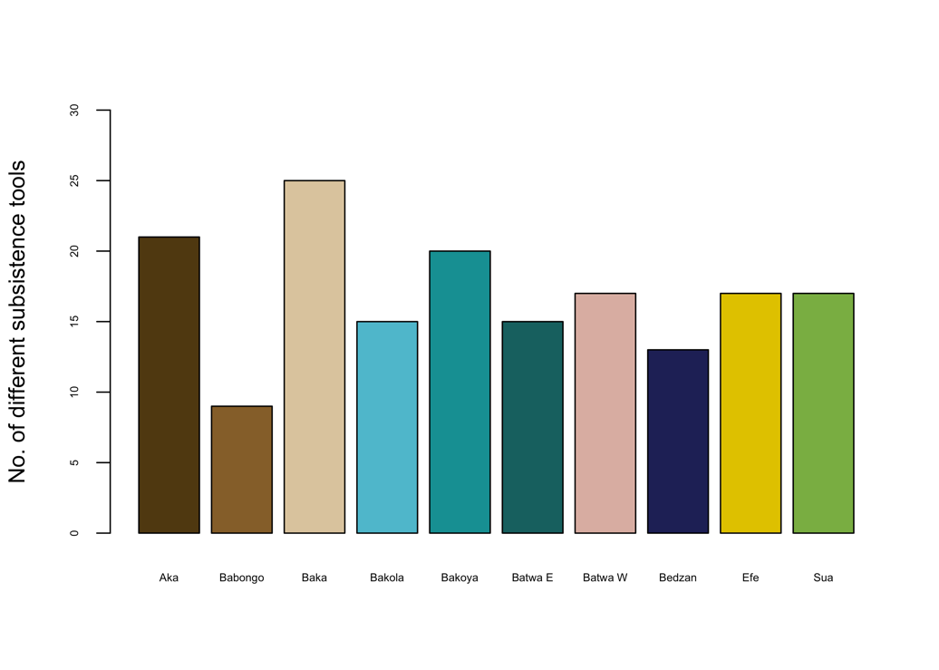
Fig S1. Count of different subsistence tools (top) and musical instruments (bottom) for the 10 CAHG populations in our sample.

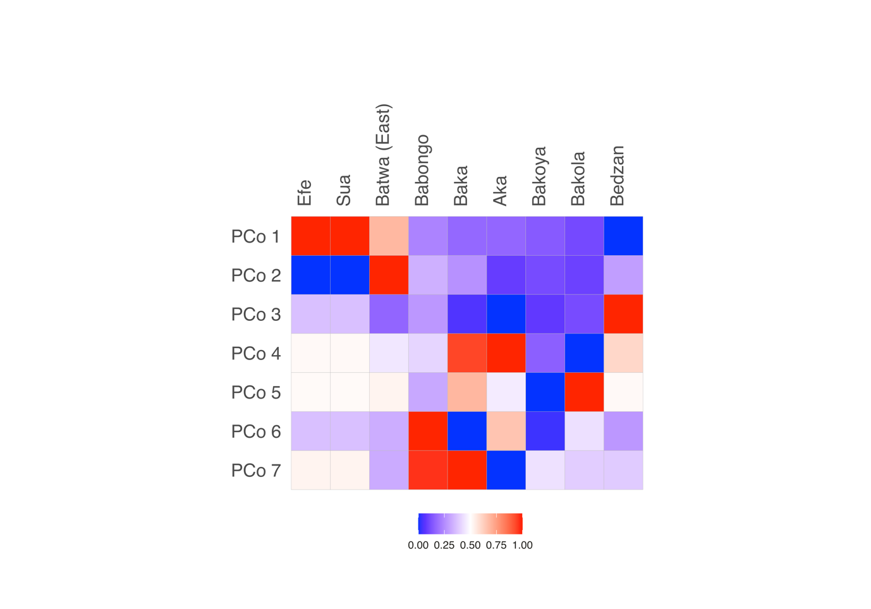
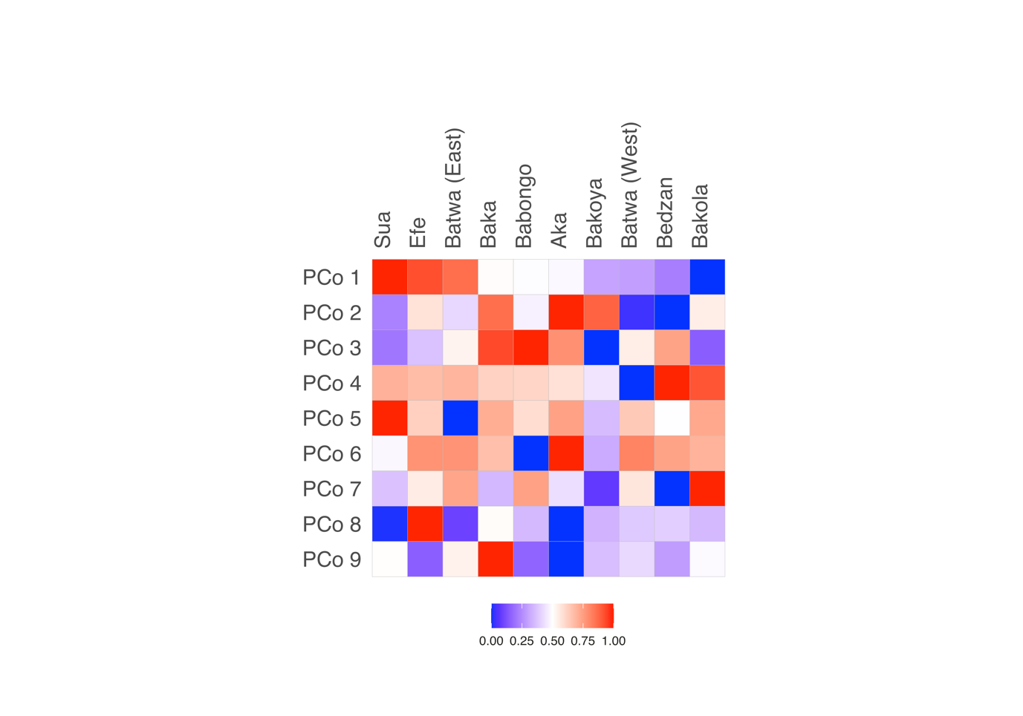
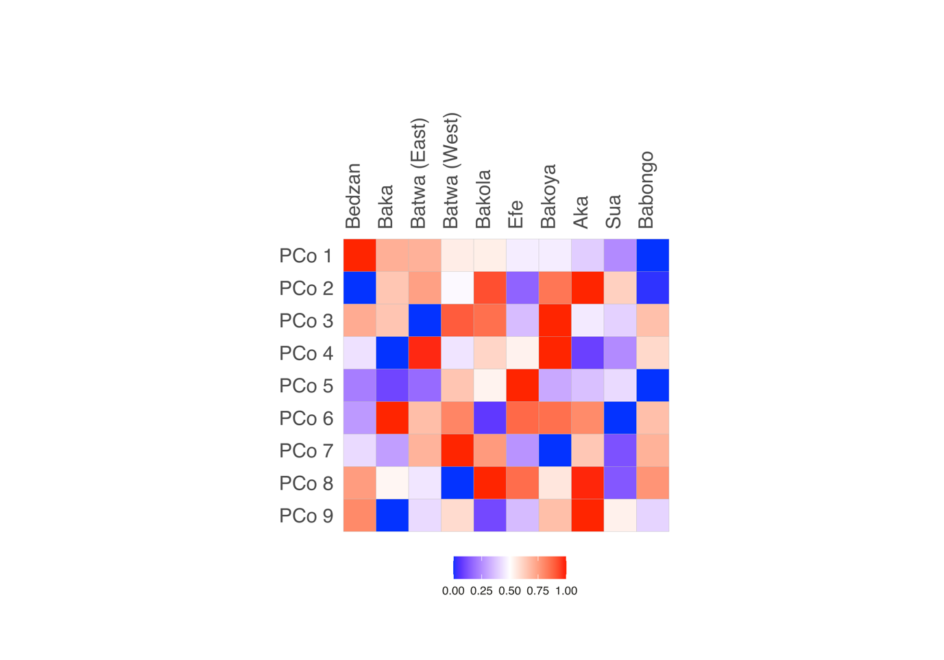
Fig S2. Contribution to PCoA heatmaps in genes using exclusively CAHG ancestry components (top left), music (top right) and subsistence toolkits (bottom)

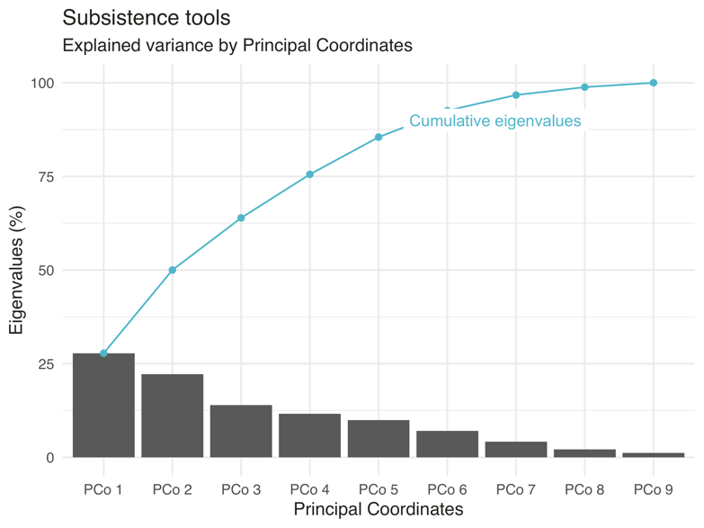
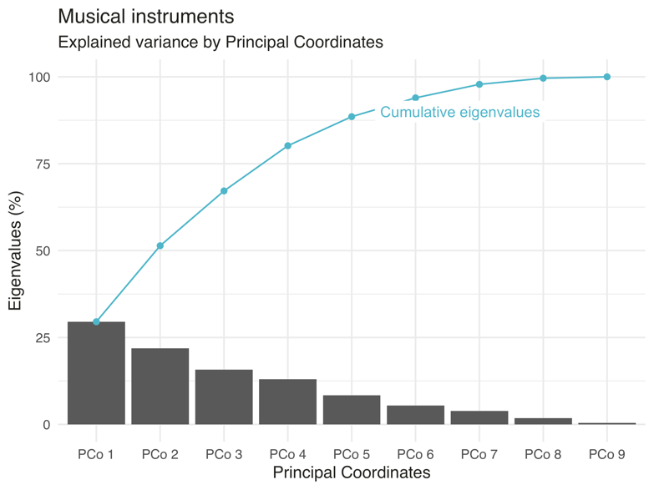
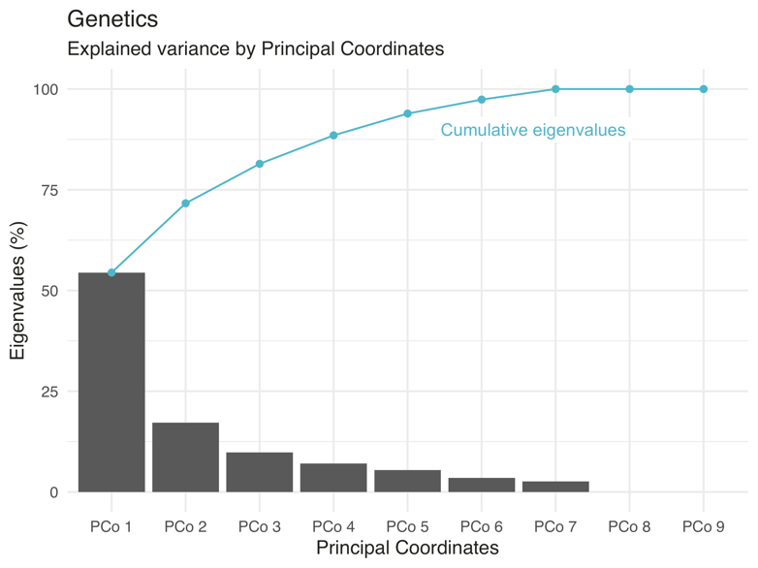
Fig S3. Explained variance by each principal coordinate in PCoA analyses for genes (top left), music (top right) and subsistence toolkits (bottom). Blue line indicates cumulative percentage of variance explained by adding each successive principal coordinate.

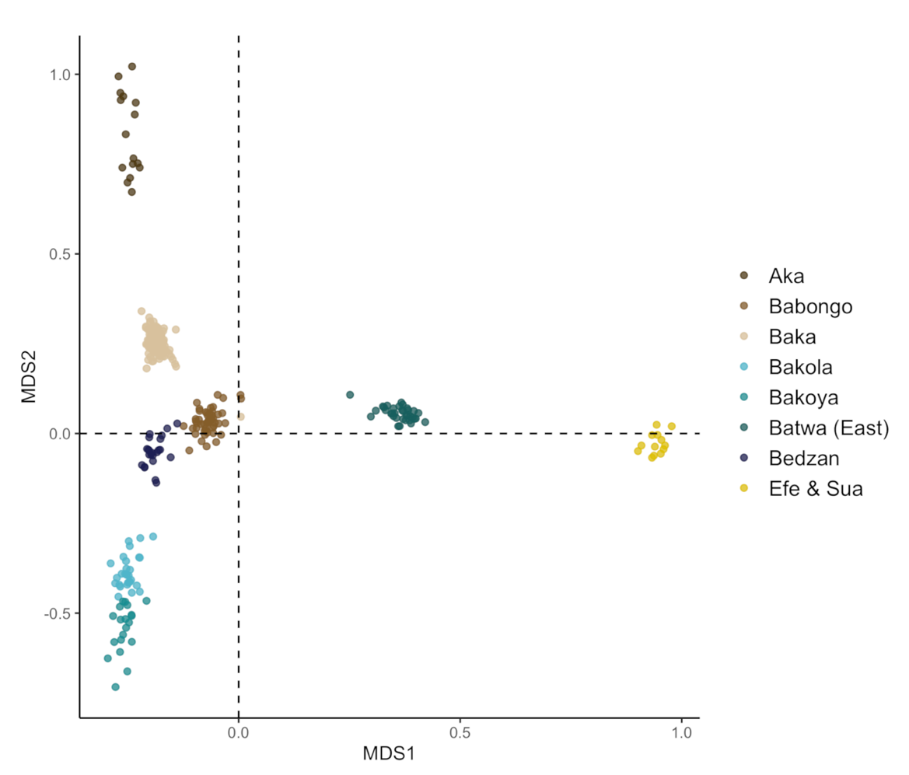

Fig S4. Multidimensional scaling (MDS) of CAHG ancestry components revealing segregation of Western and Eastern groups, and North-western and South-western groups.

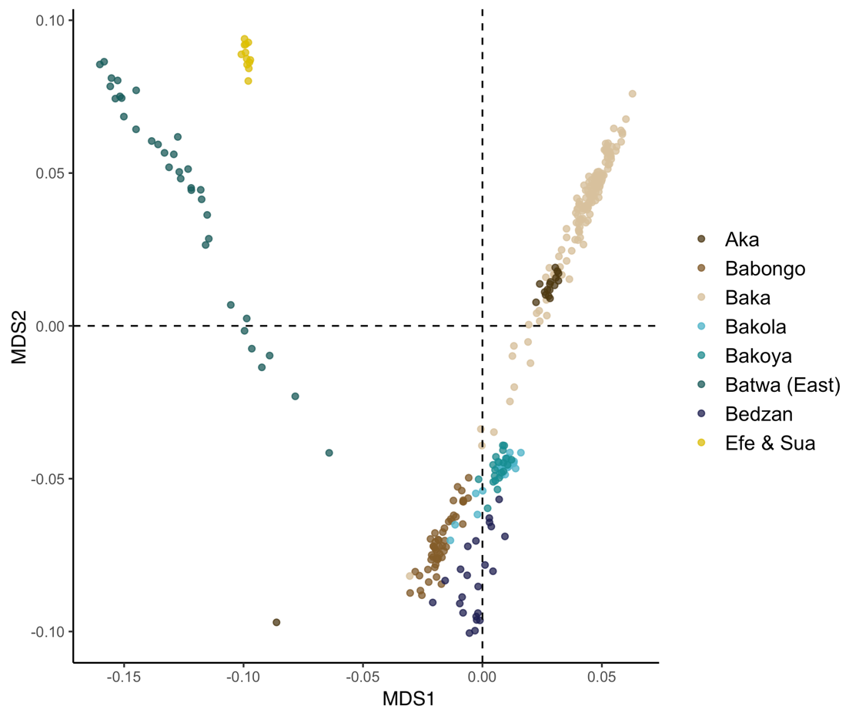
Fig S5. MDS of CAHG with available genome-wide SNP data using the full (unmasked) dataset

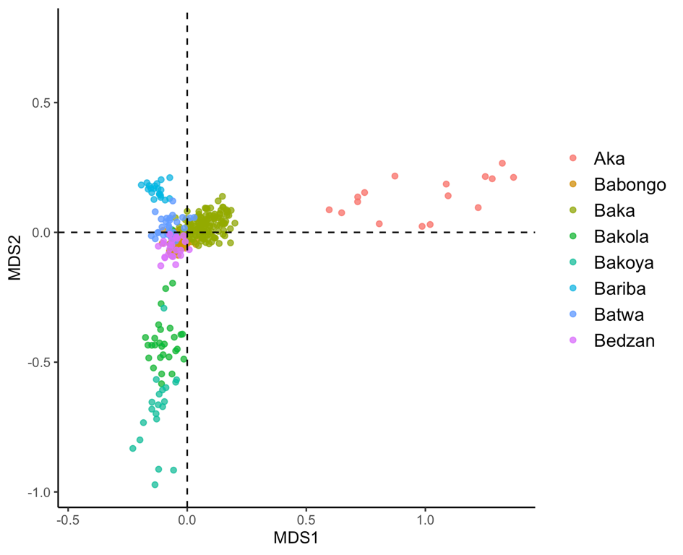
Fig S6. MDS of CAHG with available genome-wide SNP data using exclusively Bantu-associated genomic segments. Note that the Efe & Sua (Mbuti) are not included as they do not carry a sufficient amount of Bantu-associated DNA.

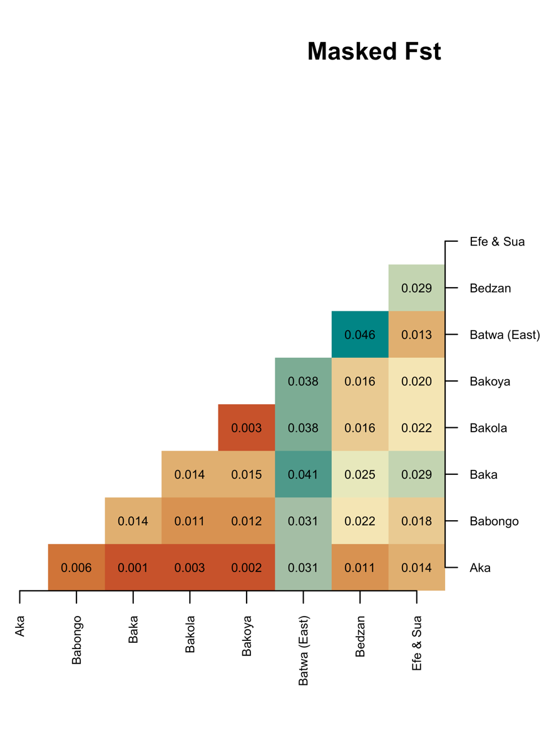
Fig S7. Inter-population F_{ST} using only CAHG ancestry components

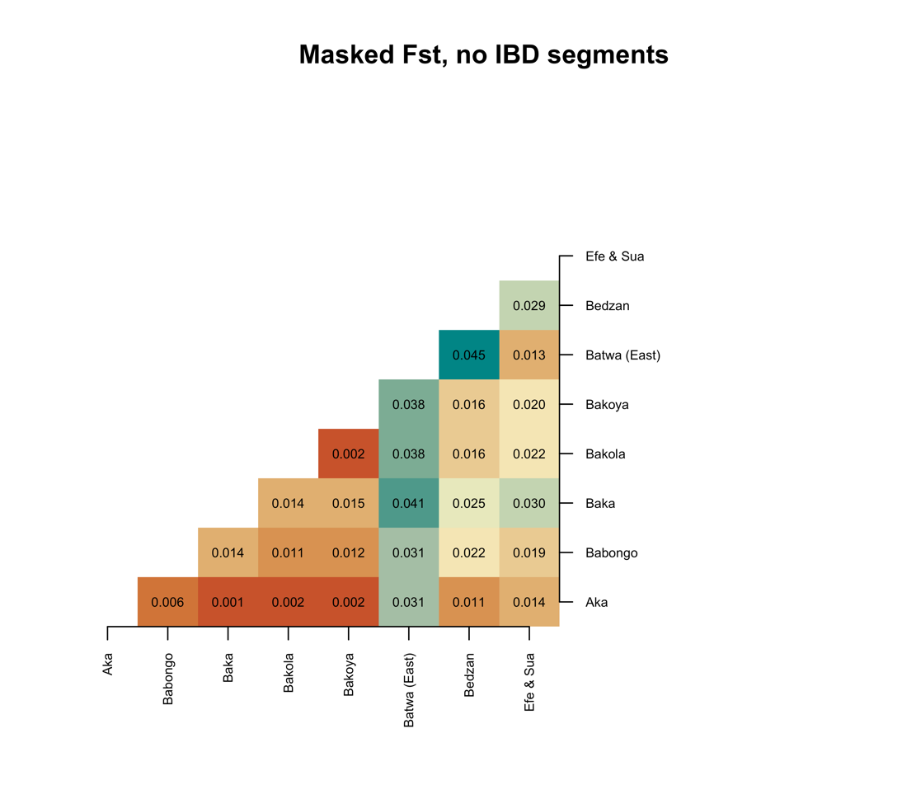
Fig S8. Pairwise F_{ST} matrix using only CAHG ancestry components and excluding shared IBD segments between populations

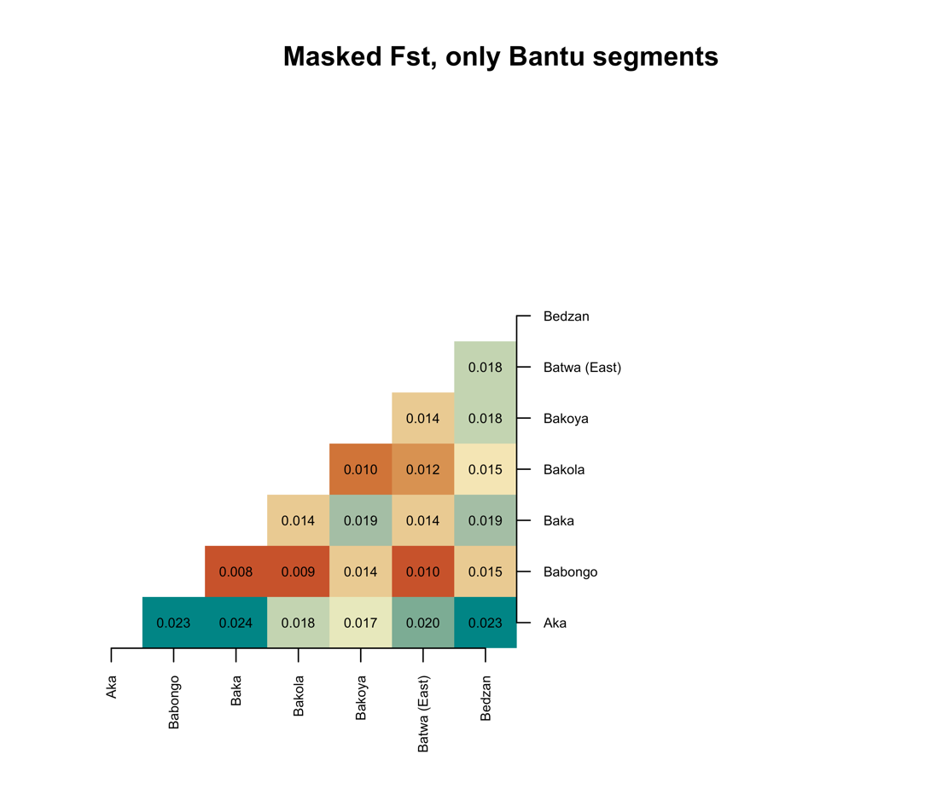
Fig S9. Pairwise F_{ST} matrix using only Bantu ancestry components.

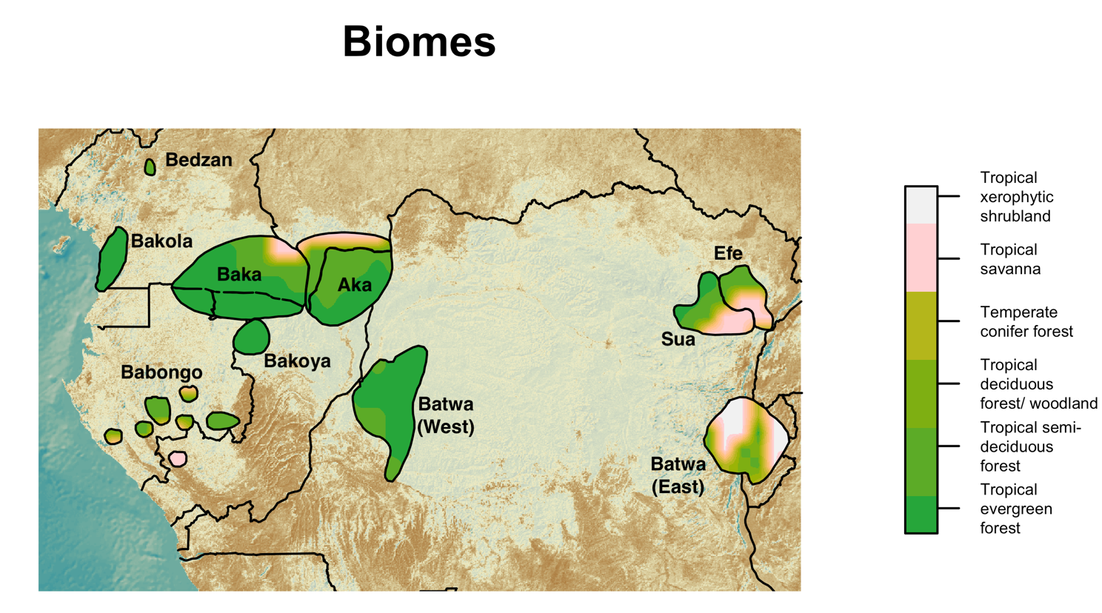
Fig S10. Biomes in the territories of the cultural groups included in our analyses obtained from Beyer et al. (2020)

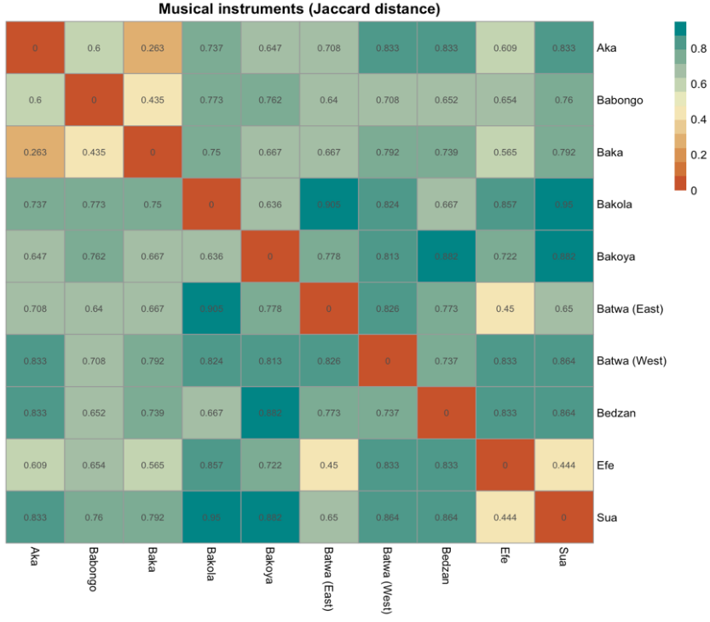
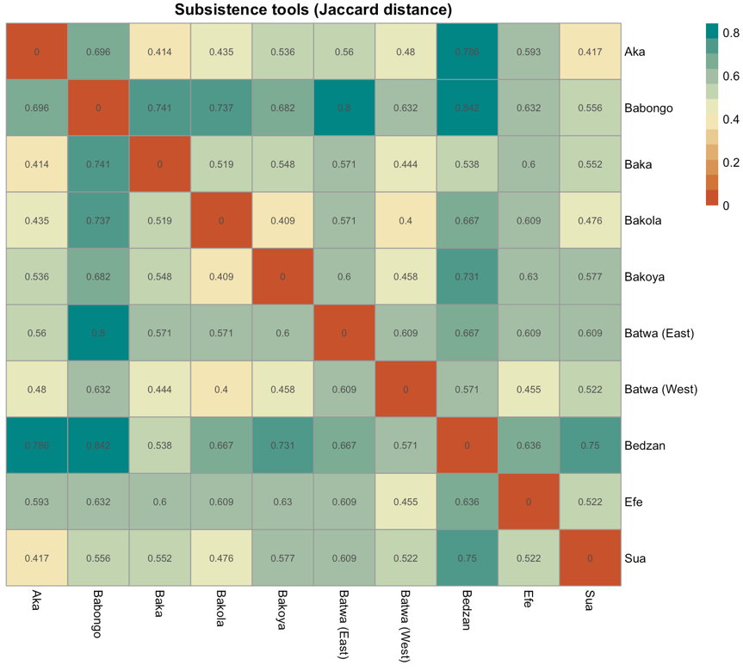
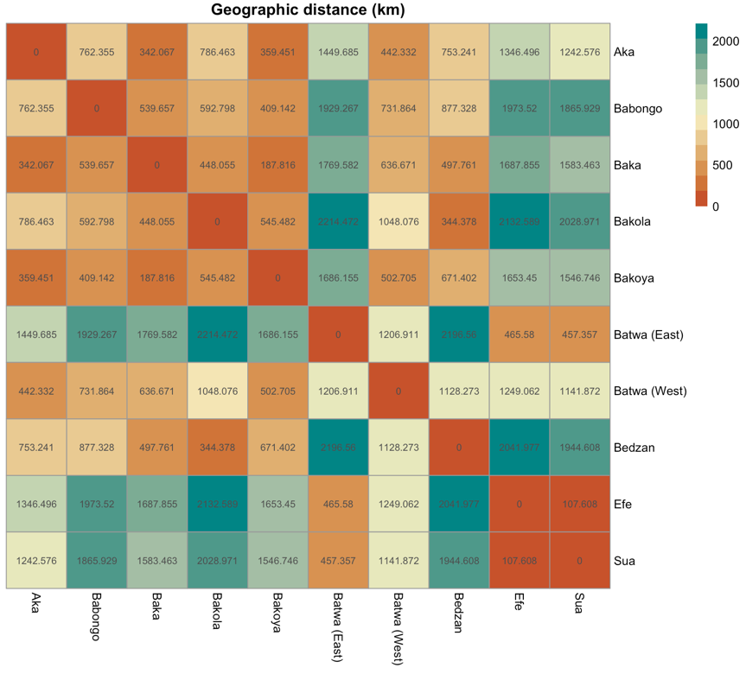
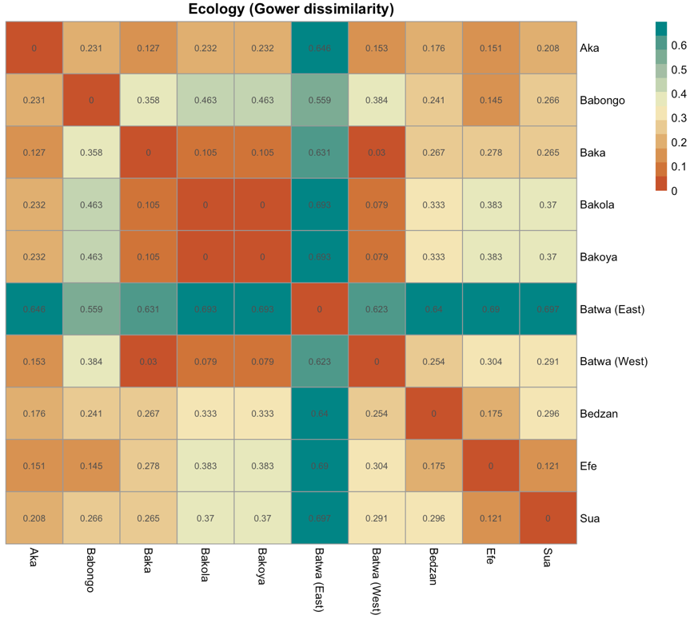
Fig S11. Between-population distance matrices used for the analyses.

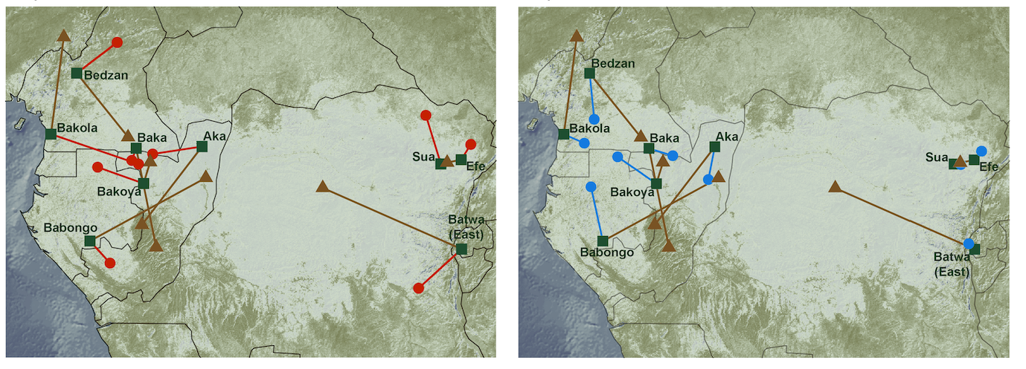
Fig S12. (Left) SpaceMix results showing pseudo-coordinates of CAHG groups based on subsistence tools (red dots), masked genomic data (triangles) and actual geographic coordinates (squares). (Right) SpaceMix results showing pseudo-coordinates of CAHG groups based on musical instruments repertoires (blue dots), masked genomic data (triangles) and actual geographic coordinates (squares).

Fig S13. Estimated recent gene flow between CAHG by SpaceMix. Bold letters indicate geo-genetic coordinates of populations in our sample, Italic letters indicate sources of admixture, and arrows indicate direction of admixture. Ellipses bound by solid lines indicate 95% confidence interval around the estimated geo-genetic location of each population and ellipses bound by dashed lines 95% confidence intervals around the hypothesised admixture source. Width of arrows is proportional to estimated proportion of ancestry of a population deriving from admixture source location (origin of the arrows).

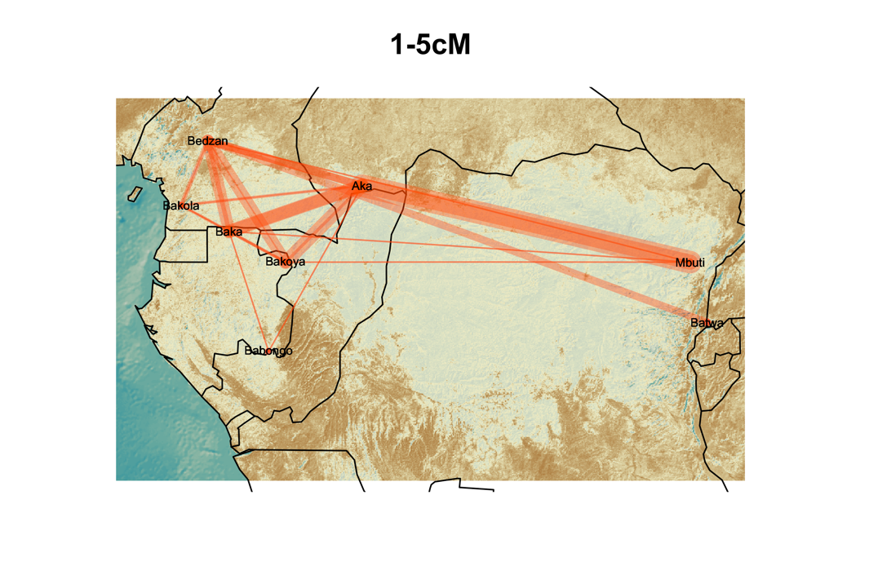
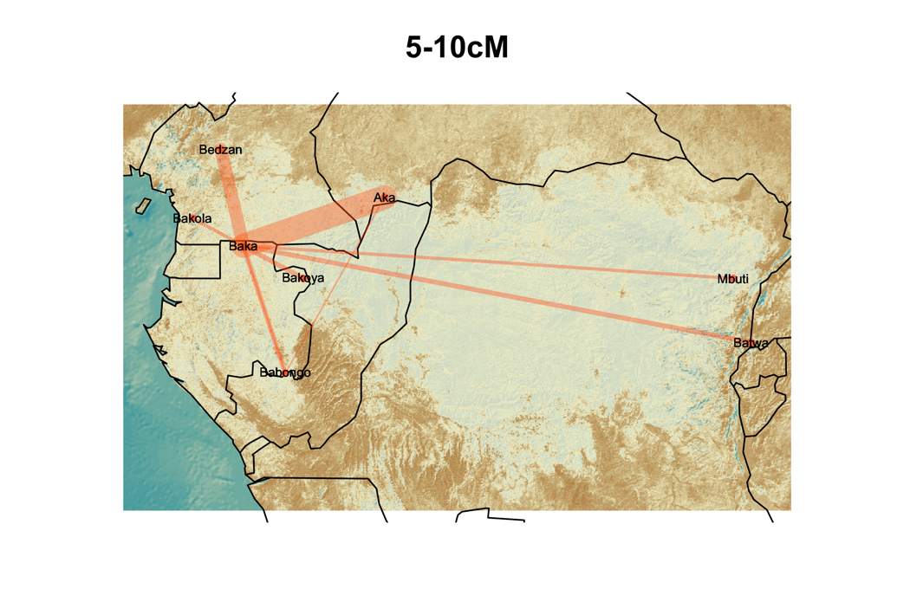
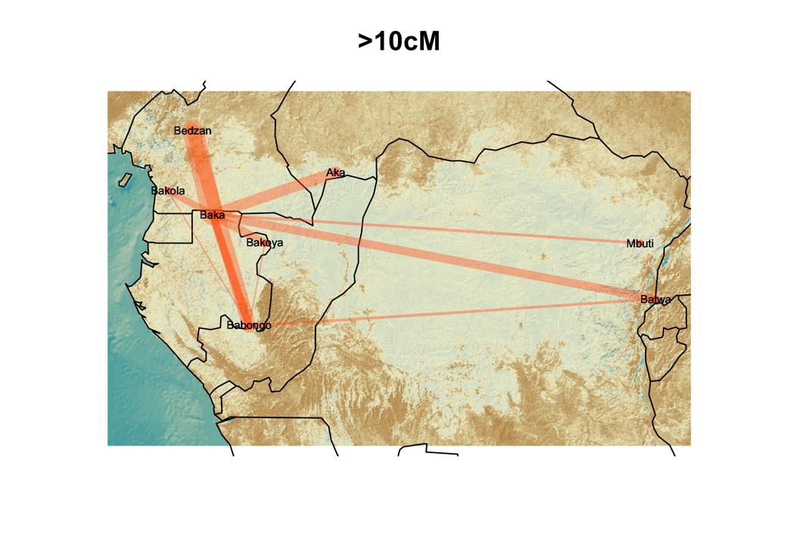

Fig S14. Recent genetic connectivity between CAHG populations. Network visualizations of the average number of IBD segments shared per cross-population individual pairs using only CAHG genetic segments with identified IBD blocks in the range of: (top-left) 1 to 5 cM (2,500 to 1,500 y ago), (top-right) 5 to 10 cM (1,500 to 500 y ago), (bottom) and over 10cM (500 to 0 y ago). Thicker lines indicate greater gene flow as identified by a higher probability of sharing IBD blocks of the specified length.

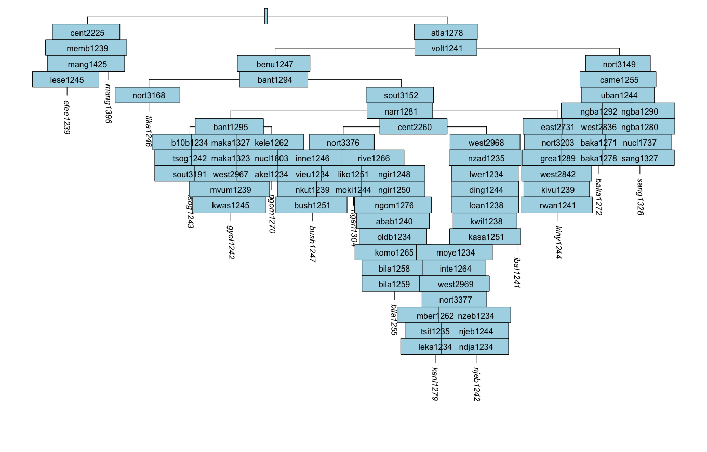
Fig S15. Glottolog tree including all languages spoken by the CAHG groups in this study. In italics, the Glottocodes of the languages in Table S3, in blue squares, the Glottocodes of the internal nodes of the tree separating the languages.

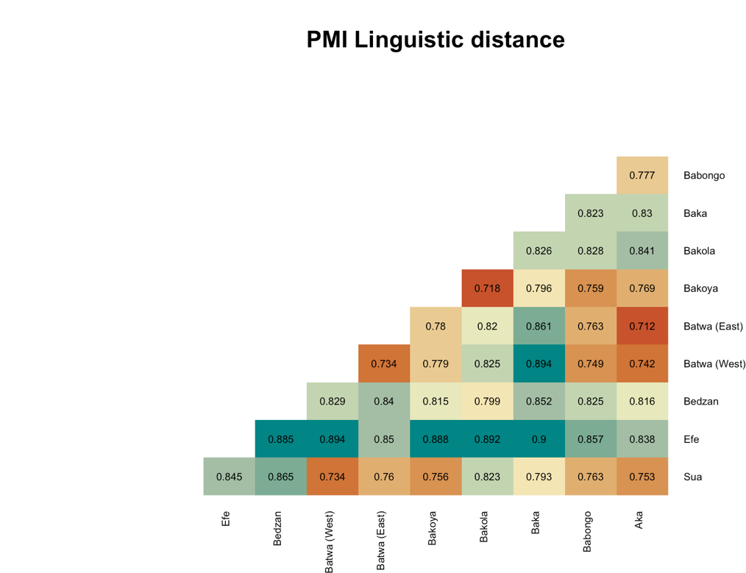
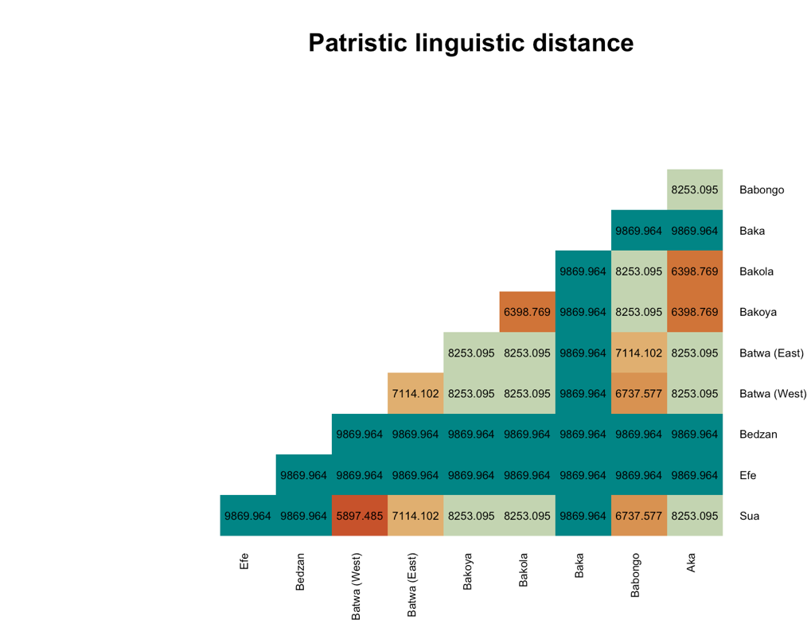
Fig S16. Between-population linguistic distance matrices averaged across all the languages spoken by each population (see Tables S2-S3). For non-Bantu speaking populations (Efe, Bedzan and Baka) a patristic distance equal to the maximum depth of the Bantu phylogenetic tree was used (9869.964).

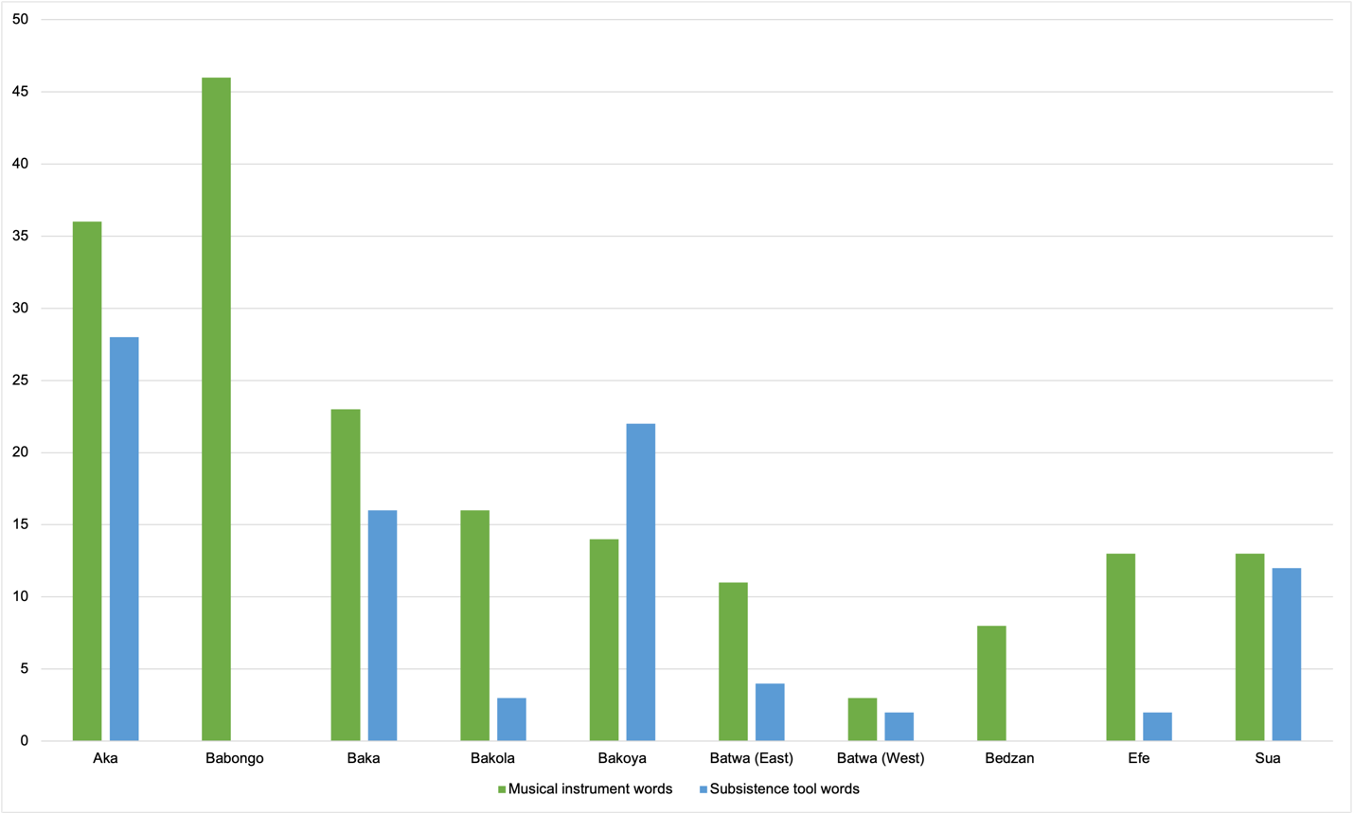
Fig S17. Number of different words compiled per population to designate musical instruments and subsistence tools.

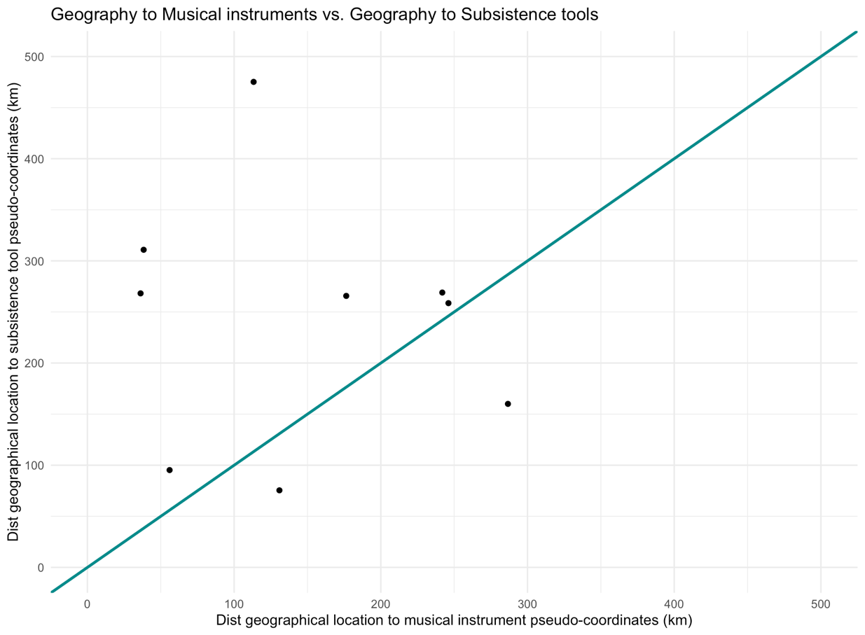
Fig S18. Comparison of distances between SpaceMix pseudo-coordinates based on musical instrument repertoires to the real geographical coordinates of CAHG populations against distance between pseudo-coordinates based on subsistence tool repertoires to the real geographical coordinates of CAHG populations. Blue line indicates where y=x (i.e. both distances are the same).

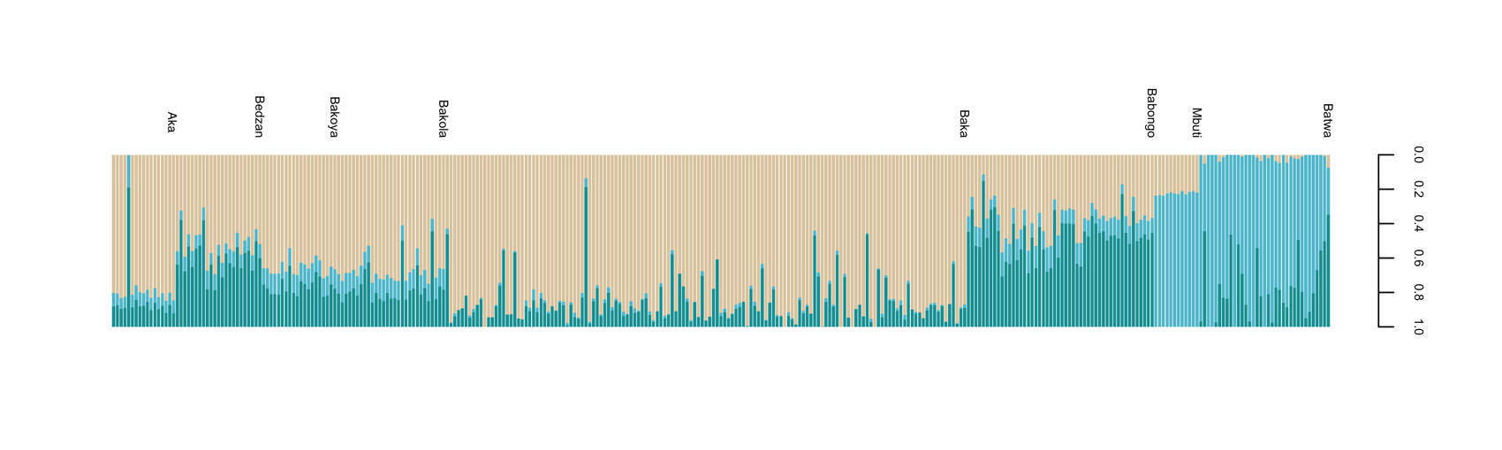
Fig S19. Results from the programme ADMIXTURE on our reduced pruned SNP dataset. Each bar corresponds to an individual and colours represent the proportion of inferred ancestry components from K=3 ancestral populations. Note the “Mbuti” group comprises the Efe and Sua.
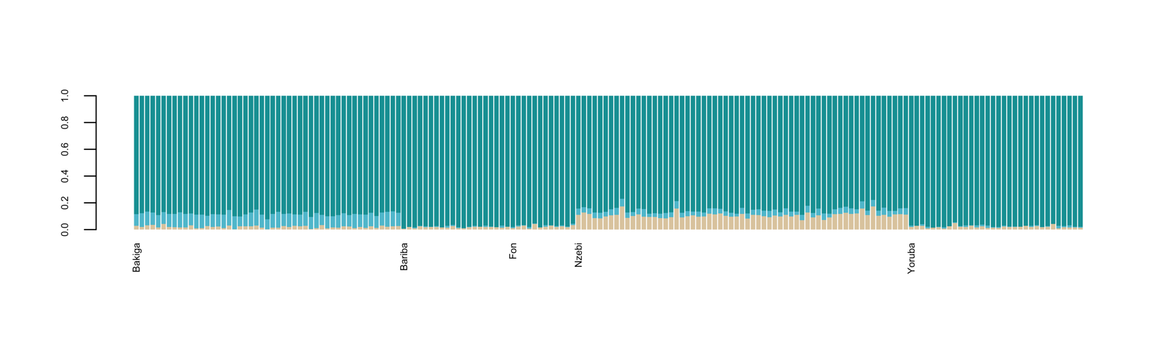

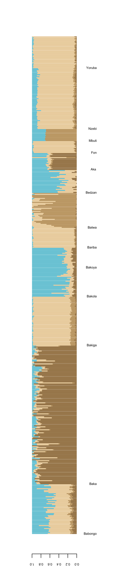
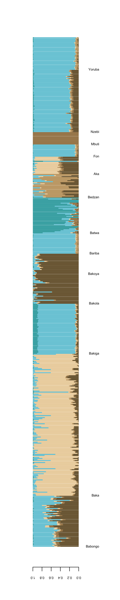
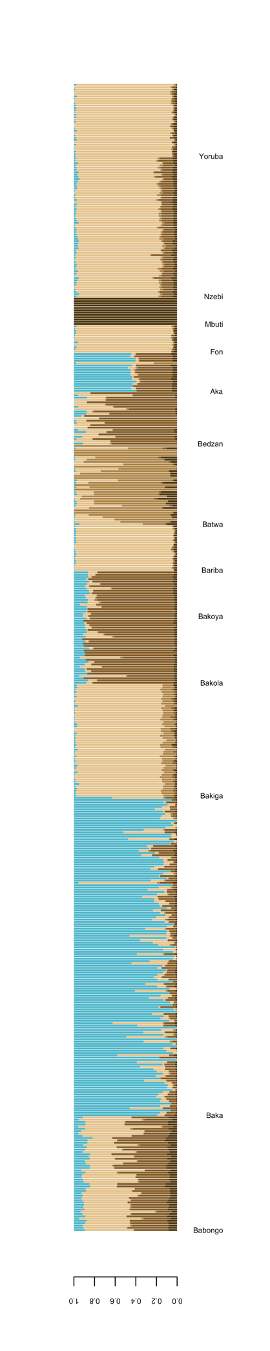
Fig S20. Admixture results at K=4 (left), K=5 (middle) and K=6 (right). Note the “Mbuti” group comprises the Efe and Sua.

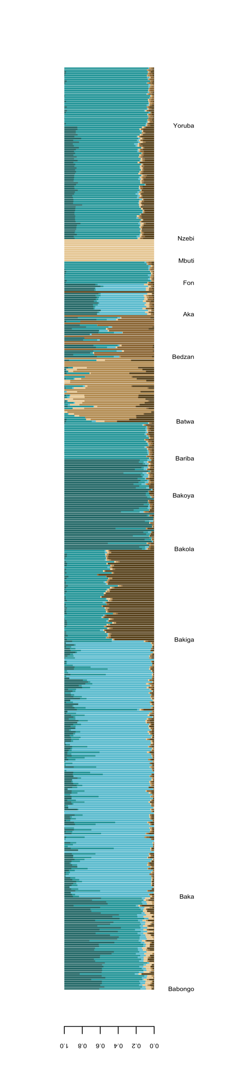
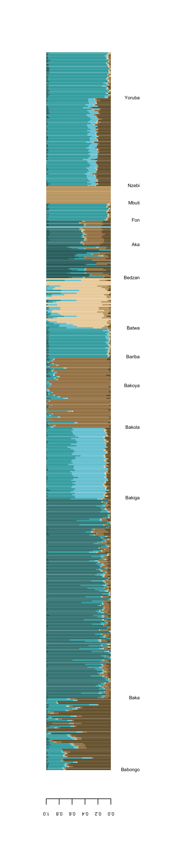
Fig S21. Admixture results at K=7 (left) and K=8 (right). Note the “Mbuti” group comprises the Efe and Sua.

Table S1. Area, and location of each group after Bahuchet 2006;2012 and estimated population size of each of the groups by Bahuchet 2006; Hewlett and Fancher, 2013 (western Batwa), and Lewis, 2000 (for the eastern Batwa). For Babongo, we merged his estimate for central and southern Babongo.
Culture | Lon | Lat | Area (degrees squared) | Estimated census pop size | Country
Aka | 17.22 | 2.43 | 6.09 | 30,000-50,000 | CAR, Congo
Babongo | 11.98 | -2.00 | 1.84 | 9,500 | Gabon
Baka | 14.14 | 2.35 | 8.01 | 30,000-40,000 | Cameroon, Gabon, Congo
Bakola | 10.16 | 3.01 | 1.12 | 4,000 | Cameroon
Bakoya | 14.49 | 0.70 | 0.88 | 2,600 | Gabon, Congo
Batwa (East) | 29.35 | -2.38 | 4.45 | 70,000-87,000 | DRC, Uganda, Rwanda
Batwa (West) | 18.53 | -1.33 | 4.89 | 14,000 | DRC
Bedzan | 11.36 | 5.87 | 0.11 | 400 | Cameroon
Efe | 29.33 | 1.81 | 1.73 | 10,000 | DRC
Sua | 28.38 | 1.62 | 2.44 | 26,000 | DRC

Table S2. Linguistic classification of the languages spoken by the CAHG populations included in this study from Bahuchet 2006;2012 (Following classification by Greenberg, 1966; Ruhen, 1991 and Guthrie, 1967-71).
CAHG group | Phylum | Stock | Family | Group | Sub-group
Baka | Nigel-Kordofanian | Niger-Congo | North Central | Adamawa-Ubangian | Gbanzili-Sere
Bedzan | Nigel-Kordofanian | Niger-Congo | South Central | Bantoid, Non-Bantu | Tikar
Bakola | Nigel-Kordofanian | Niger-Congo | South Central | Northwest Bantu | A80
Bakoya | Nigel-Kordofanian | Niger-Congo | South Central | Northwest Bantu | B20
Babongo | Nigel-Kordofanian | Niger-Congo | South Central | Northwest Bantu | B30
Babongo | Nigel-Kordofanian | Niger-Congo | South Central | Northwest Bantu | B60
Babongo | Nigel-Kordofanian | Niger-Congo | South Central | Northwest Bantu | B70
Aka | Nigel-Kordofanian | Niger-Congo | South Central | Northwest Bantu | C10
Batwa (West) | Nigel-Kordofanian | Niger-Congo | South Central | Northwest Bantu | C60
Batwa (East) | Nigel-Kordofanian | Niger-Congo | South Central | Central Bantu | J11
Batwa (East) | Nigel-Kordofanian | Niger-Congo | South Central | Central Bantu | J60
Sua | Nigel-Kordofanian | Niger-Congo | South Central | Central Bantu | D30
Efe | Nilo-Saharan | Central-Sudanic | East Central | Mangbetu-Efe | -

Table S3. Linguistic classification of the languages spoken by the CAHG populations included in this study from the Ethnologue. For those CAHG languages have not been described or classified, we write the classification of the closest language (CL) from the closest farming language from which the CAHG language is considered a dialect of, after verifying that both were classified as belonging to the same linguistic family and subgroup according to Bahuhet, 2006.* Denotes groups that do not speak a language from the Bantu family.
CAHG group | Ethnologue entry (ISO 639-3 code) | Exact language/ closest neighbour | Glottocode | Ethnologue classification
Baka* | Baka (bkc) | EL | baka1272 | Niger-Congo, Atlantic-Congo, Volta-Congo, North, Adamawa-Ubangi, Ubangi, Sere-Ngbaka-Mba, Ngbaka-Mba, Ngbaka, Western, Baka-Gundi
Bedzan* | Tikar (tik) | CL | tika1246 | Niger-Congo, Atlantic-Congo, Volta-Congo, Benue-Congo, Bantoid, Southern, Tikar
Bakola | Gyele (gyi) | EL | gyel1242 | Niger-Congo, Atlantic-Congo, Volta-Congo, Benue-Congo, Bantoid, Southern, Narrow Bantu, Northwest, A, Makaa-Njem (A.801)
Bakoya | Koya (nra) | EL | ngom1270 | Niger-Congo›Atlantic-Congo›Volta-Congo›Benue-Congo›Bantoid›Southern›Narrow Bantu›Northwest›B›Kele (B.22)
Babongo | Kaningi (kzo) | EL | kani1279 | Niger-Congo›Atlantic-Congo›Volta-Congo›Benue-Congo›Bantoid›Southern›Narrow Bantu›Northwest›B›Mbete (B.602)
Babongo | Teke (tek) | CL | ibal1241 | Niger-Congo›Atlantic-Congo›Volta-Congo›Benue-Congo›Bantoid›Southern›Narrow Bantu›Northwest›B›Teke (B.75)
Babongo | Tsogho (tsv) | CL | tsog1243 | Niger-Congo›Atlantic-Congo›Volta-Congo›Benue-Congo›Bantoid›Southern›Narrow Bantu›Northwest›B›Tsogo (B.31)
Babongo | Nzebi (nzb) | EL | njeb1242 | Niger-Congo, Atlantic-Congo, Volta-Congo, Benue-Congo, Bantoid, Southern, Narrow Bantu, Northwest, B, Nzebi (B.52)
Aka | Ngando (ngd) | CL | ngan1304 | Niger-Congo›Atlantic-Congo›Volta-Congo›Benue-Congo›Bantoid›Southern›Narrow Bantu›Northwest›C›Ngondi
Batwa (West) | Bushong (buf) | CL | bush1247 | Niger-Congo, Atlantic-Congo, Volta-Congo, Benue-Congo, Bantoid, Southern, Narrow Bantu, Northwest, C, Bushoong (C.83)
Batwa (East) | Twa (kin) | EL | kiny1244 | Niger-Congo, Atlantic-Congo, Volta-Congo, Benue-Congo, Bantoid, Southern, Narrow Bantu, Central, J, Ruanda-Rundi (D.61)
Sua | Bila (bip) | CL | bila1255 | Niger-Congo, Atlantic-Congo, Volta-Congo, Benue-Congo, Bantoid, Southern, Narrow Bantu, Central, D, Bira-  Nyali
Efe* | Efe (efe) | EL | efee1239 | Nilo-Saharan›Satellite-Core›Satellites›Central Sudanic›East›Mangbutu-Efe

Table S4. Populations included in our genetic analyses.
Population | N | Name in original datasets | Meta group
Babongo | 50 | BabongoE/BabongoS | West CAHG
Baka | 144 | BakaG/Baka | West CAHG
Bakola | 29 | Bakola | West CAHG
Bakoya | 20 | Bakoya | West CAHG
Bedzan | 24 | Bedzan/Bezan | West CAHG
Aka | 17 | Biaka | West CAHG
Batwa East | 35 | Batwa | East CAHG
Efe & Sua | 13 | Mbuti | East CAHG
Bakiga | 54 | Bakiga | Non_HG
Bariba | 20 | Bariba | Non_HG
Fon | 12 | Fon | Non_HG
Nzebi | 61 | Nzebi | Non_HG
Yoruba | 32 | Yoruba | Non_HG

Table S5. Multiple matrix regressions assessing the relationship between geographical, genetic, ecological and cultural distance with masked dataset (CAHG genomic segments).
 | Musical instruments |  | Subsistence tools
 | Coefficient | p value | Coefficient | p value
Genes (cont. Geography) | 0.185 | 0.191 | 0.244 | 0.164
Genes (cont. ecology) | 0.414 | 0.018 | 0.142 | 0.274
Geography (cont. Genes) | 0.269 | 0.088 | -0.031 | 0.578
Geography (cont. Ecology) | 0.395 | 0.008 | 0.0457 | 0.373
Ecology (cont. Geography) | -0.029 | 0.559 | 0.496 | 0.015
Ecology (cont. Genes) | -0.033 | 0.541 | 0.309 | 0.119

Table S6. Results of the (a) overall and (b) a posteriori CADM tests, using geographical, ecological, musical instrument repertoire and genetic distance matrices using CAHG ancestry segments exclusively. (c) The complementary one-tailed rank tests are also shown for equivalent tests including genetic distance matrices built from each of the other three genetic datasets. P = permutational probability, P_{H} = permutational probability after Holm adjustment, r = Mantel statistic using ranks. All probabilities are based upon 1000 permutations.
- Overall CADM tests  Kendall’s W  Friedman’s chi-squared | 0.594  83.097 | P<0.001
- A posteriori CADM tests  Musical instruments  Geography  Ecology  Genes (CAHG ancestry) | P_{H}=0.014  P_{H}=0.008  P_{H}=0.014  P_{H}=0.008
- One-tailed rank tests  Musical instruments  Geography  Ecology  Genes (CAHG ancestry)  Genes (CAHG ancestry – IBD)  Genes (full dataset)  Genes (Bantu ancestry) | Musical instruments  r=0.503  P=0.008  r=0.250  P=0.118  r=0.416  P=0.013  r=0.422  P=0.014  r=0.312  P=0.074  r=-0.015  P=0.508 | Geography  r=0.343  P=0.027  r=0.743  P=0.002  r=0.753  P=0.001  r=0.767  P=0.002  r=-0.181  P=0.666 |  |  | Ecology  r=0.494  P=0.016  r=0.498  P=0.011  r=0.351  P=0.052  r=-0.347  P=0.846

Table S7. Results of the (a) overall and (b) a posteriori CADM tests, using geographical, ecological, subsistence tool repertoire and genetic distance matrices using CAHG ancestry segments exclusively. (c) The complementary one-tailed rank tests are also shown for equivalent tests including genetic distance matrices built from each of the other three genetic datasets. P = permutational probability, P_{H} = permutational probability after Holm adjustment, r = Mantel statistic using ranks. All probabilities are based upon 1000 permutations.
- Overall CADM tests  Kendall’s W  Friedman’s chi-squared | 0.543  76.088 | P<0.001
- A posteriori CADM tests  Subsistence tools  Geography  Ecology  Genes (CAHG ancestry) | P_{H}=0.123  P_{H}=0.009  P_{H}=0.008  P_{H}=0. 012
- One-tailed rank tests  Subsistence tools  Geography  Ecology  Genes (CAHG ancestry)  Genes (CAHG ancestry – IBD)  Genes (full dataset)  Genes (Bantu ancestry) | Subsistence tools  r=0.207  P=0.107  r=0.480  P=0.023  r=0.211  P=0.156  r=0.215  P=0.160  r=0.087  P=0.362  r=-0.242  P=0.762 | Geography  r=0.353  P=0.027  r=0.743  P=0.002  r=0.753  P=0.005  r=0.767  P=0.002  r=-0.180  P=0.660 |  |  | Ecology  r=0.493  P=0.008  r=0.499  P=0.012  r=0.351  P=0.053  r=-0.347  P=0.872

Table S8. Mantel tests predicting structure of genetic diversity (Fst) using CAHG ancestry components. P values are adjusted with Benjamini Hochberg procedure.
 | Genetic diversity (F_{ST})
 | Statistic | Adj p
Geography | 0.818 | 0.001
Ecology | 0.434 | 0.022
Geography (cont. ecology) | 0.746 | 0.001
Ecology (cont. geography) | 0.201 | 0.182

Table S9. Estimated admixture proportion from hypothesised admixture source location in Spacemix (taken from MCMC run with highest posterior probability)
Population | Proportion of genome from inferred admixture source
Baka | 0.110
Bakoya | 0.054
Bakola | 0.002
Efe & Sua | 0.002
Batwa (East) | 0.063
Aka | 0.061
Bedzan | 0.128
Babongo | 0.010

Table S10. Geographical coordinates used for each of the CAHG populations (centroid of their range), as well as SpaceMix pseudo-coordinates based on genetics (using only CAHG components), musical instrument repertoires, and subsistence tool repertoires.

Group | Lon GEOG | Lat GEOG | Lon GEN | Lat GEN | Lon MUS | Lat MUS | Lon SUB | Lat SUB
Baka | 14.14 | 2.35 | 12.59 | -2.19 | 15.26 | 1.99 | 13.89 | 1.72
Bakoya | 14.48 | 0.69 | 14.09 | 4.04 | 12.66 | 1.94 | 12.29 | 1.45
Bakola | 10.15 | 3.01 | 14 | 4.21 | 11.08 | 2.58 | 14.2 | 1.63
Efe | 29.33 | 1.81 | 29.29 | 1.76 | 29.66 | 2.19 | 29.76 | 2.55
Sua | 28.38 | 1.62 | 29.29 | 1.76 | 28.7 | 1.56 | 27.63 | 3.91
Batwa | 29.35 | -2.37 | 22.26 | -0.1 | 29.07 | -2.18 | 27.31 | -4.29
Aka | 17.22 | 2.43 | 13.46 | -0.09 | 16.94 | 0.87 | 14.85 | 2.13
Bedzan | 11.36 | 5.87 | 14.6 | 2.61 | 11.59 | 3.71 | 13.28 | 7.36
Babongo | 11.98 | -2 | 16.77 | 1.37 | 11.45 | 0.52 | 12.93 | -3.08

Table S11. Total number of shared IBD segments >1cM between individuals belonging to CAHG populations (only within CAHG genomic components)

 | Babongo | Baka | Bakola | Bakoya | Batwa | Bedzan | Aka | Efe & Sua
Babongo | 1385 | 2790 | 394 | 330 | 378 | 639 | 527 | 68
Baka | 2790 | 71819 | 4549 | 4118 | 1714 | 12155 | 28922 | 339
Bakola | 394 | 4549 | 981 | 835 | 390 | 1718 | 1325 | 32
Bakoya | 330 | 4118 | 835 | 882 | 284 | 1623 | 1386 | 31
Batwa | 378 | 1714 | 390 | 284 | 4245 | 393 | 213 | 100
Bedzan | 639 | 12155 | 1718 | 1623 | 393 | 9904 | 4735 | 127
Aka | 527 | 28922 | 1325 | 1386 | 213 | 4735 | 7358 | 77
Efe & Sua | 68 | 339 | 32 | 31 | 100 | 127 | 77 | 3015

Table S12. Total length of IBD segments >1cM among shared all individuals from each CAHG population pair (only within CAHG genomic components)
 | Babongo | Baka | Bakola | Bakoya | Batwa | Bedzan | Aka | Efe & Sua
Babongo | 16893.098 | 12601.295 | 1968.582 | 1650.36 | 2423.201 | 1664.461 | 1114.199 | 128.321
Baka | 12601.295 | 254052.515 | 15724.828 | 13071.769 | 8204.875 | 29727.654 | 78632.294 | 683.507
Bakola | 1968.582 | 15724.828 | 4172.076 | 3090.363 | 2955.117 | 4285.595 | 2980.787 | 66.201
Bakoya | 1650.36 | 13071.769 | 3090.363 | 3590.363 | 2328.025 | 3976.952 | 3209.948 | 57.697
Batwa | 2423.201 | 8204.875 | 2955.117 | 2328.025 | 20928.371 | 1379.269 | 443.288 | 214.79
Bedzan | 1664.461 | 29727.654 | 4285.595 | 3976.952 | 1379.269 | 64284.796 | 11427.79 | 247.443
Aka | 1114.199 | 78632.294 | 2980.787 | 3209.948 | 443.288 | 11427.79 | 31292.914 | 149.019
Efe & Sua | 128.321 | 683.507 | 66.201 | 57.697 | 214.79 | 247.443 | 149.019 | 9804.437

Table S13. Shared lexical items between CAHG groups. The “Variation in word” column indicates all variants in original terminology used to design that object that were lumped under the same word category. Y= Yes, N= No. *Denote word variations that are likely shared but evidence is not conclusive.
Word | Variation in word | Meaning | Populations sharing word and meaning | Object CAHG unique? | Word CAHG unique?
Musical instruments
ndumu | ndùmù, ndumu | drum (conical) | Aka, Baka, Bakoya, | N | N
ngom | ngomo, ngoma,  ŋgɔm, ngomu, ngom | drum (cylyndrical) | Bakoya, Bakola, Batwa (West), Babongo | N | N
hindehu | hìndèhú, èlehú | flute (small, simple) | Aka, Baka | Y | Y
ngombi | ngòmbi, ngombi, bo.ngombe,  ngɔ̀ mbī | harp | Aka, Babongo, Baka, Batwa (West) | Y | Y
bogongo | bògóngó, bògongo | zither harp | Aka, Baka | Y | Y
ligbebe | lìgbégbé  lìgbebe,  li.gbo:gbo,  litchèké* | rattle (basket) | Aka, Baka, Efe, Babongo* | N | N
soko | sòkò, soko, soki, ma.soku, sàkà | Rattle | Aka, Babongo, Baka, Bakoya | N | N
baka | mbaka, bákà | struck beam (bamboo) | Babongo, Bakola | Y | Y
bàndá | mbàndá, banza,  mbàndā | rhythmic sticks (hunting ritual) | Aka, Baka, Sua | Y | Y
mobio | mòbìó, mobio | flute (notched) | Aka, Baka | Y | Y
ruma | ruma, baruma | flute | Efe, Sua | N | Y
sanze | sànze, sanzi, sanza | lamellaphone | Aka, Babongo | N | N
ashaka | ashaka | ankle rattles (made with seeds and tied with a string) | Aka, Baka | Y | Y
kúbù | kúbù | high-pitched drum (played alongside mokinda) | Aka, Baka | Y | Y
mokinda | mòkíndá, mokinda | single-skinned drum | Aka, Baka | Y | Y
kembe | likembe, ikembe, kembe, kembi | lamellaphone | Baka, Batwa (East), Efe, Sua | N | N
mbɛ | mbɛ, mgbæ | drum | Bedzan, Bakola | N | N
ngbídí | èngbítí, língbidi,  engbídí,  kittingbi | musical bow (2 strings, played by females) | Aka, Baka, Efe | Y | Y
gongo | mugongo, mgongo, ngàngo* | musical bow (1 string) | Babongo, Baka* | Y | Y
ngindi | ngindi, ngadi* | musical bow | Aka, Bakoya* | Y | Y
beka | di.beka, di.boka, mo.beke, móbéké | whistle (papaya leafstalk) | Aka, Babongo | Y | Y
pole.pole | pole.pole, polo, polo | whistle (seeds) | Aka, Baka | Y | Y
bisa | besa, bisa, mangisa* | rattle | Babongo, Baka* | N | Y
Subsistence tools
apekulo | apeku.lo, apokolo | cable snare | Baka, Bakoya | N | Y
api | api, apí, abi | arrow | Efe, Sua | N | N
sàwàla | sàwàla | leather sac | Aka, Baka | Y | Y
mokobe | mòkòbé, mokobe | honey container | Aka, Baka | Y | Y
mbánji | mbánji, mbadi | wooden tip arrow | Baka, Batwa (West) | Y | Y
bànzà | mbànzà, di-banzika | metal tip arrow | Aka, Bakoya | N | N
ikua | di.kuya, íkùa | basket | Aka, Bakoya | N | Y
nbgango | ngbángò, bo.ngango | bow (hunting) | Aka, Batwa* (West) | N | N
pèndi | pèndi | container | Aka, Baka | N | N
konga | e.kòngá, ekonga, kongo, dikono* | spear | Aka, Bakoya*, Sua | N | N
leki | éléki, lékè, mò.lékè | trap | Aka, Sua | N | Y

Table S14. Coefficients of Zero-Inflated Poisson model predicting the sharing of musical instrument words between CAHG populations as a function of genetic, and linguistic distance calculated with PMI scores (top) and geographic, and linguistic distance calculated with PMI scores (bottom), using the full linguistic dataset. All predictors were standardized.
 | Estimate | Std. Error | z value | p value
Count model coefficients
Intercept | 0.423 | 0.274 | 1.543 | 0.123
Genetic distance (CAHG ancestry) | -0.769 | 0.233 | -3.299 | 0.001
Linguistic distance (PMI score) | 0.360 | 0.191 | 1.882 | 0.060
Zero-inflation model coefficients
Intercept | -0.518 | 0.630 | -0.821 | 0.411
Genetic distance (CAHG ancestry) | 0.758 | 0.593 | 1.279 | 0.201
Linguistic distance (PMI score) | 1.201 | 0.710 | 1.691 | 0.091

 | Estimate | Std. Error |  | z value | p value
Count model coefficients
Intercept | 0.454 | 0.276 |  | 1.646 | 0.100
Geographical distance | -0.451 | 0.263 |  | -1.715 | 0.086
Linguistic distance (PMI score) | 0.080 | 0.155 |  | 0.518 | 0.604
Zero-inflation model coefficients
Intercept | -0.407 | 0.554 |  | -0.734 | 0.463
Geographical distance | 1.296 | 0.545 |  | 2.378 | 0.017
Linguistic distance (PMI score) | 0.431 | 0.467 |  | 0.923 | 0.356

Table S15. Coefficients of Zero-Inflated Poisson model predicting the sharing of musical instrument words between CAHG populations as a function of genetic, and linguistic distance calculated using Glottolog (top) and geographic, and linguistic distance calculated using Glottolog (bottom), using the full linguistic dataset. All predictors were standardized.
 | Estimate | Std. Error | z value | p value
Count model coefficients
Intercept | 0.298 | 0.313 | 0.954 | 0.340
Genetic distance (CAHG ancestry) | -0.793 | 0.254 | -3.124 | 0.002
Linguistic distance (Glottolog) | 0.279 | 0.154 | 1.810 | 0.070
Zero-inflation model coefficients
Intercept | -0.523 | 0.663 | -0.789 | 0.430
Genetic distance (CAHG ancestry) | 0.628 | 0.623 | 1.007 | 0.314
Linguistic distance (Glottolog) | 0.186 | 0.523 | 0.356 | 0.722

 | Estimate | Std. Error |  | z value | p value
Count model coefficients
Intercept | 0.453 | 0.258 |  | 1.757 | 0.079
Geographical distance | -0.444 | 0.241 |  | -1.847 | 0.065
Linguistic distance (Glottolog) | 0.255 | 0.153 |  | 1.668 | 0.095
Zero-inflation model coefficients
Intercept | -0.397 | 0.523 |  | -0.760 | 0.447
Geographical distance | 1.244 | 0.529 |  | 2.353 | 0.019
Linguistic distance (Glottolog) | 0.205 | 0.459 |  | 0.447 | 0.655

Table S16. Coefficients of Zero-Inflated Poisson model predicting the sharing of musical instrument words between CAHG populations as a function of genetic, and linguistic distance calculated using Koile et al.’s phylogeny (top) and geographic, and linguistic distance calculated using Koile et al.’s phylogeny (bottom), using the full linguistic dataset. All predictors were standardized.
 | Estimate | Std. Error | z value | p value
Count model coefficients
Intercept | 0.004 | 0.255 | 0.014 | 0.989
Genetic distance (CAHG ancestry) | -0.978 | 0.208 | -4.700 | 0.000
Linguistic distance (phylogenetic) | 0.570 | 0.169 | 3.365 | 0.001
Zero-inflation model coefficients
Intercept | -6.072 | 73.581 | -0.083 | 0.934
Genetic distance (CAHG ancestry) | 0.208 | 0.645 | 0.322 | 0.747
Linguistic distance (phylogenetic) | 6.631 | 88.745 | 0.075 | 0.940

 | Estimate | Std. Error |  | z value | p value
Count model coefficients
Intercept | 0.366 | 0.298 |  | 1.231 | 0.218
Geographical distance | -0.516 | 0.275 |  | -1.879 | 0.060
Linguistic distance (phylogenetic) | 0.367 | 0.186 |  | 1.969 | 0.049
Zero-inflation model coefficients
Intercept | -0.614 | 0.832 |  | -0.738 | 0.460
Geographical distance | 1.087 | 0.618 |  | 1.757 | 0.079
Linguistic distance (phylogenetic) | 0.562 | 1.054 |  | 0.533 | 0.594

Table S17. Coefficients of Zero-Inflated Poisson model predicting the sharing of musical instrument words between CAHG populations as a function of genetic, and linguistic distance calculated with PMI scores (top) and geographic, and linguistic distance calculated with PMI scores (bottom), using the subset of words that were both unique to CAHG and clear cases of sharing. All predictors were standardized.
 | Estimate | Std. Error | z value | p value
Count model coefficients
Intercept | -0.895 | 0.603 | -1.485 | 0.137
Genetic distance (CAHG ancestry) | -1.621 | 0.434 | -3.731 | <0.001
Linguistic distance (PMI score) | -1.528 | 0.318 | -0.153 | 0.664
Zero-inflation model coefficients
Intercept | -0.134 | 1.156 | -0.116 | 0.908
Genetic distance (CAHG ancestry) | 0.342 | 0.867 | 0.394 | 0.693
Linguistic distance (PMI score) | 0.082 | 1.081 | 0.076 | 0.940

 | Estimate | Std. Error |  | z value | p value
Count model coefficients
Intercept | -0.461 | 0.394 |  | -1.171 | 0.242
Geographical distance | -1.281 | 0.344 |  | -3.722 | <0.001
Linguistic distance (PMI score) | 0.080 | 0.155 |  | 0.518 | 0.604
Zero-inflation model coefficients
Intercept | -0.737 | 1.279 |  | -0.577 | 0.564
Geographical distance | -0.838 | 1.256 |  | -0.667 | 0.505
Linguistic distance (PMI score) | -0.479 | 0.547 |  | -0.875 | 0.381

Table S18. Coefficients of Zero-Inflated Poisson model predicting the sharing of musical instrument words between CAHG populations as a function of genetic, and linguistic distance calculated using Glottolog (top) and geographic, and linguistic distance calculated using Glottolog (bottom), using the subset of words that were both unique to CAHG and clear cases of sharing. All predictors were standardized.
 | Estimate | Std. Error | z value | p value
Count model coefficients
Intercept | -0.699 | 0.753 | -0.928 | 0.353
Genetic distance (CAHG ancestry) | -1.770 | 0.548 | -3.272 | 0.001
Linguistic distance (Glottolog) | 0.005 | 0.294 | 0.018 | 0.986
Zero-inflation model coefficients
Intercept | -0.341 | 1.506 | -0.226 | 0.821
Genetic distance (CAHG ancestry) | 0.226 | 1.005 | 0.225 | 0.822
Linguistic distance (Glottolog) | -0.300 | 0.554 | -0.541 | 0.588

 | Estimate | Std. Error |  | z value | p value
Count model coefficients
Intercept | -0.401 | 0.451 |  | -0.889 | 0.374
Geographical distance | -1.417 | 0.345 |  | -4.108 | <0.001
Linguistic distance (Glottolog) | 0.187 | 0.230 |  | 0.813 | 0.416
Zero-inflation model coefficients
Intercept | -0.504 | 1.316 |  | -0.383 | 0.702
Geographical distance | -0.587 | 1.324 |  | -0.444 | 0.657
Linguistic distance (Glottolog) | 0.228 | 0.505 |  | 0.451 | 0.652

Table S19. Coefficients of Zero-Inflated Poisson model predicting the sharing of musical instrument words between CAHG populations as a function of genetic, and linguistic distance calculated using Koile et al.’s phylogeny (top) and geographic, and linguistic distance calculated using Koile et al.’s phylogeny (bottom), using the subset of words that were both unique to CAHG and clear cases of sharing. All predictors were standardized.
 | Estimate | Std. Error | z value | p value
Count model coefficients
Intercept | -0.896 | 0.502 | -1.786 | 0.074
Genetic distance (CAHG ancestry) | -1.224 | 0.370 | -3.312 | <0.001
Linguistic distance (phylogenetic) | -0.002 | 0.412 | -0.007 | 0.994
Zero-inflation model coefficients
Intercept | -6.436 | 97.788 | -0.066 | 0.948
Genetic distance (CAHG ancestry) | 0.393 | 0.814 | 0.483 | 0.629
Linguistic distance (phylogenetic) | 7.817 | 117.949 | 0.066 | 0.947

 | Estimate | Std. Error |  | z value | p value
Count model coefficients
Intercept | -0.562 | 0.358 |  | -1.571 | 0.116
Geographical distance | -1.011 | 0.346 |  | -2.922 | 0.003
Linguistic distance (phylogenetic) | 0.751 | 0.295 |  | 2.547 | 0.011
Zero-inflation model coefficients
Intercept | -1.333 | 1.522 |  | -0.876 | 0.381
Geographical distance | -0.635 | 1.138 |  | -0.558 | 0.577
Linguistic distance (phylogenetic) | 1.431 | 1.629 |  | 0.878 | 0.380

Table S20. Number of iterations used for each K value in ADMIXTURE analyses

K value | Iterations
2 | 58
3 | 53
4 | 50
5 | 46
6 | 55
7 | 61
8 | 50

Table S21. Mean proportion of ancestry components from out ADMIXTURE run at K=3. CAHG_1 and CAHG_2 refer to ancestry components associated with Western and Eastern CAHG respectively. AGR refer to ancestry components associated with African agriculturalist populations.

Population | CAHG_1 | CAHG_2 | AGR
Babongo | 0.378 | 0.100 | 0.523
Baka | 0.851 | 0.012 | 0.137
Bakola | 0.663 | 0.109 | 0.228
Bakoya | 0.656 | 0.110 | 0.234
Batwa | 0.014 | 0.768 | 0.219
Bedzan | 0.522 | 0.078 | 0.400
Aka | 0.763 | 0.080 | 0.157
Efe & Sua | 0.225 | 0.775 | 0.000001

Table S22. Confusion matrix from Gnomix analyses indicating the number and proportion of correctly classified haplotypes of CAHG ancestry (CAHG_corr) and of agriculturalist associated ancestry (AGR_corr) in the validation dataset per chromosome.
CHR | CAHG_corr | CAHG_miss | CAHG_corr_prop | AGR_corr | AGR_miss | AGR_corr_prop
1 | 58444 | 9551 | 0.86 | 51978 | 9537 | 0.84
2 | 52461 | 7014 | 0.88 | 56820 | 8355 | 0.87
3 | 50155 | 7455 | 0.87 | 38596 | 7924 | 0.83
4 | 44889 | 5078 | 0.90 | 40522 | 8241 | 0.83
5 | 40876 | 7785 | 0.84 | 37714 | 7765 | 0.83
6 | 33410 | 7876 | 0.81 | 41693 | 5941 | 0.88
7 | 38056 | 6696 | 0.85 | 32656 | 6922 | 0.83
8 | 32656 | 3521 | 0.90 | 33440 | 8059 | 0.81
9 | 35558 | 6216 | 0.85 | 35518 | 5328 | 0.87
10 | 36937 | 3743 | 0.91 | 32678 | 9172 | 0.78
11 | 31328 | 3983 | 0.89 | 31732 | 5767 | 0.85
12 | 37802 | 2136 | 0.95 | 32713 | 6549 | 0.83
13 | 22428 | 4587 | 0.83 | 27022 | 3833 | 0.88
14 | 25708 | 1931 | 0.93 | 21842 | 3889 | 0.85
15 | 29849 | 3396 | 0.90 | 27538 | 6267 | 0.81
16 | 26601 | 3943 | 0.87 | 25174 | 4582 | 0.85
17 | 25540 | 4653 | 0.85 | 23535 | 4232 | 0.85
18 | 27416 | 2208 | 0.93 | 18989 | 6017 | 0.76
19 | 20253 | 1700 | 0.92 | 20436 | 5221 | 0.80
20 | 22525 | 3576 | 0.86 | 21440 | 2949 | 0.88
21 | 10831 | 2108 | 0.84 | 12664 | 2108 | 0.86
22 | 14376 | 1117 | 0.93 | 15566 | 3231 | 0.83

Data S1. (separate file)
All material cultural objects included in this study.

Data S2. (separate file)
Vocabulary items available, list of cognate sets, additional notes on linguistic terminology, criteria used for selecting cognate sets and additional references related to linguistic analyses.

