Supplementary Fig. 1. pCO2 levels in the blood before, during, and after hyperventilation. The total number of points per animal depended on its condition - some experiments were decided to finish earlier. pCO2 levels are normalized against the first measurement.
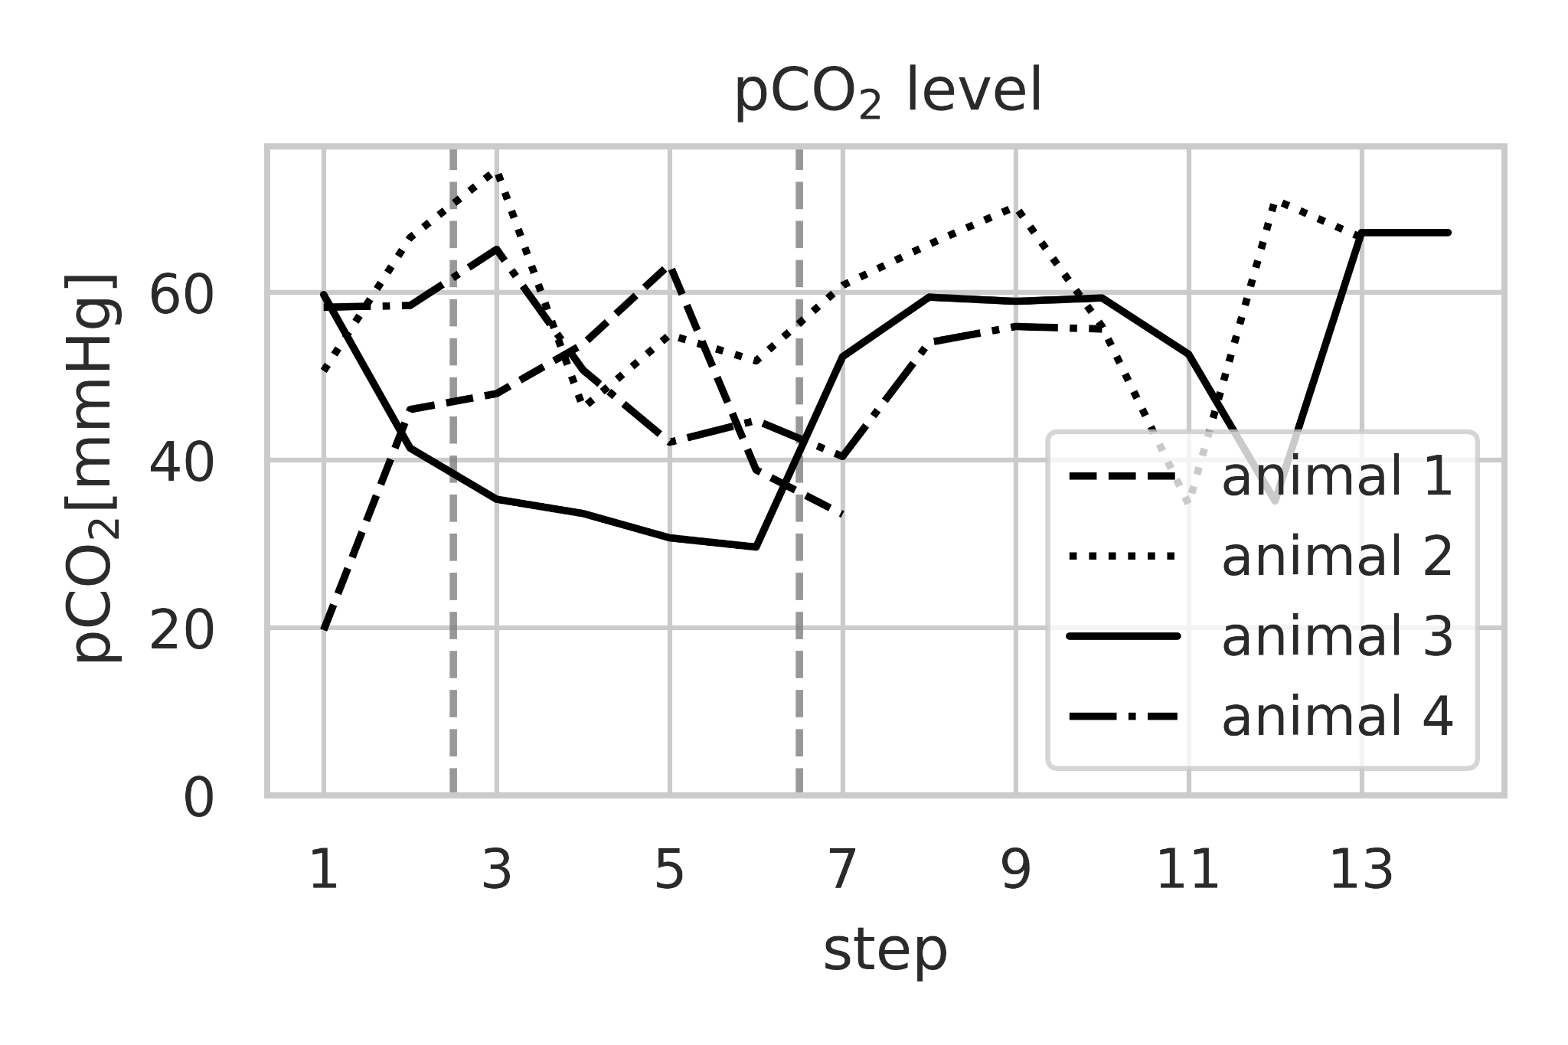
Supplementary Fig. 2. Distribution of EMG signal per animal.
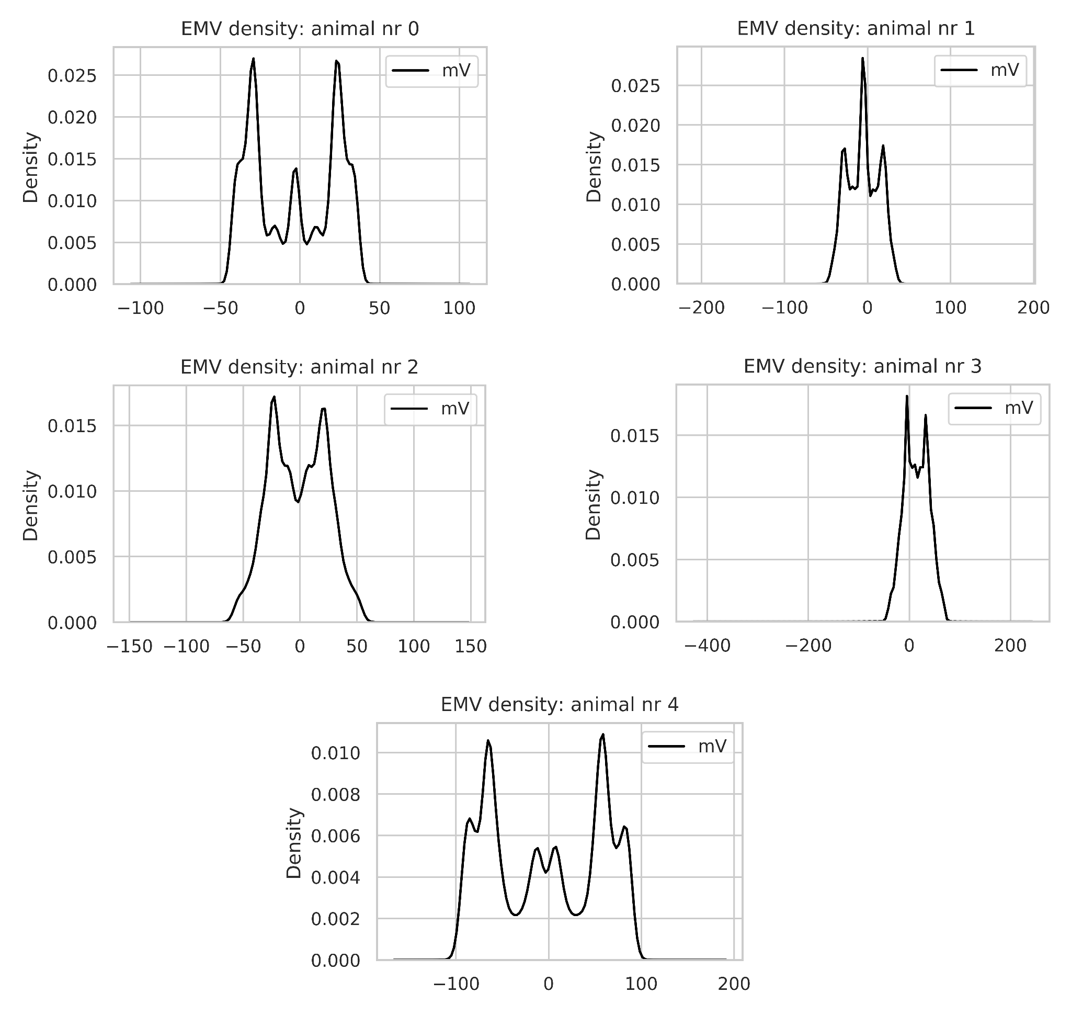

Supplemental Fig. 3. Experiment outside of the MRI chamber. The start and end of normoventilation are denoted by vertical lines. Dots are the EMG score calculated every 1s.
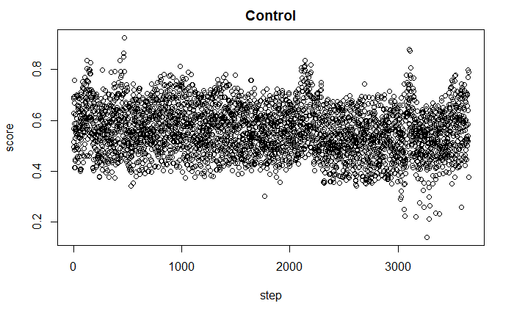

Supplemental Fig. 4. Normalized values for EMG score, inorganic phosphate levels, and pCO₂ for each animal separately. The beginning and end of hyperventilation are marked in vertical lines
