Fabrication of supramolecular system derived from Poly β-cyclodextrin coupling quinoline derivative and its fluorescence sensing of zinc ion in pure water environment
Wenping Zhu,ª Yinlong Chen,ª Zengchen Liu,^{*a} Weijie Yang,ª Yanxia Li,ª Yahong Chen,^{*a} Qingfeng Li,^{*a} Baodui Wang^{b}
ª College of Chemistry and Chemical Eningeering; Henan Key Laboratory of Rare Earth Functional Materials; International Joint Research Laboratory for Biomedical Nanomaterials of Henan; Zhoukou Key Laboratory of Nanosensing and Detection; Zhoukou Normal University, Zhoukou 466001, P.R. China
^{b} State Key Laboratory of Applied Organic Chemistry, Key Laboratory of Nonferrous Metal Chemistry and Resources Utilization of Gansu Province, Lanzhou University, Lanzhou, 730000, Gansu, P. R. China. E-mail: wangbd@lzu.cn
Corresponding author. Tel.: +86 0394 8718252; Fax: +86 0394 8178252.
- mail address: liuzengchen@zknu.cn

Fig. S1. The ¹HNMR spectrum of L

Fig. S2. The ¹³CNMR spectrum of L

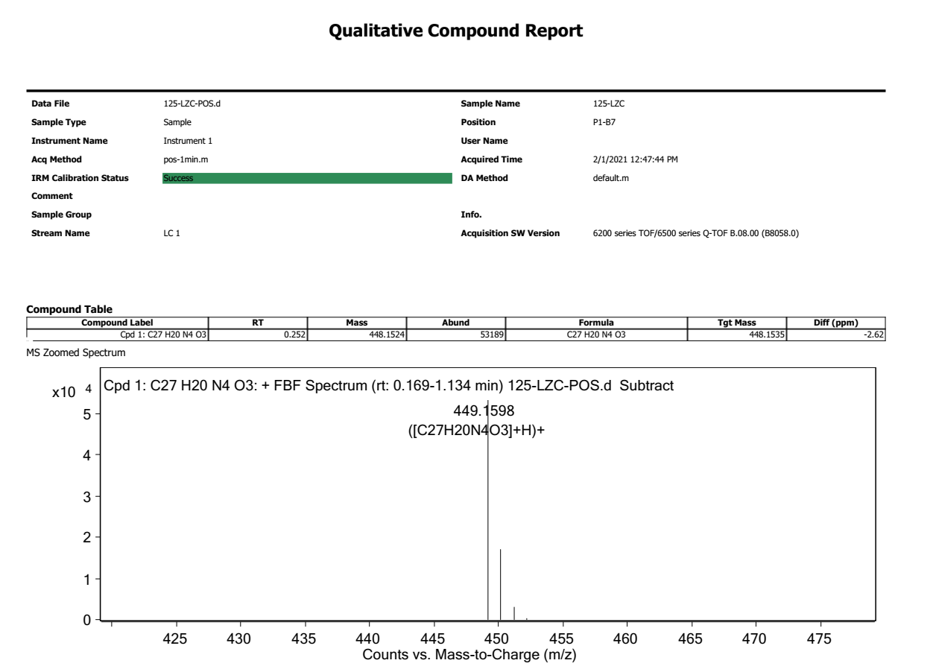Fig. S3. The HRESI-MS spectrum of P-β-CD+L

Fig. S5. The Uv-vis spectra of L (2.0×10⁻⁵ mol∙L⁻¹) in DMF/C₂H₅OH (κ_{max} = 2.19×10⁴ L∙mol⁻¹∙cm⁻¹) solution and P-β-CD+L in water solution

Fig. S5. The ¹HNMR spectrum of P-β-CD+L

Fig. S6. The Uv-vis spectra of P-β-CD+L in water solution over different periods of time (1 min, 10 h and 24 h)

Fig. S7. The IR spectra of P-β-CD, L and P-β-CD+L.

