SUPPORTING INFORMATION
Biosynthesis of trialkyl-substituted aromatic polyketide NFAT-133 involves unusual aromatization-mediating P450 monooxygenase and metallo-beta-lactamase fold thioesterase

Section-I. Tables
Table S1. Primers used in this study
Table S2. Plasmids constructed in this study
Table S3. Comparison of experimental and reported ¹H and ¹³C NMR data of 1
Table S4. Comparison of experimental and reported ¹H and ¹³C NMR data of 2
Table S5. Comparison of experimental and reported ¹H and ¹³C NMR data of 3
Table S6. Comparison of experimental and reported ¹H and ¹³C NMR data of 4
Table S7. ¹H and ¹³C NMR data for 5 in DMSO-d₆
Table S8. ¹H and ¹³C NMR data for 6 in DMSO-d₆
Table S9. ¹H and ¹³C NMR data for 7 in DMSO-d₆
Table S10. ¹H and ¹³C NMR data for 8 in DMSO-d₆

Section-II. Figs
Fig. S1. ¹H-¹H COSY and key HMBC correlations of 1 and 2
Fig. S2. Comparison of the nft BGCs derived from S. conglobatus and S. pactum
Fig. S3. Protein sequence alignment of the DH domains of the nft BGC from S. conglobatus.
Fig. S4. Protein sequence alignment of the KR domains of the nft BGC from S. conglobatus.
Fig. S5. HPLC–MS analysis of the production of compound 2 in mutant strains.
Fig. S6. HPLC–MS analysis of the culture extract of ΔnftG₁ mutant strain
Fig. S7. SDS-PAGE analysis of the recombinant proteins NftE₁ and NftF₁
Fig. S8. Protein sequence alignment of NftF₁, Chd (PDB 6UXU) and its homologous proteins from the reported BGCs of type II PKS.
Fig. S9. Superposition of the modeled structure of NftF₁ on the reported dehalogenase Chd (PDB 6UXU).
Fig. S10. NMR spectra of 1 (related to Table S3)
Fig. S11. NMR spectra of 2 (related to Table S4)
Fig. S12. NMR spectra of 3 (related to Table S5)
Fig. S13. NMR spectra of 4 (related to Table S6)
Fig. S14. NMR spectra of 5 (related to Table S7)
Fig. S15. NMR spectra of 6 (related to Table S8)
Fig. S16. NMR spectra of 7 (related to Table S9)
Fig. S17. NMR spectra of 8 (related to Table S10)

Section-I. Tables

Table S1. Primers used in this study.
Primers Sequence (5’ to 3’) Descriptions
DH3-nftC₁ (H972Y) site-directed mutagenesis by generating pRJ277
L-DH4-S | ATCCCCGGGGACCTGCAGGTCGACTGCCACGTGATCCTGGAG  (25 bp overlapping with the XbaI side of pRJ2) | Left arm of homologous recombination
L-DH4-A | ATGCCGAAGACCACGTAGTCTCGGATCCACGGCTGGGAG  (34 bp overlapping with the right arm) | Left arm of homologous recombination
R-DH4-S | AGCCGTGGATCCGAGACTACGTGGTCTTCGGCATCCCCATC | Right arm of homologous recombination
R-DH4-A | TATCACGAGGCCCTTTCGTCTTCAAGGCGCCCGAGGAGAACAGCAC  (26 bp overlapping with the EcoRI side of pRJ2) | Right arm of homologous recombination
T-DH4-S | ACGGTGGACTGGTCGGCGTTCTAC | Screening of the mutation
T-DH4-A | AGCCCGTCTCGTCGTCGAGGAC | Screening of the mutation
DH4-nftK₁ (H969Y) site-directed mutagenesis by generating pRJ278
L-DH5-S | ATCCCCGGGGACCTGCAGGTCGACTGGACATCGGCTTCTCCTC  (25 bp overlapping with the XbaI side of pRJ2) | Left arm of homologous recombination
L-DH5-A | TGCCGAAGACCATGTAGTCACGGGTCCACGGCTGCGCGTC  (28 bp overlapping with the right arm) | Left arm of homologous recombination
R-DH5-S | TGGACCCGTGACTACATGGTCTTCGGCACGGTGCTG | Right arm of homologous recombination
R-DH5-A | TATCACGAGGCCCTTTCGTCTTCAAGCACGTCCCGGAAGTTCAG  (26 bp overlapping with the EcoRI side of pRJ2) | Right arm of homologous recombination
T-DH5-S | TCACGGTGGACTGGCCGGAAC | Screening of the mutation
T-DH5-A | AGCACCAGCTCCTCCAGCACCTC | Screening of the mutation
DH7-nftD₁ (H964Y) site-directed mutagenesis by generating pRJ279
L-DH6-S | ATCCCCGGGGACCTGCAGGTCGACTACCAACGTGCACGTCATCCTG  (25 bp overlapping with the XbaI side of pRJ2) | Left arm of homologous recombination
L-DH6-A | TGCGCCCCGAGAACGACGTAATCGGCGATCCATGGCTGCGTG  (37 bp overlapping with the right arm) | Left arm of homologous recombination
R-DH6-S | AGCCATGGATCGCCGATTACGTCGTTCTCGGGGCGCAGATG | Right arm of homologous recombination
R-DH6-A2 | TATCACGAGGCCCTTTCGTCTTCAAGACCGTCCACCGAGGACAGCACGTC  (26 bp overlapping with the EcoRI side of pRJ2) | Right arm of homologous recombination
T-DH6-S | ATGTCGACTGGACGGCCTACTAC | Screening of the mutation
T-DH6-A | TTGTCGGTGAGGACCACCTG | Screening of the mutation
Deletion of the nftE₁-I₁ gene cassette (ΔnftE₁-I₁) by generating pRJ54
Lmd-SS | ATCCCCGGGGACCTGCAGGTCGACTCGTCTGCGTGCCGTCGTTC  (24 bp overlapping with the XbaI side of pRJ2) | Left arm of homologous recombination
Lmd-AA | AGCCCTGATCACCACACCACACCGTGATCTGCTCCACCGCTTC  (36 bp overlapping with the right arm) | Left arm of homologous recombination
Rmd-SS | TGGAGCAGATCACGGTGTGGTGTGGTGATCAGGGCT | Right arm of homologous recombination
Rmd-A | TATCACGAGGCCCTTTCGTCTTCAAGTGTTGTCGACTGCTCTCATTCC  (25 bp overlapping with the EcoRI side of pRJ2) | Right arm of homologous recombination
T-RJ13-S | ACTTCCTCAACGAGTGCAAGC | The ΔnftE₁-I₁ mutant screening
T-RJ13-A | TATATCGCTCGGGCAGTGGATTC | The ΔnftE₁-I₁ mutant screening
Complementation of the ΔnftE₁-I₁ mutant
RJ13-CS | AATCGTGCCGGTTGGTAGGATCCACATATGAACCCTCCCGACTCGAACGAC | Cloning of nftE₁-F₁ gene based on the pRJ5 (NdeI, EcoRV) to produce pRJ62
RJ13-CA | AAACAGCTATGACATGATTACGAATTCGATATCATGCCGGCACCCTGGTTTCC
In-frame deletion of nftG₁ (ΔnftG₁) by generating pRJ11
dd-L-S | ATCCCCGGGGACCTGCAGGTCGACTCCACGAGATCAAGGTCATG  (25 bp overlapping with the XbaI side of pRJ2) | Left arm of homologous recombination
dd-L-A | ATGTAGGCGAGCATCGAGTAGACCATGTGCGACAGAGGACCGT | Left arm of homologous recombination
dd-R-S | TGTCGCACATGGTCTACTCGATGCTCGCCTACATCCTG | Right arm of homologous recombination
dd-R-A | TATCACGAGGCCCTTTCGTCTTCAAGATCGCTGAGGTACATC  (29 bp overlapping with the EcoRI end of pRJ2) | Right arm of homologous recombination
cpy-3S | ATCGGGTTCAACGGGGAACTG | The ΔnftG₁ mutant screening
cpy-2A | ATCGCAGGACTTCAGGATGTAG | The ΔnftG₁ mutant screening
In-frame deletion of nftE₁ (ΔnftE₁) by generating pRJ141
L-cpy3-S | ACCGGGACTGATCAAGGCGAATACTATCAAGAAGAGCGACTTCGCGGAGCTGGTG  (25 bp overlapping with the XbaI side of pRJ2) | Left arm of homologous recombination
L-cpy3-A | TTGTTCATCAGCTCCACCGTGATCTGCTCCAC  (31 bp overlapping with the right arm) | Left arm of homologous recombination
R-cpy3-S | TGGAGCAGATCACGGTGGAGCTGATGAACAACGACC | Right arm of homologous recombination
R-cpy3-A | TATCACGAGGCCCTTTCGTCTTCAAGGAAACAGCTATGACATGATTAC  (29 bp overlapping with the EcoRI end of pRJ2) | Right arm of homologous recombination
T-cpy3-S | ACTTCCTCAACGAGTGCAAG | The ΔnftE₁ mutant screening
T-cpy3-A | GACATGACTTTCTCCTTGTTCAC | The ΔnftE₁ mutant screening
Complementation of the ΔnftE₁ mutant
KasOp-S | TGTAAAACGACGGCCAGTGCCAAGCTTGGGCTG  (49 bp overlapping with the NsiI side of pRJ5) | Cloning of the nftE₁ gene ORF and the KasO*P promoter based on pRJ5 (NsiI, EcoRV) to produce pRJ148
KasO-cgp3-A | TTCGAGTCGGGAGGGTTCATAACTCCCCCAGTCCTG  (42 bp overlapping with the second part of the gene)
cgp3-KasO-S | AGCGTGCAGGACTGGGGGAGTTATGAACCCTCCCGACTCGAAC
RJ13-CAA | AACAGCTATGACATGATTACGAATTCGATATCACATGAAATTCCGCGGTCAGCTG  (30 bp overlapping with the EcoRV side of pRJ5)
CRJ13-S | TGCTCGAAGTCAACACCTAC | Identification of the presence of nftE₁
CRJ13-A | ATGACCTTGATCTCGTGGATC | Identification of the presence of nftE₁
In-frame deletion of nftF₁ (ΔnftF₁) by generating pRJ142
L-cpy4-S | ACCGGGACTGATCAAGGCGAATACTTCAATGGTGGTTCTCATTCCTTGGTTACG  (25 bp overlapping with the XbaI side of pRJ2) | Left arm of homologous recombination
L-cpy4-A | AGTCAAACTCGGTGAAGGGAACAGACATGACTTTCTCCTTGTTCACATG  (33 bp overlapping with the right arm) | Left arm of homologous recombination
R-cpy4-S | AAGTCATGTCTGTTCCCTTCACCGAGTTTGACTTCGGCGAGTTCTC | Right arm of homologous recombination
R-cpy4-A | TATCACGAGGCCCTTTCGTCTTCAAGTCGTAGTGCTCCGACAG  (26 bp overlapping with the EcoRI side of pRJ2) | Right arm of homologous recombination
T-cpy4-S | ATCCACGAGATCAAGGTCATGCTG | The ΔnftF₁ mutant screening
T-cpy4-A | TTCAGATCCACCATCTGGTGCAG | The ΔnftF₁ mutant screening
Complementation of the ΔnftF₁ mutant
KasOp-S | Same as above | Cloning of the nftF₁ gene ORF and the KasO*p promoter based on pRJ5 (NsiI, EcoRV) to produce pRJ149
KasO-4-A | TGGTGAAGGGAACAGACATAACTCCCCCAGTCCTGCAC  (43 bp overlapping with the second part of the gene)
4-KasO-S | ACAGCGTGCAGGACTGGGGGAGTTATGTCTGTTCCCTTCACCAC
RJ13-CA | AAACAGCTATGACATGATTACGAATTCGATATCATGCCGGCACCCTGGTTTCC  (30 bp overlapping with the EcoRV side of pRJ5)
4sm-S-1 | TTGGGCTGCAGGTCGACTCTAGTATGCATTG  (28 bp overlapping with NsiI side) | Cloning of nftF₁ (D44A) and KasO*p based on pRJ5 (NsiI, EcoRV) to produce pRJ525
4-D44A-A | AGGGTGTAGAGGGTGGCCACCAGCAGCGCTTC  (29 bp overlapping with second part of the gene)
4-D44A-S | AAGCGCTGCTGGTGGCCACCCTCTACAC
4sm-A-1 | AAACAGCTATGACATGATTACGAATTC  (26 bp overlapping with EcoRV side)
4sm-S-1 | same as above | Cloning of nftF₁ (D79A) and KasO*p based on pRJ5 (NsiI, EcoRV) to produce pRJ438
4D79A-A-1 | ATTGCCCCACCAGTGGGCACCGTCGTGGTG  (29 bp overlapping with second part of the gene)
4D79A-S-1 | ACCACGACGGTGCCCACTGGTGGGGCAATC
4sm-A-1 | same as above
4sm-S-1 | same as above | Cloning of nftF₁ (H80A) and KasO*p based on pRJ5 (NsiI, EcoRV) to produce pRJ439
4H80A-A-1 | TGATTGCCCCACCAGGCATCACCGTCGTG  (28 bp overlapping with second part of the gene)
4H80A-S-1 | ACCACGACGGTGATGCCTGGTGGGGCAATC
4sm-A-1 | same as above
4sm-S-1 | same as above | Cloning of nftF₁ (T74A) and KasO*p based on pRJ5 (NsiI, EcoRV) to produce pRJ440
4-T74A-A | ATCACCGTCGTGGTGGGCGTTCACCACCCAG  (36 bp overlapping with second part of the gene)
4T74A-S | ATCTGCTGGGTGGTGAACGCCCACCACGAC
4sm-A-1 | same as above
4sm-S-1 | same as above | Cloning of nftF₁ (H75A) and KasO*p based on pRJ5 (NsiI, EcoRV) to produce pRJ526
4H75A-A | AGTGATCACCGTCGTGGGCGGTGTTCAC  (30 bp overlapping with second part of the gene)
4H75A-S | TGGTGAACACCGCCCACGACGGTGATC
4sm-A-1 | same as above
4sm-S-1 | same as above | Cloning of nftF₁ (D77A) and KasO*p based on pRJ5 (NsiI, EcoRV) to produce pRJ527
4D77A-A | AGTGATCACCGGCGTGGTGGGTGTTCACCAC  (25 bp overlapping with second part of the gene)
4D77A-S | AACACCCACCACGCCGGTGATCACTG
4sm-A-1 | same as above
4sm-S-1 | same as above | Cloning of nftF₁ (D77H) and KasO*p based on pRJ5 (NsiI, EcoRV) to produce pRJ523
4D77H-A | AGTGATCACCGTGGTGGTGGGTGTTCAC  (25 bp overlapping with second part of the gene)
4D77H-S | AACACCCACCACCACGGTGATCACTG
4sm-A-1 | same as above
4sm-S-1 | same as above | Cloning of nftF₁ (H165A) and KasO*p based on pRJ5 (NsiI, EcoRV) to produce pRJ528
4H165A-A | ATGACGTCGCCGTCGGTGGCGGCGGGGCCGAC  (38 bp overlapping with second part of the gene)
4H165A-S | ATCGAGGTCGGCCCCGCCGCCACCGAC
4sm-A-1 | same as above
4sm-S-1 | same as above | Cloning of nftF₁ (D184A) and KasO*P based on pRJ5 (NsiI, EcoRV) to produce pRJ524
4D184A-A | AACATCAGGACGGCGCCGGCGTACACGAC  (28 bp overlapping with second part of the gene)
4D184A-S | TCGTGTACGCCGGCGCCGTCCTGATGTTC
4sm-A-1 | same as above
T-KasO-S | TTGTAAAGTCGTGGCCAGGAG | Identification of the presence of nftF₁ or its mutations
PIB139-A | TGAGTTAGCTCACTCATTAGGCAC | Identification of the presence of nftF₁ or its mutations
In-frame deletion of nftM₁ (ΔnftM₁) by generating pRJ14
cpyA-L-S | ATCCCCGGGGACCTGCAGGTCGACTGATCTTCGACCATCCGACAC  (25 bp overlapping with the XbaI side of pRJ2) | Left arm of homologous recombination
cpyA-L-A | ATGAGGTTCTCGACGTCCAAGGCAACGGCTCGGTCGTTCATC  (38 bp overlapping with the right arm) | Left arm of homologous recombination
cpyA-R-S | AACGACCGAGCCGTTGCCTTGGACGTCGAGAACCTCATC | Right arm of homologous recombination
cpyA-R-A | TATCACGAGGCCCTTTCGTCTTCAAGACGATGGAGACAGGCGAGAC  (26 bp overlapping with the EcoRI side of pRJ2) | Right arm of homologous recombination
cpyA-T-S | TCATTCGGGAACGGGGAGATC | Screening of the mutation
cpy-7A | ACGATCTCGACGCTGTCCTCAAG | Screening of the mutation
NftE₁ protein expression
P-cgp3-S | ACTTTAAGAAGGAGATATACATATGAACCCTCCCGACTCGAACGACG  (22 bp overlapping with NdeI side of pET29a) | Cloning of nftE₁ gene with C-terminal 6×His tag based on pET-29a (Ndel, Xhol) to produce pRJ148
P-cgp3-A | TCAGTGGTGGTGGTGGTGGTGCTCAGTGGTGGTGGTGGTGGTGGCTGCCGACCGCGACCGC  (22 bp overlapping with Xhol side of pET29a)
Protein expression of NftF₁
P-cgp4-S | ACTTTAAGAAGGAGATATACATATGTCTGTTCCCTTCACCACCGGTGTG  (22 bp overlapping with NdeI side of pET29a) | Cloning of nftF₁ gene with C-terminal 6×His tag based on pET-29a (Ndel, Xhol) to produce pRJ149
P-cgp4-A | TCAGTGGTGGTGGTGGTGGTGCTCAGTGGTGGTGGTGGTGGTGTGCCGGCACCCTGGTTTCCAGGAC(22 bp overlapping with Xhol side of pET29a)

Table S2. Plasmids constructed in this study.
Plasmids | Resistance | Descriptions
pRJ11 | hygR, ampR | to generate nftG₁ in-frame deletion
pRJ14 | hygR, ampR | to generate nftM₁ in-frame deletion
pRJ54 | hygR, ampR | to generate nftE₁-I₁ in-frame deletion
pRJ62 | hygR | cloning of nftE₁-F₁ under ermEp*
pRJ141 | hygR, ampR | to generate nftE₁ in-frame deletion
pRJ142 | hygR, ampR | to generate nftF₁ in-frame deletion
pRJ148 | hygR | cloning of nftE₁ under KasO*p
pRJ149 | hygR | cloning of nftF₁ under KasO*p
pRJ266 | kanaR | NftE₁ protein express, based on pET-29a (NdeI, Xhol)
pRJ268 | kanaR | NftF₁ protein express, based on pET-29a (NdeI, Xhol)
pRJ277 | hygR, ampR | to generate nftC₁-DH3 mutation (H972Y)
pRJ278 | hygR, ampR | to generate nftK₁-DH4 mutation (H969Y)
pRJ279 | hygR, ampR | to generate nftD₁-DH7 mutation (H964Y)
pRJ438 | hygR | cloning of nftF₁ (D79A) under KasO*p
pRJ439 | hygR | cloning of nftF₁ (H80A) under KasO*p
pRJ440 | hygR | cloning of nftF₁ (T74A) under KasO*p
pRJ523 | hygR | cloning of nftF₁ (D77H) under KasO*p
pRJ524 | hygR | cloning of nftF₁ (D184A) under KasO*p
pRJ525 | hygR | cloning of nftF₁ (D44A) under KasO*p
pRJ526 | hygR | cloning of nftF₁ (H75A) under KasO*p
pRJ527 | hygR | cloning of nftF₁ (D77A) under KasO*p
pRJ528 | hygR | cloning of nftF₁ (H165A) under KasO*p
Abbreviation: amp, ampicillin; kana, kanamycin; hyg, hygromycin

Table S3. Comparison of experimental and reported ¹H and ¹³C NMR data of 1
No. | Experimental  δ_{C} (150 MHz) | Literatureª  δ_{C} (125 MHz) | Experimental  δ_{H,} mult. (600 MHz. J in Hz) | Literatureª  δ_{H,} mult. (500 MHz. J in Hz)
1 | 63.8 | 62.4 | 4.17, ddd (14.5, 5.2, 1.7)  4.15, ddd (14.5, 5.5, 1.6) | 4.2, d (6)
2 | 133.9 | 131.2 | 6.13, dt (15.6, 5.4) | 6.13, dt (6, 16)
3 | 128.8 | 128.1 | 6.79, brd (15.6) | 6.82, d (16)
4 | 137.3 | 135.49
5 | 128.8 | 127.1 | 7.21, brs | 7.20, s
6 | 137.1 | 135.47
7 | 129.6 | 128.2 | 7.05, dd (7.95, 1.2) | 7.02, d (8.0)
8 | 128.9 | 126.9 | 7.14, d (7.95) | 7.15, d (8.0)
9 | 140.5 | 138.8
10 | 39.2 | 38.3 | 3.05, dq (6.9, 6.9) | 3.09, m
11 | 76.7 | 75.7 | 3.84, dd (6.4, 6.4) | 3.96, dd (6, 8)
12 | 43.0 | 41.7 | 2.45, dq (6.7, 6.7) | 2.48, m
13 | 166.5 | 165.5
14 | 101.2 | 99.7 | 5.96 | 5.89
15 | 166.8 | 167.5
16 | 99.3 | 97.8
17 | 167.5 | 166.3
18 | 21.4 | 19.6 | 2.28, s | 2.27, s
19 | 16.7 | 16.8 | 1.22, d (6.9) | 1.27, d (7)
20 | 14.2 | 11.8 | 1.09, d (6.9) | 1.14, d (7)
21 | 9.1 | 6.8 | 1.82, s | 1.82, s
ª ACS Chem. Biol. 2020, 15, 12, 3217–3226
The sample in this study was recorded in DMSO-d₆ and the reported sample was recorded in methanol-d₄.

Table S4. Comparison of experimental and reported ¹H and ¹³C NMR data of 2
No. | Experimental  δ_{C} (150 MHz) | Literatureª  δ_{C} (175 MHz) | Experimental  δ_{H,} mult. (600 MHz. J in Hz) | Literatureª  δ_{H,} mult. (700 MHz. J in Hz)
1 | 63.3 | 63.8 | 4.17, m | 4.23, ddd (5.6, 2.7, 1.6)
2 | 133.4 | 132.8 | 6.14, dt (15.5, 5.4) | 6.13, dt (15.6, 5.6)
3 | 128.5 | 129.5 | 6.80, dd (15.5, 1.8) | 6.86, dt (15.6, 1.6)
4 | 136.8 | 136.9
5 | 128.4 | 128.5 | 7.22, d (1.8) | 7.20, d (1.6)
6 | 136.6 | 136.9
7 | 129.1 | 129.6 | 7.05, dd (7.9, 1.8) | 7.02, d (7.9, 1.6)
8 | 128.5 | 128.3 | 7.14, d (7.9) | 7.13, d (7.9)
9 | 140.1 | 140.2
10 | 38.9 | 39.8 | 3.06, m | 3.07, dq (7.8, 6.9)
11 | 76.2 | 77.1 | 3.86, t (6.3) | 3.99, dd (7.8, 5.6)
12 | 42.7 | 43.1 | 2.45, m | 2.46, dq (7.0, 5.6)
13 | 166.4 | 167.2
14 | 100.5 | 101.3 | 5.97, s | 5.88, s
15 | 165.4 | 167.6
16 | 105.1 | 105.3
17 | 166.5 | 168.6
18 | 20.9 | 21.1 | 2.28, s | 2.26 s
19 | 16.4 | 18.5 | 1.23, d (6.9) | 1.27, d (6.9)
20 | 13.7 | 13.0 | 1.10, d (6.9) | 1.12, d (7.0)
21 | 17.2 | 17.3 | 2.35, q (7.4) | 2.36, q (7.4)
22 | 12.8 | 12.8 | 1.02, t (7.4) | 1.02, t (7.4)
ª Org. Chem. Front., 2022, 9, 1604–1615
The sample in this study was recorded in CD₃CN-d₃ and the sample in literature was recorded in CD₃OD.

Table S5. Comparison of experimental and reported ¹H and ¹³C NMR data of 3
No. | Experimental  δ_{C} (150 MHz) | Literatureª  δ_{C} (125 MHz) | Experimental  δ_{H,} mult. (600 MHz. J in Hz) | Literatureª  δ_{H,} mult. (500 MHz. J in Hz)
1 | 63.7 | 63.7 | 4.33, brd (5.4) | 4.35, d (5.4)
2 | 131.7 | 131.5 | 6.17, dt (15.6, 5.4) | 6.19, dt (15.6, 5.4)
3 | 128.8 | 128.8 | 6.92, d (15.7) | 6.93, d (15.6)
4 | 136.1 | 136.0
5 | 128.0 | 127.9 | 7.23, d (1.6) | 7.24, s
6 | 135.9 | 135.8
7 | 128.6 | 128.6 | 7.03-7.06, m | 7.05, d (8.0)
8 | 126.6 | 126.5 | 7.03-7.06, m | 7.07, d (8.0)
9 | 138.6 | 138.5
10 | 37.4 | 37.3 | 3.09, p (7.0) | 3.11, dp (7.8, 6.9)
11 | 74.7 | 74.5 | 4.10, dd (7.9, 3.9) | 4.11, dd (7.8, 4.0)
12 | 48.6 | 48.5 | 2.46, m | 2.48, dq (4.0, 7.2)
13 | 214.3 | 214.2
14 | 29.3 | 29.3 | 2.11, s | 2.13, s
15 | 21.1 | 21.0 | 2.32, s | 2.33, s
16 | 17.7 | 17.5 | 1.30, d (6.8) | 1.32, d (6.9)
17 | 10.7 | 10.7 | 1.05, d (7.2) | 1.08, d (7.2)
ª J Antibiot (Tokyo). 2016, 69: 69-71
All the samples were recorded in CDCl₃.

Table S6. Comparison of experimental and reported ¹H and ¹³C NMR data of 4
No. | Experimental  δ_{C} (150 MHz) | Literatureª  δ_{C} (150 MHz) | Experimental  δ_{H,} mult. (600 MHz. J in Hz) | Literatureª  δ_{H,} mult. (600 MHz. J in Hz)
1 | 61.6 | 62.2 | 4.15, dd (4.9, 1.8) | 4.14, brs
2 | 132.8 | 133.2 | 6.16, dt (15.6, 4.9) | 6.16, dt (15.7,5.0)
3 | 125.9 | 126.6 | 6.89, dt (15.7, 2.0) | 6.89, d (15.7)
4 | 135.1 | 135.7
5 | 124.5 | 125.2 | 7.37, d (1.9) | 7.37, brs
6 | 140.1 | 140.4
7 | 125.8 | 126.7 | 7.18, dd (8.0, 1.9) | 7.18, dd (8.0,1.2)
8 | 126.7 | 127.3 | 7.25 (d, 8.0) | 7.25, d (8.0)
9 | 140.5 | 141.1
10 | 38.9 | 38.7 | 2.99, m | 2.99, m
11 | 74.0 | 74.8 | 4.17, m | 4.20, m
12 | 49.7 | 50.3 | 2.18, m | 2.18, m
13 | 210.3 | 211.8
14 | 28.0 | 28.5 | 2.04, s | 2.04, s
15 | 62.8 | 63.4 | 4.46, s | 4.45, brs
16 | 19.4 | 19.7 | 1.21, d (6.8) | 1.21, d (6.8)
17 | 8.5 | 9.1 | 0.81, d (6.9) | 0.80, d (7.0)
ª J Nat Prod. 2020, 83, 111-117.
All the samples were recorded in DMSO-d₆.

Table S7. ¹H and ¹³C NMR data for 5 in DMSO-d₆
No. | δ_{C} (150 MHz) | δ_{H,} mult.  (600 MHz. J in Hz) | COSY | HMBC | NOESY
1 | 115.7 | 4.97, dd (10.2, 1.9)  5.10, dd (17.1, 2.0) | 2
2 | 137.1 | 6.29, m | 1
3 | 131.7 | 6.06, dd (15.2, 10.5) | 4 | 1
4 | 132.2 | 5.66, dt (14.5, 6.9) | 3, 5 | 2
5 | 34.9 | 2.88, dt (14.8, 7.1) | 4
6 | 134.3
7 | 126.2 | 5.83, d (10.8) | 8 | 5
8 | 125.8 | 6.24, m | 7, 9
9 | 135.4 | 5.48, dd (15.1, 8.8) | 8, 10 | 7, 19
10 | 40.9 | 2.18, p (7.1) | 9, 19
11 | 74.5 | 3.45, m |  |  | 11-OH、15-OH
12 | 40.8 | 2.55, qd (6.7, 3.9) | 20
13 | 165.4
14 | 99.2 | 5.96, s |  | 13, 16
15 | 165.2
16 | 96.7
17 | 164.9
18 | 23.5 | 1.70, d (1.3) |  | 5, 6, 7
19 | 17.1 | 0.99, d (6.6) | 10 | 11
20 | 10.8 | 1.05, d (6.9) | 12 | 11, 13
21 | 8.4 | 1.73, s |  | 15, 16, 17
15-OH |  | 11.06, s
11-OH |  | 4.84, d (6.7)

Table S8. ¹H and ¹³C NMR data for 6 in DMSO-d₆
No. | δ_{C} (150 MHz) | δ_{H,} mult.  (600 MHz. J in Hz) | COSY | HMBC | NOESY
1 | 64.5 | 3.60, dd (11.8, 7.5)，  3.49, dd (11.8, 3.8) | 2 | 1
2 | 80.3 | 4.90, td (7.1, 3.6) | 3, 1 |  | 1
3 | 127.0 | 5.47, ddd (15.8, 6.9, 2.3) | 2
4 | 133.9 | 5.76, ddd (15.8, 8.8, 3.4) | 5 | 18
5 | 35.5 | 3.06, dd (16.4, 8.8)  2.54, t (3.0) | 4 | 3, 18
6 | 134.8
7 | 126.4 | 5.81, d (11.1) |  | 5, 9, 18
8 | 126.3 | 6.00, dd (15.1, 11.1) | 9 | 10
9 | 135.6 | 5.40, dd (15.1, 9.5) | 10, 8
10 | 41.8 | 2.00, m | 8, 19
11 | 76.7 | 3.40, s
12 | 44.2 | 2.64, p (7.2) | 20 | 13, 11
13 | 166.0
14 | 96.5 | 6.10, s |  | 12, 13, 16
15 | 165.1
16 | 100.7
17 | 164.6
18 | 25.8 | 1.78, s |  | 5, 6, 7
19 | 16.4 | 0.88, d (6.7) | 10 | 9, 10, 11
20 | 17.2 | 1.13, d (7.2), | 12 | 13, 11
21 | 8.8 | 1.81, s |  | 15, 17

Table S9. ¹H and ¹³C NMR data for 7 in DMSO-d₆
No. | δ_{C} (150 MHz) | δ_{H,} mult.  (600 MHz. J in Hz) | COSY | HMBC | NOESY
1 | 60.9 | 3.38 | 2
2 | 35.9 | 2.11, q (6.8) | 1, 3
3 | 135.1 | 5.44 | 2
4 | 128.4 | 5.35, dt (15.2, 6.5) | 5
5 | 35.2 | 2.79, q (6.7, 5.3) | 4
6 | 135.0
7 | 125.7 | 5.78, d (10.8) | 8 | 5, 6
8 | 125.7 | 6.25, dd (15.1, 10.8) | 7, 9
9 | 128.3 | 5.44 | 8, 10
10 | 40.8 | 2.18 | 9, 19, 11
11 | 74.5 | 3.45 | 10
12 | 40.8 | 2.54 | 20 | 14
13 | 165.7
14 | 99.6 | 5.94, s |  | 16, 17
15 | 165.2
16 | 96.4
17 | 165.1
18 | 23.3 | 1.68, d (1.3) |  | 5, 7
19 | 17.0 | 0.98, d (6.6) | 10 | 9, 11
20 | 10.9 | 1.05, d (6.9) | 12 | 11
21 | 8.5 | 1.72, s |  | 15. 17

Table S10. ¹H and ¹³C NMR data for 8 in DMSO-d₆
No. | δ_{C} (150 MHz) | δ_{H,} mult.  (600 MHz. J in Hz) | COSY | HMBC
1 | 66.2 | 3.23-3.15, m |  | 2, 3
2 | 72.0 | 3.85, q (5.8)
3 | 132.5 | 5.44-5.38, m
4 | 127.1 | 5.47, dt (15.7, 6.4) |  | 5
5 | 34.8 | 2.76, dt (10.9, 5.6) | 4 | 18
6 | 134.8
7 | 125.8 | 5.75, d (10.8) |  | 5, 6, 8, 18
8 | 125.7 | 6.22, dd (15.1, 10.8) | 7
9 | 135.2 | 5.44-5.38, m | 8
10 | 40.9 | 2.13, m (7.0) | 9, 11, 19
11 | 74.5 | 3.40, dd (7.8, 4.3)
12 | 40.8 | 2.50, q (1.9)
13 | 165.3
14 | 99.4 | 5.91, s |  | 12, 16, 17
15 | 165.2
16 | 96.5
17 | 165.2
18 | 23.3 | 1.64, s |  | 5, 6, 7
19 | 17.0 | 0.94, d (6.6) | 10 | 9, 11, 12
20 | 10.8 | 1.01, d (6.9) | 12 | 11, 13
21 | 8.4 | 1.68, s |  | 15, 17, 16

Fig. S1. ¹H-¹H COSY and key HMBC correlations of 1 and 2

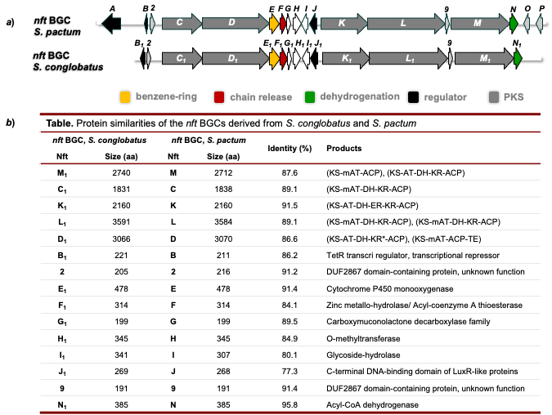

Fig. S2. Comparison of the nft BGCs derived from S. conglobatus and S. pactum. Gene organization of the nft BGCs derived from S. conglobatus and S. pactum (a) and the similarities of proteins encoded by the two BGCs (b).

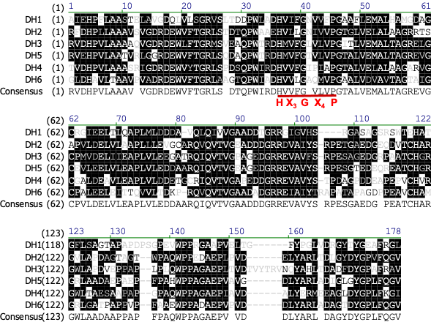

Fig. S3. Protein sequence alignment of the DH domains of the nft BGC from S. conglobatus. The conservative HX₃GX₄P motif in DHs is labeled in red.

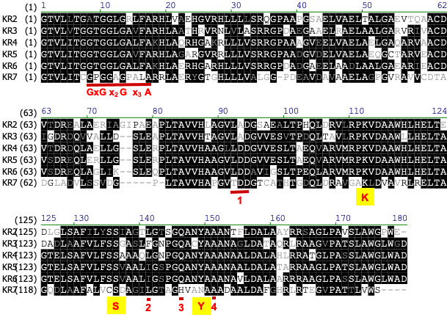

Fig. S4. Protein sequence alignment of the KR domains of the nft BGC from S. conglobatus.
The motifs diagnostic of established KR types: A1 (1 no LDD; 2 W, 3 no H); A2 (1 no LDD; 2 W, 3 H); B1 (1 LDD; 4 no P); B2 (1 LDD; 4 P) (Chem Biol 2007, 14:898-908).
The KR4, KR5 and KR6 should belong to B1 type; KR7 lacks the Y conservative active site; The KR2 and KR3 lack the conserved sequence motifs of B1 type KRs;

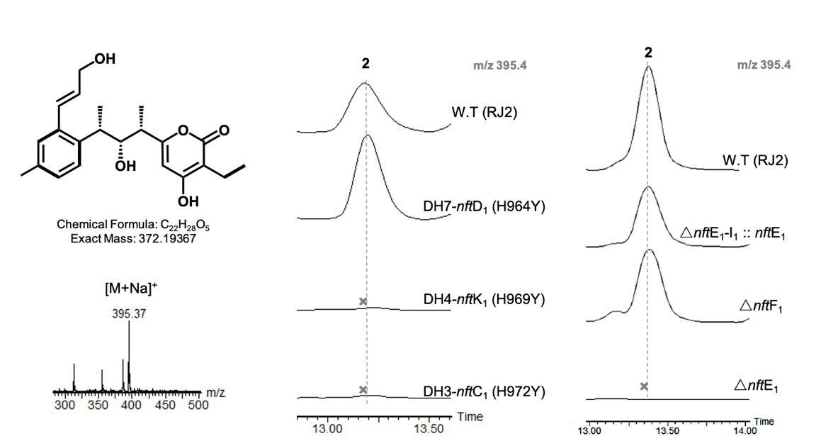

Fig. S5. HPLC–MS analysis of the production of compound 2 in mutant strains. The crosses mean that the target compounds were not detected.

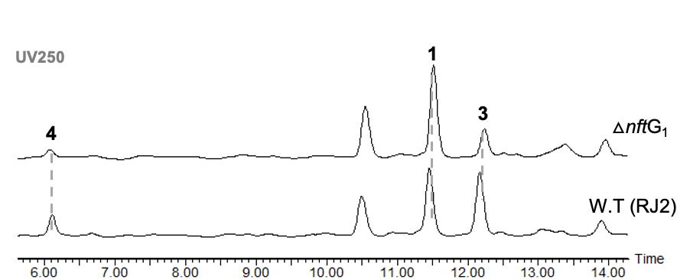

Fig. S6. HPLC–MS analysis of the culture extract of ΔnftG₁ mutant strain

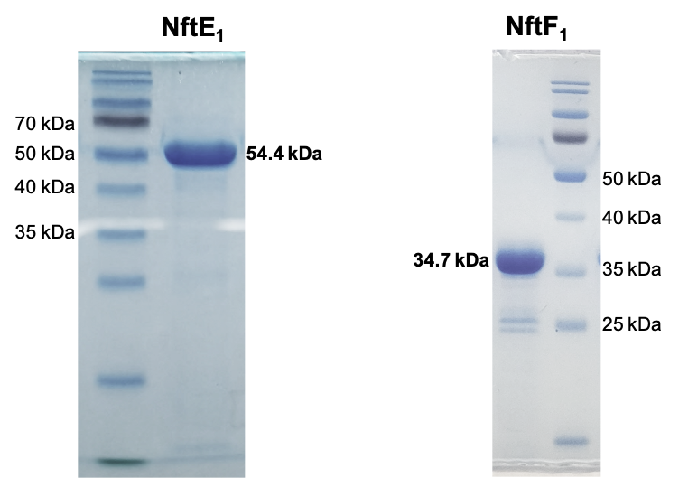

Fig. S7. SDS-PAGE analysis of the recombinant proteins NftE₁ and NftF₁.
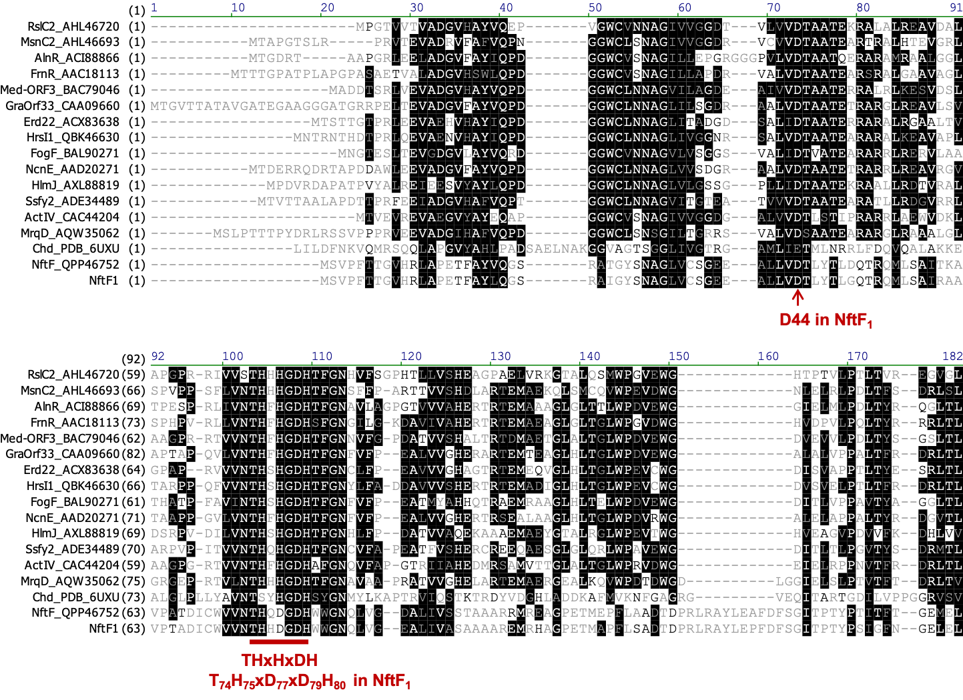
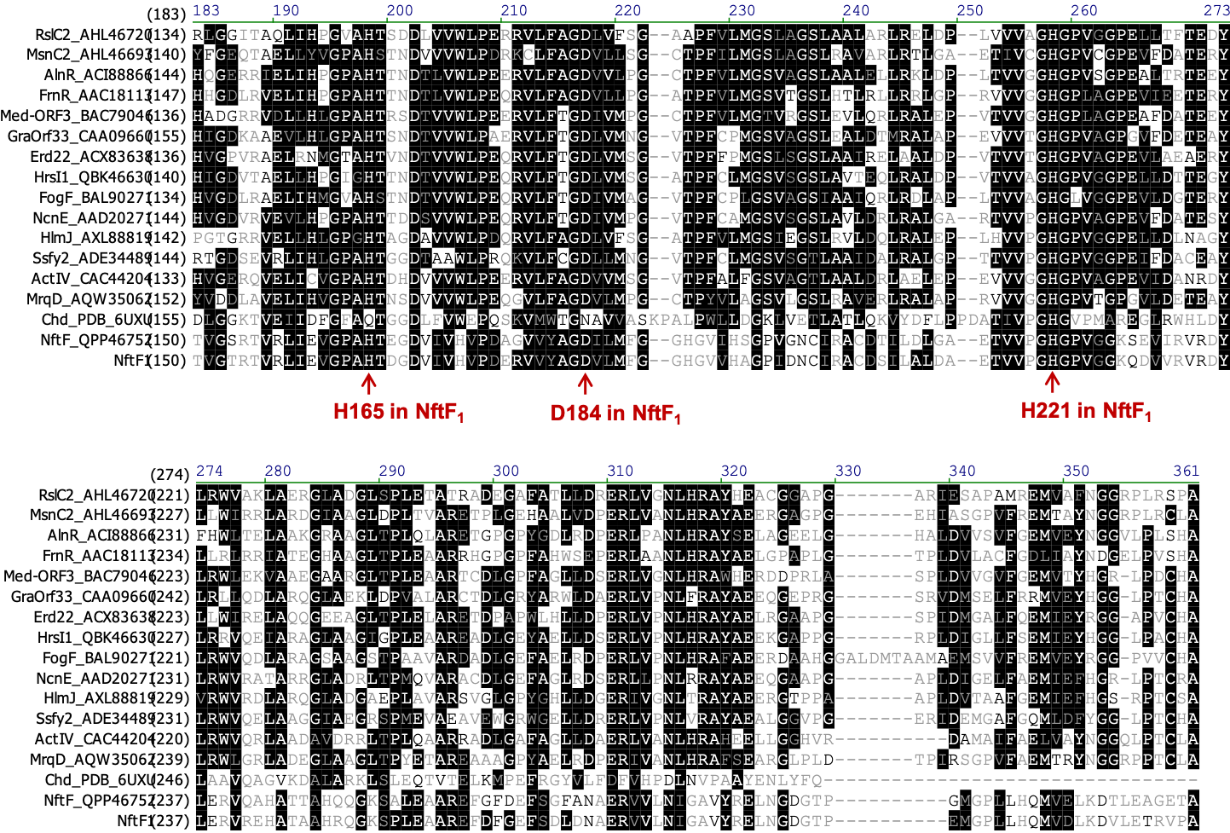

Fig. S8. Protein sequence alignment of NftF₁, Chd (PDB 6UXU) and its homologous proteins from the reported BGCs of type II PKS.
The conservative THxDxDH motif in MBL hydrolase and the mutation sites in NftF₁ are labeled.
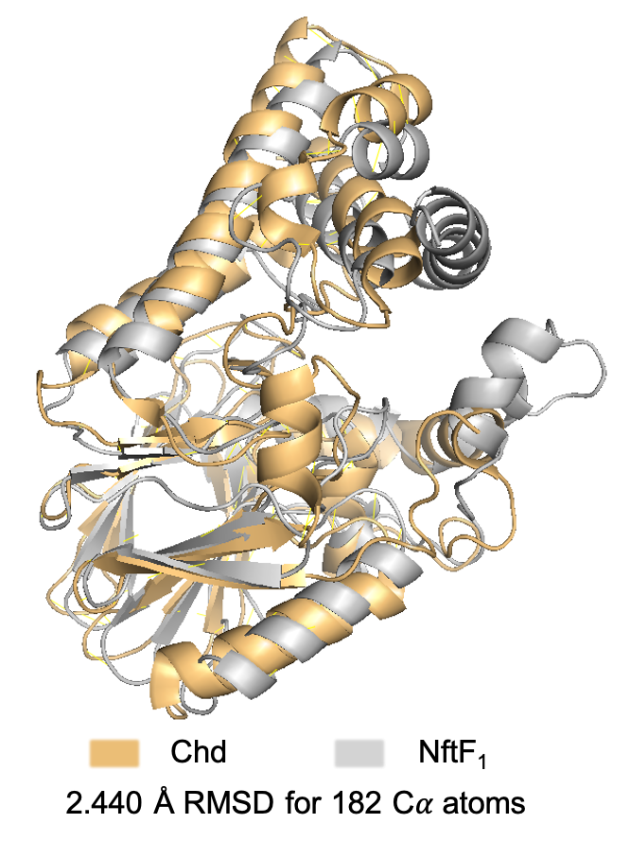
Fig. S9. Superposition of the modeled structure of NftF1 on the reported dehalogenase Chd (PDB 6UXU).

Fig. S10. NMR spectra of 1. (related to Table S3)

- ¹H-NMR of 1.
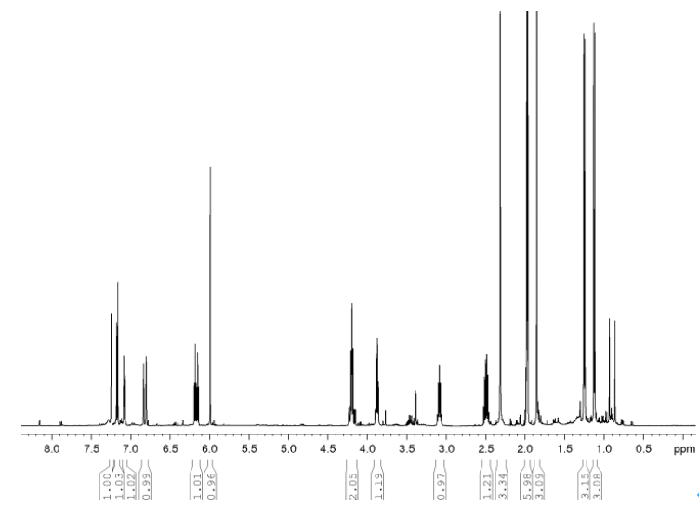

- ¹³C-NMR of 1
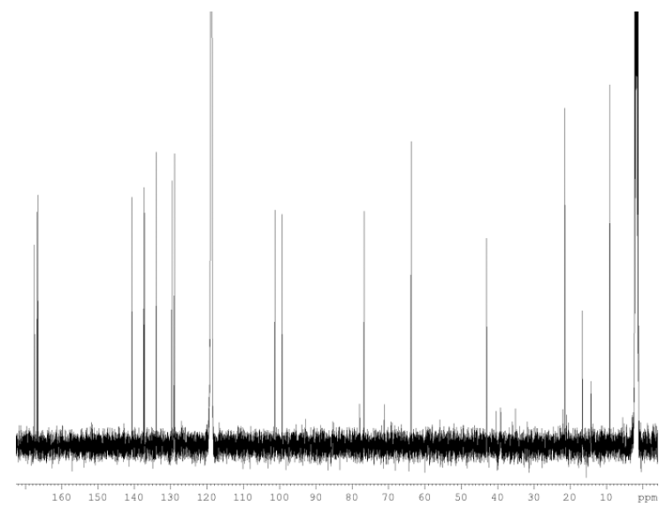
Fig. S11. NMR spectra of 2 (related to Table S4)

- ¹H-NMR of 2
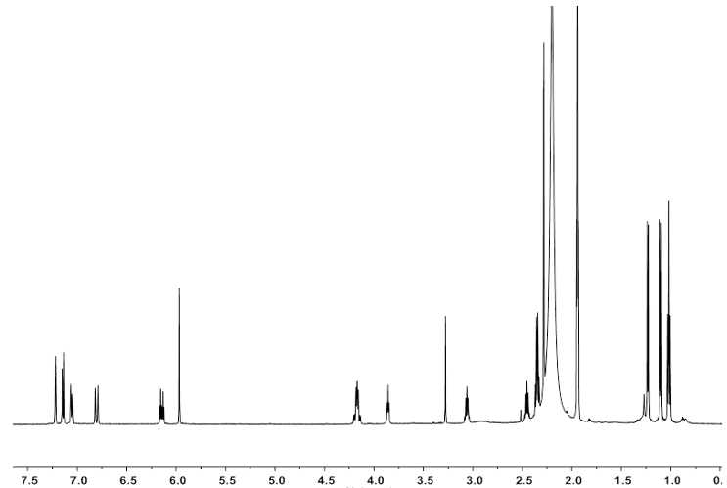

b. ¹³C-NMR of 2
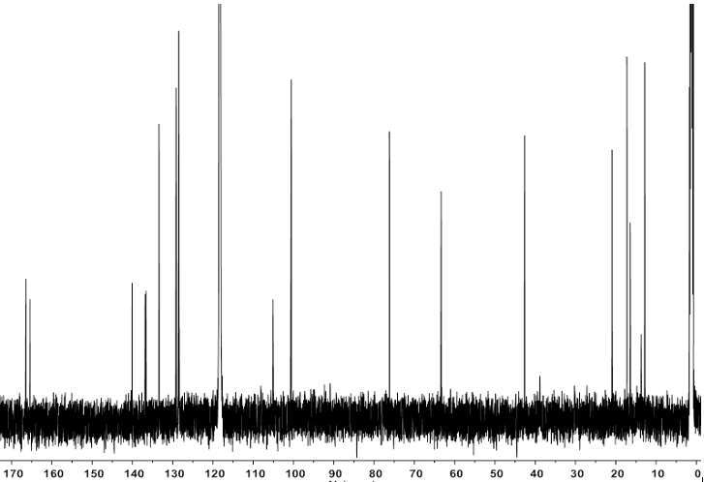

Fig. S12. NMR spectra of 3. (related to Table S5)

a. ¹H-NMR of 3
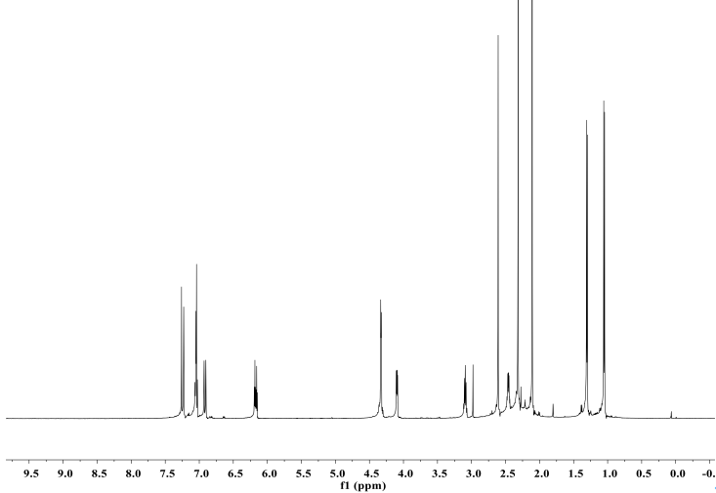

b. ¹³C-NMR of 3
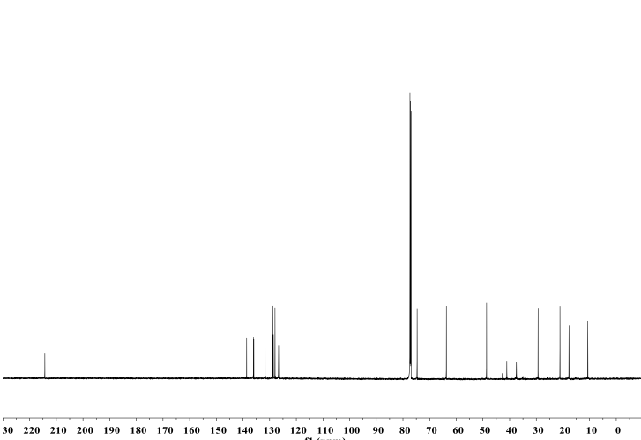

Fig. S13. NMR spectra of 4. (related to Table S6)

- ¹H-NMR of 4
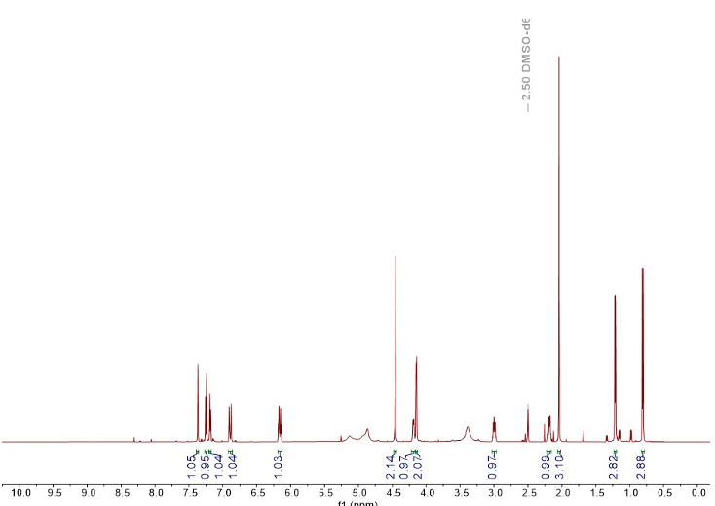

b. ¹³C-NMR of 4
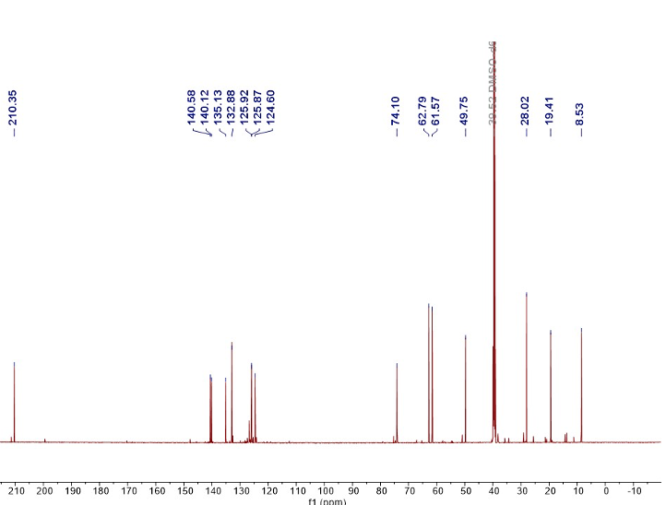
Fig. S14. NMR spectra of 5 (related to Table S7)

a. ¹H-NMR of 5
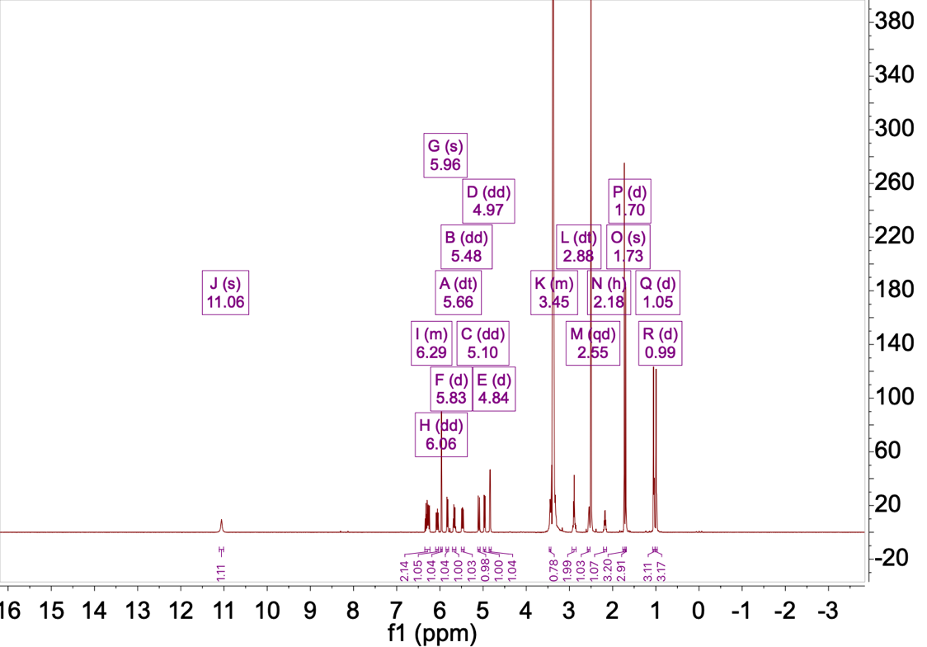

b. ¹³C-NMR of 5
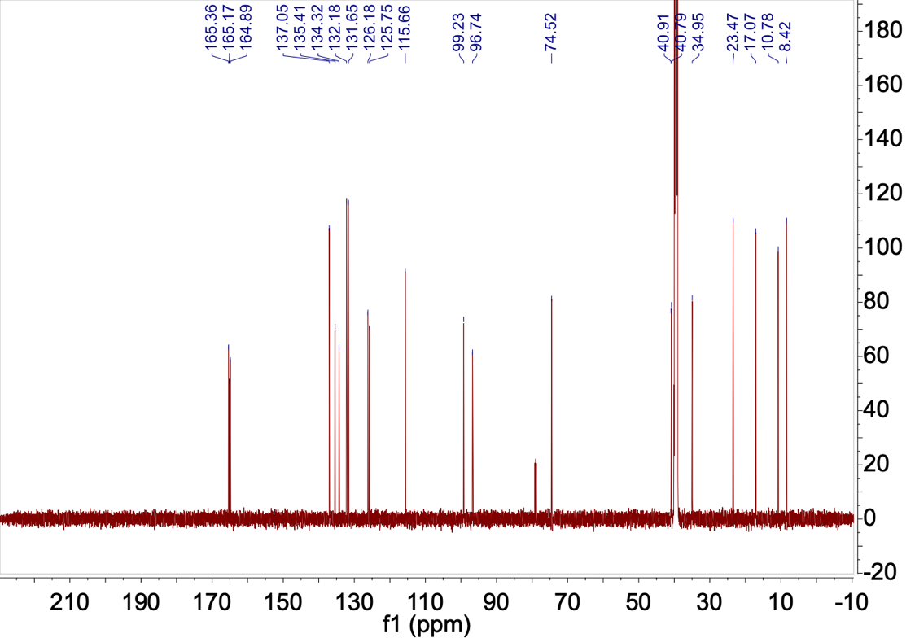

c. DEPT-NMR of 5
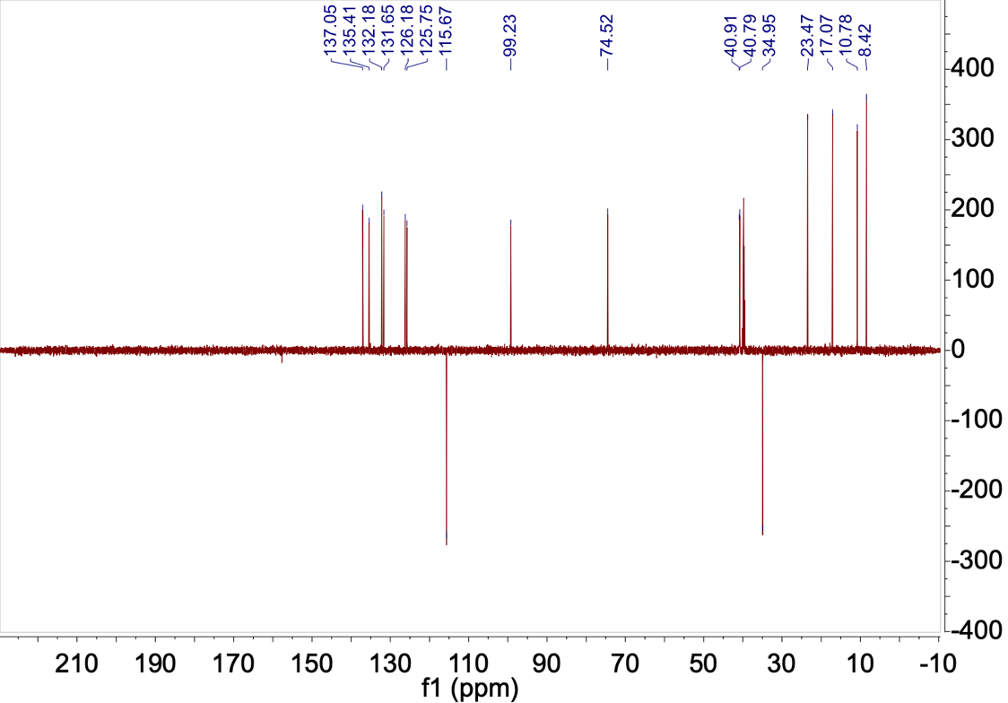

d. COSY of 5
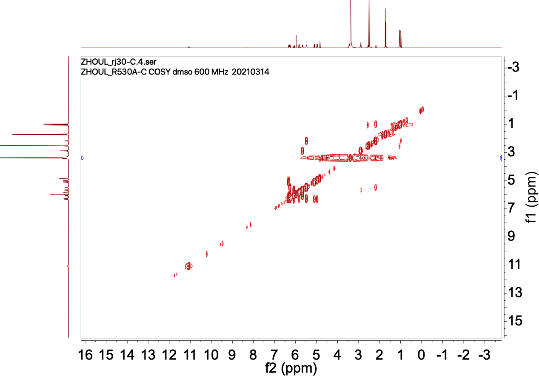

e. HSQC of 5
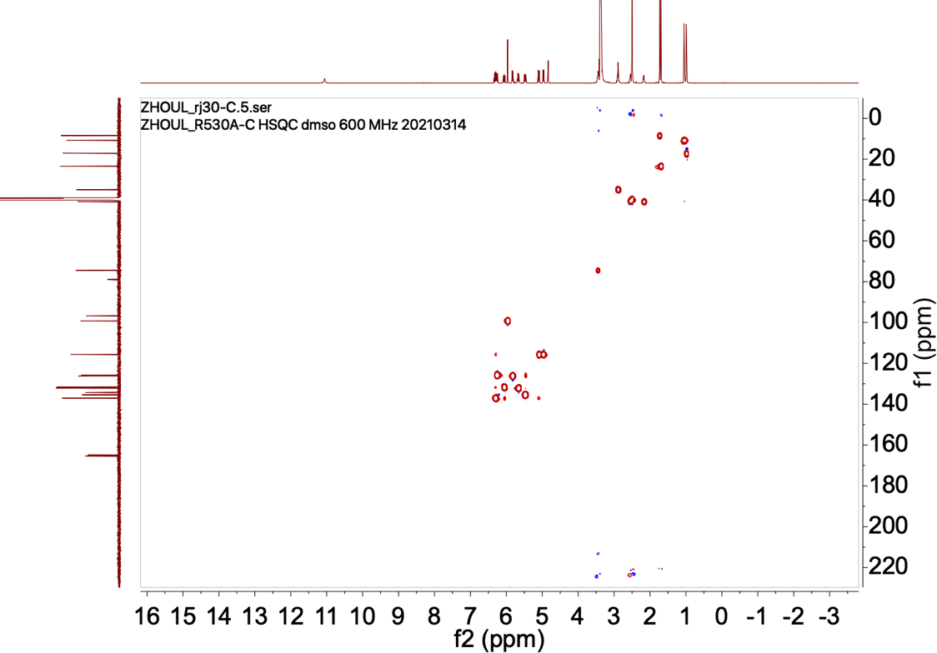

f. HMBC of 5
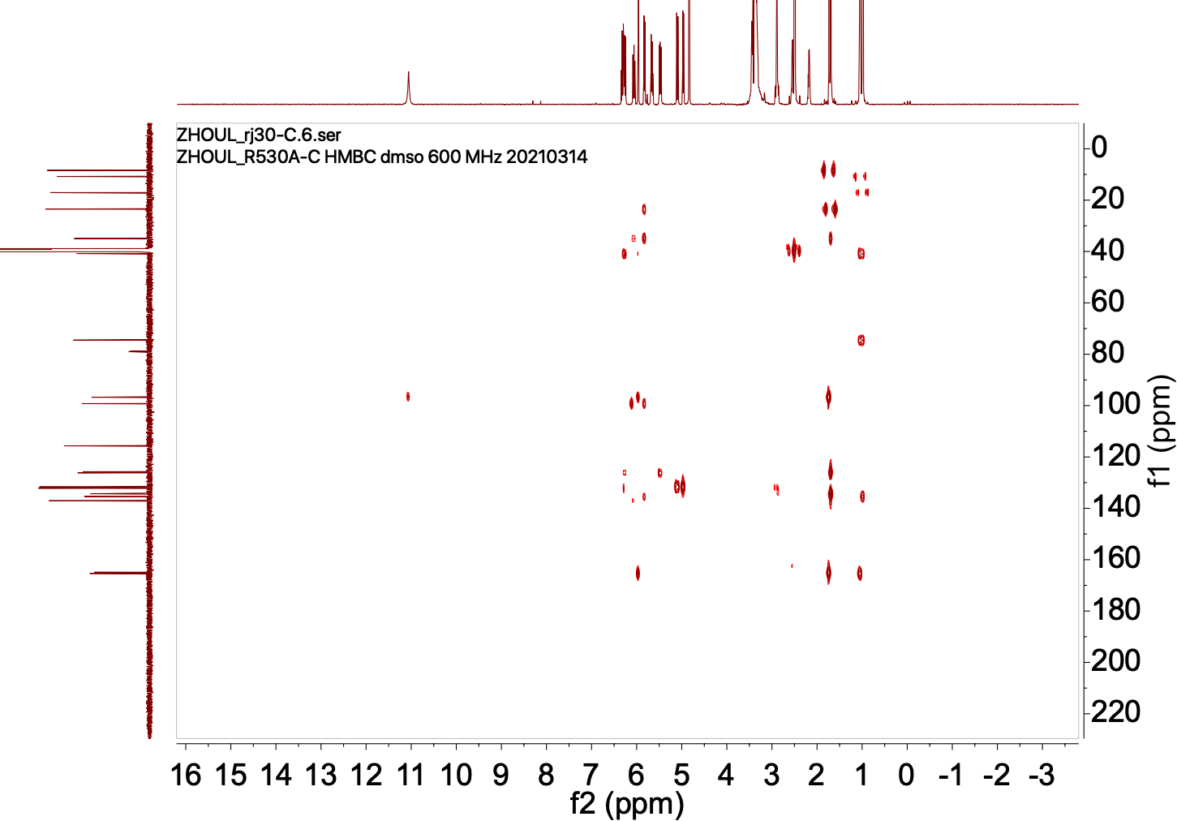

g. NOESY of 5
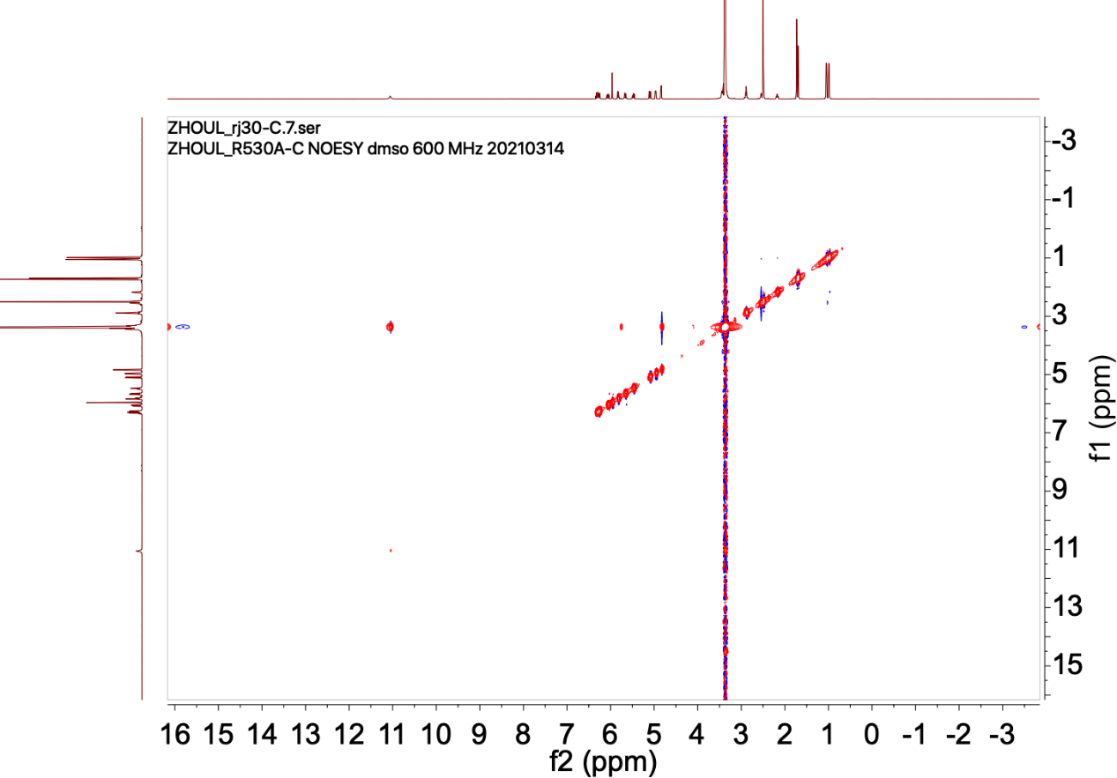

Fig. S15. NMR spectra of 6. (related to Table S8)

a. ¹H-NMR of 6
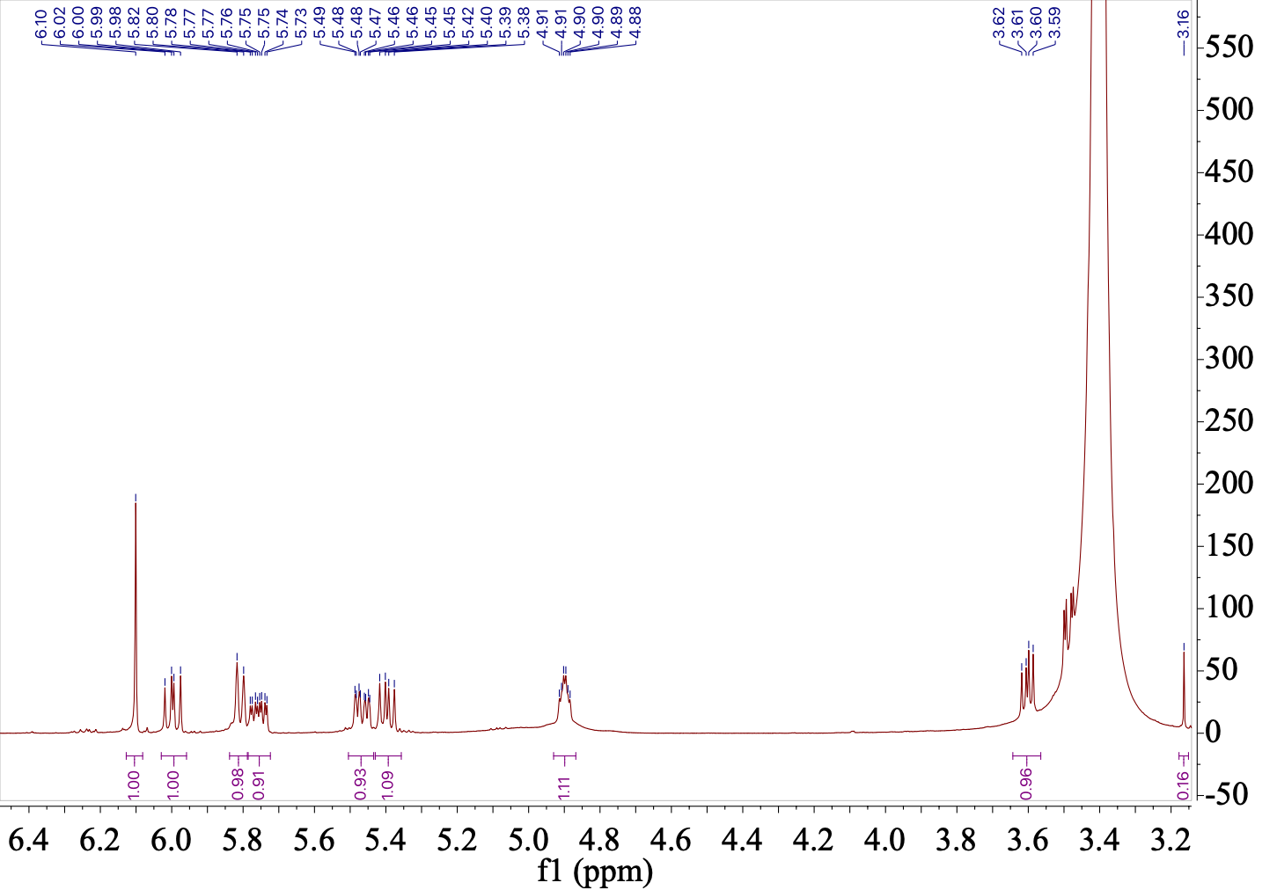

b. ¹³C-NMR of 6
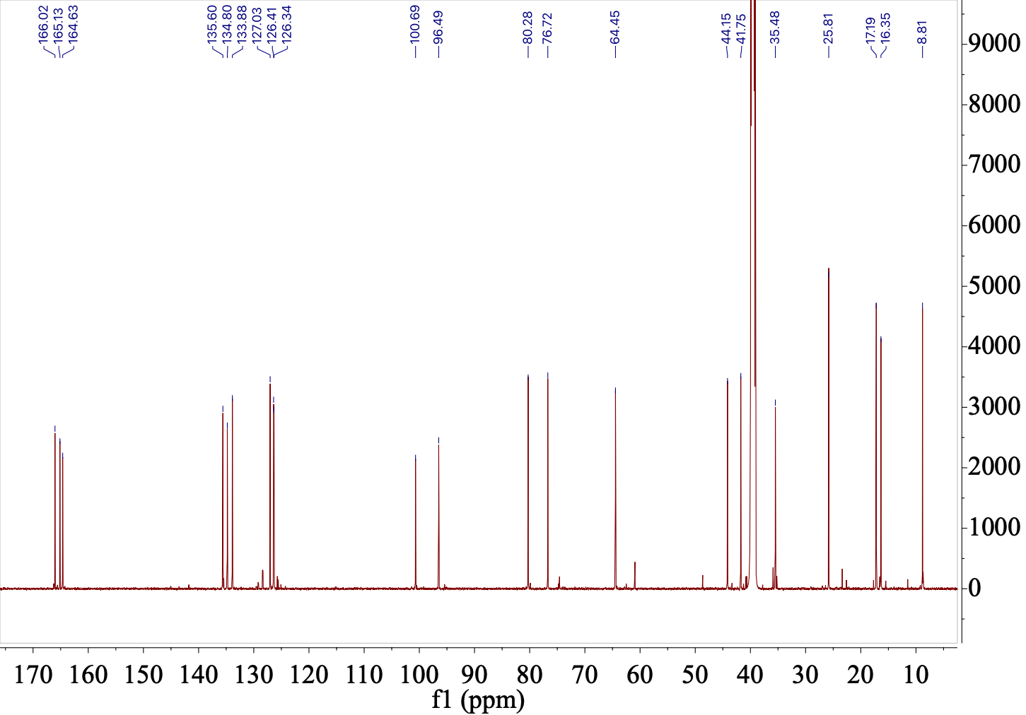

- DEPT-NMR of 6

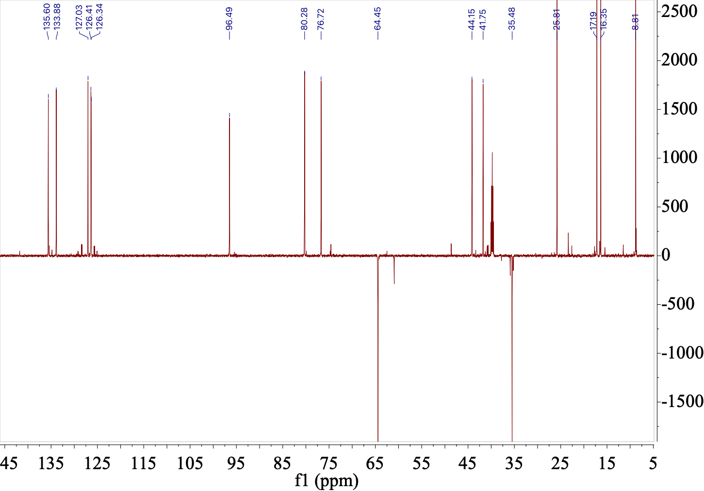

d. COSY of 6
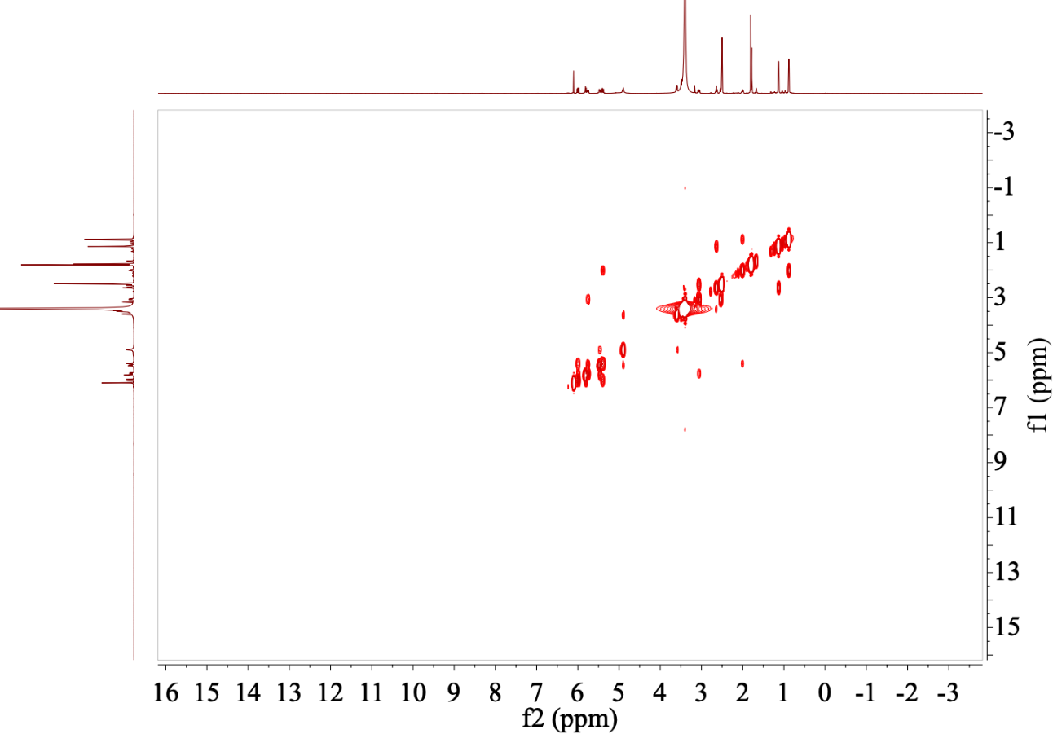

e. HSQC of 6
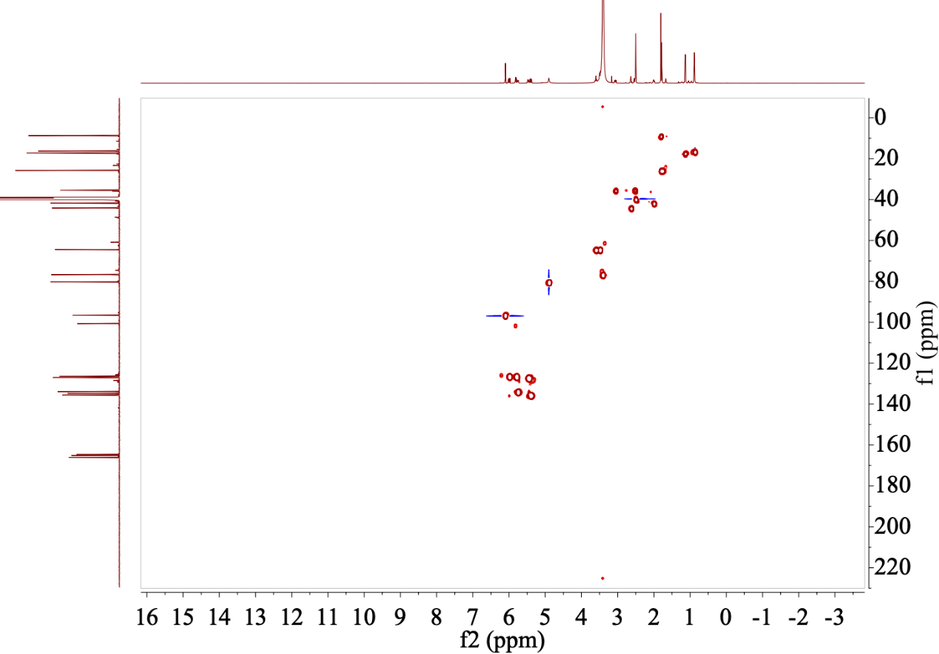

f. HMBC of 6
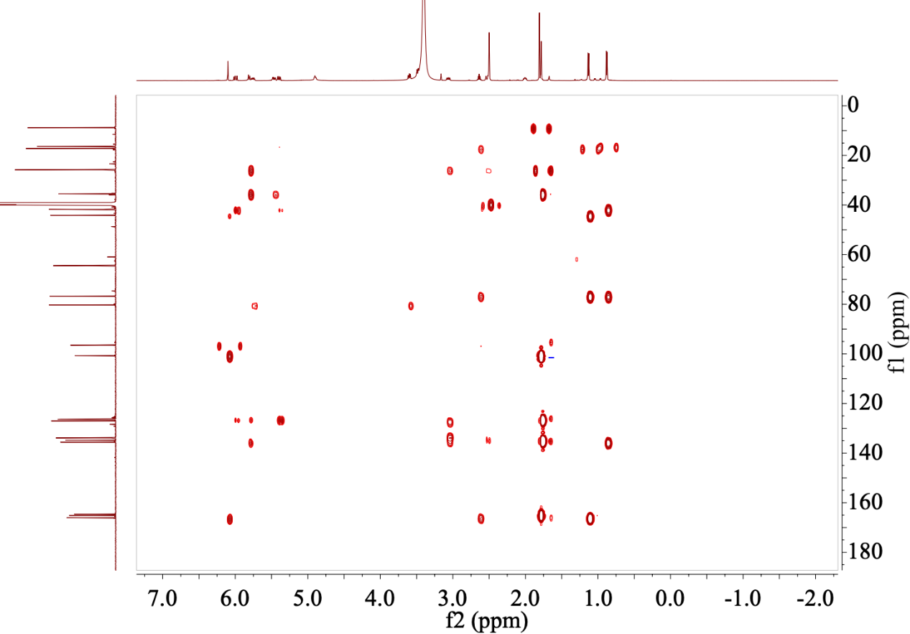

g. NOESY of 6
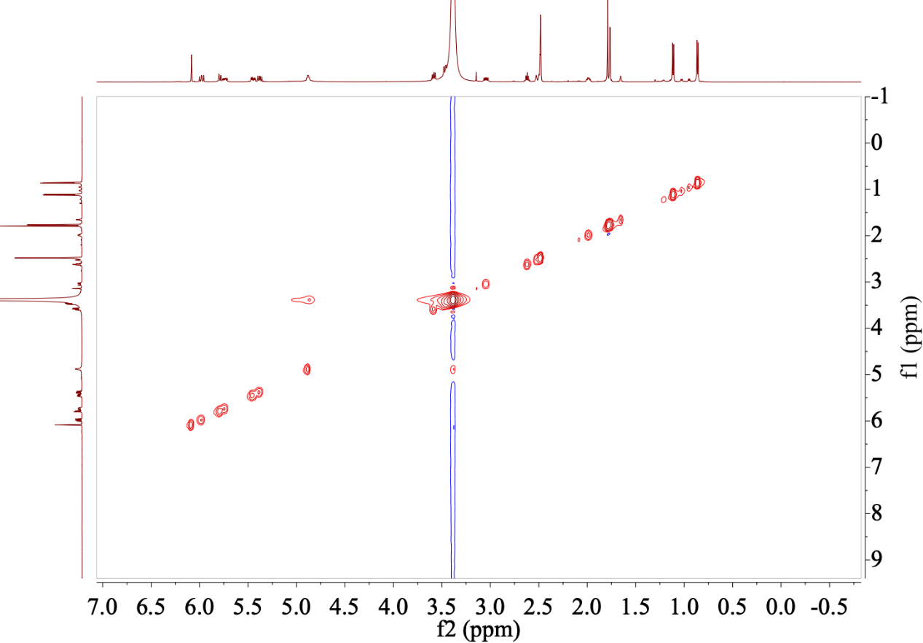

Fig. S16. NMR spectra of 7. (related to Table S9)

a. ¹H-NMR of 7
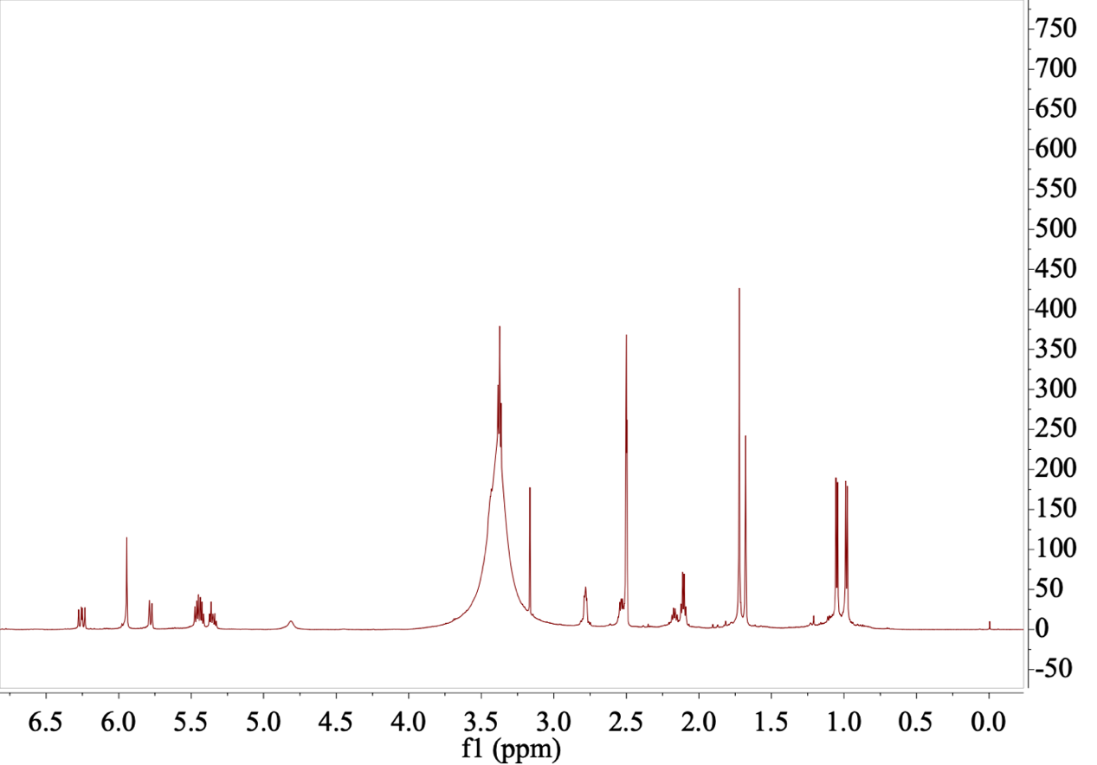

b. ¹³C-NMR of 7
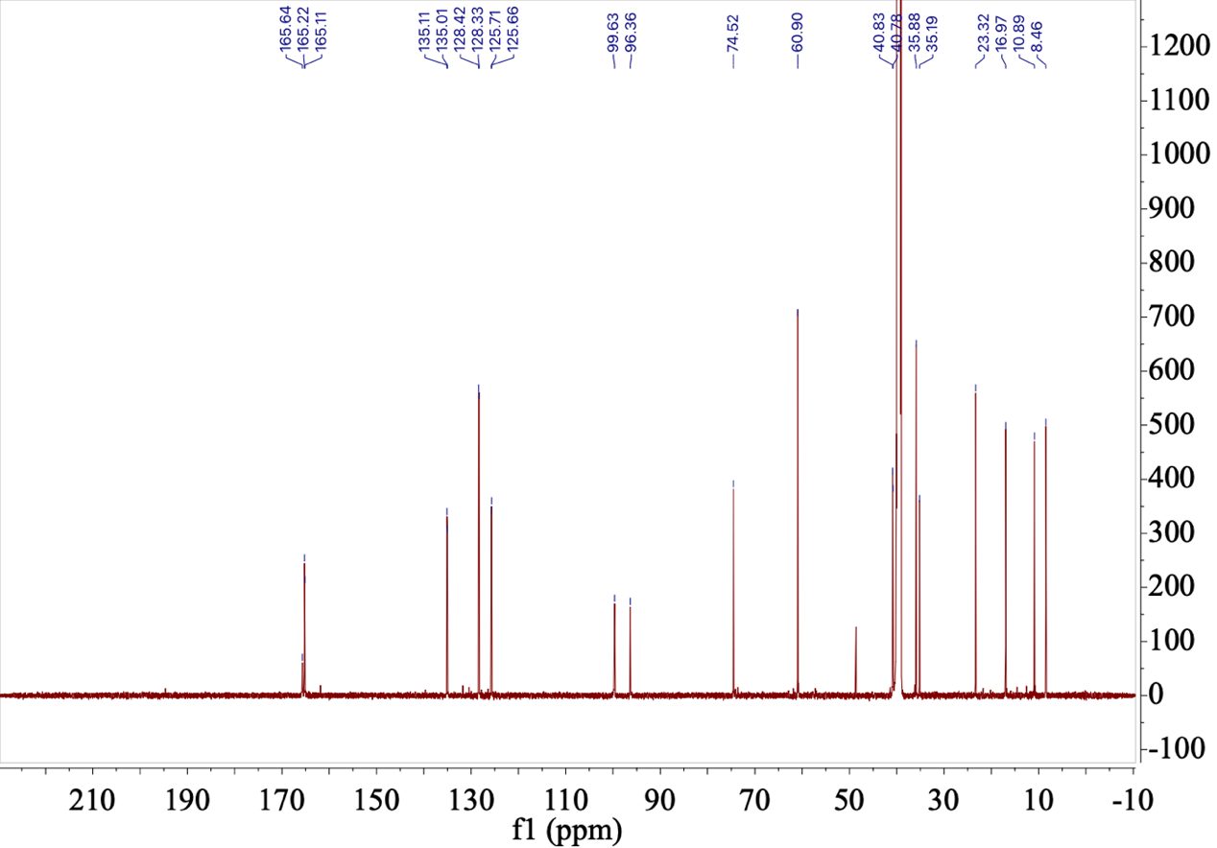

c. DEPT-NMR of 7
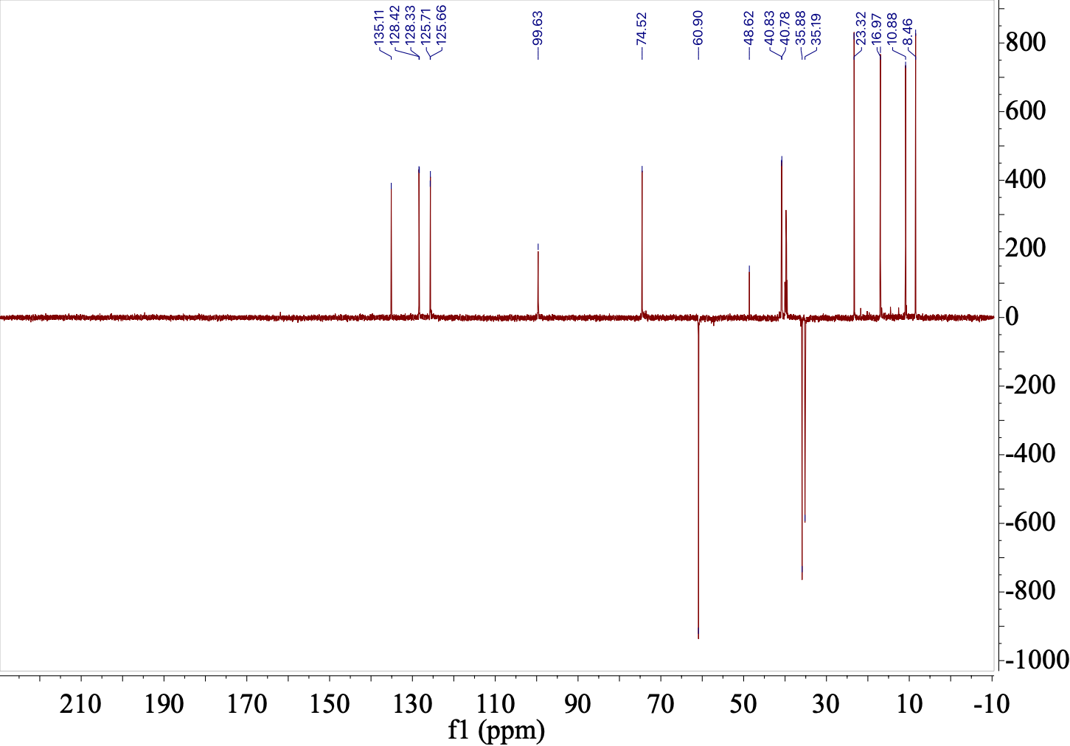

d. COSY of 7
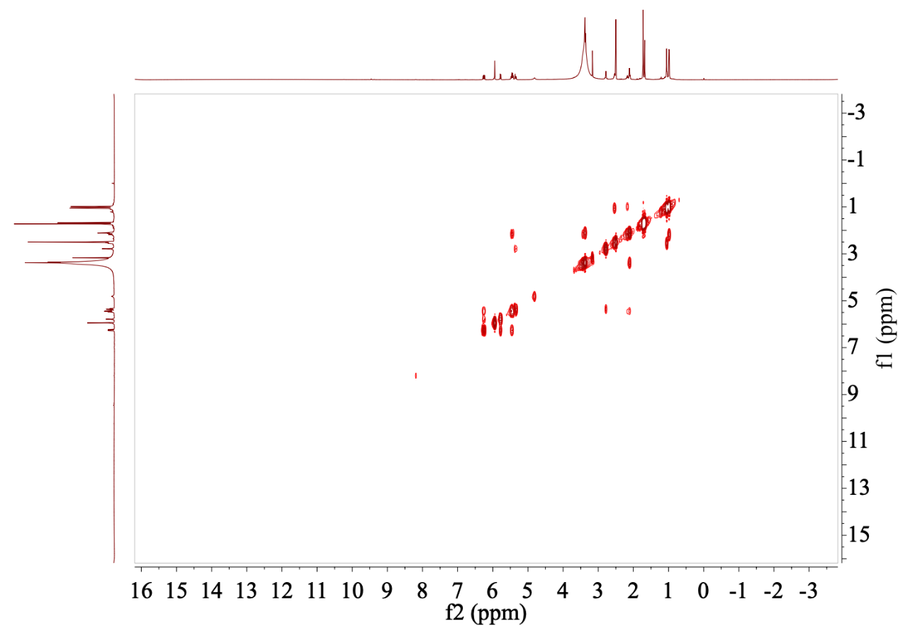

e. HSQC of 7
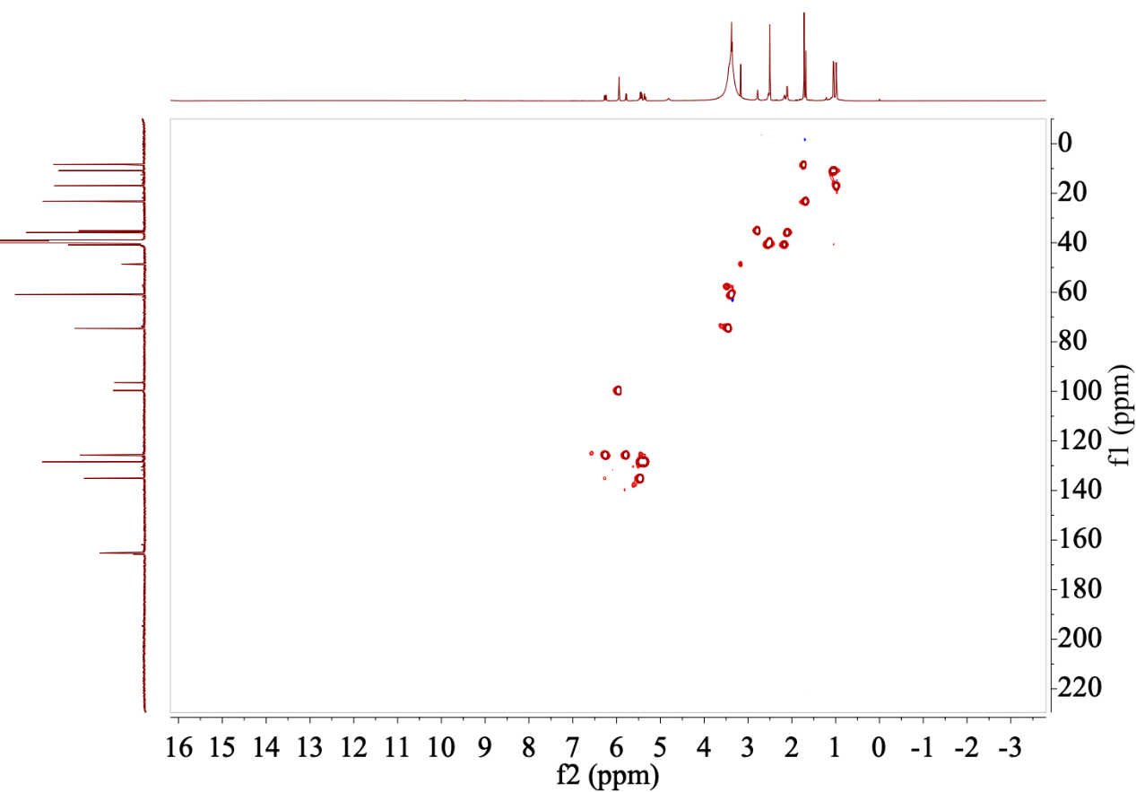

f. HMBC of 7
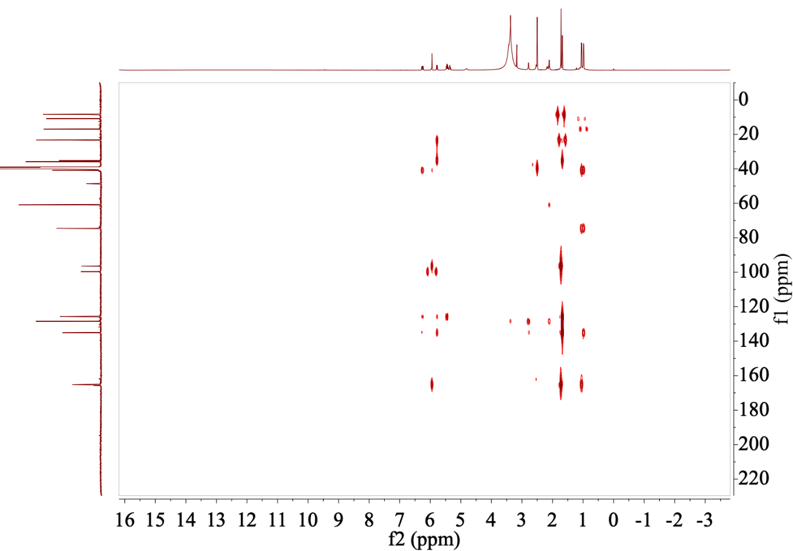

g. NOESY of 7

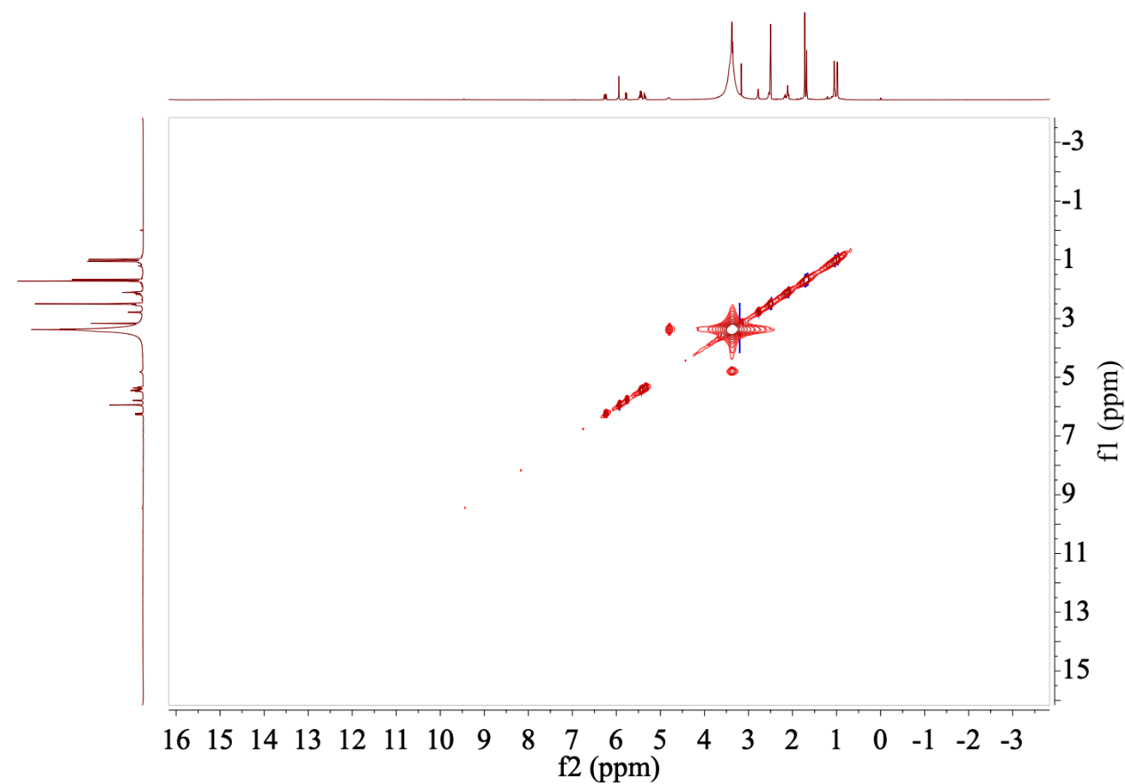

Fig. S17. NMR spectra of 8. (related to Table S10)
- ¹H-NMR of 8

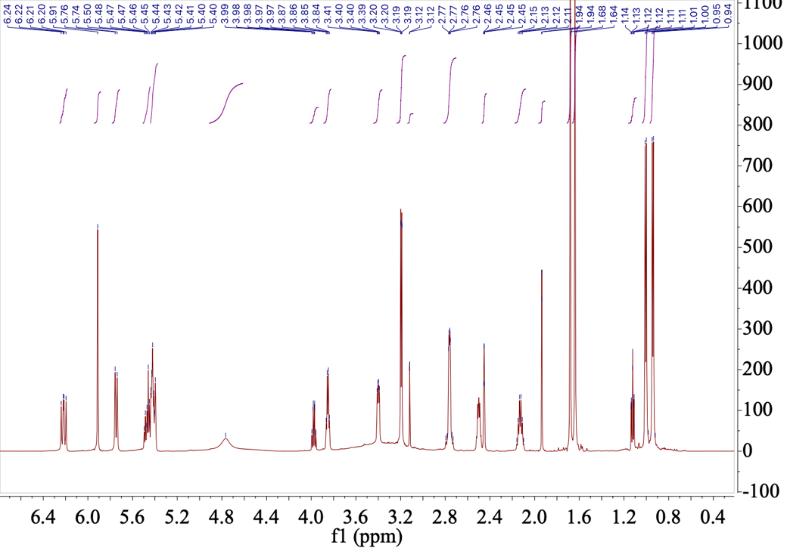

b. ¹³C-NMR of 8
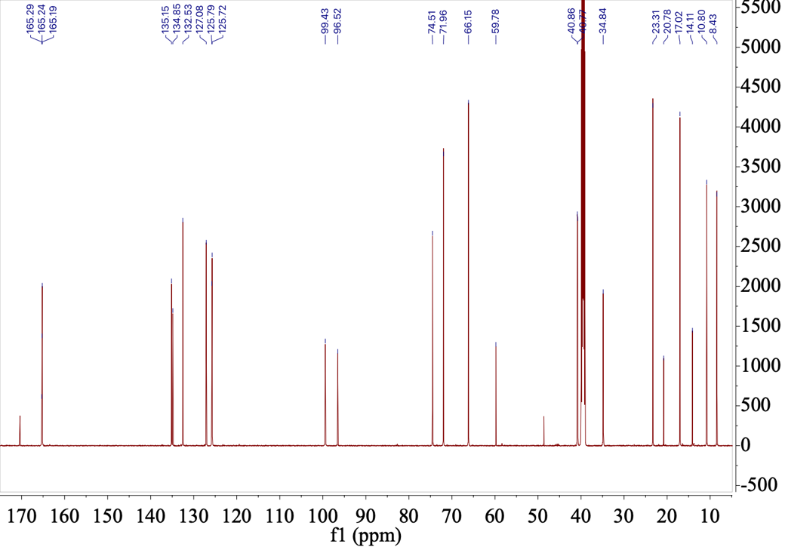
c. DEPT-NMR of 8
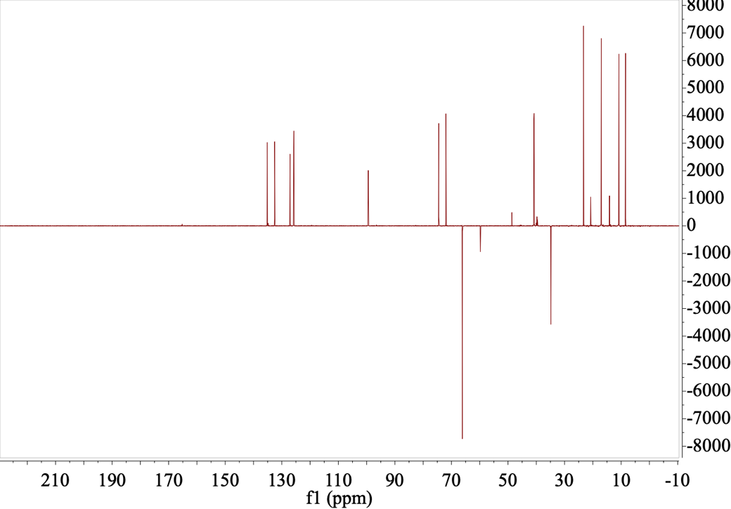

d. COSY of 8
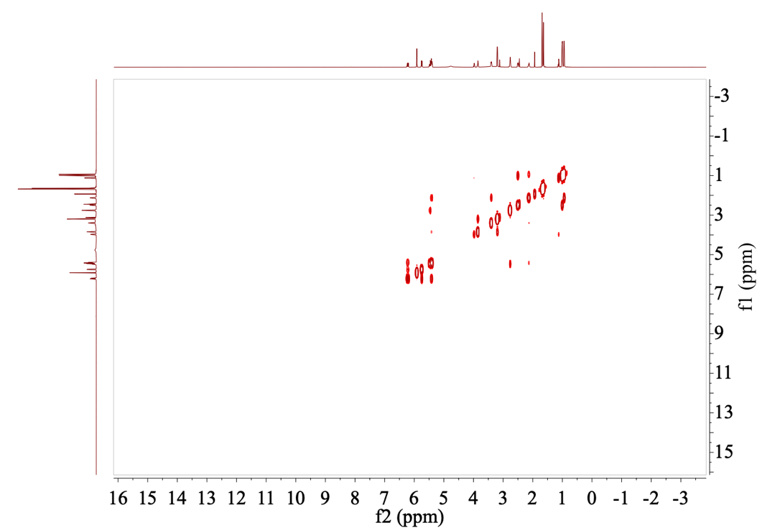

e. HSQC of 8
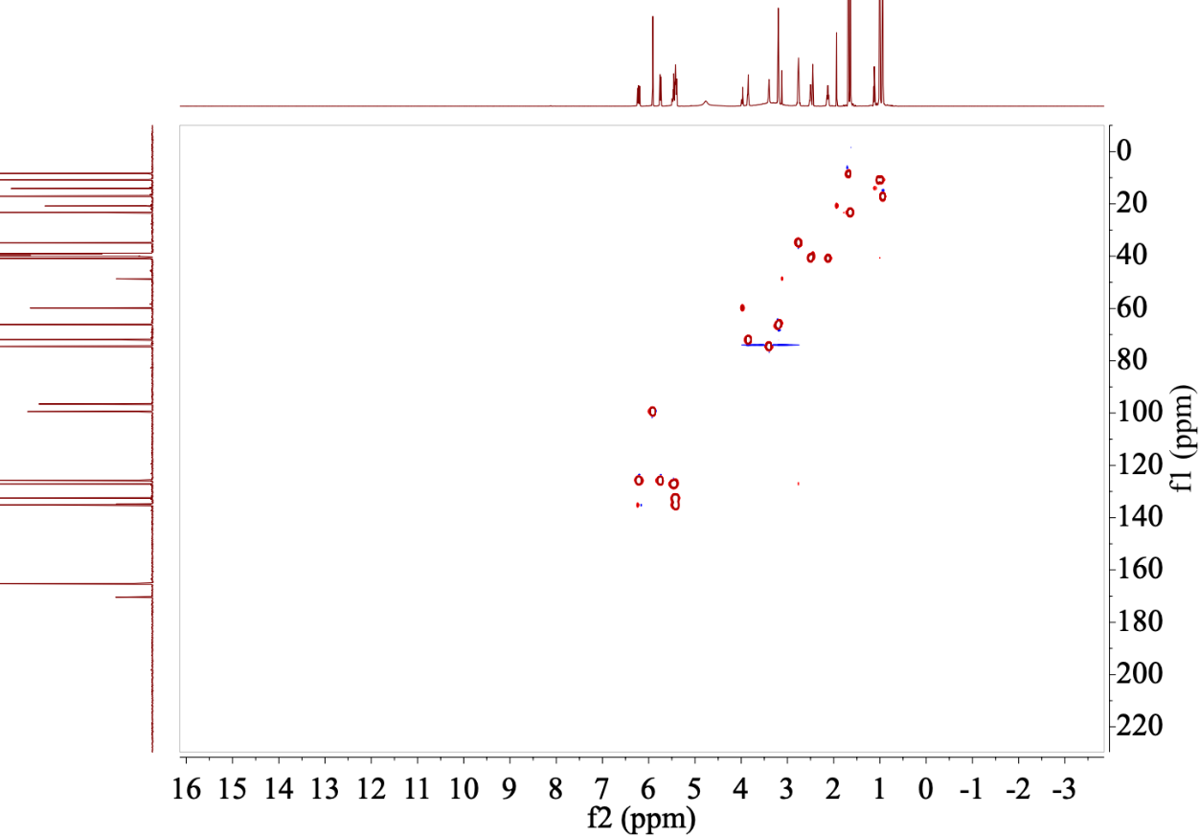

f. HMBC of 8
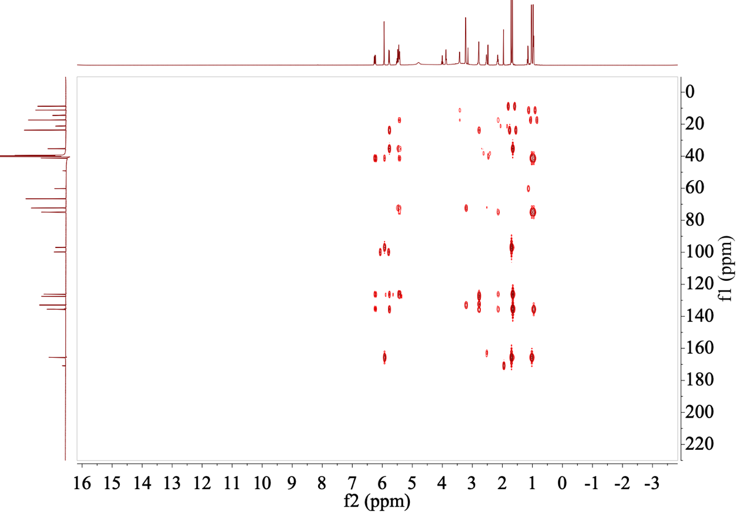

g. NOESY of 8
