Total Cost of Ownership as a Sustainability Indicator to Evaluate Environmental and Economic Performance of Sustainable Lightweight Vehicles
(Supplementary Information Document)
Karim A. Moawad¹, Ammar Hummieda¹, Ahmad T. Mayyas^{1,}*, Roger Stace², Saed T Amer¹, Mohammed A. Omar¹
¹ Department of Industrial and Systems Engineering, Khalifa University, Abu Dhabi, UAE 127788
² CU Denver Business School, University of Colorado-Denver, Denver, CO 80202
* Corresponding Author

- Advanced drivetrains and lightweight vehicle design
Figure 1 from the U.S. Environmental Protection Agency (EPA) shows the trend of passenger car weights, fuel economy, and horsepower for the past five decades. The values in 1975 are the reference value, the average passenger vehicle weight declined from about 1830 kg, and fuel economy is 13.5 mpg and 138 horsepower. A noticeable decrease in weight in 1982 reaching slightly over 20%, over the same period, according to the U.S. Environmental Protection Agency numbers, the number of plastics used in a typical U.S. passenger vehicle increased from about 4.6% in 1980 to about 10-12% today ‎(EPA, 2022, Goguen et al., 2015), and we can see the huge increase in fuel economy. However, the customer demand and preference were for larger more durable vehicles, as a result, the average vehicle weight increased again until it reached about 1890 kg in 2009 ‎ (Goguen et al., 2015). The average weight of vehicles in 2016 returned to 1830 kg because of the added subsystem in the car which made car rides more enjoyable and easier. Weight, horsepower, and fuel economy have seen and will continue to see increasing trends in the next few years.
There are many examples of using lightweight material in the vehicle. In 1990, Aluminum vacuum die casting was introduced along with welding and joining technologies which enabled the production of Aluminum intensive bodies, which were used in high-end vehicles. In 1996, General Motors developed the largest magnesium die casting of instrument panel beams. In 2006, The first one-piece magnesium die-casting engine cradle was introduced in the Chevy corvette Z06 which reduced 35% of the mass over Aluminum and 54.5% of the mass over steel. In 2012, a Multi-material vehicle was developed by ford it achieved 23.5% mass reduction and sustained crash testing (Goguen et al., 2015). Full battery-electric vehicle manufacturers are looking into weight reduction as the weight of the drivetrain is nearly 1.25 times heavier than the internal combustion engine. Light weighting could help in extending the range or reducing the cost via secondary mass reduction through downsizing the battery and motor and keeping the same range ‎(Cheah, 2009). A project of introducing Aluminum brakes in electric is under consideration because of the reduced braking demand of electric vehicles as it depends on regenerative braking (Cheah, 2009). The new trends in vehicle light-weighting aim at enhancing the vehicle fuel efficiency as well as improving its driving performance while lowering its tailpipe emissions (Fuchs et al., 2008). Many experimental studies found that a 10% reduction in vehicle weight translates into a 6-8% improvement in the vehicle’s fuel economy in terms of Miles per Gallon MPG or kWh per mile (Czerwinski, 2021; Das, 2000; Timeline, 2022).
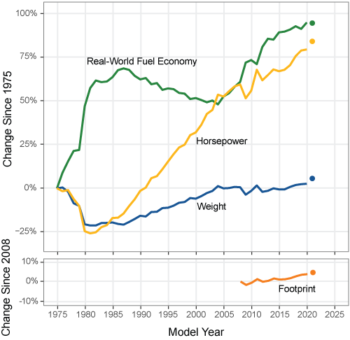
Figure 1. Change in Adjusted Fuel Economy, Weight, and Horsepower for Model Years 1975-2020 (Cheah, 2010)

When it comes to the energy expenditures in driving the car on the road, and as we can see in Figure 2, the mass of the vehicle is involved in three out of the four typical force components that the vehicle has to resist while moving. It was found empirically for many vehicles that for each 100 kg mass reduction there is a potential reduction in fuel consumption for about 0.3 to 0.5 liter per 100 km and 8.5 to 14 grams of carbon dioxide gas reduction per km driven (EPA, 2022). The reduction of the mass will result in lesser horsepower needed to move the vehicle which could translate into two enhancements; the first is keeping the high horsepower engine to get a more powerful car, or the second improvement, which is considered more environmentally friendly, is to downsize the engine to the needed horsepower. A smaller engine means that many parts under the hood will also be down-scaled resulting in a lighter vehicle. Another important fact to highlight in this context is that the percentage of the weight of the passenger relative to the total mass is 0.5% on average, so 99.5% of the energy consumed is to move the vehicle so reducing the mass of the vehicle will make the transportation process more efficient and more environmentally-friendly.
- (b)
Figure 2. Schematic showing (a) the forces acting on the vehicle while on the road, and the effect of mass on the driving performance and (b) the correlation between vehicle weight, fuel consumption, and CO2 emissions (Mayyas et al., 2012)
- Eco-material Selection for Autobodies
The material selection process has 3 major steps: the first step is the formulation of the model with the required objectives and constraints that the material should satisfy to achieve the desired function. The second is the formulation of the performance metric to measure how well a material can match a set of design requirements. And in the third step, the search procedure is used for exploring solution space, identifying materials that meet the constraints, and ranking them by their ability to meet the requirements (Ashby et al., 2004).
Here is an example of eco-material selection for a flat panel subject to bending force that has a length L, width w, and thickness t, subjected to a bending force F (Figure 3). Typical BIW panels that are under such stress include roof reinforcement, inner hood panel, and inner trunk panel. Schematic of the panel dimensions and the force acting on it are shown in Figure 3.
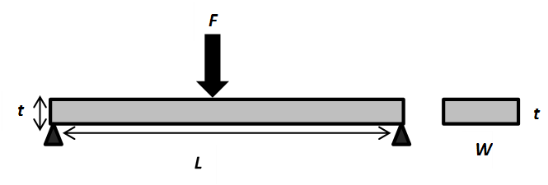
Figure 3. Simply Supported Solid Rectangular Panel under Bending Force
Table 1 summarizes the major functional panels in the body-in-white alongside their main design functions. Generally speaking, structural panels such as floor pan and inner pillars are designed for bending stiffness, while outer panels (e.g. roof, hood and outer trunk) are designed for dent resistance.

Table 1. The main design function for BIW parts (Mayyas et al., 2012)
No. | Panel Name | Main Design Functions
1 | Roof | Dent Resistance, NVH, Durability
2 | Roof Reinforcement | Bending Stiffness, NVH, Ease of manufacturing
3 | Hood (inner) | Bending Stiffness, NVH, Ease of manufacturing
4 | Hood (outer) | Dent Resistance, NVH
5 | Trunk (inner) | Bending Stiffness, NVH, Ease of manufacturing
6 | Trunk (outer) | Dent Resistance, NVH
7 | Trunk Pan | Strength, NVH, Durability
8 | Tunnel Reinforcement | Strength, NVH, Durability
9 | Engine Cradle | Crashworthiness, Temperature Performance, NVH, Durability
10 | Shock Towers | Bending Stiffness, NVH, Durability
11 | Splash/fire Wall | Temperature Performance, NVH, Durability
12 | Quarter Panel | Dent Resistance, NVH
13 | Front Fender | Dent Resistance, NVH
14 | Door (inner) | Bending Stiffness, NVH, Ease of manufacturing
15 | Door (outer) | Dent Resistance, NVH
16 | Side Members | Bending Stiffness, NVH, Durability
17 | Wheel House | Bending Stiffness, NVH, Durability
18 | A, B Pillars | Bending Stiffness, NVH, Ease of manufacturing, Durability
19 | Floor pan | Strength, NVH, Durability
20 | Bumper | Crashworthiness, NVH, Durability
NVH: Noise, vibration, and harshness
This panel should not fail under bending force. For eco-materials selection in this example, the objective would be minimizing the mass of the panel (m). That implies that the bending stress on the panel should not exceed its yield stress to avoid plastic deformation. That is:
$σ_{y}>\frac{M.t/2}{I}=\frac{3F.L}{w.t^{2}}$ (1)
$I=\frac{w.t^{3}}{12}$ (2)
Where: m = mass, w = width, L = length, ρ = density, t = thickness, I = the second moment of area, σ_{y} = yield strength.
In this example, assuming that we have a BIW panel with fixed length and width due to the limitations in the space design while the thickness can be varied to meet the design requirements. Rearranging Equation 1 gives the following equation for thickness t as a function of yield strength and physical dimensions of the panel:
$t={(\frac{3F.L}{w.σ_{y}})}^{1/2}$ (3)
Substituting this in the mass equation m=A.L.ρ= w.t.L.ρ, gives the following:
$m={\left(3F.w\right)}^{1/2}{\left(L\right)}^{\frac{3}{2}}\left(\frac{ρ}{σ_{y}^{1/2}}\right)$= K. $\left(\frac{ρ}{σ_{y}^{1/2}}\right)$ (4)
Where ${K=\left(3F.w\right)}^{1/2}{\left(L\right)}^{\frac{3}{2}}$ is constant. As mentioned above, the panel thickness can be varied in the lightweight design to meet the design requirements. Under this assumption, the mass substitution rate is defined in terms of the ratio of the material density and yield strength which can be expressed mathematically as:
 | $$\frac{m_{LWM}}{m_{ref}}=\frac{ρ_{LWM}}{\sqrt{σ_{y, LWM}}}\frac{\sqrt{σ_{y, ref}}}{ρ_{ref}}$$ | (5)
Where subscript LWM: refers to the candidate lightweight material which can replace the conventional steel in the BIW, while subscript ref refers to the reference material (dual-phase steel in this context) (Mayyas et al., 2012). In this example, we considered a BIW part with a free thickness choice, which resulted in a material selection index that has a square root in the formula. Other choices such as free width or free length may result in other exponents in the equation, but with the same mechanical and physical properties. Using Equation 5 and the material yield strength will give us the mass substitution rates for this panel relative to any other material used as reference material, whether this reference material is steel or any other engineering materials. For illustration purposes, Dual Phase 280 /600 (yield strength 280 MPa, ultimate tensile strength 600 MPa), was selected as the reference material in this example. Figure 4 provides a comparison of the average, minimum, and maximum substitution rates within each material class. Error bars represent the minimum and maximum within each material class.

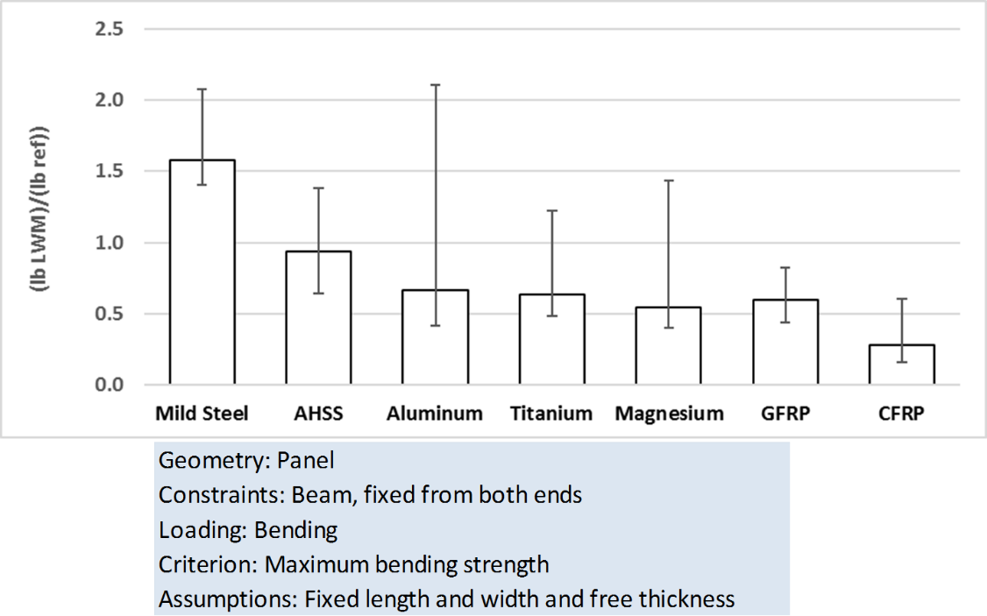
Figure 4. Average, minimum, and maximum mass substitution rates relative to Dual Phase 280/600 Steel (reference material) (error bar represents min and max).

Material selection indices were derived for all major panels in the BIW shown in Table 1. These derived material selection indices were used to estimate the new weight of the BIW, which is a necessary input for the weight reduction estimated for all lightweight auto bodies considered in this study, namely BIW with the base case (i.e. BIW made from dual-phase steel), and those made using lightweight materials such as advanced high strength steels (AHSS), aluminum alloys, magnesium alloys, carbon fiber reinforced plastics (CFRP) and glass-fiber reinforced plastics (GFRP).
The vehicles under consideration in this study were assumed to be combinations of different drivetrains with different lightweight materials in the body in weight (BIW) only. That means we did not consider other weight reductions in other systems in the vehicle, which could be more complicated than the material replacement in the structural and body panels in the BIW. The drivetrains under consideration include internal combustion engine vehicles (ICEV), hybrid electric vehicles (HEV), plug-in hybrid electric vehicles (PHEV), and electric Vehicle (EV), as for the material used in BIW we considered dual-phase steel to be the base case, then we compared other lightweight materials to it. Lightweight materials include advanced high-strength steel (AHSS), aluminum (Al), magnesium (Mg), glass fiber-reinforced plastic (GFRP), and carbon fiber-reinforced plastic (CFRP).
- GHG emissions in the Vehicle Production and end of Life Phases
The UCSB model was originally developed by the University of California-Santa Barbara to help users analyze the environmental impacts of new vehicle design using a reliable LCA approach. Then, we used the same weights obtained from UCSB and ratios for EOL as inputs in the GREET model to calculate the other emissions in production and EOL phases. For carbon tax, we used the U.S. national average of 51 USD/ton CO_{2-eq} that was recently set by the federal government (Skibba, 2021). The discount rate used to compute the NPV is 5%, and the reduction in insurance costs was assumed to be 5% year over year (YOY).
Table 2 Production and End of life emission for each vehicle
Vehicle | Final weight | Production |  |  |  | End Of Life
Vehicle | Final weight | CO2-eq kg | PM2.5 gm | SOx gm | NOx gm | CO2-eq kg | PM2.5 gm | SOx gm | NOx gm
ICV Base | 1640.0 | 8462.0 | 912.2 | 13176.9 | 4293.2 | -139.2 | -141.7 | -236.4 | -36.5
ICV AHSS | 1540.4 | 8091.6 | 841.9 | 12241.6 | 4048.9 | -131.4 | -129.1 | -216.9 | -34.0
ICV Al | 1431.2 | 10432.7 | 780.7 | 10738.6 | 3803.8 | -204.9 | -144.8 | -230.0 | -38.7
ICV Mg | 1395.0 | 10999.9 | 715.7 | 10188.4 | 4245.7 | -231.3 | -142.1 | -233.7 | -46.2
ICV GFRP | 1394.7 | 8887.2 | 778.7 | 10172.3 | 4160.0 | -111.5 | -92.3 | -139.2 | -27.0
ICV CFRP | 1348.0 | 10084.1 | 759.3 | 10318.6 | 4301.3 | -111.5 | -79.3 | -124.5 | -24.6
HEV Base | 1752.0 | 8944.7 | 978.3 | 14121.7 | 4574.8 | -150.1 | -155.1 | -258.5 | -39.7
HEV AHSS | 1652.4 | 8574.3 | 908.1 | 13186.5 | 4330.5 | -142.4 | -142.4 | -238.8 | -37.2
HEV Al | 1543.2 | 10915.4 | 846.9 | 11683.5 | 4085.5 | -215.8 | -158.1 | -252.0 | -41.8
HEV Mg | 1507.0 | 11482.5 | 781.9 | 11133.3 | 4527.4 | -242.3 | -155.8 | -256.2 | -49.4
HEV GFRP | 1506.7 | 9369.8 | 844.8 | 11117.2 | 4441.6 | -122.5 | -104.3 | -158.5 | -30.0
HEV CFRP | 1460.0 | 10566.8 | 825.5 | 11263.5 | 4582.9 | -122.5 | -90.4 | -142.4 | -27.5
PHEV Base | 1512.0 | 9347.0 | 935.4 | 12142.7 | 4582.9 | -164.1 | -155.1 | -232.5 | -41.6
PHEV AHSS | 1412.4 | 8850.8 | 855.0 | 11156.4 | 5693.2 | -153.3 | -139.8 | -210.7 | -51.0
PHEV Al | 1303.2 | 11065.8 | 783.6 | 9602.2 | 5278.2 | -223.6 | -149.5 | -211.6 | -55.2
PHEV Mg | 1267.0 | 11583.5 | 714.5 | 9031.8 | 5653.4 | -248.8 | -144.9 | -211.6 | -62.8
PHEV GFRP | 1266.7 | 9470.8 | 777.5 | 9015.7 | 5567.6 | -129.0 | -100.0 | -134.0 | -39.3
PHEV CFRP | 1220.0 | 10609.3 | 753.4 | 9138.3 | 5630.1 | -127.6 | -85.6 | -119.9 | -35.0
EV Base | 1334.0 | 11544.7 | 1040.2 | 10678.3 | 5630.1 | -226.9 | -193.0 | -228.9 | -57.3
EV AHSS | 1234.4 | 10838.4 | 952.3 | 9789.7 | 9613.9 | -210.6 | -174.8 | -207.5 | -96.7
EV Al | 1125.2 | 13374.9 | 866.7 | 8118.9 | 8783.8 | -291.7 | -178.5 | -193.1 | -99.1
EV Mg | 1089.0 | 14557.5 | 784.0 | 7444.0 | 9253.4 | -340.2 | -173.0 | -189.7 | -111.9
EV GFRP | 1088.7 | 11625.8 | 871.4 | 7421.7 | 9134.4 | -174.0 | -123.2 | -121.1 | -70.7
EV CFRP | 1042.0 | 14243.0 | 867.1 | 7734.7 | 9409.0 | -169.1 | -97.2 | -100.2 | -57.8

- Total Cost of Ownership Results
Here we can notice that the TCO change from one state to the other as expected because of the change in almost all parameters, like driven miles, fuel and electricity costs, and incentives. In Arizona (Figure 5) HEV-AHSS has the lowest TCO followed by HEV-base, this is partially linked to the low driven miles (relative to other states like Wyoming for example), low fuel price, low emission cost, and the absence of incentives. Below are the results of the TCO model for different combinations of drivetrain-lightweight materials in figures 5, 6, and 7 for Arizona, Michigan and New York, respectively.

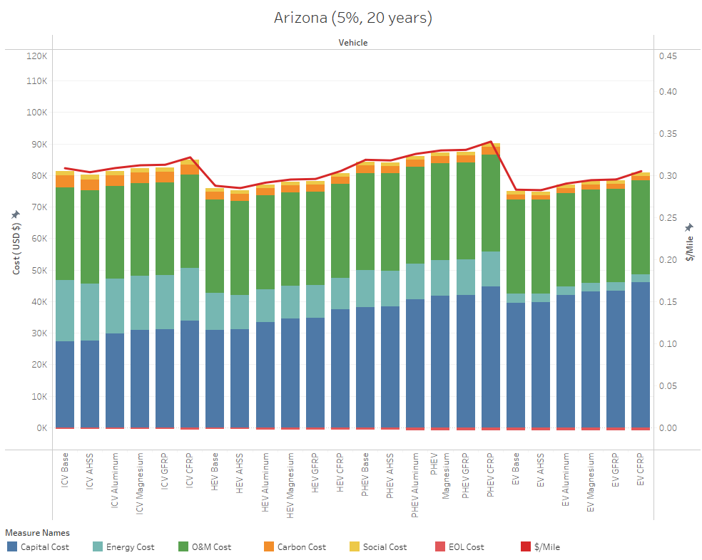
Figure 5. TCO in the State of Arizona
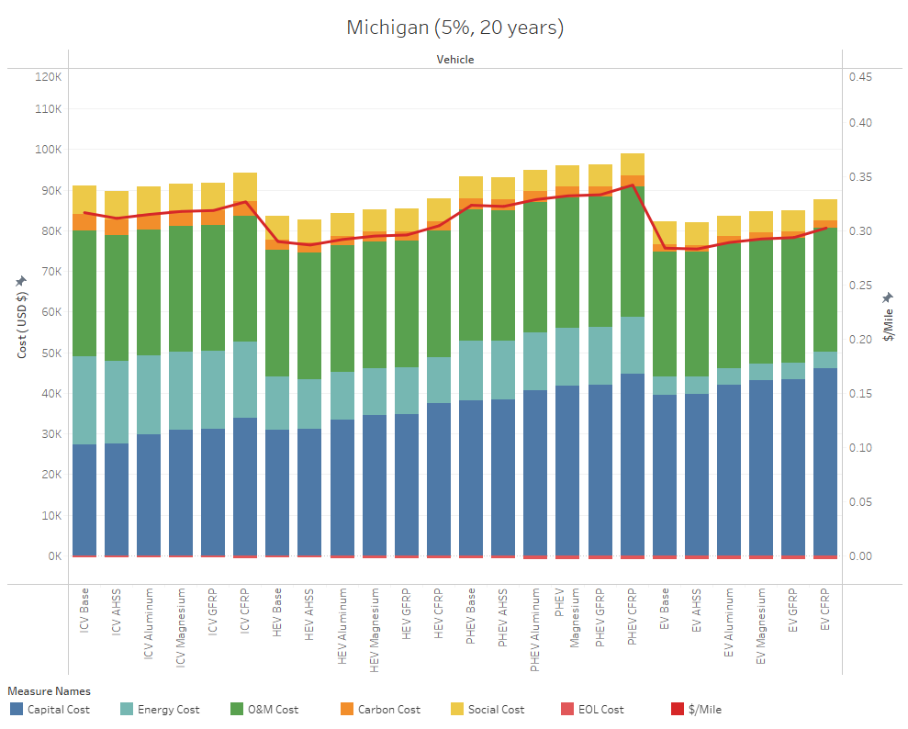
Figure 6. TCO in the State of Michigan
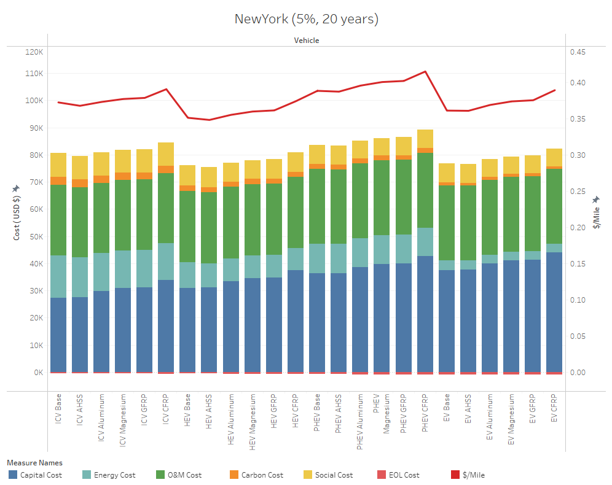
Figure 7. TCO in the State of New York

- Sensitivity Analysis
Figures 8 and 9 show the results of the sensitivity analysis of the TCO model for HEV, and PHEV, respectively.
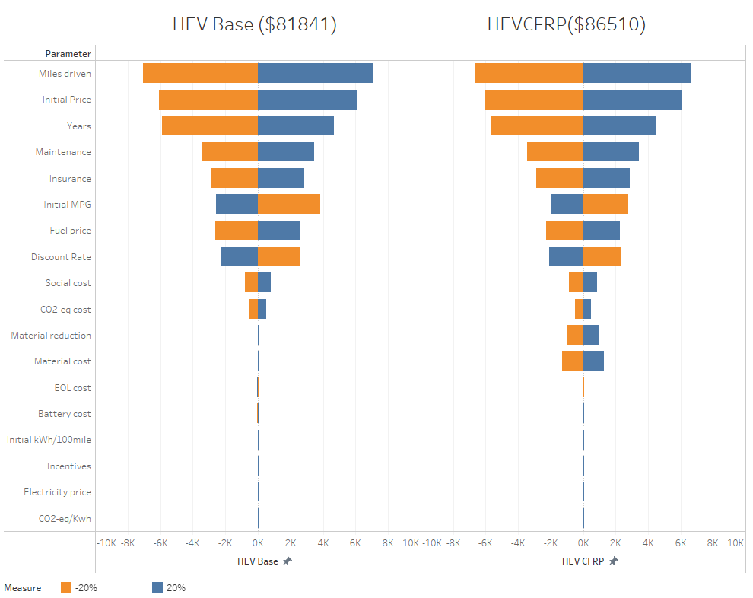
Figure 8. Sensitivity analysis for HEV
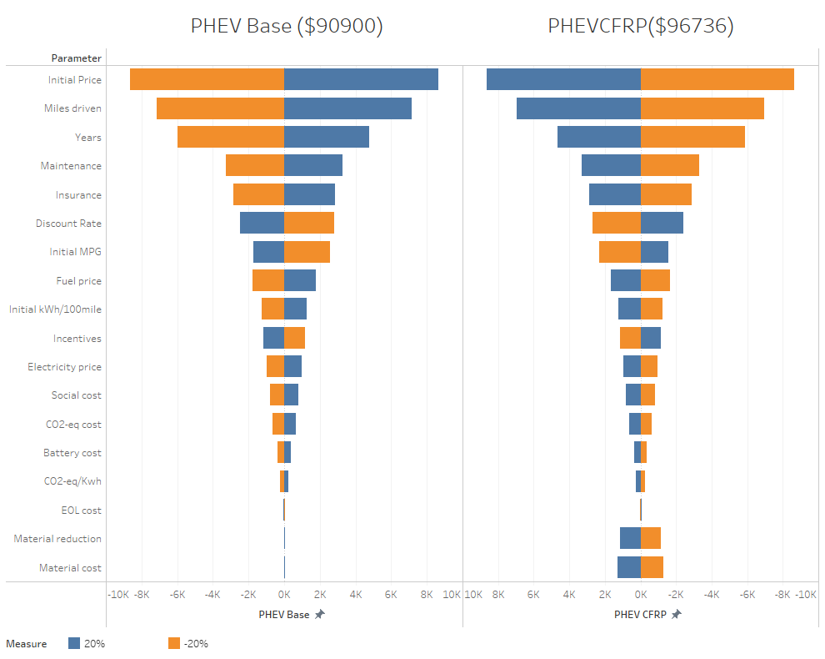
Figure 9. Sensitivity analysis for PHEV
References
EPA (December 12, 2022). U.S. Environmental Protection Agency. Highlights of the Automotive Trends Report. Retrieved February, 20, 2023. https://www.epa.gov/automotive-trends/highlights-automotive-trends-report
Goguen S, Schutte C, Joost W. (2015). Lightweight materials. Vehicle Technologies Office’s Annual Merit Review, Washington, D.C. June 2015.
Cheah, L.W. (2009). The trade-off between automobile acceleration performance, weight, and fuel consumption. SAE International Journal of Fuels and Lubricants, 1:771-777
Fuchs, E, Field, F, Roth, R, Kirchain, R. (2008). Strategic materials selection in the automobile body: Economic opportunities for polymer composite design. Composites Science and Technology, 68:1989-2002
Das, S. (2000). The life-cycle impacts of aluminum body-in-white automotive material. Journal of the Minerals, Metals and Materials Society, 52:41-44
DOE (U.S. Department of Energy). (August, 25, 2016). Timeline: A Path to Lightweight Materials in Cars and Trucks. Energy.Gov. Retrieved February 21, 2022, from https://www.energy.gov/eere/articles/timeline-path-lightweight-materials-cars-and-trucks
Czerwinski, F. (2021). Current trends in automotive lightweighting strategies and materials. Materials, 14(21), 6631.
Mayyas AT, Qattawi A, Mayyas A, Omar M. (2012). Life cycle assessment-based selection for a sustainable lightweight body-in-white design. Energy, 39: 412-425
Brooker, A. D., Ward, J., & Wang, L. (2013). Lightweighting impacts on fuel economy, cost, and component losses (Vol. 1, No. NREL/CP-5400-57607). National Renewable Energy Lab.(NREL), Golden, CO (United States).
Cheah, L. W. (2010). Cars on a diet: the material and energy impacts of passenger vehicle weight reduction in the US (Doctoral dissertation, Massachusetts Institute of Technology).
Farag, M. M. (2006). Quantitative methods of materials selection. Materials and Mechanical Design, 466.
Ashby, M., Bréchet, Y., Cebon, D., & Salvo, L. (2004). Selection strategies for materials and processes. Materials & Design, 25(1), 51-67. doi:10.1016/s0261-3069(03)00159-6
Skibba, R. (2021, March 6). The Biden Administration Weighs the Social Cost of Carbon. Wired. https://www.wired.com/story/the-biden-administration-weighs-the-social-cost-of-carbon/

