Molecular genetic diversity and differentiation of Nile tilapia (Oreochromis niloticus, L. 1758) in East African natural and stocked populations

Papius Dias Tibihika^{†, §, α}, Manuel Curto†, Esayas Alemayehu^{‡, ß}, Herwig Waidbacher‡, Charles Masembe¶, Harald Meimberg†
† Institute for Integrative Nature Conservation Research, University of Natural Resources and Life Sciences Vienna (BOKU), Gregor Mendel Straße 33, 1180 Wien, Austria. papius.tibihika@students.boku.ac.at, manuel.curto@boku.ac.at, meimberg@boku.ac.at
‡ Institute for Hydrobiology and Aquatic Ecosystems Management, University of Natural Resources and Life Sciences Vienna (BOKU), Gregor Mendel Straße 33/DG, 1180 Wien, Austria. esayas.negash@students.boku.ac.at, herwig.waidbacher@boku.ac.at
§ National Agricultural Research Organization, Kachwekano Zonal Agricultural Research and Development Institute, P.O. Box 421, Kabale, Uganda.
¶ Department of Zoology, Entomology and Fisheries Sciences-Makerere University Kampala, Uganda, P. O. Box 7062, Kampala. cmasembe@cns.mak.ac.ug
^{ß} National Fishery and Aquatic Life Research Centre, Sebeta, P.O. Box 64, Addis Ababa, Ethiopia. esayas.negash@students.boku.ac.at

^{α} Corresponding author; Papius Dias Tibihika
papiust@yahoo.com, papius.tibihika@students.boku.ac.at
Tel. +4368 864 971870

Additional file 1
Table S1 Final List of 40 SSR primers utilized in PCR reactions
Locus | F: Primer sequence (5'-3') | R: Primer sequence (5'-3') | Repeat motif | Asr
Ti1 | TTATCACTGCTGAACGTCTT | GTTTTGGCTGCTACACATTC | (TG)10 | 393-411
Ti2 | TTCTGGGCTAACACACAAG | AAGGTGTCACACAGTTTAGG | (CA)18 | 396-438
Ti4 | TGTGCAGAATAGAATAGCCC | GAAAGGAAAAATGTTGGTGGT | (GT)18 | 384-436
Ti5 | AAGGAGGATGATCAGGACAC | AGACCTCCACTGTGATCTTA | (CA)10 | 401-423
Ti6 | CAGCTCTCATGAACACTTGA | ACCCATAAATCACACCAGTC | (GA)23 | 384-437
Ti7 | TCTTTGTGTCAGAACTGTGT | ACTCTGCTTTTAGCCAATCA | (AC)17 | 385-430
Ti8 | CTGAAGTCCTGCTGAGATTT | CATTGTTCTTGGCACCTCTA | (AC)15 | 400-446
Ti9 | CTCAGTGACGAAGCCAAA | CCTGGCAATCAAAAGAACAA | (AC)10 | 409-419
Ti12 | GCCACCAAAATATTCGTGTT | CCATGTTCTGTCTCCTTGAA | (TAC)12 | 377-431
Ti13 | AATCCGTTAGCTGCAGATAG | GCTGATTAAACACAAAGTTGG | (ATG)10 | 369-427
Ti14 | TCCCTAAAATATGCCACCAA | TAGTGCTTTAATGGCTCTGG | (TAA)19 | 340-408
Ti15 | GCTGTGATCATCTGGAGAAA | AGGATCTAGAACCTCCAACC | (TGC)10 | 385-406
Ti16 | CAGACGTAGGCGATAAATCT | GAACACATCCATTTCCACAC | (AAC)10 | 368-428
Ti17 | AACTGAAGAAGAAGCCTTGG | ATCATCTTCCTCTACTGCCT | (GAA)21 | 361-430
Ti18 | AGCAAGTGAGATAAGCACTG | TACATAGCAGTGCAGTTTGC | (ATCT)8 | 373-461
Ti24 | ACTGACAACATAAAGACATATGC | CACAGTTTGAATCCACCATC | (TTAC)9 | 403-483
Ti26 | ATTGCTTCATCCCTTGAGTT | ACACGGAAAACCTAATGACA | (ACAA)10 | 402-475
Ti27 | CTGTCTTTCTTGATGTGGGA | ATGCACAAATTTTAAGGGCC | (TTTG)6 | 391-405
Ti28 | TGTCTTGGGATTTGAGATCA | CGGAGGTTTCTTCCTGTTAA | (ATTCA)8 | 307-409
Ti29 | AGGTCAAGATCAAGCAGTTT | CATCAACATAATTCAGTGTGGA | (TAAAA)10 | 321-400
Ti31 | GAAACTATCCACAGAAGCCA | AGGCTTCTTACAGTTGGATG | (CTAAT)7 | 302-395
Ti32 | CAGGAAATGGCTCCAAAATG | TTGTAGCTAGGAATCAGTGC | (AAAAT)7 | 325-361
Ti33 | GCTTATGGCTGTATGGAGTT | CGACTTCTGTTGTGATTTGG | (TTCAA)6 | 382-427
Ti34 | GCTTACAGTACATTGTGTGC | CTGATGAGAAAAACAGACGC | (TCTCT)10 | 355-448
Ti35 | TCAACCACAAACTCCTCTTT | AAACTAAGTGCAGCTCATGA | (AAAAG)14 | 364-434
Ti39 | TACCTGCCAGTCATGTGCTG | TGCTCAGACTGGTCCCTTCT | (ATGG)8 | 368-420
Ti41 | TCGCAGCTGCTCCTGTTTAA | TTGTGCACGTGGACATGTTG | (AAAC)11 | 381-471
Ti43 | ATTGCCATCACCAGGAACCA | TGCTAGCCCAGAGCATTTGA | (GAATA)6 | 425-478
Ti44 | TGCTCCTGACTCAGCATCAC | GCAGCACTCTGACATGAAGC | (GAAAA)6 | 419-469
Ti49 | TCGAAGTAGCGTGGAAAACCT | ACAACAACAACAGGTCGGGA | (TGT)8 | 395-403
Ti50 | CCTGTGACAGACTGGTGACC | ACACTGATGCGGTTTACGGT | (ATGG)7 | 442-517
Ti51 | TGCTAAACGCCAGCTGATGA | TTACCACACGATGTCGCAGG | (TGT)8 | 401-428
Ti52 | GAGAAACGTCCAGTGGCAGA | TTTCGATCTGCTGCCCCTTT | (TAT)8 | 373-429
Ti54 | TTTCTTGCCAGCAAAAACAGT | CAGATTCTTCCAGTGCTTGTGC | (GGAT)7 | 390-480
Ti55 | GAGCCCAGACAGCAGACAAT | AGGACCTTCTATGGCCCTGT | (TCTA)7 | 417-491
Ti56 | TGCAGTGAATTTGGCACCTG | AGCCTGAGATACCTGTGCCT | (TGTT)6 | 310-462
Ti57 | CAGTGGGAGGAAGCTCCAAA | GCTGCATGGATCCAATAGGC | (TCCA)7 | 400-444
Ti59 | ATGGACTTAAGCTGCACCCC | TGAGCATTTGACCCCAGCAT | (AGGA)6 | 429-461
Ti60 | GAGCCGCCATAGTGTCACTT | CCTGCTCTCACTCAAAGAGGG | (ATCC)7 | 473-516
Ti61 | GCTACACAGGAAAGCAGAGC | ACTCAATGCTGGACGTGACC | (TGGA)6 | 474-501
F=Forward and R=Reverse, Asr=Allelic size range

Table S2 Variation of the final set of 40 SSR loci. Loci Ti1–Ti35 were taken from Tibihika et al. (28) while loci Ti39–Ti61 were developed in the current study
Loci | Na | Ho | He | Ht | PIC
Ti1 | 17 | 0.377 | 0.571 | 0.601 | 0.500
Ti2 | 54 | 0.704 | 0.854 | 0.864 | 0.844
Ti4 | 22 | 0.757 | 0.842 | 0.862 | 0.823
Ti5 | 19 | 0.438 | 0.644 | 0.671 | 0.614
Ti6 | 50 | 0.866 | 0.841 | 0.879 | 0.828
Ti7 | 35 | 0.843 | 0.820 | 0.833 | 0.801
Ti8 | 29 | 0.197 | 0.387 | 0.469 | 0.375
Ti9 | 10 | 0.156 | 0.597 | 0.589 | 0.558
Ti12 | 36 | 0.306 | 0.552 | 0.633 | 0.527
Ti13 | 12 | 0.224 | 0.449 | 0.485 | 0.431
Ti14 | 18 | 0.341 | 0.618 | 0.708 | 0.591
Ti15 | 14 | 0.138 | 0.417 | 0.461 | 0.381
Ti16 | 30 | 0.126 | 0.423 | 0.507 | 0.407
Ti17 | 64 | 0.661 | 0.820 | 0.861 | 0.804
Ti18 | 76 | 0.652 | 0.951 | 0.950 | 0.948
Ti24 | 68 | 0.654 | 0.879 | 0.900 | 0.873
Ti26 | 20 | 0.480 | 0.735 | 0.734 | 0.696
Ti27 | 7 | 0.060 | 0.325 | 0.390 | 0.310
Ti28 | 15 | 0.201 | 0.386 | 0.420 | 0.361
Ti29 | 39 | 0.230 | 0.718 | 0.808 | 0.675
Ti31 | 24 | 0.191 | 0.830 | 0.828 | 0.811
Ti32 | 84 | 0.938 | 0.931 | 0.929 | 0.926
Ti33 | 18 | 0.606 | 0.832 | 0.823 | 0.809
Ti34 | 79 | 0.811 | 0.940 | 0.946 | 0.936
Ti35 | 56 | 0.562 | 0.951 | 0.951 | 0.948
Ti39 | 33 | 0.384 | 0.644 | 0.686 | 0.615
Ti41 | 50 | 0.539 | 0.880 | 0.904 | 0.871
Ti43 | 61 | 0.364 | 0.654 | 0.729 | 0.647
Ti44 | 29 | 0.600 | 0.839 | 0.850 | 0.821
Ti49 | 24 | 0.303 | 0.381 | 0.427 | 0.370
Ti50 | 22 | 0.434 | 0.616 | 0.695 | 0.584
Ti51 | 40 | 0.545 | 0.759 | 0.789 | 0.737
Ti52 | 14 | 0.271 | 0.694 | 0.776 | 0.651
Ti54 | 47 | 0.677 | 0.920 | 0.932 | 0.914
Ti55 | 29 | 0.728 | 0.905 | 0.902 | 0.897
Ti56 | 24 | 0.200 | 0.747 | 0.784 | 0.721
Ti57 | 16 | 0.054 | 0.401 | 0.476 | 0.370
Ti59 | 28 | 0.596 | 0.803 | 0.835 | 0.778
Ti60 | 22 | 0.531 | 0.737 | 0.740 | 0.697
Ti61 | 17 | 0.127 | 0.259 | 0.307 | 0.250
Total | 1,352 |  | 80%>0.5 | 82.5>0.5 | 78%>0.5
Na = number of alleles, Ho = observed heterozygosity, He = expected heterozygosity, Ht = total expected heterozygosity, PIC = Polymorphic Information Content.

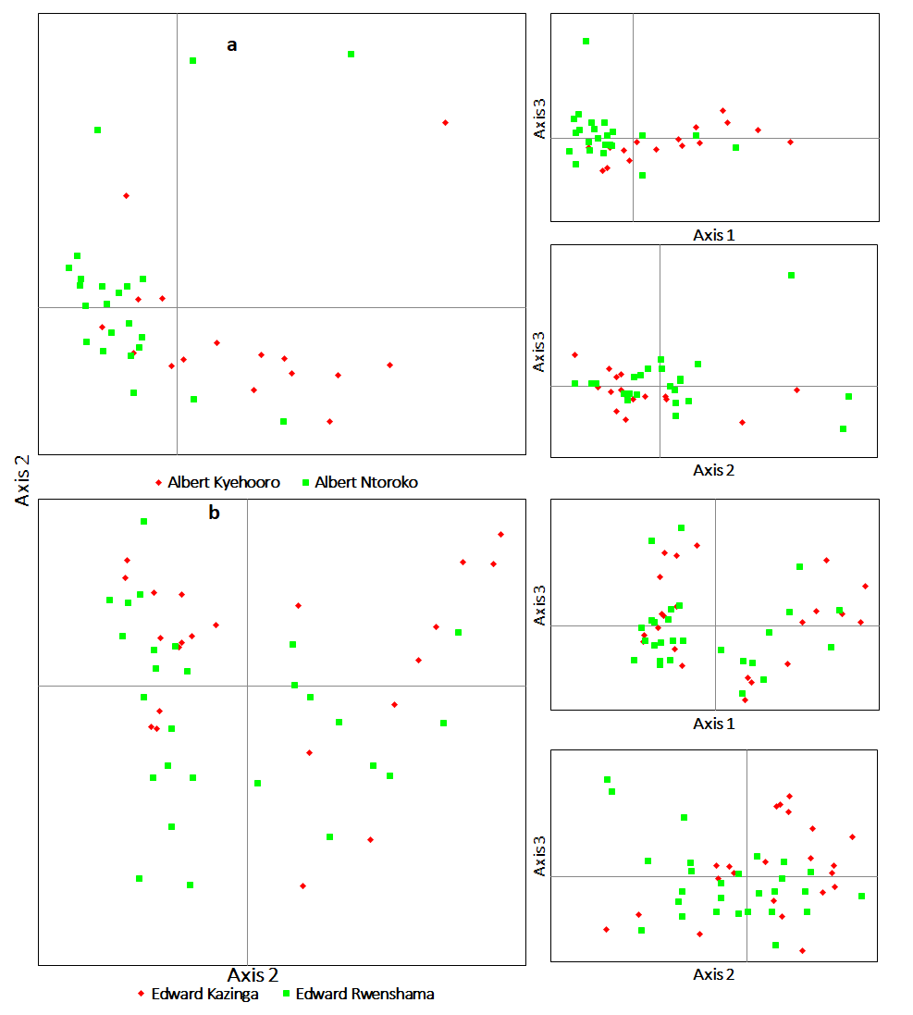
Figure S1 Genetic structure based on PCoA within the East African Western Rift Valley lakes, Albert (a) and Edward (b) metapopulations

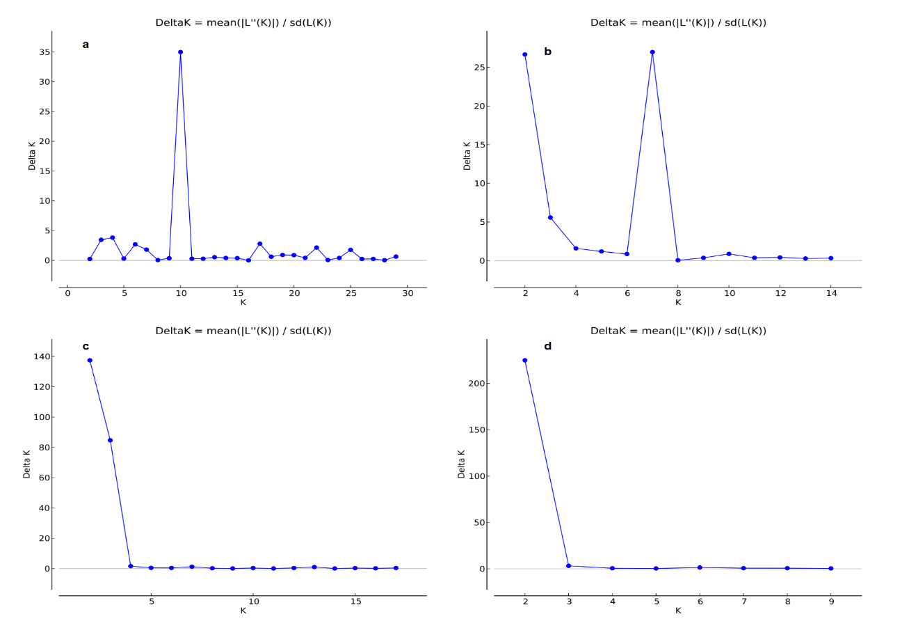
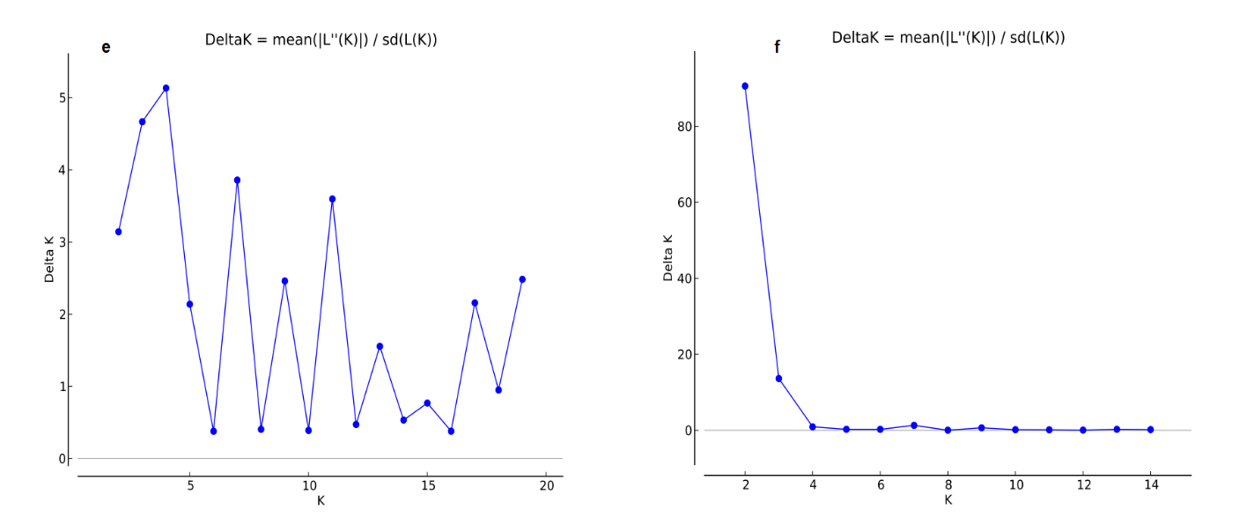
Figure S2 STRUCTURE HARVESTER analyses for depicting the optimal K values, which is derived from STRUCTURE results. a represents the best K for all populations (K=10), b best K for all native populations (K=7), c best K for East African native populations (K=2), d best K for only Ugandan native populations (K=2), e best K for all Ugandan populations including farms (K=4) and f best K for Lake Victoria within populations (K=2)

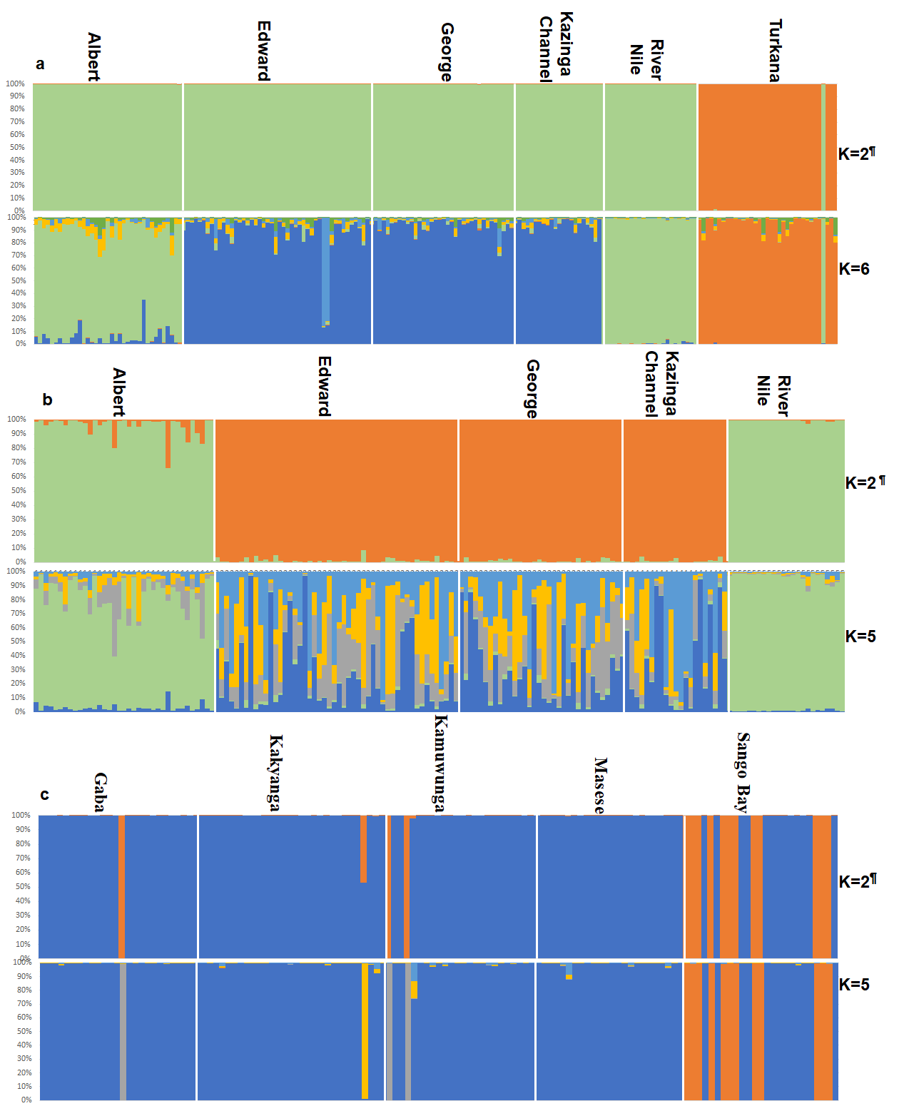
Figure S3 Bayesian clustering for genetic assignments of O. niloticus populations. a represents East African native, b Only Uganda native populations and c Lake Victoria subpopulations. K values with a superscript symbol (¶) indicate the optimal K value based on STRUCTURE HARVESTER analyses.

Table S3 Matrix for the number of migrants per generation between population pairs as evidenced by Fst values. Bold values (>10) indicate the vital number of migrants explained by Fst values: Note the variations in boldness which explains the level of important migrations between population pairs

Population pair |  | Fst | Nm
River Nile | Kyoga | 0.009 | 26.495
Edward | George | 0.010 | 23.754
Edward | Kazinga Channel | 0.014 | 17.627
Kyoga | Sindi Farm | 0.017 | 14.628
Albert | Bagena Farm | 0.017 | 14.341
George | Kazinga Channel | 0.018 | 13.735
Albert | Sindi Farm | 0.021 | 11.447
George | Mulehe | 0.023 | 10.466
River Nile | Sindi Farm | 0.025 | 9.878
Albert | Kyoga | 0.025 | 9.604
Bagena Farm | Sindi Farm | 0.027 | 9.178
Albert | Victoria | 0.027 | 8.972
Victoria | Sindi Farm | 0.028 | 8.764
Albert | Rwitabingi Farm | 0.029 | 8.431
Edward | Mulehe | 0.029 | 8.418
Edward | Victoria | 0.029 | 8.242
George | Victoria | 0.030 | 8.129
Kyoga | Victoria | 0.030 | 8.034
Albert | River Nile | 0.031 | 7.837
Kyoga | Bagena Farm | 0.032 | 7.485
Victoria | Bagena Farm | 0.034 | 7.206
George | Kayumbu | 0.035 | 6.965
Victoria | Mulehe | 0.035 | 6.950
River Nile | Victoria | 0.036 | 6.745
Edward | Kayumbu | 0.036 | 6.649
Kazinga Channel | Mulehe | 0.037 | 6.581
Rwitabingi Farm | Sindi Farm | 0.037 | 6.568
River Nile | Bagena Farm | 0.038 | 6.398
Kazinga Channel | Victoria | 0.038 | 6.319
Kyoga | Rwitabingi Farm | 0.038 | 6.304
Victoria | Rwitabingi Farm | 0.039 | 6.130
Rwitabingi Farm | Bagena Farm | 0.040 | 5.967
Kazinga Channel | Kayumbu | 0.041 | 5.904
Mulehe | Kayumbu | 0.042 | 5.674
River Nile | Rwitabingi Farm | 0.046 | 5.239
Albert | Edward | 0.048 | 4.964
Albert | George | 0.049 | 4.899
Victoria | Kayumbu | 0.049 | 4.802
George | Bagena Farm | 0.050 | 4.754
Edward | Bagena Farm | 0.052 | 4.565
George | Sindi Farm | 0.052 | 4.515
Edward | Sindi Farm | 0.054 | 4.399
Albert | Kazinga Channel | 0.055 | 4.288
Mulehe | Bagena Farm | 0.055 | 4.266
Albert | Mulehe | 0.056 | 4.185
Mulehe | Sindi Farm | 0.057 | 4.160
Kazinga Channel | Bagena Farm | 0.058 | 4.082
Edward | Kyoga | 0.059 | 3.980
Kazinga Channel | Sindi Farm | 0.061 | 3.826
Edward | River Nile | 0.062 | 3.774
George | Kyoga | 0.062 | 3.773
Edward | Rwitabingi Farm | 0.068 | 3.444
George | River Nile | 0.068 | 3.438
Kazinga Channel | Kyoga | 0.068 | 3.405
Kyoga | Mulehe | 0.068 | 3.405
George | Rwitabingi Farm | 0.069 | 3.378
Albert | Kayumbu | 0.072 | 3.243
Kazinga Channel | River Nile | 0.072 | 3.232
Mulehe | Rwitabingi Farm | 0.072 | 3.211
Kayumbu | Bagena Farm | 0.073 | 3.184
Kayumbu | Sindi Farm | 0.075 | 3.084
River Nile | Mulehe | 0.076 | 3.057
Kazinga Channel | Rwitabingi Farm | 0.076 | 3.035
Kayumbu | Rwitabingi Farm | 0.089 | 2.561
Kyoga | Kayumbu | 0.089 | 2.544
River Nile | Kayumbu | 0.096 | 2.365
Ziway | Chamo | 0.101 | 2.223
Victoria | Turkana | 0.130 | 1.680
George | Turkana | 0.140 | 1.541
Edward | Turkana | 0.145 | 1.472
Albert | Turkana | 0.148 | 1.435
Sindi Farm | Turkana | 0.153 | 1.384
Bagena Farm | Turkana | 0.153 | 1.379
Kazinga Channel | Turkana | 0.155 | 1.363
Rwitabingi Farm | Turkana | 0.157 | 1.342
Mulehe | Turkana | 0.160 | 1.311
Kyoga | Turkana | 0.162 | 1.295
Ziway | Hashenge | 0.162 | 1.294
Kayumbu | Turkana | 0.164 | 1.277
River Nile | Turkana | 0.170 | 1.225
Hashenge | Chamo | 0.217 | 0.902
Victoria | Burkina Faso | 0.238 | 0.802
Turkana | Chamo | 0.240 | 0.791
George | Burkina Faso | 0.243 | 0.781
Edward | Burkina Faso | 0.251 | 0.748
Turkana | Burkina Faso | 0.261 | 0.707
Kazinga Channel | Burkina Faso | 0.261 | 0.707
Turkana | Ziway | 0.263 | 0.701
Mulehe | Burkina Faso | 0.264 | 0.696
Kayumbu | Burkina Faso | 0.273 | 0.667
Albert | Burkina Faso | 0.275 | 0.659
Bagena Farm | Burkina Faso | 0.279 | 0.645
Sindi Farm | Burkina Faso | 0.287 | 0.620
Kyoga | Burkina Faso | 0.293 | 0.603
Victoria | Chamo | 0.298 | 0.590
Rwitabingi Farm | Burkina Faso | 0.300 | 0.584
Turkana | Hashenge | 0.300 | 0.583
River Nile | Burkina Faso | 0.307 | 0.564
George | Chamo | 0.312 | 0.551
Edward | Chamo | 0.316 | 0.540
Victoria | Ziway | 0.317 | 0.538
Sindi Farm | Chamo | 0.331 | 0.506
George | Ziway | 0.333 | 0.501
Mulehe | Chamo | 0.335 | 0.497
Edward | Ziway | 0.336 | 0.494
Kazinga Channel | Chamo | 0.337 | 0.491
Kayumbu | Chamo | 0.338 | 0.489
Albert | Chamo | 0.339 | 0.487
Victoria | Tana | 0.343 | 0.478
Bagena Farm | Chamo | 0.345 | 0.475
George | Tana | 0.348 | 0.469
Kyoga | Chamo | 0.350 | 0.465
Rwitabingi Farm | Chamo | 0.352 | 0.461
Mulehe | Ziway | 0.356 | 0.452
Sindi Farm | Ziway | 0.358 | 0.449
Kayumbu | Ziway | 0.358 | 0.448
Edward | Tana | 0.359 | 0.446
Kazinga Channel | Ziway | 0.359 | 0.446
Albert | Ziway | 0.364 | 0.436
River Nile | Chamo | 0.364 | 0.436
Victoria | Hashenge | 0.367 | 0.432
Turkana | Tana | 0.368 | 0.429
Bagena Farm | Ziway | 0.371 | 0.425
Kayumbu | Tana | 0.371 | 0.424
Kyoga | Ziway | 0.377 | 0.413
Rwitabingi Farm | Ziway | 0.378 | 0.412
Albert | Tana | 0.379 | 0.409
Mulehe | Tana | 0.381 | 0.406
Bagena Farm | Tana | 0.382 | 0.404
River Nile | Ziway | 0.382 | 0.404
Kazinga Channel | Tana | 0.384 | 0.401
Sindi Farm | Tana | 0.387 | 0.395
Edward | Hashenge | 0.391 | 0.389
Chamo | Burkina Faso | 0.392 | 0.387
George | Hashenge | 0.393 | 0.385
Rwitabingi Farm | Tana | 0.401 | 0.374
Ziway | Burkina Faso | 0.406 | 0.365
Sindi Farm | Hashenge | 0.410 | 0.359
Mulehe | Hashenge | 0.418 | 0.349
Albert | Hashenge | 0.418 | 0.348
Kazinga Channel | Hashenge | 0.419 | 0.347
Kyoga | Tana | 0.420 | 0.345
Kayumbu | Hashenge | 0.421 | 0.344
Kyoga | Hashenge | 0.424 | 0.340
Bagena Farm | Hashenge | 0.425 | 0.339
Rwitabingi Farm | Hashenge | 0.426 | 0.337
River Nile | Tana | 0.428 | 0.334
River Nile | Hashenge | 0.441 | 0.317
Hashenge | Burkina Faso | 0.480 | 0.271
Tana | Burkina Faso | 0.487 | 0.263
Tana | Chamo | 0.521 | 0.230
Ziway | Tana | 0.548 | 0.206
Tana | Hashenge | 0.599 | 0.167

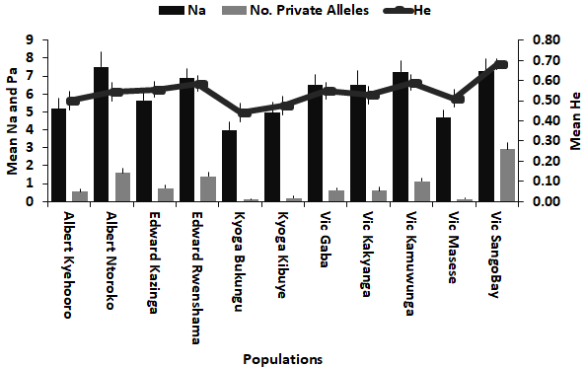
Figure S4 Within-population genetic diversity of Albert, Edward, Kyoga, and Victoria. Vic=Victoria, Na=number of alleles, Pa=Private alleles and He=expected heterozygosity

