Supplementary material

Zinc oxide nanoparticles induce renal injury by initiating oxidative stress, mitochondrial damage and apoptosis in renal tubular epithelial cells

Shuang Liu^{1,2,†}, Han Zhou^{1,†}, Yang Shi^{1,†}, Jingyan Li², Simeng Yi¹, Bin Liao², Ji-Min Cao^{3,*}, Guang Li^{1,*}

¹ Key Laboratory of Medical Electrophysiology, Ministry of Education & Medical Electrophysiological Key Laboratory of Sichuan Province, and Collaborative Innovation Center for Prevention of Cardiovascular Diseases, Institute of Cardiovascular Research, Southwest Medical University, Luzhou 646000, China
² Department of Cardiovascular Surgery, Affiliated Hospital of Southwest Medical University, Southwest Medical University, Luzhou 646000, China
³ Key Laboratory of Cellular Physiology at Shanxi Medical University, Ministry of Education, and the Department of Physiology, Shanxi Medical University, Taiyuan 030607, China
* Correspondence: caojimin@sxmu.edu.cn (J.-M.C.); liguang@swmu.edu.cn (G.L.)
† These authors contributed equally to this work.

Supplementary Figures
Figure S1. (A, B) TUNEL staining of kidney tissues. Green, TUNEL-positive nuclei. Blue, DAPI-positive nuclear. Red arrow, normal cells. Yellow arrow, apoptotic cells. (C) Blood and urine tests.

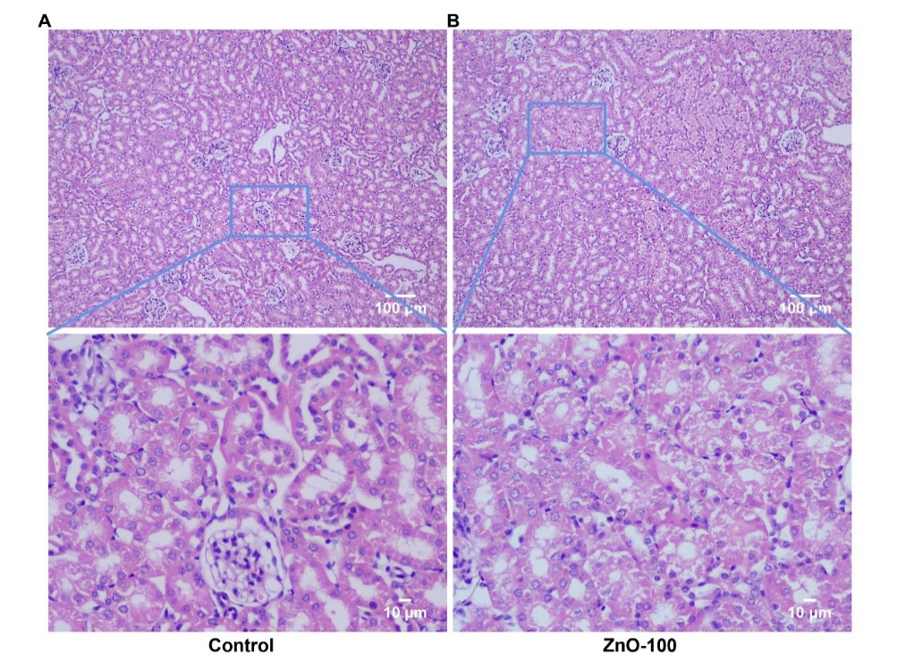
Figure S2. H&E stains of kidney tissues of mice. (A) Control. (B) oral ingestion of ZnO-100 for 2 months. Mild damage of renal tubules was observed in the renal tissues.

