Supplementary Information to:
Molecular rearrangement of bicyclic peroxy radicals: key route to aerosol from aromatics

Siddharth Iyer^{1∗}, Avinash Kumar¹, Anni Savolainen¹, Shawon Barua¹, Christopher Daub², Lukas Pichelstorfer³, Pontus Roldin^{4,5}, Olga Garmash^{1,6}, Prasenjit Seal¹, Theo Kurtén², Matti Rissanen^{1,2∗}

¹Aerosol Physics Laboratory, Tampere University, FI-33101 Tampere, Finland
²Department of Chemistry, University of Helsinki, P.O. Box 55, FI-00014 Helsinki, Finland
³Department of Chemistry and Physics of Materials, University of Salzburg, 5020 Salzburg, Austria
⁴Division of Nuclear Physics, Department of Physics, Lund University, P.O. Box 118, SE-221 00 Lund, Sweden
⁵Swedish Environmental Research Institute IVL, SE-211 19 Malmö, Sweden
⁶Department of Atmospheric Sciences, University of Washington Seattle, WA, USA

∗Corresponding author:
Siddharth Iyer (siddharth.iyer@tuni.fi)
Matti Rissanen (matti.rissanen@tuni.fi)

Contents
1 Short residence time experiments 2
2 Toluene oxidation scheme 4
2.1 Fate of C-alkyl and C-peroxy 5
2.2 Loss rate of B-alkyl 8
3 Comparison with previous toluene oxidation experiments 10
4 NO experiments 12
5 D₂O experiments 14
6 Ring breaking rate coefficients for other toluene BPR isomers and other aromatics 16
7 Rearrangement reactions of bicyclic radicals and closed-shell products from OH reactions with benzene and toluene 17
8 Branching between autoxidation and the formation of closed-shell species 19
9 Flow tube simulations 20
10 References 22

1 Short residence time experiments

Using an injector tube to add toluene to the reactor, the residence time between toluene and OH was reduced to 1.5 seconds and 0.8 seconds. Table S1 shows the mass / charge (Th) of dominant peaks from the OH reaction of toluene and CD3-toleune. Figs. S1, S2 and S3 show the results of the experiments carried out at 0.8, 1.5 and 3.7 second residence times, respectively. The results clearly show the rapid formation of the 9-oxygen containing O9-RO₂.

Table S1- Mass / charge (Th) of important peaks from the OH reaction of toluene and CD3-toluene.
Molecule (clustered to NO₃⁻) | Mass / charge (Th)
C₇H₉O₇ | 267
C₇D₃H₆O₇ | 270
C₇H₉O₉ | 299
C₇D₃H₆O₉ | 302
C₇H₉O₁₁ | 331
C₇D₃H₆O₁₁ | 334

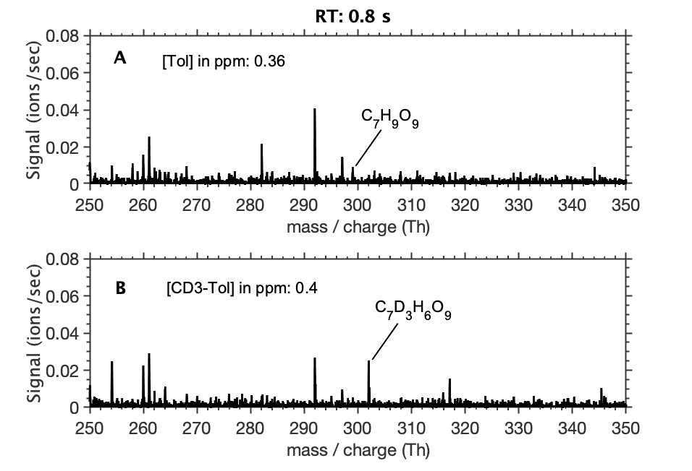
Fig. S1 – Mass spectra of experiment where OH reacts with (A) toluene (C₇H₈) and (B) CD3-toluene (C₇D₃H₆) with a residence time of 0.8 seconds. [Toluene]: 0.36 ppm, [CD3-toluene]: 0.4 ppm, [TME]: 0.04 ppm, [O₃]: 0.2 ppm.
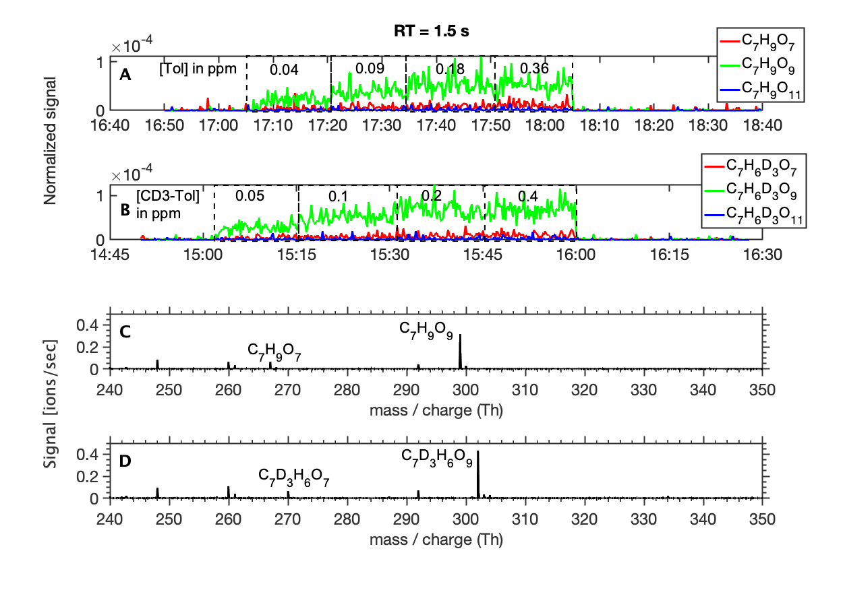
Fig. S2 - Product distribution (A,B) and mass spectra (C,D) of experiments where OH reacts with toluene and CD3-toluene, respectively, with a residence time of 1.5 seconds. Product signals reducing to near zero corresponds to 0 toluene/CD3-toluene flow. [TME]: 0.04 ppm, [O₃]: 0.2 ppm.
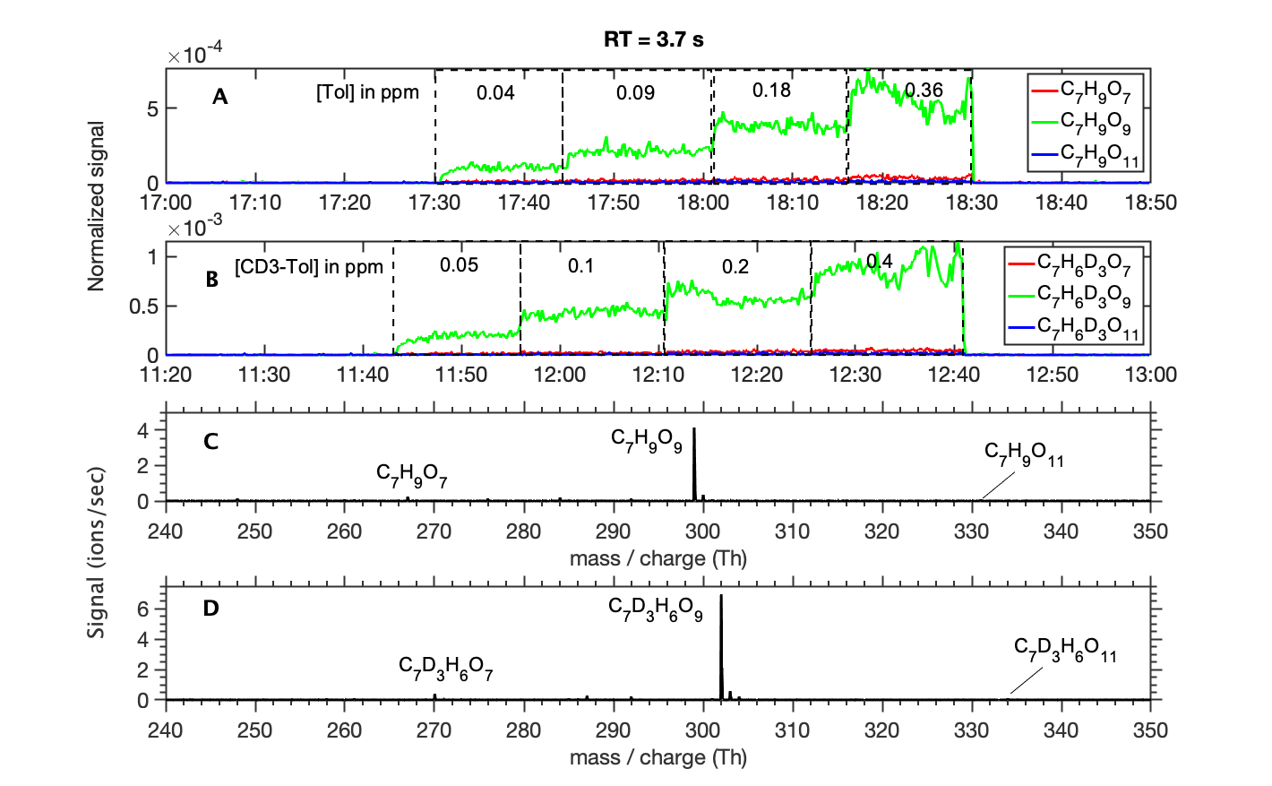
Fig. S3 - Product distribution (A,B) and mass spectra (C,D) of experiments where OH reacts with toluene and CD3-toluene, respectively, with a residence time of 3.7 seconds. Product signals reducing to near zero corresponds to 0 toluene/CD3-toluene flow. [TME]: 0.05 ppm, [O₃]: 0.23 ppm.

2 Toluene oxidation scheme

Toluene is one of the most abundant aromatic compounds in the atmosphere, and its oxidation plays an important role in the formation of tropospheric ozone and secondary organic aerosol (SOA). The initial steps of OH addition to toluene is shown in Fig. S4. While OH additions to non-ipso positions can lead to cresol, addition to the ipso position is followed primarily by O₂ addition to form a peroxy radical. The fates of the peroxy radical and the subsequent intermediates are discussed next. Previously, the mechanistic understanding of the fate of BPR was primarily bimolecular reactions with e.g., NO and HO₂ because of slow unimolecular rates. This work reports a new unimolecular pathway available to BPR with a competitive reaction rate coefficient that leads to highly oxygenated SOA precursor molecules sub-second timescales.

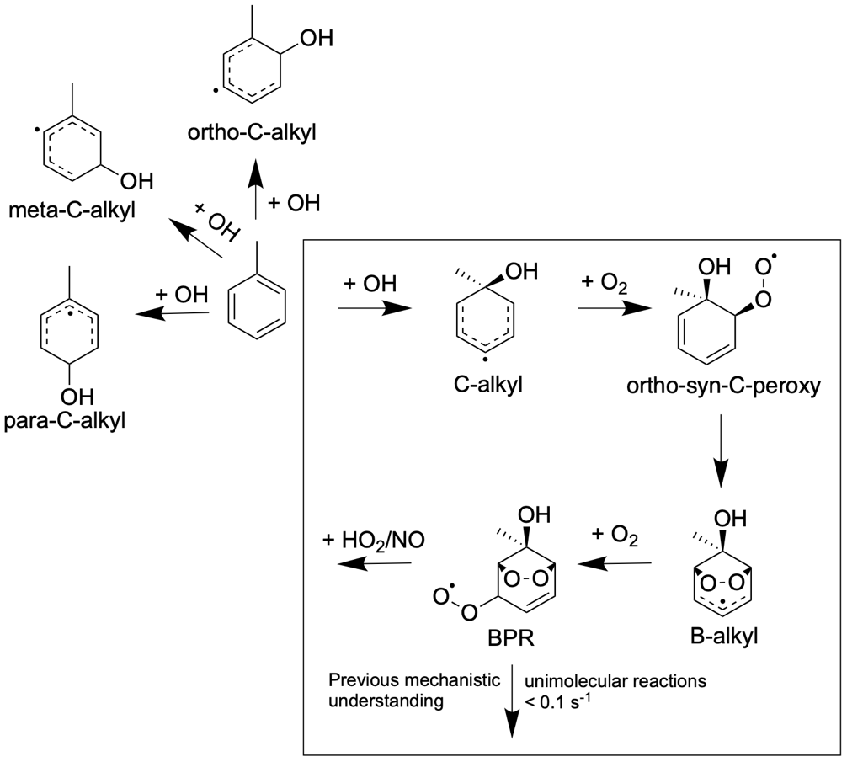
Fig. S4 – OH initiated oxidation by addition of toluene. The critical early steps are detailed for the OH addition to the ipso site (inside box). Previous mechanistic understanding was that the unimolecular reactions of BPR are too slow to compete with bimolecular reactions with trace atmospheric radicals.

2.1 Fate of C-alkyl and C-peroxy

Under atmospheric conditions, the primary fate of C-alkyl is to add O₂ to form a peroxy radical. The O₂ addition is site specific, and addition to the para position has been calculated to be faster than ortho(1), however the subsequent reactions of para-C-peroxy, with O₂ in both anti and syn positions relative to OH, are slow (see Fig. S5 and Table S2). Note that B3LYP/6-31+G(d) is a relatively low level of theory. Because the unimolecular reactions of ortho-C-peroxy are calculated to be orders of magnitude faster (see Table S3 and Table S4), ortho O₂ addition channels likely funnel the bulk of the formation of highly oxygenated products.
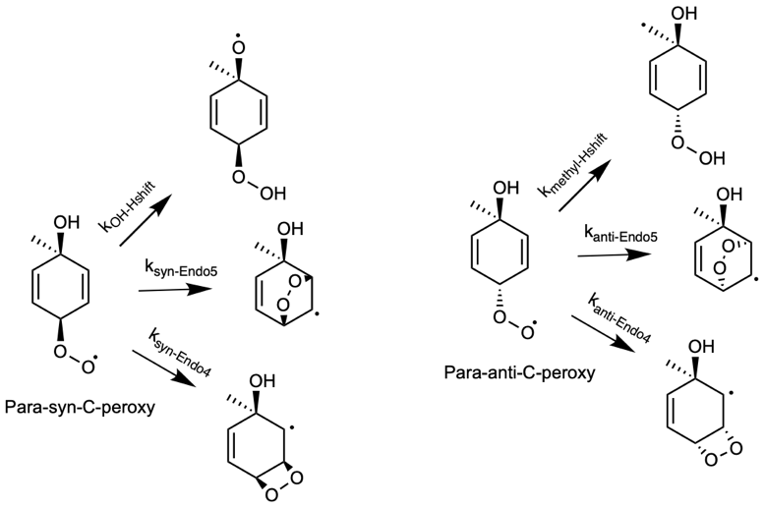
Fig. S5 - Unimolecular reactions of toluene + OH derived ipso para-C-peroxy with O₂ in the syn and anti positions relative to OH.
Table S2 - Calculated unimolecular rate coefficients using MC-TST method at B3LYP/6-31+G(d) level of theory.
Para-C-peroxy
syn | Rate (s⁻¹) | anti | Rate (s⁻¹)
OH-Hshift | 1.3×10⁻⁹ | Methyl-Hshift | 1.4×10⁻¹⁴
Endo4 | 7.0×10⁻¹⁰ | Endo4 | 2.2×10⁻¹⁰
Endo5 | 1.8×10⁻¹¹ | Endo5 | 5.1×10⁻¹³

The O₂ addition to the ortho position also produces syn and anti isomers. However, the former is known to dominate due to a lower energy barrier for O₂ addition and for the subsequent cyclization(1). This corroborates with the energy barriers for the syn and anti O₂ additions we calculated at the F12 level of theory - 2.5 kcal/mol and 3.4 kcal/mol, respectively. Nevertheless, if formed, the potential fates of ortho-anti-C-peroxy is shown in Fig. S6 with the calculated rate coefficients shown in Table S3. Because of issues with F12 calculations on H-abstractions from -OH groups (see Materials and methods), the OH H-shift rate coefficient was computed at the ωB97X-D/aug-cc-pVTZ level of theory. The unimolecular rate coefficients of ortho-syn-C-peroxy, specifically endo-cyclization Endo5-C6 and OH-Hshift, are significantly faster than ortho-anti-C-peroxy (see Fig. S7 and Table S4). Therefore, forming B-alkyl via ortho-syn-C-peroxy is likely the dominant fate of ipso OH addition to toluene.

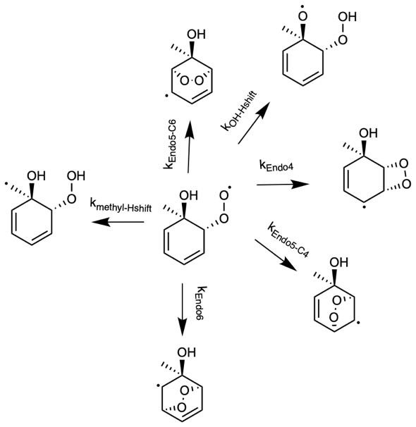
Fig. S6 - Unimolecular reactions of Ortho-anti-C-peroxy.
Table S3 - Unimolecular rate coefficients calculated using MC-TST at ªF12, ^{b}ωB97X-D/aug-cc-pVTZ and ^{c}B3LYP/6-31+G(d) levels of theory.
Ortho-anti-C-Peroxy | Rate (s⁻¹)
Endo5-C6 | 2.2×10^{-1a}
OH-Hshift | 3.7×10^{-3b}
Endo4 | 8.2×10^{-4c}
Endo5-C4 | 2.2×10^{-12c}
Endo6 | 1.9×10^{-7c}
Methyl-Hshift | 4.9×10^{-7c}

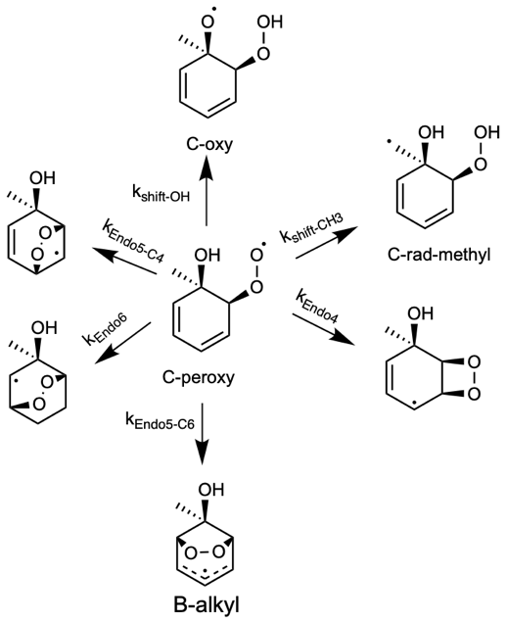
Fig. S7 - Reaction scheme of C-peroxy.
Table S4 - Unimolecular rate coefficients calculated using MC-TST at ªF12, ^{b}ωB97X-D/aug-cc-pVTZ and ^{c}B3LYP/6-31+G(d) levels of theory.
Ortho-syn-C-Peroxy | Rate (s⁻¹)
Endo5-C6 | 2.9×10^{2a}
OH-Hshift | 5.8×10^{-2b}
Endo4 | 1.0×10^{-2c}
Endo5-C4 | 4.7×10^{-10c}
Endo6 | 4.1×10^{-5c}
Methy-Hshift | 6.7×10^{-8c}

2.2 Loss rate of B-alkyl

In addition to adding an O₂ to form BPR, B-alkyl can undergo an isomerization reaction to form B-oxy (see Fig. S8). To probe the importance of the ipso-BPR channel for toluene, we compare the effective loss rate of B-alkyl via O₂ addition to form BPR (k_{eff,BPR}) and by isomerization to B-oxy (see Fig. S8). Following a similar procedure as followed by Xu et al.(2), k_{eff,BPR} can be calculated by considering the reversible O₂ addition to B-alkyl, and assuming molecular rearrangement (k_{mr}; proposed in this work) as the only fate of BPR:
$k_{eff,BPR}= k_{mr}\frac{k_{add}}{k-add}{[O}_{2}]$= $k_{mr}K_{eq,add}[O_{2}]$ (S2)

Where k_{mr} = 0.16 + 0.59 = 0.75 s⁻¹. K_{eq,add} is the equilibrium constant = 1.3×10⁻¹⁵ calculated at F12 level of theory. Assuming atmospheric O₂ concentration and by applying these values into equation (S2), k_{eff,BPR} is calculated to be 4.9×10³ s⁻¹. Alternatively, assuming reaction with NO as the sole fate of the BPR (with [NO] = 1 ppbv and k_{RO2+NO} = 9.15×10⁻¹²), k_{eff,BPR} is calculated to be 1.5×10³ s⁻¹. On the other hand, the loss rate of B-alkyl by isomerization into B-oxy, k_{oxy}, is calculated to be 2.2×10⁻¹ s⁻¹ at F12 level of theory. Thus, the formation of B-oxy is unlikely to be competitive under atmospheric conditions as k_{oxy} is orders-of-magnitude slower than the formation of BPR.
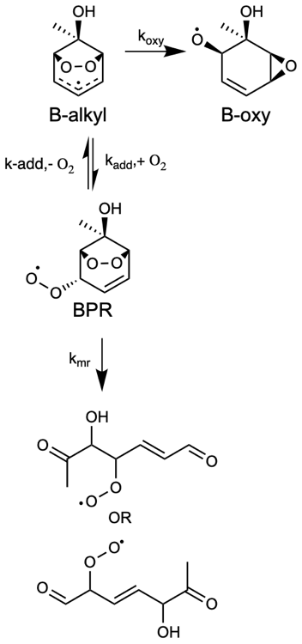
Fig. S8 - Reaction scheme of B-alkyl.
The ring rearrangement mechanism reported in this work is the first such fate of the BPR reported to date. Fig. S4 shows the results of the intrinsic reaction coordinate calculation (at ωB97X-D/aug-cc-pVTZ level of theory) on the ring rearrangement mechanism C2 transition state for the toluene derived ipso BPR. It shows that the transition state connects to the BPR on the reactant side, and to the completely ring broken RO₂, P-C2, on the product side.
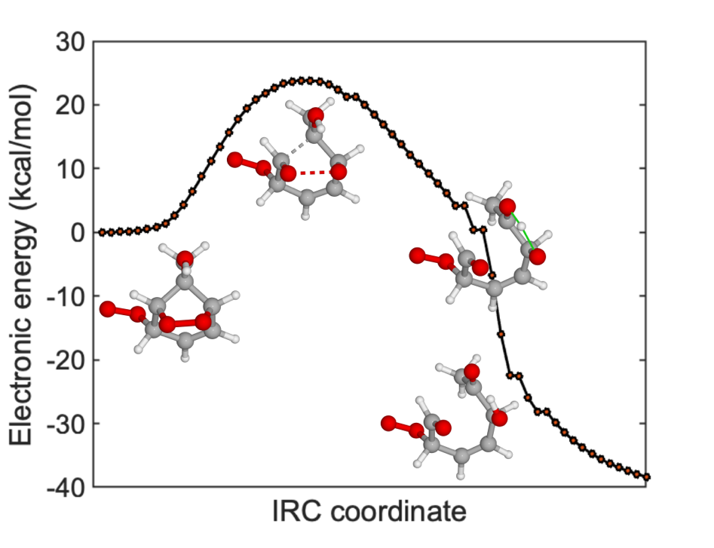
Fig. S9 – Rearrangement mechanism of toluene i-BPR. Intrinsic reaction coordinate (IRC) calculations on the C2 transition state reveals the reaction and product wells. Note that it is electronic energies (kcal/mol) along the y-axis at ωB97X-D/aug-cc-pVTZ level of theory, while it is ROHF-ROCCSD(T)-F12a/VDZ-F12/ωB97X-D/aug-cc-pVTZ zero-point corrected energies in Fig. 1 A in the main manuscript.

3 Comparison with previous toluene oxidation experiments

The formation of SOA precursors from toluene oxidation has been extensively studied in the past years(3-6). Molteni et al. observed that toluene oxidation produced monomer peaks with up to 11 oxygen atoms(3) (Fig. 2 and conclusions in their main manuscript), possibly indicating an autoxidation radical chain reaction occurs that adds several oxygen atoms to the initial BPR. It should be noted that they had high OH concentrations during their experiments, and products derived from multiple OH attacks cannot be discounted. Wang et al. 2017(7) showed that the fastest unimolecular reaction of the toluene derived BPR is for OH in the para position and with a rate coefficient of 2.6 × 10⁻² s⁻¹ at 298 K. This corresponds to the abstraction of the H-atom from the methyl group of toluene and leads to the formation of the peroxy radical C₇H₉O₇ following the addition of O₂. They reported that this peroxy radical rapidly loses an OH (with a rate coefficient of 8 s⁻¹) to form the closed-shell species C₇H₈O₆ (see black box in fig. S5). To investigate if this is a major pathway in toluene oxidation, we conducted experiments with CD3-toluene (see red box in fig. S5). The measurement of the O6 closed-shell species with one of the deuterated atoms missing would demonstrate the importance of this pathway. However, as can be observed in Fig. S6, the dominant closed-shell products contained all three D atoms, while lower signals of the corresponding species minus one D atom were measured. In addition, the signals of the closed-shell species were significantly lower than the radical signals in general (compare Fig. S6 with Fig. S3 B), which is in line with the autoxidation mechanism proposed in Fig. 2 in the main manuscript where no dominant pathway exists that lead to their formation under our experimental conditions.

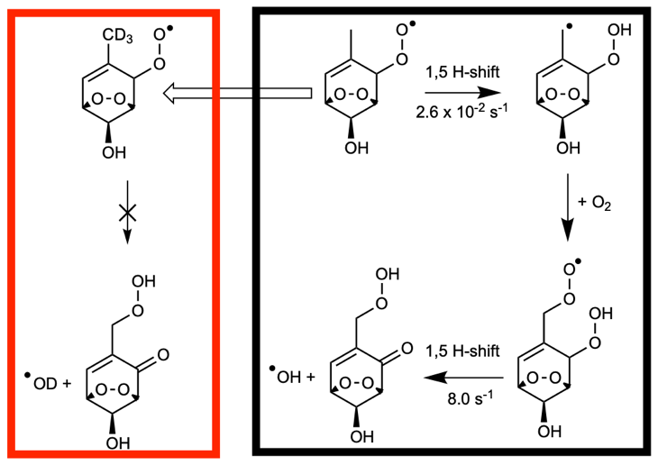
Fig. S10 – Previous understanding of toluene autoxidation mechanism. Black box: Wang et al. 2017 (7) report that the most competitive unimolecular pathway involves the toluene derived para BPR, and is a 1,5 H-shift from the methyl group. This is followed rapidly by the loss of OH to form the closed-shell molecule C₇H₈O₆. Red box: Our experiments with CD3-toluene + OH. The Wang et al. mechanism should lead to an OD loss in our case.
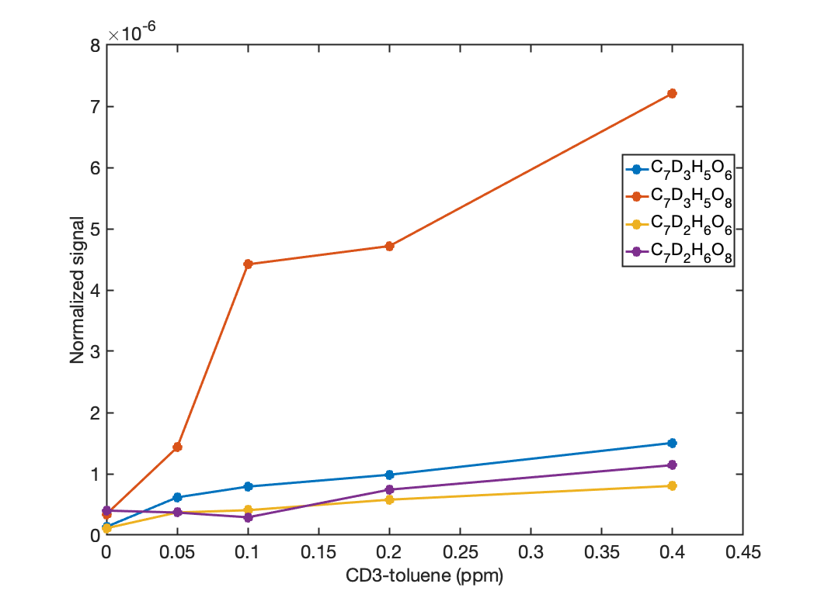
Fig. S11 – Normalized signal as a function of CD3-toluene concentration of the closed-shell O6 and O8 products from CD3-toluene + OH experiments. Signals containing all three deuterated atoms dominate those that have lost one D atom.

4 NO experiments

Experiments with NO were carried out to test the functionality of the proposed RO₂ radicals by measuring the corresponding organo nitrates (RO₂NO). RO₂NO is formed by the reaction RO₂ + NO → RONO₂. Table S5 shows the mass / charge (Th) of the important peaks. Fig. S7 shows the change in product signals and the mass spectra of toluene + OH experiments when NO is added. The detection of the expected organo nitrate peaks confirms that the signals corresponding to C₇H₉O₇ and C₇H₉O₉ are peroxy radicals. The expected organo nitrate peak of C₇H₉O₁₁ was also detected. Fig. S8 is a similar figure from experiments carried out on D3-toluene. These experiments also confirm that the formation of C₇H₉O₉ is rapid since it is detected at non-negligible signals even at high NO concentrations of 0.2 ppm, or 200 ppb, representing an extremely polluted urban air(8-10) with corresponding RO₂ lifetimes around tens of milliseconds.
Table S5 - Mass / charge (Th) of important peaks from the OH reaction of toluene and CD3-toluene with and without NO.
Molecule (clustered to NO₃⁻) | Mass / charge (Th)
C₇H₉O₇ | 267
C₇H₉O₇NO | 297
C₇D₃H₆O₇ | 270
C₇D₃H₆O₇NO | 300
C₇H₉O₉ | 299
C₇H₉O₉NO | 329
C₇D₃H₆O₉ | 302
C₇D₃H₆O₉NO | 332

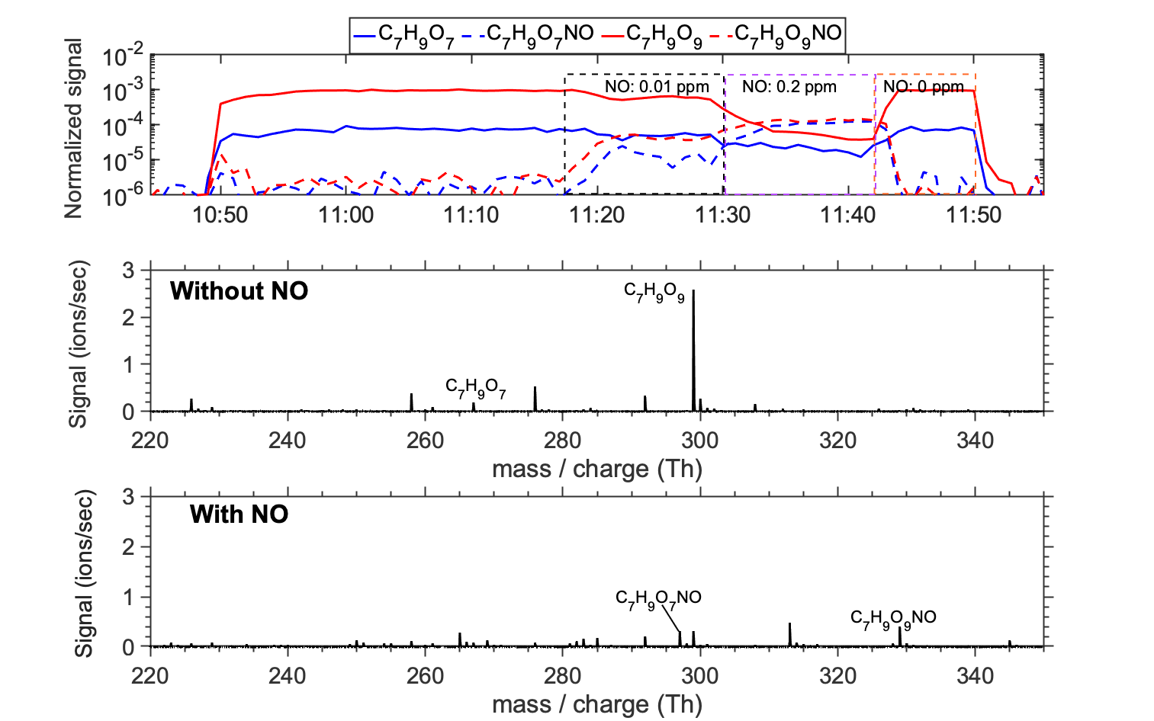
Fig. S12 – Product distribution of experiments where OH reacts with toluene in the presence and in the absence of NO. Experiment residence time was 3.7 seconds. Top figure shows the variations in the normalized signals of select RO₂ and RO₂NO as NO is added to the reactor (1 minute averaging time). Middle and bottom figures show the mass spectra in time windows where NO was absent and present, respectively.
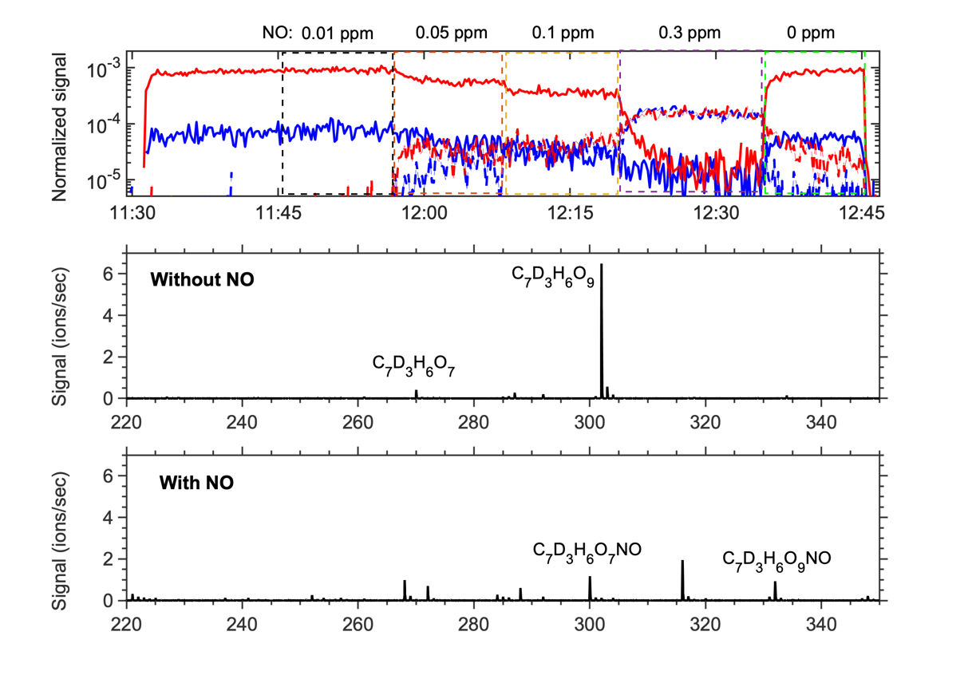
Fig. S13 – Product distribution of experiments where OH reacts with D3-toluene in the presence and in the absence of NO. Experiment residence time was 3.7 seconds. Time averaging of signals in top figure = 12 seconds.

5 D₂O experiments

Experiments to study the H/D exchange were carried out by adding D₂O to the flow tube reactor during toluene + OH experiments. These experiments reveal the number of acidic H-atoms in the measured molecules, i.e. the number of -OH and -OOH functional groups. Table S6 shows the mass / charge (Th) of the important peaks. As shown in Fig. S9, these experiments reveal that at least two isomers of the C₇H₉O₇ peroxy radical are detected, one with one acidic functional group and another with two. This corresponds well with the autoxidation mechanism proposed in Fig. 2 in the main manuscript. Similarly, the proposed autoxidation mechanism points to the C₇H₉O₉ peroxy radical isomer with two acidic functional groups that forms rapidly and is likely the dominant signal. This is corroborated by the D₂O experiment. The corresponding peaks for the CD3-toluene experiment is shown in Fig. S10, and Fig. S11 shows the time series of the normalized signals during toluene/CD3-toluene + OH experiments in the presence and absence of D₂O. The D₂O experiment also indicates three C₇H₉O₁₁ peroxy radical isomers with two, three and four H->D exchanges. While isomers with three labile H-atoms agrees with the proposed mechanism in Fig. 2, the source of the other two isomers could be autoxidation along the P-C1 pathway not explored in this work.

Table S6 - Mass / charge (Th) of important peaks from the OH reaction of toluene and CD3-toluene with and without D₂O.
Molecule (clustered to NO₃⁻) | Mass / charge (Th)
C₇H₉O₇ | 267
C₇D₁H₈O₇ (= +1) | 268
C₇D₂H₇O₇ (= +2) | 269
C₇D₃H₆O₇ | 270
C₇D₄H₅O₇ (= +1) | 271
C₇D₅H₄O₇ (= +2) | 272
C₇H₉O₉ | 299
C₇D₂H₇O₉ (= +2) | 301
C₇D₃H₆O₉ | 302
C₇D₅H₄O₉ (= +2) | 304

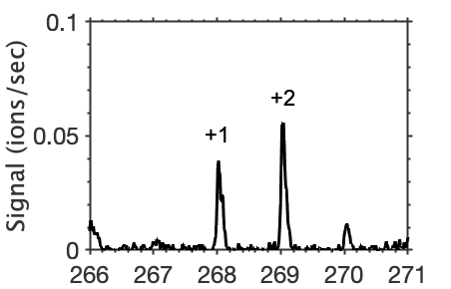
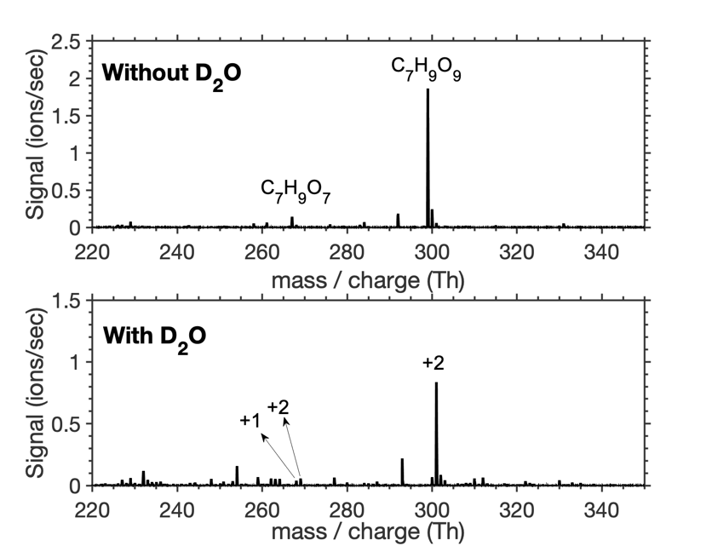
Fig. S14 – Mass spectra recorded of toluene + OH experiments in the absence (top) and presence of heavy water D₂O. Experiment residence time was 3.7 seconds. The bottom figure illustrates the signal shift, thereby indicating the number of -OH and -OOH groups in the detected molecule. At least two isomers of C₇H₉O₇ are detected, one with one acidic functional group (+1) and one with two acidic functional groups (+2). C₇H₉O₉ with two acidic functional groups (+2) is the dominant isomer.

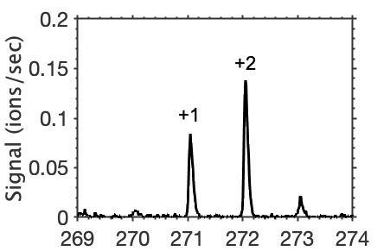
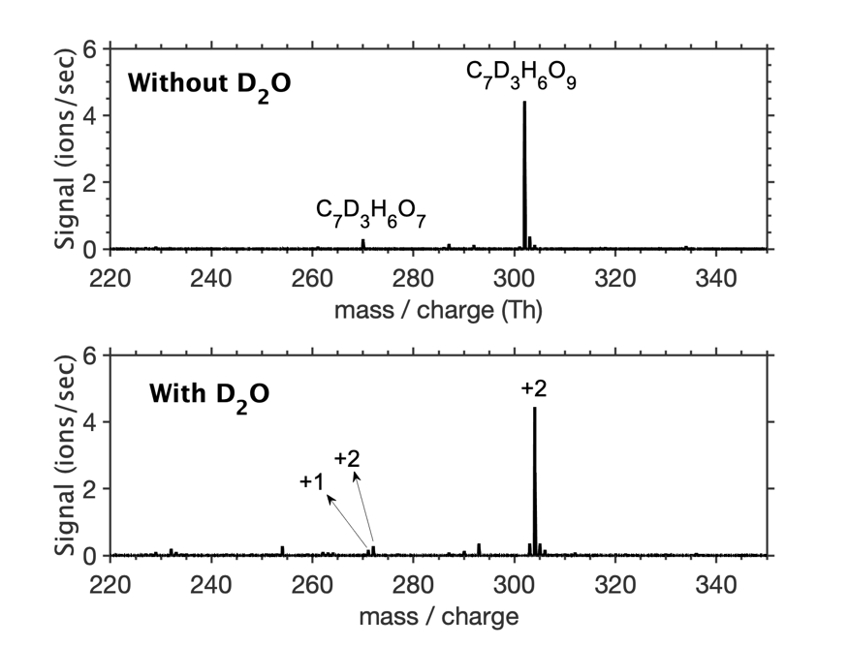
Fig. S15 - Mass spectra recorded of CD3-toluene + OH experiments in the absence (top) and presence of heavy water D₂O. Experiment residence time was 3.7 seconds.

6 Ring breaking rate coefficients for other toluene BPR isomers and other aromatics

The rearrangement mechanism is the fastest for ipso BPR, but also exists for the other BPR isomers. Table S7 shows the rate coefficients of the rearrangement mechanism for the four possible BPR isomers of the toluene + OH system.

Table S7 – Energy barriers and rate coefficients of ring breaking reactions of the four possible BPR isomers of the toluene + OH system. Of the two possible ring breaking pathways, only the one with the lowest energy barrier is shown.
OH addition site | Barrier (kcal/mol) | Rate (s⁻¹)
Ipso | 17.9 | 0.59
Meta | 21.0 | 3.0×10⁻³
Para | 22.0 | 1.0×10⁻³
Ortho | 23.2 | 9.0×10⁻⁵

7 Rearrangement reactions of bicyclic radicals and closed-shell products from OH reactions with benzene and toluene

In addition to BPRs, the rearrangement mechanism is also possible for other aromatic derived bicyclic molecules. Table S8 shows the computed barriers of rearrangement mechanisms for benzene and toluene derived bicyclic alkyl radical, peroxy radical, hydroperoxide and organo nitrate.
Table S8 – Barriers to the rearrangement of other bicyclic intermediates and products of benzene and toluene.
Benzene derived | Rearrangement barrier (kcal/mol) | Toluene derived | Rearrangement barrier (kcal/mol)
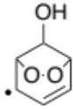 | 22.4 | 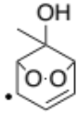 | 18.7
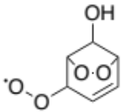 | 21.5 | 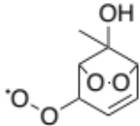 | 17.9
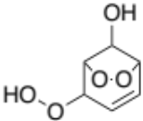 | 22.1 | 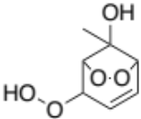 | 18.5
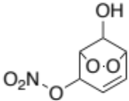 | 22.7 | 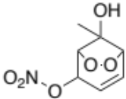 | 19.4

The previous mechanistic understanding of aromatic oxidation was that the primary fate of BPRs under polluted conditions is bimolecular reactions with NO to form alkoxy radicals or organo nitrates (BPR + NO => B-RONO₂; B = bicyclic). As shown in Table S7, the rate coefficients for the molecular rearrangements of non-ipso BPRs from toluene (and for other aromatics; see Fig. 4 in the main manuscript) are likely too slow to be competitive with reactions with NO, and these BPRs will likely lead to a significant fraction of B-RONO₂s. As described before, these B-RONO₂s can subsequently undergo molecular rearrangement reactions to form completely ring broken RONO₂s (RB-RONO₂). The RB-RONO₂s are formed with significant excess energy and can potentially lose the NO₂ to form ring broken alkoxy radicals (RB-RO) that can further oxidize. Additionally, via this reaction, RONO₂s could act as long-range transport reservoirs of NO₂, which has implications for tropospheric ozone formation. Fig. S11 illustrates the general reaction coordinate for this reaction, and Table S9 provides the corresponding zero-point corrected energies (in kcal/mol and at F12 level) and the MESMER derived rate coefficients (in s⁻¹) for the key reactions that determine the fate of the RONO₂s.

The rate coefficient for the conversion of ortho-B-RONO₂ to ortho-RB-RO + NO₂ is much too slow to be significant, but the others convert at atmospherically relevant time scales. The conversion of the ipso-B-RONO₂ is the fastest, but the BPR is likely to undergo molecular rearrangement as a peroxy radical before reacting with NO to form the organo nitrate. The relatively fast conversion of the benzene derived B-RONO₂ to RB-RO + NO₂ is significant as it corresponds to an atmospheric lifetime of Ben-B-RONO₂ of about 34 minutes.
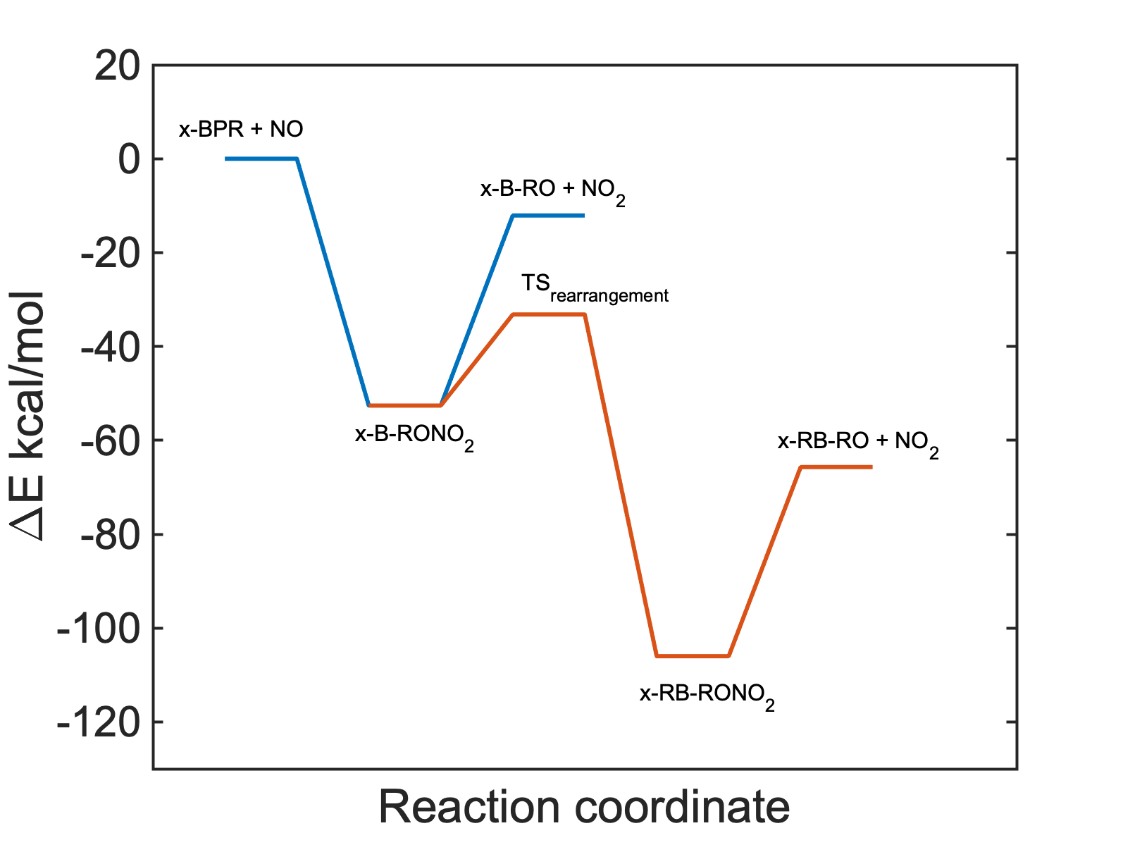
Fig. S16 – General reaction coordinate of BPR + NO reaction. Here, x = benzene and toluene derived ipso, ortho, meta and para. B = bicyclic, RB = ring broken.
Table S9 - Relative energies (in kcal/mol) and MESMER derived rate coefficients (in s⁻¹) corresponding to the stationary points in Fig. S11. Here, x = benzene and toluene derived ipso, ortho, meta and para. B = bicyclic, RB = ring broken.
 | Benzene | Toluene
 |  | Ipso | Ortho | Meta | Para
x-BPR + NO | 0.0 | 0.0 | 0.0 | 0.0 | 0.0
x-B-RONO₂ | -52.6 | -52.6 | -52.5 | -49.8 | -52.6
x-B-RO + NO₂ | -11.5 | -12.1 | -11.4 | -11.4 | -11.6
TS_{rearrangement} | -30.4 | -33.2 | -27.0 | -28.6 | -30.7
x-RB-RONO₂ | -101.4 | -106.0 | -103.7 | -95.8 | -95.1
x-RB-RO + NO₂ | -59.1 | -65.7 | -61.8 | -55.5 | -52.9
k_{x-B-RONO2 => x-B-RO + NO2} | 9.3×10⁻¹² | 1.6×10⁻¹¹ | 1.3×10⁻¹³ | 1×10⁻⁹ | 7.6×10⁻¹²
k_{x-B-RONO2 => x-RB-RO + NO2} | 4.9×10⁻⁴ | 0.1 | 3.6×10⁻⁸ | 6×10⁻⁴ | 1×10⁻⁴

8 Branching between autoxidation and the formation of closed-shell species

The alkyl radical R₁ in Fig. 2 can either lead to the closed-shell species C₇H₈O₅ or continue the autoxidation chain by forming R_{1b}-RO₂ as illustrated in Fig. S17. The branching fraction of the latter is key to establishing the importance of this channel in the formation of the peroxy radical C₇H₉O₉. Computations indicated that the H-abstraction by O₂ to form C₇H₈O₅ is not direct but follows the initial addition of O₂ to the C(OH) carbon. The yield of R1b-RO₂ is therefore sensitive to the O₂ addition transition states TS_{i} and TS_{j} forming R1a-RO₂ and R1b-RO₂, respectively. These transition states were calculated to be -0.7 kcal/mol and 1.9 kcal/mol, respectively, above R₁ at F12 level of theory. The formation of R₁ is significantly exothermic, and excess energy likely plays an important role in the branching fraction of R1a-RO₂ and R1b-RO₂. Therefore, the potential energy surface shown in Fig. S12 was used as input in a MESMER simulation to account for the excess energy of R₁. This resulted in a 20% yield for R_{1b}-RO₂.
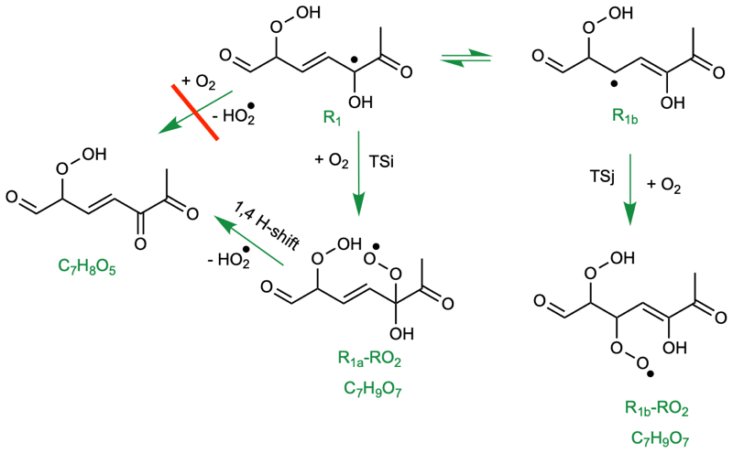
Fig. S17 - Subsequent reactions of the alkyl radical R1. Intrinsic reaction coordinate calculations show that R1 does not directly react with O₂ to form C₇H₈O₅, but first adds O₂ to form R1a-RO₂ instead. Alternatively, the O₂ can add to a different carbon to form R1b-RO₂. The latter is key for the formation of the highly oxygenated O9-RO₂, C₇H₉O₉.
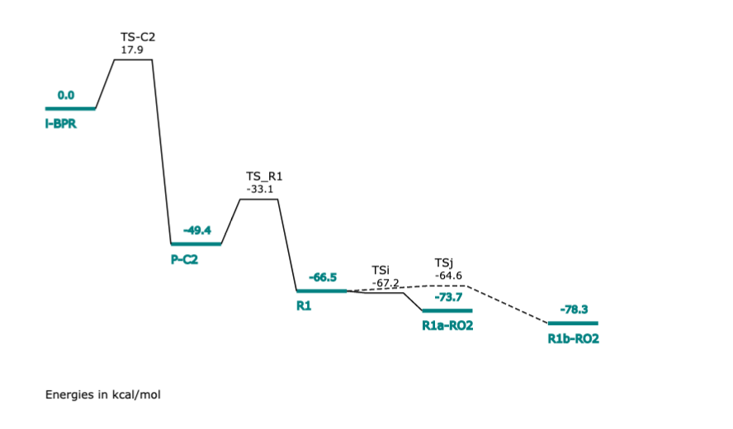
Fig. S18 - The potential energy surface used in the MESMER simulation to calculate the branching ratios of R1a-RO₂ and R1b-RO2.

9 Flow tube simulations

The chemical system in the simulations is described by the Chemical Mechanism, MCM v3.3.1(11-13) including the precursors toluene and TME. The ipso BPR pathway described in this work is embedded into the existing equations. To quantify potential loss of chemical species at the tube walls, a wall loss function was added. It considers the diffusional losses of chemical species in a fully developed laminar flow field(14). To allow accounting for local sources/sinks of the species, the analytical solution is represented by its Taylor expansion(15). The range of deposition is considered to lie between zero deposition and a cross section averaged deposition to the walls with a sticking coefficient of 1. The mean deposition is represented by a 50% reduced loss with regard to the formulations suggested by Ingham(14) as the reactive species are added at the center line of the flow tube to limit influence of the tube walls. As noted in the manuscript, the computed yields of R₁, R₂ and R₃ in Fig. 2 likely have high uncertainties. Therefore, these were varied in the model and checked for closure with the measured mass spectrum. Of the 79% yield of P-C2, the branching of R₁, R₂ and R₃ that reproduced the measurements the best was 92:3:5, respectively. As discussed in the previous section, computations indicate that the branching of R₁ towards the closed-shell species C₇H₈O₅ is favored. In the model, 85% yield of C₇H₈O₅ and a 15% yield R_{1b}-RO₂ was used. Finally, in the simulations, the RO₂ + RO₂ reaction rate coefficients need to be ~1×10⁻¹¹ cm³ molec⁻¹ s⁻¹ or less in order for the model to not overestimate the closed shell products in the flow tube setup. The likely reason for this is the less reactive TME RO₂s.
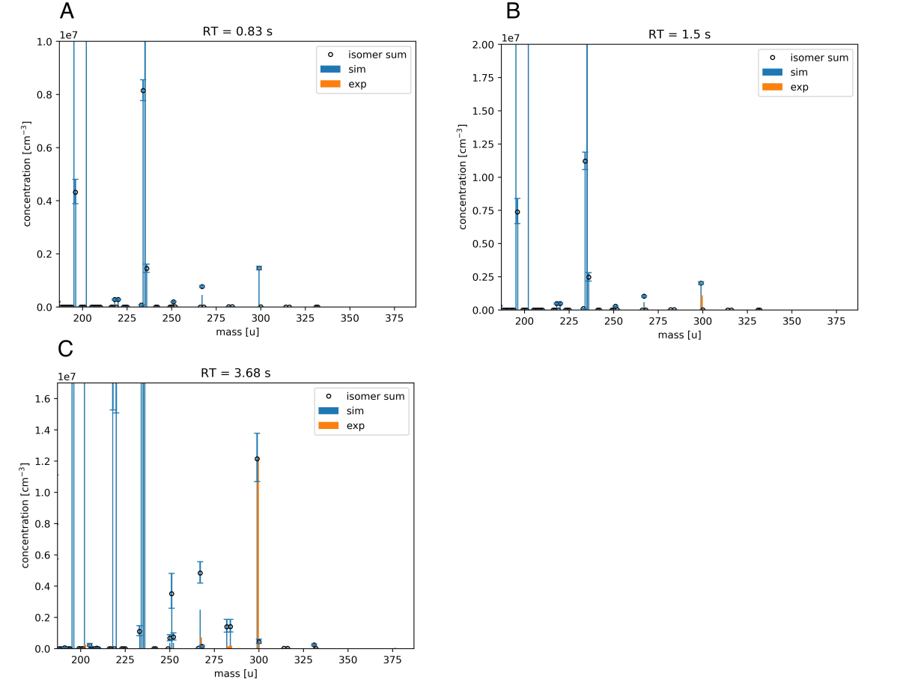
Fig. S19 - Comparison of experimental findings and simulated results. A) Reaction time in flow tube (RT) = 0.83 s, B) RT = 1.5 s and C) RT = 3.68 s. Mass in atomic mass is plotted on the x-axis and y-axis denotes the concentration of the chemical species. While isomers are summed up in the experimental data (yellow bars), the simulation results resolve several isomers (blue bars). The sum of simulated isomers (“isomer sum”) are depicted by black circles. Potential impact by wall losses is illustrated by error bars. The less oxygenated products at smaller atomic masses are not detected in experiments due to the low of sensitivity of the NO₃-CIMS method for these molecules.

Table S10 – Model inputs.
Simulation time [s] | 0.83 | 1.5 | 3.83
C₀(TME) [cm⁻³] | 9.25×10¹¹ | 9.25×10¹¹ | 1.12×1012
C₀(Toluene) [cm⁻³] | 8.8×10¹² | 8.8d×10¹² | 1.07×10¹³
C₀(O₃) [cm⁻³] | 4.79×10¹² | 4.79×10¹² | 5.79×10¹²
T [K] | 298 | 298 | 298
RH [%] | 0.1 | 0.1 | 0.1
Tube diameter [cm] | 4.7 | 4.7 | 4.7
Δt – simulation [s] | 1.0×10⁻³ | 1.0×10⁻³ | 1.0×10⁻³

10 References

- R. Wu, S. Pan, Y. Li, L. Wang, Atmospheric oxidation mechanism of toluene. The Journal of Physical Chemistry A 118, 4533–4547 (2014). Vertiotie.4P
- L. Xu, K. H. Møller, J. D. Crounse, H. G. Kjaergaard, P. O. Wennberg, New insights into the radical chemistry and product distribution in the OH-initiated oxidation of benzene. Environmental Science & Technology 54, 13467–13477 (2020).
- U. Molteni, F. Bianchi, F. Klein, I. El Haddad, C. Frege, M. J. Rossi, J. Dommen, U. Baltensperger, Formation of highly oxygenated organic molecules from aromatic compounds. Atmospheric Chemistry and Physics 18, 1909–1921 (2018).
- O. Garmash, M. P. Rissanen, I. Pullinen, S. Schmitt, O. Kausiala, R. Tillmann, D. Zhao, C. Percival, T. J. Bannan, M. Priestley, Å. Hallquist, E. Kleist, A. Kiendler-Scharr, M. Hallquist, T. Berndt, G. McFiggans, J. Wildt, T. Mentel, M. Ehn, Multi-generation OH oxidation as a source for highly oxygenated organic molecules from aromatics. Atmospheric Chemistry and Physics 20, 515–537 (2020).
- Z. Dong, R. Tang, H. Liu, Q. Zhang, W. Zong, J. Cheng, X. Shi, The formation mechanism of highly oxygenated organic molecules produced by toluene in the urban atmosphere. Atmospheric Environment 295, 119555 (2023).
- X. Cheng, Q. Chen, Y. Jie Li, Y. Zheng, K. Liao, G. Huang, Highly oxygenated organic molecules produced by the oxidation of benzene and toluene in a wide range of OH exposure and NO x conditions. Atmospheric Chemistry and Physics 21, 12005–12019 (2021).
- S. Wang, R. Wu, T. Berndt, M. Ehn, L. Wang, Formation of highly oxidized radicals and multifunctional products from the atmospheric oxidation of alkylbenzenes. Environmental science & technology 51, 8442–8449 (2017).
- M. Wang, D. Chen, M. Xiao, Q. Ye, D. Stolzenburg, V. Hofbauer, P. Ye, A. L. Vogel,
R. L. I. Mauldin, A. Amorim, A. Baccarini, B. Baumgartner, S. Brilke, L. Dada, A. Dias, J. Duplissy, H. Finkenzeller, O. Garmash, X.-C. He, C. R. Hoyle, C. Kim, A. Kvashnin, K. Lehtipalo, L. Fischer, U. Molteni, T. Petäjä, V. Pospisilova, L. L. J. Quéléver, M. Rissanen, M. Simon, C. Tauber, A. Tomé, A. C. Wagner, L. Weitz, R. Volkamer, P. M. Winkler, J. Kirkby, D. R. Worsnop, M. Kulmala, U. Baltensperger, J. Dommen, I. El-Haddad, N. M. Donahue, Photo-oxidation of aromatic hydrocarbons produces low-volatility organic compounds. Environmental science & technology 54, 7911–7921 (2020).
- J. Liu, Z. Liu, Z. Ma, S. Yang, D. Yao, S. Zhao, B. Hu, G. Tang, J. Sun, M. Cheng, Z. Xu, Y. Wang, Detailed budget analysis of HONO in Beijing, China: Implication on atmosphere oxidation capacity in polluted megacity. Atmospheric Environment 244, 117957 (2021).
- R. M. Harrison, M. Dall’Osto, D. C. S. Beddows, A. J. Thorpe, W. J. Bloss, J. D. Allan, H. Coe, J. R. Dorsey, M. Gallagher, C. Martin, J. Whitehead, P. I. Williams, R. L. Jones, J. M. Langridge, A. K. Benton, S. M. Ball, B. Langford, C. N. Hewitt, B. Davison, D. Martin, F. Petersson, S. J. Henshaw, I. R. White, D. E. Shallcross, J. F. Barlow, T. Dunbar,F. Davies, E. Nemitz, G. J. Phillips, C. Helfter, C. F. Di Marco, S. Smith, Atmospheric chemistry and physics in the atmosphere of a developed megacity (London): an overview of the REPARTEE experiment and its conclusions. Atmospheric Chemistry and Physics 12, 3065–3114 (2012).
- M. E. Jenkin, S. M. Saunders, M. J. Pilling, The tropospheric degradation of volatile organic compounds: a protocol for mechanism development. Atmospheric Environment 31, 81-104 (1997).
- S. M. Saunders, M. E. Jenkin, R. G. Derwent, M. J. Pilling, Protocol for the development of the Master Chemical Mechanism, MCM v3 (Part A): tropospheric degradation of non-aromatic volatile organic compounds. Atmospheric Chemistry and Physics 3, 161-180 (2003).
- M. E. Jenkin, K. P. Wyche, C. J. Evans, T. Carr, P. S. Monks, M. R. Alfarra, M. H. Barley, G. B. McFiggans, J. C. Young, A. R. Rickard, Development and chamber evaluation of the MCM v3. 2 degradation scheme for β-caryophyllene. Atmospheric Chemistry and Physics 12, 5275-5308 (2012).
- D. B. Ingham, Diffusion of aerosols from a stream flowing through a cylindrical tube. Journal of Aerosol Science 6, 125-132 (1975).
- Pichelstorfer, L. and Hofmann, W., Simulation of cigarette smoke dynamics in denuder tubes considering particle phase chemistry. Aerosol Science and Technology 51, 1419-1428 (2017).

