Supplementary Information

Uncertainty Assessment of Future Climate Change Using Bias-Corrected High-Resolution Multi-Regional Climate Model Datasets over East Asia

Changyong Park¹, Seok-Woo Shin¹, Dong-Hyun Cha¹, Youngeun Choi², Seung-Ki Min³, Yeon-Hee Kim³, Eun-Chul Chang⁴, Myoung-Seok Suh⁴, Joong-Bae Ahn⁵, and Young-Hwa Byun⁶

¹ Department of Urban and Environmental Engineering, Ulsan National Institute of Science and Technology, Ulsan, Republic of Korea.
² Department of Geography, Konkuk University, Seoul, Republic of Korea.
³ Division of Environmental Science and Engineering, Pohang University of Science and Technology, Pohang, Republic of Korea.
⁴ Department of Atmospheric Science, Kongju National University, Kongju, Republic of Korea.
⁵ Department of Atmospheric Science, Pusan National University, Busan, Republic of Korea.
⁶ National Institute of Meteorological Sciences, Seogwipo, Republic of Korea.

March 2023

Submitted to Climate Dynamics

Corresponding author: Dong-Hyun Cha (dhcha@unist.ac.kr)
Figure captions
Fig. S1. Temporal changes of the S/N ratio of TAS and PR over East Asia.
Fig. S2. Gridded patterns of the S/N ratio of TAS and PR averaged for the future three decadal periods.

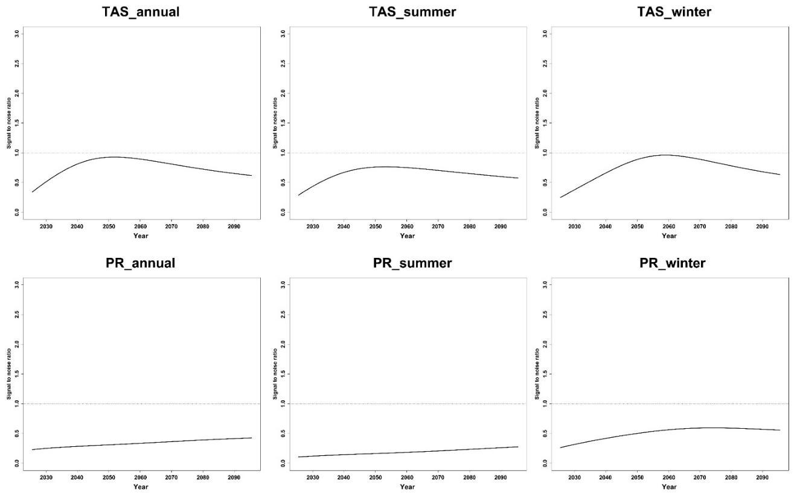
Fig. S1. Temporal changes of the S/N ratio of TAS and PR over East Asia.
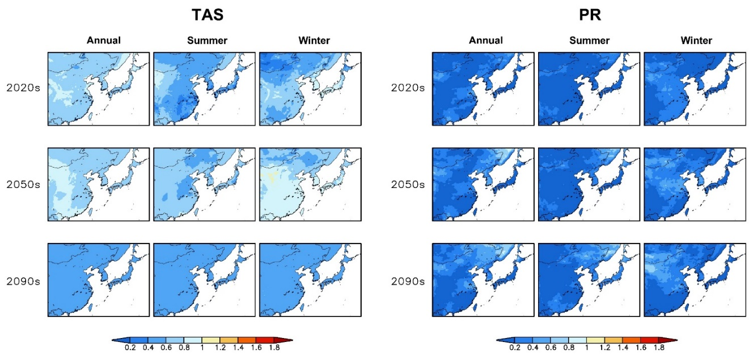
Fig. S2. Gridded patterns of the S/N ratio of TAS and PR averaged for the future three decadal periods.

