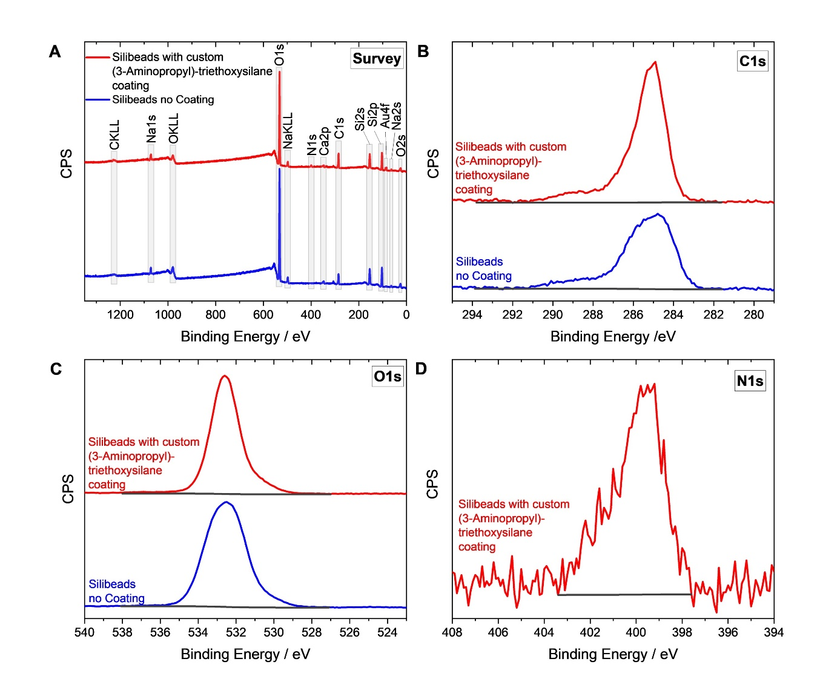
Figure S 1. XPS Survey (A) and HR-spectra in the C1s (B) and O1s region (C) for the Silibeads before (blue) and after (red) custom (3-Aminopropyl)-triethoxysilane coating. The XPS-HR spectrum in the N1s peak region is shown for Silibeads with modification (D).

Tested Dry | Tested after Conditioning
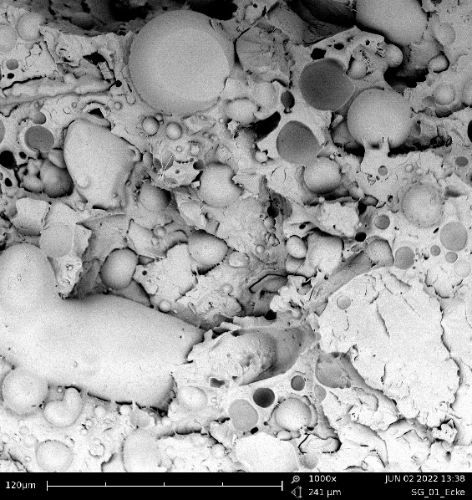 | 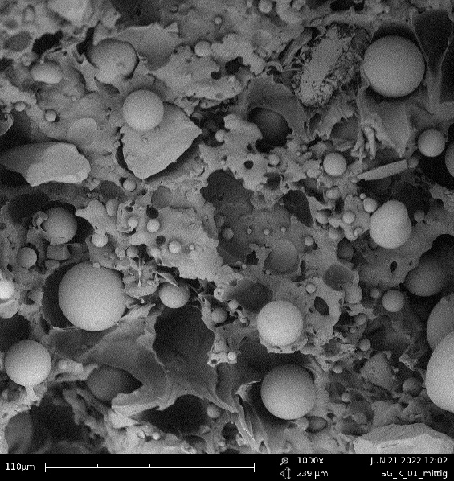
Figure S 2. SEM Images of fracture surface of injection molded tensile specimens (PA613 + 20 vol% Spheriglass with manufacturer recommended silane coupling agent)

