Appendices
Appendix 1 Search strategy in different literature source
No | Data source | Key elements
 | Pubmed | ADHD OR (Hyperkinetic Syndrome) OR (Syndromes, Hyperkinetic) OR ADDH OR (Disorder, Attention Deficit) OR (Disorders, Attention Deficit) OR (Defiant Disorder, Oppositional) OR (Disruptive Behavior Disorder) OR (Disorder, Disruptive Behavioral) OR (Disruptive Behavioral Disorders)  AND (Centedrin OR Concerta OR Methylin OR Ritalin* OR Daytrana OR methylphenidate)  AND (height OR stature OR (body length) OR anthropometry OR"Growth and Development/drug effects"[Mesh] OR "Growth and Development/growth and development"[Mesh])
 | Cochrane | MeSH descriptor: [Attention Deficit Disorder with Hyperactivity] explode all trees OR MeSH descriptor: [Attention Deficit and Disruptive Behavior Disorders] explode all trees OR (Disruptive Behavior Disorder) OR (Disruptive Behavioral Disorder) OR (Disruptive Behavioral Disorders) OR (Deficit Disorders with Hyperactivity) OR ADDH OR ADHD OR (Attention Deficit Disorders) OR (Disorder, Attention Deficit) OR (Syndromes, Hyperkinetic) OR (Hyperkinetic Syndrome)  AND (MeSH descriptor: [Methylphenidate] explode all trees OR Concerta OR Metadate OR Medikinet OR Methylfenidate OR Methylphenidate OR Penid OR Quasym OR Ritalin OR Rubifen)  AND (MeSH descriptor: [Body Height] explode all trees OR MeSH descriptor: [Anthropometry] explode all trees OR MeSH descriptor: [Growth and Development] explode all trees OR stature OR heights OR height OR (body length))
 | Embase | ('attention deficit disorder'/exp OR 'adhd' OR 'attention deficit' OR 'attention deficit and disruptive behavior disorders' OR 'attention deficit and disruptive behaviour disorders' OR 'attention deficit disorder' OR 'attention deficit disorder with hyperactivity' OR 'attention deficit hyperactivity disorder' OR 'hyperkinesia'/exp OR 'dyskinesia, hyperkinetic' OR 'hypercinetic syndrome' OR 'hyperkinesia' OR 'hyperkinesis' OR 'hyperkinetic dyskinesia' OR 'hyperkinetic syndrome')  AND (('methylphenidate'/exp OR 'adhansia' OR 'adhansia xr' OR 'alpha phenyl 2 piperidineacetic acid methyl ester' OR 'alpha phenyl alpha (2 piperidyl) acetic acid methyl ester' OR 'aptensio' OR 'aptensio xr' OR 'attenta' OR 'c 4311-b' OR 'c4311-b' OR 'c4311b' OR 'centedrin' OR 'concerta' OR 'concerta lp' OR 'concerta xl' OR 'cotempla' OR 'cotempla xr odt' OR 'd erythro methyl phenidylacetate' OR 'daytrana' OR 'difumenil' OR 'dl erythro methyl phenidylacetate' OR 'dl threo methylphenidate' OR 'equasym' OR 'equasym depot' OR 'equasym retard' OR 'equasym xl' OR 'equasym xr' OR 'jornay' OR 'jornay pm' OR 'medanef' OR 'medicebran' OR 'medikinet' OR 'medikinet cr' OR 'medikinet em' OR 'medikinet mr' OR 'medikinet retard' OR 'medikinet xl' OR 'mefinad' OR 'metadate' OR 'metadate cd' OR 'metadate cr' OR 'metadate e.r.' OR 'metadate er' OR 'methyl 2 phenyl 2 piperid 2 ylacetate' OR 'methyl phenidate' OR 'methylfenidaat' OR 'methylfenidate' OR 'methylin' OR 'methylin er' OR 'methylphenidate' OR 'methylphenidate hydrochloride' OR 'methylphenidylacetate' OR 'methylphenindate' OR 'methylphenydate' OR 'methypatch' OR 'penid' OR 'phenidyl hydrochloride' OR 'phenidylate' OR 'quasym' OR 'quasym lp' OR 'quillichew' OR 'quillichew er' OR 'quillivant' OR 'quillivant xr' OR 'rilatine' OR 'rilatine mr' OR 'ritalin' OR 'ritalin hydrochloride' OR 'ritalin la' OR 'ritalin sr' OR 'ritalin uno' OR 'ritalin-sr' OR 'ritalina' OR 'ritaline' OR 'ritaline lp' OR 'ritaphen' OR 'rubifen' OR 'sr 20' OR 'tranquilyn'))  AND (('body height'/exp OR 'body height' OR 'body length' OR 'height, body' OR 'length, body' OR 'stature' OR 'height'/exp OR 'height' OR 'anthropometry'/exp OR 'anthropometric index' OR 'anthropometrics' OR 'anthropometry' OR 'antropometry' OR 'body measurement' OR 'growth inhibition'/exp OR 'growth depression' OR 'growth inhibiting' OR 'growth inhibition' OR 'growth repression' OR 'growth suppression' OR 'inhibiting, growth' OR 'inhibition, growth'))
 | Web of Science® | TS=(Hyperkinetic Syndrome) OR TS=(ADHD) OR TS=(ADDH) OR TS=(Disruptive Behavior Disorder) OR TS=(Attention Deficit Disorders) OR TS=(Oppositional Defiant Disorder) OR TS=(hyperkinesia)  AND (TS=(Methylphenidate) OR TS=(Attenta) OR TS=(Concerta) OR TS=(Equasym) OR TS=(Daytrana) OR TS=(Metadate) OR TS=(Medikinet) OR TS=(Methylin) OR TS=(Penid) OR TS=(Ritalin))  AND (TS=(Height) OR TS=(body length) OR TS=(anthropometry) OR TS=(stature) OR TS=(growth inhibition) OR TS=(anthropometric))

Appendix 2 Forest plot of mean height Z score value (absolute HZS) compared between
- MPH use vs. Healthy subjects and non-MPH use ADHD patients (N=9)
- MPH use vs. Healthy subjects and non-MPH use ADHD patients (N=4)

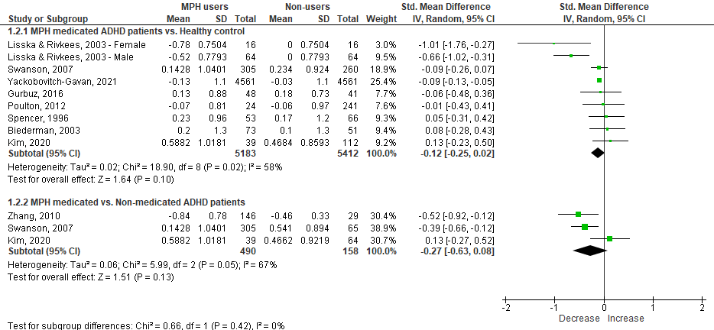
(a)

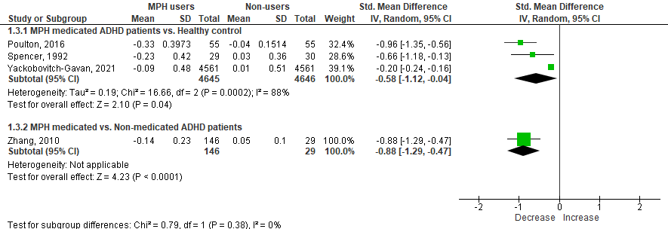
(b)

ADHD: Attention-deficit hyperactivity disorder; 95% CI: 95 percent confident interval; MPH: methylphenidate; SD: standard deviation; Std.: standard

Appendix 3 Funnel plot of overall meta-analysis for mean height Z-score change to baseline between pre- and post-MPH treatment groups

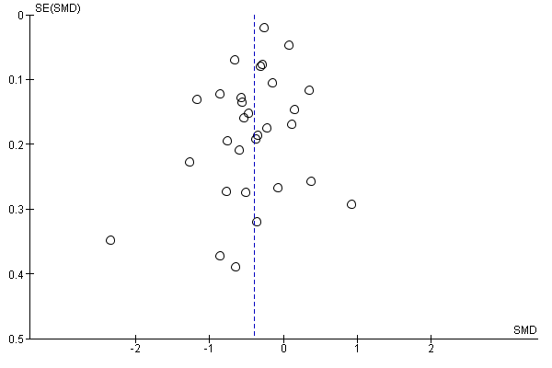

SE: standard error; SMD.: standardized mean difference
Appendix 4 Sensitivity analysis

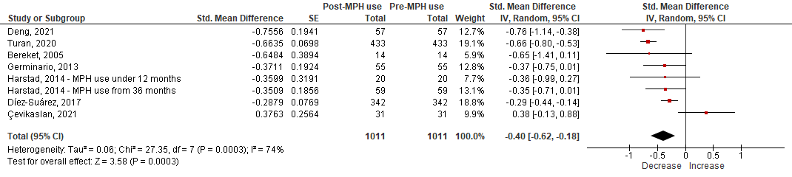

ADHD: Attention-deficit hyperactivity disorder; 95% CI: 95 percent confident interval; MPH: methylphenidate; SE: standard error; Std.: standard

Appendix 5 Subgroup analysis
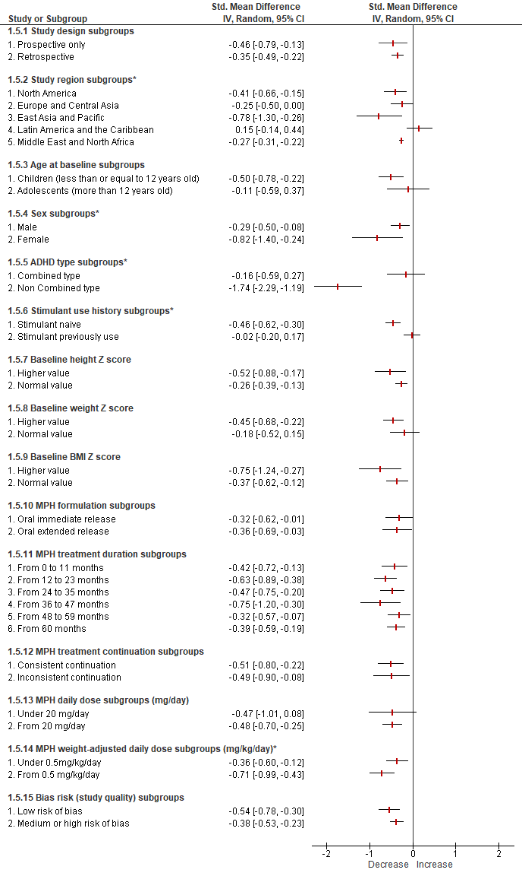
ADHD: Attention-deficit hyperactivity disorder; 95% CI: 95 percent confident interval; MPH: methylphenidate; Std.: standard. Higher NOS scores for cohort studies (> 7/9) and cross-sectional studies (> 6/8) indicated lower risks of bias

Appendix 6 Other related outcomes reported

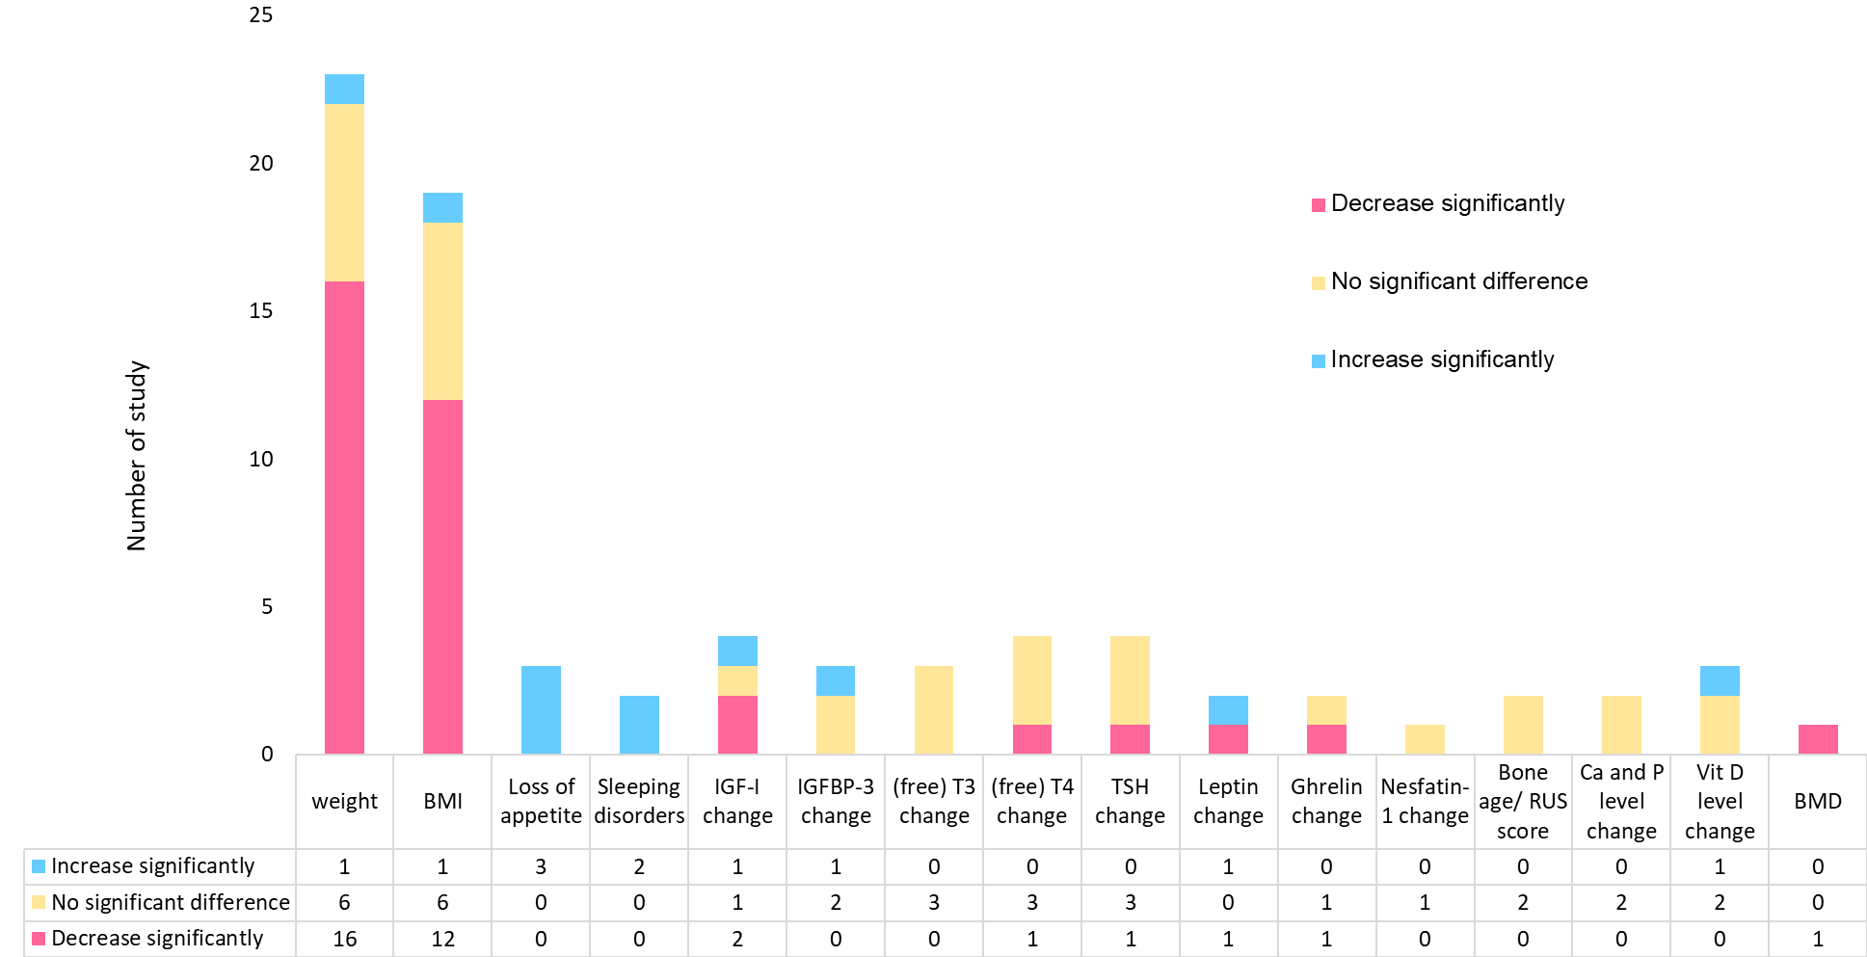

* Including: height velocity, height difference with expectation/deficit, parent-corrected height z-score, height percentile, height percent deficit, change in cumulative frequency percentiles, and percent change of height, predicted height. BMD: bone mineral density; BMI: body mass index; RUS: score which assesses the maturity of the radius, ulna, and short bones; Vit D: vitamin D

