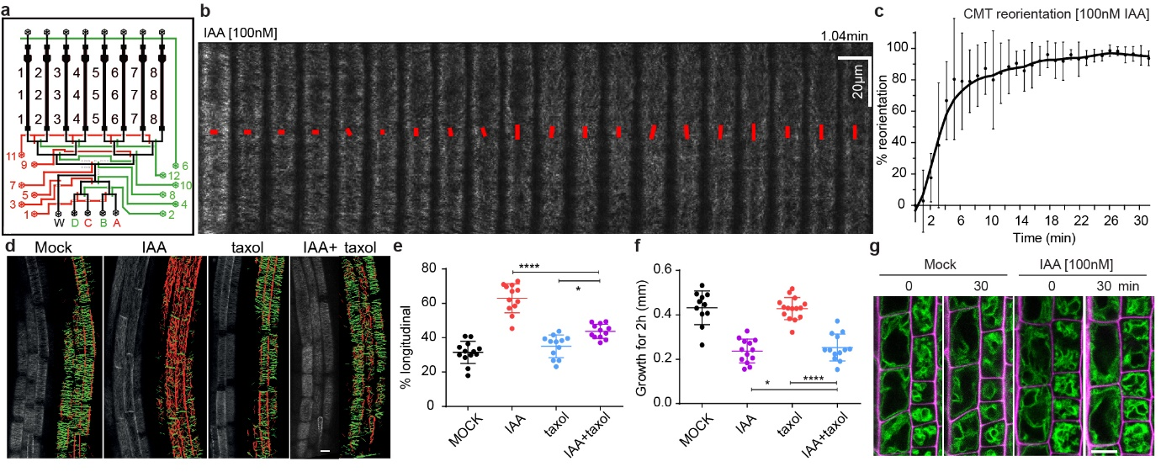
Extended Data Figure 1. Investigation of CMT and vacuolar morphology in auxin-induced rapid root growth inhibition.
a, Scheme of the modified vRootchip adding valve 6 and with adjusted valve routes.
b-c, Dynamic cortical microtubule (CMT) transversal to longitudinal reorientation in response to 100nM IAA treatment. CMT were imaged at 6.25s intervals in elongating root epidermal cells in the pEB1b::EB1b-GFP marker line in vRootchip. Max Z-projection of 10 subsequent time frames was analysed using the FibrilTool. Average orientation of CMT is represented by the slope of the red line and the length of the line represents its anisotropy (b). (c) Quantification of CMT reorientation as in b. CMT reorientation at every time point is calculated as the difference in angle of that time point minus the initial time point angle divided by the difference in the angles of the initial time point and end time point (42min). Mean of 5 elongating cells±SD (c).
d-f, Analysis of CMT reorientation in elongating root epidermal cells (d, e) and root growth (f) of 35S::MAP4-GFP in response to 10nM IAA, 10µM taxol and IAA+taxol co-treatment. CMT orientation was analysed with the Bioline script. Green-colored CMTs mark transversal oriented CMT (angle between -45° and +45°), while red-colored CMTs indicate longitudinal orientation (angle between +45° and 135°). Scale bar=15µm (d). Percentage of longitudinal CMT. n>11 roots, One-way ANOVA (e). Growth on respective treatments after 2h. n>10 roots. Box plots depicts minimum to maximum, mean±SD. One-way ANOVA without modifications for multiple comparison (f). *p≤0.05, ****p≤0.0001.
g, Vacuolar morphology tracked using pSYP22::SYP22-YFP (green signal) in elongating cells before and after 30min of 100nM IAA. Scale bar=15µm. Magenta signal represents propidium-iodide stained cell walls.
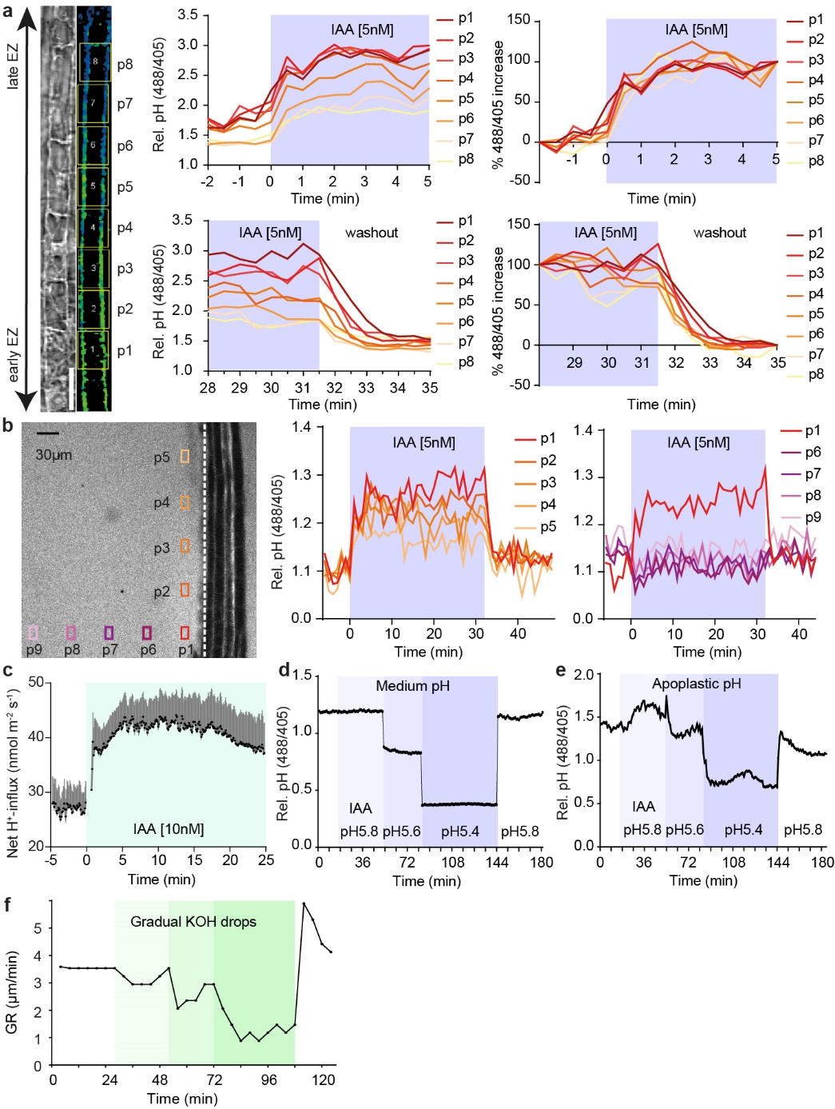
Extended Data Figure 2. Apoplastic pH in auxin-induced rapid root growth inhibition.
a, Apoplastic pH dynamics measured across the whole EZ (p1-p8) in vRootchip. The TL and blue-yellow scale image are from the same sample shown in Fig. 1a. Scale bar=30µm. The upper charts depict apoplastic pH in the indicated cells in response to 5nM IAA, and the lower charts represent the pH in response to washout. The right two charts show the speed at which each cell reaches its maximum pH change calculated as the difference between pH at a given time point and pre-stimulus pH, divided by the final pH change.
b, Dynamics of root surface pH and medium pH in vRootchip. The left graph shows the elongation zone of the root. ROIs p1-p5 were chosen vertically along the root, 30µm away from the root surface indicated by the vertical white dotted line, while ROIs p6-p9 were distanced horizontally away from the root. The pH at the surface of the root (p1-p5) increased after IAA and recovered within 30s after washout. In contrast, the pH away from the root surface did not change significantly (p6-p9).
c, H⁺-net influx measured by a non-invasive microelectrode before and after 10nM IAA treatment in the elongating zone of WT roots. Mean of 9 roots+SEM.
d-e, Changes in medium pH (d) and apoplastic pH (e) after different medium pH exchanges in vRootchip. Sequentially used media: basal medium at pH 5.8, auxin-containing medium at pH 5.8, more acidic medium of pH 5.6, followed by pH 5.4 and again basal medium at pH 5.8.
f, Quantification of root growth in response to gradual addition of KOH in the medium in the vRootchip. The greener the shade, the more KOH was added and followed by washout with initial pH 5.8 medium.

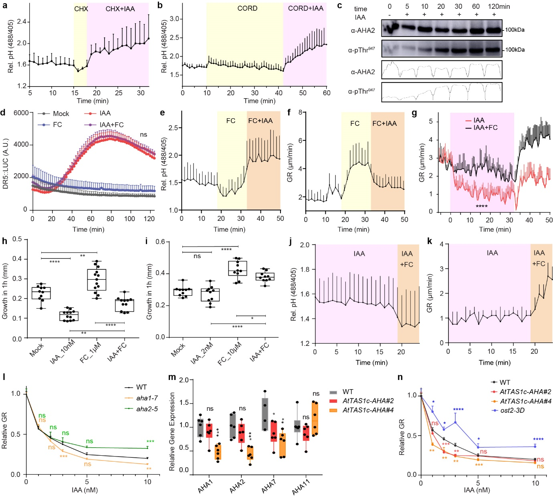
Extended Data Figure 3. H⁺-ATPase activation counteracts auxin-mediated apoplast alkalinisation and growth inhibition
a-b, Apoplastic pH of WT elongating root cells pre-treated (yellow) with 1µM cycloheximide (CHX) for 3min (a), or 50µM cordycepin (CORD) for 32min (b) followed by addition of 5nM IAA (pink). Mean of 3 (a) or 4 (b) roots+SD.
c, 10nM IAA induced Thr⁹⁴⁷ phosphorylation in roots using AHA2 and pThr947 specific antibodies. Band intensities of the different lanes were quantified by the Gel Analysis function in ImageJ.
d, Measurement of DR5::LUC luminescence intensity in the root tip after 10µM FC, 10nM IAA and IAA+FC co-treatment. n>3 roots. IAA and IAA+FC are significantly different from the mock (p ≤0.0001). No significant difference between IAA and IAA+FC (ns, p>0.05). Two-way ANOVA.
e-k, FC and IAA counteract each other. In vRootchip, addition of IAA still increased apoplastic pH (e) and inhibited root growth (f) in presence of FC, while addition of FC decreased apoplastic pH (j) and promoted root growth (k) in presence of IAA. Upon simultaneous addition of 10µM FC and 10nM IAA, both apoplastic pH (Fig 2d) and root growth (g) were less affected than by IAA alone. Shaded area represents the duration of the treatments. Mean of 4 roots+SD. ****p≤0.0001 between IAA and IAA+FC from 0–31min (g), Two-way ANOVA. (h-i) Steady-state 1h root growth after FC, IAA and co-treatment was obtained by scanner. 1µM FC and 10nM IAA were used in (h) while 10µM FC and 2nM IAA were used in (i). n>9 roots. Box plot depicts minimum to maximum, mean±SD. ns p>0.05, *p≤0.05, **p≤0.01, ****p≤0.0001, One-way ANOVA (h, i).
l, Dose-response of auxin-induced root growth inhibition of aha single mutants. n>22 roots. Relative GR is ratio between auxin-affected growth and mock for the same genotype. ns p>0.05, **p≤0.01, ***p≤0.001, Welch ANOVA.
m, Quantitative Real-time PCR on the AHA1,2,7,11 expression in root tips of AtTAS1c-AHA#2 and #4. The expression level was normalized to EF1α as housekeeping gene. Mean of 6 biological replicates in 3 technical replicates+SD. Box plot depicts minimum to maximum, mean±SD. ns p>0.05, *p≤0.05, **p≤0.01, ***p≤0.001, One-way ANOVA.
n, Dose-response of auxin-induced root growth inhibition of AtTAS1c-AHA lines and ost2-3D mutants reveals hypersensitivity and resistance respectively to IAA in comparison to WT (n>15 roots). Relative GR is calculated as mentioned in (l). ns p>0.05, *p≤0.05, **p≤0.01, ***p≤0.001, ****p≤0.0001, Welch ANOVA.

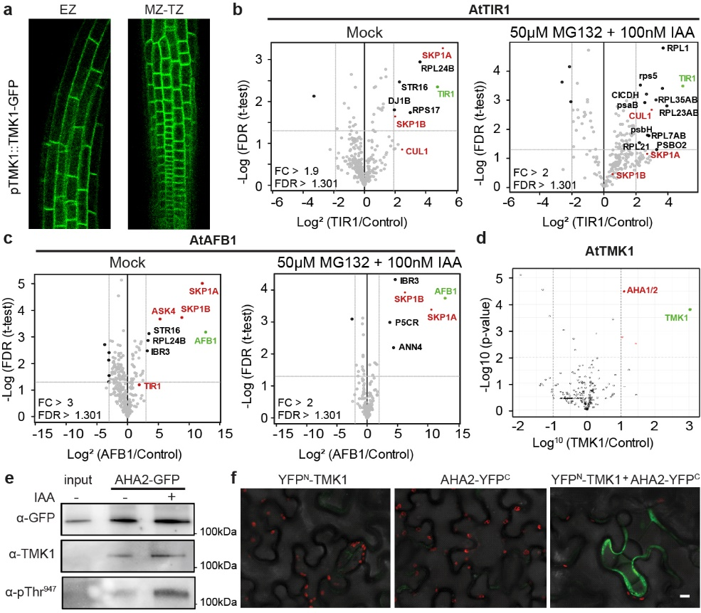
Extended Data Figure 4. TMK1 interacts with PM H⁺-ATPase.
a, TMK1 expression pattern in the elongation zone (EZ), meristematic and transition zone (MZ-TZ) in the primary root shown by pTMK1::TMK1-GFP. Scale bar=60 μm.
b-c, IP-MS/MS on pTIR1::TIR1-VENUS in tir1-1 (b) and pAFB1::AFB1-VENUS in afb1-3 (c) under mock condition compared to 1h 50µM MG132 pre-treatment and 2min 100nM IAA treatment. Proteins surpassing the threshold FDR of 0.05 are marked. Green depicts the respective bait protein and red depicts known members of the SCF E3 ubiquitin ligase complex. Pulldowns were performed in triplicate, LFQ analysis.
d, IP-MS/MS on pTMK1::TMK1-GFP. Peptides corresponding to AHA1/2 are shown in red. p-values are calculated based on three biological replicates using two-sided t-tests.
e, Co-IP of pAHA2::AHA2-GFP roots, followed by Western blot detection of TMK1 and Thr⁹⁴⁷-phosphorylated AHA2 after 100nM IAA for 30min. Auxin did not affect interaction, but induced AHA2-phosphorylation. Input of pAHA2::AHA2-GFP roots was the control.
f, Bimolecular Fluorescent Complementation (BiFC) in Nicotiana benthamiana leaves transiently transformed with the reciprocal controls for Fig. 3b: YFP^{N}-TMK1, AHA2-YFP^{C} or both. Scale bar=10µm.

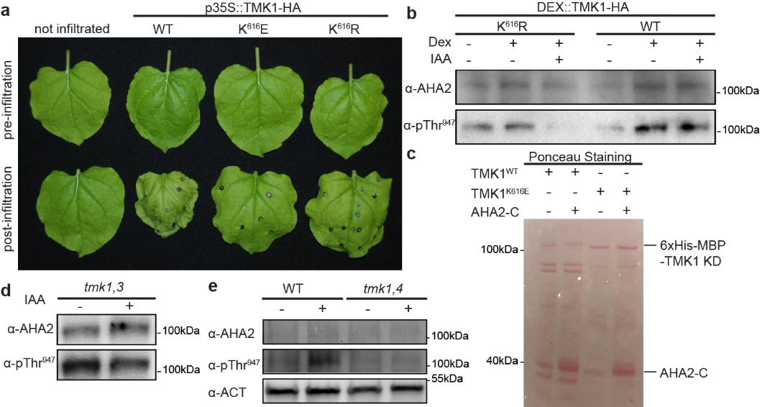
Extended Data Figure 5. TMK1 directly phosphorylates PM H⁺-ATPases.
a, Wilting N. benthamiana leaves that transiently express TMK1^{WT} and ATP-site mutated forms: p35S::TMK1^{K616E or K616R}-HA.
b, Western blot analysis of the AHA2 levels and the Thr⁹⁴⁷ phosphorylation in roots of DEX::TMK1^{WT or K616R}-HA treated +/- DEX (30µM for 24h) and +/- IAA (100nM for 1h).
c, Ponceau-stained SDS-PAGE gel as loading control for in vitro kinase assay with [γ-³²P]-ATP, substrate C-terminal AHA2 (AHA2-C) and the intracellular kinase domain of TMK1^{WT} or kinase dead TMK1^{K616E}.
d-e, Western blot detection of AHA2 levels and Thr⁹⁴⁷ phosphorylation in tmk1,3 roots (d) or tmk1,4 roots (e) treated with 100nM IAA for 1h. WT control for (d) is shown in Fig. 3e.

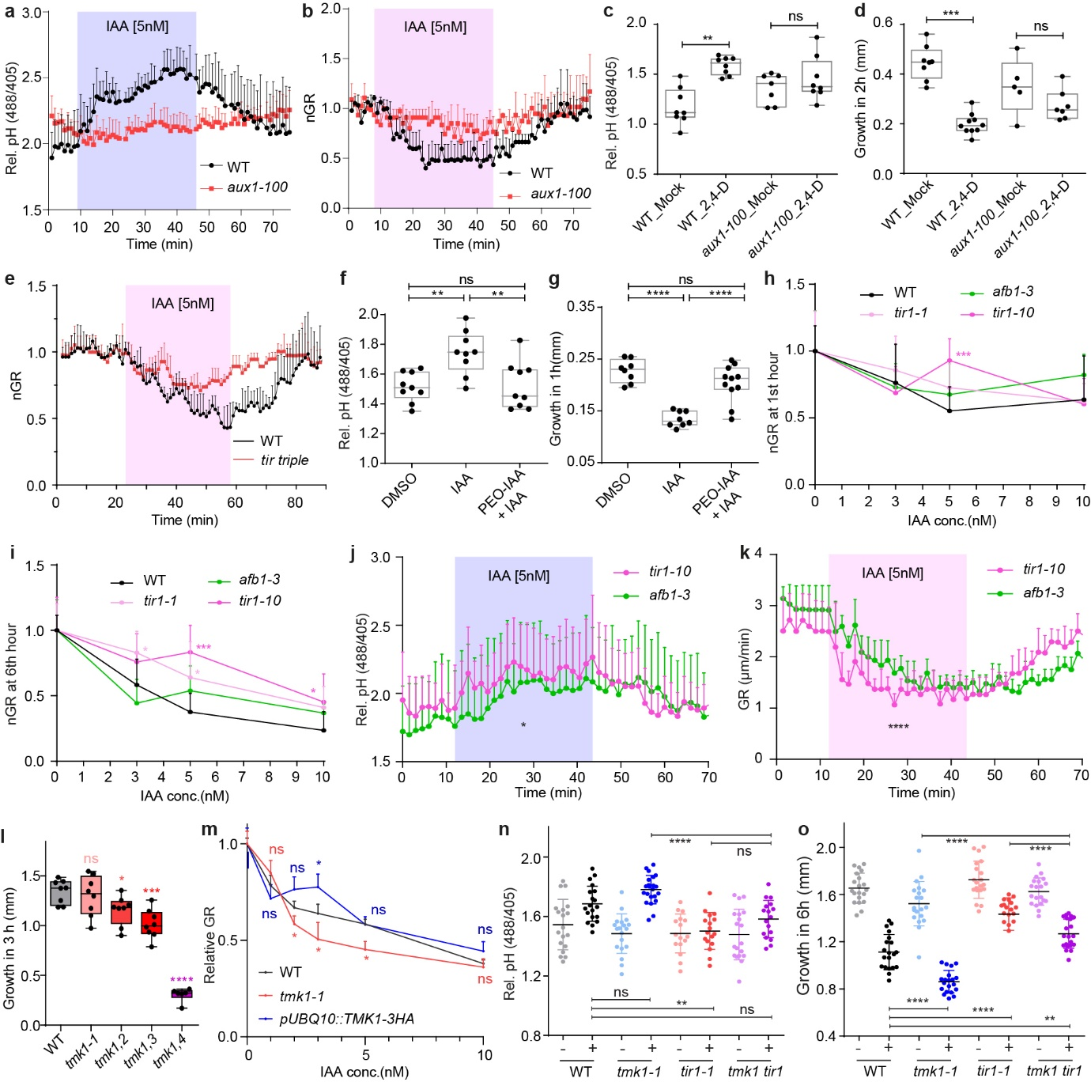Extended Data Figure 6. Cytosolic TIR1/AFB mediates rapid apoplast alkalinisation and root growth inhibition.
a-b, Apoplastic alkalinisation (a) and root growth inhibition (b) in response to IAA measured in aux1-100 mutant compared to WT roots in vRootchip. Mean of 3 roots+SD. ****p ≤ 0.0001, Two-way ANOVA.
c-d, Apoplastic alkalinisation (c) and root growth inhibition (d) in response to 2,4-D in aux1-100 mutant compared to WT roots. Steady state pH measured 30min after mock or 100nM 2,4-D treatment. Mean of >6 roots+SD, One-way ANOVA (c). (d) Growth obtained in 2h was captured by scanner. Mean of >4 roots+SD, One-way ANOVA. ns p>0.05, **p≤0.01, ***p≤0.001.
e, Root growth of tir triple mutants compared to WT in response to 5nM IAA in the vRootchip. Mean of 3, 2 roots+SD. ****p≤0.0001, two-way ANOVA.
f-g, Apoplastic pH (f) and root growth (g) after 10µM PEO-IAA and 5nM IAA. The steady state pH was measured 30min after treatments, while the root growth obtained in 1h was recorded by scanning the plates. Mean of >7 roots+SD. ns p>0.05, **p≤0.01, ****p≤0.0001, One-way ANOVA.
h-i, Dose-response of auxin-induced root growth inhibition of tir1-1, tir1-10 and afb1-3 mutants reveals slight resistance to 5nM IAA in comparison to WT (n>6 roots). Relative GR is calculated as the ratio of GR at 1h (h) or 6h (i) after IAA treatments relative to mock-treated GR of the same genotype. Mean+SD. *p≤0.05, ***p≤0.001, One-way ANOVA.
j-k, Apoplastic pH (j) and root growth (k) analysis comparing tir1-10 null mutant and afb1-3 mutants in response to IAA in vRootchip. Shaded area represents the duration of the treatment. Mean of 4 roots for each treatment+SD. p≤0.0001 (j) and p≤0.05 (k), Two-way ANOVA.
l, Steady-state root growth over 6h in tmk1-related mutants. n=6 roots for tmk1,4; n>26 for others. Mean+SD. Box plot depicts minimum to maximum, mean±SD. ****p≤0.0001, One-way ANOVA.
m, Dose-response of auxin-induced root growth inhibition of pUBQ10::TMK1-3HA compared to WT and tmk1-1. Relative GR is the ratio between auxin-affected growth to the mock growth in the same genotype. Mean of >7 roots+SD. ns p>0.05, *p≤0.05, Welch ANOVA.
n-o, Raw data for Figure 4d, e, respectively. n>16 roots. Box plot depicts minimum to maximum, mean±SD. ns p>0.05, **p≤0.01, ****p≤0.0001, One-way ANOVA.

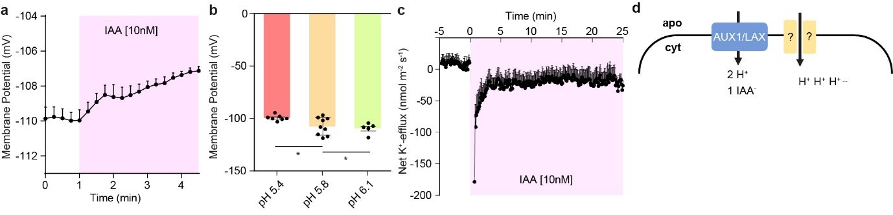Extended Data Figure 7. PM potential and AUX1 involvement in auxin-induced apoplast alkalinisation
Since auxin causes simultaneously membrane depolarizatio⁴⁴ and apoplast alkalinisation, both of which are interdependent and required for growth, we addressed which of them mediates the auxin effect on root inhibition. By manipulating the external pH, we found that pH and growth were correlated (Fig. 1d-g) while membrane potential (MP) was uncoupled (a, b). Additionally, we observed that K⁺-efflux (c) compensates auxin-induced H⁺- and Ca²⁺-influx (Extended Data Fig. 2c, Extended Data Fig. 8a), suggesting that auxin-induced MP change is the result of complex ion fluxes, while H⁺-influx and resulting apoplastic pH change for growth regulation is just a subset of those.

a-b, Membrane potential recorded by invasive micro-electrode in root elongating cells with IAA treatment (magenta). 4 roots+SEM (a). Membrane potential measured in root elongating cells after 40min incubation in different pH medium. n>5 roots±SEM. *p≤0.05, One-way ANOVA (b). Alkaline medium, which alkalinised the apoplast and inhibited root growth (Fig. 1d, e) mimicking the auxin effect, did not result in membrane depolarization. Acidic medium, which acidified the apoplast and promoted root growth (Fig. 1f, g) depolarized membrane. MP is thus uncoupled from growth and apoplastic pH.
c, PM net K⁺-efflux measured by a non-invasive microelectrode before and after 10nM IAA treatment in the elongating zone of WT roots. 16 roots+SEM.
d, Scheme showing AUX1/LAX-mediated IAA⁻/2H⁺ symport and mechanistically elusive H⁺ influx.
IAA⁻/2H⁺ symport by AUX1 auxin influx carrier was proposed⁴⁵ a possible mechanism of auxin-induced H⁺ influx and apoplast alkalinisation. Comparison of H⁺ influx rates in root hair cells⁴⁵, or elongating root epidermal cells (Extended Data Fig. 2c) and conservative estimates of AUX1-mediated ³H-IAA transport in Xenopus oocytes^{46,47} argue against this. Below we show that calculations based on data of Xenopus oocytes, primary root and root hairs suggest that AUX1-mediated H⁺ symport is not sufficient to account for the auxin-induced H⁺-fluxes:
(1) ³H-IAA transport in the AUX1 overexpressing Xenopus oocytes after 100nM ³H-IAA⁴⁶:
ca. 2.6x10⁻¹⁴molmin⁻¹
- Min. diameter of the Xenopus oocyte at stage V/VI⁴⁷ is ca. 1.0mm so the surface area is minimally 3.142x10⁻⁶m²
- Max. speed of IAA uptake across the membrane is calculated as:
2.6 x 10⁻¹⁴mol/(60s x 3.142x10⁻⁶m²) = 1.38x10⁻¹⁰molm⁻²s⁻¹
- Based on 2 H⁺ per IAA⁻, the max. speed of AUX1-symported H⁺ is 2.76x10⁻¹⁰ molm⁻²s⁻¹.
(2) H⁺ uptake after 10nM IAA (ten times less than in Xenopus) in Arabidopsis root elongating cells: 1.7x10⁻⁸molm⁻²s⁻¹ (Extended Data Figure 2c). This is still 62 times more than the conservatively estimated Max. speed in (1)
(3) H⁺ uptake NAA in Arabidopsis root hairs⁴⁵ is ca. 1.0x10⁻⁷molm⁻²s⁻¹. This is 362 times more than the conservatively estimated Max. speed in (1)

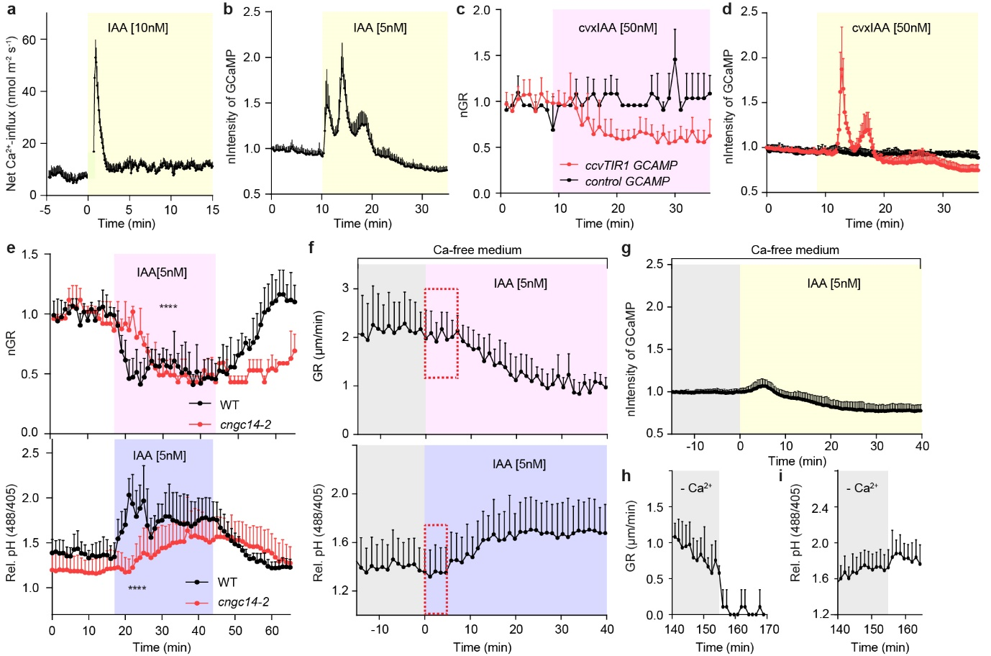Extended Data Figure 8. TIR1-mediated Ca²⁺-signalling contributes to auxin-induced apoplast alkalinisation
Another rapid output of TIR1/AFB perception mechanism are cytosolic Ca²⁺-transients in root hairs⁴⁵. Therefore, we evaluated Ca²⁺-transients in apoplast alkalinisation and root growth inhibition. Using vRootchip, GCaMP3 Ca²⁺-marker⁵, non-invasive microelectrodes and cvxIAA/ccvTIR1 system¹⁰, we confirmed that auxin via TIR1/AFB triggered rapid Ca²⁺-influx correlates with root growth inhibition (a-d). We noted a distinct Ca²⁺-response measured by the microelectrode (a-b) and GCaMP3 (c). Namely, Ca²⁺-channels are activated at the plasma membrane resulting in net influx, while the GCaMP3 reported more complex responses possibly involving intracellular Ca²⁺-storage and release. Moreover, the use of cvxIAA/ccvTIR1 (d) provided additional proof that TIR1-mediated auxin perception activates Ca²⁺-signalling. Further, we verified that mutants in the Ca²⁺-permeable cation channel Cyclic NUCLEOTIDE-GATED CHANNEL 14 (CNGC14) have delayed auxin-induced apoplast alkalinisation and root growth inhibition (e) as reported¹². Furthermore, depletion of external Ca²⁺ resulted in attenuated auxin-induced Ca²⁺-spike, delayed apoplast alkalinisation and growth inhibition (b, f, g). Ca²⁺-addition resulted in rapid growth inhibition (h, i). These observations collectively suggest that TIR1/AFB-mediated Ca²⁺-signalling is part of the mechanism for auxin-induced rapid apoplast alkalinisation and growth inhibition.

a, PM net Ca²⁺-influx measured by a non-invasive microelectrode before and after 10nM IAA treatment in the elongating zone of WT roots. 9 roots+SEM.
b, Normalised fluorescence intensity of GCaMP3, cytosolic Ca²⁺-marker, in elongating cells responding to 5nM IAA treatment in vRootchip. The intensity was normalized to the initial intensity of the same root. Mean of 7 roots+SD. Note the three peaks in cytosol compared to the single major peak outside of cells (a).
c-d, Root growth (c) and fluorescence intensity in elongating cells (d) in GCaMP3 crossed into ccvTIR1 compared to control. Growth rate and intensity are normalized to the pre-stimulus value. Mean of 7 for ccvTIR1 and 2 for control+SD. ****p≤0.0001, Two-way ANOVA.
e, Root growth (upper graph) and apoplastic pH (lower graph) analysis in cngc14-2 and WT in response to IAA in vRootchip. Mean of 5 roots for WT and 3 for cngc14-2+SD. ****p≤0.0001, Two-way ANOVA.
f-g, Root growth (upper graph in f) and apoplastic pH (lower graph in f) in WT, as well as cytosolic Ca²⁺ analysis in GCaMP3 reporter marker line in vRootchip (g) with 140min pre-treatment of Ca²⁺-free medium (grey) followed by 5nM IAA addition (magenta for growth, blue for pH in f and yellow for Ca²⁺ in g). Auxin induced significant less Ca²⁺-response in Ca-free medium, compared to normal medium in (b). The red dotted square marked the non-responsive delay after auxin. Mean of 5 (f) and 6 (g) roots+SD.
h-i, Root growth (h) and apoplastic pH (i) analysis in WT upon Ca²⁺ addition after 140min Ca²⁺-free medium in the presence of 5nM IAA in vRootchip. Mean of 5 roots+SD.

Extended Data Table 1. Phospho-proteomic data of rapid auxin effects in roots and phospho-proteomic analysis of H⁺-ATPases in tmk1-1 mutants
Differentially regulated phospho-peptides (FDR ≤0.05) in H⁺-ATPases in IAA treated versus mock-treated roots. IAA treatment was at 100 nM for 2 minutes. QHF and LTQXL analysis are given in Tab 1 and 2, respectively. Tab 3 shows the differentially phosphorylated phospho-sites of AHAs in tmk1-1 background compared to WT.

Extended Data Table 2. IP-MS analysis of pTIR1::TIR1-VENUS and pAFB1::AFB1-VENUS
Overview of the putative TIR1 and AFB1 interactors after MaxQuant and Perseus statistical analysis. Samples were TIR1- and AFB1-VENUS lines under mock, 50 µM MG132 pre-incubation for 1 hour and 100 nM IAA treatment for 2 minutes. Proteins passing the threshold of FDR 0.05 and specific fold change are included in the table. P-values are calculated based on the three replicates using a two-sided t-test. Pulldowns were performed in triplicate. Yellow highlight indicates the respective bait protein.

Extended Data Table 3. IP-MS analysis of pTMK1::TMK1-GFP.
Overview of the putative TMK1 interactors after MaxQuant and Perseus statistical analysis. The list is sorted based on the ratio of pTMK1::TMK1-GFP vs WT control. Proteins passing the threshold of FDR 0.05 and specific fold change are included in the table. P-values are calculated based on the three replicates using a two-sided t-test. Yellow highlight indicates bait, green indicates GFP and orange indicates selected proteins.

Extended Data Table 4. Primers used for cloning and qPCR analysis

