Appendix S1 species distribution models
1.1 The flowing table includes environmental variables and their explanations within our model.
Variables | Explanations | Data source
bio2 | Mean Diurnal Range | the WorldClim 2.1 database  (https://www.worldclim.org/)
bio3 | Isothermality ((bio2/bio7) × 100) | the WorldClim 2.1 database  (https://www.worldclim.org/)
bio10 | Mean temperature of warmest quarter | the WorldClim 2.1 database  (https://www.worldclim.org/)
bio13 | Precipitation of wettest month | the WorldClim 2.1 database  (https://www.worldclim.org/)
bio15 | Precipitation Seasonality (Coefficient of Variation) | the WorldClim 2.1 database  (https://www.worldclim.org/)
vegetation | / | 1:1 million vegetation map of China from the National Science & Technology Infrastructure (http://data.tpdc.ac.cn/zh-hans/)
elevation | / | ASTER GDEM 30M data from the Geospatial Data Cloud（https://www.gscloud.cn/)
slope | /
aspect | /
T_gravel | Topsoil gravel content | Soil map based Harmonized World Soil Database (v1.2) from the National Science & Technology Infrastructure (http://data.tpdc.ac.cn/zh-hans/)
T_sand | Topsoil sand fraction
T_silt | Topsoil silt fraction
T_clay | Topsoil clay fraction

1.2 The next picture is the data's receiver operating characteristic (ROC) curve. The AUC is 0.816
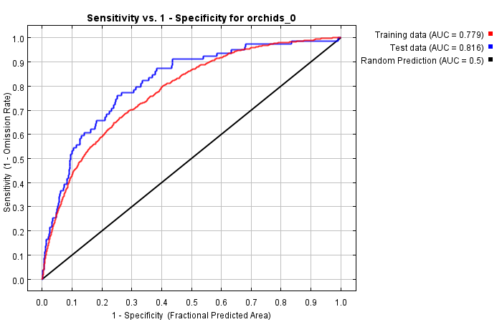

1.3 The following picture shows the results of the jackknife test of variable importance. The percent contribution of vegetation is 36.7%, the elevation is 31.8%, and the bio10 is 1.2% (not the third variable in percent contribution but is the third in the permutation importance, and combining with the jackknife of AUC or test gain, it can be regarded as an important factor).
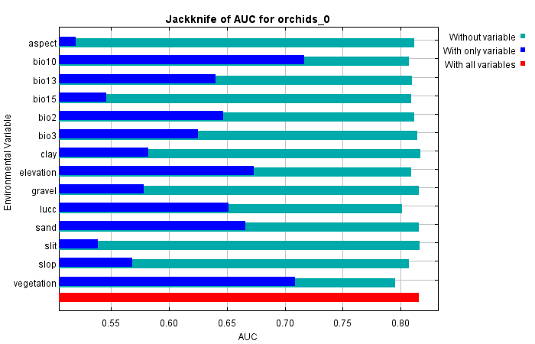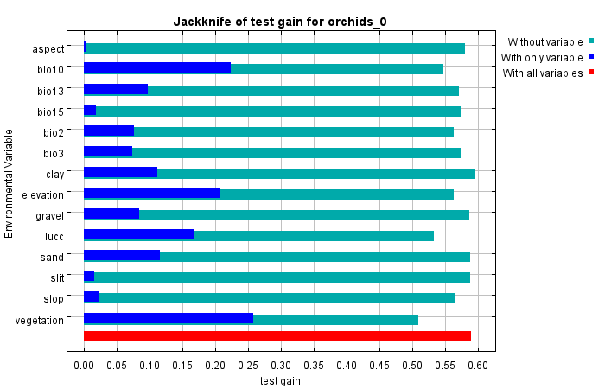

1.4 These curves show how each environmental variable affects the Maxent prediction.

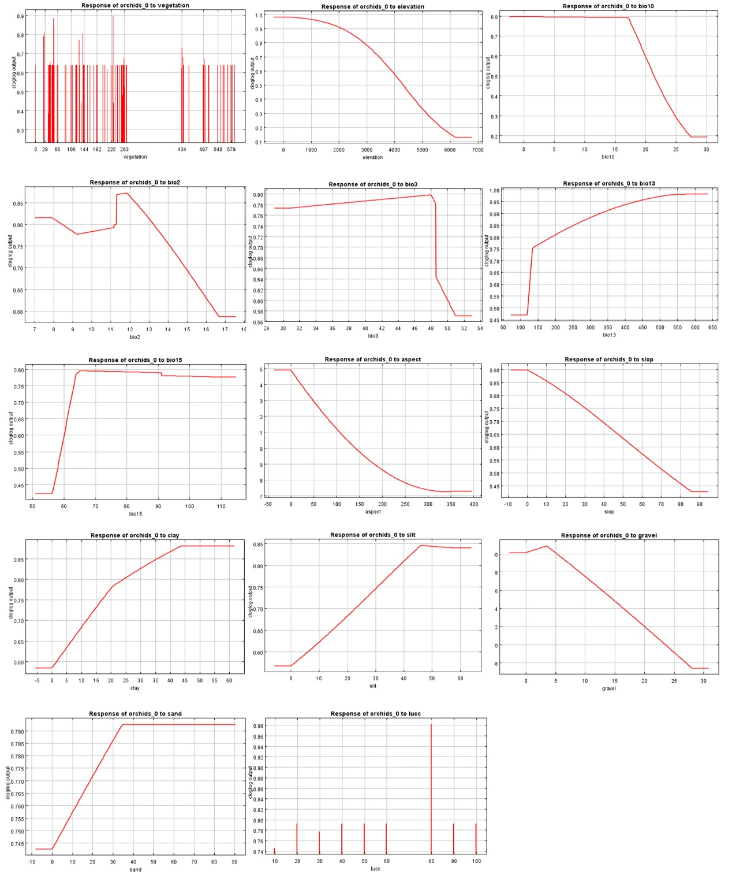

Appendix S2 spatial analysis
2.1 the following table shows the area of diversity and protected hotspots beyond the suitability, in km².
Layers | Protected buffer | R1 | P1 | all | R1+R2 | P1+P2 | all | R1+R2+R3 | P1+P2+P3 | all
S1 | 5km | 139.28 | 375.48 | 422.51 | 665.13 | 990.53 | 1004.9 | 14626.91 | 10995.46 | 15039.26
S1 | 10km | 456.21 | 1275.19 | 1429.3 | 2034.81 | 2920.67 | 2945.17 | 38357.29 | 30007.24 | 38822.98
S1+S2 | 5km | 20.06 | 200.12 | 201.41 | 321.14 | 498.81 | 504.31 | 9742.4 | 7165.9 | 10035.78
S1+S2 | 10km | 164.3 | 706.89 | 737.21 | 1138.3 | 1662.6 | 1675.3 | 27373.74 | 20834.69 | 27732.27
S1+S2+S3 | 5km | 7.64 | 98.35 | 99.05 | 179.64 | 259.25 | 262.59 | 5704.93 | 4175.13 | 5884,19
S1+S2+S3 | 10km | 70.55 | 339.94 | 335.52 | 616.84 | 850.62 | 857.02 | 16104.64 | 12172.92 | 16331.72

