Supplementary Figures
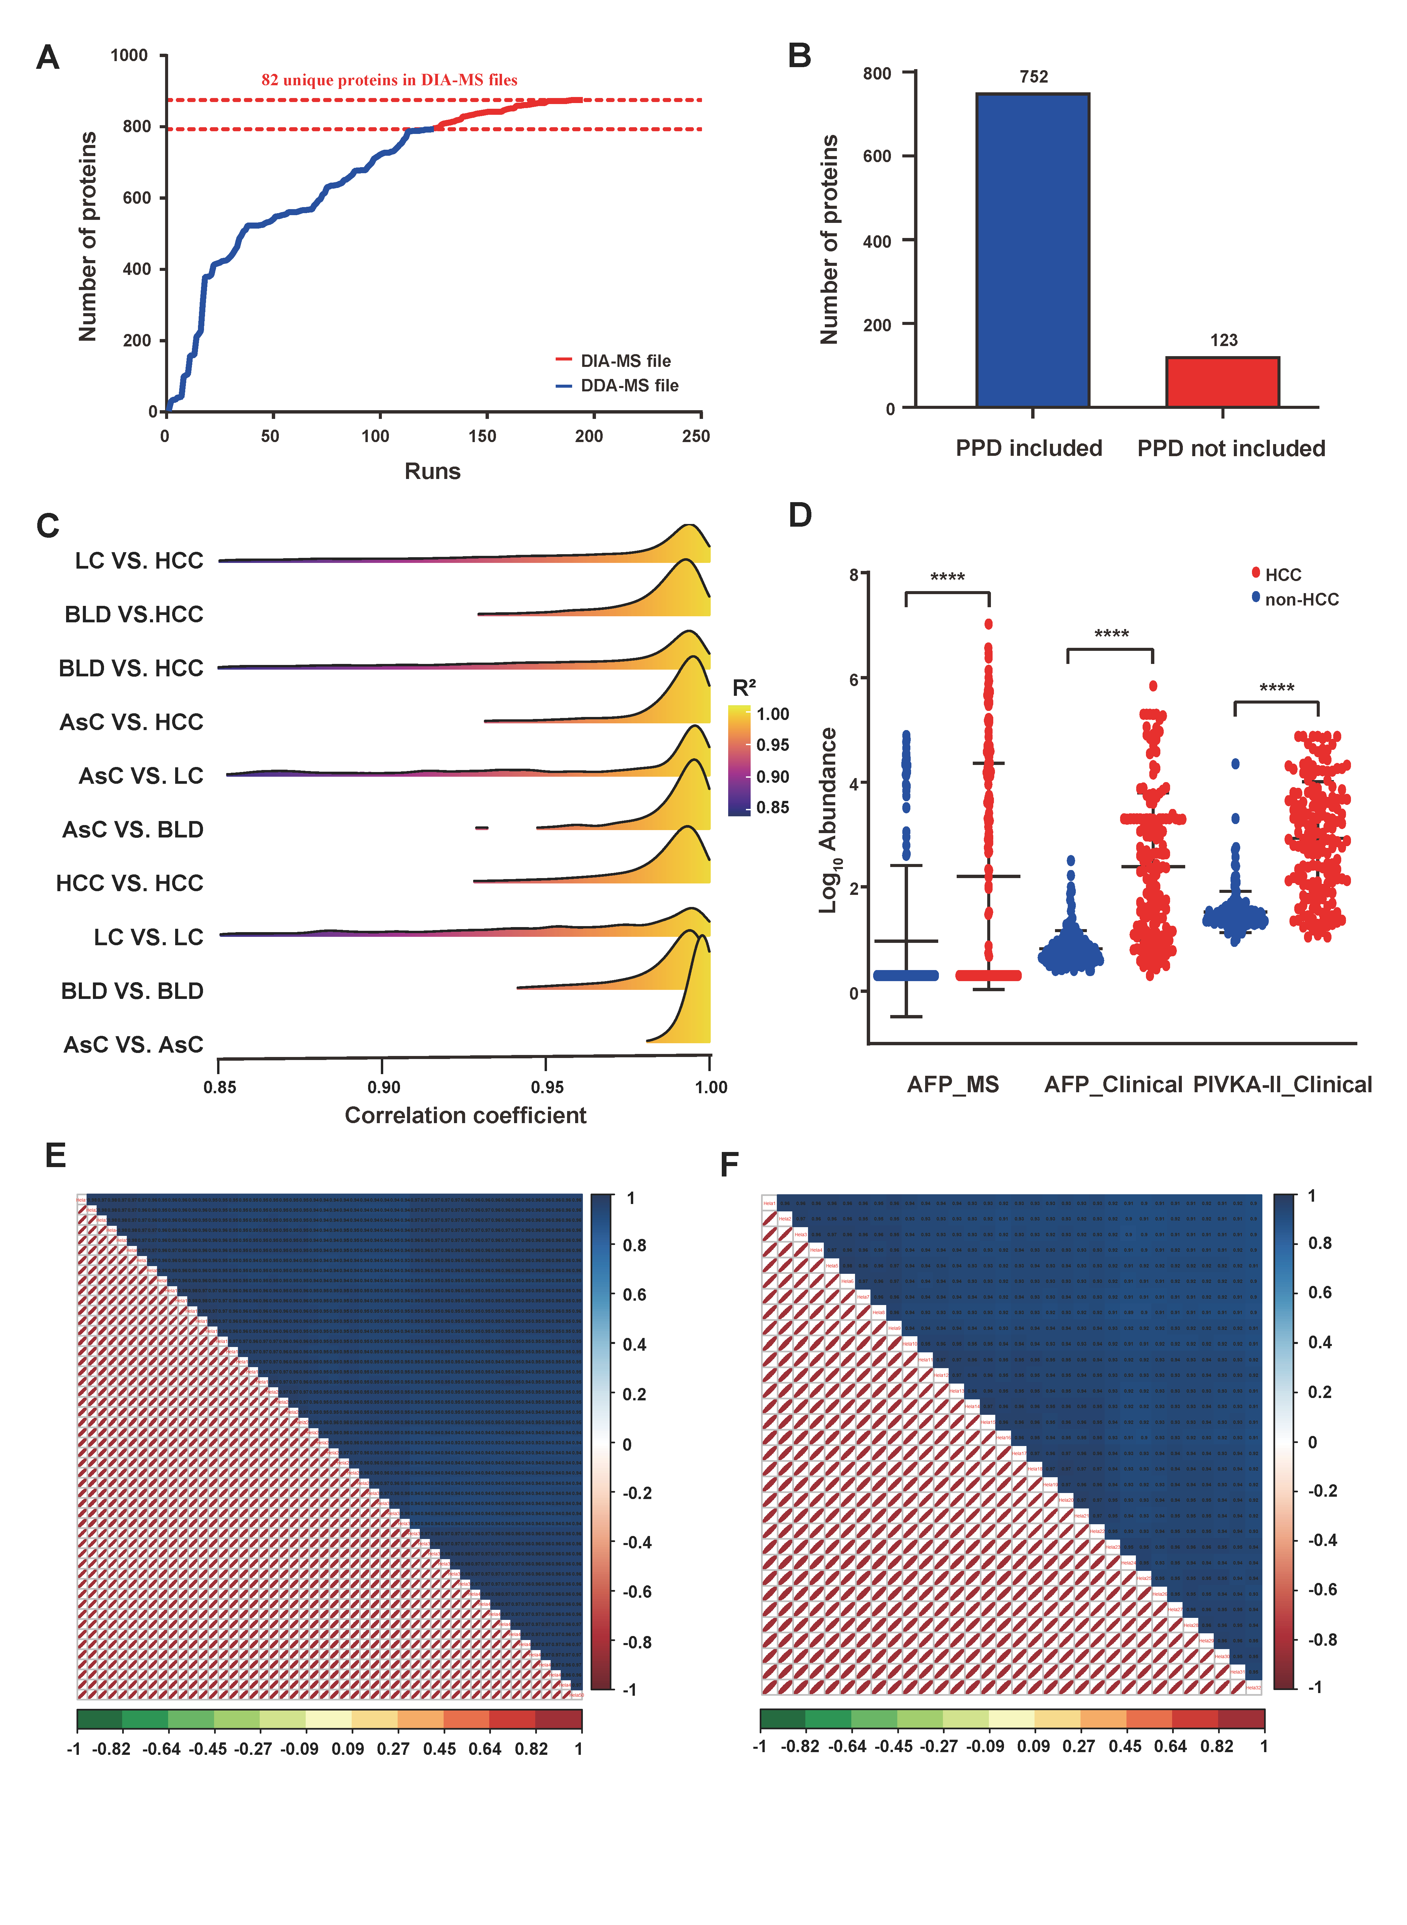
Figure S1 Summary of serum proteome and quality control of standards
- The protein number accumulation curve distinguishing the data acquisition mode. B. Comparison of the number of proteins identified in the serum proteome and the spectral library. C. Correlation coefficient distribution of identified proteins in every two groups. D. Quantitative analysis of AFP_MS, AFP_Clinical and PIVKA-II_Clinical in HCC and non-HCC patients. E. The pearson’s correlation coefficients of standards through library process in DDA mode, and targeted process in DIA mode (F).
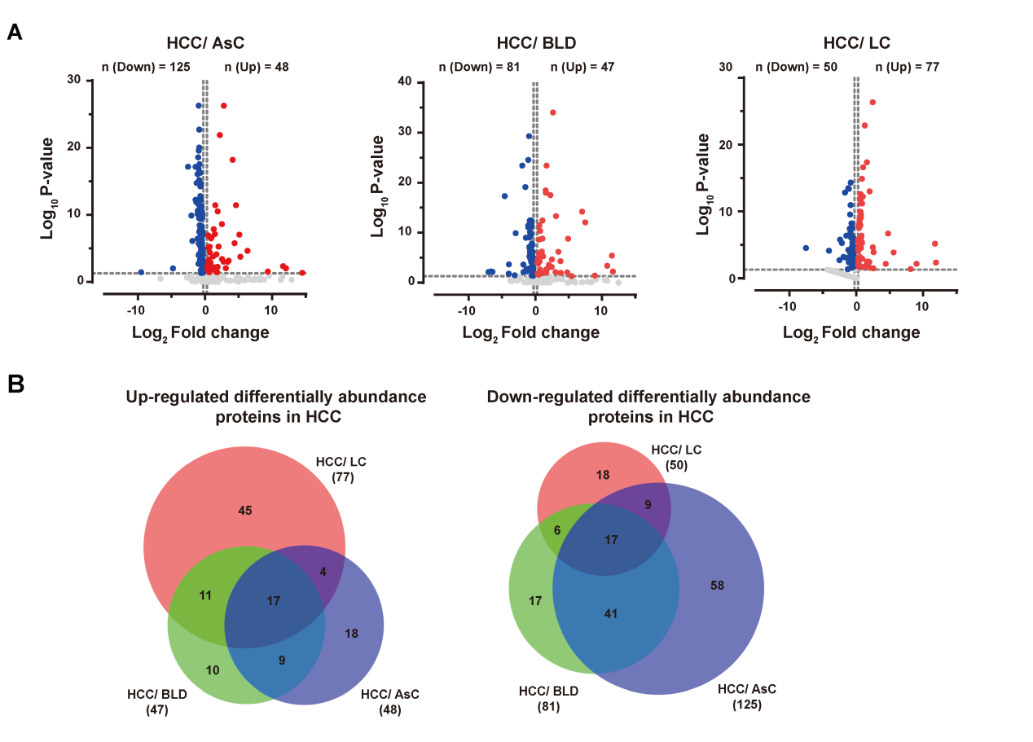
Figure S2 Screening of differentially abundant proteins.
- Volcano plot represented the protein abundance changes in the comparison between HCC and AsC, HCC and BLD, and HCC and LC groups, respectively. Dashed lines delimit significantly down-regulated (blue dots) and up-regulated proteins (red dots). B. Venn diagrams exhibited the overlay of these differentially abundant proteins in 3 comparisons. Up-regulated proteins were shown on the left and down-regulated proteins were shown on the right.
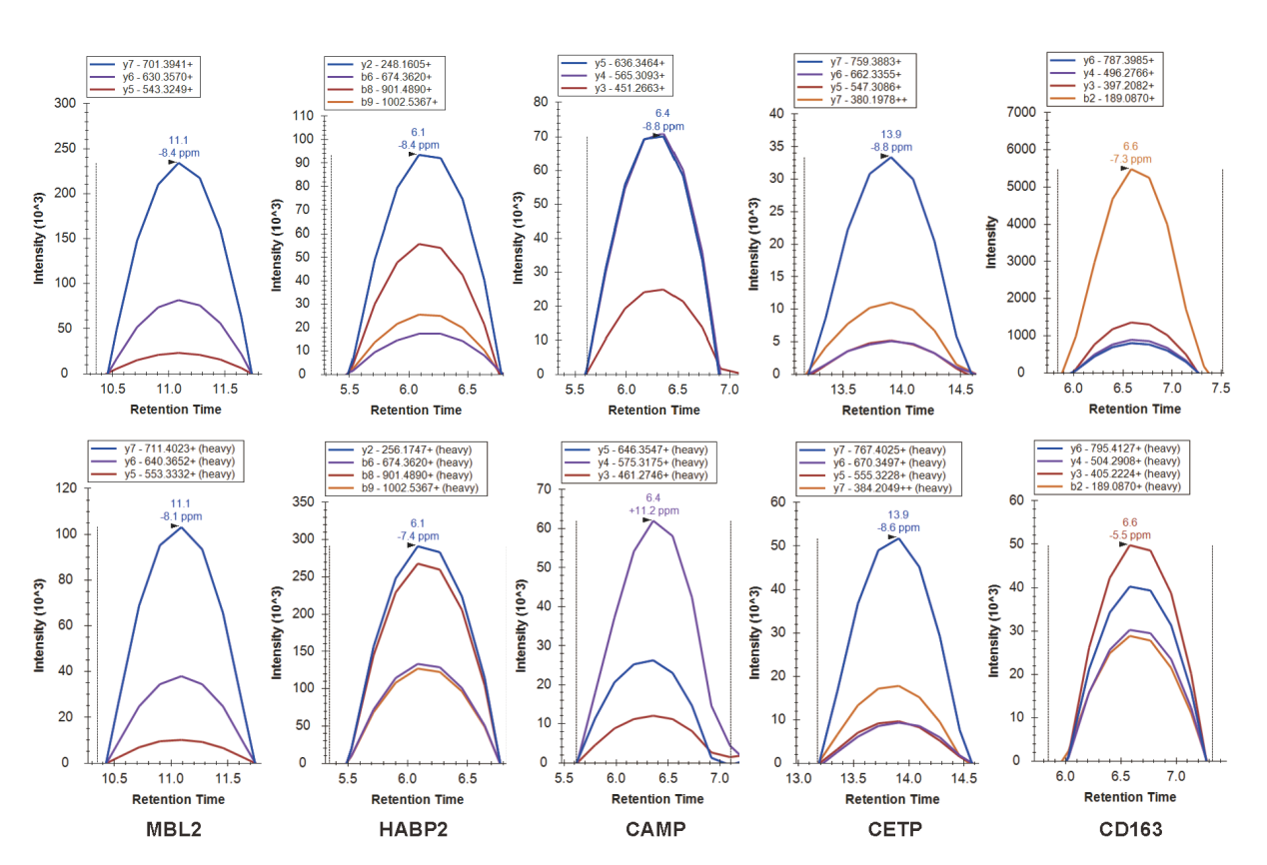
Figure S3 Peak contributions of the individual fragment ions from the unique peptide of MBL2, HABP2, CAMP, CETP and CD163.
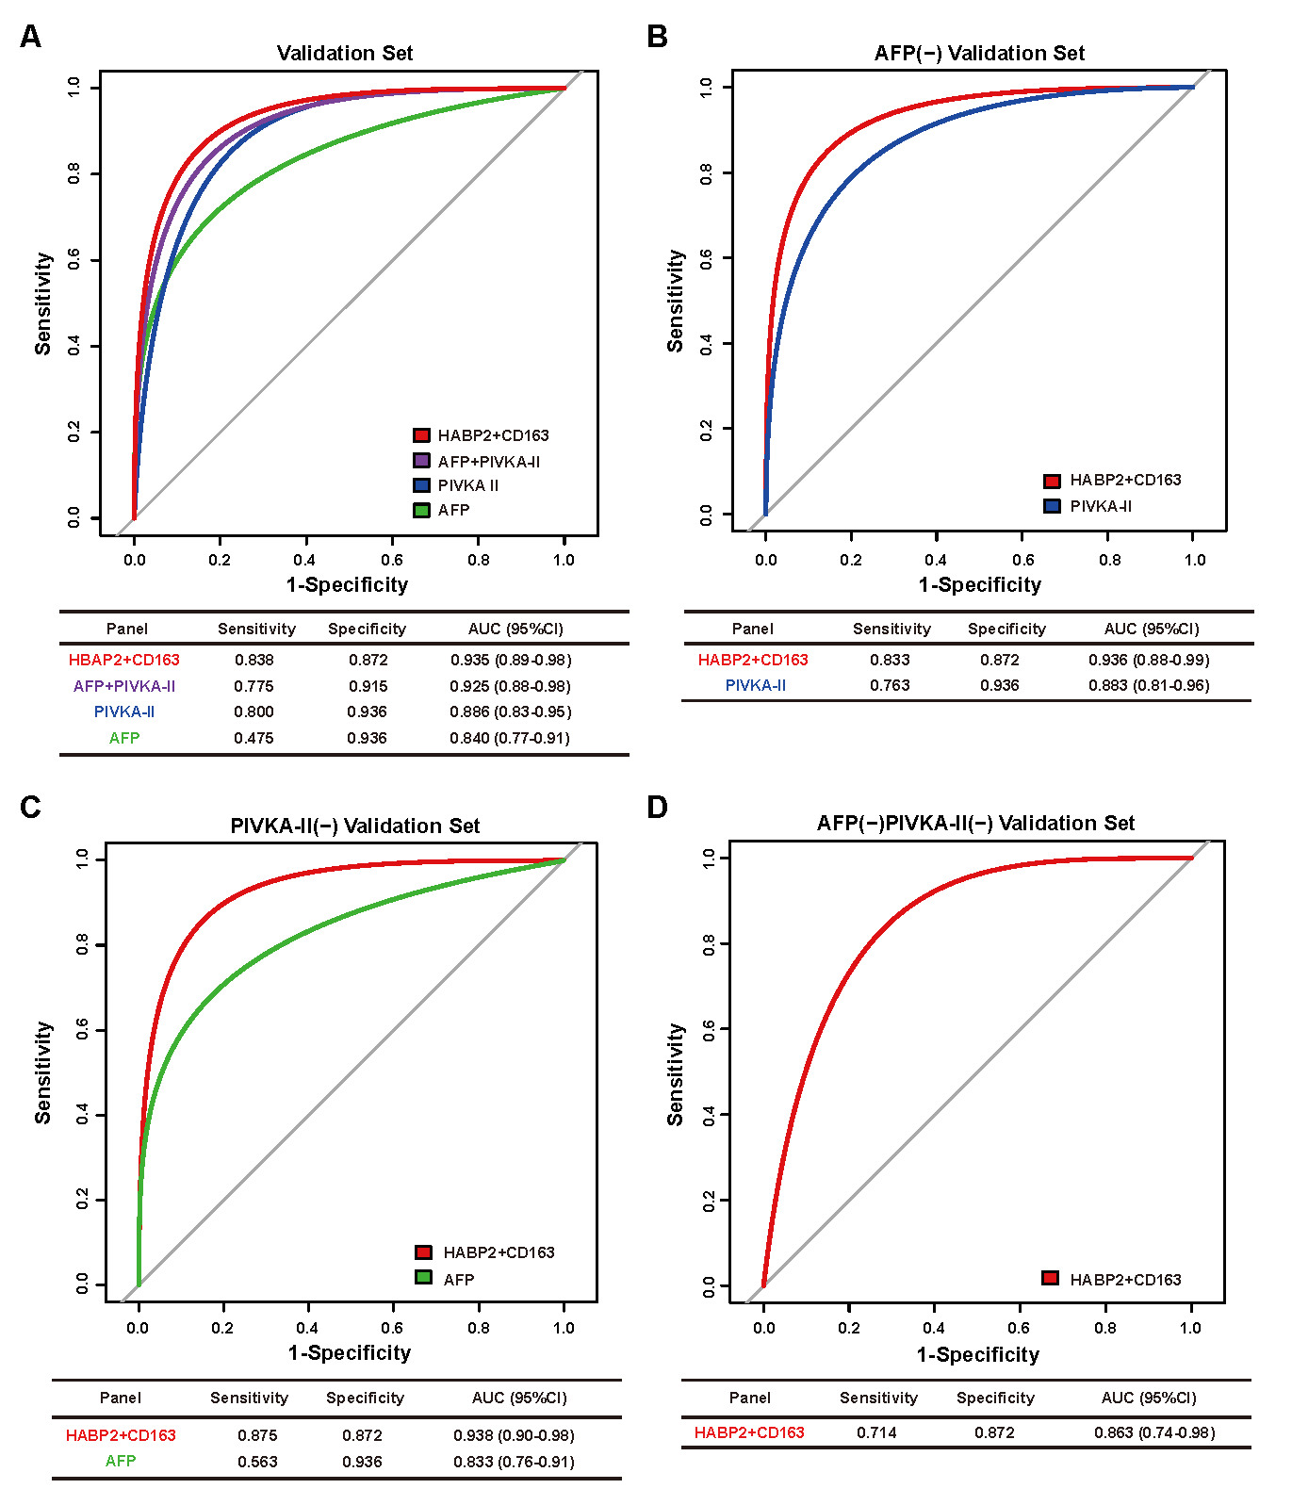
Figure S4 Performance of the HABP2+ CD163 panel in validation cohort.
- ROC curves of the HABP2+ CD163 panel, AFP, PIVKA-II and their combination for HCC patients versus LC patients in the validation cohort. B. ROC curves of the HABP2+ CD163 panel and PIVKA-II for HCC AFP-negative patients versus LC patients. C. ROC curves of the HABP2+ CD163 panel and AFP for HCC PIVKA-II -negative patients versus LC patients. D. ROC curves of the HABP2+ CD163 panel for AFP-negative and PIVKA-II-negative of HCC patients versus LC patients.
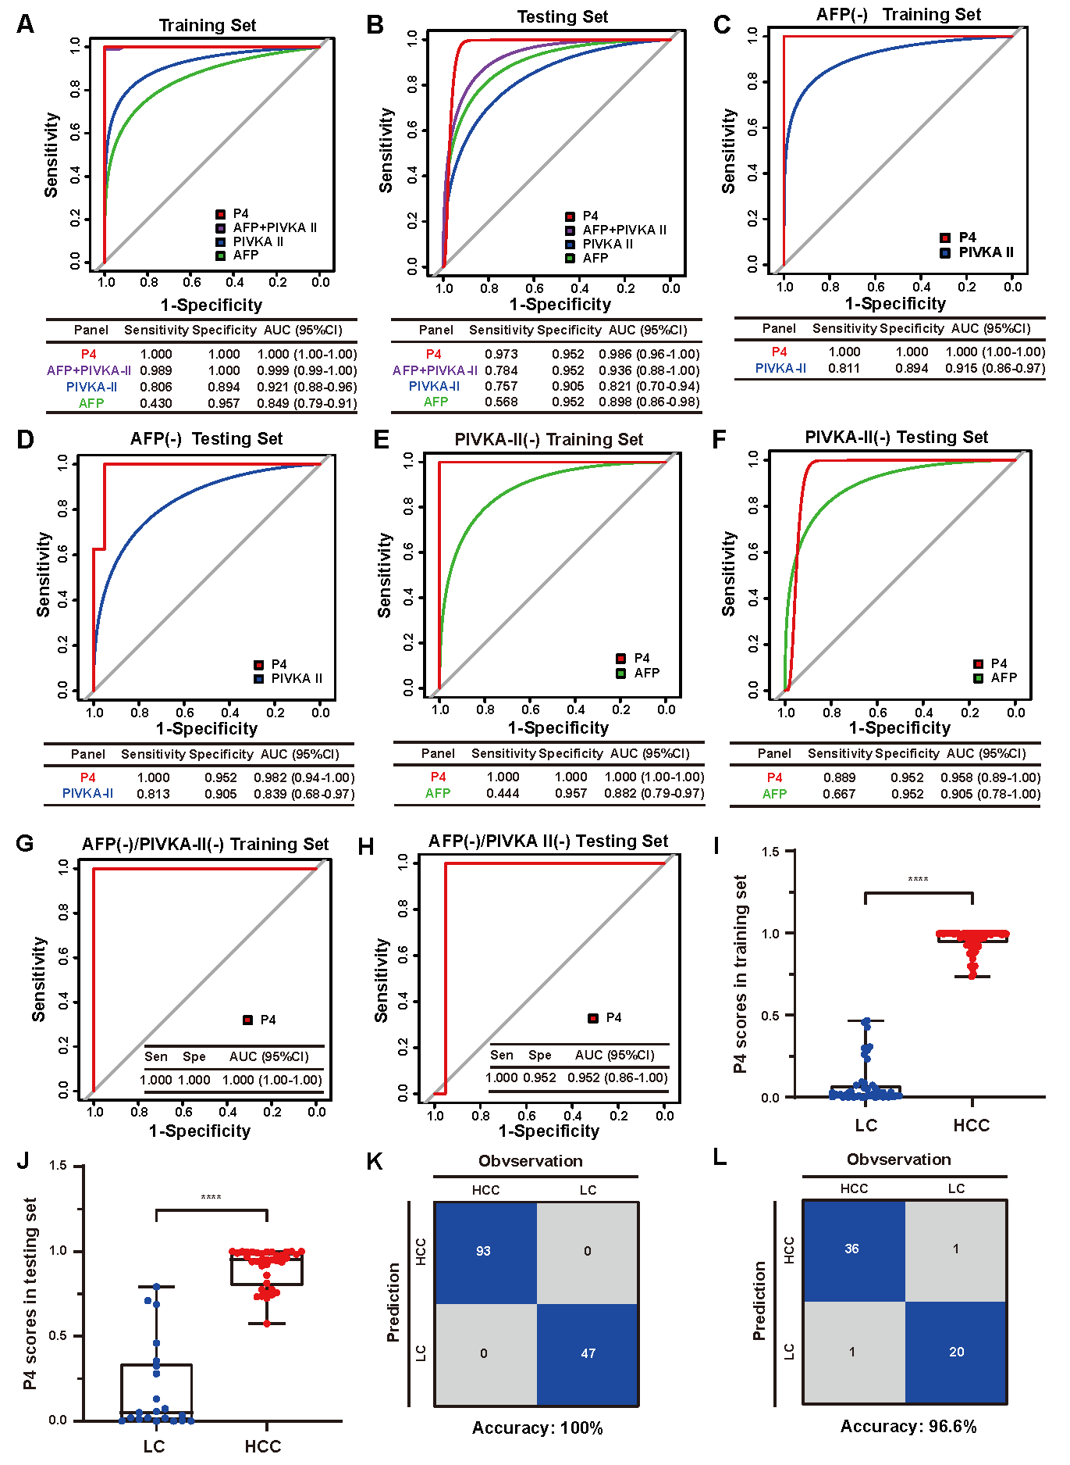
Figure S5 Diagnosis performance of the P4 model in training set and testing set.
- ROC curves of P4 panel, AFP, PIVKA-II and their combination for HCC patients versus LC patients in the training set and testing set (B). C. ROC curves of P4 panel and PIVKA-II for HCC AFP-negative patients versus LC patients in the training set and testing set (D). E. ROC curves of P4 panel and AFP for HCC PIVKA-II -negative patients versus LC patients in the training set and testing set (F). G. ROC curves of P4 panel for AFP-negative and PIVKA-II-negative of HCC patients versus LC patients in the training set and testing set (H). I. Differences of P4 scores between HCC patients and LC patients in the training set and testing set (J). K. Confusion matrix showed P4 panel performance for classifying HCC and LC in the validation set in the training set and testing set (L).
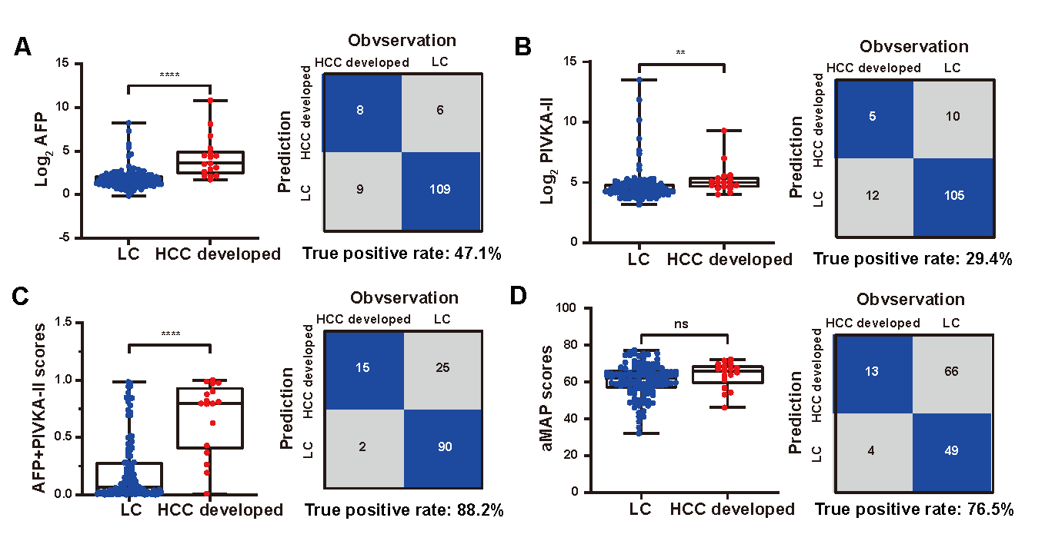
Figure S6 Performance of the P4 model in predicting people at high risk of HCC in prospective cohort.
Performance of the AFP (A), PIVKA-II (B), AFP+PIVKA-II (C) and aMAP scores (D) for LC patients to identify people at high risk of HCC, who were diagnosed with HCC at subsequent follow up. The left panel showed the differences of scores between LC patients who developed HCC and LC patients who did not develop HCC, and the right panel illustrated the confusion matrix for predicting people at high risk of HCC.

