Occurrence of titanium dioxide nanoparticle in Taihu Lake (China) and its removal at a full-scale drinking water treatment plant
Zhiyuan Liu^{1, 2}, Min Rui^{1, 2}, Shuili Yu^{3*}
1 Shanghai Municipal Engineering Design Institute (Group) Co., LTD., Shanghai 200092, China
2 Shanghai Water Industrial Design Engineering Co., LTD., Shanghai 200092, China
3 State Key Laboratory of Pollution Control and Resources Reuse, Tongji University, Shanghai, 200092, China
* Corresponding author.
Address: Department of Municipal Engineering, College of Environmental Science and Engineering, Tongji University, Shanghai 200092, China.
Tel: +86 21 65982708. Fax: +86 21 65982708.
Email address: 8566liliu@tongji.edu.cn

Supplementary Material

Pages: 6
Tables: 1
Figures: 6

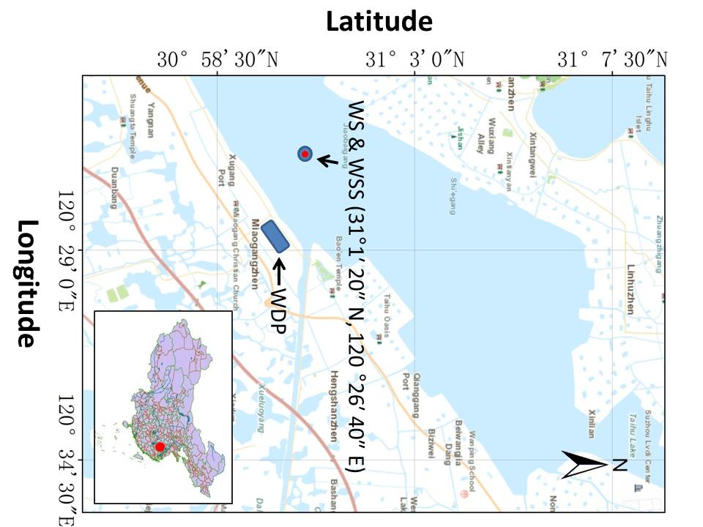
Fig. S1 – Locations of the sites for water/sediment sampling relative to the Wujiang Drinking Water Plant (WDP). WS represents the sites for water sampling. WSS represents the sites for sediment sampling.
Acid dissolution analysis
The water samples were injected with HCl and HNO₃ to achieve the pH value of 2 and then centrifuged at 24149 g (12000 rpm) for 30 min (Jouan KR25i, Thermo Fisher Scientific, USA) to obtain the supernatant. The Ti concentration in the supernatant was then determined to evaluate the acid solubility of the Ti-containing matter. The sediments were subjected to the same procedures as the water samples after being dissolved in ultrapure water.
Size grading analysis
The water samples were treated with ultrasonication and then filtered through 0.1, 0.45, 0.8, 1.2, 5 μm PTFE membranes (Millipore, UK Ltd.) using a vacuum filtration device (Xinghua Glass Instrument Plant, Zhengzhou, China). The Ti concentrations in the filtrates were then determined to evaluate the size grading of the Ti-containing matter. The sediments were subjected to the same procedures as the water samples after being dissolved in ultrapure water.
SEM analysis
The water samples were firstly filtered through a 5 μm membrane to remove the large impurities (Millipore, UK Ltd.). The filtrate was centrifuged for 30 min at 12000 rpm to obtain the sludge (Jouan KR25i, Thermo Fisher Scientific, USA). Then, the concentrate was digested using 50% hydrogen peroxide for 20 min to remove the organic matter. The mixtures were rinsed twice using ultrapure water and dried on a 0.22 μm membrane for SEM analysis at 20 kV (FEI Company, USA).
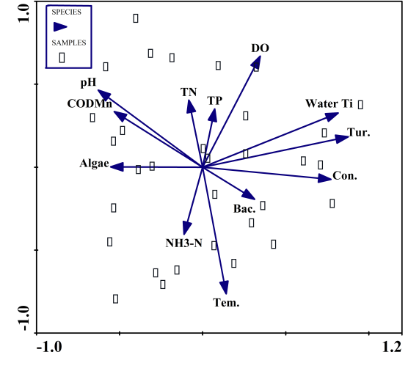
Fig. S2 – Principle component analysis (PAC) based on the Ti concentrations and the relevant water indicators in the water source of east Taihu Lake determined from December 10, 2014 to January 11, 2015.
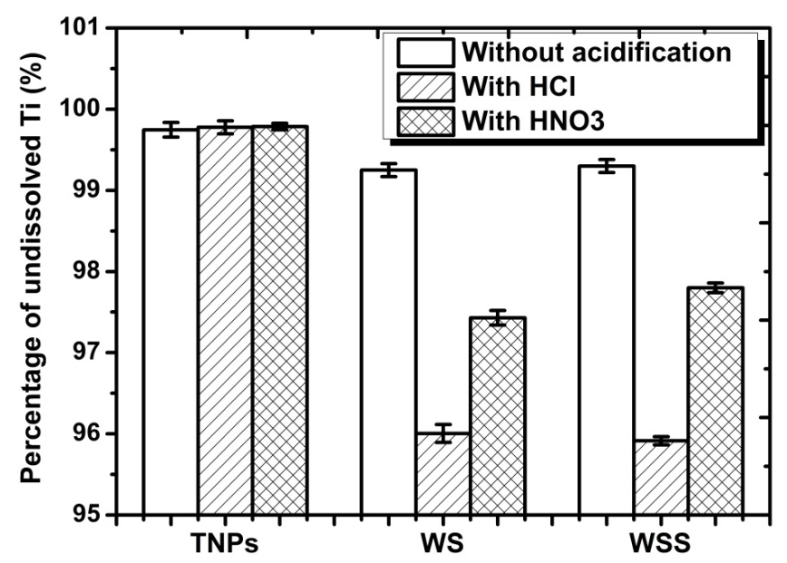
Fig. S3 – Acid solubility analysis of Ti-containing matter in the representative water sample and the sediment sample collected from the water source of east Taihu Lake. WS and WSS represent the water sample and the sediment sample collected from the water source, respectively. TNPs represent the commercial nano-scaled titanium dioxide. n=3.
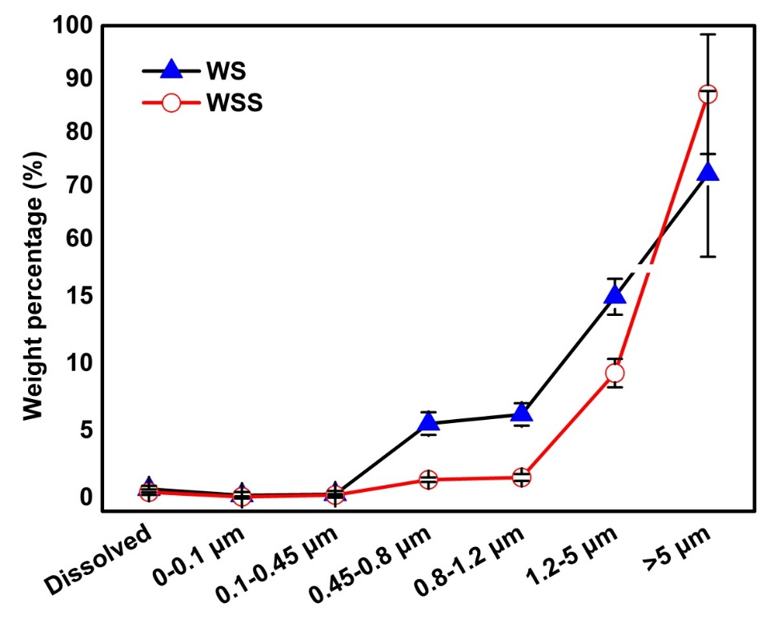
Fig. S4 – Weight percentage (mean ± SD) of varying size fractionation of Ti-containing matter in the water samples and the sediment samples collected from the water source of east Taihu Lake. WS and WSS represent the representative water sample and sediment sample in east Taihu Lake, respectively. n=3.

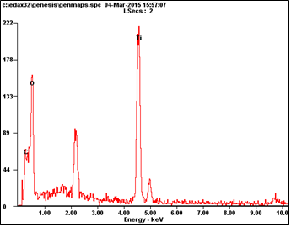
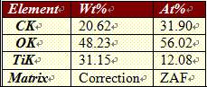
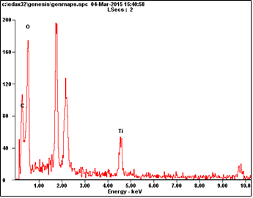
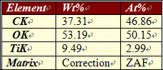
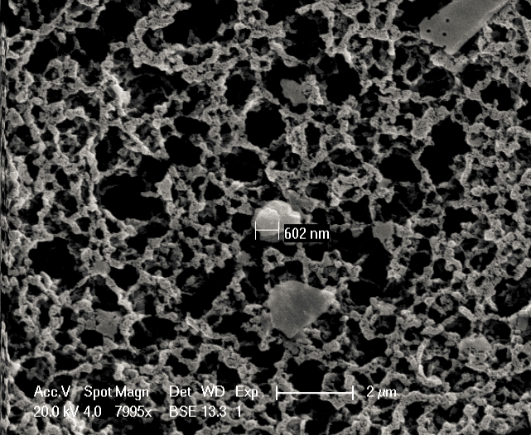
a
b
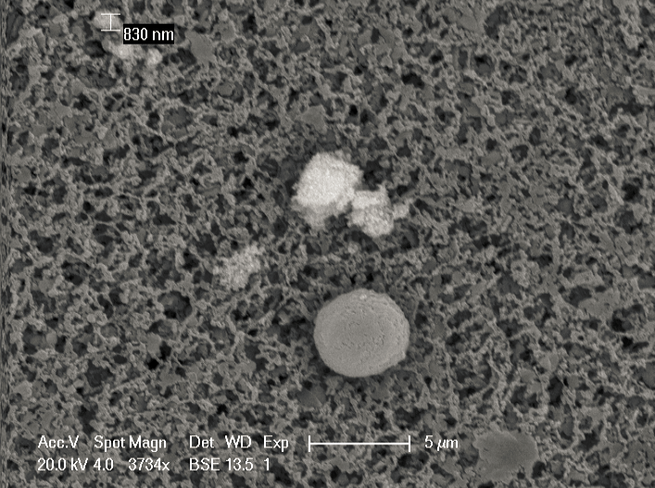
c
d
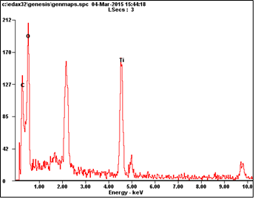
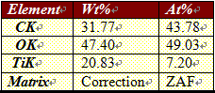
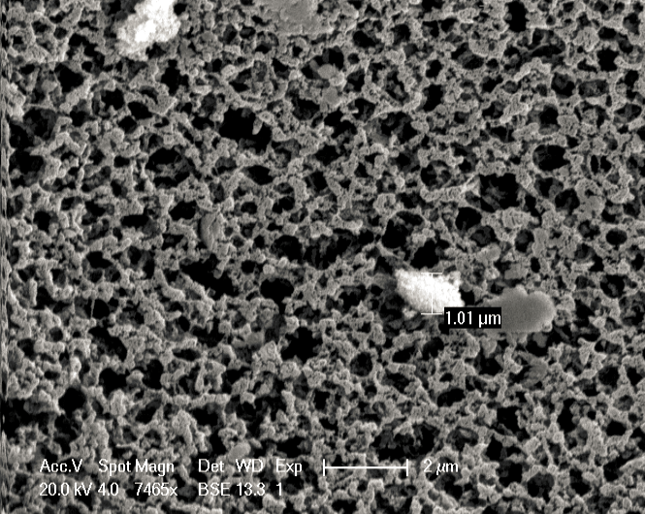
e
f
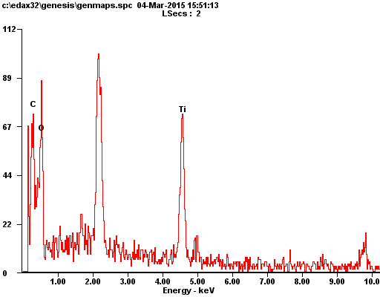
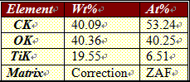
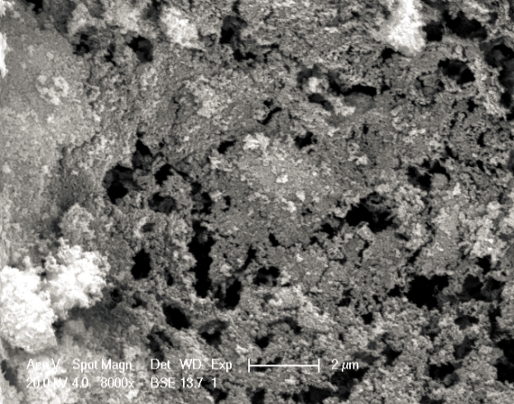
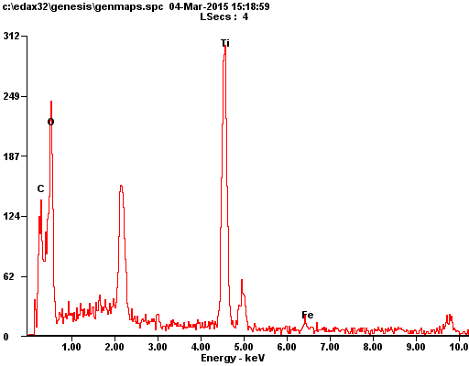
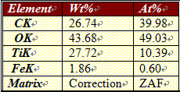
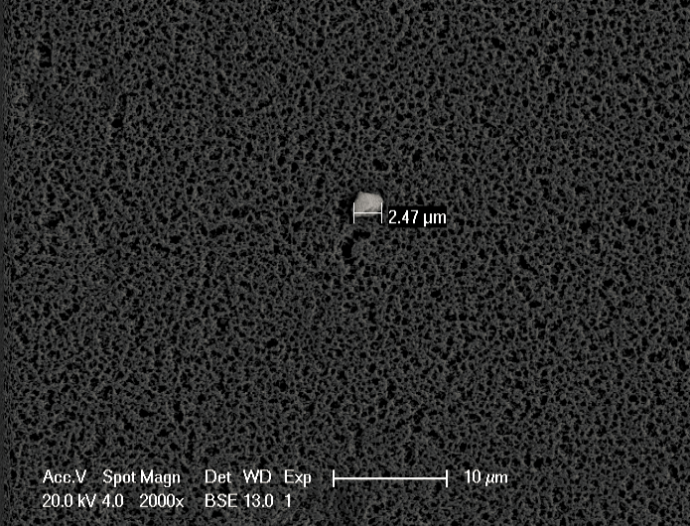
i
j
g
h
Fig. S5 – SEM analysis of Ti-containing matter (a, c, e, g) in the representative water samples collected from the water source of east Taihu Lake and the commercial nano-scaled titanium dioxide (i). The Energy Dispersive X-ray Spectra (b, d, f, h, j) provide elemental compositions of the points in the parts (a, c, e, g, i) labeled with red crosses, respectively.
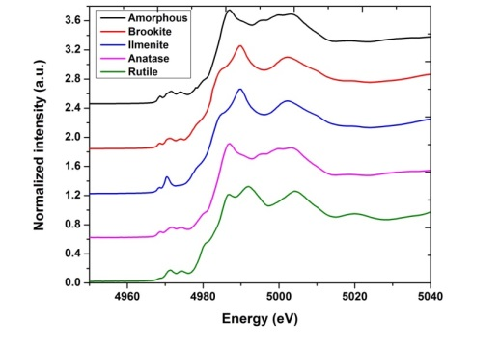
Fig. S6 – Normalized Ti K-edge XANES spectra of different Ti reference compounds.
Table S1 – Results of the least-squares linear combination fitting (LCF) on the Ti K-edge XANES spectraª
Sample | Amorphous % | Anatase % | Ilmenite % | Rutile % | R-factor
WSS | 32.8 (5.5) | 29 (0.6) | 7.3 (1.1) | 30.9 (5.6) | 0.00054
WS | 30 (2) | 33.5 (2) | 8 (2) | 28.5 (2) | 0.0007
Coagulation/sediment | 26 (2) | 42 (2) | 12 (2) | 20 (2) | 0.00047
Sand filtration | 21 (2) | 47 (2) | 12 (2) | 20 (2) | 0.00056
Effluent | 21 (1) | 47 (1) | 12 (1) | 20 (1) | 0.00036
ª For each sample, the LCF result is presented as a percentage with the value in the brackets showing the percent variation. The goodness of fit is represented by the mean square sum of the misfit at each data point, i.e., the R-factor, which was also used by Tong, T. Z. et al. (Tong et al. 2015).
References
Tong TZ et al. (2015) Spectroscopic Characterization of TiO2 Polymorphs in Wastewater Treatment and Sediment Samples Environ Sci Tech Let 2:12-18 doi:10.1021/ez5004023

