Supplemental Appendix

Supplemental Methods

Figure S1. Gene expression biomarker development.
Figure S2. Gene expression biomarker characteristics in the discovery cohort.
Figure S3. Gene expression biomarker across somatic short variants in the discovery cohort.
Figure S4. Gene expression biomarker characteristics in the analytical validation cohort.
Figure S5. Gene expression biomarker characteristics in the clinical validation cohort.
Figure S6. Molecular classification comparisons in the clinical validation cohort.
Figure S7. Gene expression biomarker nomograms for meningioma outcomes.
Figure S8. Molecular classification systems and response to treatment.

Table S1. Targeted gene expression biomarker discovery panel.
Table S2. UCSF discovery cohort characteristics.
Table S3. Optimized gene expression biomarker panel.
Table S4. Analytical and clinical validation cohorts.
Table S5. The University of Hong Kong clinical validation cohort characteristics.
Table S6. Northwestern University clinical validation cohort characteristics.
Table S7. UCSF WHO grade 2 or grade 3 clinical validation cohort characteristics.
Table S8. Baylor College of Medicine clinical validation cohort characteristics.
Table S9. Heidelberg University and Medical University of Vienna clinical validation cohort characteristics.
Table S10. Multivariable Cox models for recurrence in clinical validation cohort meningiomas.
Table S11. Multivariable Cox models for death in clinical validation cohort meningiomas.
Table S12. Propensity matched clinical validation cohort meningiomas.
Table S13. RTOG 0539 clinical validation cohort characteristics.
Table S14. RTOG 0539 characteristics by risk group and multivariate analysis.
Table S15. Gene expression biomarker reclassification rates compared to clinical criteria.

Supplemental References
Supplemental Methods
Nucleic acid extraction
Frozen meningiomas were mechanically lysed and DNA and RNA were extracted as previously described¹. For FFPE meningiomas processed at UCSF, a 2mm core punch was obtained from tissue blocks. Punches were deparaffinized using xylene, mechanically lysed using a TissueLyser II according to manufacturer instructions, and DNA and RNA was extracted using the Qiagen QIAmp DNA FFPE Tissue kit (#56404) and RNEasy FFPE kit (#73504), according to manufacturer instructions. DNA and RNA quality and concentration were assessed using a NanoDrop One (Thermo Fisher Scientific). For meningiomas independently processed at Canopy Biosciences (Hayward, CA), FFPE punches of tumor tissue were deparaffinized with Qiagen Deparaffinization solution (#19093). Tissue samples were lysed and total RNA was extracted using the Roche High Pure FFPE RNA kit (#04823125001). Quality and quantity of RNA eluted from the columns was determined using A260/A280 measurements from a Nanodrop. For FFPE meningiomas independently processed at Northwestern University, 6 10-micron curls were sectioned for each tumor and extracted using the Qiagen AllPrep DNA/RNA FFPE Kit (#80234), according to manufacturer instructions. For frozen meningiomas independently processed at Northwestern University, tissue underwent douncing using a Kontes Pellet Pestle (DWK Life Sciences, #7495200090), followed by disruption using a TissueLyser II (Qiagen, #85300). RNA and DNA were subsequently extracted using the Qiagen All Prep mini kit (#80004) according to manufacturer instructions. DNA and RNA were quantified using a Qubit 2.0 Fluorometer (Thermo Scientific). RNA quality was assessed using Bioanalyzer RNA pico assay chip, including RNA integrity number and fraction of molecules above 300 base pairs.

nCounter specifications across laboratories
For samples processed at the City of Hope Integrative Genomics and Bioinformatics Core (Duarte, CA; UCSF discovery and The University of Hong Kong validation cohorts) and at the UCSF/San Francisco Veterans Affairs Core (San Francisco, CA; UCSF validation, Baylor College of Medicine validation, University of Heidelberg and Medical University of Vienna validation, and RTOG 0539 validation cohorts), 200 ng of total RNA per sample was hybridized to barcoded reporter probes and biotin-conjugated capture probes from a custom codeset targeting genes of interest (Table S1) at 65C for 16 hours according to manufacturer instruction. Hybridization mixtures were washed and target/probe complexes were purified and bound to streptavidin coated cartridges. Cartridges were scanned on the nCounter Digital Analyzer with a FOV setting of 550. For samples processed at Canopy Biosciences (Hayward, CA) for paired frozen-FFPE validation (N=64 meningiomas), 100 ng of total RNA per sample was hybridized with barcoded reporter probes and biotin-conjugated capture probes targeting genes of interest at 65C for 16 hours according to manufacturer instructions. Hybridization mixtures were washed and target/probe complexes were purified and bound to streptavidin coated cartridges. Cartridges were scanned on the nCounter Digital Analyzer with a FOV setting of 280. For samples extracted and processed independently at Northwestern University, cartridges were scanned on a nCounter SPRINT profiler according to manufacturer instructions. A minimum of 200 ng of total RNA per was loaded for each sample, and higher amounts were used in cases where the percentage of RNA fragments > 300bp was less than 25%.

Nanostring targeted gene expression analysis
Targeted gene expression profiling was performed using a hybridization and barcode-based Nanostring panel as described above, with quality control from internal negative and spike-in positive controls. Raw Nanostring RCC output files were pre-processed using the nSolver software (v4.0) provided by the manufacturer, following manufacturer recommended procedures in the software to apply positive control normalization. Positive-control normalized counts were standardized by normalization to the geometric mean count of a set of meningioma specific housekeeping genes (ACTB, CASC3, GUSB, KIAA1715, MRPL19, POP4, TTC21B). This was followed by a log₂ transformation, resulting in log₂-transformed, reference gene-set normalized counts, which served as the input for all subsequent biomarker development and validation analyses. The ratio of geometric means of housekeeping genes and the spike-in positive controls were used to assess signal adequacy, and meningiomas with a ratio ≤0.20 were excluded from analysis (N=69 excluded, 5.7%; total number of meningiomas analyzed using targeted gene expression profiling = 1211).
Meningioma related genes of interest (Table S1) were selected based on prognostic or biologic significance in the literature (e.g, NF2, PGR, IGF2, ARID1B, NDRG2, CDKN2A, COL1A1, TOP2A, TERT, CD3E, CCL21, LYVE1, CXCL8, FOXM1, and FOXM1 target genes), genes located on chromosome arms that are lost or gained in aggressive meningiomas (e.g, LINC02593 and MUTYH on chromosome 1p; TMEM30B on chromosome 14q; TOP2A, BIRC5, and COL1A1 on chromosome 17q, USF1 on chromosome 1q), genes correlated with copy number variant burden and chromosomal instability (e.g FOXM1, CHEK1, AURKA, MCM4, MCM6, MDM4), and genes related to cell stress and the DNA damage response (e.g RAD51, RAD51C, RACGAP1, SOS2). Candidate housekeeping genes were identified from the literature^{2–4}, and narrowed to 7 by curating stable genes with the lowest variance spanning the full dynamic range of the assay. We previously reported a pilot study⁵ examining the feasibility of targeted gene expression profiling for meningioma. Only 9 genes overlapped between the 2 studies, as described in Figure S1.
Feature selection from the discovery gene set of 100 meningioma-related genes (Table S1) was performed using a Lasso regularized Cox regression model with the concordance index (c-index) of local freedom from recurrence as the target endpoint, which was accomplished using the glmnet and cv.glmnet functions from the glmnet package in R. Model training was performed using 10-fold cross validation within the UCSF discovery cohort (N=173). An optimal set of 34 genes was identified within 1 standard error of the model achieving maximal c-index to reduce over-fitting. A risk metric was calculated for each tumor, defined as the product of the Lasso regression coefficients and the normalized counts. This metric was linearly rescaled between 0 and 1 based on minimum and maximum values in the discovery dataset, resulting in a highly discriminatory set of risk scores within the discovery cohort (LFFR c-index 0.89, Figure S1). To further reduce over-fitting and to facilitate re-calibration of the model for data derived from different tissue sources (FFPE) or from different approaches for RNA quantification (RNA sequencing, microarray), bootstrap aggregation⁶ was used to train 500 ridge-regression sub-models using normalized and log-transformed gene counts at hand as input and discovery cohort (N=173) risk scores between 0 and 1 as target variables. This procedure nominates a bootstrap aggregated risk score for each tumor defined as the arithmetic mean across sub-model risk scores, and was applied for all validation cohorts.
Risk score cutoffs were determined using a nested procedure. An initial cutoff was determined in the discovery cohort using the maximally selected rank statistic via the surv_cutpoint function in the survminer package in R. The subsets above and below this threshold were again split by maximally selected rank statistic. The lowest risk score group was considered low risk (LFFR cutoff ≤0.3760769, OS cutoff ≤0.4206913), and the highest risk score group was considered high risk (LFFR cutoff >0.5651741, OS cutoff >0.6453035). The intervening risk score groups were combined as intermediate risk (LFFR cutoff (0.3760769, 0.5651741], OS cutoff (0.4206913, 0.6453035]). All model training, calibration, and cutoff determination was performed in the discovery cohort (N=173), and models and cutoffs were locked and applied to all analytical and clinical validation cohorts without alteration.

Clinical data from retrospective discovery and validation cohort meningiomas
A retrospective discovery cohort of frozen meningiomas (N=173, Table S2) that were resected from 1991 to 2016 was identified from an institutional biorepository and clinical database at UCSF, with an emphasis on high-grade meningiomas and low-grade meningiomas with long clinical follow up. All WHO grade 2 and grade 3 meningiomas with available frozen samples were included (N=90). For WHO grade 1 meningiomas, frozen samples in the tissue bank were cross-referenced for clinical follow up data from a retrospective institutional meningioma clinical outcomes database, and all cases with available frozen tissue and clinical follow up greater than 10 years were included (N=23). The remaining cases in the discovery cohort were comprised of WHO grade 1 meningiomas with available frozen tissue and the longest possible clinical follow up (N=60, median follow up 5.1 years). A retrospective validation cohort of consecutive frozen meningiomas (N=339, Table S5) that were resected from 2000 to 2019 were identified from an institutional biorepository at The University of Hong Kong. Clinical data, DNA methylation profiles, and RNA sequencing from UCSF discovery cohort and The University of Hong Kong validation cohort meningiomas were previously reported^{1,7}. For the UCSF discovery (N=173) and The Hong Kong University validation cohorts (N=339), surgical pathology specimens were re-reviewed for diagnostic accuracy based on criteria in the 2016 WHO Classification of Tumors of the Central Nervous system⁸ by board-certified neuro-pathologists at each institution.
Extent of resection was defined on postoperative magnetic resonance. Median imaging follow up is reported in Tables S2 and S5-S9. The interval between MRI surveillance scans was per provider discretion, and generally consisted of MRI imaging every 6 months up to 5 years after surgery or at shorter intervals as clinically indicated, and then at least annually thereafter. Patients in the UCSF discovery cohort received a median of 5 surveillance MRI studies (IQR 2-11) during follow up, with a median of 6.6 months (IQR 2.8-13.3) between serial scans. Patients in The University of Hong Kong clinical validation cohort received a median of 5 surveillance MRI studies (IQR 3-8) during follow up, with a median of 12.0 months (IQR 5.0-19.6) between serial scans. Sequences considered standard for evaluation of meningioma were used, including gadolinium enhanced T1, T2, and FLAIR. At UCSF, fat-suppressed sequences are often used for skull base lesions, and diffusion weighted imaging (DWI) and apparent diffusion coefficient (ADC) maps are routinely obtained for brain tumor imaging, in addition to pre- and post-contrast T1, T2, and FLAIR sequences. For this study, all available preoperative and follow up MRI studies from UCSF and University of Hong Kong were independently re-reviewed by neuro-radiologists (TJU, JEVM).
Primary outcomes of interest were local freedom from recurrence (LFFR) and overall survival (OS). In cases of gross total resection (GTR), local failure (LF) was defined as growth of new disease within or immediately adjacent to the resection cavity. In cases of subtotal resection (STR), local failure was defined as growth of residual tumor by 25% or more in any dimension on interval MRI. Dates and causes of death were extracted from medical records, institutional cancer registries, nationwide hospital databases, publicly available obituaries, and SEER, Department of Motor Vehicles, and Social Security databases. Clinical variables and events in the discovery and validation cohorts were reviewed independently at each institution by neurological surgeons, radiation oncologists, and neuro-oncologists specialized in meningioma treatment and blinded to molecular data. This study was approved by the Institutional Review Boards at UCSF (#13-12587, #17-22324, #17-23196, and #18-24633) and The University of Hong Kong (UW 07-273 and UW 21-112).
Additional retrospective clinical validation cohorts were identified from Northwestern University (Table S6, N=180, 105 frozen and 75 FFPE), UCSF (Table S7, N=158 FFPE samples, WHO 2016 grade 2 or 3), Baylor College of Medicine (Table S8, N=116 frozen), and Heidelberg University plus the Medical University of Vienna (Table S9, N=73 FFPE). Patients were identified from respective institutional databases and cross referenced with clinical pathology and research databases to identify patients with available FFPE or frozen meningioma tissue. As was done for discovery and consecutive validation cohort meningiomas from UCSF (DRR) or The University of Hong Kong (TCL, JKSP, LFL, GKKL), respectively, clinical data for Northwestern University, UCSF, Baylor College of Medicine, and Heidelberg University and Medical University of Vienna validation cohort meningiomas were collected independently at each institution by radiation oncologists (WCC, JC, DRR), neurological surgeons (AJP, MWY, STM), neuro-oncologists (ASB, MP) and neuro-pathologists (CHGL, SLNM, CH, CMH, FS) specialized in meningioma diagnosis and treatment. Surgical pathology from meningiomas comprising the discovery and consecutive validation cohorts from UCSF or The University of Hong Kong, respectively, were reviewed for histological concordance with the 2016 WHO Classification of Central Nervous System Tumors by neuro-pathologists at each institution⁹. Surgical pathology for analytical validation and retrospective clinical validation meningiomas was not re-reviewed, and may therefore better represent the intrinsic heterogeneity in routine clinical practice. Nevertheless, inter-pathologist concordance was previously reported to be high in determination of meningioma WHO grade based on local versus central review of the meningiomas from RTOG 0539 that were included in our study¹⁰. Moreover, there was no difference in LFFR across different WHO epochs (epoch 1: <Jan 1, 2000, epoch 2: Jan 1, 2000 - Jan 1, 2007, epoch 3: Jan 1, 2007 - Jan 1, 2016, and epoch 4: Jan 1, 2016 - Jan 1, 2021; epoch 2 vs 1, P=0.09, epoch 3 vs 1, P=0.12, epoch 4 vs 1, P=0.98; N=814 meningiomas), nor was there a significant interaction between WHO grade and WHO epoch for LFFR (N=814 meningiomas, interaction P>0.20 for all epoch and WHO grade combinations). In the University of Hong Kong validation cohort, which was comprised of consecutive meningiomas resected at a single institution, no statistically significant interaction term was observed between the gene expression biomarker and epoch (P=0.592).
Neurofibromatosis type 2 (NF2) syndrome status was available for 745 cases across 3 cohorts (UCSF discovery, The University of Hong Kong, and Northwestern University), and was identified in 21 cases (2.8%, N=10 WHO grade 1, N=3 WHO grade 2, and N=3 WHO grade 3). With 9 local meningioma recurrences in 21 cases associated with NF2 syndrome, sample size precluded robust interrogation of the gene expression biomarker in this clinical population. Meningiomas in patients with NF2 syndrome were more likely to be recurrent (7 of 21, 33%) and recurred frequently (10 of 21, 47.6%, 5-year LFFR 54.6%, 95% CI 34.5%-86.5%).
Postoperative fractionated external beam radiotherapy characteristics were collected from available medical records. External beam radiotherapy (N=147 cases) was exclusively photon-based for all cohorts except for 5 patients from Northwestern University who received proton therapy. The median postoperative radiotherapy dose was 59.4Gy (IQR 54-60Gy), consistent with doses used in contemporary clinical trials and guidelines^{11–13}.
Additional analytical validation cohorts comprised of microarray or RNA sequencing data with or without clinical follow up data were obtained from publicly available sources or from co-authors (Table S4). RNA sequencing data was provided in the form of pre-processed transcript-per-million (TPM) matrices. These included 360 FFPE meningiomas with RNA sequencing data from Caris Life Sciences, 110 frozen meningiomas with RNA sequencing data from Baylor College of Medicine, 47 frozen meningiomas with RNA sequencing data from Brigham and Women’s Hospital, 64 FFPE meningiomas with RNA sequencing data from Heidelberg University, 56 frozen meningiomas with microarray data from the University of California Los Angeles, 29 frozen pediatric meningiomas from the Children’s Brain Tumor Network, and 31 frozen meningiomas with RNA sequencing data from University Hospital Magdeburg.

Clinical data and analyses from prospective RTOG 0539 validation cohort meningiomas
Prospectively-collected FFPE meningiomas from the RTOG 0539^{11,12,14} clinical trial were obtained from NRG Oncology, and non-NRG Oncology authors were blinded to the clinical data from this study. Available FFPE cores (N=103) were provided by NRG Oncology, which represented all non-depleted RTOG 0539 samples available in the NRG biobank in 2022. Cohort characteristics are shown in Table S13. FFPE cores were processed and gene expression risk scores were calculated by the primary authors (WCC, DRR) according to the procedures described above. All statistical evaluation of gene expression biomarker performance in RTOG 0539 meningiomas was performed independently by statisticians at NRG Oncology (MYCP, MW).
In brief, RTOG 0539 was a Phase II multicenter prospective trial stratifying meningioma patients into 3 clinical risk groups after surgical resection: low clinical risk comprised of primary WHO grade 1 meningiomas after any resection; intermediate clinical risk comprised of recurrent WHO grade 1 meningiomas after any resection, or primary WHO grade 2 meningiomas after GTR; and high clinical risk comprised of WHO grade 3 meningiomas after any resection, recurrent WHO grade 2 meningiomas after any resection, and primary WHO grade 2 meningiomas after STR. Intermediate and high clinical risk patients enrolled on RTOG 0539 received adjuvant radiotherapy, while low clinical risk patients underwent postoperative surveillance.
Surveillance imaging in RTOG 0539 was standardized per protocol, and was comprised of MRI imaging at 6-month intervals for at least 3 years, or more frequently if indicated clinically. Patients receiving radiotherapy underwent surveillance MRI 3 months post-radiation, followed by MRI imaging at 6-month intervals for at least 3 years. Thereafter, protocol imaging consisted of MRI imaging at 12-month intervals for 10 years. The trial protocol stipulated at minimum the inclusion of pre- and post-contrast T1, T2, and FLAIR sequences, and multi-planar MRI imaging. Postoperative MRI imaging within 3 months of surgery was mandated, and imaging studies from RTOG 0539 were centrally reviewed for determination of extent of resection.

RNA sequencing and analysis
RNA sequencing of discovery cohort samples was performed as previously described¹. For RNA sequencing of The University of Hong Kong clinical validation cohort, library preparation was performed using the TruSeq Standard mRNA Kit (#20020595, Illumina), and 150 bp paired-end reads were sequenced on an Illumina NovaSeq 6000 to an average of 20 million reads per sample. Sequencing was performed at MedGenome Inc. (Foster City, CA). Analysis was performed using a pipeline comprised of FastQC for quality control and Kallisto (v0.46.2) for pseudo alignment and transcript abundance quantification using default settings. Gene expression types¹⁵ were assigned independently by authors who developed this classification system (JCB, ASH, TK, AJP), and who were blinded to clinical outcomes and other molecular characteristics.

DNA methylation profiling and analysis
DNA methylation profiling was performed as previously described¹ using the Illumina Methylation EPIC Beadchip (WG-317-1003, Illumina) according to manufacturer instructions. Pre-processing and β-value calculations were performed using the SeSAMe (v1.12.9) pipeline (BioConductor 3.13) with default settings. All DNA methylation profiling was performed at the Molecular Genomics Core at the University of Southern California (Los Angeles, CA). Assignment of meningiomas to DNA methylation groups or DNA methylation subgroups was performed using previously trained support vector models by the authors who developed these classification systems (https://william-c-chen.shinyapps.io/MeninMethylClassApp/)^{1,7}. DNA methylation families¹⁶ and integrated score¹⁷ were assigned independently by authors who developed these classification systems (SLNM, FS), and who were blinded to clinical outcomes and other molecular characteristics.

Copy number variant and CDKN2A/B analysis
Copy number variant profiles were generated from DNA methylation data using the SeSaMe package as previously described¹. In brief the “cnSegmentation” command with default settings and the ‘EPIC.5.normal’ dataset as a copy-number normal control were used. Chromosome segments with mean intensity values less than -0.1 were defined as lost from frozen meningiomas, greater than 0.15 were defined as gained from frozen meningiomas, and -0.3 as lost and 0.3 as gained for from FFPE meningiomas due to greater baseline noise. A loss or gain affecting at least 30% of a chromosome arm was considered a broad loss¹⁸. CNV profiling excluded sex chromosomes and p arms of acrocentric chromosomes (13p, 14p, 15p, 21p and 22p).
CDKN2A/B locus loss was defined as previously described¹⁹, using manual inspection of copy number variant profiles and annotation of focal deletion or segmental loss. Zygosity of CDKN2A/B losses were defined based on the depth of the loss in comparison to other known hemizygous chromosome arm losses, most commonly losses of chromosome 22q or chromosome 1p. CDKN2A/B losses and zygosity were agreed on by the lead author and 2 fellowship trained molecular neuro-pathologists (WCC, CHGL, AKS).

TERT promoter amplicon sequencing and analysis
TERT promoter amplicon sequencing was performed at CD Genomics (Shirley, NY). The TERT promoter was amplified using sequence specific primers (forward CAGCGCTGCCTGAAACTC, reverse GTCCTGCCCCTTCACCTT) targeting a 163 bp region spanning hot spot mutations at positions 1,295,228 and 1,295,250 on chromosome 5²⁰. Polymerase chain reactions (PCR) were carried out using 2x KAPA2G HotStat ReadyMix (#KK5702), 0.2 μM of forward and reverse primers, and 10 ng template DNA. Thermal cycling consisted of initial denaturation at 95°C for 10 min, followed by 27 cycles of denaturation at 98°C for 15 s plus annealing at 63°C for 15 s and elongation at 72°C for 20 s, and finally, terminal elongation at 72℃ for 5 min. 1 ul of the PCR product was loaded on 2% agarose gel for detection of size. The PCR products were quantified using QPCR, mixed in equidensity ratios, and purified with AMPure XP beads (#A63882). Sequencing libraries were generated using the TruSeq DNA PCR-Free Sample Preparation Kit (Illumina, USA) following manufacturer instructions. The library quality was assessed on the Qubit 2.0 Fluorometer (Thermo Scientific) and Agilent Bioanalyzer 2100 system. The library was sequenced on an Illumina NovaSeq and a median of 323,025 150 bp paired-end reads per sample were generated (IQR 296,612-327,717). Reads were aligned to the GRCh38/hg19 reference genome using hisat2 (v2.2.1) with default settings. Variant calling was performed using samtools (v1.10) with mpileup and call commands in the bcftools program using default settings, and visualized using the Integrative Genome Viewer (IGV, Broad Institute, MA) to confirm hotspot mutations.

Targeted DNA sequencing and analysis
Genes for targeted DNA sequencing in the UCSF discovery cohort were selected based on recurrent somatic short variants in meningiomas^{21,22} (NF2, TRAF7, AKT1, BAP1, PIK3CA, the TERT promoter, SMARCB1, SMARCE1, SMO, SUFU, KLF4, or POLR2A). Targeted DNA sequencing was performed by the City of Hope Integrative Genomics and Bioinformatics Core (Duarte, CA). Targeted DNA sequencing reads (median sequencing depth 551.5, IQR 354-856) were aligned to the GRCh38/hg19 reference genome, somatic short variants were annotated and cross-validated using CLC Genomics Workbench and NextGENE, and processed using previously published criteria²³. Synonymous variants, variants located >2 base pairs outside protein-coding regions, polymorphisms present in >1% of population databases such as ExAC and gnomAD, and variants with <30X coverage were filtered. The remaining variants were evaluated for clinical significance using tumor-specific databases such as COSMIC and cBioportal, sequence conservation, and in silico prediction algorithms, such as SIFT, Polyphen-2, and FATHMM. Pathogenic short somatic variants with variant allele frequency (VAF) of at least 5% were considered to be possibly clinically significant and reported.

Reproduction of molecular classification systems in validation cohort meningiomas
Assignment of meningiomas to DNA methylation groups or DNA methylation subgroups was performed using previously trained support vector models by the lead author who developed these classification systems (AC)^{1,7}. DNA methylation families¹⁶ and integrated score¹⁷ were assigned independently by authors who developed these classification systems (SLNM, FS). Gene expression types were assigned independently by authors who developed this classification system (JCB, ASH, TK, AJP)¹⁵. Integrated grade¹⁸ was assigned using CNV calls derived from DNA methylation profiles and mitoses per 10 high-power-fields. DNA methylation probe risk scores²⁴ were estimated by training a Lasso regularized Cox regression model with local freedom from recurrence as the endpoint in the discovery cohort (N=173) using β-values of 283 unfavorable previously reported CpG loci. The resulting continuous risk score was converted into low, intermediate, and high risk groups using the same nested procedure described above for the gene expression risk score. All molecular classification system assignments were performed by authors who were blinded to clinical outcomes and other molecular characteristics.

Statistics
Statistical analyses were conducted in R (v3.6.2) or Graphpad Prism (v9.3.1). The performance of the targeted gene expression risk score was assessed using c-index, log-rank test, univariate and multivariate Cox regression via the survival package in R (v3.2-13), time-dependent area under the receiver operant curve (AUC) using the survivalROC package (v1.0.3) and the Kaplan Meier method, and Brier error score using the pec package (2021.10.11)^{25–32}. Likelihood-ratio tests for model comparison³³ were conducted using the lrtest function in the lmtest package in R (v0.9-39). Continuous variables were compared using ANOVA or Student’s t test, as appropriate. Pearson correlation (R) was used to estimate correlations between continuous variables when appropriate, with statistical significance assessed using the F-test. A minimum of 5 events per variable were maintained for all multivariate analyses. A bootstrap procedure with resampling with replacement (1000 iterations) was used to estimate delta-AUC. Confidence intervals (95% CI) and P-values were determined using non-parametric rank estimates^{34,35}. Nomograms were generated using Cox regression models using the nomogram function in the rms package in R (v6.2-0). Imputation of clinical variables was not used for any analyses. Propensity matching was performed using the MatchIt package (v4.3.3) in R, with default settings, using nearest neighbor matching with caliper set to 0.2 and ratio of 3:1. Propensity matching was necessary due to selection bias among patients receiving postoperative radiotherapy in the multicenter retrospective clinical validation cohort (median gene expression risk score 0.55 with postoperative radiotherapy versus 0.43 with postoperative surveillance, P<0.0001). All statistical tests were two-tailed, P-values less than 0.05 were considered significant, and standard errors of the relevant statistic are displayed unless otherwise specified.

Data and code availability
Raw data from Nanostring targeted gene expression panels are deposited in the NCBI Gene Expression Omnibus (https://www.ncbi.nlm.nih.gov/geo/) under accession number GSE222054. Raw DNA methylation data from the UCSF WHO grade 2 or grade 3 validation cohort and the RTOG 0539 validation cohort are available under accession number GSE221029. Raw amplicon and targeted exome sequencing data from discovery and validation cohort meningiomas are deposited in the NCBI Sequencing Reads Archive (https://www.ncbi.nlm.nih.gov/sra) under project numbers PRJNA916225 and PRJNA916253. Matrices containing TPM data from RNA sequencing cohorts used for analytical validation are deposited along with code on github (https://github.com/william-c-chen/Meningioma_GE_Biomarker). Accession numbers and publications containing previously reported data are available in Table S4. The publicly available GRCh38 (hg38), CRCh37.p13 (hg19), and Kallisto index v10 datasets were used in this study.
Figure S1. Gene expression biomarker development.
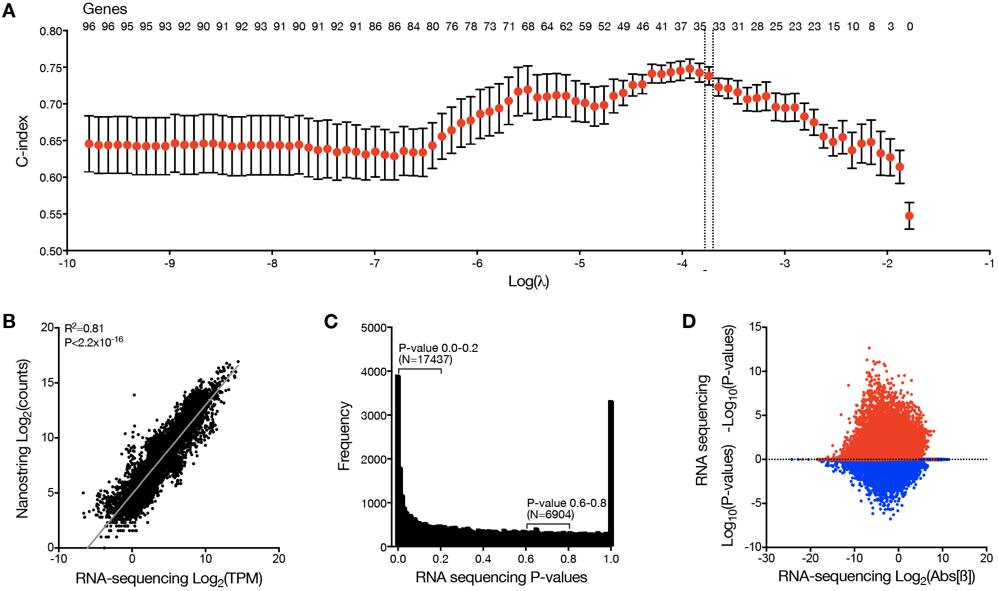Panel A shows concordance index (c-index) for LFFR models based on meningioma Nanostring targeted gene expression profiling plotted against the log of the lambda parameter during algorithm training. Error bars show 95% confidence intervals. Candidate model performance was estimated using 10-fold cross validation in the UCSF discovery cohort (N=173). An optimal gene set (N=34 genes, dotted lines Table S3) was selected within 1 standard error of the model achieving maximal c-index to reduce over-fitting. The number of genes in each model is displayed at the top of the graph. In order to further reduce over-fitting, improve calibration and stability, and facilitate risk score calculations using FFPE meningiomas or gene expression quantification from RNA sequencing or microarrays (Figure S4), bootstrap aggregation⁶ was used to train 500 ridge-regression sub-models using the normalized and log-transformed gene counts as inputs and discovery cohort risk scores between 0 and 1 as target variables. In brief, this procedure nominates a bootstrap aggregated risk score defined as the arithmetic mean across sub-model risk scores. Panel B shows log₂ values for Nanostring counts or RNA sequencing data (transcripts per million, TPM) for the 34 genes comprising the gene expression risk score in the frozen meningioma from the UCSF discovery cohort (N=173), revealing high concordance with an R²=0.81 (P<2.2x10⁻¹⁶). As an orthogonal measure of validation, a non-regularized Cox model for LFFR using RNA sequencing TPMs for the same 34 genes also achieved excellent performance in the UCSF discovery cohort (N=173 meningiomas, LFFR c-index 0.89 ± 0.02, OS c-index 0.84 ± 0.02), and significantly outperformed 10,000 randomly sampled sets of 34 genes (bootstrap P<0.0001). Panel C shows barriers to using RNA sequencing for targeted gene expression biomarker discovery in contrast to successes in using RNA sequencing for targeted gene expression biomarker validation (as described for the previous panel and shown in Figure S4). The distribution of univariate LFFR Cox model P-values for all RNA sequencing genes in the UCSF discovery cohort are shown (N=58,830 genes, N=173 meningiomas). A background uniform distribution of P-values is evident, with a peak towards lower P-values. 6904 P-values were distributed between 0.6 and 0.8, serving as an estimate of the background P-value frequency within a similar interval. Thus, between P=0.0 and 0.2, at least 6904 of 17437 P-values (40%) could be expected to be false positives rather than related to true biological or clinical significance. The true and false detection rate of biologically and clinically meaningful genes using RNA sequencing is complex to estimate, but spike-in experiments and simulations report false discovery rates across bioinformatic methods and experimental conditions between 10-75%, depending on the ground-truth prevalence of differentially-expressed genes³⁶. Panel D shows additional barriers to using RNA sequencing for targeted gene expression biomarker discovery. Log₁₀ $β$ coefficient magnitudes (red for positive coefficients, blue for negative coefficients) versus log₂ transformed P-values from individual Cox models for all RNA sequencing genes from the UCSF discovery cohort are shown, again demonstrating challenges with feature selection using sparse observations in high dimensional space. Methods of dimensional reduction such as gene-set/pathway enrichment analysis or network and clustering analyses represent important research developments, but the reproducibility and clinical applicability of these methods for developing clinically relevant or robust biomarkers is yet to be well established despite prior efforts³⁷. Despite the limitations in using unsupervised transcriptomics to discover or develop clinical biomarkers, we show RNA sequencing can be used to deploy the 34-gene expression biomarker for meningiomas that was developed using Nanostring targeted gene expression profiling (Figure S4).
We previously published results from a small pilot study investigating the feasibility of targeted gene expression profiling for estimating meningioma prognosis⁵, using 96 meningiomas from UCSF as a discovery cohort (25 overlapping with the discovery cohort in the current study). This pilot study suggested targeted gene expression profiling may be useful for meningioma risk stratification, but was limited in several significant ways. First, the pilot study was comprised a very small sample size with very few events. Second, the Nanostring gene expression panel in our pilot study was a generic gene panel and was not tailored for meningioma biology. Most importantly, there were no meningioma specific reference or housekeeping genes in the panel of our pilot study. As a result, the method of normalization in our pilot prior study involved a global z-score across all genes within the panel, which was feasible due to the relatively large size of the pilot panel (N=266 genes). This method, however, may not be as effective for reproducibility in a clinical setting, when assessment of batch effect is not possible in an “N of one” sample. Thus, among the advances made in our current study is the identification and use of stable reference genes for within-sample normalization, and the demonstration of robustness across both frozen and FFPE samples and in multiple batches across time (Figure S4). Because of these fundamental differences in normalization and gene panel size, the algorithms for generation of risk scores in our pilot study and in the current study are not directly comparable, beyond a comparison of the genes selected. Overlapping genes between the 2 signatures were limited to 9 genes (COL1A1, MMP9, PIM1, IGF2, KDR, CCND2, CCN1, TMEM30B, PGR). A superficial comparison by training of Cox regression models with the 34-gene signature we report in the current study resulted in a higher c-index (0.82) as compared to the prior 36 gene signature (0.78), among samples with overlapping gene expression data encompassing the older signature (N=530 meningiomas).
Figure S2. Gene expression biomarker characteristics in the discovery cohort.
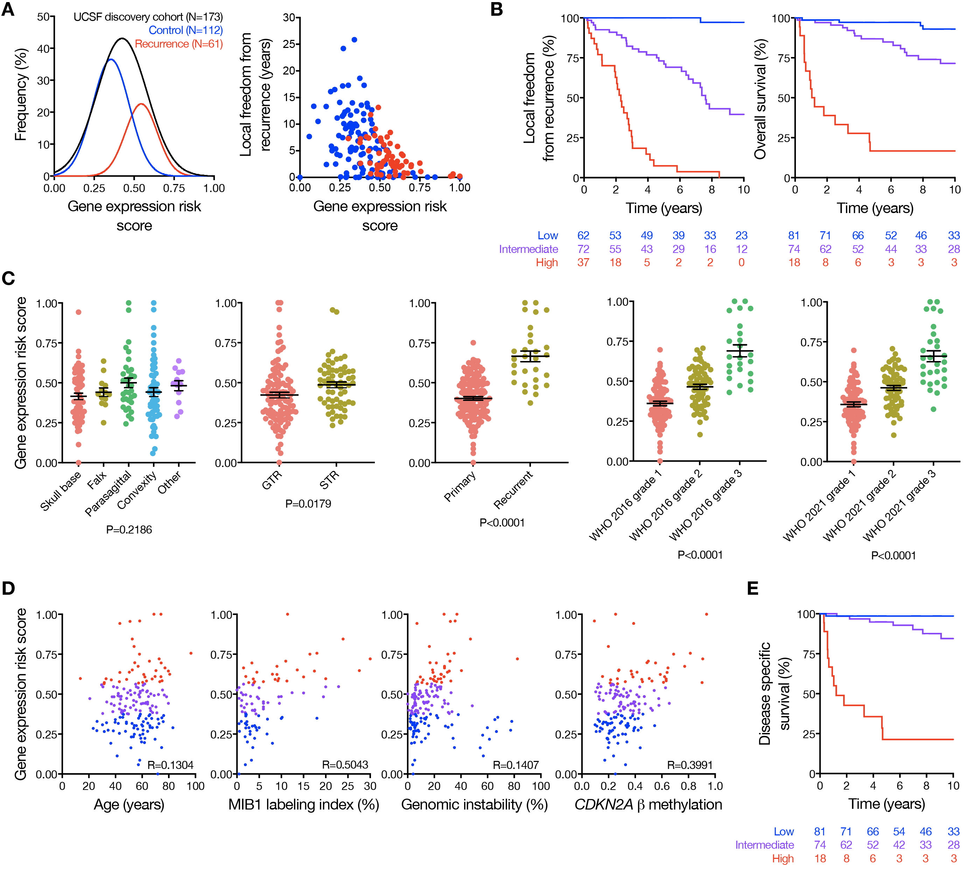Panel A shows Gaussian fits to the distribution of gene expression risk scores within the UCSF discovery cohort, stratified by cases with local recurrence (red) or without local recurrence (blue) on clinical follow up. The gene expression risk score was also plotted against the time to censorship or local recurrence (right), and higher risk score correlated with greater risk of local recurrence and shorter time to recurrence. Panel B shows Kaplan Meier curves for local freedom from recurrence or overall survival in the UCSF discovery cohort stratified by the gene expression risk score. Panel C shows gene expression risk score distributions stratified by clinical characteristics in the UCSF discovery cohort. There was no significant difference across meningioma locations (P=0.21), but gene expression risk scores were higher among subtotally resected meningiomas (P=0.02), recurrent meningiomas (P<0.0001), and were stratified by WHO 2016 or 2021 grade (P<0.0001). Panel D shows UCSF discovery cohort gene expression risk score scatter plots across clinical or molecular variables associated with meningioma biology or outcomes (blue, low risk; purple, intermediate risk; red, high risk). There was no clear association between patient age and gene expression risk score, but risk score was loosely correlated with MIB1 labeling index³⁸, genomic instability as defined by the proportion of non-centromeric, non-acrocentric chromosomes affected by copy number gain or loss³⁹, and DNA methylation of the CDKN2A locus⁷. Thus, the gene expression biomarker correlated with surrogate markers of aggressive meningiomas. Panel E shows disease specific survival among patients in the UCSF discovery cohort stratified by gene expression risk score.
Figure S3. Gene expression biomarker across somatic short variants in the discovery cohort.
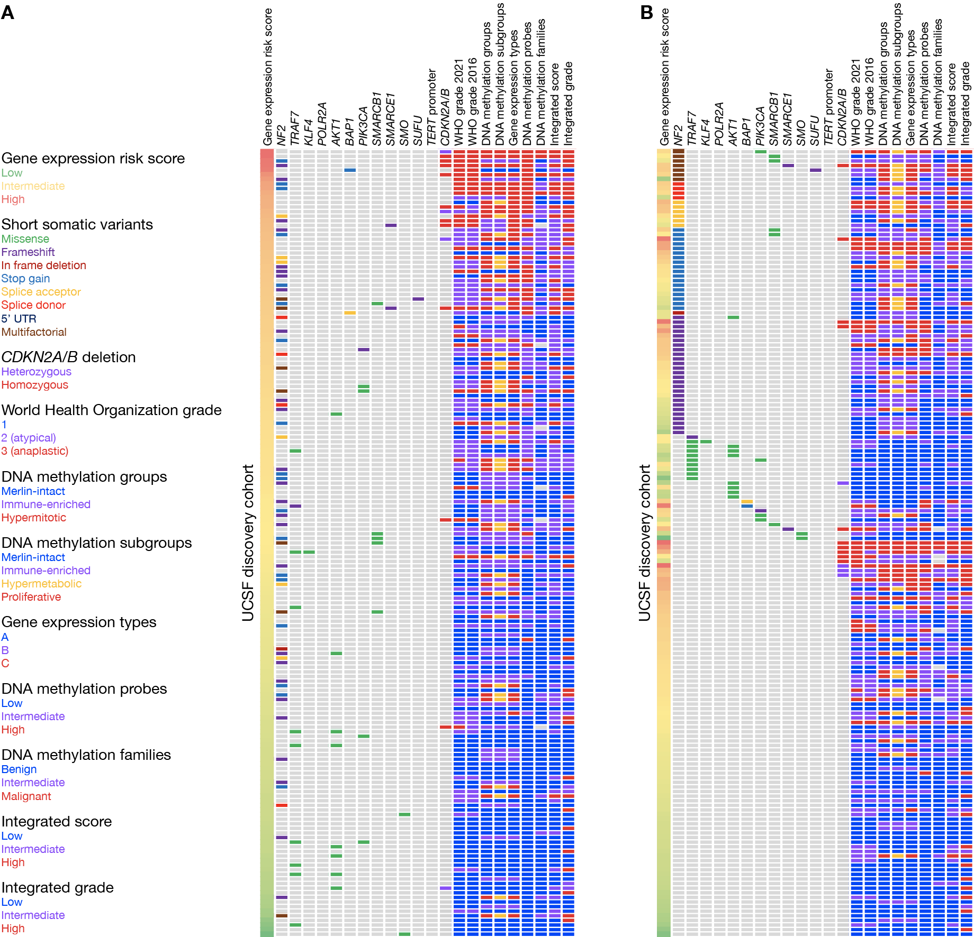Targeted DNA sequencing of recurrent somatic short variants was performed on 171 meningiomas from the UCSF discovery cohort (98.8%). Panel A shows an oncoplot distribution of identified pathogenic short somatic variants with variant allele frequency (VAF) of at least 5.0% (N=98 variants, median VAF 38.0%, interquartile range [IQR] 29-43%, median sequencing depth 551.5, IQR 354-856). Consistent with prior reports, variants in NF2 were most common (N=67, 39.2%), followed by TRAF7 (N=10, 5.8%) and AKT1 (N=8, 4.7%). A minority of meningiomas (N=16, 9.4%) were identified without alteration of NF2 or loss of chromosome 22q, but with a characteristic pathogenic variant in one of the following genes: TRAF7, AKT1, PIK3CA, SMARCB1, SMARCE1, SMO, SUFU, KLF4, or POLR2A. The majority of these were WHO 2021 grade 1 meningiomas (N=9, 60.0%), and were associated with favorable histologic characteristics and outcomes (median MIB1 labeling index 2.0%, range 0.5-4.0, 5-year LFFR 90.9%). TERT promoter C228T and C250T hotspot mutations were not identified in the discovery cohort. BAP1 mutations were rare (N=5, 2.9%) and correlated with high histological grade and poor outcomes (N=3 [60.0%] WHO 2016 grade 2 or 3, 5-year LFFR 40.0%). Homozygous CDKN2A/B loss, derived from meningioma DNA CNVs (Supplemental Methods), was identified in 10 meningiomas from the UCSF discovery cohort (5.8%, 80.0% WHO 2016 grade 3, 20.0% WHO 2016 grade 2) and was associated with poor outcomes (5-year LFFR 14.2%). These findings were supported by targeted DNA sequencing of recurrent somatic short variants in 35 consecutive clinical validation cohort meningiomas from The University of Hong Kong using the same approach. Panel B shows the same oncoplot from the UCSF discovery cohort but ordered by VAF instead of gene expression risk score.
Figure S4. Gene expression biomarker characteristics in the analytical validation cohort.
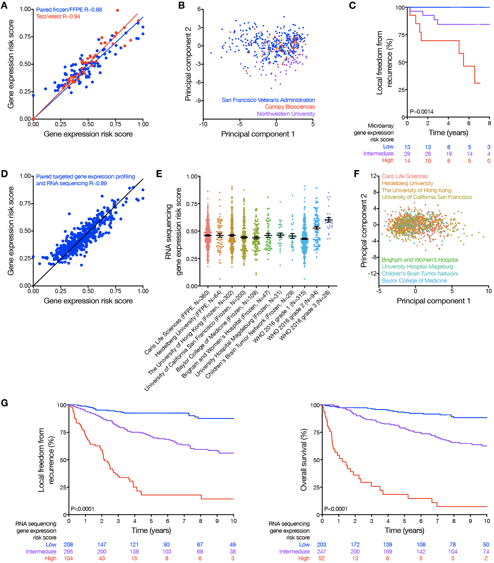
Panel A shows gene expression risk score concordance across multiple conditions and replicates. Test-retest conditions (combined N=44, R=0.94, P<0.0001) were comprised of varying probe batches (N=10, R=0.98, P<0.0001), within probe batch testing of technical replicates (N=12, R=0.98, P<0.0001), and test-retest conditions for meningiomas with serial RNA extraction on the same FFPE block or frozen tumor chunk at least 4 weeks apart (N=22, R=0.94, P<0.001). Gene expression risk scores on paired frozen/FFPE meningiomas also demonstrated high concordance (N=90, R=0.88, P<0.001), and FFPE gene expression risk scores provided excellent discrimination of outcomes across FFPE clinical validation datasets, including a prospective clinical trial (Figures 2, 3, 5, S5, S6, S8). Panel B shows principal component analysis on FFPE gene expression risk scores from meningiomas processed at multiple laboratories spanning academic institutions (Northwestern University, San Francisco Veterans Administration) or Clinical Laboratory Improvement Amendments (CLIA) certified private industry (Canopy Biosciences), demonstrating no laboratory batch effects. Panel C shows publicly available microarray and clinical data that were used to test the performance of the gene expression risk score on a non-Nanostring platform (N=33 of 34 genes available). No paired microarray/Nanostring data was available to train a calibration model, which precluded direct comparison. Thus, the RNA sequencing calibration model described below (and described in further detail in the Supplemental Methods) was adapted to microarray data as an exploratory analysis, yielding prognostic risk groups as shown in the Kaplan Meier plot. Panel D shows concordance of gene expression risk scores derived from RNA sequencing or Nanostring targeted gene expression profiling on the same meningiomas (N=475 meningiomas, R=0.89, P<0.0001). Panel E shows the distribution of gene expression risk scores derived from RNA sequencing of cohorts overlapping (UCSF, The University of Hong Kong, N=502) or non-overlapping (Caris Life Sciences, Heidelberg University, Brigham and Women’s Hospital, University Hospital Magdeburg, Children’s Brain Tumor Network, Baylor College of Medicine, N=640) with the discovery or clinical validation cohorts, comprising 1142 unique meningiomas. Gene expression risk scores remained well distributed across all datasets, including RNA sequencing of pediatric meningiomas (Children’s Brain Tumor Network, N=29), meningiomas with KLF4 or AKT1 somatic short variants⁴⁰ (University Hospital Magdeburg, N=31), or FFPE (N=428) or frozen (N=718) meningiomas, and demonstrated similar stratification by WHO histological grade (2016) as with Nanostring targeted gene expression profiling analyses (Figure S2C). Panel F shows principal component analysis of gene expression risk scores across RNA sequencing cohorts after correction for batch effects using the COMBAT⁴¹ pipeline in the sva package in R. Panel G shows local freedom from recurrence or overall survival stratified by gene expression risk scores from RNA sequencing of cohorts with available clinical data (UCSF discovery, The University of Hong Kong, and Baylor College of Medicine).
Figure S5. Gene expression biomarker characteristics in the clinical validation cohort.
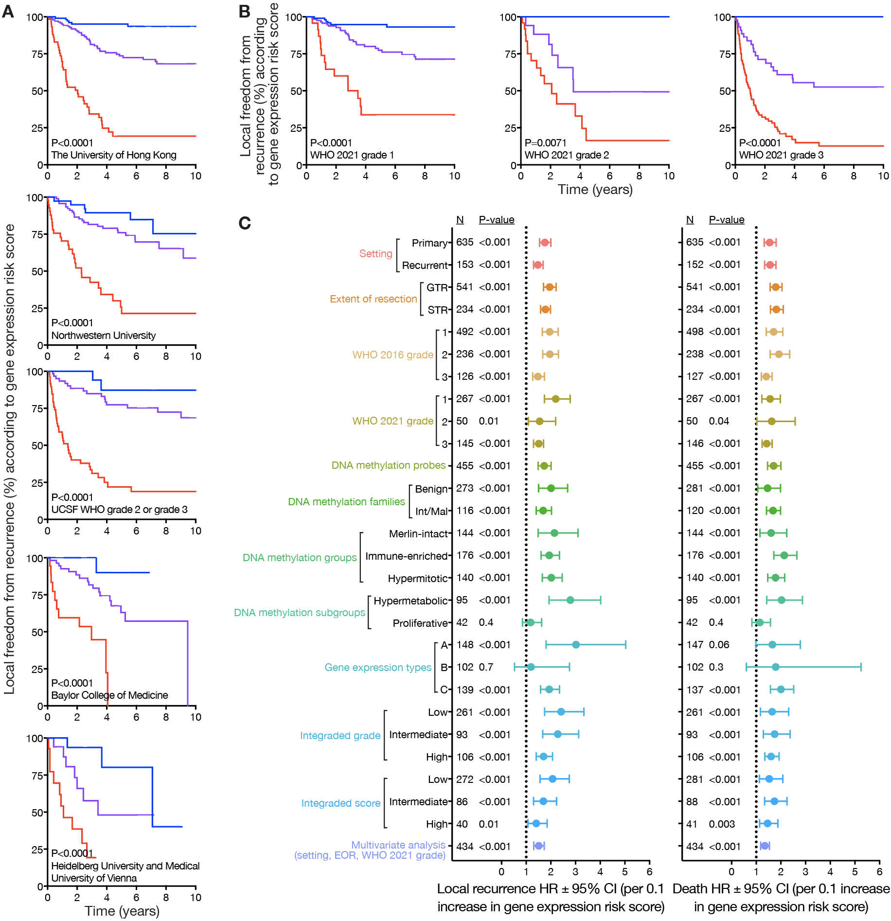Panel A shows Kaplan Meier curves for local freedom from recurrence stratified by gene expression risk score (blue lines, low risk; purple lines, intermediate risk; red lines, high risk) for individual clinical validation cohorts, including The University of Hong Kong (Frozen N=339; low risk N=122, 5-year LFFR 95.1%; intermediate risk N=151, 5-year LFFR 73.6%; high risk N=66, 5-year LFFR 19.5%), Northwestern University (Frozen and FFPE N=180; low risk N=42, 5-year LFFR 90.0%; intermediate risk N=98, 5-year LFFR 76.0%; high risk N=42, 5-year LFFR 21.4%), UCSF WHO grade 2 or grade 3 (FFPE N=158; low risk N=24, 5-year LFFR 87.4%; intermediate risk N=69, 5-year LFFR 77.5%; high risk N=65, 5-year LFFR 22.0%), Baylor College of Medicine (Frozen N=116; low risk N=35, 5-year LFFR 90.0%; intermediate risk N=61, 5-year LFFR 63.0%; high risk N=20, 5-year LFFR 0.0%), and Heidelberg University plus the Medical University of Vienna (FFPE N=61 with LFFR data; low risk N=24, 5-year LFFR 80.4%; intermediate risk N=23, 5-year LFFR 48.1%; high risk N=14, 5-year LFFR 19.3%). The gene expression risk score remained well calibrated across multiple independent clinical validation cohorts comprising both frozen and FFPE meningiomas. When assessed separately within each independent retrospective cohort site, the gene expression risk score remained independently prognostic in multivariate analysis combining the risk score with WHO 2016 grade (P<0.001 in all cases). Panel B shows Kaplan Meier curves for local freedom from recurrence in clinical validation cohort meningiomas stratified by gene expression risk score within WHO 2021 grades, demonstrating that the gene expression biomarker remained discriminatory across WHO 2021 grade 1 (low risk N=114, intermediate risk N=127, high risk N=26), WHO 2021 grade 2 (low risk N=7, intermediate risk N=17, high risk N=26), and WHO 2021 grade 3 meningiomas (low risk N=2, intermediate risk N=46, high risk N=98). Panel C shows forest plots of hazard ratios (HR) with 95% confidence intervals (CI) for local recurrence (left) or death (right) for each 0.1 increase in gene expression risk score. The gene expression biomarker was prognostic across all molecular classification systems tested for both recurrence and survival. HRs according to gene expression risk score across meningioma settings, extent of resection (EOR), and WHO grades from Figure 2B are re-presented for ease of comparison to HRs in molecular classification systems. LFFR concordance index (c-index) for the gene expression biomarker was 0.78, while LFFR c-index was 0.68 for WHO 2016 grade, 0.72 for WHO 2021 grade, 0.72 for integrated score, 0.72 for integrated grade, 0.68 for DNA methylation groups, 0.69 for DNA methylation subgroups, 0.74 for DNA methylation probes, and 0.70 for gene expression type. OS c-index for the gene expression biomarker was 0.78, while OS c-index was 0.72 for WHO 2016 grade, 0.74 for WHO 2021 grade, 0.73 for integrated score, 0.75 for integrated grade, 0.66 for DNA methylation groups, 0.68 for DNA methylation subgroups, 0.73 for DNA methylation probes, and 0.70 for gene expression type.
Figure S6. Molecular classification comparisons in the clinical validation cohort.
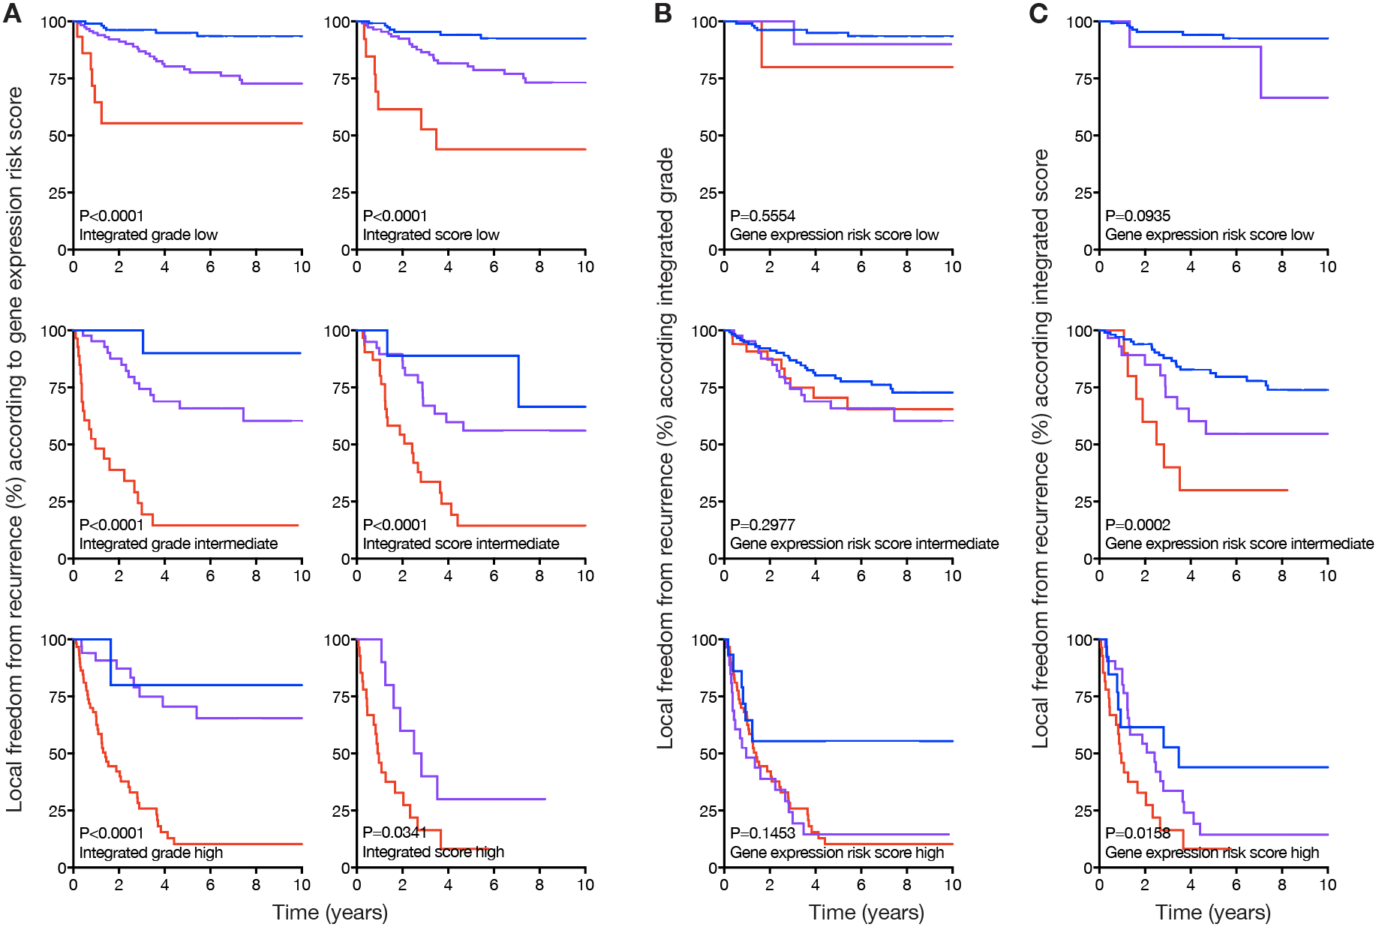
Kaplan Meier curves are shown for local freedom from recurrence in clinical validation cohort meningiomas stratified by molecular risk groups (blue lines, low risk; purple lines, intermediate risk; red lines, high risk) using the gene expression biomarker in Panel A, or 2 contemporary supervised meningioma classification systems based on combined molecular and clinical features: integrated grade¹⁸ based on CNVs and mitoses in Panel B, or integrated score¹⁷ based on CNVs, DNA methylation families¹⁶, and WHO 2016 grade in Panel C. In Panel A, the gene expression biomarker remained robustly discriminatory across integrated grade or integrated score risk groups, concordant with the independent prognostic value of the gene expression risk score on multivariate analyses (Tables S10 and S11) and within groups from the 6 other molecular and/or histological classification systems tested (Figure 3A). The converse was examined in Panels B and C, where integrated grade was unable to discriminate outcomes across gene expression risk score groups, and integrated score had limited discriminatory power for intermediate and high gene expression risk score groups and was not discriminatory for low gene expression low risk groups.
Figure S7. Gene expression biomarker nomograms for meningioma outcomes
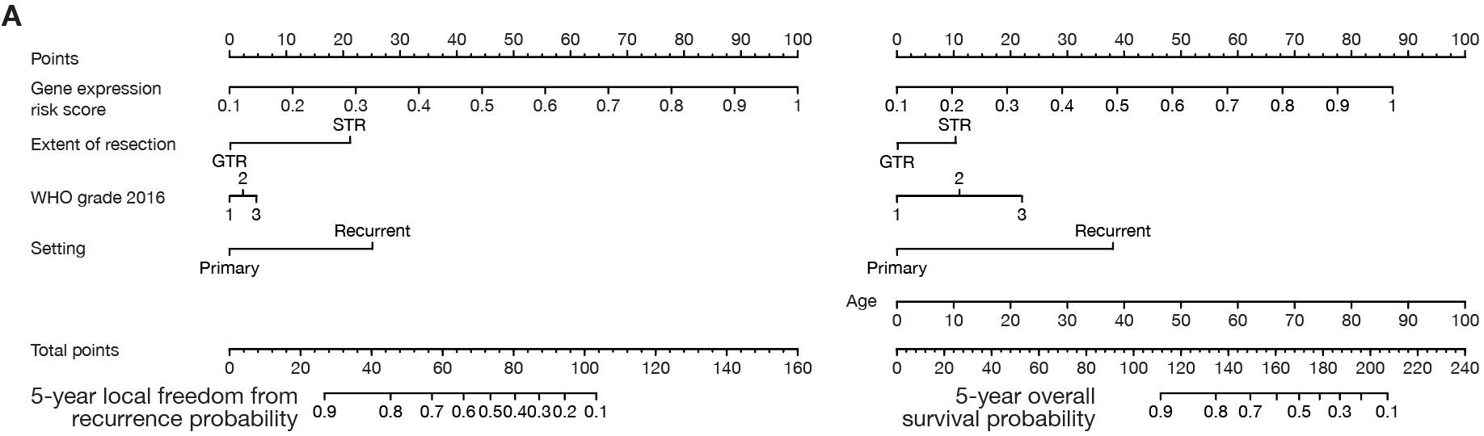
Nomograms are shown for prediction of 5-year local freedom from recurrence or overall survival based on gene expression risk score, extent of resection, setting, and WHO 2016 histologic grade.
Figure S8. Molecular classification systems and response to treatment.
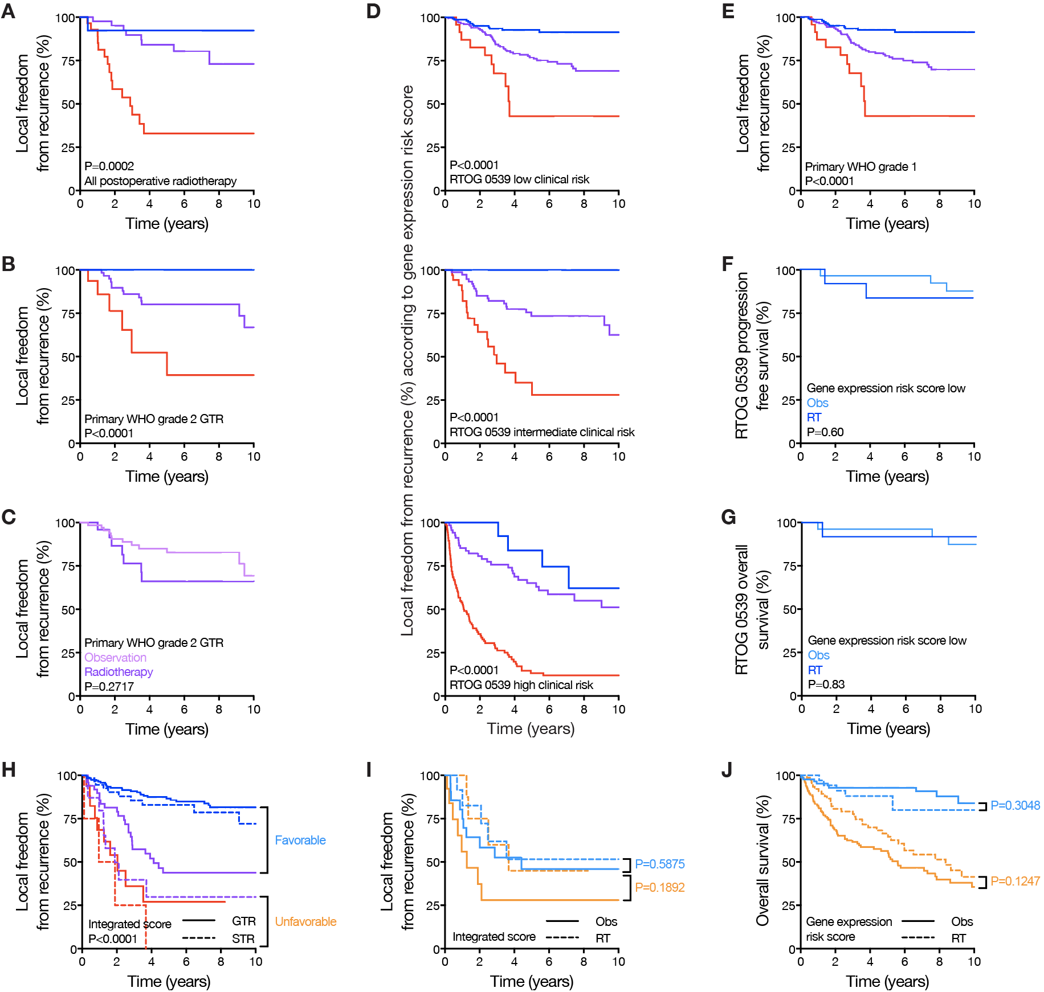
Kaplan Meier curves are shown for local freedom from recurrence or overall survival in retrospective clinical validation cohort meningiomas or prospective RTOG 0539 meningiomas, stratified by gene expression risk score (blue lines, low risk; purple, intermediate risk lines; red lines, high risk), extent of resection, postoperative observation (Obs), or postoperative radiotherapy (RT). Panel A shows primary retrospective clinical validation cohort meningiomas receiving postoperative external beam radiotherapy (N=89) stratified by gene expression risk score (low risk N=14, intermediate risk N=45, high risk N=30), revealing the gene expression biomarker remained prognostic among patients receiving postoperative radiotherapy. Panel B shows primary WHO 2016 grade 2 meningiomas with GTR from the retrospective clinical validation cohort stratified by gene expression risk score (N=21 low risk, N=63 intermediate risk, N=18 high risk). The gene expression risk score remained prognostic among gross totally resected primary WHO grade 2 meningiomas (N=102, HR for local recurrence of 1.75 per 0.1 increase, 95% CI 1.18-2.59, P=0.0057). Panel C shows primary WHO grade 2 meningiomas with GTR from the retrospective clinical validation cohort stratified by postoperative radiotherapy (N=28) or observation (N=74). Patients with meningiomas meeting these criteria are eligible for 2 ongoing Phase III randomized multi-institutional trials (BN003 and ROAM-EORTC 1308) examining clinical outcomes with postoperative radiotherapy versus observation. Postoperative radiotherapy did not offer a benefit to patients with meningiomas meeting these criteria in the retrospective clinical validation cohort. Panel D shows retrospective clinical validation cohort meningiomas stratified by gene expression risk score across RTOG 0539 clinical risk groups (low clinical risk, primary WHO grade 1 meningiomas; intermediate clinical risk, recurrent WHO grade 1 meningiomas or primary WHO grade 2 meningiomas status post GTR; high clinical risk, recurrent or STR WHO grade 2 meningiomas or WHO grade 3 meningiomas after any resection). The gene expression biomarker remained prognostic across RTOG 0539 low clinical risk (gene expression risk score low risk N=173, intermediate risk N=224, high risk N=27), RTOG 0539 intermediate clinical risk (gene expression risk score low risk N=32, intermediate risk N=80, high risk N=38), and RTOG 0539 high clinical risk groups (gene expression risk score low risk N=16, intermediate risk N=75, high risk N=128). Panel E shows primary WHO grade 1 meningiomas from the retrospective clinical validation cohort stratified (equivalent to RTOG 0539 low clinical risk meningiomas) stratified by gene expression risk score (N=173 low risk, N=224 intermediate risk, N=27 high risk, 5-year LFFR 92.7%, 77.3%, and 43.0% for low, intermediate, or high risk meningiomas, respectively). Panels F and G show prospective validation cohort meningiomas from RTOG 0539 identified as low risk by the gene expression biomarker stratified by postoperative radiotherapy (N=12 WHO 2016 grade 2 or 3 or recurrent WHO 2016 grade 1 meningiomas) or observation (N=27 primary WHO 2016 grade 1 meningiomas). These analyses showed favorable outcomes for prospectively collected meningiomas with low gene expression risk scores across clinical risk strata, consistent with findings from retrospective clinical validation cohort meningiomas. More broadly, these data support the hypothesis that the gene expression biomarker may be useful for identifying meningiomas where postoperative radiotherapy could be safely omitted, even in the setting of conventionally high risk clinical features. Panel H shows meningiomas treated with surgical monotherapy from the retrospective clinical validation cohort stratified by integrated score¹⁷ (the only contemporary molecular classification system potentially providing additional prognostic information for LFFR within gene expression biomarker strata, Figure S6C) and extent of resection. Favorable (light blue) and unfavorable (yellow) groups were identified using the same criteria for identification of biomarker/surgical strata (Figure 5A). Panel I shows favorable and unfavorable strata based on integrated score were unable to identify meningiomas benefitting from postoperative radiotherapy even after propensity matching on integrated score, extent of resection, and WHO 2016 grade. Panel J shows overall survival in the same meningiomas as Figure 5C (i.e. propensity matched favorable and unfavorable retrospective clinical validation cohort meningiomas based on biomarker/surgical strata), demonstrating a trend towards benefit with postoperative radiotherapy for unfavorable meningiomas.
Table S1. Targeted gene expression biomarker discovery panel.
Context | Gene | NCBI Standard ID (RefSeq)
Meningioma | APEX2 | NM_014481.3:1990
Meningioma | AREG | NM_001657.2:547
Meningioma | ARID1B | NM_020732.3:6335
Meningioma | AURKA | NM_003600.2:405
Meningioma | AURKB | NM_004217.2:615
Meningioma | BIRC5 | NM_001168.2:1215
Meningioma | BMI1 | NM_005180.5:1145
Meningioma | BMP4 | NM_001202.3:659
Meningioma | BMPR1A | NM_004329.2:1720
Meningioma | BRIP1 | NM_032043.2:2512
Meningioma | CCL21 | NM_002989.2:180
Meningioma | CCN1 | NM_001554.3:1390
Meningioma | CCN2 | NM_001901.2:1100
Meningioma | CCNA2 | NM_001237.2:1210
Meningioma | CCNB1 | NM_031966.3:1102
Meningioma | CCND2 | NM_001759.2:5825
Meningioma | CCND3 | NM_001760.2:1215
Meningioma | CD3E | NM_000733.2:75
Meningioma | CDC20 | NM_001255.2:430
Meningioma | CDC25A | NM_001789.2:1229
Meningioma | CDC25C | NM_001287582.1:1944
Meningioma | CDK1 | NM_001786.4:178
Meningioma | CDK4 | NM_000075.2:1055
Meningioma | CDK6 | NM_001259.6:2404
Meningioma | CDKN2A | NM_000077.4:559
Meningioma | CDKN2C | NM_001262.2:1295
Meningioma | CDKN3 | NM_005192.3:510
Meningioma | CENPF | NM_016343.3:5822
Meningioma | CHEK1 | NM_001114121.1:2225
Meningioma | CKS2 | NM_001827.1:195
Meningioma | COL1A1 | NM_000088.3:5210
Meningioma | CXCL8 | NM_000584.2:25
Meningioma | DRAM1 | NM_018370.2:1730
Meningioma | DTL | NM_016448.2:715
Meningioma | E2F2 | NM_004091.3:1104
Meningioma | EME1 | XM_011524392.1:416
Meningioma | ERCC4 | NM_005236.2:1700
Meningioma | ESR1 | NM_000125.2:1595
Meningioma | EZH2 | NM_001203247.1:1121
Meningioma | FANCB | NM_001018113.2:238
Meningioma | FBLIM1 | NM_001024215.1:976
Meningioma | FGF18 | NM_003862.1:850
Meningioma | FGFR4 | NM_002011.3:1585
Meningioma | FGR | NM_001042747.1:890
Meningioma | FLT1 | NM_002019.4:530
Meningioma | FOXK2 | NM_004514.3:4220
Meningioma | FOXM1 | NM_202002.1:1000
Meningioma | GAS1 | NM_002048.2:1525
Meningioma | GATA3 | NM_001002295.1:1691
Meningioma | GPHA2 | NM_130769.3:274
Meningioma | IFNGR1 | NM_000416.1:1140
Meningioma | IGF2 | NM_000612.4:765
Meningioma | KDR | NM_002253.2:1420
Meningioma | KIF14 | NM_014875.2:4335
Meningioma | KIF20A | NM_005733.2:1209
Meningioma | KRT14 | NM_000526.4:523
Meningioma | L1CAM | NM_024003.2:3240
Meningioma | LINC02593 | NR_026874.2:685
Meningioma | LYVE1 | NM_006691.3:1422
Meningioma | MCM4 | NM_182746.1:1200
Meningioma | MCM6 | NM_005915.4:515
Meningioma | MDM4 | NM_001204172.1:346
Meningioma | MKI67 | NM_002417.2:4020
Meningioma | MMP9 | NM_004994.2:1530
Meningioma | MPL | NM_005373.2:895
Meningioma | MUTYH | NM_001293196.1:1288
Meningioma | MYBL1 | NM_001080416.3:1030
Meningioma | MYBL2 | NM_002466.2:445
Meningioma | NDRG2 | NM_016250.2:1515
Meningioma | NF2 | NM_000268.3:1895
Meningioma | NOTCH2 | NM_024408.3:2842
Meningioma | NOTCH3 | NM_000435.2:1965
Meningioma | NQO1 | NM_000903.2:790
Meningioma | NRAS | NM_002524.3:877
Meningioma | PGK1 | NM_000291.2:1030
Meningioma | PGR | NM_000926.4:2392
Meningioma | PIM1 | NM_002648.2:1630
Meningioma | PINK1 | NM_032409.2:1610
Meningioma | PLAUR | NM_001005376.2:538
Meningioma | PTEN | NM_000314.3:1675
Meningioma | PTPRK | NM_001135648.1:472
Meningioma | PTTG1 | NM_004219.2:542
Meningioma | RACGAP1 | NM_013277.3:1850
Meningioma | RAD51 | NM_133487.2:566
Meningioma | RAD51AP1 | NM_001130862.1:1125
Meningioma | RAD51C | NM_002876.2:300
Meningioma | REL | NM_002908.3:2067
Meningioma | SAMD11 | NM_152486.2:280
Meningioma | SFRP4 | NM_003014.2:1060
Meningioma | SLC7A8 | NM_001267036.1:2662
Meningioma | SMARCE1 | NM_003079.4:690
Meningioma | SOS2 | NM_006939.2:3845
Meningioma | SPOP | NM_001007226.1:1400
Meningioma | SPP1 | NM_000582.2:760
Meningioma | TAGLN | NM_003186.3:260
Meningioma | TERT | NM_198253.1:2570
Meningioma | TMEM30B | NM_001017970.2:2420
Meningioma | TOP2A | NM_001067.3:3563
Meningioma | TRIM37 | NM_015294.4:1910
Meningioma | TROAP | NM_001100620.2:127
Meningioma | USF1 | NM_007122.3:1516
Housekeeping | ACTB | NM_001101.2:1010
Housekeeping | AK3 | NM_016282.2:450
Housekeeping | B2M | NM_004048.2:235
Housekeeping | CASC3 | NM_007359.3:3505
Housekeeping | COQ4 | NM_016035.3:114
Housekeeping | GUSB | NM_000181.3:1899
Housekeeping | HPRT1 | NM_000194.1:240
Housekeeping | LDHA | NM_001165414.1:1690
Housekeeping | LNPK | NM_030650.1:1144
Housekeeping | MRPL19 | NM_014763.3:364
Housekeeping | NUDT2 | NM_147173.1:445
Housekeeping | POP4 | NM_006627.1:765
Housekeeping | PPIA | NM_021130.3:315
Housekeeping | RAPGEF1 | NM_005312.2:1705
Housekeeping | RETREG2 | NM_024293.4:2341
Housekeeping | RPL19 | NM_000981.3:315
Housekeeping | RPLP0 | NM_001002.3:250
Housekeeping | SCRN3 | NM_001193528.1:564
Housekeeping | SDHA | NM_004168.1:230
Housekeeping | SMC5 | NM_015110.3:236
Housekeeping | TTC21B | NM_024753.4:916
Housekeeping | UBQLN1 | NM_053067.2:990
Housekeeping | UXS1 | NM_001253875.1:986
Housekeeping | VCP | NM_007126.2:615
Table S2. UCSF discovery cohort characteristics.
Meningiomas - no. | 173
Patients - no. | 166
Females - no. (%) | 112 (67.5)
Median age (IQR) - yr. | 57.0 (45.0-65.1)
Setting - no. (%)
Primary | 143 (82.7)
Recurrent | 30 (17.3)
Extent of resection - no. (%)
Gross total | 110 (63.6)
Subtotal | 63 (36.4)
WHO 2016 grade - no. (%)
1 | 83 (50.0)
2 | 65 (37.6)
3 | 25 (14.4)
WHO 2021 grade - no. (%)
1 | 82 (47.4)
2 | 62 (35.8)
3 | 29 (16.8)
TERT promoter sequencing* | 171 (98.8)
C228T mutant | 0 (0.0)
C250T mutant | 0 (0.0)
Other SNV | 0 (0.0)
Copy number variants (including CDKN2A/B zygosity) | 173 (100)
CDKN2A/B deletion (heterozygous/homozygous) | 5 (2.9)/13 (7.5)
DNA methylation profiling - no. (%) | 173 (100)
RNA sequencing | 173 (100)
Nanostring targeted gene expression profiling - no. (%) | 173 (100)
Gene expression risk score - no. (%)
Low | 63 (36.4)
Intermediate | 72 (41.6)
High | 38 (22.0)
Postoperative radiotherapy - no. (%) | 33 (19.1)
Median follow up (IQR) - yr.** | 8.1 (3.9-11.9)
Local recurrence - no. (%) | 61 (35.3)
Death - no. (%)
Meningioma | 24 (13.8)
Other | 11 (6.4)
Unknown | 11 (6.4)
*TERT promoter sequencing was performed using next generation targeted sequencing.
**Estimated using the reverse Kaplan Meier method. Median clinical follow up time to survival events or censorship was 7.4 years. Median time to censorship among surviving patients without meningioma recurrence was 6.8 years. Median imaging follow up among patients without recurrence was 5.7 years. Median time to local recurrence was 2.8 years. Dates of surgery ranged between November 1991 and July 2016. Nucleic acids were extracted from frozen meningiomas.
Table S3. Optimized gene expression biomarker panel.
Gene | Function | Chr | Band | Expression in meningiomas with worse clinical outcomes | Reference PMID
ARID1B | Chromatin regulation, tumor suppressor | 6 | q25.3 | Suppressed | 28195122, 30202034
CCL21 | Meningeal lymphatics | 9 | p13.3 | Enriched | 35534562
CCN1 | Growth factor signaling, cell proliferation, preliminary gene expression risk score component | 1 | p22.3 | Suppressed | 32860417, 20685720
CCND2 | Cell proliferation, preliminary gene expression risk score component | 12 | p13.32 | Suppressed | 32860417, 20386868
CD3E | Meningeal lymphatics | 11 | q23.3 | Suppressed | 35534562
CDC20 | Cell proliferation | 1 | p34.2 | Enriched | 20015288, 28195122, 24724603
CDK6 | Cell proliferation | 7 | q21.2 | Suppressed | 18048012, 29391485, 25148008
CDKN2A | Inhibits cell proliferation | 9 | p21.3 | Enriched | 21168406, 11485924
CDKN2C | Inhibits cell proliferation | 1 | p32.3 | Suppressed | 11485924
CHEK1 | Cell cycle regulation, DNA damage response | 11 | q24.2 | Enriched | 20015288, 21945852
CKS2 | Cell proliferation, preliminary gene expression risk score component | 9 | q22.2 | Enriched | 32860417, 20015288, 21948653
COL1A1 | Extracellular matrix, invasion, migration, preliminary gene expression risk score component | 17 | q21.33 | Enriched | 32860417, 23285163, 27096627
ESR1 | Estrogen hormone signaling | 6 | q25.1 | Enriched | 28195122, 25965831
EZH2 | Chromatin and methylation regulation, cell proliferation | 7 | q36.1 | Enriched | 28195122, 32729292, 31591222
FBLIM1 | Chromosome 1p loss marker | 1 | p36.21 | Enriched | 20015288
FGFR4 | Growth factor signaling | 5 | q35.2 | Enriched | 20015288, 28552950, 19918127
GAS1 | Inhibits cell proliferation, preliminary gene expression risk score component | 9 | q21.33 | Suppressed | 32860417, 20386868, 20015288
IFNGR1 | Cytokine signaling, preliminary gene expression risk score component | 6 | q23.3 | Suppressed | 32860417, 32860417
IGF2 | IGF2 signaling, preliminary gene expression risk score component | 11 | p15.5 | Enriched | 32860417, 20386868, 15540215
KDR | Angiogenesis, preliminary gene expression risk score component | 4 | q12 | Suppressed | 30519894, 32860417
KIF20A | Mitotic stability, cell proliferation | 5 | q31.2 | Enriched | 21168406, 30991738
KRT14 | Invasion, migration | 17 | q21.2 | Enriched | 21168406
LINC02593 | Chromosome 1p loss marker | 1 | p36.33 | Suppressed | 21168406
MDM4 | Oncogene, cell proliferation | 1 | q32.1 | Enriched | 21168406, 15540215
MMP9 | Extracellular matrix remodeling, invasion, preliminary gene expression risk score component | 20 | q13.12 | Enriched | 32860417, 20652360, 11702875, 25821815
MUTYH | DNA damage repair, 1p loss marker | 1 | p34.1 | Suppressed | 28195122, 20150366
MYBL1 | Cell proliferation, cell cycle regulation | 8 | q13.1 | Enriched | 32860417
PGK1 | Glycolysis metabolism | X | q21.1 | Enriched | 20015288
PGR | Progesterone hormone signaling, preliminary gene expression risk score component | 11 | q22.1 | Suppressed | 32860417, 15452155, 8443810, 8988089
PIM1 | Oncogene, preliminary gene expression risk score component | 6 | p21.2 | Enriched | 32860417, 21318223
SPOP | Tumor suppressor, ubiquination regulation | 17 | q21.33 | Suppressed | 20015288
TAGLN | Cytoskeletal organization, invasion, migration | 11 | q23.3 | Suppressed | 28195122, 29424888, 15540215, 24289128
TMEM30B | Preliminary gene expression risk score component | 14 | q23.1 | Suppressed | 32860417, 20685720
USF1 | Cell proliferation, transcription factor | 1 | q23.3 | Enriched | 35534562
ACTB | Housekeeping | 7 | p22.1 | N/A | 21806841
CASC3 | Housekeeping | 17 | q21.1 | N/A | 21806841
GUSB | Housekeeping | 7 | q11.21 | N/A | 21806841
KIAA1715 | Housekeeping | 2 | q31.1 | N/A | 17878933
MRPL19 | Housekeeping | 2 | p12 | N/A | 17878933
POP4 | Housekeeping | 19 | q12 | N/A | 17878933
TTC21B | Housekeeping | 2 | q24.3 | N/A | 17878933
Table S4. Analytical and clinical validation cohorts.
Institution | Meningiomas | Data | Analyses | References
Northwestern University | 180 (63 FFPE, 117 frozen) | Clinical follow up, targeted gene expression profiling | Clinical and analytic validation (Figures 2-5, S4-8) | NCBI GEO accession number GSE222054
Caris Life Sciences | 360 FFPE | RNA sequencing without clinical follow up data | Analytical validation (Figure S4) | Github: https://github.com/william-c-chen/Meningioma_GE_Biomarker
The University of Hong Kong | 365 frozen | Clinical follow up, DNA methylation profiling (N=365), CNV and CDKN2A/B profiling (N=365), TERT promoter amplicon sequencing (N=297), targeted exome sequencing (N=35), RNA sequencing (N=302) and targeted gene expression profiling (N=339) | Clinical and analytical validation (Figures 2-5, S4-8) | PMID 35534562 and 36227281, NCBI GEO accession numbers GSE212666 and GSE221029, NCBI SRA accession numbers PRJNA916225 and PRJNA916253
University of California San Francisco | 358 (158 FFPE, 200 frozen) | Clinical follow up, DNA methylation profiling (N=323), CNV and CDKN2A/B profiling (N=323), RNA sequencing (N=200, 173 overlapping with the discovery cohort), targeted DNA sequencing including the TERT promoter (N=171) | Biomarker discovery and analytical validation (Figures 1, S1-4) | PMID 35534562 and 36227281, NCBI GEO accession numbers GSE183656 and GSE221029, NCBI SRA project number PRJNA916253
Baylor College of Medicine | 190 frozen | Clinical follow up, RNA sequencing (N=110) and targeted gene expression profiling (N=116) with partial overlap (N=36) | Clinical and analytical validation (Figures 2-5, S4-8) | PMID 31591222 and 35108039, NCBI GEO accession numbers GSE189673  and GSE222054
Heidelberg University and Medical University of Vienna | 137 FFPE | RNA sequencing (N=64 without clinical follow up data) and targeted gene expression profiling (N=73 with clinical follow up data), DNA methylation profiling (N=73) for integrated score and DNA methylation families | Clinical and analytical validation (Figures 2-5, S4-8) | PMID 28314689, NCBI GEO accession number GSE222054, Github: https://github.com/william-c-chen/Meningioma_GE_Biomarker
University of California Los Angeles | 56 frozen | Clinical follow up, microarray | Analytical validation (Figure S4) | PMID 20015288, NCBI GEO accession number GSE16581
Brigham and Women’s Hospital | 47 frozen | RNA sequencing without clinical follow up data | Analytical validation (Figure S4) | Github: https://github.com/william-c-chen/Meningioma_GE_Biomarker
University Hospital Magdeburg | 31 frozen | RNA sequencing without follow up data, DNA sequencing showing KLF4 or AKT1 mutations | Analytical validation (Figure S4) | PMID 32245394, Github: https://github.com/william-c-chen/Meningioma_GE_Biomarker
Children’s Brain Tumor Network | 29 frozen | RNA sequencing without clinical follow up data | Analytical validation (Figure S4) | https://cavatica.sbgenomics.com/u/cavatica/pbta-cbttc
RTOG 0539 | 103 FFPE | Clinical follow up, targeted gene expression profiling | Clinical validation (Figures 5, S8) | PMID 31786276, 28984517, and 35657335, NCBI GEO accession number GSE222054
Total | 1856 meningiomas
Table S5. The University of Hong Kong clinical validation cohort characteristics.
Meningiomas - no. | 339
Patients - no. | 304
Females - no. (%) | 212 (69.7)
Median age (IQR) - yr. | 58.2 (48.8-68.4)
Setting - no. (%)
Primary | 277 (81.7)
Recurrent | 62 (18.3)
Extent of resection - no. (%)
Gross total | 258 (76.1)
Subtotal | 74 (21.8)
WHO 2016 grade - no. (%)
1 | 277 (81.7)
2 | 57 (16.8)
3 | 5 (1.5)
WHO 2021 grade - no. (%)
1 | 272 (80.2)
2 | 46 (13.6)
3 | 21 (6.2)
Somatic short variant sequencing | 35 (10.3)
TERT promoter sequencing* | 332 (97.9)
C228T mutant | 7 (2.1)
C250T mutant | 0 (0.0)
Other SNV* | 2 (0.6)
Copy number variants (including CDKN2A/B zygosity) | 339 (100)
CDKN2A/B deletion (heterozygous/homozygous) | 7 (2.1)/11 (3.2)
DNA methylation profiling - no. (%) | 339 (100)
RNA sequencing | 296 (87.3)
Nanostring targeted gene expression profiling - no. (%) | 339 (100)
Gene expression risk score - no. (%)
Low | 122 (36.0)
Intermediate | 151 (44.5)
High | 66 (19.5)
Postoperative radiotherapy - no. (%) | 42 (12.4)
Median follow up (IQR) - yr.** | 6.1 (2.1-9.6)
Local recurrence - no. (%) | 82 (24.2)
Death - no. (%)
Meningioma | 30 (8.8)
Other | 29 (8.6)
Unknown | 16 (4.7)
*Combination of targeted exome sequencing (N=35) and TERT promoter amplicon sequencing (N=297). Other SNVs consisted of two 5’ untranslated region variants, one (c.-57A>C) annotated as possibly pathogenic on ClinVar, the other of uncertain significance (c.-59T>G).
**Estimated using the reverse Kaplan Meier method. Median clinical follow up time to survival events or censorship was 5.2 years. Median time to censorship among surviving patients without meningioma recurrence was 6.1 years. Median imaging follow up among patients without recurrence was 5.2 years. Median time to local recurrence was 1.6 years. Dates of surgery ranged between November 1999 and March 2019. Nucleic acids were extracted from frozen meningiomas.
Table S6. Northwestern University clinical validation cohort characteristics.
Meningiomas - no. | 180
Patients - no. | 180
Females - no. (%) | 121 (67.2)
Median age (IQR) - yr. | 60.9 (49.2-68.3)
Setting - no. (%)
Primary | 152 (84.4)
Recurrent | 28 (15.6)
Extent of resection - no. (%)
Gross total | 109 (60.6)
Subtotal | 70 (38.9)
WHO 2016 grade - no. (%)
1 | 99 (55.0)
2 | 61 (33.9)
3 | 20 (11.1)
Nanostring targeted gene expression profiling - no. (%) | 180 (100)
Gene expression risk score - no. (%)
Low | 40 (22.2)
Intermediate | 98 (54.4)
High | 42 (23.3)
Postoperative radiotherapy - no. (%) | 25 (13.9)
Median follow up (IQR) - yr.* | 5.7 (3.8-7.5)
Local recurrence - no. (%) | 57 (31.7)
Death - no. (%) | 17 (9.4)
*Estimated using the reverse Kaplan Meier method. Median clinical follow up time to survival events or censorship was 5.9 years. Median imaging follow up among patients without recurrence was 5.5 years. Median time to local recurrence was 1.8 years. Dates of surgery ranged between February 2005 and October 2021. Nucleic acids were extracted from both frozen (N=105) and FFPE (N=75) meningiomas.
Table S7. UCSF WHO grade 2 or grade 3 clinical validation cohort characteristics.
Meningiomas - no. | 158
Patients - no. | 133
Females - no. (%) | 80 (60.2)
Median age (IQR) - yr. | 56.9 (45.4-66.4)
Setting - no. (%)
Primary | 131 (82.9)
Recurrent | 27 (17.1)
Extent of resection - no. (%)
Gross total | 82 (51.9)
Subtotal | 74 (46.8)
WHO 2016 grade - no. (%)
1 | 0 (0)
2 | 76 (48.1)
3 | 82 (51.9)
Copy number variants (including CDKN2A/B zygosity) | 122 (77.2)
CDKN2A/B deletion (heterozygous/homozygous) | 16 (13.1)/10 (8.2)
DNA methylation profiling - no. (%) | 122 (77.2)
Nanostring targeted gene expression profiling - no. (%) | 158 (100)
Gene expression risk score - no. (%)
Low | 24 (15.2)
Intermediate | 68 (43.0)
High | 64 (40.5)
Postoperative radiotherapy - no. (%) | 53 (33.5)
Median follow up (IQR) - yr.* | 7.1 (3.1-10.0)
Local recurrence - no. (%) | 64 (40.5)
Death - no. (%)
Meningioma | 40 (25.3)
Other | 11 (7.0)
Unknown | 20 (12.7)
*Estimated using the reverse Kaplan Meier method. Median clinical follow up time to survival events or censorship was 7.0 years. Median time to censorship among surviving patients without meningioma recurrence was 8.7 years. Median imaging follow up among patients without recurrence was 6.2 years. Median time to local recurrence was 1.1 years. Dates of surgery ranged between December 1992 and January 2021. Nucleic acids were extracted from FFPE meningiomas.
Table S8. Baylor College of Medicine clinical validation cohort characteristics.
Meningiomas - no. | 116
Patients - no. | 113
Females - no. (%) | 76 (66.6)
Median age (IQR) - yr. | 60 (50-68)
Setting - no. (%)
Primary | 94 (81.0)
Recurrent | 17 (14.7)
Extent of resection - no. (%)
Gross total | 82 (70.9)
Subtotal | 26 (22.2)
WHO 2016 grade - no. (%)
1 | 93 (80.2)
2 | 20 (17.2)
3 | 3 (2.6)
Nanostring targeted gene expression profiling - no. (%) | 116 (100)
Gene expression risk score - no. (%)
Low | 35 (30.2)
Intermediate | 61 (52.6)
High | 20 (17.2)
Postoperative radiotherapy - no. (%) | 3 (2.6)
Median follow up (IQR) - yr.* | 3.4 (1.7-5.0)
Local recurrence - no. (%) | 30 (25.6)
Death - no. (%) | 7 (6.0)
*Estimated using the reverse Kaplan Meier method. Median clinical follow up time to survival events or censorship was 3.3 years. Median imaging follow up among patients without recurrence was 2.7 years. Median time to local recurrence was 2.4 years. Dates of surgery ranged between July 2012 and April 2017. Nucleic acids were extracted from frozen meningiomas.
Table S9. University of Heidelberg and Medical University of Vienna clinical validation cohort characteristics.
Meningiomas - no. | 73
Females - no. (%) | 56 (76.7)
WHO 2016 grade - no. (%)
1 | 27 (37.0)
2 | 29 (39.7)
3 | 17 (23.3)
Nanostring targeted gene expression profiling - no. (%) | 73 (100)
Gene expression risk score - no. (%)
Low | 31 (42.5)
Intermediate | 27 (37.0)
High | 15 (20.5)
Postoperative radiotherapy - no. (%) | 25 (34.2)
Median follow up (IQR) - yr.* | 2.5 (0.8-4.4)
Local recurrence - no. (%) | 21 (28.8)
Death - no. (%) | 18 (24.7)
*Estimated using the reverse Kaplan Meier method. Median imaging follow up among patients without recurrence was 2.2 years. Median time to local recurrence was 1.3 years. Nucleic acids were extracted from FFPE meningiomas.
Table S10. Multivariable Cox models for recurrence in clinical validation cohort meningiomas.
MVR model 1, N=775 | HR - LF | 95% CI - Lower | 95% CI - Upper | P-value
Gene expression risk score (per 0.1 increase) | 1.57 | 1.41 | 1.75 | 2.00E-16
STR vs GTR | 2.32 | 1.77 | 3.05 | 1.43E-09
Setting (recurrent vs primary) | 2.83 | 2.05 | 3.90 | 2.59E-10
WHO 2016 grade 2 vs 1 | 1.34 | 0.97 | 1.85 | 0.0748
WHO 2016 grade 3 vs 1 | 1.15 | 0.77 | 1.73 | 0.4924
MVR model 2, N=332
Gene expression risk score (per 0.1 increase) | 1.60 | 1.30 | 1.97 | 1.05E-05
Integrated score¹⁷ (intermediate vs low) | 1.52 | 0.80 | 2.87 | 0.197963
Integrated score (high vs low) | 2.08 | 0.82 | 5.29 | 0.123746
STR vs GTR | 1.51 | 0.90 | 2.54 | 0.12176
Setting (recurrent vs primary) | 2.72 | 1.55 | 4.77 | 0.000466
WHO 2016 grade 2 vs 1 | 1.41 | 0.77 | 2.60 | 0.267862
WHO 2016 grade 3 vs 1 | 0.66 | 0.08 | 5.81 | 0.710323
MVR model 3, N=452
Gene expression risk score (per 0.1 increase) | 1.71 | 1.45 | 2.01 | 1.64E-10
Integrated grade¹⁸ | 0.97 | 0.88 | 1.07 | 0.55904
STR vs GTR | 1.78 | 1.23 | 2.58 | 0.00224
Setting (recurrent vs primary) | 3.64 | 2.29 | 5.79 | 4.36E-08
WHO 2016 grade 2 vs 1 | 1.33 | 0.83 | 2.13 | 0.2365
WHO 2016 grade 3 vs 1 | 1.79 | 1.06 | 3.02 | 0.02979
MVR model 4, N=324
Gene expression risk score (per 0.1 increase) | 1.64 | 1.32 | 2.04 | 1.07E-05
DNA methylation families¹⁶ (intermediate vs benign) | 1.77 | 0.96 | 3.27 | 0.06623
DNA methylation families (malignant vs benign) | 2.42 | 0.87 | 6.71 | 0.0904
STR vs GTR | 1.64 | 0.95 | 2.85 | 0.07773
Setting (recurrent vs primary) | 2.40 | 1.34 | 4.29 | 0.00309
WHO 2016 grade 2 vs 1 | 1.30 | 0.72 | 2.37 | 0.38717
WHO 2016 grade 3 vs 1 | 0.00 | 0.00 | Inf | 0.99594
MVR model 5, N=375
Gene expression risk score (per 0.1 increase) | 1.66 | 1.35 | 2.04 | 1.77E-06
Gene expression types¹⁵ (B vs A) | 0.93 | 0.44 | 1.92 | 0.83487
Gene expression types (C vs A) | 1.42 | 0.71 | 2.81 | 0.31847
STR vs GTR | 1.75 | 1.08 | 2.84 | 0.02398
Setting (recurrent vs primary) | 2.32 | 1.39 | 3.87 | 0.00121
WHO 2016 grade 2 vs 1 | 1.78 | 1.08 | 2.91 | 0.02281
WHO 2016 grade 3 vs 1 | 1.06 | 0.14 | 8.06 | 0.95376
MVR model 6, N=447
Gene expression risk score (per 0.1 increase) | 1.51 | 1.28 | 1.79 | 1.61E-06
DNA methylation probe score²⁴ | 1.18 | 1.01 | 1.38 | 0.0336
STR vs GTR | 1.64 | 1.12 | 2.39 | 0.0109
Setting (recurrent vs primary) | 3.47 | 2.17 | 5.54 | 1.95E-07
WHO 2016 grade 2 vs 1 | 1.29 | 0.83 | 1.99 | 0.2629
WHO 2016 grade 3 vs 1 | 1.69 | 1.02 | 2.78 | 0.041
MVR model 7, N=452
Gene expression risk score (per 0.1 increase) | 1.62 | 1.39 | 1.89 | 1.43E-09
DNA methylation groups¹ (Immune-enriched vs Merlin-intact) | 1.64 | 0.90 | 2.99 | 0.109044
DNA methylation groups (Hypermitotic vs Merlin-intact) | 1.70 | 0.93 | 3.11 | 0.08295
STR vs GTR | 1.90 | 1.31 | 2.75 | 0.000751
Setting (recurrent vs primary) | 3.51 | 2.24 | 5.51 | 4.31E-08
WHO 2016 grade 2 vs 1 | 1.24 | 0.80 | 1.93 | 0.327479
WHO 2016 grade 3 vs 1 | 1.78 | 1.08 | 2.93 | 0.022962
MVR model 8, N=452
Gene expression risk score (per 0.1 increase) | 1.57 | 1.32 | 1.85 | 1.63E-07
DNA methylation groups (Immune-enriched vs Merlin-intact) | 1.51 | 0.85 | 2.66 | 0.15662
DNA methylation subgroups⁷ (Hypermetabolic vs Merlin-intact) | 1.37 | 0.76 | 2.47 | 0.30056
DNA methylation subgroups (Proliferative vs Merlin-intact) | 2.01 | 0.98 | 4.10 | 0.05614
STR vs GTR | 1.84 | 1.27 | 2.67 | 0.00134
Setting (recurrent vs primary) | 3.56 | 2.26 | 5.61 | 4.39E-08
WHO 2016 grade 2 vs 1 | 1.30 | 0.84 | 2.03 | 0.24175
WHO 2016 grade 3 vs 1 | 1.87 | 1.13 | 3.11 | 0.01499
MVR model 9, N=476
Gene expression risk score (per 0.1 increase) | 1.45 | 1.25 | 1.67 | 5.40E-07
MIB1 labeling index (per 1% increase) | 1.03 | 1.01 | 1.05 | 0.0123
STR vs GTR | 2.81 | 2.01 | 3.93 | 1.72E-09
Setting (recurrent vs primary) | 2.47 | 1.70 | 3.59 | 1.93E-06
WHO 2016 grade 2 vs 1 | 1.08 | 0.71 | 1.64 | 0.7098
WHO 2016 grade 3 vs 1 | 1.04 | 0.59 | 1.84 | 0.8982
MVR model 10, N=434
Gene expression risk score (per 0.1 increase) | 1.50 | 1.31 | 1.72 | 8.06E-09
STR vs GTR | 2.04 | 1.44 | 2.90 | 6.45E-05
Setting (recurrent vs primary) | 2.72 | 1.80 | 4.10 | 1.85E-06
WHO 2021 grade 2 vs 1 | 1.82 | 1.06 | 3.13 | 0.0292
WHO 2021 grade 3 vs 1 | 1.43 | 0.88 | 2.34 | 0.1529
HR, hazard ratio; IQR, interquartile range; LF, local failure; GTR, gross total resection; MVR, multivariate regression; STR, subtotal resection; RT, radiotherapy.
Table S11. Multivariable Cox models for death in clinical validation cohort meningiomas.
MVR model 1, N=775 | HR - Death | 95% CI - Lower | 95% CI - Upper | P-value
Gene expression risk score (per 0.1 increase) | 1.42 | 1.26 | 1.61 | 6.35E-09
STR vs GTR | 1.42 | 1.03 | 1.95 | 0.03261
Setting (recurrent vs primary) | 3.28 | 2.29 | 4.70 | 9.24E-11
WHO 2016 grade 2 vs 1 | 1.28 | 0.85 | 1.92 | 0.23855
WHO 2016 grade 3 vs 1 | 1.80 | 1.16 | 2.81 | 0.00934
MVR model 2, N=332
Gene expression risk score (per 0.1 increase) | 1.46 | 1.18 | 1.82 | 0.000607
Integrated score¹⁷ (intermediate vs low) | 1.42 | 0.72 | 2.80 | 0.306698
Integrated score (high vs low) | 2.33 | 0.88 | 6.17 | 0.087968
STR vs GTR | 1.41 | 0.81 | 2.47 | 0.226345
Setting (recurrent vs primary) | 2.46 | 1.36 | 4.44 | 0.002912
WHO 2016 grade 2 vs 1 | 1.48 | 0.78 | 2.81 | 0.231732
WHO 2016 grade 3 vs 1 | 3.32 | 0.77 | 14.28 | 0.106861
MVR model 3, N=452
Gene expression risk score (per 0.1 increase) | 1.44 | 1.23 | 1.68 | 4.42E-06
Integrated grade¹⁸ | 1.12 | 1.03 | 1.21 | 0.00916
STR vs GTR | 1.40 | 0.96 | 2.04 | 0.07789
Setting (recurrent vs primary) | 2.81 | 1.80 | 4.38 | 4.93E-06
WHO 2016 grade 2 vs 1 | 1.02 | 0.64 | 1.62 | 0.93776
WHO 2016 grade 3 vs 1 | 1.93 | 1.18 | 3.15 | 0.00906
MVR model 4, N=324
Gene expression risk score (per 0.1 increase) | 1.39 | 1.10 | 1.75 | 0.00652
DNA methylation families¹⁶ (intermediate vs benign) | 2.00 | 1.05 | 3.81 | 0.03565
DNA methylation families (malignant vs benign) | 1.92 | 0.63 | 5.85 | 0.25034
STR vs GTR | 1.37 | 0.76 | 2.47 | 0.30241
Setting (recurrent vs primary) | 2.39 | 1.30 | 4.39 | 0.00485
WHO 2016 grade 2 vs 1 | 1.74 | 0.95 | 3.16 | 0.07123
WHO 2016 grade 3 vs 1 | 3.25 | 0.58 | 18.12 | 0.17844
MVR model 5, N=375
Gene expression risk score (per 0.1 increase) | 1.60 | 1.25 | 2.06 | 0.000229
Gene expression types¹⁵ (B vs A) | 0.62 | 0.25 | 1.53 | 0.29646
Gene expression types (C vs A) | 1.08 | 0.50 | 2.33 | 0.842969
STR vs GTR | 1.49 | 0.83 | 2.67 | 0.181939
Setting (recurrent vs primary) | 2.24 | 1.21 | 4.12 | 0.009754
WHO 2016 grade 2 vs 1 | 1.61 | 0.91 | 2.85 | 0.098931
WHO 2016 grade 3 vs 1 | 6.10 | 1.70 | 21.91 | 0.00561
MVR model 6, N=447
Gene expression risk score (per 0.1 increase) | 1.48 | 1.25 | 1.75 | 6.29E-06
DNA methylation probe score²⁴ | 1.11 | 0.95 | 1.30 | 0.17615
STR vs GTR | 1.31 | 0.90 | 1.92 | 0.1648
Setting (recurrent vs primary) | 2.86 | 1.83 | 4.47 | 4.22E-06
WHO 2016 grade 2 vs 1 | 1.25 | 0.81 | 1.95 | 0.31455
WHO 2016 grade 3 vs 1 | 2.06 | 1.27 | 3.35 | 0.00366
MVR model 7, N=452
Gene expression risk score (per 0.1 increase) | 1.49 | 1.27 | 1.75 | 6.72E-07
DNA methylation groups¹ (Immune-enriched vs Merlin-intact) | 0.65 | 0.41 | 1.03 | 0.0659
DNA methylation groups (Hypermitotic vs Merlin-intact) | 0.83 | 0.46 | 1.48 | 0.52353
STR vs GTR | 1.36 | 0.93 | 1.99 | 0.1089
Setting (recurrent vs primary) | 2.89 | 1.85 | 4.52 | 2.90E-06
WHO 2016 grade 2 vs 1 | 1.19 | 0.76 | 1.84 | 0.45179
WHO 2016 grade 3 vs 1 | 2.21 | 1.37 | 3.59 | 0.00126
MVR model 8, N=452
Gene expression risk score (per 0.1 increase) | 1.43 | 1.21 | 1.70 | 3.53E-05
DNA methylation groups (Immune-enriched vs Merlin-intact) | 0.79 | 0.48 | 1.29 | 0.340335
DNA methylation subgroups⁷ (Hypermetabolic vs Merlin-intact) | 0.97 | 0.54 | 1.74 | 0.926411
DNA methylation subgroups (Proliferative vs Merlin-intact) | 1.52 | 0.89 | 2.61 | 0.127766
STR vs GTR | 1.31 | 0.90 | 1.92 | 0.160029
Setting (recurrent vs primary) | 2.93 | 1.86 | 4.63 | 3.86E-06
WHO 2016 grade 2 vs 1 | 1.28 | 0.81 | 2.01 | 0.287587
WHO 2016 grade 3 vs 1 | 2.30 | 1.41 | 3.76 | 0.000881
MVR model 9, N=476
Gene expression risk score (per 0.1 increase) | 1.39 | 1.15 | 1.66 | 0.000471
MIB1 labeling index (per 1% increase) | 1.01 | 0.99 | 1.04 | 0.196864
STR vs GTR | 1.35 | 0.88 | 2.07 | 0.167565
Setting (recurrent vs primary) | 3.26 | 2.08 | 5.11 | 2.47E-07
WHO 2016 grade 2 vs 1 | 1.31 | 0.72 | 2.38 | 0.371957
WHO 2016 grade 3 vs 1 | 2.07 | 1.04 | 4.09 | 0.037265
MVR model 10, N=434
Gene expression risk score (per 0.1 increase) | 1.35 | 1.18 | 1.54 | 1.48E-05
STR vs GTR | 1.52 | 1.05 | 2.20 | 0.02492
Setting (recurrent vs primary) | 2.65 | 1.78 | 3.95 | 1.84E-06
WHO 2021 grade 2 vs 1 | 1.56 | 0.85 | 2.87 | 0.15566
WHO 2021 grade 3 vs 1 | 1.95 | 1.20 | 3.18 | 0.00742
HR, hazard ratio; IQR, interquartile range; GTR, gross total resection; MVR, multivariate regression; STR, subtotal resection; RT, radiotherapy.
Table S12. Propensity matched clinical validation cohort meningiomas.

Unfavorable meningiomas
Variable | RT - Yes (N=80) | RT - No (N=136) | P-Value
GTR | 35 (43.8) | 48 (35.3) | P=0.25
STR | 45 (56.2) | 88 (64.7)
Gene expression risk score | 0.612 (IQR 0.53-0.70) | 0.637 (IQR 0.56-0.71) | P=0.55
Gene expression risk score group
Low | NA | NA
Intermediate | 26 (32.5) | 36 (26.5) | P=0.35
High | 54 (67.5) | 100 (73.5)
WHO 2016 grade
1 | 9 (11.3) | 27 (19.9) | P=0.07
2 | 45 (56.3) | 56 (41.2)
3 | 26 (32.5) | 53 (39.0)
IQR, interquartile range, GTR, gross total resection; STR, subtotal resection; RT, radiotherapy.

Favorable meningiomas
Variable | RT - Yes (N=37) | RT - No (N=87) | P-Value
GTR | 30 (81.1) | 77 (88.5) | P=0.27
STR | 7 (18.9) | 10 (11.5)
Gene expression risk score | 0.467 (IQR 0.35-0.52) | 0.451 (IQR 0.37-0.52) | P=0.96
Gene expression risk score group
Low | 13 (35.1) | 25 (28.7) | P=0.53
Intermediate | 24 (64.9) | 62 (71.3)
High | NA | NA
WHO 2016 grade
1 | 3 (8.1) | 9 (10.3) | P=0.55
2 | 25 (67.6) | 64 (73.6)
3 | 9 (24.3) | 14 (16.1)
IQR, interquartile range, GTR, gross total resection; STR, subtotal resection; RT, radiotherapy.
Table S13. RTOG 0539 clinical validation cohort characteristics.
Meningiomas - no. | 103
Patients - no. | 103
Females - no. (%) | 68 (66.0)
Median age (IQR) - yr. | 57 (49-65)
Setting - no. (%)
Primary | 81 (78.6)
Recurrent | 22 (21.4)
Extent of resection - no. (%)
Gross total | 70 (68.0)
Subtotal | 17 (16.5)
WHO 2016 grade - no. (%)
1 | 51 (49.5)
2 | 37 (35.9)
3 | 15 (14.6)
Nanostring targeted gene expression profiling - no. (%) | 103 (100)
Gene expression risk score - no. (%)
Low | 39 (37.9)
Intermediate | 46 (44.7)
High | 18 (17.5)
Postoperative radiotherapy - no. (%) | 63 (61.1)
Median follow up (IQR) - yr.* | 8.4 (5.1-9.3)
Progression or death - no. (%) | 29 (28.2)
Death - no. (%) | 21 (20.4)
Nucleic acids were extracted from FFPE meningiomas. Clinical data from these cases were previously reported^{11,12,14}.
Table S14. RTOG 0539 characteristics by risk group and multivariate analysis.
 | Gene expression low risk* | Gene expression intermediate risk* | Gene expression high risk*
 | (N=39) | (N=46) | (N=18)
Extent of resection - no. (%)
GTR | 31 (86.1) | 30 (81.1) | 9 (64.3)
STR | 5 (13.9) | 7 (18.9) | 5 (35.7)
Status of tumor (setting) - no. (%)
Initial diagnosis (primary) | 35 (89.7) | 34 (73.9) | 12 (66.7)
Recurrent | 4 (10.3) | 12 (26.1) | 6 (33.3)
Meningioma grade (WHO 2016) - no. (%)
WHO grade 1 | 31 (79.5) | 20 (43.5) | 0 (0.0)
WHO grade 2 | 7 (17.9) | 22 (47.8) | 8 (44.4)
WHO grade 3 | 1 (2.6) | 4 (8.7) | 10 ( 55.6)
RTOG 0539 assigned treatments - no. (%)
Group I, low clinical risk (observation) | 27 (69.2) | 13 (28.3) | 0 (0.0)
Group II, intermediate clinical risk (radiotherapy) | 10 (25.6) | 20 (43.5) | 3 (16.7)
Group III, high clinical risk (radiotherapy) | 2 (5.1) | 13 (28.3) | 15 (83.3)
*Low = (0, 0.3760769], Intermediate = (0.3760769, 0.5651741], High = (0.5651741, 1.0]
Cox proportional hazards model for overall survival with gene expression risk score (N=87)
Variable | P-value | Hazard ratio (95% confidence interval)*
Gene expression risk score (Continuous) | 0.037 | 1.58 (1.03, 2.41)
Extent of Resection (STR vs GTR) | 0.013 | 4.19 (1.35, 12.99)
Status of tumor (Recurrent vs primary) | 0.202 | 2.26 (0.65, 7.91)
Meningioma grade (WHO grade 3 vs grade 1) | 0.889 | 1.15 (0.15, 8.63)
(WHO grade 2 vs grade 1) | 0.578 | 1.48 (0.37, 5.83)
*HR corresponds to 0.1 increments in gene expression risk score
Table S15. Gene expression biomarker reclassification rates compared to clinical criteria.
Retrospective clinical validation cohort | Gene expression low risk | Gene expression intermediate risk | Gene expression high risk
RTOG 0539 low clinical risk | 173 (40.8%) | 224 (52.8%) | 27 (3.4%)
RTOG 0539 intermediate clinical risk | 32 (21.3%) | 80 (53.3%) | 38 (25.3%)
RTOG 0539 high clinical risk | 16 (7.3%) | 75 (34.3%) | 128 (58.4%)
Reclassification rate defined as sum of non-diagonal values: N=412 of 793, 52.0%. Postoperative refinement rate defined as sum of gene expression low:unfavorable, gene expression intermediate/high:favorable, divided by all available samples, or N=235 of 789, 29.8%.
Prospective Clinical Validation Cohort | Gene expression low risk | Gene expression intermediate risk | Gene expression high risk
RTOG 0539 low clinical risk | 27 (67.5%) | 13 (22.5%) | 0 (0.0%)
RTOG 0539 intermediate clinical risk | 10 (30.3%) | 20 (60.6%) | 3 (9.0%)
RTOG 0539 high clinical risk | 2 (6.7%) | 13 (43.3%) | 15 (50.0%)
Reclassification rate defined as sum of non-diagonal values: N=41 of 103, 39.8%.
Supplemental References
1. Choudhury A, Magill ST, Eaton CD, et al. Meningioma DNA methylation groups identify biological drivers and therapeutic vulnerabilities. Nat Genet. 2022;54(5):649-659. doi:10.1038/s41588-022-01061-8
2. Chang CW, Cheng WC, Chen CR, et al. Identification of human housekeeping genes and Tissue-Selective genes by microarray Meta-Analysis. PLoS One. 2011. doi:10.1371/journal.pone.0022859
3. Pfister C, Tatabiga MS, Roser F. Selection of suitable reference genes for quantitative real-time polymerase chain reaction in human meningiomas and arachnoidea. BMC Res Notes. 2011;4. doi:10.1186/1756-0500-4-275
4. De Ferrari L, Aitken S. Mining housekeeping genes with a Naive Bayes classifier. BMC Genomics. 2006. doi:10.1186/1471-2164-7-277
5. Chen WC, Vasudevan HN, Choudhury A, et al. A prognostic gene-expression signature and risk score for meningioma recurrence after resection. Neurosurgery. 2021;88(1):202-210. doi:10.1093/neuros/nyaa355
6. Breiman L. Bagging predictors - Springer. Mach Learn. 1996;(24):123-140.
7. Choudhury A, Chen WC, Lucas C-HG, et al. Hypermitotic meningiomas harbor DNA methylation subgroups with distinct biological and clinical features. Neuro Oncol. October 2022. doi:10.1093/neuonc/noac224
8. Louis DN, Perry A, Wesseling P, et al. The 2021 WHO classification of tumors of the central nervous system: A summary. Neuro Oncol. 2021;23(8):1231-1251. doi:10.1093/neuonc/noab106
9. Louis DN, Perry A, Reifenberger G, et al. The 2016 World Health Organization Classification of Tumors of the Central Nervous System: a summary. Acta Neuropathol. 2016;131(6):803-820. doi:10.1007/s00401-016-1545-1
10. Rogers CL, Perry A, Pugh S, et al. Pathology concordance levels for meningioma classification and grading in NRG Oncology RTOG Trial 0539. Neuro Oncol. 2016;18(4):565-574. doi:10.1093/neuonc/nov247
11. Rogers L, Zhang P, Vogelbaum MA, et al. Intermediate-risk meningioma: Initial outcomes from NRG Oncology RTOG 0539. J Neurosurg. 2018;129(1):35-47. doi:10.3171/2016.11.JNS161170
12. Rogers CL, Won M, Vogelbaum MA, et al. High-risk Meningioma: Initial Outcomes From NRG Oncology/RTOG 0539. Int J Radiat Oncol Biol Phys. 2020;106(4):790-799. doi:10.1016/j.ijrobp.2019.11.028
13. Goldbrunner R, Stavrinou P, Jenkinson MD, et al. EANO guideline on the diagnosis and management of meningiomas. Neuro Oncol. 2021;23(11):1821-1834. doi:10.1093/neuonc/noab150
14. Rogers CL, Pugh SL, Vogelbaum MA, et al. Low-Risk Meningioma: Initial Outcomes from NRG Oncology/RTOG 0539. Neuro Oncol. June 2022. doi:10.1093/neuonc/noac137
15. Patel AJ, Wan YW, Al-Ouran R, et al. Molecular profiling predicts meningioma recurrence and reveals loss of DREAM complex repression in aggressive tumors. Proc Natl Acad Sci U S A. 2019;116(43):21715-21726. doi:10.1073/pnas.1912858116
16. Sahm F, Schrimpf D, Stichel D, et al. DNA methylation-based classification and grading system for meningioma: a multicentre, retrospective analysis. Lancet Oncol. 2017;18(5):682-694. doi:10.1016/S1470-2045(17)30155-9
17. Maas SLN, Stichel D, Hielscher T, et al. Integrated Molecular-Morphologic Meningioma Classification: A Multicenter Retrospective Analysis, Retrospectively and Prospectively Validated. J Clin Oncol. 2021;39(34):3839-3852. doi:10.1200/JCO.21.00784
18. Driver J, Hoffman SE, Tavakol S, et al. A molecularly integrated grade for meningioma. Neuro Oncol. 2022;24(5):796-808. doi:10.1093/neuonc/noab213
19. Sievers P, Hielscher T, Schrimpf D, et al. CDKN2A/B homozygous deletion is associated with early recurrence in meningiomas. Acta Neuropathol. 2020;140(3):409-413. doi:10.1007/s00401-020-02188-w
20. Koelsche C, Sahm F, Capper D, et al. Distribution of TERT promoter mutations in pediatric and adult tumors of the nervous system. Acta Neuropathol. 2013;126(6):907-915. doi:10.1007/s00401-013-1195-5
21. Youngblood MW, Duran D, Montejo JD, et al. Correlations between genomic subgroup and clinical features in a cohort of more than 3000 meningiomas. J Neurosurg. 2020;133(5):1345-1354. doi:10.3171/2019.8.JNS191266
22. Youngblood MW, Miyagishima DF, Jin L, et al. Associations of meningioma molecular subgroup and tumor recurrence. Neuro Oncol. 2021;23(5):783-794. doi:10.1093/neuonc/noaa226
23. Li MM, Datto M, Duncavage EJ, et al. Standards and Guidelines for the Interpretation and Reporting of Sequence Variants in Cancer: A Joint Consensus Recommendation of the Association for Molecular Pathology, American Society of Clinical Oncology, and College of American Pathologists. J Mol Diagnostics. 2017;19(1):4-23. doi:10.1016/j.jmoldx.2016.10.002
24. Olar A, Wani KM, Wilson CD, et al. Global epigenetic profiling identifies methylation subgroups associated with recurrence-free survival in meningioma. Acta Neuropathol. 2017;133(3):431-444. doi:10.1007/s00401-017-1678-x
25. Therneau T. A Package for Survival Analysis in S. R package version. Survival (Lond). 2012:1-3. http://r-forge.r-project.org.
26. Lin H, Zelterman D. Modeling Survival Data: Extending the Cox Model. In: Technometrics. Vol 44. ; 2002:85-86. doi:10.1198/tech.2002.s656
27. Simon N, Friedman J, Hastie T, Tibshirani R. Regularization paths for Cox’s proportional hazards model via coordinate descent. J Stat Softw. 2011;39(5):1-13. doi:10.18637/jss.v039.i05
28. Mogensen UB, Ishwaran H, Gerds TA. Evaluating Random Forests for Survival Analysis Using Prediction Error Curves. J Stat Softw. 2012;50(11):1-23. doi:10.18637/jss.v050.i11
29. Ho DE, Imai K, King G, Stuart EA. MatchIt: Nonparametric preprocessing for parametric causal inference. J Stat Softw. 2011;42(8):1-28. doi:10.18637/jss.v042.i08
30. Saha-Chaudhuri P. Time-dependent ROC curve estimation from censored survival data. 2013;1:2-6. https://cran.r-project.org/package=survivalROC.
31. Harrell Jr FE. rms: Regression Modeling Strategies. 2018:1-246. https://cran.r-project.org/web/packages/rms/rms.pdf.
32. Friedman J, Hastie T, Tibshirani R. Regularization paths for generalized linear models via coordinate descent. J Stat Softw. 2010;33(1):1-22. doi:10.18637/jss.v033.i01
33. Vuong QH. Likelihood Ratio Tests for Model Selection and Non-Nested Hypotheses. Econometrica. 1989;57(2):307. doi:10.2307/1912557
34. Efron B. Bootstrap Methods: Another Look at the Jackknife. Ann Stat. 2007;7(1). doi:10.1214/aos/1176344552
35. Ledell E, Petersen M, Van Der Laan M. Computationally efficient confidence intervals for cross-validated area under the ROC curve estimates. Electron J Stat. 2015;9(1):1583-1607. doi:10.1214/15-EJS1035
36. Baik B, Yoon S, Nam D. Benchmarking RNA-seq differential expression analysis methods using spike-in and simulation data. PLoS One. 2020;15(4). doi:10.1371/journal.pone.0232271
37. Domany E. Using high-throughput transcriptomic data for prognosis: A critical overview and perspectives. Cancer Res. 2014;74(17):4612-4621. doi:10.1158/0008-5472.CAN-13-3338
38. Chen WC, Magill ST, Wu A, et al. Histopathological features predictive of local control of atypical meningioma after surgery and adjuvant radiotherapy. J Neurosurg. 2019;130(2):443-450. doi:10.3171/2017.9.JNS171609
39. Bi WL, Greenwald NF, Abedalthagafi M, et al. Genomic landscape of high-grade meningiomas. npj Genomic Med. 2017;2(1). doi:10.1038/s41525-017-0014-7
40. Von Spreckelsen N, Waldt N, Poetschke R, et al. KLF4 K409Q-mutated meningiomas show enhanced hypoxia signaling and respond to mTORC1 inhibitor treatment. Acta Neuropathol Commun. 2020. doi:10.1186/s40478-020-00912-x
41. Leek JT, Johnson WE, Parker HS, Jaffe AE, Storey JD. The SVA package for removing batch effects and other unwanted variation in high-throughput experiments. Bioinformatics. 2012. doi:10.1093/bioinformatics/bts034

