Arcticle Title
Exploring the ameliorative role of Equisetum diffusum D. Don whole-plant methanolic-extract in acute inflammation and molecular docking analysis of GC-MS-identified phytocompounds with few prominent inflammatory markers/cytokines for inspecting the potent drug targets.

Authors:
Sourav Sarkar¹, Debabrata Modak¹, Md. Salman Haydar², John J. Georrge³ and Soumen Bhattacharjee^{1*}
¹Cell and Molecular Biology Laboratory, Department of Zoology, University of North Bengal, Darjeeling, 734013, West Bengal, India.
²Department of Botany, University of North Bengal, Darjeeling, 734013, West Bengal, India.
³Department of Bioinformatics, University of North Bengal, Darjeeling, 734013, West Bengal, India.

*E. Mail of Corresponding author:
soumenb@nbu.ac.in / soumenb123@rediffmail.com

Title: Supplementary File 8.
Description: Paw images of different experimental group rats of the in vivo anti-inflammatory activity of whole plant methanolic extract of Equisetum diffusum.

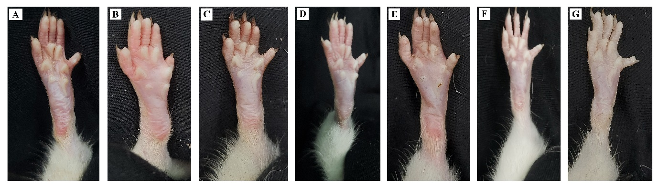
A: Vehicle control group; B: Negative control group; C: Low dose group-single day; D: Low dose Protective group; E: High dose group-single day; F: High dose Protective group; G: Positive control group.

