Supplement 2. Acoustic intensity output according to waveform generator settings
In the main text of the paper, the cycle count and amplitude of the tone burst generated from the waveform generator were set to 35 cycles and 500 ${mV}_{pp}$, respectively.
The number of cycles of the tone burst signal was determined such that the spatial-peak pulse-average intensity ($I_{sppa}$) would converge. Fig. S2-1 shows the acoustic pressure and intensity at the focal point of the VZPUT when the peak-to-peak voltage output from the waveform generator ($V_{sgpp}$) is 40 ${mV}_{pp}$. As shown in Fig. S2-1, the peak positive pressure ($p_{+}$), peak negative pressure ($p_{-}$), and $I_{sppa}$ converge at approximately 35 cycles.
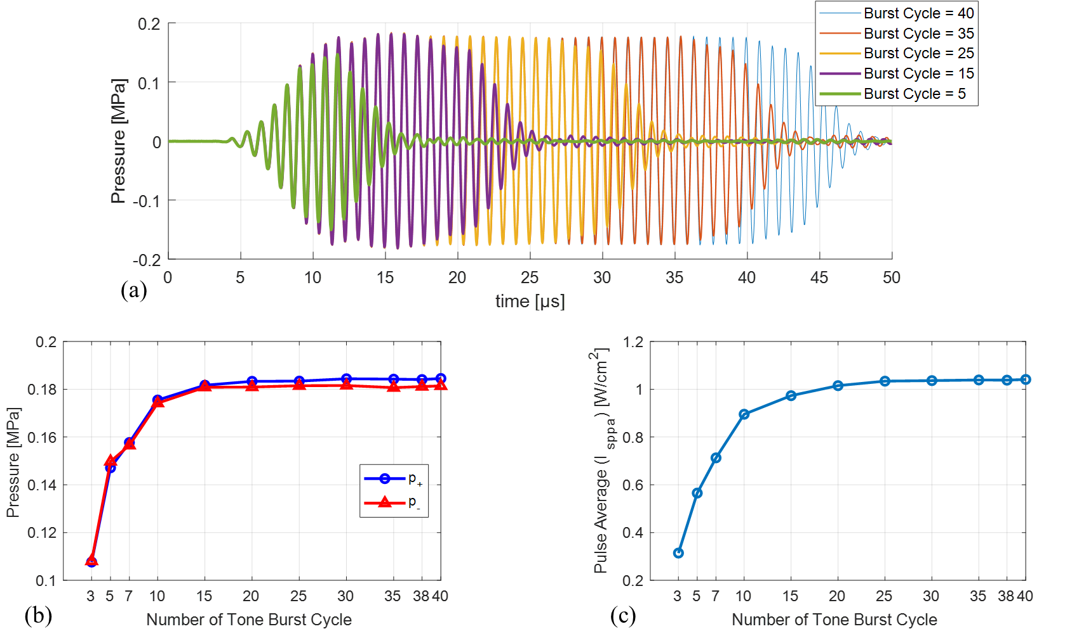
Figure S2-1. Acoustic pressure and intensity at the focal point with a tone burst signal of 1.1 $MHz$ center frequency and $V_{sgpp}$ = 40 ${mV}_{pp}$: (a) the pressure waveform, (b)$p_{+}$ and $p_{-}$, (c) $I_{sppa}$.

Typical diagnostic ultrasound transducers¹, FUS transducers², and High-intensity FUS (HIFU) transducers¹ deliver ultrasound with $I_{sppa}$ of approximately 0.1-100 $mW/{cm}^{2}$, 3-54 $W/{cm}^{2}$, and 100-10,000 $mW/{cm}^{2}$ to the focal point, respectively.
Fig. S2-2 shows the acoustic pressure and intensity at the focal point of the VZPUT when the tone burst is 35 cycles. As shown in Fig. S2-2, the VZPUT shows a wide range of intensity output from the FUS region to the HIFU region in the water tank experiment.

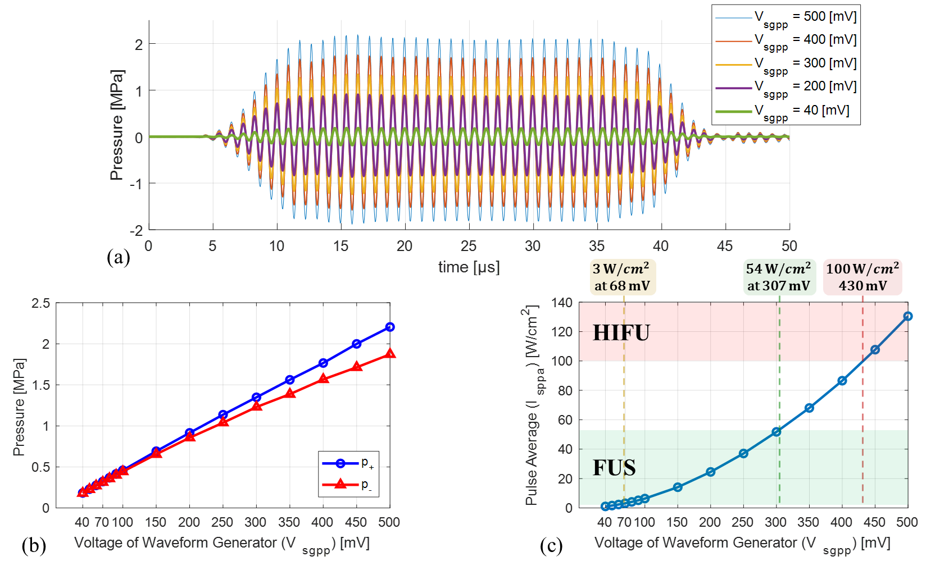
Figure S2-2. Acoustic pressure and intensity at the focal point with a tone burst signal of 35 cycles and 1.1 $MHz$ center frequency: (a) the pressure waveform, (b)$p_{+}$ and $p_{-}$, (c) $I_{sppa}$.

Supplementary References
- Dubinsky, T. J., Cuevas, C., Dighe, M. K., Kolokythas, O. & Hwang, J. H. High-intensity focused ultrasound: current potential and oncologic applications. AJR Am. J. Roentgenol. -NEW SERIES- 190, 191 (2008), DOI: https://doi.org/10.2214/AJR.07.2671
- Lee, W., Weisholtz, D. S., Strangman, G. E., & Yoo, S. S. Safety review and perspectives of transcranial focused ultrasound brain stimulation. Brain Neurorehabil, 14. (2020), DOI: https://doi.org/10.12786/bn.2021.14.e4

