Supplement 1. Physical meaning of Fresnel Zone Plate (FZP)
The sound pressure $p\left(r\right)$ at a specific point radiated by a circular planar piston source can be obtained by the following integral equation¹.
$p\left(r, θ,t\right)=jρ_{0}ck\frac{U_{0}}{2π}\int_{S}{\frac{1}{r'}e^{j\left(ωt-kr'\right)}}dS$ (s1-1)
where $r$ is the displacement from the center of the surface of the circular piston to the point of interest, $θ$ is the angle between the radial axis and the displacement vector, and $t$ is time. $ρ_{0}$ and $c$ on the right side of the equation are the density and sound velocity of the propagation medium, respectively. The angular frequency and wave number are represented $ω$ and $k$, respectively. And $U_{0}dS$ is the source strength. $j=\sqrt{-1}$ and $r^{'}$ are imaginary symbol and the displacement from the surface element $dS$ to the point of interest, respectively.
For simplicity, assuming that the radius of the circular piston is $a$, ignoring the time dependence, and using axial symmetry, the equation becomes:
$p\left(z\right)=jρ_{0}ck\frac{U_{0}}{2π}\int_{0}^{a}{\frac{exp\left(-jk\sqrt{z^{2}+σ^{2}}\right)}{\sqrt{z^{2}+σ^{2}}}}dS$ (s1-2)
where $σ$ is the displacement from the origin to the area element which corresponds to $dS=2πσdσ$. The integrand $p_{σ}\left(z\right)=j\left({ρ_{0}ckU_{0}}/{2π}\right)\left({exp\left[-jk\sqrt{z^{2}+σ^{2}}\right]}/{\sqrt{z^{2}+σ^{2}}}\right)$ is a complex, and its phase at the axial distance $z$ depends on $σ$.
$Φ\left(z,σ\right) = ∠\left[j\frac{ρ_{0}ckU_{0}}{2π}\frac{exp\left[-jk\sqrt{z^{2}+σ^{2}}\right]}{\sqrt{z^{2}+σ^{2}}}\right]$ (s1-3)
Assuming that the frequency is 1.1 MHz and the point of interest on the acoustic axis, that is, the focal length is 75 mm, calculated the $σ$-dependence of the phase from the origin to 60 mm is shown in the graph of Fig. S1-1. The two blue lines are the phase boundaries that determine the ring radii of classical FZP. As seen in the graph of Fig. S1-1, $ϕ_{0}=0.5151$ rad and $ϕ_{1}=-2.6265$ rad, therefore the phase difference between $ϕ_{0}$ (dotted line) and $ϕ_{1}$ (dashed line) is $π$ rad ($ϕ_{1}$ is the phase at $σ=0$). The radii of FZP determined by these phase boundaries and Eq. (s1-3) are indicated by red circular markers on the graph, and the corresponding radius values are displayed in the 2nd and 3rd columns of the table in Fig. S1-1. This table compares the inner- and outer- radii of the rings composing the FZP determined by Eq. (s1-3) and Eq. (1) in the main text. The dimensions of all rings are almost same. This implies that acoustic waves having the same phase in the $π$ range are superposed at the Fresnel distance, and as a result, an acoustic focus is formed at the point.
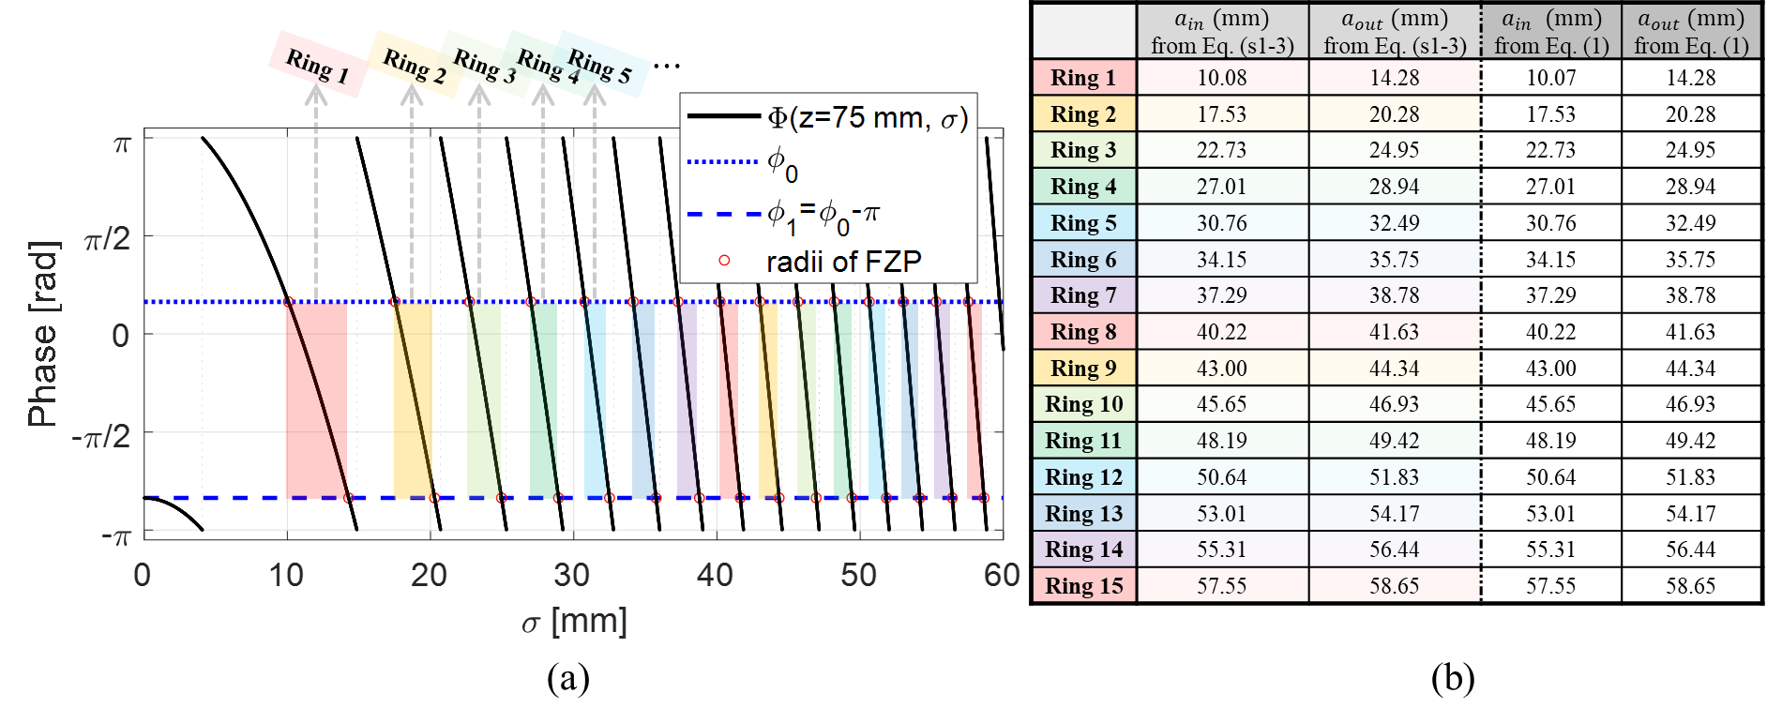
Figure S1-1. The inner- and outer- radii of the rings composing the FZP: (a) graph of the pressure phase $Φ\left(z=75 mm,σ\right)$ at $1.1 MHz$, the phase boundaries ($ϕ_{0}$ and $ϕ_{1}$), and the radii of FZP obtained therefrom, (b) table comparing the radii of FZP determined by Eq. (s1-3) of the Supplement 1 and Eq. (1) of the main text.

Supplementary References
- Kinsler, L. E., Frey, A. R., Coppens, A. B., & Sanders, J. V. Fundamentals of acoustics. (John wiley & sons, 2000)

