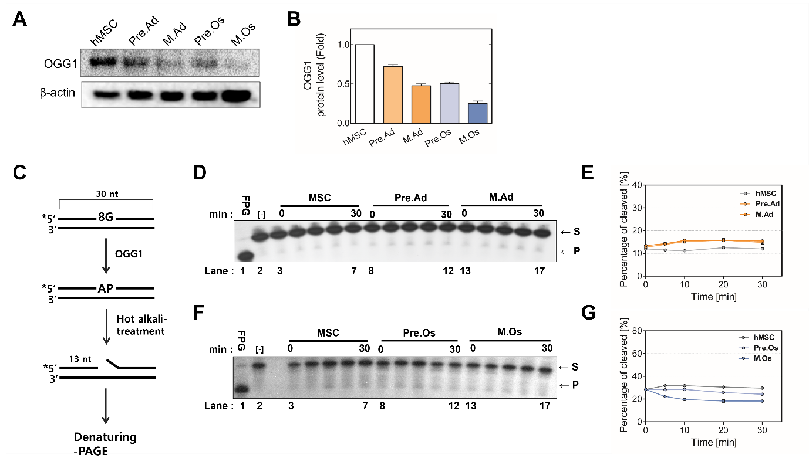
Supplementary figure 1. Modulation of OGG1 expression and activity during the adipogenesis and osteogenesis of hMSCs.
(A) Western blot showing the protein level of OGG1, and (B) quantitation results. (C) Schematic representation of the OGG1-activity assay. The 30-bp duplex DNA substrates containing single 8-oxo-guanine residue were labeled with [γ-32P]ATP at the 5'-end. The AP site generated through the enzymatic removal of the 8-oxo-guanine residue was hydrolyzed to produce the 13-bp cleaved products. Enzyme reactions contained 50 ng whole-cell extracts of (D) the adipogenic and (F) osteogenic differentiated cells at each phase in the reaction buffer. Purified E. coli FPG was used for generating 13-mer products as a positive control. The products were resolved using denaturing 15% PAGE and detected using autoradiography. (E and G) Each activity was quantified and plotted into a graph. MSC, proliferating hMSC; Pre.Ad, pre-adipocytes; M.Ad, mature adipocytes; Pre.O, pre-osteoblast; M.Os, mature osteoblast; S, substrate; P, product.

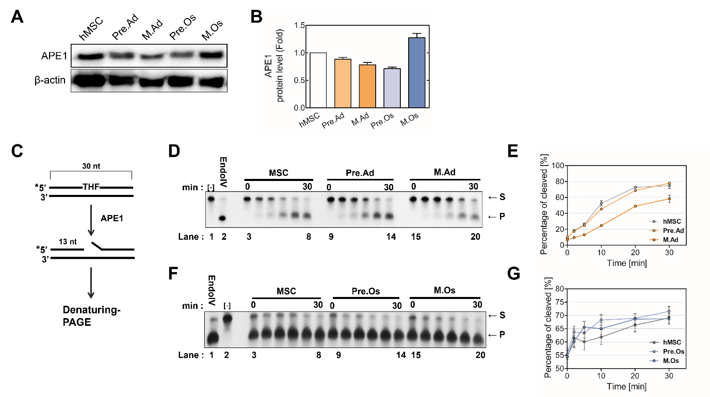
Supplementary figure 2. Modulation of APE1 expression and activity during the adipogenesis and osteogenesis of hMSCs.
(A) Western blot showing the protein level of APE1, and (B) quantitation results. (C) Schematic representation of the APE1-activity assay. The 30-bp duplex DNA substrates containing single THF residue were labeled with [γ-32P]ATP at the 5'-end. The AP site generated through the enzymatic removal of the uracil residue was hydrolyzed to produce the 13-bp cleaved products. Enzyme reactions contained 50 ng whole-cell extracts of (D) the adipogenic and (F) osteogenic differentiated cells at each phase in the reaction buffer. Purified E. coli endonucleaseIV (EndoIV) was used for generating 13-mer products as a positive control. The products were resolved using denaturing 15% PAGE and detected using autoradiography. (E and G) Each activity was quantified and plotted into a graph. MSC, proliferating hMSC; Pre.Ad, pre-adipocytes; M.Ad, mature adipocytes; Pre.O, pre-osteoblast; M.Os, mature osteoblast; S, substrate; P, product.
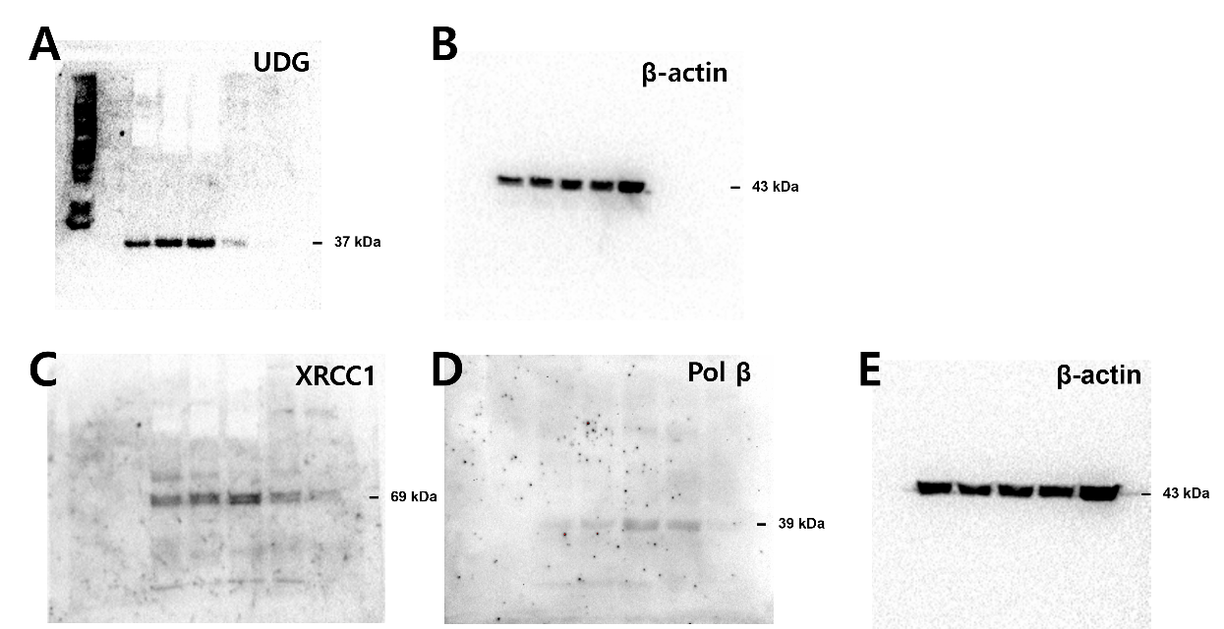
Supplementary figure 3. Full-length blots/gels of figure 3 and 4
(A) UDG in Fig 3A. (B) β-actin in Fig 3A and 4A. UDG and XRCC were detected using equal blot. (C) XRCC1 in Fig 4A. (D) Polβ and (E) β-actin in Fig 4B.

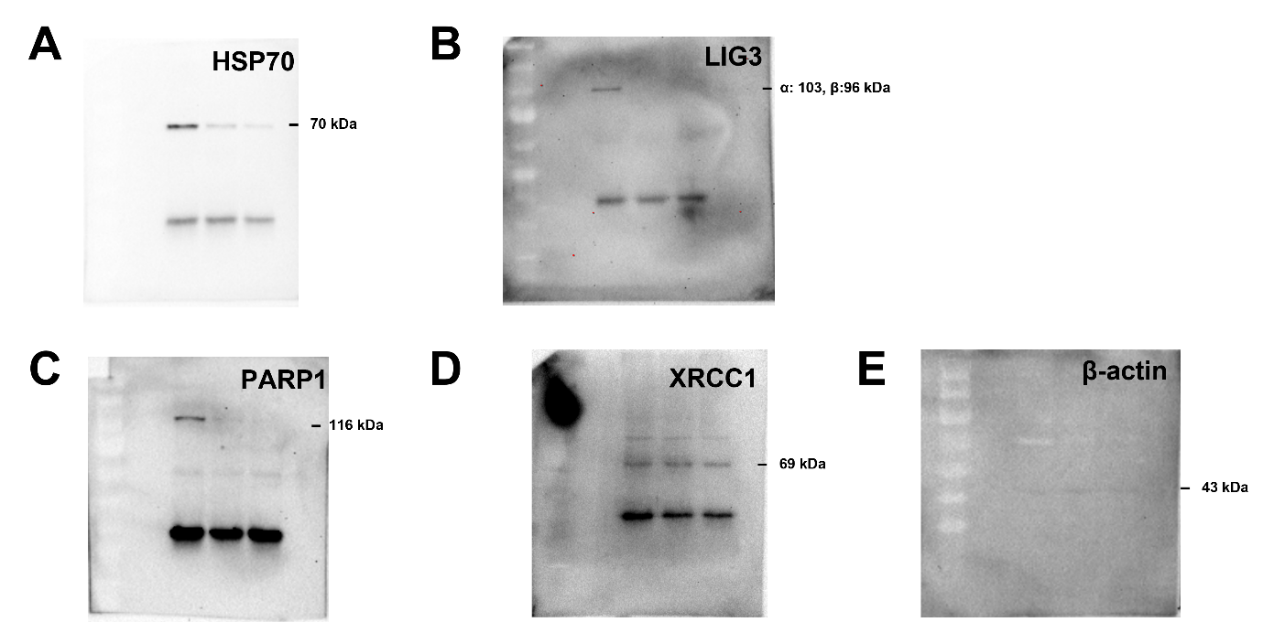
Supplementary figure 4. Full-length blots/gels of figure 5A
(A) HSP70, (B) LIG3, (C) PARP1, and (D) XRCC1 detected after immunoprecipitation and shown in Fig 5A. They are rabbit polyclonal antibodies. (E) β-actin in Fig 5A is mouse monoclonal antibody.

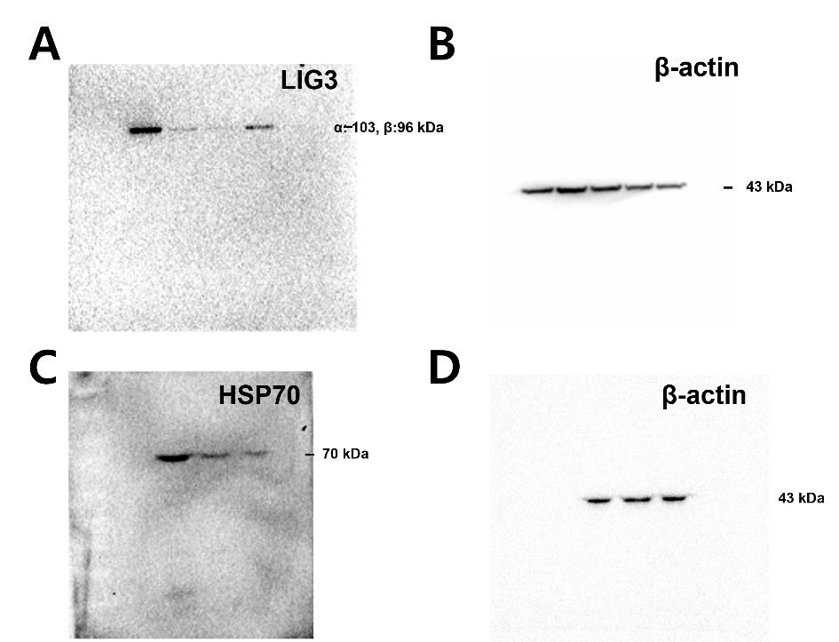
Supplementary figure 5. Full-length blots/gels of figure 5B
(A) LIG3 and (B) its β-actin in Fig 5B. (C) HSP70 and (D) its β-actin in Fig 5B.

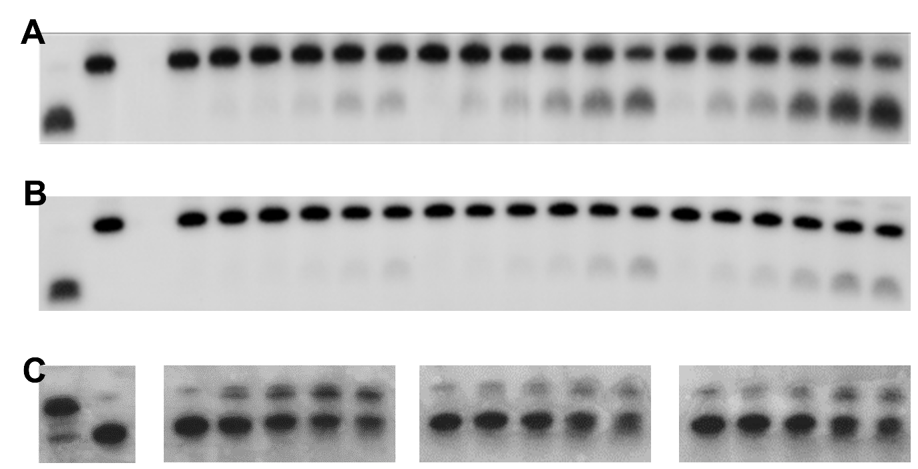
Supplementary figure 6. Full-length blots/gels of figure 3D, 3F, and 5D
The results of UDG activity of (A) adipocyte and (B) osteoblast are obtained by urea PAGE using 300 mm x 500 mm sequencing gel. (C) The results of the ligation assay are obtained by urea PAGE using 100 mm x 170 mm mini gels analyzed at the same time.

