N-linked glycosylation is essential for anti-tumor activities of KIAA1324 in gastric cancer
Rebecca Yun^{1,2,#}, Eunji Hong^{1,3,#}, Junil Kim^{4,#}, Bora Park⁵, Staci Jakyong Kim⁶, Bona Lee⁷, Yong Sang Song^{2,8}, Seong-Jin Kim^{1,9}, Sujin Park^{1*}, and Jin Muk Kang^{10*}

¹GILO Institute, GILO Foundation, Seoul 06668, Republic of Korea, ²Interdisciplinary Program in Cancer Biology, Seoul National University, Gwanak-gu, Seoul 08826, Republic of Korea, ³Department of Biomedical Science, College of Life Science, Sungkyunkwan University, Suwon, Gyeonggi-do 16419, Republic of Korea, ⁴School of Systems Biomedical Science, Soongsil University, Seoul 06978, Republic of Korea, ⁵WellSpan York Hospital Family Medicine Residency Program, York, Pennsylvania, USA, ⁶International Institute for Integrative Sleep Medicine, University of Tsukuba, Tsukuba, Japan, ⁷Case Western Reserve University School of Medicine, Cleveland, OH, United States, ⁸Department of Obstetrics and Gynecology, College of Medicine, Seoul National University, Seoul, Republic of Korea, ⁹Medpacto Inc., Seoul 06668, Republic of Korea, ¹⁰Department of Pediatric Hematology & Oncology, University Hospitals Cleveland Medical Center, Cleveland, Ohio, USA,

#These authors contributed equally.

* Correspondence: Jin Muk Kang, Ph.D. (E-mail: jinmuk.kang@uhhospitals.org), Sujin Park, Ph.D. (E-mail: sujinpark@gilo.or.kr), Research Institute, GILO Foundation, 92 Myeongdal-ro, Seocho-gu, Seoul, 06668, Republic of Korea. Phone: +82-2-581-0023; Fax: +82-2-581-0125;

Running title: Role of N-linked glycosylation in KIAA1324-induced tumor suppressive activity
Key words: N-glycoslyation, Elapor1, tumor suppressor, prognostic marker, apoptosis, cell cycle arrest, stomach cancer

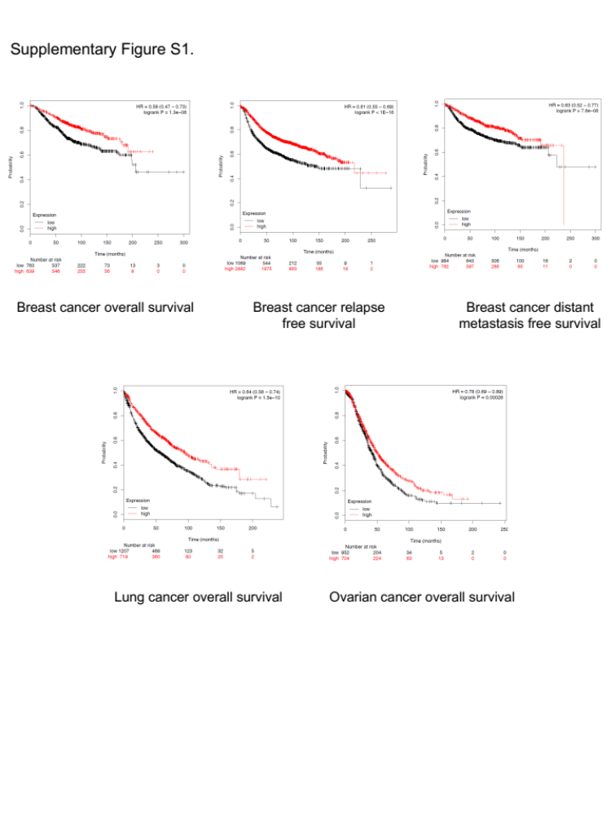
Supplementary Fig. 1
KIAA1324 is a favorable prognostic marker in various cancer patients. Graphs of the public datasets showed an association between KIAA1324 expression level and breast, lung, or ovarian cancer patients’ overall survival, relapse-free survival, or distant metastasis-free survival.
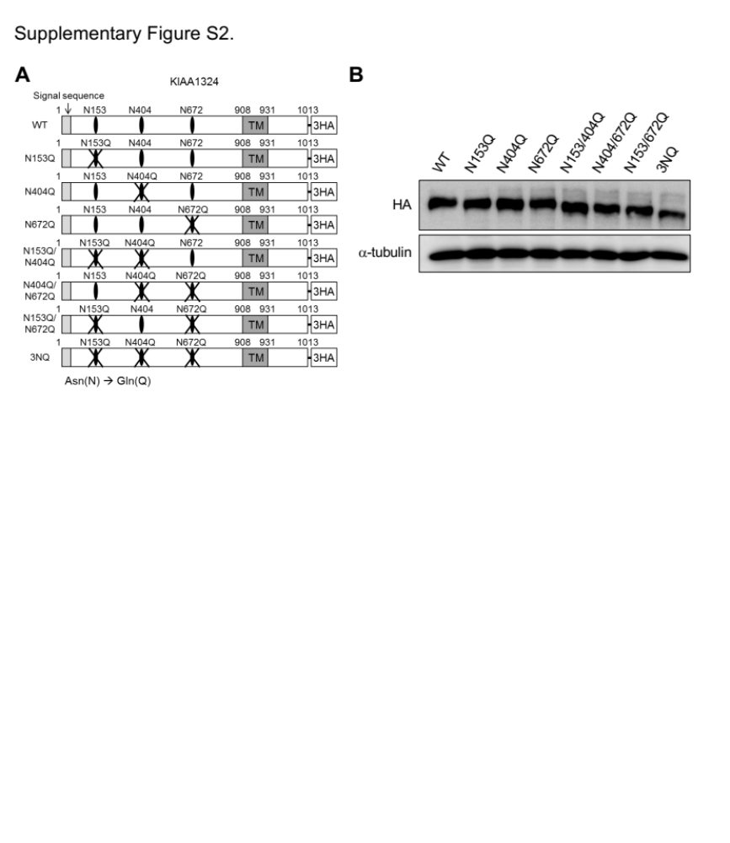
Supplementary Fig. 2
A) A schematic diagram of N-glycosylation loci of KIAA1324 at amino acids 153, 404, 672, asparagine (N) replaced with glutamine (Q). B) Immunoblot of KIAA1324 with one, two, or all three loci with NQ mutations.
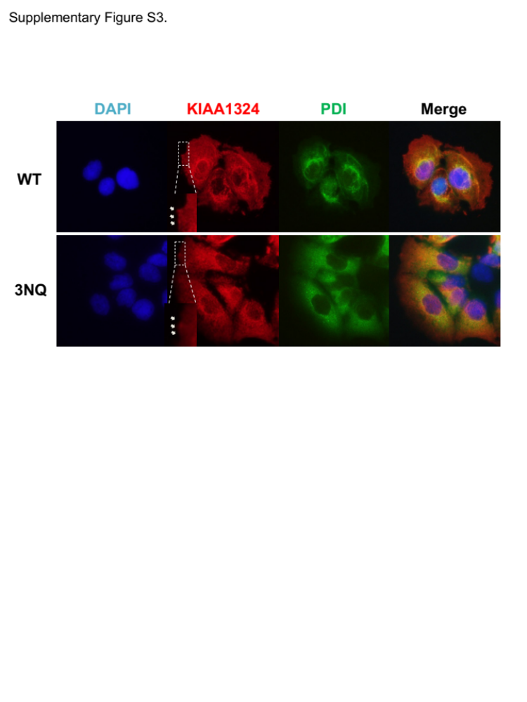
Supplementary Fig. 3
Subcellular localization of KIAA1324. Immunofluorescence assays were conducted using anti-KIAA1324, and anti-PDI antibodies in MKN28 cells harboring tet-on KIAA1324 WT and 3NQ. The nuclei were stained with DAPI.
Supplementary Fig. 4
Blocking N-glycosylation demolished the effect of KIAA1324 on the interaction between GRP78 and caspase-7. A) Immunoprecipitation assay was performed in MKN28 cells harboring tet-on KIAA1324 WT, 3NQ, and ΔTM. B) Immunoprecipitation assay of interaction between GRP78 and caspase-7 was evaluated in MKN28 harboring tet-on KIAA1324 3NQ mutant after 24 h treatment of 1 μg/mL doxycycline.
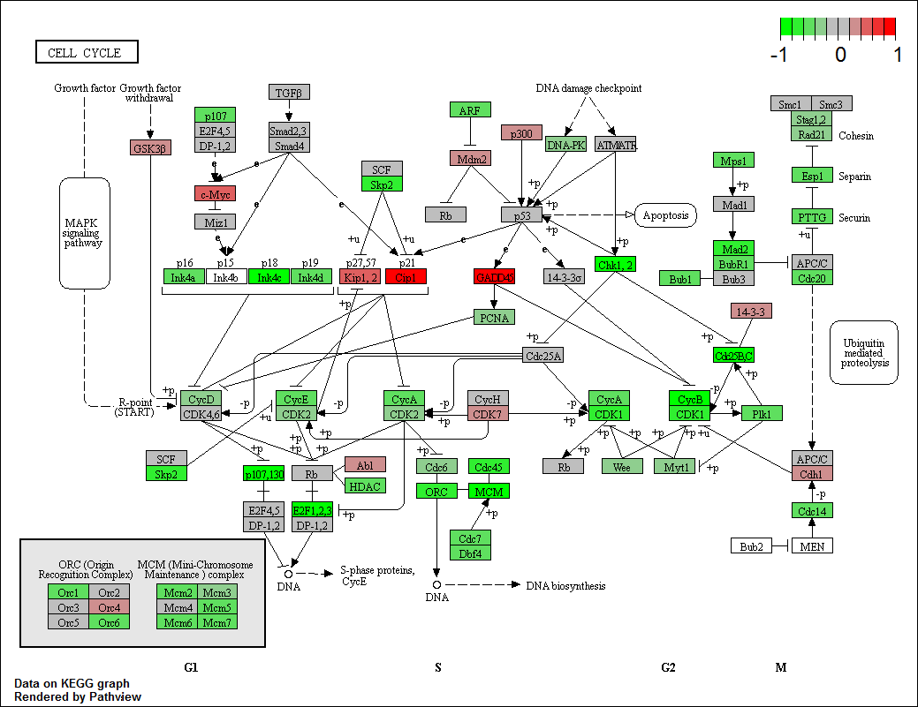
Supplementary Fig. 5
Network of DEGs in KIAA1324 WT expressing MKN28 cells on KEGG graph rendered by Pathview.
Supplementary Fig. 6
KIAA1324 induced apoptosis through the JNK pathway. A) Immunoblot of p38 and JNK of the signaling pathway in MNK28 tet-on KIAA1324 WT cells. B) Cleavage of caspase-3 and PARP was shown in immunoprecipitation assay performed by treating MKN28 cells harboring tet-on KIAA1324 WT with 0, 10, 25, and 50 µM of JNK inhibitor, SP600125. C) Flow cytometry analysis of MKN28 cells harboring tet-on KIAA1324 WT treated for 36 h with 1 μg/mL doxycycline and an inhibitor: tunicamycin, U0126, or SB203580. Annexin V–positive and PI-negative populations signify apoptotic cells. The quantification of the early, late, and total apoptotic cell population from a triplicate of samples is graphed. Mean±SD vs Luc.
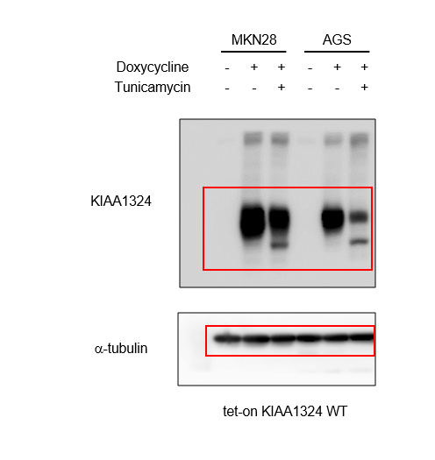
Figure 1B. Original full length western blots
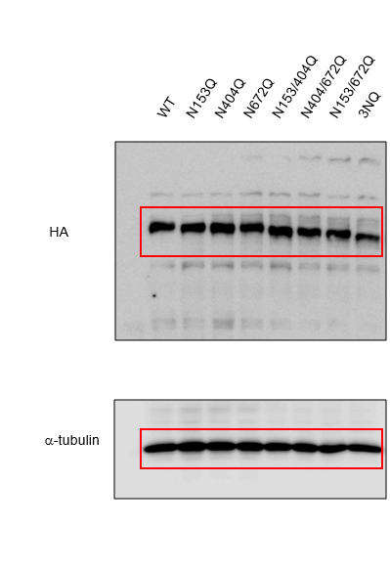
Supplementary Figure 2B. Original full length western blots
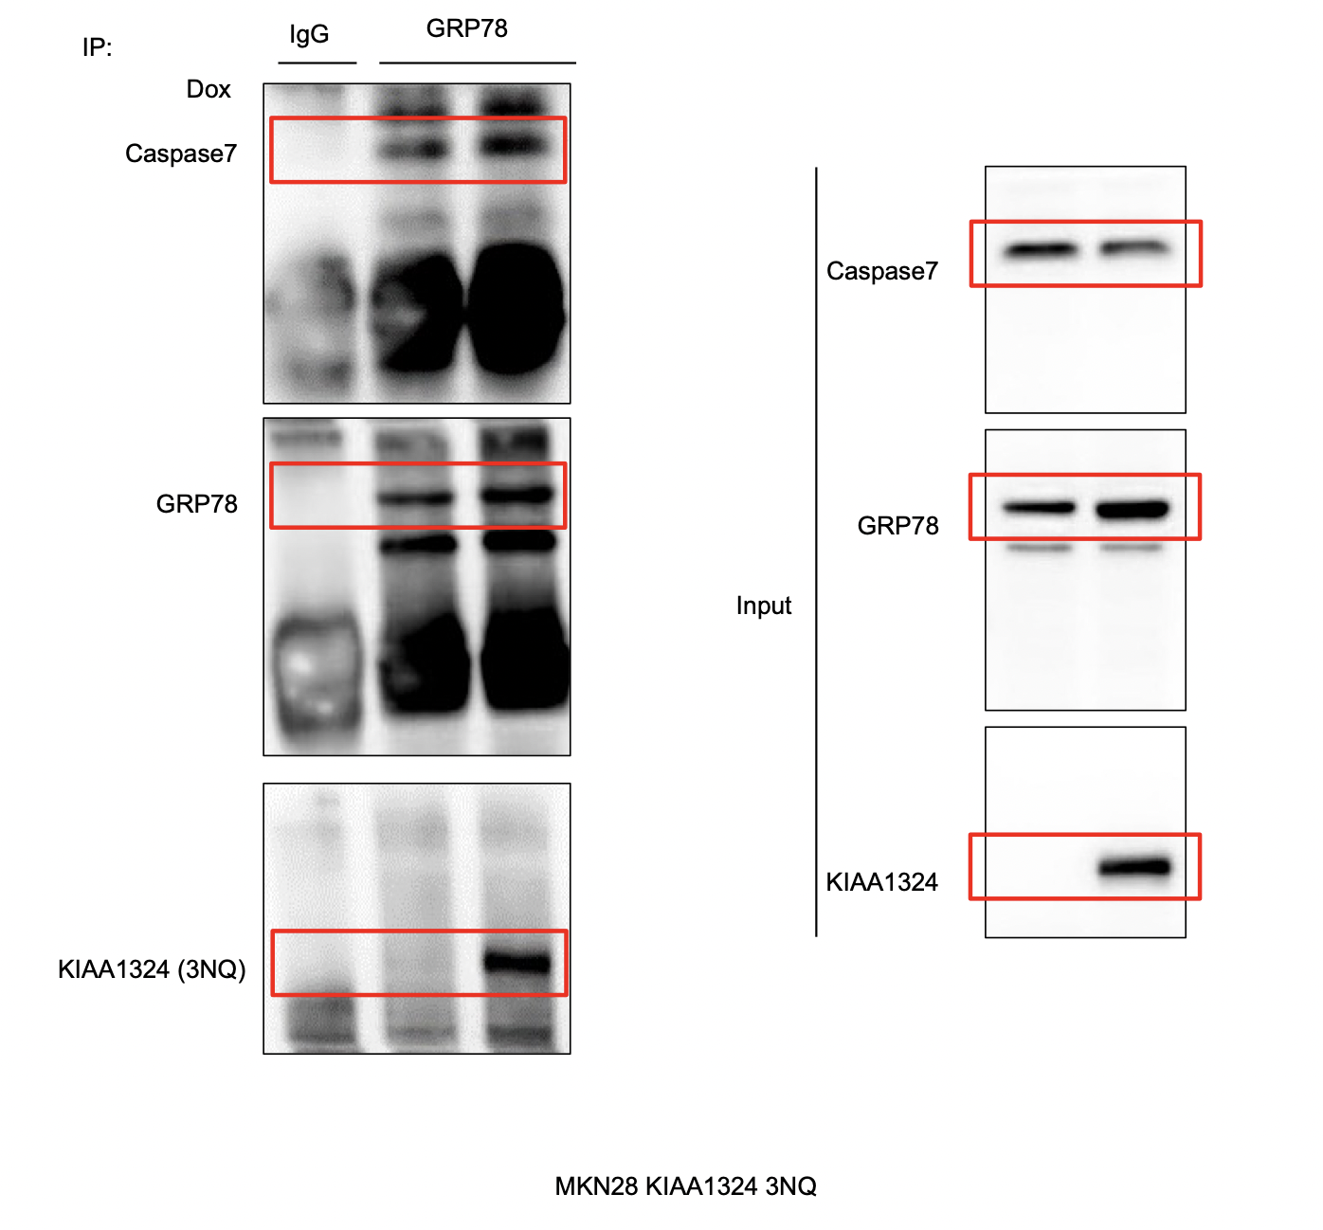
Supplementary Figure 4B. Original full length western blots

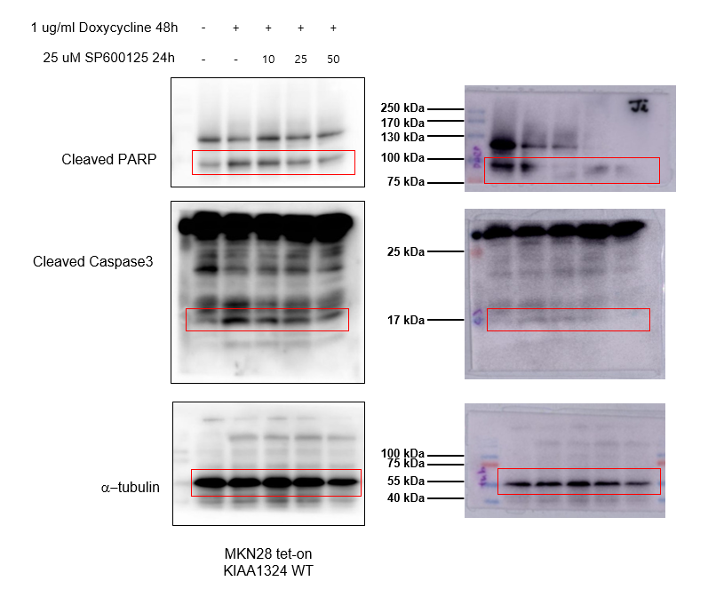
Supplementary Figure 5B. Original full length western blots

