Table 3. Products during photocatalytic degradation of salbutamol.

m/z  [M+H]⁺ | t_{R} (min) | Molecular weight  (M_{W}) | Structure | Ref.
240 | 5.83 | 239 | 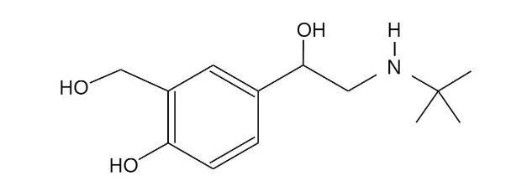  2-(tert-Butylamino)-1-(4-hydroxyl-3- hydroxymethylphenyl)ethanol | Sakkas et al., 2007; Zhou, Wang, Zhang, Ji, & Yang, 2017
238 | 11.08 | 237 | 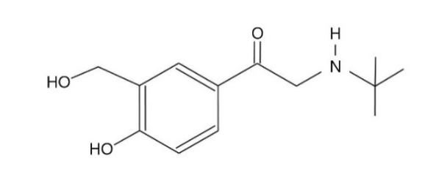  2-(tert-Butylamino)-1-(4-hydroxyl-3- hydroxymethylphenyl) ethanone | Zhou, Wang, Zhang, Ji, & Yang, 2017
224 | 4.64 | 223 | 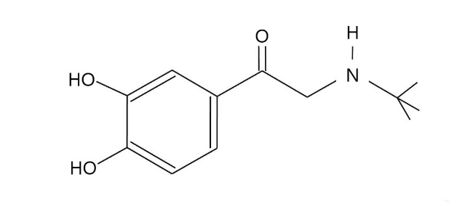  2-(tert-Butylamino)-1- (4-hydroxyl-3-methylphenyl)ethanol | Sakkas et al., 2007
182 | 4.68 | 181 | 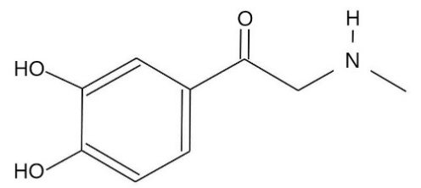  2-(Methylamino)-1- (3,4-dihydroxyphenyl)ethanone | Sakkas et al., 2007
169 | 6.02 | 168 | 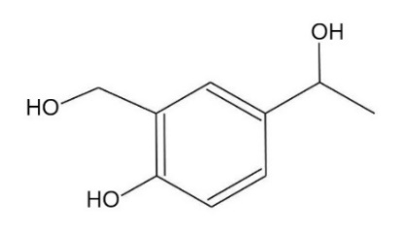  1-(4-hydroxyl-3- hydroxymethylphenyl)ethanol | Zhou, Wang, Zhang, Ji, & Yang, 2017
139 | 10.36 | 138 | 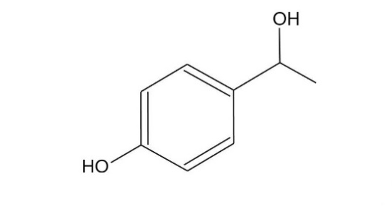  1-(4-hydroxylphenyl)ethanol | Zhou, Wang, Zhang, Ji, & Yang, 2017
132 | 4.73 | 131 | 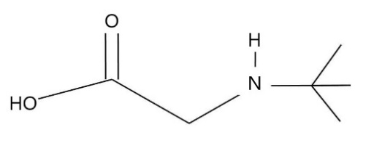  2-(tert-Butylamino)-acetic acid | Sakkas et al., 2007
118 | 6.03 | 117 | 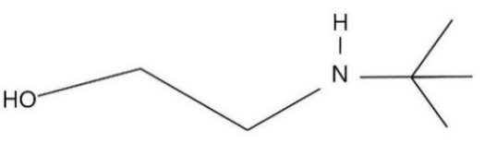  2-(tert-Butylamino)-ethanol | Sakkas et al., 2007
111 | 12.46 | 110 | 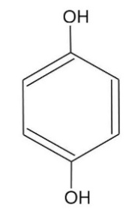  hydroquinone | Sakkas et al., 2007
109 | 11.63 | 108 | 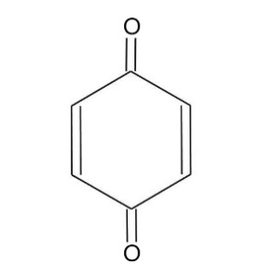  para benzoquinone | Sakkas et al., 2007

