Supplementary Materials
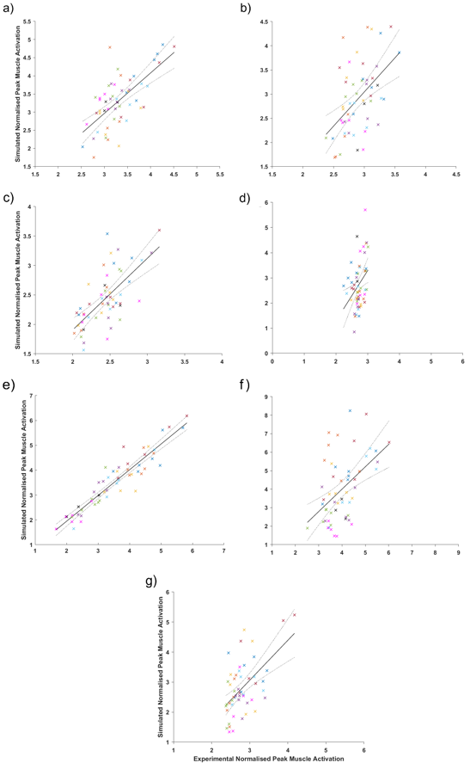
Online Resource 1. Linear models (including regression line (solid) and 95% confidence intervals (dotted)) from the individual-level analysis between experimental and simulated normalised peak muscle activation for SOL (a), GL (b), GM (c), TA (d), VL (e), RF (f ), and BF (g) with different colours representing each individual participant’s data.

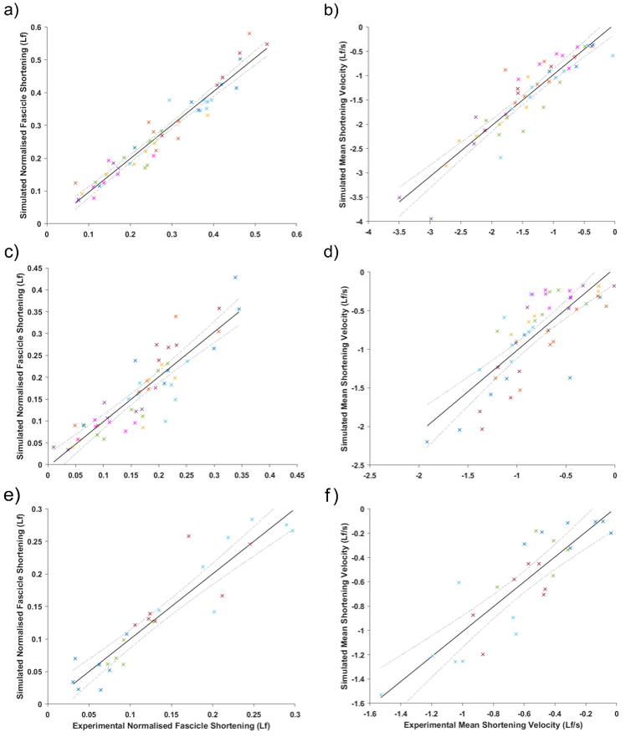
Online Resource 2. Linear models (including regression line (solid) and 95% confidence intervals (dotted)) from the individual-level analysis between experimental and simulated normalised fascicle shortening for SOL (a), GL (c), and VL (e), and normalised mean shortening velocity for SOL (b), GL (d), and VL (f), with different colours representing each individual participant’s data.

