An exploration into the causal relationships between educational attainment, intelligence, and wellbeing: an observational and two-sample Mendelian randomisation study

Supplementary tables and figures

Index of Supplementary Tables
- Supplementary Table 1: Univariable MR analyses assessing bidirectional associations between educational attainment and intelligence
- Supplementary Table 2: Univariable MR assessing bidirectional associations between educational attainment and wellbeing, and between intelligence and wellbeing
- Supplementary Table 3: Univariable MR analyses assessing associations between wellbeing and educational attainment, and between wellbeing and intelligence following Steiger filtering
- Supplementary Table 4: F statistic and regression dilution I² statistic for the heterogeneity of SNP-exposure effects
- Supplementary Table 5: Univariable MR analyses assessing impact of educational attainment and intelligence on positive affect
- Supplementary Table 6: Univariable MR analyses assessing impact of educational attainment and intelligence on life satisfaction
- Supplementary Table 7: Univariable MR analyses assessing impact of educational attainment and intelligence on depressive symptoms
- Supplementary Table 8: Univariable MR analyses assessing impact of educational attainment and intelligence on neuroticism
- Supplementary Table 9: Comparison of main variable scores between ALSPAC subsamples
- Supplementary Table 10: Description of main study variables in ALSPAC
- Supplementary Table 11: Observational regression results assessing linear associations between educational attainment and wellbeing, and between intelligence and wellbeing (unstandardised)
- Supplementary Table 12: Observational regression results from linear, quadratic, cubic and quartic models assessing associations between intelligence and wellbeing
- Supplementary Table 13: Univariable MR analyses assessing bidirectional associations between educational attainment (using discovery and replication cohort)
- Supplementary Table 14: List of SNPs used for multivariable MR
- Supplementary Table 15: Selective attrition for educational attainment and intelligence based
- Supplementary Table 16: Variables included in multiple imputation
Index of Supplementary Figures
- Supplementary Figure 1: Funnel plots for univariate MR analysis of years of schooling on wellbeing and wellbeing on years of schooling.
- Supplementary Figure 2: Forest plots from univariate MR analysis of years of schooling on wellbeing and wellbeing on years of schooling.
- Supplementary Figure 3: Funnel and forest plots from univariate MR analysis of wellbeing on intelligence.
- Supplementary Figure 4: Flowchart of data available for use in ALSPAC.
Supplementary Tables
Supplementary Table 1: Univariable MR analyses assessing bidirectional associations between educational attainment and intelligence
 |  | Causal effect estimates |  |  | Heterogeneity statistics
 | N SNPs | β (95% CI) | P |  | Q | df | P
Years of schooling on intelligence
IVW | 63 | 0.736 (0.647, 0.826) | 4.88E-58 |  | 272.2 | 62 | 8.90E-26
MR-Egger | 63 | 1.171 (0.724, 1.62) | 3.12E-06 |  | 256.3 | 61 | 3.95E-28
MR-Egger intercept | 63 | -0.008 (-0.016, 0.002) | 0.056 |  | - | - | -
MR-Egger (SIMEX) ª | 63 | 1.850 (1.28, 2.42) | 1.44E-08 |  | - | - | -
Weighted median | 63 | 0.655 (0.566, 0.743) | 1.20E-50 |  | - | - | -
Weighted mode | 63 | 0.632 (0.410, 0.854) | 1.25E-07 |  | - | - | -
Intelligence on years of schooling
IVW | 144 | 0.398 (0.359, 0.438) | 2.40E-85 |  | 466.1 | 143 | 7.11E-36
MR-Egger estimate | 144 | 0.534 (0.346, 0.721) | 1.17E-07 |  | 459.9 | 142 | 4.16E-35
MR-Egger intercept | 144 | -0.003 (-0.006, 0.001) | 0.150 |  | - | - | -
MR-Egger (SIMEX) | 144 | 0.815 (0.562, 1.07) | 2.69E-09 |  | - | - | -
Weighted median | 144 | 0.341 (0.301, 0.381) | 1.92E-65 |  | - | - | -
Weighted mode | 144 | 0.277 (0.175, 0.379) | 1.56E-06 |  | - | - | -
Note: IVW= Inverse variance weighted estimate. Analyses conducted using the educational attainment discovery cohort (n=293,723).
ª Weighted simulation extrapolation (SIMEX) correction applied.

Supplementary Table 2: Univariable MR assessing bidirectional associations between educational attainment and wellbeing, and between intelligence and wellbeing
 |  | Causal effect estimates |  |  | Heterogeneity statistics
 | N SNPs | β (95% CI) | P |  | Q | df | P
Years of schooling on wellbeing
IVW | 54 | 0.057 (0.042, 0.074) | 5.18E-13 |  | 336.7 | 53 | 6.83E-43
MR-Egger | 54 | -0.071 (-0.323, 0.180) | 5.81E-01 |  | 330.1 | 52 | 4.38E-42
MR-Egger intercept | 54 | 0.002 (-0.002, 0.006) | 0.313 |  | - | - | -
MR-Egger (SIMEX) ª | 54 | -0.085 (-0.424, 0.252) | 0.621 |  | - | - | -
Weighted median | 54 | 0.050 (0.023, 0.077) | 2.29E-04 |  | - | - | -
Weighted mode | 54 | 0.067 (0.016, 0.119) | 1.26E-02 |  | - | - | -
Wellbeing on years of schooling
IVW | 147 | 0.206 (0.071, 0.341) | 2.71E-03 |  | 574.9 | 146 | 3.19E-52
MR Egger estimate | 147 | 0.049 (-0.651, 0.749) | 0.890 |  | 574.1 | 145 | 2.15E-52
MR Egger intercept | 147 | 0.001 (-0.004, 0.004) | 0.655 |  | - | - | -
MR-Egger (SIMEX) ª | 147 | 0.528 (-0.265, 1.32) | 0.19 |  | - | - | -
Weighted median | 147 | 0.187 (0.063, 0.311) | 2.80E-04 |  | - | - | -
Weighted mode | 147 | 0.236 (-0.094, 0.566) | 0.163 |  | - | - | -
Intelligence on wellbeing
IVW | 126 | -0.004 (-0.028, 0.017) | 0.713 |  | 688.5 | 125 | 7.58E-108
MR-Egger | 126 | 0.003 (-0.096, 0.103) | 0.946 |  | 688.4 | 124 | 5.54E-108
MR-Egger intercept | 126 | -0.001 (-0.003, 0.001) | 0.883 |  | - | - | -
MR-Egger (SIMEX) ª | 126 | 0.016 (-0.066, 0.098) | 0.702 |  | - | - | -
Weighted median | 126 | -0.001 (-0.018, 0.015) | 0.876 |  | - | - | -
Weighted mode | 126 | 0.004 (-0.034, 0.041) | 0.844 |  | - | - | -
Wellbeing on intelligence
IVW | 128 | 0.199 (0.014, 0.390) | 3.48E-02 |  | 665.4 | 127 | 6.72E-74
MR Egger estimate | 128 | -0.104 (-1.17, 0.960) | 8.47E-01 |  | 663.7 | 126 | 5.81E-74
MR Egger intercept | 128 | 0.001 (-0.006, 0.006) | 0.571
MR-Egger (SIMEX) ª | 128 | 0.688 (-0.375, 1.75) | 0.207 |  | - | - | -
Weighted median | 128 | 0.301 (0.159, 0.443) | 3.40E-05 |  | - | - | -
Weighted mode | 128 | 0.347 (-0.007, 0.702) | 5.17E-02 |  | - | - | -
Note: IVW= Inverse variance weighted estimate. Analyses conducted using the educational attainment discovery cohort (n=293,723). ª Unweighted simulation extrapolation (SIMEX) correction applied

Supplementary Table 3: Univariable MR analyses assessing associations between wellbeing and educational attainment, and between wellbeing and intelligence following Steiger filtering
 |  | Causal effect estimates |  |  | Heterogeneity statistics
 | N SNPs | β (95% CI) | P |  | Q | df | P
Wellbeing on years of schooling
IVW | 143 | 0.162 (0.033, 0.291) | 0.014 |  | 499.6 | 142 | 1.34E-41
MR Egger estimate | 143 | 0.065 (-0.605, 0.734) | 0.850 |  | 499.9 | 141 | 2.28E-41
MR Egger intercept | 143 | 0.000 (-0.005, 0.005) | 0.998 |  | - | - | -
Weighted median | 143 | 0.177 (0.056, 0.299) | 0.004 |  | - | - | -
Weighted mode | 143 | 0.236 (-0.107, 0.580) | 0.180 |  | - | - | -
Wellbeing on intelligence
IVW | 117 | 0.242 (0.098, 0.386) | 9.66E-04 |  | 334.8 | 116 | 6.35E-23
MR Egger estimate | 117 | -0.163 (-0.976, 0.649) | 6.95E-01 |  | 331.9 | 115 | 4.23E-23
MR Egger intercept | 117 | 0.003 (-0.002, 0.008) | 0.322
Weighted median | 117 | 0.297 (0.153, 0.441) | 5.47E-05 |  | - | - | -
Weighted mode | 117 | 0.318 (-0.059, 0.696) | 1.01E-01 |  | - | - | -
Note: IVW= Inverse variance weighted estimate. Analyses conducted using the educational attainment discovery cohort (n=293,723).

Supplementary Table 4: F statistic and regression dilution I² statistic for the heterogeneity of SNP-exposure effects
Exposure | F | I² (unweighted) | I² (weighted)
Educational attainment on intelligence | 38.44 | 0.38 | 0.52
Intelligence on educational attainment | 42.72 | 0.48 | 0.51
Educational attainment on wellbeing | 38.88 | 0.11 | 0
Intelligence on wellbeing | 43.35 | 0.45 | 0.26
Wellbeing on educational attainment | 40.78 | 0.35 | 0.35
Wellbeing on intelligence | 40.83 | 0.35 | 0
Note: All based on analyses using educational attainment discovery GWAS (n=293,723).

Supplementary Table 5: Univariable MR analyses assessing impact of educational attainment and intelligence on positive affect
 |  | Causal effect estimates |  |  | Heterogeneity statistics
Total effects | N SNPs | β (95% CI) | P |  | Q | df | P
Years of schooling on positive affect
Inverse variance weighted | 54 | 0.037 (0.013, 0.061) | 0.002 |  | 193.6 | 53 | 6.90E-18
MR-Egger | 54 | -0.044 (-0.335, 0.247) | 0.766 |  | 192.4 | 52 | 5.42E-18
MR-Egger intercept | 54 | 0.001 (-0.004, 0.006) | 0.597 |  | - | - | -
MR-Egger (SIMEX) ª | 54 | -0.130 (-0.561, 0.302) | 0.558 |  | - | - | -
Weighted median | 54 | 0.058 (0.020, 0.097) | 0.003 |  | - | - | -
Weighted mode | 54 | 0.063 (-0.011, 0.137) | 0.101 |  | - | - | -
Positive affect on years of schooling
Inverse variance weighted estimate | 94 | 0.039 (-0.022, 0.100) | 0.217 |  | 368.8 | 93 | 1.65E-34
MR Egger estimate | 94 | -0.257 (-0.787, 0.273) | 0.343 |  | 363.8 | 92 | 5.43E-34
MR Egger intercept | 94 | 0.003 (-0.004, 0.004) | 0.263 |  | - | - | -
MR-Egger (SIMEX) ª | 94 | -0.254 (-0.985, 0.478) | 0.498 |  | - | - | -
Weighted median | 94 | 0.000 (-0.118, 0.118) | 1.00 |  | - | - | -
Weighted mode | 94 | -0.120 (-0.458, 0.219) | 0.490 |  | - | - | -
Intelligence on positive affect
Inverse variance weighted | 126 | -0.003 (-0.016, 0.010) | 0.677 |  | 561.9 | 125 | 1.17E-56
MR-Egger | 126 | -0.017 (-0.153, 0.119) | 0.808 |  | 561.8 | 124 | 5.93E-57
MR-Egger intercept | 126 | 0.000 (-0.002, 0.002) | 0.835 |  | - | - | -
MR-Egger (SIMEX) ª | 126 | -0.130 (-0.561, 0.302) | 0.559 |  | - | - | -
Weighted median | 126 | -0.001 (-0.023, 0.022) | 0.927 |  | - | - | -
Weighted mode | 126 | 0.005 (-0.042, 0.051) | 0.842 |  | - | - | -
Positive affect on intelligence
Inverse variance weighted estimate | 83 | 0.953 (0.022, 0.168) | 0.011 |  | 525.3 | 82 | 7.28E-66
MR Egger estimate | 83 | -0.695 (-1.48, 0.088) | 0.086 |  | 499.8 | 81 | 1.39E-61
MR Egger intercept | 83 | 0.007 (0.001, 0.01) | 0.045 |  | - | - | -
MR-Egger (SIMEX) ª | 83 | -0.980 (-1.98, 0.02) | 0.058 |  | - | - | -
Weighted median | 83 | 0.183 (0.034, 0.332) | 0.016 |  | - | - | -
Weighted mode | 83 | 0.242 (-0.072, 0.556) | 0.135 |  | - | - | -
Note: Analyses conducted using the educational attainment discovery cohort (n=293,723).
ª Weighted simulation extrapolation (SIMEX) correction. ^{b} Unweighted simulation extrapolation (SIMEX) correction

Supplementary Table 6: Univariable MR analyses assessing impact of educational attainment and intelligence on life satisfaction
 |  | Causal effect estimates |  |  | Heterogeneity statistics
Total effects | N SNPs | β (95% CI) | P |  | Q | df | P
Years of schooling on life satisfaction
Inverse variance weighted | 54 | 0.056 (0.028, 0.083) | 6.29E-05 |  | 169.6 | 53 | 3.90E-14
MR-Egger | 54 | -0.020 (-0.330, 0.291) | 9.01E-01 |  | 168.9 | 52 | 2.49E-14
MR-Egger intercept | 54 | 0.001 (-0.004, 0.006) | 0.631 |  | - | - | -
Weighted median | 54 | 0.067 (0.024, 0.111) | 2.41E-03 |  | - | - | -
Weighted mode | 54 | 0.086 (0.004, 0.169) | 4.54E-02 |  | - | - | -
Life satisfaction on years of schooling
Inverse variance weighted estimate | 75 | 0.190 (0.123, 0.256) | 2.06E-08 |  | 270.4 | 74 | 3.56E-24
MR Egger estimate | 75 | 0.589 (-0.059, 1.24) | 7.93E-02 |  | 264.9 | 73 | 1.38E-23
MR Egger intercept | 75 | -0.003 (-0.009, 0.009) | 0.223 |  | - | - | -
MR-Egger (SIMEX) ª | 75 | 0.776 (-0.049, 1.60) | 0.069 |  | - | - | -
Weighted median | 75 | 0.181 (0.063, 0.299) | 2.68E-03 |  | - | - | -
Weighted mode | 75 | 0.195 (-0.088, 0.478) | 1.81E-02 |  | - | - | -
Intelligence on life satisfaction
Inverse variance weighted | 126 | 0.003 (-0.012, 0.018) | 0.687 |  | 449.9 | 125 | 3.11E-38
MR-Egger | 126 | 0.015 (-0.126, 0.157) | 0.831 |  | 449.8 | 124 | 1.69E-38
MR-Egger intercept | 126 | 0.000 (-0.002, 0.002) | 0.861 |  | - | - | -
Weighted median | 126 | -0.009 (-0.036, 0.18) | 0.510 |  | - | - | -
Weighted mode | 126 | 0.003 (-0.053, 0.060) | 0.909 |  | - | - | -
Life satisfaction on intelligence
Inverse variance weighted estimate | 63 | 0.222 (0.140, 0.304) | 9.98E-08 |  | 332.1 | 62 | 1.41E-38
MR Egger estimate | 63 | -0.423 (-1.44, 0.601) | 4.21E-01 |  | 323.7 | 61 | 1.87E-38
MR Egger intercept | 63 | 0.006 (-0.002, 0.012) | 0.214 |  | - | - | -
MR-Egger (SIMEX) ª | 63 | -0.284 (-1.36, 0.793) | 0.607 |  | - | - | -
Weighted median | 63 | 0.239 (0.083, 0.395) | 2.59E-03 |  | - | - | -
Weighted mode | 63 | 0.293 (-0.026, 0.612) | 7.71E-02 |  | - | - | -
Note: Analyses conducted using the educational attainment discovery cohort (n=293,723).
ª Weighted simulation extrapolation (SIMEX) correction

Supplementary Table 7: Univariable MR analyses assessing impact of educational attainment and intelligence on depression
 |  | Causal effect estimates |  |  | Heterogeneity statistics
Total effects | N SNPs | β (95% CI) | P |  | Q | df | P
Years of schooling on depression
Inverse variance weighted | 54 | -0.049 (-0.068, -0.032) | 2.72E-08 |  | 252.2 | 53 | 1.03E-27
MR-Egger | 54 | 0.086 (-0.154, 0.326) | 4.84E-01 |  | 246.2 | 52 | 5.13E-27
MR-Egger intercept | 54 | -0.002 (-0.006, 0.002) | 0.265 |  | - | - | -
MR-Egger (SIMEX) ª | 54 | 0.086 (-0.265, 0.437) | 0.633 |  | - | - | -
Weighted median | 54 | -0.047 (-0.077, -0.018) | 1.39E-03 |  | - | - | -
Weighted mode | 54 | -0.019 (-0.071, 0.032) | 4.63E-01 |  | - | - | -
Depression on years of schooling
Inverse variance weighted estimate | 114 | -0.172 (-0.241, -0.102) | 1.45E-06 |  | 456.2 | 113 | 8.30E-43
MR Egger estimate | 114 | -0.176 (-0.871, (0.520) | 6.21E-01 |  | 456.4 | 112 | 4.09E-43
MR Egger intercept | 114 | 0.000 (-0.006, 0.006) | 0.223 |  | - | - | -
MR-Egger (SIMEX) ª | 114 | -0.661 (-1.55, 0.230) | 0.149 |  | - | - | -
Weighted median | 114 | -0.181 (-0.314, -0.049) | 7.28E-03 |  | - | - | -
Weighted mode | 114 | -0.261 (-0.609, 0.086) | 1.43E-01 |  | - | - | -
Intelligence on depression
Inverse variance weighted | 126 | 0.001 (-0.004, 0.015) | 0.279 |  | 632.1 | 125 | 8.97E-69
MR-Egger | 126 | 0.014 (-0.093, 0.121) | 0.799 |  | 632.1 | 124 | 4.17E-69
MR-Egger intercept | 126 | 0.000 (-0.002, 0.002) | 0.873 |  | - | - | -
MR-Egger (SIMEX) ª | 126 | 0.020 (-0.121, 0.161) | 0.785 |  | - | - | -
Weighted median | 126 | 0.007 (-0.011, 0.024) | 0.451 |  | - | - | -
Weighted mode | 126 | 0.001 (-0.036, 0.039) | 0.943 |  | - | - | -
Depression on intelligence
Inverse variance weighted estimate | 98 | -0.222 (-0.304, -0.140) | 9.98E-08 |  | 332.1 | 62 | 1.41E-38
MR Egger estimate | 98 | 0.423 (-0.601, 1.44) | 4.21E-01 |  | 323.7 | 61 | 1.87E-38
MR Egger intercept | 98 | -0.006 (-0.012, 0.002) | 0.214 |  | - | - | -
MR-Egger (SIMEX) ^{b} | 98 | 0.788 (-0.491, 2.07) | 0.230 |  | - | - | -
Weighted median | 98 | -0.239 (-0.395, -0.083) | 2.59E-03 |  | - | - | -
Weighted mode | 98 | -0.293 (-0.612, 0.026) | 7.71E-02 |  | - | - | -
Note: Analyses conducted using the educational attainment discovery cohort (n=293,723).
ª Weighted simulation extrapolation (SIMEX) correction. ^{b} Weighted simulation extrapolation (SIMEX) correction

Supplementary Table 8: Univariable MR analyses assessing impact of educational attainment and intelligence on neuroticism
 |  |  | Causal effect estimates |  |  |  | Heterogeneity statistics
Total effects | N SNPs |  |  | β (95% CI) | P |  | Q | df | P
Years of schooling on neuroticism
Inverse variance weighted |  | 54 | -0.099 (-0.127, -0.072) |  | 1.56E-12 |  | 360.9 | 53 | 2.11E-47
MR-Egger |  | 54 | 0.027 (-0.433, 0.487) |  | 9.07E-01 |  | 358.9 | 52 | 1.93E-47
MR-Egger intercept |  | 54 | -0.002 (-0.010, 0.006) |  | 0.587 |  | - | - | -
MR-Egger (SIMEX) ª |  | 54 | -0.089 (-0.704, 0.526) |  | 0.777 |  | - | - | -
Weighted median |  | 54 | -0.084 (-0.133, -0.035) |  | 6.99E-04 |  | - | - | -
Weighted mode |  | 54 | -0.070 (-0.154, 0.014) |  | 1.07E-01 |  | - | - | -
Neuroticism on years of schooling
Inverse variance weighted estimate |  | 113 | -0.126 (-0.171, -0.082) |  | 3.07E-08 |  | 391.3 | 112 | 1.26E-32
MR Egger estimate |  | 113 | -0.212 (-0.575, 0.151) |  | 2.55E-01 |  | 390.5 | 111 | 8.91E-33
MR Egger intercept |  | 113 | 0.001 (-0.005, 0.005) |  | 0.636 |  | - | - | -
MR-Egger (SIMEX) ª |  | 113 | -0.568 (-1.06, -0.077) |  | 0.025 |  | - | - | -
Weighted median |  | 113 | -0.111 (-0.193, -0.030) |  | 7.37E-03 |  | - | - | -
Weighted mode |  | 113 | 0.078 (-0.146, 0.300) |  | 5.01E-01 |  | - | - | -
Intelligence on neuroticism
Inverse variance weighted |  | 126 | -0.015 (-0.030, 0.003) |  | 0.055 |  | 632.1 | 125 | 8.97E-69
MR-Egger |  | 126 | -0.041 (-0.208, 0.125) |  | 0.627 |  | 632.1 | 124 | 4.17E-69
MR-Egger intercept |  | 126 | 0.000 (-0.003, 0.003) |  | 0.751 |  | - | - | -
MR-Egger (SIMEX) ª |  | 126 | -0.052 (-0.188, 0.085) |  | 0.461 |  | - | - | -
Weighted median |  | 126 | 0.000 (-0.028, 0.029) |  | 0.978 |  | - | - | -
Weighted mode |  | 126 | 0.004 (-0.057, 0.065) |  | 0.909 |  | - | - | -
Neuroticism on intelligence
Inverse variance weighted estimate |  | 96 | -0.180 (-0.234, -0.126) |  | 6.31E-11 |  | 332.1 | 62 | 1.41E-38
MR Egger estimate |  | 96 | -0.058 (-0.618, 0.503) |  | 8.40E-01 |  | 323.7 | 61 | 1.87E-38
MR Egger intercept |  | 96 | -0.001 (-0.007, 0.005) |  | 0.661 |  | - | - | -
MR-Egger (SIMEX) ^{b} |  | 96 | -0.164 (-0.807, 0.480) |  | 0.619 |  | - | - | -
Weighted median |  | 96 | -0.186 (-0.291, -0.082) |  | 4.85E-04 |  | - | - | -
Weighted mode |  | 96 | -0.152 (-0.431, 0.126) |  | 2.84E-01 |  | - | - | -
Note: Analyses conducted using the educational attainment discovery cohort (n=293,723).
ª Weighted simulation extrapolation (SIMEX) correction. ^{b} Weighted simulation extrapolation (SIMEX) correction

Supplementary Table 9: Comparison of main variable scores between ALSPAC subsamples.
 | N | Sex | Subjective Happiness | Life Satisfaction | University degree | Intelligence
Subsample |  | % Female | Mean, SD | Mean, SD | % With degree | Mean, SD
Wellbeing onlyª | 4,254 | 65.9 | 4.88 (1.29) | 24.05 (6.98) | - | -
Education and wellbeing^{b} | 3,788 | 66.1 | 4.89 (1.28) | 24.17 (6.96) | 64.0 | -
Intelligence and wellbeing^{c} | 3,179 | 64.3 | 4.90 (1.27) | 24.33 (6.89) | - | 107.68 (16.03)
Complete data^{d} | 2,844 | 64.6 | 4.92 (1.27) | 24.37 (6.84) | 66.6 | 107.82 (16.05)
Note: ªData on subjective happiness and life satisfaction at 26 years. ^{b}Data on educational attainment, subjective happiness, and life satisfaction at 26 years. ^{c}Data on intelligence at 8 years, and subjective happiness and life satisfaction at 26 years. ^{d}Data on educational attainment at 26 years, intelligence at 8 years, and subjective happiness and life satisfaction at 26 years.

Supplementary Table 10: Description of study variables in ALSPAC
Construct | Scale used | Number of items | Scoring | Composite creation / notes | Completed by | Age
Predictors
Educational attainment | 1 item, “Do you have a university degree?” | 1 | 0=”No”, 1=”Yes”,  2=”Still at university” | Those responding 2 excluded* | Participant | 26
Intelligence | Wechsler Intelligence Scale for Children (WISC-III) |  | Sum across various verbal and performance tests | Higher score equates to higher IQ | Participant | 8
Outcomes
Subjective happiness | Subjective Happiness Scale | 4 | 1-7 (“Not a very happy person” – “A very happy person) | Reverse code final item and then take the mean. Higher score reflects greater happiness | Participant | 23
Life Satisfaction | Satisfaction with Life Scale | 5 | 1-7 (“Strongly disagree” - “Strongly agree”) | Sum all items. Higher score represents higher life satisfaction | Participant | 23
Note: Those who responded ‘still at university’ (n=200) were excluded because such individuals at 26 years would not necessarily represent those who followed the typical educational trajectory. For example, individuals may have taken a break from education and returned, or re-taking courses. Including such individuals may therefore have skewed analyses or created noise between the observational and MR findings.

Supplementary Table 11: Observational regression results assessing linear associations between educational attainment and wellbeing, and between intelligence and wellbeing (unstandardised)
 | Unadjusted |  | Adjusted using IPW |  | Adjusted using multiple imputation (n=4,298) |  | Complete cases  (n=2,844)
 | β (95% CI) | P | β (95% CI) | P | β (95% CI) | P | β (95% CI) | P
Subjective happiness
Model 1
University degree | 0.004 (-0.080, 0.090) | 0.920 | -0.028 (-0.126, 0.070) | 0.581 | -0.026 (-0.131, 0.079) | 0.624 | -0.021 (-0.101, 0.060) | 0.615
Model 2
Intelligence | -0.003 (-0.006, -0.000) | 0.038 | -0.003 (-0.006, -0.000) | 0.033 | -0.004 (-0.006, -0.002) | 4.58E-06 | -0.003 (-0.006, -0.000) | 0.008
Model 3
University degree | -0.291 (-0.436, -0.145) | 9.18E-05 | -0.282 (-0.447, -0.117) | 7.98E-04 | -0.281 (-0.454, -0.109) | 0.001 | -0.313 (-0.450, -0.175) | 8.54E-06
Sex | -0.239 (-0.382, -0.096) | 0.001 | -0.180 (-0.347, -0.012) | 0.036 | -0.123 (-0.274, 0.028) | 0.111 | -0.236 (-0.372, -0.100) | 6.63E-04
University degree*Sex | 0.447 (0.268, 0.626) | 1.05E-06 | 0.395 (0.189, 0.601) | 1.69E-04 | 0.397 (0.179, 0.615) | 3.60E-04 | 0.443 (0.274, 0.612) | 3.08E-07
Model 4
Intelligence | -0.007 (-0.011, -0.002) | 0.003 | -0.005 (-0.010, -0.000) | 0.027 | -0.004 (-0.006, -0.001) | 0.003 | -0.007 (-0.011, -0.003) | 4.27E-04
Sex | -0.612 (-1.23, 0.008) | 0.053 | -0.325 (0.979, 0.328) | 0.329 | -0.176 (-0.204, 0.557) | 0.364 | -0.634 (-1.18, -0.093) | 0.022
Intelligence*Sex | 0.006 (0.000, 0.012) | 0.029 | 0.004 (-0.002, 0.010) | 0.223 | 0.000 (-0.004, 0.003) | 0.670 | 0.006 (0.001, 0.011) | 0.013
Life satisfaction
Model 5
University degree | 0.031 (0.017, 0.046) | 3.66E-05 | 0.029 (0.014, 0.045) | 2.40E-04 | 0.029 (0.019, 0.039) | 2.66E-08 | 0.030 (0.017, 0.043) | 5.27E-06
Model 6
Intelligence | 0.031 (0.017, 0.046) | 3.66E-05 | 0.029 (0.014, 0.045) | 2.40E-04 | 0.029 (0.019, 0.039) | 2.66E-08 | 0.030 (0.017, 0.043) | 5.27E-06
Model 7
University degree | 0.529 (-0.254, 1.31) | 0.185 | 0.492 (-0.394, 1.38) | 0.276 | 0.104 (-0.828, 1.04) | 0.826 | 0.636 (-0.105, 1.38) | 0.092
Sex | -0.147 (-0.917, 0.623) | 0.701 | -0.056 (0.956, 0.844) | 0.903 | -0.238 (-1.06, 0.579) | 0.568 | -0.055 (-0.787, 0.677) | 0.883
University degree*Sex | 1.74 (0.776, 2.71) | 4.07E-04 | 1.64 (0.538, 2.75) | 0.004 | 1.96 (0.782, 3.13) | 0.001 | 1.49 (0.580, 2.40) | 0.001
Model 8
Intelligence | 0.012 (-0.012, 0.035) | 0.340 | 0.017 (-0.008, 0.043) | 0.174 | 0.029 (0.015, 0.043) | 4.21E-05 | 0.014 (-0.008, 0.035) | 0.206
Sex | -2.92 (-6.27, 0.424) | 0.087 | -1.39 (-4.91, 2.13) | 0.439 | -1.27 (-0.805, 3.35) | 0.230 | -2.12 (-5.04, 0.800) | 0.155
Intelligence*Sex | 0.036 (0.006, 0.067) | 0.019 | 0.023 (-0.010, 0.055) | 0.158 | 0.001 (-0.021, 0.019) | 0.923 | 0.029 (0.002, 0.056) | 0.035
Note:†FDR. IPW= Inverse probability weighting. Sex coded as 0=Male and 1=Female, analyses therefore used male as the reference. In unadjusted models and models adjusted for IPW, n=3,788 for educational attainment and n=3,179 for intelligence.

Supplementary Table 12: Observational regression results from linear, quadratic, cubic and quartic models assessing associations between intelligence and wellbeing
 | Linear model |  |  | Quadratic model |  |  | Cubic model |  |  | Quartic model
 | β | SE | P | β | SE | P | β | SE | P | β | SE | P
Subjective happiness
Intercept (β0) | 0.262 | 0.119 | 0.028 | 0.018 | 0.018 | 0.295 | 0.018 | 0.018 | 0.295 | 0.018 | 0.018 | 0.295
Intelligence (linear) | -0.002 | 0.001 | 0.038 | -2.05 | 0.987 | 0.038 | -2.05 | 0.987 | 0.038 | -2.05 | 0.987 | 0.038
Intelligence² (quadratic) | - | - | - | -1.09 | 0.987 | 0.271 | -1.09 | 0.987 | 0.271 | -1.09 | 0.987 | 0.271
Intelligence³ (Cubic) | - | - | - | - | - | - | -.238 | 0.987 | 0.809 | -0.238 | 0.987 | 0.809
Intelligence⁴ (Quartic) | - | - | - | - | - | - | - | - | - | -1.35 | 0.987 | 0.172
Adjusted R² | 0.001 |  |  | 0.001 |  |  | 0.001 |  |  | 0.001
RMSE | 0.987 |  |  | 0.986 |  |  | 0.986 |  |  | 0.986
AIC | 8941.877 |  |  | 8942.666 |  |  | 8944.607 |  |  | 8944.740
BIC | 8960.070 |  |  | 8966.923 |  |  | 8974.929 |  |  | 8981.126
Life satisfaction
Intercept | -0.460 | 0.119 | 0.001 | 0.025 | 0.018 | 0.149 | 0.025 | 0.018 | 0.149 | 0.025 | 0.018 | 0.149
Intelligence (linear) | 0.005 | 0.001 | 3.66E-05 | 4.07 | 0.984 | 3.67E-05 | 4.07 | 0.984 | 3.67E-05 | 4.07 | 0.984 | 3.67E-05
Intelligence² (quadratic) | - | - | - | 0.237 | 0.984 | 0.809 | 0.237 | 0.984 | 0.809 | 0.237 | 0.984 | 0.809
Intelligence³ (Cubic) | - | - | - | - | - | - | 0.769 | 0.984 | 0.435 | 0.769 | 0.984 | 0.435
Intelligence⁴ (Quartic) | - | - | - | - | - | - | - | - | - | -1.59 | 0.984 | 0.106
Adjusted R² | 0.005 |  |  | 0.005 |  |  | 0.005 |  |  | 0.005
RSME | 0.984 |  |  | 0.984 |  |  | 0.984 |  |  | 0.984
AIC | 8925.193 |  |  | 8927.135 |  |  | 8928.524 |  |  | 8927.904
BIC | 8943.386 |  |  | 8951.392 |  |  | 89.58.846 |  |  | 8964.290
RMSE = Residual standard error; AIC = Akaike information criterion; BIC = Bayesian information criterion.

Supplementary Table 13: Univariable MR analyses assessing bidirectional associations between educational attainment (using discovery and replication cohort, n=405,072) and intelligence
 |  | Causal effect estimates |  | Heterogeneity statistics
 | N SNPs | β (95% CI) | P |  | Q | df | P
Years of schooling on intelligence
Inverse variance weighted estimate | 122 | 0.775 (0.710, 0.842) | 4.09E-117 |  | 443.2 | 121 | <0.001
MR Egger estimate | 122 | 1.06 (0.784, 1.33) | 7.01E-12 |  | 427.7 | 120 | <0.001
MR Egger intercept | 122 | -0.004 (-0.009, -0.002) | 0.042 |  | - | - | -
MR-Egger (SIMEX) ª | 122 | 1.36 (1.04, 1.68) | 5.98E-14 |  | - | - | -
Weighted median | 122 | 0.682 (0.614, 0.751) | 4.56E-84 |  | - | - | -
Weighted mode | 122 | 0.668 (0.493, 0.844) | 1.45E-11 |  | - | - | -
Intelligence on years of schooling
Inverse variance weighted estimate | 144 | 0.436 (0.399, 0.472) | 1.33E-119 |  | 813.5 | 143 | <0.001
MR Egger estimate | 144 | 0.510 (0.341, 0.679) | 2.47E-08 |  | 809.1 | 142 | <0.001
MR Egger intercept | 144 | -0.003 (-0.006, 0.001) | 0.150 |  | - | - | -
MR-Egger (SIMEX) ª | 144 | 0.790 (0.552, 1.03) | 9.93E-10 |  | - | - | -
Weighted median | 144 | 0.339 (0.306, 0.371) | 2.15E-93 |  | - | - | -
Weighted mode | 144 | 0.296 (0.229, 0.364) | 1.49E-14 |  | - | - | -
Note: Analyses conducted using the educational attainment discovery and replication cohort (n=405,072).
ª Weighted simulation extrapolation (SIMEX) correction applied

Supplementary Table 14: List of SNPs used for multivariable MR
 |  |  | Association with  years of schooling |  |  | Association with  intelligence |  |  | Association with  wellbeing
SNP | A1 | A2 | BETA | SE | P | BETA | SE | P | BETA | SE | P
rs10006235 | C | T | 0.010 | 0.002 | 1.45E-07 | 0.003 | 0.003 | 0.304 | 0.001 | 0.001 | 0.122
rs1008078 | T | C | -0.017 | 0.002 | 1.20E-23 | -0.011 | 0.003 | 1.11E-04 | -0.001 | 0.001 | 0.167
rs10189857 | G | A | -0.017 | 0.002 | 6.70E-24 | -0.019 | 0.003 | 4.91E-12 | 0.000 | 0.001 | 0.458
rs10189912 | A | G | -0.016 | 0.002 | 6.49E-20 | -0.019 | 0.003 | 1.22E-11 | -0.003 | 0.001 | 4.90E-04
rs1035578 | A | G | -0.011 | 0.002 | 1.33E-10 | -0.009 | 0.003 | 0.002 | -0.001 | 0.001 | 0.241
rs10483349 | G | A | 0.019 | 0.002 | 1.54E-17 | 0.013 | 0.004 | 3.28E-04 | 0.000 | 0.001 | 0.489
rs10772644 | G | C | -0.016 | 0.003 | 1.50E-09 | -0.008 | 0.004 | 0.057 | 0.000 | 0.001 | 0.471
rs10779271 | A | G | 0.004 | 0.002 | 0.015 | 0.016 | 0.003 | 2.17E-08 | 0.000 | 0.001 | 0.359
rs10831912 | C | T | 0.011 | 0.002 | 5.19E-11 | 0.009 | 0.003 | 0.022 | 0.000 | 0.001 | 0.308
rs10917152 | C | T | -0.006 | 0.003 | 0.0128 | -0.024 | 0.004 | 2.23E-09 | 0.001 | 0.001 | 0.345
rs10954779 | C | T | 0.010 | 0.002 | 1.06E-08 | 0.016 | 0.003 | 3.04E-09 | 0.001 | 0.001 | 0.091
rs1106761 | A | G | -0.017 | 0.002 | 7.71E-22 | -0.018 | 0.003 | 9.12E-10 | 0.002 | 0.001 | 0.010
rs11076962 | T | C | 0.007 | 0.002 | 2.00E-04 | 0.017 | 0.003 | 2.57E-08 | 0.004 | 0.001 | 2.01E-04
rs11191193 | G | A | -0.018 | 0.002 | 5.51E-23 | -0.023 | 0.003 | 1.29E-15 | -0.001 | 0.001 | 0.083
rs112780312 | G | A | 0.007 | 0.002 | 1.37E-04 | 0.018 | 0.003 | 3.66E-09 | -0.001 | 0.001 | 0.297
rs1145123 | C | T | -0.004 | 0.002 | 0.020 | -0.021 | 0.003 | 1.20E-13 | 0.000 | 0.001 | 0.484
rs115064 | C | T | -0.006 | 0.002 | 4.95E-04 | -0.016 | 0.003 | 1.07E-08 | 0.002 | 0.001 | 0.036
rs11605348 | G | A | -0.004 | 0.002 | 0.020 | 0.017 | 0.003 | 9.73E-09 | -0.006 | 0.001 | 7.81E-11
rs11634187 | T | G | 0.006 | 0.002 | 0.010 | 0.022 | 0.004 | 1.12E-08 | 0.002 | 0.001 | 0.044
rs11646221 | T | G | 0.011 | 0.002 | 3.01E-11 | 0.018 | 0.003 | 1.57E-10 | -0.006 | 0.001 | 7.82E-12
rs11678106 | C | T | -0.004 | 0.002 | 0.011 | -0.016 | 0.003 | 4.62E-09 | -0.001 | 0.001 | 0.091
rs11720523 | C | A | -0.013 | 0.002 | 1.54E-14 | -0.018 | 0.003 | 3.89E-11 | -0.002 | 0.001 | 0.021
rs11898362 | G | A | 0.007 | 0.002 | 6.84E-05 | 0.018 | 0.003 | 2.25E-09 | 0.002 | 0.001 | 0.047
rs12190777 | A | G | 0.009 | 0.002 | 5.45E-06 | 0.017 | 0.003 | 3.63E-08 | -0.002 | 0.001 | 0.025
rs12410444 | G | A | 0.019 | 0.002 | 4.86E-24 | 0.016 | 0.003 | 9.40E-08 | 0.000 | 0.001 | 0.374
rs12470949 | C | T | 0.003 | 0.002 | 0.16 | 0.017 | 0.003 | 1.32E-08 | 0.003 | 0.001 | 0.003
rs12514965 | C | T | -0.015 | 0.002 | 5.35E-14 | -0.014 | 0.003 | 1.18E-05 | 0.004 | 0.001 | 4.1E-04
rs12535854 | G | C | 0.005 | 0.002 | 0.003 | 0.018 | 0.003 | 6.73E-10 | 0.001 | 0.001 | 0.245
rs12761761 | T | C | 0.016 | 0.002 | 8.63E-15 | 0.018 | 0.003 | 2.44E-08 | 0.002 | 0.001 | 0.045
rs1280049 | A | C | 0.005 | 0.002 | 0.002 | 0.015 | 0.003 | 3.92E-08 | 0.001 | 0.001 | 0.172
rs12886584 | C | T | -0.007 | 0.002 | 0.002 | -0.021 | 0.004 | 9.41E-09 | 0.000 | 0.001 | 0.491
rs12962421 | A | G | -0.009 | 0.002 | 1.16E-07 | -0.003 | 0.003 | 0.285 | 0.001 | 0.001 | 0.074
rs12969294 | G | A | 0.018 | 0.002 | 1.13E-23 | 0.005 | 0.003 | 0.120 | 0.008 | 0.001 | 1.96E-15
rs13010288 | G | T | -0.020 | 0.003 | 1.04E-14 | -0.002 | 0.004 | 0.621 | -0.001 | 0.001 | 0.255
rs13071190 | T | C | 0.007 | 0.002 | 3.83E-05 | 0.018 | 0.003 | 5.55E-10 | -0.001 | 0.001 | 0.263
rs13212044 | G | T | 0.009 | 0.002 | 1.38E-05 | 0.018 | 0.003 | 1.46E-08 | 0.003 | 0.001 | 0.006
rs13223152 | G | A | -0.006 | 0.002 | 2.24E-04 | -0.018 | 0.003 | 2.34E-10 | 0.003 | 0.001 | 0.001
rs13253386 | T | G | -0.005 | 0.002 | 0.005 | -0.020 | 0.003 | 2.37E-13 | -0.003 | 0.001 | 0.002
rs13276212 | T | G | 0.004 | 0.002 | 0.033 | 0.015 | 0.003 | 4.48E-08 | 0.001 | 0.001 | 0.282
rs13421974 | C | T | -0.012 | 0.002 | 1.33E-11 | -0.010 | 0.003 | 5.34E-04 | -0.001 | 0.001 | 0.248
rs1362739 | A | C | 0.010 | 0.002 | 1.16E-08 | 0.021 | 0.003 | 1.83E-14 | 0.004 | 0.001 | 2.54E-05
rs1369429 | T | C | 0.001 | 0.002 | 0.477 | 0.018 | 0.003 | 1.15E-09 | -0.004 | 0.001 | 1.54E-05
rs1378214 | T | C | -0.013 | 0.002 | 1.90E-14 | -0.002 | 0.003 | 0.4367 | -0.004 | 0.001 | 5.54E-05
rs1408579 | C | T | -0.007 | 0.002 | 1.12E-05 | -0.016 | 0.003 | 5.23E-09 | 0.001 | 0.001 | 0.170
rs144246 | A | G | 0.009 | 0.002 | 8.79E-08 | 0.015 | 0.003 | 4.91E-08 | -0.001 | 0.001 | 0.194
rs1589652 | G | A | -0.002 | 0.002 | 0.183 | -0.017 | 0.003 | 5.82E-10 | -0.002 | 0.001 | 0.032
rs166820 | G | A | -0.009 | 0.002 | 3.12E-05 | -0.024 | 0.004 | 1.37E-11 | -0.002 | 0.001 | 0.056
rs16845580 | C | T | -0.014 | 0.002 | 1.54E-15 | -0.017 | 0.003 | 1.27E-09 | -0.002 | 0.001 | 0.008
rs17128425 | T | A | -0.007 | 0.003 | 0.0169 | -0.026 | 0.005 | 1.87E-08 | 0.002 | 0.002 | 0.074
rs17425572 | G | A | -0.012 | 0.002 | 6.89E-13 | -0.011 | 0.003 | 9.06E-05 | -0.001 | 0.001 | 0.102
rs1831539 | C | T | 0.005 | 0.002 | 0.002 | 0.017 | 0.003 | 4.72E-10 | -0.002 | 0.001 | 0.017
rs1840847 | A | G | 0.005 | 0.002 | 0.005 | 0.016 | 0.003 | 1.44E-08 | -0.001 | 0.001 | 0.237
rs1906252 | C | A | -0.022 | 0.002 | 6.88E-40 | -0.032 | 0.003 | 7.48E-31 | -0.001 | 0.001 | 0.095
rs1972860 | G | A | 0.010 | 0.002 | 2.05E-08 | 0.018 | 0.003 | 2.09E-09 | -0.003 | 0.001 | 0.003
rs2007176 | T | C | 0.015 | 0.002 | 2.29E-18 | 0.015 | 0.003 | 2.64E-08 | 0.001 | 0.001 | 0.167
rs2008514 | A | G | -0.017 | 0.002 | 7.43E-22 | -0.029 | 0.003 | 1.25E-24 | 0.001 | 0.001 | 0.273
rs2071407 | C | T | 0.009 | 0.002 | 2.25E-07 | 0.022 | 0.003 | 1.52E-14 | -0.006 | 0.001 | 8.27E-10
rs2072490 | C | T | -0.004 | 0.002 | 0.016 | -0.017 | 0.003 | 5.93E-10 | 0.000 | 0.001 | 0.318
rs2285640 | G | A | -0.006 | 0.002 | 5.47E-04 | -0.018 | 0.003 | 2.38E-10 | 0.004 | 0.001 | 2.49E-05
rs2309812 | T | C | 0.021 | 0.002 | 1.80E-32 | 0.023 | 0.003 | 9.95E-16 | 0.001 | 0.001 | 0.218
rs2373353 | G | A | 0.007 | 0.002 | 3.54E-05 | 0.016 | 0.003 | 1.56E-08 | 0.000 | 0.001 | 0.356
rs2393967 | A | C | -0.011 | 0.002 | 1.61E-09 | -0.019 | 0.003 | 2.70E-10 | 0.000 | 0.001 | 0.480
rs2450333 | A | G | -0.012 | 0.002 | 1.61E-12 | -0.019 | 0.003 | 1.73E-11 | 0.002 | 0.001 | 0.024
rs2456973 | C | A | 0.017 | 0.002 | 2.99E-22 | 0.015 | 0.003 | 4.31E-07 | -0.001 | 0.001 | 0.292
rs2478286 | G | C | 0.009 | 0.002 | 9.65E-06 | 0.026 | 0.003 | 1.64E-16 | 0.000 | 0.001 | 0.446
rs2558096 | T | G | -0.005 | 0.002 | 0.009 | -0.016 | 0.003 | 1.74E-08 | -0.002 | 0.001 | 0.013
rs2647995 | C | T | 0.007 | 0.002 | 1.71E-04 | 0.020 | 0.003 | 8.68E-11 | -0.003 | 0.001 | 0.005
rs2678210 | T | C | 0.010 | 0.002 | 7.43E-08 | 0.019 | 0.003 | 6.97E-10 | 0.002 | 0.001 | 0.011
rs2726491 | G | A | 0.013 | 0.002 | 1.40E-14 | 0.028 | 0.003 | 4.17E-23 | -0.004 | 0.001 | 1.63E-06
rs2836921 | A | G | 0.005 | 0.002 | 0.004 | 0.020 | 0.003 | 6.54E-12 | -0.001 | 0.001 | 0.184
rs28620532 | G | A | 0.004 | 0.002 | 0.012 | 0.016 | 0.003 | 1.51E-08 | -0.003 | 0.001 | 0.003
rs287879 | G | A | 0.006 | 0.002 | 0.001 | 0.019 | 0.003 | 8.47E-10 | 0.001 | 0.001 | 0.149
rs2920940 | T | C | -0.007 | 0.002 | 7.51E-04 | -0.025 | 0.003 | 2.76E-14 | 0.003 | 0.001 | 0.001
rs297578 | A | G | 0.007 | 0.002 | 1.34E-04 | 0.018 | 0.003 | 1.73E-09 | 0.001 | 0.001 | 0.120
rs3095075 | A | G | -0.012 | 0.002 | 2.10E-12 | -0.008 | 0.003 | 0.006 | -0.003 | 0.001 | 0.001
rs31768 | A | T | 0.004 | 0.002 | 0.026 | 0.018 | 0.003 | 2.65E-09 | 0.002 | 0.001 | 0.012
rs329672 | C | T | -0.007 | 0.002 | 2.80E-05 | -0.017 | 0.003 | 1.00E-09 | -0.003 | 0.001 | 2.54E-04
rs34316 | C | A | -0.020 | 0.002 | 3.35E-30 | -0.021 | 0.003 | 2.82E-14 | 0.004 | 0.001 | 9.69E-06
rs34344888 | A | G | -0.014 | 0.002 | 6.20E-15 | -0.006 | 0.003 | 0.043 | -0.001 | 0.001 | 0.206
rs35731967 | T | C | 0.007 | 0.002 | 0.007 | 0.022 | 0.004 | 2.38E-09 | 0.001 | 0.001 | 0.194
rs36033 | T | C | 0.003 | 0.002 | 0.059 | 0.016 | 0.003 | 1.02E-08 | 0.001 | 0.001 | 0.231
rs4240470 | G | C | -0.013 | 0.002 | 7.44E-13 | -0.009 | 0.003 | 0.003 | -0.002 | 0.001 | 0.052
rs4244613 | A | G | -0.010 | 0.002 | 2.12E-08 | -0.015 | 0.005 | 0.0042 | -0.002 | 0.001 | 0.008
rs4463213 | A | G | 0.006 | 0.002 | 6.03E-04 | 0.019 | 0.003 | 3.00E-12 | -0.005 | 0.001 | 4.47E-07
rs4468571 | A | G | -0.013 | 0.002 | 5.55E-14 | -0.006 | 0.003 | 0.0375 | -0.005 | 0.001 | 5.30E-08
rs4478846 | T | C | 0.018 | 0.002 | 8.48E-16 | 0.013 | 0.004 | 0.005 | -0.001 | 0.001 | 0.312
rs4484297 | C | G | 0.005 | 0.002 | 0.015 | 0.018 | 0.003 | 7.45E-09 | 0.000 | 0.001 | 0.349
rs4493682 | C | G | 0.011 | 0.002 | 1.70E-06 | 0.008 | 0.003 | 0.0165 | 0.002 | 0.001 | 0.078
rs4725065 | A | G | -0.012 | 0.002 | 5.94E-12 | -0.017 | 0.003 | 1.52E-09 | 0.001 | 0.001 | 0.080
rs4731392 | A | G | -0.009 | 0.002 | 5.51E-07 | -0.022 | 0.003 | 2.69E-13 | 0.000 | 0.001 | 0.344
rs4800490 | C | A | 0.014 | 0.002 | 3.04E-16 | 0.008 | 0.003 | 0.004 | -0.001 | 0.001 | 0.240
rs4821995 | A | G | 0.005 | 0.002 | 0.007 | 0.016 | 0.003 | 2.62E-08 | 0.003 | 0.001 | 0.001
rs4852252 | C | T | 0.004 | 0.002 | 0.030 | 0.021 | 0.003 | 3.84E-14 | -0.003 | 0.001 | 0.001
rs4863692 | G | T | -0.014 | 0.002 | 3.77E-15 | -0.015 | 0.003 | 4.81E-07 | -0.002 | 0.001 | 0.039
rs4974424 | A | G | -0.015 | 0.002 | 1.98E-10 | -0.017 | 0.004 | 5.38E-06 | 0.000 | 0.001 | 0.462
rs4981713 | T | G | 0.009 | 0.002 | 1.15E-07 | 0.016 | 0.003 | 7.23E-09 | 0.005 | 0.001 | 5.01E-08
rs523934 | A | G | 0.015 | 0.002 | 1.23E-16 | 0.015 | 0.003 | 1.23E-07 | 0.000 | 0.001 | 0.479
rs538628 | G | C | 0.017 | 0.002 | 3.94E-15 | 0.015 | 0.003 | 2.03E-05 | 0.005 | 0.001 | 7.54E-07
rs55754731 | C | T | -0.011 | 0.002 | 2.20E-06 | -0.021 | 0.004 | 6.06E-09 | -0.003 | 0.001 | 0.006
rs55763037 | A | G | 0.008 | 0.002 | 5.66E-05 | 0.018 | 0.003 | 3.74E-08 | 0.002 | 0.001 | 0.055
rs566237 | G | A | 0.003 | 0.002 | 0.076 | 0.019 | 0.003 | 1.82E-10 | 0.000 | 0.001 | 0.413
rs5750830 | C | A | -0.008 | 0.002 | 6.44E-05 | -0.023 | 0.003 | 2.46E-13 | 0.000 | 0.001 | 0.415
rs58694847 | C | G | -0.014 | 0.002 | 1.37E-12 | -0.010 | 0.003 | 0.001 | -0.002 | 0.001 | 0.011
rs59142272 | G | A | -0.011 | 0.002 | 1.33E-06 | -0.023 | 0.004 | 7.32E-10 | 0.003 | 0.001 | 0.016
rs600806 | A | G | -0.012 | 0.002 | 1.58E-09 | -0.019 | 0.003 | 3.57E-10 | 0.002 | 0.001 | 0.033
rs6019535 | G | A | -0.008 | 0.002 | 1.56E-05 | -0.025 | 0.003 | 3.28E-17 | 0.006 | 0.001 | 8.51E-09
rs60262711 | T | C | 0.007 | 0.002 | 0.002 | 0.016 | 0.003 | 1.65E-08 | 0.001 | 0.001 | 0.244
rs61160187 | A | G | -0.020 | 0.002 | 1.17E-30 | -0.012 | 0.003 | 3.01E-05 | -0.001 | 0.001 | 0.176
rs62181012 | T | C | 0.006 | 0.002 | 0.002 | 0.021 | 0.004 | 1.73E-09 | -0.001 | 0.001 | 0.100
rs62263923 | A | G | -0.015 | 0.002 | 6.59E-17 | -0.008 | 0.003 | 0.004 | 0.000 | 0.001 | 0.431
rs6508220 | G | A | 0.011 | 0.002 | 9.97E-11 | 0.023 | 0.003 | 9.56E-17 | 0.005 | 0.001 | 1.49E-08
rs6535809 | G | A | -0.009 | 0.002 | 1.17E-07 | -0.020 | 0.003 | 6.65E-13 | -0.001 | 0.001 | 0.085
rs6539284 | T | C | -0.011 | 0.002 | 3.53E-10 | -0.019 | 0.003 | 5.56E-12 | -0.001 | 0.001 | 0.087
rs6550835 | G | A | 0.006 | 0.002 | 9.71E-04 | 0.025 | 0.003 | 2.44E-17 | 0.000 | 0.001 | 0.349
rs6668048 | T | C | -0.012 | 0.002 | 6.61E-13 | -0.021 | 0.003 | 4.24E-15 | -0.003 | 0.001 | 0.003
rs66954617 | A | G | -0.006 | 0.002 | 0.002 | -0.021 | 0.003 | 1.72E-13 | 0.000 | 0.001 | 0.407
rs67482514 | G | C | 0.008 | 0.002 | 4.01E-05 | 0.018 | 0.003 | 3.21E-08 | -0.002 | 0.001 | 0.025
rs6819372 | G | A | 0.011 | 0.002 | 4.34E-11 | 0.020 | 0.003 | 4.02E-13 | 0.003 | 0.001 | 0.001
rs6860963 | C | T | -0.004 | 0.002 | 0.058 | -0.020 | 0.003 | 5.57E-09 | 0.002 | 0.001 | 0.049
rs6903716 | G | A | -0.006 | 0.002 | 6.77E-04 | -0.018 | 0.003 | 2.39E-09 | -0.001 | 0.001 | 0.174
rs702222 | C | T | 0.006 | 0.002 | 6.82E-04 | 0.020 | 0.003 | 5.02E-12 | 0.001 | 0.001 | 0.151
rs7029201 | G | A | -0.024 | 0.002 | 1.98E-44 | -0.028 | 0.003 | 9.45E-23 | -0.002 | 0.001 | 0.008
rs7069887 | A | C | -0.001 | 0.002 | 0.605 | 0.023 | 0.004 | 7.44E-09 | 0.001 | 0.001 | 0.291
rs7116046 | T | C | 0.007 | 0.002 | 1.16E-04 | 0.016 | 0.003 | 3.27E-08 | 0.001 | 0.001 | 0.092
rs7146434 | G | A | 0.011 | 0.002 | 2.37E-10 | 0.005 | 0.003 | 0.053 | -0.004 | 0.001 | 3.76E-05
rs7172979 | T | G | 0.017 | 0.005 | 0.005 | 0.061 | 0.009 | 2.47E-11 | -0.001 | 0.003 | 0.413
rs7248006 | C | T | 0.005 | 0.002 | 0.003 | 0.019 | 0.003 | 1.05E-11 | 0.000 | 0.001 | 0.365
rs72768642 | T | C | -0.006 | 0.003 | 0.095 | -0.031 | 0.005 | 1.46E-08 | -0.005 | 0.002 | 0.006
rs73068339 | C | G | 0.001 | 0.002 | 0.432 | 0.019 | 0.003 | 5.96E-10 | 0.000 | 0.001 | 0.353
rs7312919 | C | G | -0.001 | 0.002 | 0.726 | 0.018 | 0.003 | 4.83E-10 | -0.002 | 0.001 | 0.007
rs7573001 | C | G | -0.002 | 0.002 | 0.224 | -0.016 | 0.003 | 1.32E-08 | 0.001 | 0.001 | 0.201
rs7640196 | C | T | 0.007 | 0.002 | 8.02E-04 | 0.017 | 0.003 | 3.15E-08 | 0.002 | 0.001 | 0.027
rs7652296 | G | A | -0.004 | 0.002 | 0.0146 | -0.017 | 0.003 | 3.51E-09 | 0.001 | 0.001 | 0.172
rs766406 | G | T | -0.014 | 0.002 | 3.17E-16 | -0.006 | 0.003 | 0.037 | -0.002 | 0.001 | 0.041
rs7731260 | G | A | -0.006 | 0.002 | 3.33E-04 | -0.015 | 0.003 | 2.50E-08 | 0.000 | 0.001 | 0.475
rs7757476 | G | A | -0.019 | 0.002 | 1.18E-16 | -0.006 | 0.004 | 0.1 | -0.001 | 0.001 | 0.154
rs7941785 | G | A | -0.006 | 0.002 | 7.28E-04 | -0.016 | 0.003 | 4.75E-08 | -0.001 | 0.001 | 0.084
rs7964899 | G | A | -0.013 | 0.002 | 1.33E-14 | -0.010 | 0.003 | 1.64E-04 | 0.001 | 0.001 | 0.187
rs799444 | T | C | 0.006 | 0.002 | 0.003 | 0.018 | 0.003 | 2.48E-11 | 0.000 | 0.001 | 0.407
rs8006700 | T | A | 0.012 | 0.002 | 1.32E-10 | 0.018 | 0.003 | 4.96E-10 | 0.001 | 0.001 | 0.084
rs80170948 | T | G | 0.002 | 0.005 | 0.656 | 0.045 | 0.007 | 7.69E-10 | 0.000 | 0.002 | 0.464
rs8051038 | A | G | 0.009 | 0.002 | 3.27E-06 | 0.019 | 0.003 | 1.78E-09 | 0.001 | 0.001 | 0.217
rs889169 | A | G | 0.005 | 0.002 | 0.007 | 0.016 | 0.003 | 2.75E-08 | 0.000 | 0.001 | 0.474
rs9384679 | T | C | -0.010 | 0.002 | 4.88E-08 | -0.027 | 0.003 | 7.94E-22 | 0.000 | 0.001 | 0.356
rs9503599 | C | T | 0.011 | 0.002 | 4.90E-10 | 0.017 | 0.003 | 8.05E-10 | 0.000 | 0.001 | 0.451
rs9516855 | A | G | 0.012 | 0.004 | 0.002 | 0.033 | 0.006 | 4.19E-08 | 0.008 | 0.002 | 1.08E-04
rs9527702 | A | G | 0.023 | 0.002 | 7.62E-35 | 0.013 | 0.003 | 3.49E-05 | 0.003 | 0.001 | 0.003
rs9616906 | G | A | -0.015 | 0.002 | 2.92E-18 | -0.008 | 0.003 | 0.003 | -0.002 | 0.001 | 0.037
rs967569 | T | C | -0.006 | 0.002 | 0.002 | -0.018 | 0.003 | 8.21E-10 | -0.001 | 0.001 | 0.134
rs9739070 | A | G | 0.022 | 0.002 | 8.95E-26 | 0.016 | 0.003 | 2.78E-06 | 0.002 | 0.001 | 0.052
rs9888986 | G | A | 0.008 | 0.003 | 0.005 | 0.024 | 0.004 | 3.52E-08 | 0.002 | 0.002 | 0.059

Supplementary Table 15: Selective attrition for educational attainment and intelligence based on sex
 | Educational attainment |  |  |  | Intelligence |  |  |  | Comparison between sexes across groups
 | Female available (n=2,505) | Male available (n=1,283) |  | p¹ | Female available (n=2,045) | Male available (n=1,134) |  | p² | p³ | p⁴
Ethnicity
White | 2,107 (95.9) | 1,129 (96.7) |  | 0.86 | 1,831 (97.1) | 1,033 (96.5) |  | 0.07 | 0.47 | 0.88
Non-white | 88 (4.1) | 39 (3.3) |  | 0.36 | 67 (2.9) | 31 (3.5) |  | 0.45 | 0.47 | 0.63
Mother education
O level or less | 407 (18.3) | 247 (21.0) |  | 0.06 | 386 (20.1) | 241 (22.6) |  | 0.13 | 0.15 | 0.40
A level | 602 (27.1) | 361 (30.7) |  | 0.03 | 568 (29.6) | 332 (31.1) |  | 0.42 | 0.08 | 0.89
Degree | 1,215 (54.6) | 567 (48.3) |  | <0.001 | 965 (50.3) | 495 (46.3) |  | 0.04 | <0.001 | 0.39
Partner education
O level or less | 537 (24.6) | 338 (29.2) |  | <0.001 | 483 (25.6) | 313 (29.8) |  | 0.02 | 0.53 | 0.80
A level | 606 (27.9) | 343 (29.6) |  | 0.29 | 568 (30.0) | 317 (30.1) |  | 0.99 | 0.12 | 0.82
Degree | 1,036 (47.5) | 478 (41.2) |  | <0.001 | 839 (44.4) | 422 (40.1) |  | 0.03 | 0.05 | 0.62
Mother occupational status
Professional | 90 (4.6) | 62 (5.8) |  | 0.16 | 85 (5.0) | 60 (6.2) |  | 0.24 | 0.61 | 0.83
Managerial/technical | 662 (33.8) | 384 (36.1) |  | 0.22 | 605 (35.7) | 356 (36.5) |  | 0.69 | 0.26 | 0.88
Skilled non-manual | 816 (41.7) | 427 (40.1) |  | 0.43 | 689 (40.6) | 403 (41.3) |  | 0.74 | 0.53 | 0.61
Skilled manual | 60 (3.1) | 40 (3.8) |  | 0.36 | 55 (3.2) | 37 (3.8) |  | 0.52 | 0.83 | 0.99
Partly skilled | 277 (14.1) | 130 (12.2) |  | 0.15 | 223 (13.1) | 105 (10.8) |  | 0.08 | 0.40 | 0.34
Unskilled | 53 (2.7) | 21 (2.0) |  | 0.26 | 40 (2.4) | 14 (1.4) |  | 0.12 | 0.57 | 0.45
Marital status
Single | 309 (13.6) | 125 (10.5) |  | <0.001 | 239 (12.3) | 107 (9.9) |  | 0.05 | 0.22 | 0.70
First | 1,727 (76.3) | 918 (77.2) |  | 0.57 | 1,508 (77.9) | 845 (78.5) |  | 0.73 | 0.25 | 0.51
Marriage 2 or 3 | 147 (6.5) | 90 (7.6) |  | 0.26 | 115 (5.9) | 80 (7.4) |  | 0.13 | 0.50 | 0.96
Widowed/divorced/separated | 81 (3.6) | 56 (4.7) |  | 0.13 | 75 (3.9) | 45 (4.2) |  | 0.75 | 0.68 | 0.61
Home ownership
Mortgage/owned | 1,873 (83.6) | 1,018 (86.8) |  | 0.02 | 1,658 (86.4) | 940 (88.5) |  | 0.11 | 0.01 | 0.24
Privately rented | 113 (5.0) | 61 (5.2) |  | 0.91 | 78 (4.1) | 52 (4.9) |  | 0.33 | 0.15 | 0.82
Council rented | 185 (8.3) | 68 (5.8) |  | 0.01 | 132 (6.9) | 48 (4.5) |  | 0.01 | 0.11 | 0.21
Other | 70 (3.1) | 26 (2.2) |  | 0.16 | 51 (2.6) | 22 (2.1) |  | 0.39 | 0.42 | 0.93
Car ownership
Yes | 2,037 (95.3) | 1,090 (96.0) |  | 0.36 | 1,795 (95.8) | 999 (96.6) |  | 0.35 | 0.54 | 0.55
No | 101 (4.7) | 45 (4.0) |  | 0.36 | 78 (4.2) | 35 (3.4) |  | 0.35 | 0.54 | 0.55
Mother depressed
Yes | 149 (7.1) | 78 (6.9) |  | 0.88 | 105 (5.8) | 72 (7.0) |  | 0.24 | 0.12 | 0.98
No | 1,948 (92.9) | 1,054 (93.1) |  | 0.88 | 1,699 (94.2) | 954 (93.0) |  | 0.24 | 0.12 | 0.98
Smoked during pregnancy
Yes | 369 (16.3) | 187 (15.6) |  | 0.64 | 271 (14.0) | 139 (12.9) |  | 0.41 | 0.04 | 0.07
No | 1,892 (83.7) | 1,008 (84.4) |  | 0.64 | 1,664 (86.0) | 941 (87.1) |  | 0.41 | 0.04 | 0.07
Parity
0 | 1,039 (46.6) | 592 (50.3) |  | 0.05 | 918 (48.2) | 559 (52.4) |  | 0.03 | 0.32 | 0.33
1 | 804 (36.1) | 397 (33.7) |  | 0.18 | 674 (35.4) | 347 (32.5) |  | 0.12 | 0.68 | 0.59
2+ | 387 (17.4) | 189 (16.0) |  | 0.36 | 313 (16.4) | 161 (15.1) |  | 0.36 | 0.45 | 0.57
Note:
¹ Comparison of proportion of males and females with measured variable and educational attainment data.
² Comparison of proportion of males and females with measured variable and intelligence data.
³ Comparison of proportion of females with measured variable across two groups.
4 Comparison of proportion of males with measured variable across two groups.

Supplementary Table 16: Variables included in multiple imputation
Variable | Measure | Age at assessment | Question answered by | Number of items | Sample item | Item response options | Item scoring
Ethnicity of child | 1 item | 32 weeks gestation | Mother | 2 | “How would you describe the race or ethnic group of yourself/your partner?” | 8 response options, including ‘Other (please describe)’. | Child’s ethnic background defined as non-white if either mother or father are non-white
Mother’s age at first pregnancy | 1 item | 18 weeks gestation | Mother | 1 | “How old were you when you became pregnant for the very first time?” | Open response. | Higher score signifies higher age
Homeownership status | 1 item | 8 months | Mother | 1 | “Do you currently live in..” | 6 response options including “Mortgaged” and “Rented from private landlord” | Higher score signifies greater home ownership
Mother marital status | 1 item | 32 weeks gestation | Mother | 1 | “What is your present marital status? | 6 response options including “Married” and “Separated” | High score signifies currently married
Mother and partner educational qualifications | 2 items | 32 weeks gestation | Mother | 2 | “What educational qualifications do you/your partner have?” | List of qualifications, respondent must tick all that apply | Higher score signifies more educational qualifications
Maternal smoking during pregnancy | 1 item | 32 weeks gestation | Mother | 1 | “How many cigarettes per day are you yourself smoking?” | Open response | Greater tar intake
Maternal depression | Edinburgh Postnatal Depression Scaleª | 32 weeks gestation | Mother | 10 | “Felt sad/miserable in past week” | 4-point scale ranging, including ‘Yes, most of the time” | Greater depressive symptoms
Adolescent depressive symptoms | Moods and Feelings Questionnaire^{b} | 13 | Child | 9 | “Teenager felt miserable or unhappy” | 3-pont scale ranging from “Not at all” to “True” | Greater depressive symptoms
Childhood IQ | Wechsler Intelligence Scale for Children (WISC)^{c} | 8 | Child | - | - | Responses range from 45 to 151. | Higher IQ
Note: Multiple imputation was conducted using these sociodemographic factors. These were selected as they have previously been associated with missingness in ALSPAC^{d}. In total, 60 imputations were ran using Chained Equations (MICE).
ª Cox, J. L., Holden, J. M., & Sagovsky, R. (1987). Detection of postnatal depression: Development of the 10-item Edinburgh Postnatal Depression Scale. British Journal of Psychiatry, 150, 782-786.
^{b} Angold, A., Costello, E. J., Messer, S. C., Pickles, A., Winder, F., & Silver, D. (1995). The development of a short questionnaire for use in epidemiological studies of depression in children and adolescents. International Journal of Methods in Psychiatric Research, 5, 237-249.
^{c} Wechsler, D. (1949). Wechsler Intelligence Scale for Children. San Antonio, TX, US: Psychological Corporation
^{d} Houtepen, L. C., Heron, J., Suderman, M. J., Tilling, K., & Howe, L. D. (2018). Adverse childhood experiences in the children of the Avon Longitudinal Study of Parents and Children (ALSPAC). Wellcome open research, 3, 106. https://doi.org/10.12688/wellcomeopenres.14716.1.

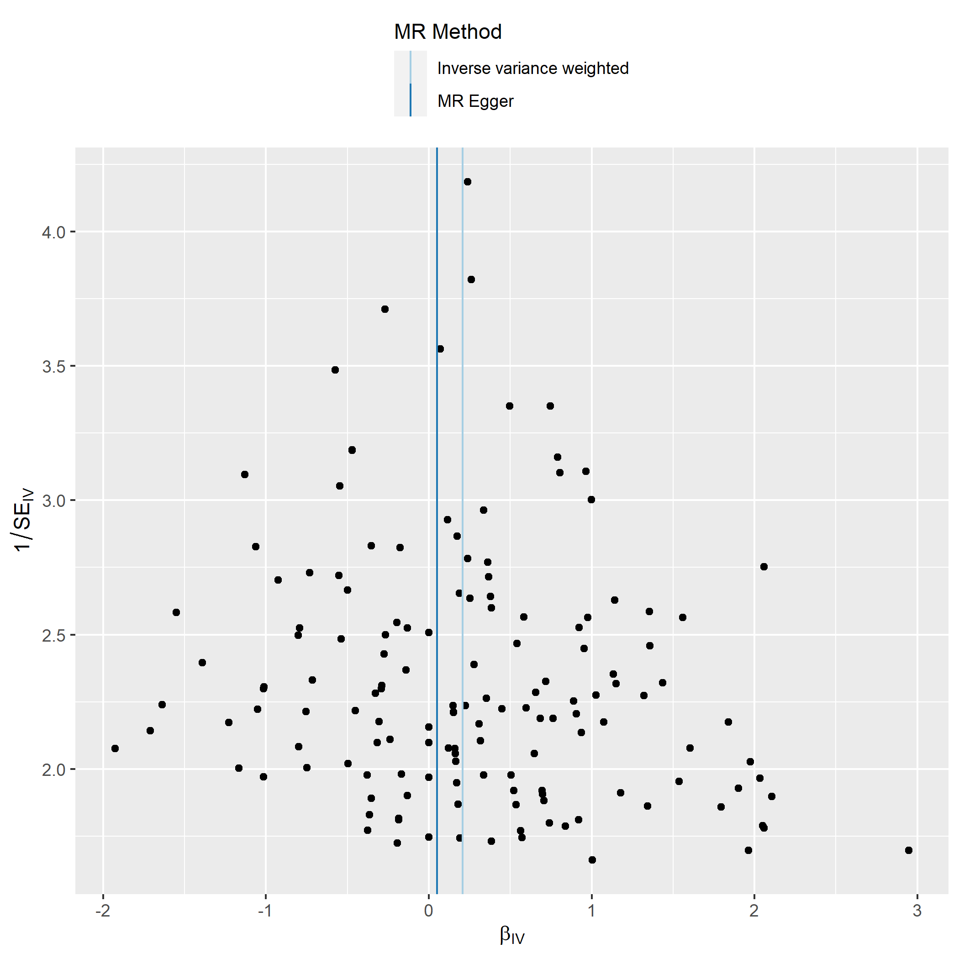
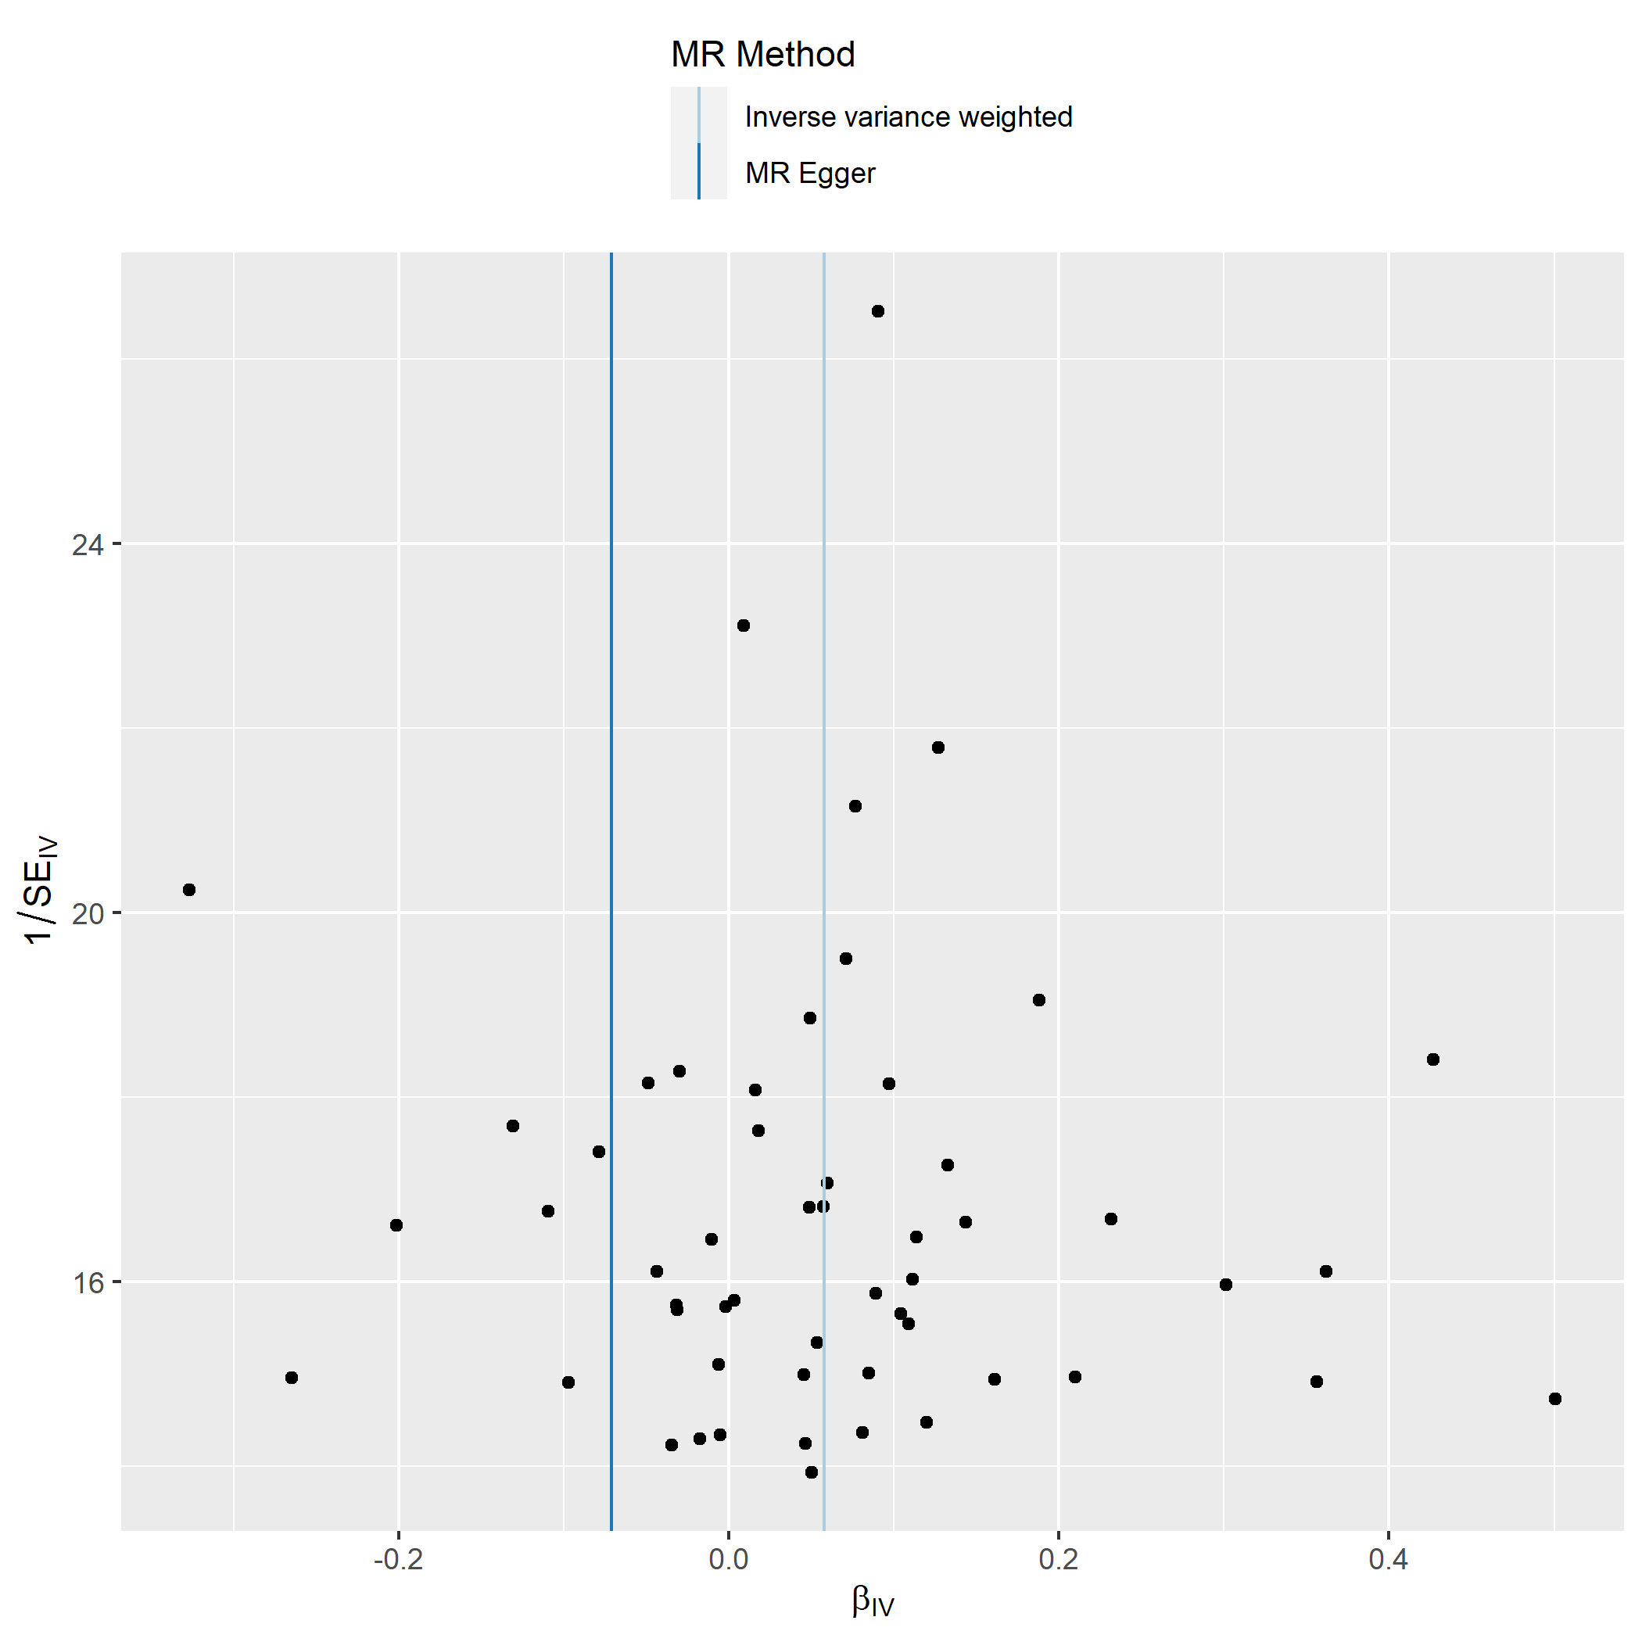
Supplementary Figure 1: Funnel plot assessing the extent to which pleiotropy is balanced across the set of instruments used in the univariate MR analysis of A) years of schooling on wellbeing and B) wellbeing on years of schooling. βIV represents the effect size of each SNP, and 1/SEIV represents the inverse standard error for each SNP effect.

B.

A.

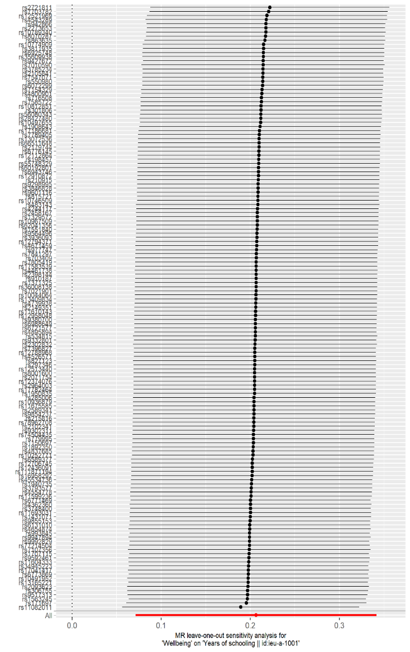
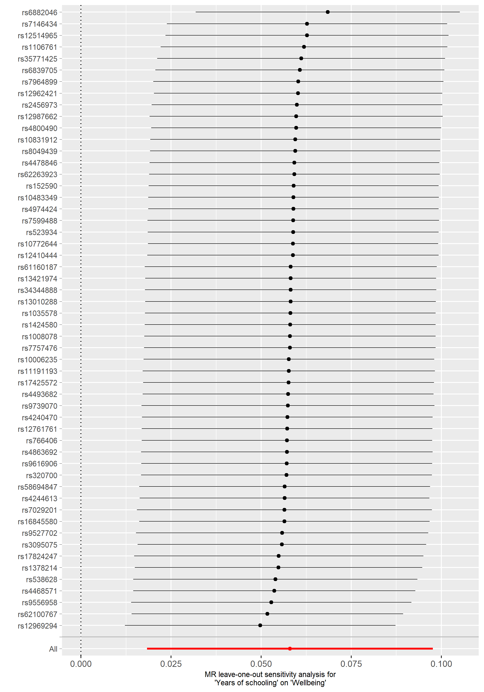
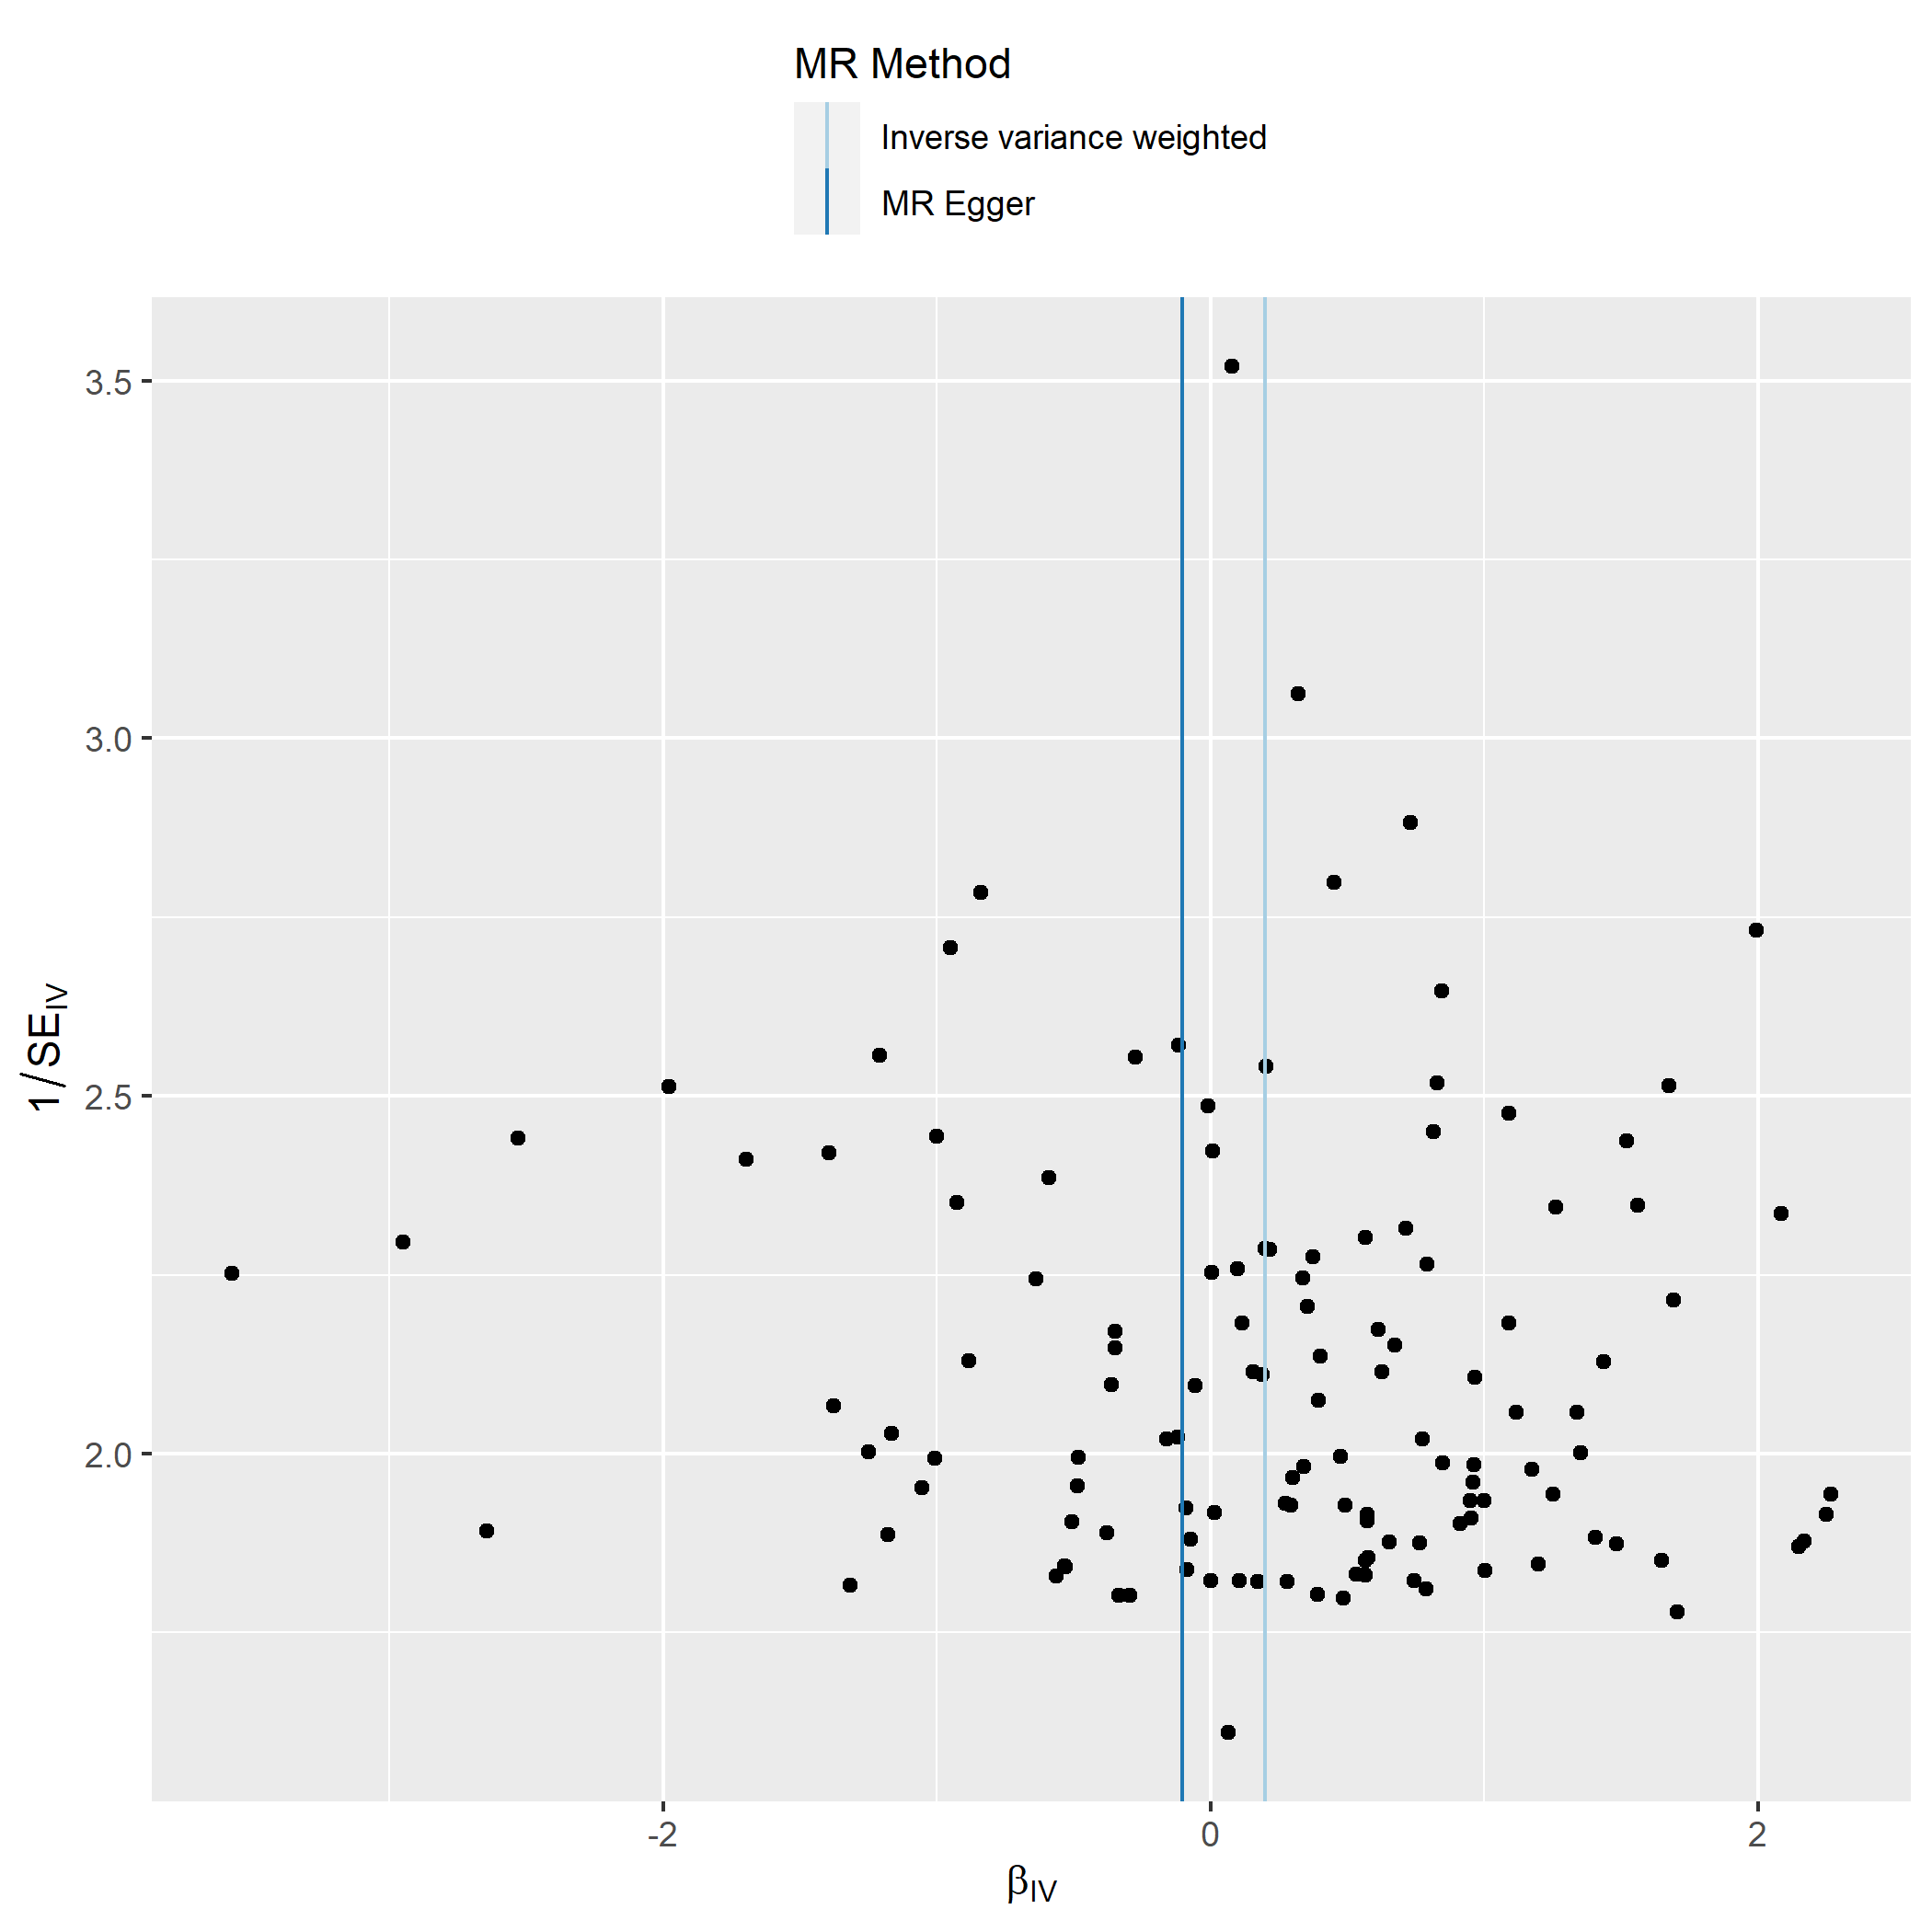
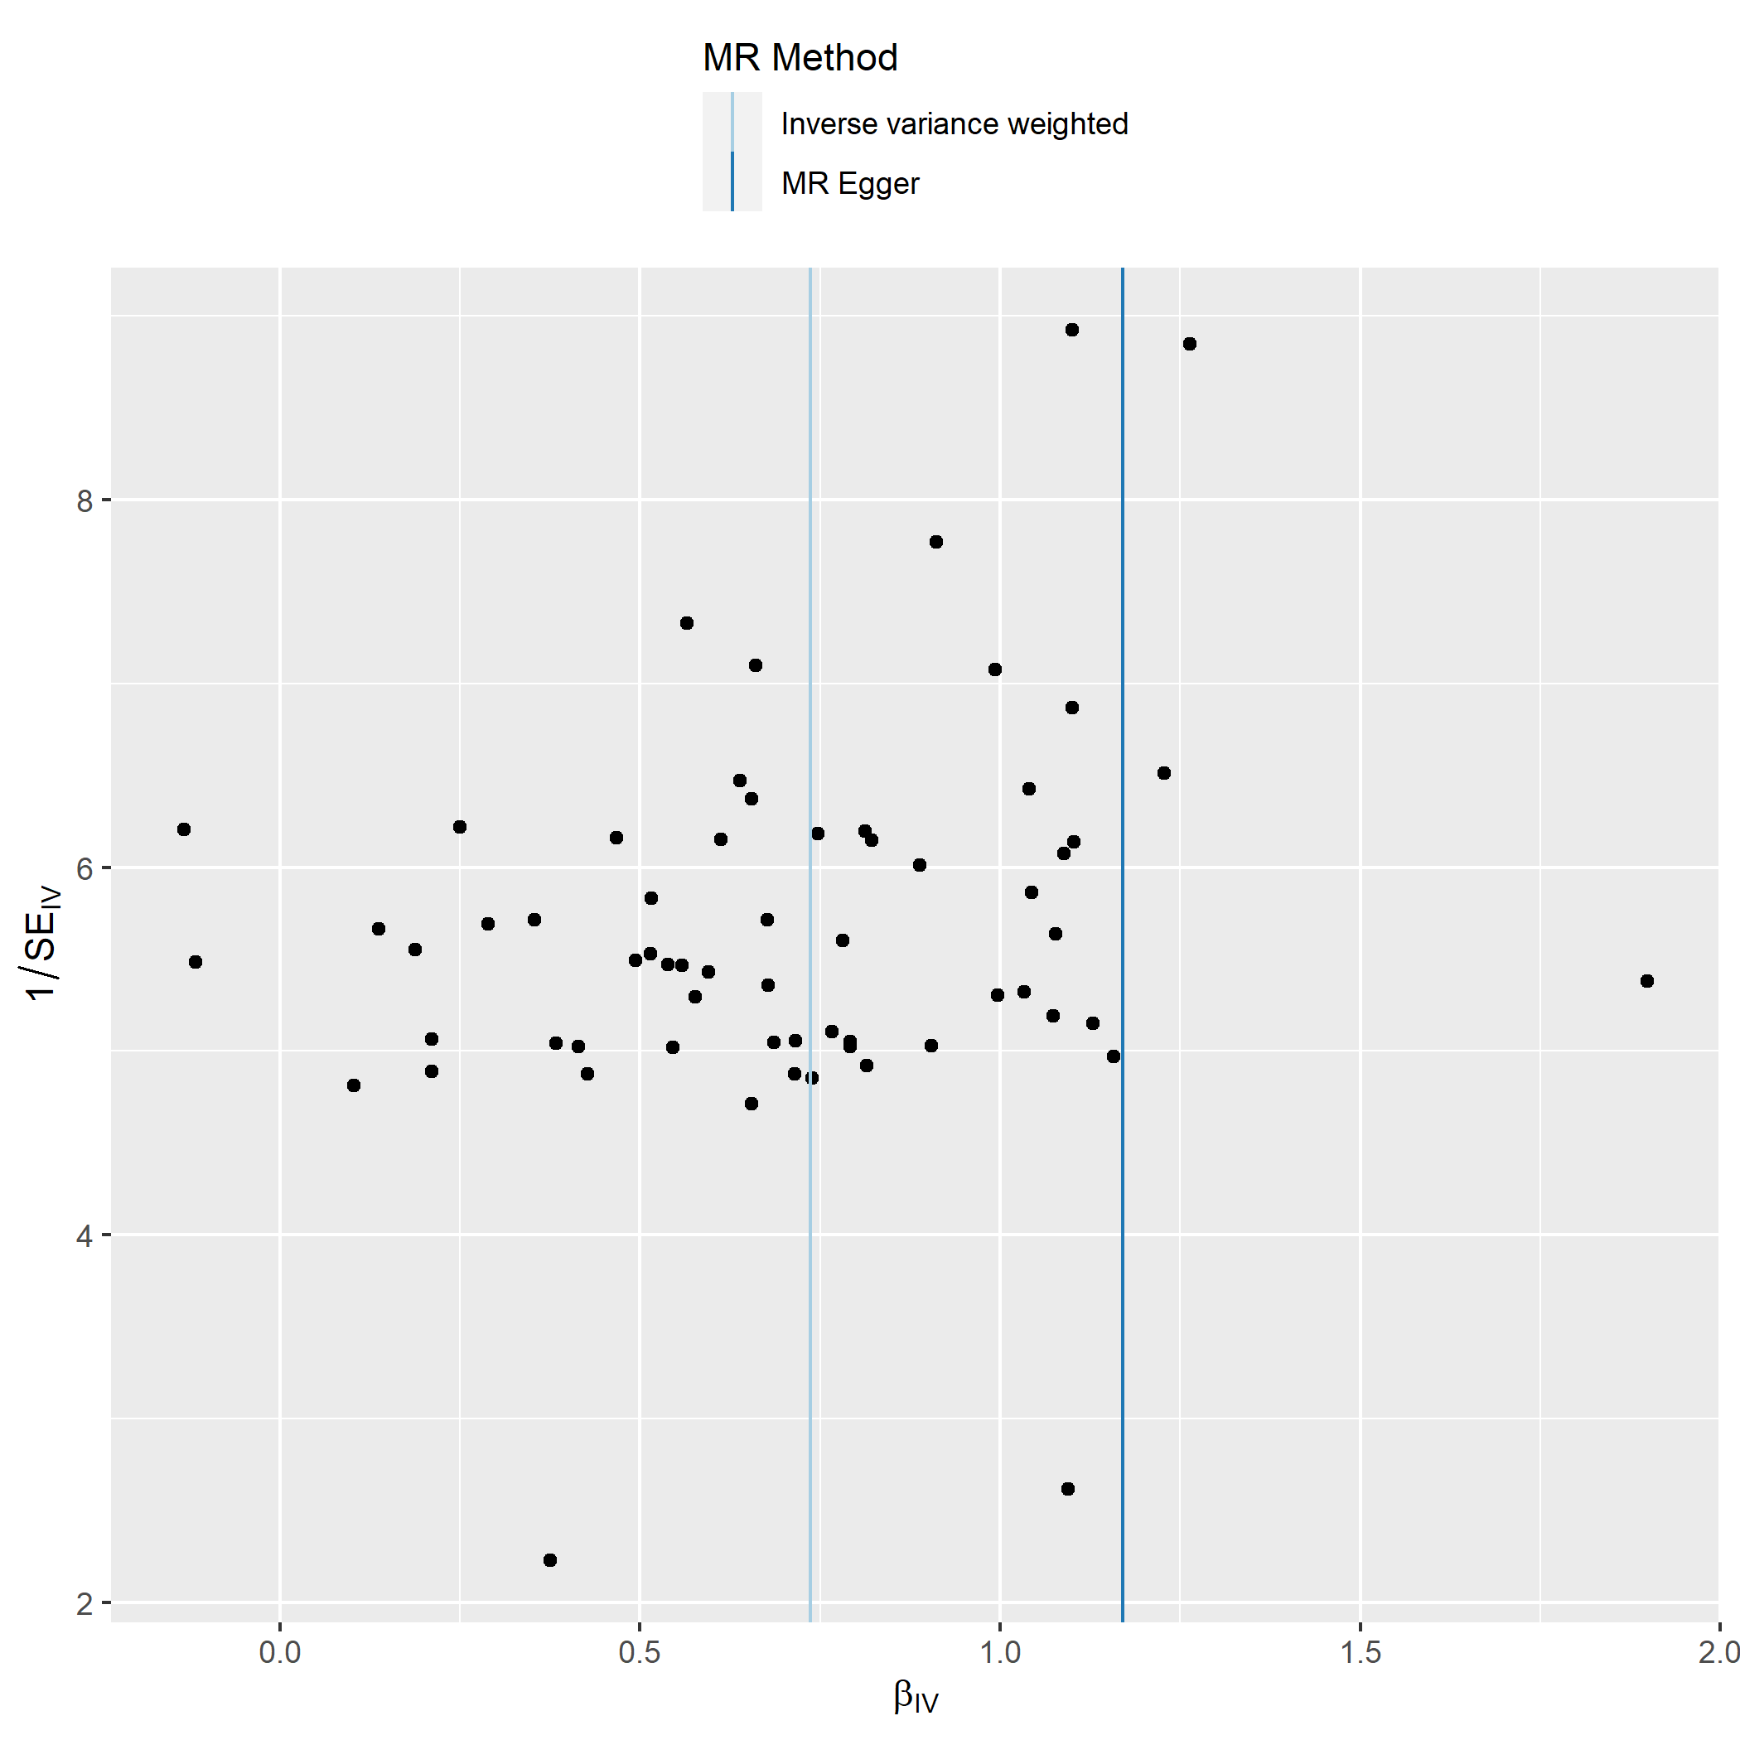
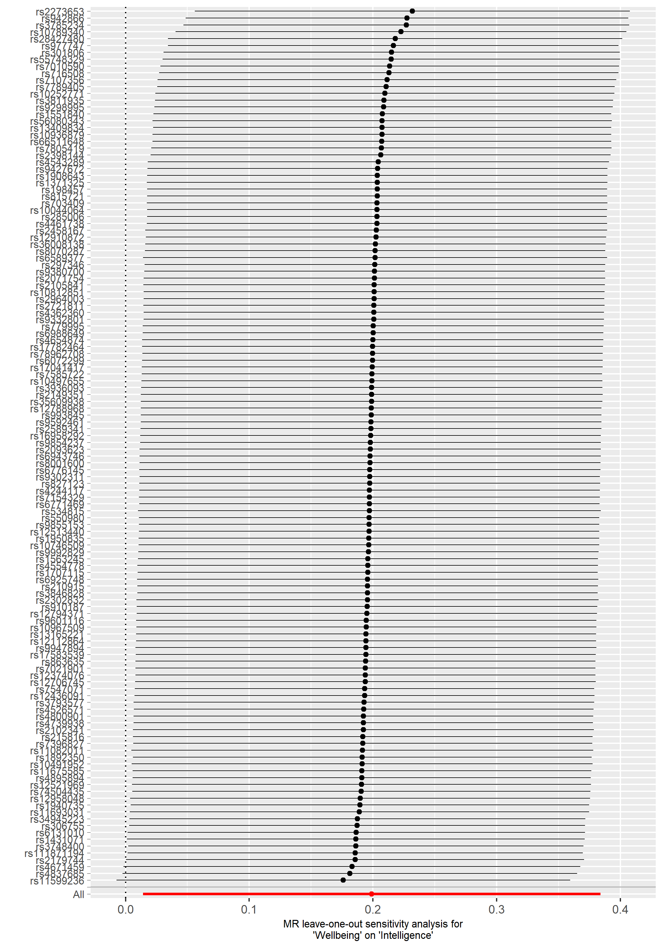
B.

A.

Supplementary Figure 2: Leave-one-out analyses for A) two-sample univariable MR analysis of years of schooling on wellbeing and B) two-sample univariable MR analysis of wellbeing on years of schooling. As evident in both forest plots, neither of the univariable associations were driven by a single SNP.

Supplementary Figure 3: A) Funnel plot assessing the extent to which pleiotropy is balanced across the set of instruments used in the univariate MR analysis of wellbeing on intelligence. βIV represents the effect size of each SNP, and 1/SEIV represents the inverse standard error for each SNP effect. B) Leave-one-out analyses for two-sample univariable MR analysis of wellbeing on intelligence. As evident in both the funnel and forest plots, the univariable association did not appear to be not driven by a single SNP.

Supplementary Figure 4: Flowchart of data available for use in ALSPAC. Boxes in red represent data imputed during multiple imputation.

Education and wellbeing data at 26 years (n=3,788)
Intelligence and wellbeing data at 26 years (n=3,179)
Original enrolment to ALSPAC (n=14,541)
Not alive at 1 year (n=566)
Offspring alive after 1 year (n=13,975)
Intelligence data at 8 years (n=7,258)
Educational attainment data at 26 years (n=4,013)
Wellbeing data at 26 years (n=4,254)
Complete data on wellbeing, educational attainment, and intelligence (n=2,844)
Missing intelligence data (n=6,717)
Missing educational attainment data (n=10,217)
Missing wellbeing data (n=4,079)
Missing wellbeing data (n=225)
Missing wellbeing data (n=466)
Missing wellbeing data (n=1,075)

