SUPPLEMENTARY INFORMATION

Mechanistic Insights into Glycoside 3-Oxidases Involved in C-Glycoside Metabolism in Soil Microorganisms

André Taborda^{1†}, Tomás Frazão^{1†}, Miguel V. Rodrigues¹, Xavier Fernández-Luengo³, Ferran Sancho², Maria Fátima Lucas², Carlos Frazão¹, M. Rita Ventura¹, Laura Masgrau^{2,3}, Patrícia T. Borges¹* and Lígia O. Martins¹*

¹Instituto de Tecnologia Química e Biológica António Xavier, Universidade Nova de Lisboa, Av da República, 2780-157 Oeiras, Portugal
²Zymvol Biomodeling, C/ Pau Claris, 94, 3B, 08010 Barcelona, Spain
³Department of Chemistry, Universitat Autònoma de Barcelona, 08193 Bellaterra, Spain

† A.T. and T. F. contributed equally to this work.
*Corresponding Author: lmartins@itqb.unl.pt

Table of Contents
1. Experimental information 3
1.1. Transient-state kinetics 3
1.2. Optimization of activity assay of PsG3Ox. 4
1.3. Prediction of structural models of bacterial POxs by alphafold 5
1.4 In vitro deflavinylation and reconstitution of PsG3Ox 6
1.5 Saturation mutagenesis of the residue N120 8
2. Supplementary Tables 10
Supplementary Table 1. 10
Supplementary Table 2. 13
Supplementary Table 3. 14
Supplementary Table 4. 15
Supplementary Table 5. 16
Supplementary Table 6. 17
Supplementary Table 7. 18
Supplementary Table 8. 19
Supplementary Table 9. 20
Supplementary Table 10. 21
3. Supplementary Figures 22
Supplementary Figure 1. 22
Supplementary Figure 2. 23
Supplementary Figure 3. 24
Supplementary Figure 4. 25
Supplementary Figure 5. 26
Supplementary Figure 6. 27
Supplementary Figure 7. 28
Supplementary Figure 8. 29
Supplementary Figure 9. 30
Supplementary Figure 10. 31
Supplementary Figure 11. 32
Supplementary Figure 12. 33
Supplementary Figure 13. 34
Supplementary Figure 14. 35
Supplementary Figure 15. 36
Supplementary Figure 16. 37
Supplementary Figure 17. 38
Supplementary Figure 18. 39
Supplementary Figure 19. 40
Supplementary Figure 20. 41
Supplementary Figure 21. 42
Supplementary Figure 22. 43
Supplementary Figure 23. 44
Supplementary Figure 24. 45
Supplementary Figure 25. 46
Supplementary Figure 26. 47
Supplementary Figure 27. 48
Supplementary Figure 28. 49
Supplementary Figure 29. 50
4. References 51

Experimental information

1.1. Transient-state kinetics
The catalytic cycle of PsG3Ox was explored by transient-state kinetics following independently its two half-reactions, the reductive and the oxidative (Supplementary Figure 1a). All experiments were conducted inside an anaerobic glove box to ensure an oxygen-free atmosphere. The PsG3Ox enzyme in a previously deoxygenized 100 mM sodium phosphate buffer, pH 7.5, supplemented with 0.2 M of NaCl, was mixed with D-Glc solutions (prepared anaerobically in the same buffer) in a Hi-Tech SF-61DX2 stopped-flow apparatus (TgK Scientific, Bradford-on-Avon, UK) coupled to a diode array, at 25 °C. The reduction of enzyme cofactor was followed by the decrease of absorbance at 460 nm during time (Supplementary Figure 2a). For the oxidative half-reaction, the PsG3Ox enzyme (previously reduced by 50 mM of D-Glc) was mixed with buffer containing different O₂ concentrations (these buffer solutions were prepared previously by mixing in different ratios the oxygenized and deoxygenized 100 mM sodium phosphate buffer, pH 7.5 supplemented with 0.2 M of NaCl buffer). The reoxidation of PsG3Ox by dioxygen was followed in a stopped-flow apparatus coupled to a diode array, at 25 ºC (Fig. S2b), following the increase of absorbance at 460 nm over time. To determine the real oxygen concentration used to re-oxidize the enzyme, the oxygen containing buffers were mixed with 300 µM sodium dithionite (Sigma Aldrich, Missouri, USA, and its oxidation (Na₂S₂O₄ + O₂ + H₂O → NaHSO₄ + NaHSO₃) was monitored by the decrease of the absorbance maximum of sodium dithionite at 315 nm (ε₃₁₅= 8,043 M⁻¹ cm⁻¹) in the stopped-flow apparatus under a photomultiplier detector (TgK Scientific, Bradford-on-Avon, UK) (Supplementary Figure 2c). All oxidative and reductive half-reactions traces were analyzed using Kinetic studio software (TgK Scientific, Bradford-on-Avon, UK), and the data were adjusted to a single exponential equation Eq.1. using the Solver Ad tool of Microsoft excel.
$$\left[P\right]=-A*\exp^{-k_{obs} * t}+C (1)$$
([P] is the cofactor concentration in the enzyme preparation, A is the amplitude of the exponential extrapolated to infinite time, k_{obs} is the pseudo-first-order constant, t is the time of reaction and C is a constant equal to the absorbance, at 460 nm at an infinite time).
The determined k_{obs} at different concentrations of D-Glc or molecular oxygen show a linear dependence in the range of concentrations tested (Supplementary Figure 1b-c), which allows extracting the second-order rate constant for the reductive half-reaction (k^{red}) or for oxidative half-reaction (k^{ox}) by the slope of the data. The obtained k^{red} and k^{ox} of 0.15 ± 0.02 M⁻¹s⁻¹ and (0.76 ± 0.06) × 10⁶ M⁻¹s⁻¹, respectively, indicate that the rate-limiting step of PsG3Ox reaction is the oxidation of D-glucose to 2-keto-D-glucose that shows a constant 6-orders of magnitude lower than the oxidative-half reaction.

1.2. Optimization of activity assay of PsG3Ox.
The most typical routine method to determine the P2Oxs activity, when molecular oxygen is used as an electron acceptor, is based on a coupled assay using horseradish peroxidase (HRP, Sigma Aldrich, Missouri, USA) with 2,2'-azino-bis(3-ethylbenzothiazoline-6-sulfonic acid) (ABTS, ApplieChem, Darmstadt, Germany) as substrate¹⁻⁴. This compound is oxidized to ABTS^{•+}, a green-colored radical cation easily monitored following absorbance at 420 nm. However, some reports showed that the oxidized form of ABTS, ABTS^{•+}, can also act as an electron acceptor of P2Oxs^{2,5}, which would lead to an underestimation of the enzymatic activity. Therefore, we have tested this possibility in the presence and absence of oxygen (Supplementary Table 2). First, we oxidized 10 mM ABTS to ABTS^{•+}using 1U/mL of CotA laccase⁶. The color changed from colorless to dark green, indicating the formation of the desired compound. CotA laccase was removed from the reaction mixture by ultrafiltration using an ultra-centrifugal filter vivaspin20 of 30 kDa cutoff (Cytiva, Massachusetts, USA) at 4000 rpm for 30 min (Eppendorf 5810 R centrifuge). PsG3Ox enzymatic assays were then performed using 1 M of D-Glc, 35 μM of ABTS^{•+}, and 10 μg of wild-type PsG3Ox (control assays were performed without D-glucose). For the aerobic assays, reaction mixtures without PsG3Ox protein were bubbled with pure O₂ for 15 min. For anaerobic assays, a cuvette with a rubber cap was used, and N₂ was bubbled with a needle directly into the reaction mixture for 15 min. The absorbance changes at 420 nm were measured in a Nicolet Evolution 300 spectrophotometer (Thermo Industries, Massachusetts, USA). Our data show that PsG3Ox can efficiently reduce ABTS^{•+} to ABTS in the absence and the presence of oxygen without significant differences (Supplementary Table 2), suggesting that this system can affect the oxidase measurements since PsG3Ox shows a preference for ABTS^{•+} even when the solution is saturated in O₂. Based on these results, we have tested the HRP coupled assay replacing ABTS by the two substrates 4-Aminophenazone (AAP) and 3,5-dichloro-2-hydroxybenzene-sulfonic acid (DCHBS), which originate upon oxidation by HRP, the compound N-(4-antipyryl)-3-chloro-5-sulfonate-p-benzoquinone-monoimine, a pink chromogen that can be spectrophotometrically followed⁷. We have tested if N-(4-antipyryl)-3-chloro-5-sulfonate-p-benzoquinone-monoimine (from here on called pink chromogen) is an electron acceptor of PsG3Ox (Supplementary Table 2). The pink chromogen was generated by mixing 0.1 mM AAP, 1 mM DCHBS, 8 U/ml HRP and 0.1 mM H₂O₂. After the reaction, HRP was removed by ultrafiltration using an ultra-centrifugal filter vivaspin20 of 30 kDa cutoff (Cytiva, Massachusetts, USA) at 4000 rpm for 30 min (Eppendorf 5810 R centrifuge). PsG3Ox enzymatic assays were performed using 1 M of D-Glc, 35 μM of pink chromogen, 100 μg of wild-type PsG3Ox (control assay was performed without D-glucose). The absorbance changes at 515 nm were measured in a Nicolet Evolution 300 spectrophotometer (Thermo Industries, Waltham). The data obtained showed that pink chromogen is also bleached over the reaction time. However, the bleaching rate is ~ 6-fold and ~ 15-fold lower than the one obtained for ABTS^{•+} in the absence or presence of molecular oxygen, respectively. This data suggests that despite a small reduction of pink chromogen, the HRP-AAP/DCHBS system is more suitable than the HRP-ABTS system for measuring PsG3Ox oxidase activity.

1.3. Prediction of structural models of bacterial POxs by alphafold
To investigate the structural differences between the bacterial POxs, models of the bacterial enzymes AgCarA, CarA, ScP2Ox and KaP2Ox were predicted using AlphaFold that was accessed on 22 November 2022 through the Google Colab platform and AlphaFold2_advanced option https://colab.research.google.com/github/sokrypton/ColabFold/blob/main/beta/AlphaFold2_advanced.ipynb#scrollTo=Riekgf0KQv_3 ⁸. The refinement was performed using the Amber-relax option to enhance the accuracy of the side chains geometry. The predicted local-distance difference test (pLDDT) confidence values (higher = better) are indicated in the B-factor column. Only the best model among the five best given by default was examined and represented in Supplementary Figure 10. The structural analysis of the crystal structures of PsG3Ox, MtCarA (PDB 7DVE) and predicted models of AgCarA CarA, ScP2Ox and KaP2Ox shows that enzyme segments equivalent to the PsG3Ox insertion-1 are also present in the other bacterial enzymes with exception of KaP2Ox (Supplementary Figure 10b-g). This last enzyme, similarly, to the fungal ones, contains two oligomerization domains which could be relevant for its dimeric arrangement (Supplementary Figure 10f). Moreover, the insertion region in PsG3Ox and AgCarA has a high number of residues, 33, similarly to the CarA that contains 27 residues in that region. Nevertheless the other two enzymes, ScP2Ox and MtCarA, has shorter insertions, 14 and 22 residues, respectively. The structural analysis of the superimposed bacterial enzymes in the substrate loop region has low confidence values of predicted local-distance difference which impairs an accurate structural analysis/alignment of this region. The sequence alignment (Supplementary Figure 10h) of the substrate loop in bacterial enzymes revealed that its composition in PsG3Ox is more similar to AgCarA, CarA and MtCarA where ³⁴⁶ASP³⁴⁸ and D354 are conserved among these organisms. The residue V349 in PsG3Ox is conserved in AgCarA and MtCarA; in CarA that residue is replaced by an isoleucine. The P350 in PsG3Ox is replaced by basic residues, arginine, lysine, in CarA and MtCarA, respectively. The ³⁵¹LAD³⁵³ from PsG3Ox is conserved in MtCarA and replaced by ³⁴¹FHV³⁴³, in CarA. Interestingly, the amino acids that compose the substrate loop in fungal enzymes (Fig 1F) are more conserved among them than in bacterial ones (Supplementary Figure 10h). Interestingly, the bacterial KaP2Ox has a substrate loop with an amino acid composition ³⁶⁹DAFHYGDVP³⁷⁷ highly similar to the fungal enzymes ⁴⁵²DAFSYGAVQ⁴⁶⁰ where the only differences are the H372, D375 and P377 that are replaced by S455, A458 and Q460 in TmP2Ox, respectively⁹.

1.4 In vitro deflavinylation and reconstitution of PsG3Ox
One of the distinctive properties of PsG3Ox in comparison to the described fungal enzymes is the cofactor attachment which is non-covalent in the PsG3Ox and covalent in fungal counterparts. This property led us to test if our enzyme can incorporate exogenous FAD. For that purpose, an apo-PsG3Ox enzyme preparation was obtained by an immobilized unfolding/refolding procedure. Briefly, a FAD-loaded preparation PsG3Ox was immobilized onto a 5 ml-HisTrap HP column (Cytiva, Massachusetts, USA) pre-equilibrated with 20 mM Tris-HCl, pH 7.6 (supplemented with 0.2 M of NaCl), and a urea gradient (0 – 1.3 M in 8 column volumes (CV)) was applied using 0.5 ml min⁻¹ as flow rate. Immediately after the cofactor release, as monitored by absorbance at 450 nm in the AKTA system, a refolding gradient was applied to decrease the urea concentration from 1.3 M to 0 M in 18 CV, followed by 5 CV of urea-free buffer to remove all denaturants from the column. The apo-enzyme was eluted using a gradient of 0-1 M of imidazole in 5 CV, and finally, the imidazole was removed with a PD-10 desalting column (GE Healthcare, Illinois, USA). To assess the secondary structure, far-UV circular dichroism spectra were performed in Jasco J-815 using a protein concentration of 0.15 mg ml⁻¹ with a bandwidth of 2 nm, DIT: 8 sec, Scan speed: 50 nm/min (Supplementary Figure 11a). The tertiary structure was also checked by following the intrinsic fluorescence emission of PsG3Ox tryptophan when excited at 296 nm in a Cary Eclipse fluorimeter (Supplementary Figure 11b). Both CD and fluorescence reveal a similar spectrum between the FAD-loaded PsG3Ox and the apo- PsG3Ox, ensuring that the unfolding process did not disrupt the structural features. To reconstitute the holo-PsG3Ox and determine the affinity constant to the FAD cofactor, the apo- PsG3Ox was incubated for 1 h with several ratios of flavin adenine nucleotide (FAD, Sigma Aldrich, Missouri, USA) at room temperature. The quenching of intrinsic fluorescence of the tryptophan’s that are localized close to the cofactor (Supplementary Figure 12a) was used to follow the binding of the FAD to the protein. An emission spectrum (310-450 nm) was recorded when the sample was excited at 296 nm in all ratios apo-PsG3Ox: FAD. The inner filter effect from FAD absorbance was corrected using Eq. (2), and the total fluorescence was determined by integrating the corrected emission spectra. The experimental protein-ligand bond fraction given by the normalized fluorescence as a function of ligand/protein ratio (Supplementary Figure 12b) was fitted to Eq. (3) of the one-binding site¹⁰. KD was determined using the Solver ad tool of Excel to minimize the differences between the experimental points and the fit equation.
$$F_{corr}= F_{obs} antilog\left(\frac{{Abs}_{296}+{Abs}_{em}}{2}\right) (2)$$
(F_{corr} is the fluorescence corrected to the inner filter effect, F_{obs} is the measured fluoresce, Abs_{ex} is the absorbance of the sample at the excitation wavelength: 296 nm, and Abs_{em} is the absorbance of the sample at each emission wavelength. The absorbances were measured in the FAD solution without enzyme)
$$Y= \frac{\left(1+\frac{L_{T}}{P_{T}}+\frac{K_{D}}{P_{T}}\right)- \sqrt{{\left(1+\frac{L_{T}}{P_{T}}+\frac{K_{D}}{P_{T}}\right)}^{2}-4 \frac{L_{T}}{P_{T}}}}{2} (3)$$
(Y is the protein-ligand bound fraction, L_{T} is the total concentration of the ligand, P_{T} is the total protein concentration and K_{D} is the dissociation constant).
Our data suggest a strong quenching of the tryptophan fluorescence below two equivalents of FAD (Supplementary Figure 12b). The dissociation constant, K_{D} = (2.0 ± 0.7) × 10⁻⁷ M and the affinity constant, K_{A} = (5.3 ± 1.9) × 10⁶ M⁻¹ were determined by the fitting the data points to the equation mentioned above, suggesting a high affinity of the enzyme to attach exogenous FAD. This high affinity to incorporate FAD was also reported for other flavoproteins¹¹⁻¹³. To prove that the reconstituted PsG3Ox also recovers its catalytic properties, the incubated enzyme preparations with several ratios of Enzyme: FAD were tested towards D-Glc oxidation (Supplementary Figure 12c). The profile shows a similar pattern to the one obtained from the quenching assays, which confirms that Apo-PsG3Ox is amenable to incorporating FAD and recovering its activity. Moreover, the catalytic parameters of the reconstituted enzyme were similar to those obtained for the native enzyme (data not shown).

1.5 Saturation mutagenesis of the residue N120
The analysis of PsG3Ox structure shows that His127 is in the incorrect rotamer to favor the covalent linkage, moreover this residue is interacting through a hydrogen bond with Asn120 (at 2.9 Å) (Fig 1e). In the structure of fungal enzymes, in place of an Asn it is found a valine or a glycine, both residues without the capability to form hydrogen bonds. The mutation N120V in PsG3Ox led to an enzyme produced without FAD. Site saturation mutagenesis of the residue 120 was performed to find other possible replacement residues for that position. The plasmid pSM-1 was used as template and the degenerated primers NNS in the codon that codifies for the residue 120 are listed in the Supplementary Table 1. Amplification PCR was performed in a thermal cycler (MyCyclerTM thermocycler, Biorad, California, USA) in 50 μL reaction volumes containing 100 ng of DNA template, 0.25 μM of primers (forward and reverse), 500 μM of dNTPs (NZYTech, Lisbon, Portugal), NZYProof polymerase buffer, and 1 U of NZYProof polymerase (NZYTech, Lisbon, Portugal). After an initial denaturation of 3 min at 95 ºC, 30 cycles of 1 min at 95 ºC, 1.5 min at 72 ºC and 8 min at 72ºC and a final elongation of 10 min 72 ºC were performed. The amplified product was digested with 10 U of DpnI (Thermo Scientific, Massachusetts, USA) at 37 ºC for 6 h to eliminate the DNA template prior purification using Illustra GFX PCR DNA kit (GE Healthcare, Illinois, USA). The PCR product was used to transform KRX electrocompetent cells (Promega, Wiscosin, USA) in a Gene Pulser XcellTM (Biorad), that were spread in LA media supplemented with 100 μg/mL of ampicillin. The resulting colonies (around 180) were picked to 96-deep well plates (VWR, Pennsylvania, USA) containing 400 μl of LB supplemented with appropriate antibiotics. The growths proceed overnight at 37 ºC under 750 rpm (pre-culture). New 96-deep wells plates containing 900 μL of LB supplemented with ampicillin were inoculated with 100 μL of the pre-culture and incubated during 3 h at 37 ºC, 750 rpm. Then, the expression of the target gene was induced with 12 mM rhamnose, and the cultures were grown overnight under 750 rpm at room temperature. Cells were collected by centrifugation at 4000 rpm (Eppendorf 5810 R) and the supernatants were discarded. The 96-well-plates containing the cell pellets were submerged in liquid nitrogen and thawed at room temperature for 10 min in a process that was repeated three times. Afterwards the cell pellet was resuspended in 200 μL of 20 mM Tris-HCl buffer, pH 7.6 supplemented with 2 mg/mL of lysozyme, 1U/ml DNase, 5 mM MgCl₂ and protease inhibitors (3.5 μM antipain and 5 μM leupeptin) and incubated during 20 min at room-temperature under 750 rpm. The lysate was clarified by centrifugation at 4000 rpm, 30 min at 4ºC. The supernatants were collected (cell crude extracts) and used for enzymatic activity measurements by transferring 50 μL of cell crude extracts to a new 96-well microtiters with 150 μL of reaction mixture containing 0.1 mM of 4-aminophenazone (AAP), 1 mM of 3,5-Dichloro-2-hydroxybenzene-sulfonic acid (DCHBS), 8 U of Horseradish peroxidase (HRP) and 0.5 M of D-Glc in 100 mM sodium phosphate buffer, pH 7.5. PsG3Ox activity was followed by the increase of absorbance at 515 nm using a Synergy2 microplate reader (BioTek). The variants that displayed activity were sequenced to determine the mutations introduced by the degenerated primers. From the 180 variants screened in a 96-well plate system around 80 % were inactive suggesting that residue position is very resistant to changes, although two mutations were found displaying activity, a substitution for a cysteine (N120C) and for a tyrosine (N120Y). Pure protein preparations were tested for activity displaying similar to 2-fold lower k_{cat}/K_{m} for D-Glc (Supplementary Table 5) and the cofactor attachment was analyzed, but FAD remains non covalently bound (Supplementary Figure 13). The two mutations found are residues that, similarly as asparagine, offers the possibility to form a hydrogen bond interaction with H127 and then the histidine could adopt a similar orientation instead of being oriented as the H167 in fungal TmP2Ox.

2. Supplementary Tables

Supplementary Table 1. Bacterial strains, plasmids, and primers used in the construction of PsG3Ox variants. F indicates forward primers, and R reverse primers.

Strains, Plasmids, or Primers | Genotype, property, or sequence | Reference or source
E. coli Strains
DH5𝛂 | F– φ80lacZΔM15 Δ(lacZYA argF)U169 recA1 endA1 hsdR17(r_{K}–, m_{K}⁺) phoA supE44 λ– thi-1 gyrA96 relA1 | Novagen
KRX | [F ́, traD36, DompP, roa+B+, lacIq, D(lacZ)M15] DompT, endA1, recA1, gyrA96 (Nalr), thi-1, hsdR17 (rK–, mK+), e14– (McrA–), relA1, supE44, D(lac-proAB), D(rhaBAD)::T7 RNA polymerase | Promega
Rosetta(DE3) pLysS | F⁻ ompT hsdSB(rB- mB-) gal dcm (DE3) pLysSRARE (CamR) | Novagen
Plasmids
pET15b | Cloning vector with a T7 promoter with a N-terminal T7tag and C-terminal 6xHis tag; amp^{r} | Novagen
pSM1 | pET15b with psg3ox gene cloned into NdeI and XhoI sites | (Mendes et al., 2016)
pDS1 | pET15b with psg3ox gene cloned into NdeI and XhoI sites. The A125S mutation was introduced by site-directed mutagenesis | This work
pDS2 | pET15b with psg3ox gene cloned into NdeI and XhoI sites. The A126T mutation was introduced by site-directed mutagenesis | This work
pDS3 | pET15b with psg3ox gene cloned into NdeI and XhoI sites. The A125S and A126T mutations were introduced by site-directed mutagenesis | This work
pDS13 | pET15b with psg3ox gene cloned into NdeI and XhoI sites. The H440A mutation was introduced by site-directed mutagenesis | This work
pDS14 | pET15b with psg3ox gene cloned into NdeI and XhoI sites. The N484A mutation was introduced by site-directed mutagenesis | This work
pAT16 | pET15b with psg3ox gene cloned into NdeI and XhoI sites. The N120V mutation was introduced by site-directed mutagenesis | This work
pAT23 | pET15b with psg3ox gene cloned into NdeI and XhoI sites. The N120Y mutation was introduced by site-saturation mutagenesis | This work
pAT24 | pET15b with psg3ox gene cloned into NdeI and XhoI sites. The N120C mutation was introduced by site-saturation mutagenesis | This work
pAT27 | pET15b with psg3ox gene cloned into NdeI and XhoI sites containing the deletion of the residues 345-359 (Δloop(345-359)) introduced by site-directed mutagenesis | This work
pAT28 | pET15b with psg3ox gene cloned into NdeI and XhoI sites containing the deletion of the residues 73-93 (Δinsertion-1) introduced by site-directed mutagenesis | This work
pAT29 | pET15b with psg3ox gene cloned into NdeI and XhoI sites. The R94A mutation was introduced by site-directed mutagenesis | This work
pAT31 | pET15b with psg3ox gene cloned into NdeI and XhoI sites. The Q297A mutation was introduced by site-directed mutagenesis | This work
pAT33 | pET15b with psg3ox gene cloned into NdeI and XhoI sites. The K55A mutation was introduced by site-directed mutagenesis | This work
pAT35 | pET15b with psg3ox gene cloned into NdeI and XhoI sites. The Q340A mutation was introduced by site-directed mutagenesis | This work
pAT39 | pET15b with psg3ox gene cloned into NdeI and XhoI sites. The T129A mutation was introduced by site-directed mutagenesis | This work
Primers
PsG3Ox-A125S F | 5’-GCAACGTGGGCGGGATGTCGGCCCACTGGACCGCCGCCTG-3’ | This work
PsG3Ox -A125S R | 5’-CAGGCGGCGGTCCAGTGGGCCGACATCCCGCCCACGTTGC-3’ | This work
PsG3Ox -A126T F | 5’-CGTGGGCGGGATGGCCACCCACTGGACCGCCGCCTGC-3’ | This work
PsG3Ox -A126T R | 5’-GCAGGCGGCGGTCCAGTGGGTGGCCATCCCGCCCACG-3’ | This work
PsG3Ox -A125S/A126T F | 5’-GCAACGTGGGCGGGATGTCCACCCACTGGACCGCCGCCTGC-3’ | This work
PsG3Ox -A125S/A126T R | 5’-GCAGGCGGCGGTCCAGTGGGTGGACATCCCGCCCACGTTGC-3’ | This work
PsG3Ox -H440A F | 5’-GCCGGGTGCGTCGCTGGCCTACCAGGGCACCA-3’ | This work
PsG3Ox -H440A R | 5’-TGGTGCCCTGGTAGGCCAGCGACGCACCCGGC-3’ | This work
PsG3Ox -N484A F | 5’-CCACCGCTACAGCATGCGCCCCCACCCTGACGT-3’ | This work
PsG3Ox -N484A R | 5’-ACGTCAGGGTGGGGGCGCATGCTGTAGCGGTGG-3’ | This work
PsG3Ox -N120V F | 5’- CCATGTCCAGCGTCGTGGGCGGGATGG -3’ | This work
PsG3Ox -N120V R | 5’- CCATCCCGCCCACGACGCTGGACATGG -3’ | This work
PsG3Ox -N120sat F | 5’- GGCCATGTCCAGCNNSGTGGGCGGGATGGC -3’ | This work
PsG3Ox -N120sat R | 5’- GCCATCCCGCCCACSNNGCTGGACATGGCC -3’ | This work
PsG3Ox -del345-359 F | 5’(Phosphorylated)-GAGCTGCATGATCTGGCCGTGGAAGGGCGC-3’ | This work
PsG3Ox -del345-359 R | 5’(Phosphorylated)-GGCTCCATCGTGGGGCTGGGCCTGTTCTGC-3’ | This work
PsG3Ox -del73-93 F | 5’(Phosphorylated)-CGCCCTGGAACTTACCTGCTGCAGGACGG-3’ | This work
PsG3Ox -del73-93 R | 5’(Phosphorylated)-ACCCTCCGACGCCCGCTGGGCG-3’ | This work
PsG3Ox -R94A F | 5’-CGAACGCCGTGCGGCCCCTGGAACTTACC-3’ | This work
PsG3Ox – R94A R | 5’-GGTAAGTTCCAGGGGCCGCACGGCGTTCG-3’ | This work
PsG3Ox -Q297A F | 5’-CCTGAACGACCAGGCGGCCGTGGTGTTCGCG-3’ | This work
PsG3Ox – Q297A R | 5’-CGCGAACACCACGGCCGCCTGGTCGTTCAGG-3’ | This work
PsG3Ox -K55A F | 5’-CGCGCACGTCGCGAACATCGAGGACC-3’ | This work
PsG3Ox – K55A R | 5’-GGTCCTCGATGTTCGCGACGTGCGCG-3’ | This work
PsG3Ox -Q340A F | 5’-CCTTCCACGGCGCGATCATGCAGC-3’ | This work
PsG3Ox – Q340A R | 5’-GCTGCATGATCGCGCCGTGGAAGG-3’ | This work
PsG3Ox -T129A F | 5’-CGCCCACTGGGCTGCCGCCTGC-3’ | This work
PsG3Ox – T129A R | 5’-GCAGGCGGCAGCCCAGTGGGCG-3’ | This work

Supplementary Table 2. X-ray data collection and refinement statistics. Values in parentheses belong to the highest resolution shell.
 | PsG3Ox |  | PsG3Ox-Glc |  | PsG3Ox-Mang
Data collection
Beamline | ESRF ID23-2 |  | ESRF ID30A-1 |  | ALBA XALOC
Wavelength (Å) | 0.8731 |  | 0.9654 |  | 0.97926
Space group | C 2 2 2₁ |  | C 2 2 2₁ |  | C 2 2 2₁
Unit cell parameters (Å) | a = 78.5, b = 78.8, c = 151.3 |  | a = 78.3, b = 78.5, c = 150.2 |  | a = 76.7, b = 78.9, c = 147.3
Resolution (Å) | 39.39 – 2.01 (2.11 – 2.01) |  | 75.11 – 2.35 (2.46 – 2.35) |  | 73.67 – 2.60 (2.70 – 2.60)
Nr. observations | 361063 (51690) |  | 94766 (9314) |  | 87843 (13386)
Nr. unique reflections | 31572 (5031) |  | 18894 (2511) |  | 14110 (2229)
Completeness (%) | 99.8 (99.6) |  | 96.2 (90.8) |  | 99.5 (97.9)
Multiplicity | 11.4 (10.3) |  | 5.0 (3.7) |  | 6.2 (6.0)
Mosaicity (ᵒ) | 0.43 |  | 0.43 |  | 0.48
CC_{1/2} (%)ª | 99.6 (65.3) |  | 97.3 (42.4) |  | 98.5 (49.5)
R_{sym} (%)^{b} | 15.2 (181.3) |  | 18.8 (185.9) |  | 17.8 (44.9)
R_{meas} (%)^{c} | 17.9 (188.6) |  | 28.4 (154.9) |  | 20.8 (63.0)
R_{p.i.m.} (%)^{d} | 4.6 (26.4) |  | 14.7 (47.4) |  | 7.8 (20.2)
<I/σ(I)> | 9.57 (0.99) |  | 4.11 (0.94) |  | 6.99 (1.16)
Wilson B (Å²) | 42.0 |  | 50.9 |  | 44.0
V_{M} (Å³ Da⁻¹) | 1.83 |  | 1.80 |  | 2.01
Estimated solvent content (%) | 32.7 |  | 31.8 |  | 39.0
Refinement
R_{work} (%)^{e} | 19.9 |  | 24.5 |  | 22.8
R_{free} (%)^{e} | 24.4 |  | 26.2 |  | 28.2
rmsd for bond lengths (Å) | 0.003 |  | 0.002 |  | 0.002
rmsd for bond angles (°) | 0.542 |  | 0.465 |  | 0.467
Structure <a.d.p.> (Å²) | 52.2 |  | 64.9 |  | 30.8
Ramachandran plot
Residues in favored regions (%) | 98.0 |  | 93.5 |  | 96.4
Residues in allowed regions (%) | 2.0 |  | 6.5 |  | 3.6
Residues in disallowed regions (%) | 0 |  | 0 |  | 0
PDB code | 7QF8 |  | 7QFD |  | 7QVA

ª CC_{1/2} = Percentage of correlation between intensities from random half-datasets.
^{b} R_{sym} = Σhkl Σi |Ii(hkl) - <I(hkl)>|/ Σhkl Σi Ii (hkl), where Ii(hkl) is the observed intensity and <I(hkl)> is the average intensity of multiple observations from symmetry-related reflection.
^{c} R_{meas} = Σhkl [N/(N(hkl) -1)]1/2 Σi |Ii(hkl) - <I(hkl) >|/Σhkl Σi Ii (hkl), where N(hkl) is the data multiplicity, Ii(hkl) is the observed intensity and <I(hkl)> is the average intensity of multiple observations from symmetry-related reflections. It is an indicator of the agreement between symmetry related observation.
^{d} R_{p.i.m.} = Σhkl [1/(N(hkl) -1)]1/2 Σi |Ii(hkl) - <I(hkl) >|/Σhkl Σi Ii (hkl), where N(hkl) is the data multiplicity, Ii(hkl) is the observed intensity and <I(hkl)> is the average intensity of multiple observations from symmetry-related reflections. It indicates the precision of the final merged and averaged data set.
^{e} R_{work} refers to the actual working data set used in reﬁnement, while R_{free} refers to a cross-validation set that is not directly used in reﬁnement and is therefore free from reﬁnement bias.
Supplementary Table 3. Optimization of the colorimetric assay to measure the oxidase activity of PsG3Ox. The rate of consumption by PsG3Ox of ABTS^{•+} and N-(4-antipyryl)-3-chloro-5-sulfonate-p-benzoquinone-monoimine, a pink chromogen, was determined in the presence and absence of molecular oxygen using D-Glc as the electron donor.

 | Rate of consumption (nmol min⁻¹ mg⁻¹)
 | ABTS^{•+} | Pink chromogen
+ O₂ | 368 $±$ 46 | 25 $±$ 1
- O₂ | 441 $±$ 74 | 77 $±$ 12

Supplementary Table 4. Apparent steady-state catalytic parameters for D-Glc and O₂ for P2Oxs in the literature.

Origin | Enzyme | D-Glcª |  |  |  | O₂^{b}
Origin | Enzyme | k_{cat}  (s⁻¹) | K_{m}  (M) | k_{cat}/K_{m}  (M⁻¹s⁻¹) |  | k_{cat}  (s⁻¹) | K_{m}  (M) | k_{cat}/K_{m}  (M⁻¹s⁻¹) |  | References
Bacterial | Pseudarthrobacter siccitolerans PsG3Ox | 0.19 | 0.46 | 0.45 |  | 0.14 | 5.8 × 10⁻⁶ | 19.9 × 10³ |  | This work
Bacterial | Pantoea ananatis Sd-1 PaP2Ox | ND | - | - |  | ND | - | - |  | ¹⁴
Bacterial | Kitasatospora aureofaciens KaP2Ox | 15.4 | 1.5 × 10⁻³ | 1.0 × 10⁴ |  | 32.4 | 1.1 × 10⁻³ | 3.0 × 10⁴ |  | ¹⁵
Bacterial | Microbacterium sp. 5-2b CarA | nd | - | - |  | ND | - | - |  | ¹⁶
Bacterial | Arthrobacter globiformis AgCarA | nd | - | - |  | ND | - | - |  | ¹⁶
Bacterial | Microbacterium trichothecenolyticum MtCarA | nd | - | - |  | ND | - | - |  | ¹⁶
Bacterial | Streptomyces canus ScP2Ox | > 0.38 | > 2.0 | > 0.19 |  | 0.02 | 6.0 × 10⁻⁵ | 3.3 × 10² |  | ¹⁷
Fungal | Phlebiopsis gigantea PhgP2Ox | 40.5 | 1.2 × 10⁻³ | 3.4 × 10⁴ |  | ND | - | - |  | ¹⁸
Fungal | Trametes multicolor TmP2Ox | 54.0 | 0.7 × 10⁻³ | 7.3 × 10⁴ |  | 71.0 | 9.0 × 10⁻⁵ | 7.9 × 10⁵ |  | ²
Fungal | Tricholoma matsutake TmaP2Ox | 111.0 | 1.3 ×10⁻³ | 8.7 × 10⁴ |  | ND | - | - |  | ¹⁹
Fungal | Peniophora gigantea PegP2Ox | 56 | 1.1 × 10⁻³ | 5.0 × 10⁴ |  | ND | - | - |  | ¹
Fungal | Peniophora sp. PsP2Ox | 9.4 | 5.0 × 10⁻³ | 1.8 × 10³ |  | ND | - | - |  | ²⁰
Fungal | Phanerochaete chrysosporium PcP2Ox | 83.1 | 0.8 × 10⁻³ | 9.9 × 10⁴ |  | 109.0 | 1.2 × 10⁻³ | 8.9 × 10⁴ |  | ³
Fungal | Lyophyllum shimeji LsP2Ox | 6.9 | 0.3 × 10⁻³ | 2.2 × 10⁴ |  | ND | - | - |  | ²¹
Fungal | Aspergillus nidulans AnP2Ox | 35.4 | 1.8 × 10⁻³ | 2.0 × 10⁴ |  | ND | - | - |  | ⁴
Fungal | Aspergillus oryzae AoP2Ox | 1.5 | 2.9 × 10⁻³ | 0.5 × 10³ |  | ND | - | - |  | ⁴
Fungal | Irpex lacteus IlP2Ox | 33.8 | 0.7 × 10⁻³ | 4.6 × 10⁴ |  | ND | - | - |  | ²²
ª Molecular oxygen was used as an electron acceptor; ^{b} D-Glc was used as an electron donor (except for ScP2Ox where xylose was used); ND-not determined; nd-not detected
Supplementary Table 5. Summary of ¹H (400 MHz) and ¹³C (100.61 MHz) chemical shift in DMSO-d6 for Mang sugar moiety and for its oxidation product catalyzed by PsG3Ox.

 | Position | ¹H, 𝞭H (ppm) | Multiplicity, J(MHz) | ¹³C, 𝞭C (ppm)
Mangiferin  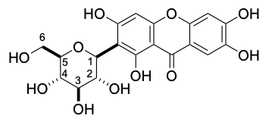 | 1 | 4.60 | d, 10.01 | 73.7
 | 2 | 4.06 | t, 9.30 | 70.7
 | 3 | [3.25-3.09] | m | 79.6
 | 4 | [3.25-3.09] | m | 70.8
 | 5 | [3.25-3.09] | m | 82.2
 | 6 | 3.69 | m | 61.9
 | 6 | 3.38 | m | 61.9
Oxidation product  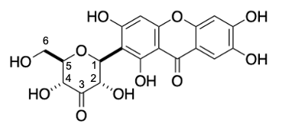 | 1 | 5.17 | d, 10.06 | 73.4
 | 2 | 4.69 | d, 10.05 | 76.1
 | 3 | nd | - | 209
 | 4 | 4.14 | d, 9.82 | 73.6
 | 5 | 3.27 | m | 83.8
 | 6 | 3.71 | m | 61.8
 | 6 | 3.55 | m | 61.8
nd- Not detected.

Supplementary Table 6. Apparent steady-state kinetic parameters for D-Glc and mangiferin of PsG3Ox variants. The catalytic parameters for D-Glc were estimated using the HRP-AAP/DCHBS coupled assay in a reaction mixture containing 0-1.25 M D-Glc, 0.1 mM of AAP, 1 mM of DCHBS and 8 U ml⁻¹ of HRP, whereas reactions with mangiferin were monitored by oxygen consumption in an Oxygraph. All reactions were performed in 100 mM sodium phosphate buffer at pH 7.5 at 37 ºC. The kinetic parameters were determined by fitting the data directly on the Michaelis-Menten equation using OriginLab.

 | D-Glucose |  |  |  | Mangiferin
Variant | k_{cat}  (s⁻¹) | K_{m}  (M) | k_{cat}/ K_{m}  (M⁻¹s⁻¹) |  |  | k_{cat}  (s⁻¹) | K_{m}  (M) | k_{cat}/ K_{m}  (M⁻¹s⁻¹)
Wild-type | 0.19 ± 0.03 | 0.5 ± 0.1 | 0.45 ± 0.09 |  |  | 8.1 ± 1.7 | (0.5 ± 0.1) ×10⁻³ | (19.0 ± 3.0) ×10³
A125S | 0.14 ± 0.02 | 0.6 ± 0.1 | 0.24 ± 0.03 |  |  | ND | - | -
A126T | 0.09 ± 0.03 | 0.6 ± 0.1 | 0.15 ± 0.06 |  |  | ND | - | -
A125S-A126T | nd | - | - |  |  | nd | - | -
H440A | nd | - | - |  |  | nd | - | -
N484A | nd | - | - |  |  | nd | - | -
N120V | nd | - | - |  |  | ND | - | -
N120Y | 0.15 ± 0.03 | 0.7 ± 0.1 | 0.22 ± 0.02 |  |  | ND | - | -
N120C | 0.29 ± 0.05 | 0.9 ± 0.2 | 0.34 ± 0.07 |  |  | ND | - | -
Q340A | (0.30 ± 0.04) ×10⁻² | 0.5 ± 0.1 | (0.70 ± 0.04) ×10⁻² |  |  | 0.6 ± 0.1 | (1.2 ± 0.1) ×10⁻³ | (0.4 ± 0.1) ×10³
Q297A | 0.04 ± 0.01 | 0.7 ± 0.1 | 0.08 ± 0.01 |  |  | 2.2 ± 0.5 | (0.7 ± 0.2) ×10⁻³ | (2.7 ± 0.1) ×10³
K55A | 0.11 ± 0.02 | 0.4 ± 0.1 | 0.31 ± 0.06 |  |  | 9.5 ± 2.7 | (1.5 ± 0.4) ×10⁻³ | (8.7 ± 0.8) ×10³
R94A | 0.20 ± 0.04 | 0.6 ± 0.2 | 0.36 ± 0.05 |  |  | 0.7 ± 0.1 | (1.8 ± 0.3) ×10⁻³ | (0.4 ± 0.1) ×10³
T129A | 0.09 ± 0.01 | 0.2 ± 0.02 | 0.53 ± 0.03 |  |  | 0.5 ± 0.1 | (0.7 ± 0.2) ×10⁻³ | (0.7 ± 0.1) ×10³
ND-not determined; nd-not detected
Supplementary Table 7. Atomic displacement parameters (<a.d.p.>) values (Å²) of residues in substrate loops of P2Oxs with known crystal structure (PsG3Ox from P. siccitolerans; MtCarA from M. trichothecenolyticum; TmP2Ox from T. multicolor; PsP2Ox from Peniophora sp. SG and PcP2Ox from P. chrysosporium). The <a.d.p.> values are shown in parentheses.

Bacterial |  | Fungal
PsG3Ox  (PDB 7QF8) | MtCarA  (PDB 7DVE) | TmP2Ox  (PDB 2IGK) | PsP2Ox  (PDB 1TZL) | PcP2Ox  (PDB 4MIF)
A346 (50.0) | A350 (47.5) | D452 (38.6) | D452 (37.4) | D458 (67.8)
S347 (49.4) | S351 (49.7) | A453 (41.7) | A453 (41.9) | A459 (57.8)
P348 (48.7) | P352 (50.3) | F454 (43.8) | F454 (47.7) | F460 (62.8)
V349 (53.9) | V353 (54.0) | S455 (47.3) | S455 (48.1) | S461 (63.0)
P350 (58.1) | P354 (60.7) | Y456 (50.5) | Y456 (48.3) | Y462 (54.5)
L351 (64.4) | L355 (57.8) | G457 (48.6) | G457 (49.0) | G463 (55.9)
A352 (72.7) | A356 (61.1) | A458 (48.7) | A458 (48.6) | A464 (65.1)
D353 (84.0) | D357 (64.4) | V459 (46.6) | V459 (46.6) | V465 (71.4)
D354 (88.2) | D358 (57.9) | Q460 (38.3) | Q460 (40.5) | A466 (52.1)

Supplementary Table 8. Solvent accessible surface area (ASA) values of residues present in substrate loops of P2Oxs with known crystal structure (PsG3Ox from P. siccitolerans; MtCarA from M. trichothecenolyticum; TmP2Ox from T. multicolor; PsP2Ox from Peniophora sp. SG and PcP2Ox from P. chrysosporium). The ASA values in % are shown in parenthesis.

Bacterial |  | Fungal
PsG3Ox  (PDB 7QF8) | MtCarA  (PDB 7DVE) | TmP2Ox  (PDB 2IGK) | PsP2Ox  (PDB 1TZL) | PcP2Ox  (PDB 4MIF)
A346 (4) | A350 (2) | D452 (13) | D452 (8) | D458 (20)
S347 (14) | S351 (15) | A453 (10) | A453 (8) | A459 (17)
P348 (11) | P352 (11) | F454 (23) | F454 (20) | F460 (25)
V349 (7) | V353 (13) | S455 (35) | S455 (33) | S461 (74)
P350 (28) | P354 (73) | Y456 (29) | Y456 (28) | Y462 (13)
L351 (9) | L355 (24) | G457 (55) | G457 (51) | G463 (53)
A352 (19) | A356 (20) | A458 (72) | A458 (57) | A464 (84)
D353 (69) | D357 (70) | V459 (59) | V459 (65) | V465 (55)
D354 (37) | D358 (33) | Q460 (43) | Q460 (13) | A466 (5)

Supplementary Table 9. Amino acid residues that limit the cavity in the substrate-free PsG3Ox, PsG3Ox-glucose (PsG3Ox-Glc), and PsG3Ox-mangiferin (PsG3Ox-Mang) complex structures. The cavity contains the residues ¹²⁵AAHW¹²⁸, the substrate loop (³⁴⁶ASPVPLADD³⁵⁴), and the insertion-1 segment (60-93).

Enzyme | Residues |  | Volume (Å³) |  | Area (Å²) | Depth (Å)
PsG3Ox |  | Q67, R94, P95, H127, W128, T129, L344, D345, S347, P348, V349, P350 |  | 117.7 | 264.0 | 11.3
PsG3Ox-Glc |  | Q67, R94, P95, H127, W128, T129, Q297, Q340, L344, F368 |  | 187.5 | 298.8 | 14.1
PsG3Ox-Mang |  | Q67, R94, P95, T97, S118, H127, W128, T129, A131, Q297, Q340, F368, A437, S438 |  | 282.3 | 503.2 | 15.9

Supplementary Table 10. Solvent accessible surface area (ASA) values of amino acid residues limiting the cavities in PsG3Ox wild-type, PsG3Ox-glucose (PsG3Ox-Glc), and PsG3Ox-mangiferin (PsG3Ox-Mang) complex structures.

Residues | PsG3Ox | PsG3Ox-Glc | PsG3Ox-Mang
Q67 | 19 | 21 | 21
R94 | 15 | 19 | 28
P95 | 20 | 49 | 51
T97 | 1 | 3 | 3
S118 | 0 | 0 | 0
H127 | 9 | 7 | 6
W128 | 1 | 1 | 0
T129 | 8 | 17 | 15
A131 | 3 | 2 | 1
Q297 | 4 | 7 | 6
Q340 | 1 | 2 | 4
L344 | 20 | 66 | 28
D345 | 36 | - | 85
S347 | 14 | - | 37
P348 | 11 | - | 55
V349 | 7 | - | 39
P350 | 28 | - | 93
F368 | 1 | 1 | 1
A437 | 6 | 3 | 5
S438 | 4 | 0 | 1

3. Supplementary Figures
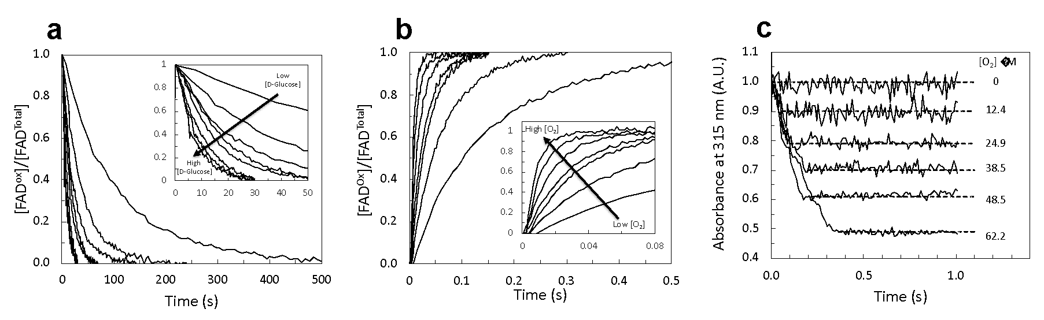
Supplementary Figure 1. Example of normalized raw data of transient state kinetics for the wild-type PsG3Ox and dioxygen quantification in the samples. (a) Normalized traces were obtained for the reductive half-reaction following the reduction of FAD. The inset zooms the traces taken at shorter timescales. The final concentration of D-Glc was 0.05, 0.15, 0.25, 0.35, 0.45, 0.55, 0.65, and 1 M. (b) Normalized traces obtained for oxidative half-reaction following the oxidation of FAD. The inset zooms the traces taken at shorter timescales. The oxygen concentration in the samples used in the oxidative half-reaction was determined using sodium dithionite and monitoring the absorbance changes at 315, as shown in (c). The horizontal lines represent the average absorbance at 315 nm to calculate the ∆Abs₃₁₅ allowing further determination of consumed dithionite, equivalent to O₂ present in the samples. All assays were performed at 25ºC in 100 mM sodium phosphate buffer, pH 7.5, with 200 mM NaCl, under an anaerobic atmosphere.
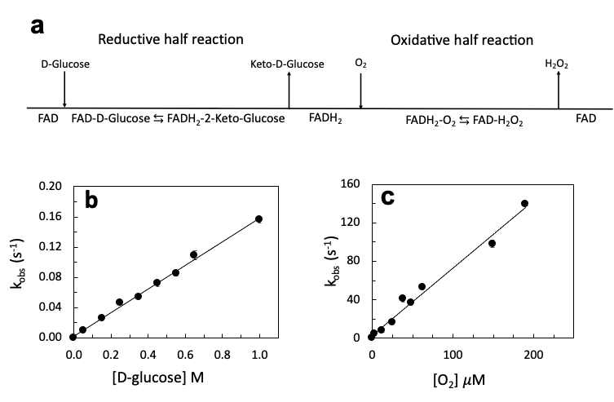
Supplementary Figure 2. Transient-state kinetics of wild-type PsG3Ox for D-Glc and molecular oxygen. (a) Bi-Bi ping-pong scheme proposed for pyranose-2-oxidases showing the two distinct half-reactions of the enzymatic turnover (^{23,24}. (b) Kinetics of the reductive-half reaction following the decrease of absorbance at 460 nm in the presence D-Glc, the pseudo-second-order constant for reductive half-reaction, was obtained from the slope of the linear regression of the data (black line), $k_{red}^{}$ = 0.15 ± 0.02 M⁻¹ s⁻¹. (c) Kinetics obtained for the oxidative half-reaction following the FAD oxidation at 460 nm by molecular oxygen, the slope of the linear regression of data allowed to determine the second order constant for oxidative half-reaction $k_{ox}^{}$ = (0.76 ± 0.06) × 10⁶ M⁻¹ s⁻¹. All transient-state data were obtained using a stopped-flow apparatus under an anaerobic atmosphere at 25ºC. The routine buffer was 100 mM sodium phosphate buffer with 200 mM NaCl at pH 7.5. Some traces for both half-reactions are shown in Fig. S1a-b. The quantification of oxygen for the oxidative half-reaction using sodium dithionite is exemplified in Fig. S1c.
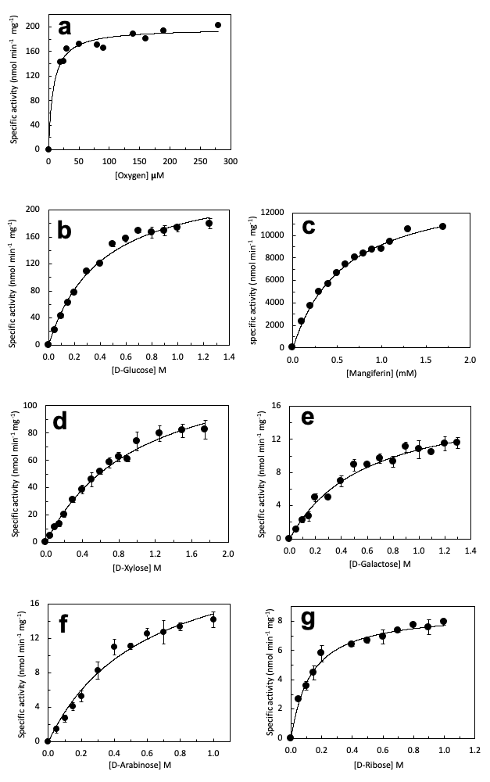
Supplementary Figure 3. Apparent steady-state kinetics of wild-type PsG3Ox at 37ºC in 100 mM sodium phosphate buffer at pH 7.5. The black circles represent the experimental enzymatic activities measured, and the black line is the fit of the experimental data to the Michaelis-Menten equation (v = V_{max}[S]/(K_{m}+[S]) using OriginLab software. The activity for dioxygen was obtained by measuring the oxygen consumption in an Oxygraph using 1 M of D-Glc as the electron donor. The kinetics for Mangiferin was obtained by measuring the oxygen consumption in an Oxygraph. The oxidation rate of the monosaccharides was followed using the HRP-AAP/DCHBS coupled assay.
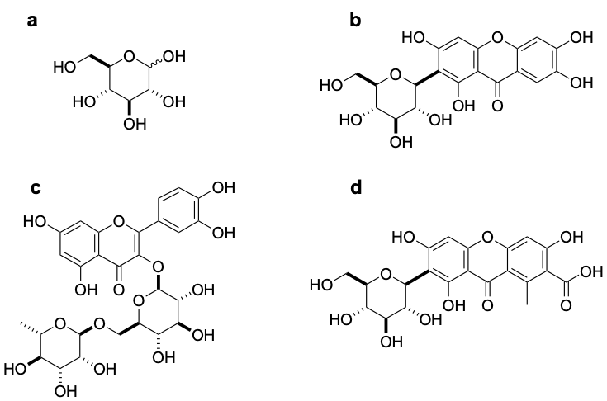
Supplementary Figure 4. Chemical structures of substrates used in this study. (a) D-Glucose (D-Glc), (b) Mangiferin (Mang), (c) Rutin and (d) Carminic acid.
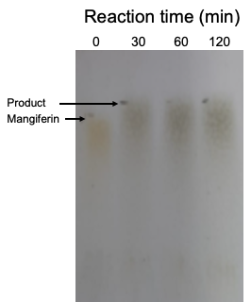

Supplementary Figure 5. TLC analysis of the time-course oxidation of Mang by PsG3Ox. Aliquots of the reaction mixture were taken prior to the addition of PsG3Ox (0 min) and 30, 60 and 120 min after the addition of the enzyme. The TLC was performed in silica gel 60 F₂₅₄ plates using a mixture of butanol, acetic acid and water 4:1:2.2 (v/v) as the mobile phase. The TLC was revealed using a diphenylamine-aniline-phosphoric acid reagent ²⁵.

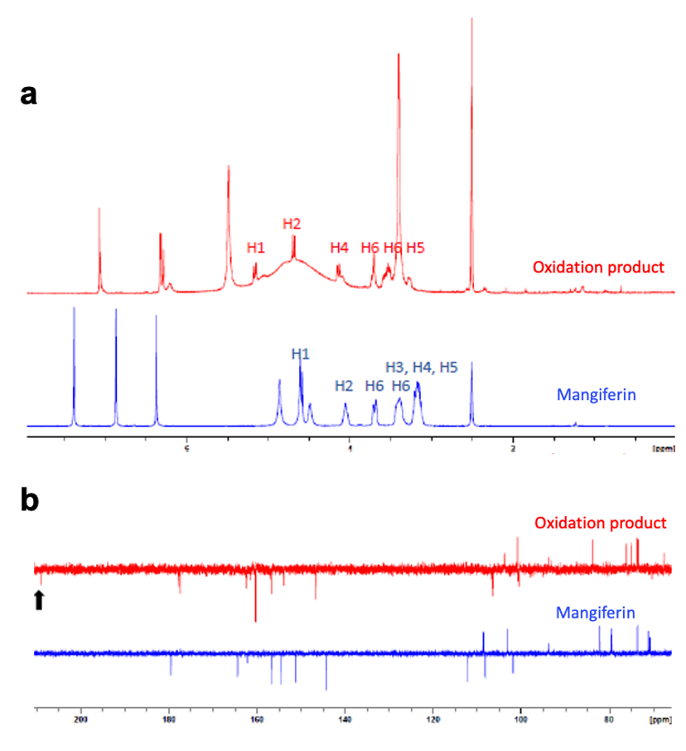

Supplementary Figure 6. Analysis of the Mang and the product of the reaction catalysed by PsG3Ox. (a) ¹H NMR spectra of Mang (blue) and the product of its oxidation by PsG3Ox (red) in DMSO-d₆, the protons of the sugar moiety are identified near the peaks. (b) ¹³C APT NMR spectra of Mang (blue) and the product of its oxidation by PsG3Ox (red) in DMSO-d₆, the black arrow highlights a new peak at 209 ppm which suggests a new ketone formed in the reaction catalysed by PsG3Ox and that has been attributed to the C3.

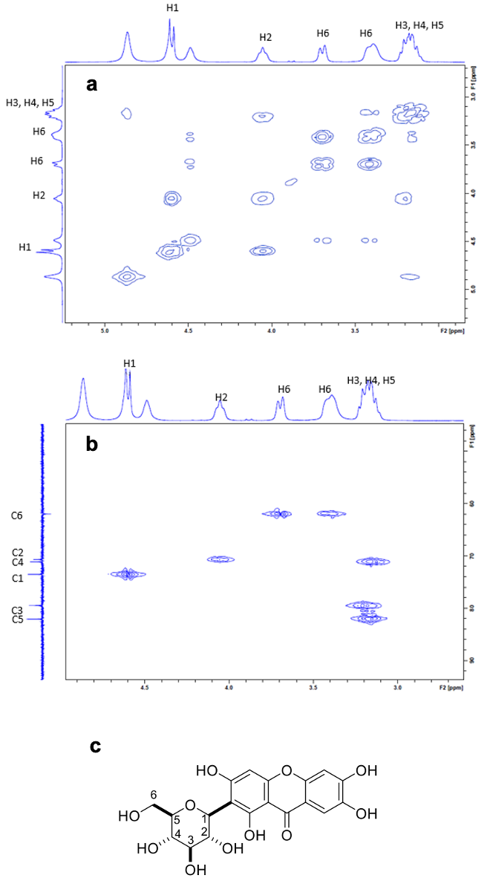

Supplementary Figure 7. NMR characterization of Mang. (a) 2D-COSY NMR spectrum. (b) HMQC NMR spectrum. (c) Chemical structure of Mang.

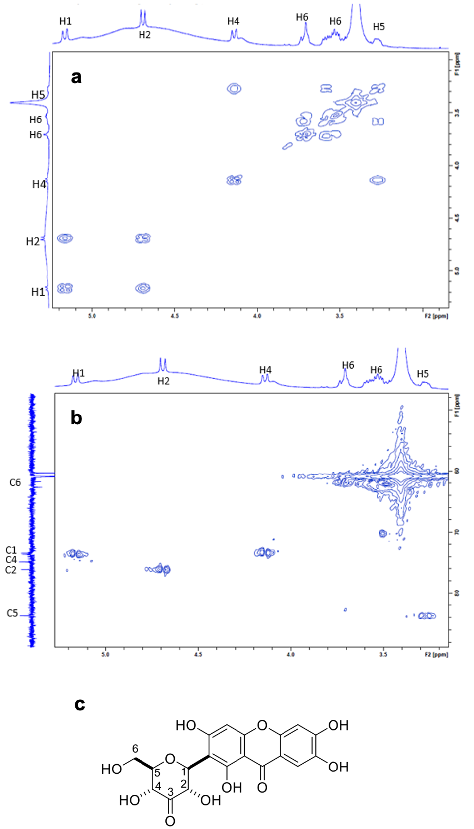

Supplementary Figure 8. NMR characterization of the oxidation product of Mang catalysed by PsG3Ox. (a) 2D-COSY NMR spectrum. (b) HMQC NMR spectrum. (c) Chemical structure of 3-keto-Mang, the reaction product identified by NMR.

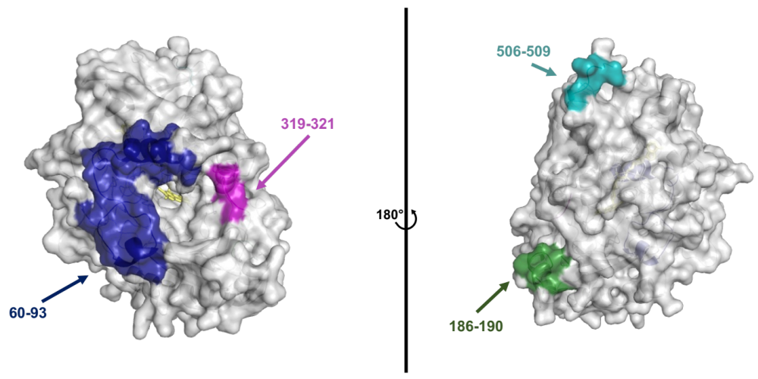
Supplementary Figure 9. Insertion regions in PsG3Ox as compared to fungal P2Oxs. The PsG3Ox monomeric form is shown as solvent-accessible surface colored gray. The insertion regions, 60-93, 186-190, 319-321 and 506-509 are colored in dark-blue, green, magenta, and cyan, respectively. The FAD is shown as sticks colored in yellow.
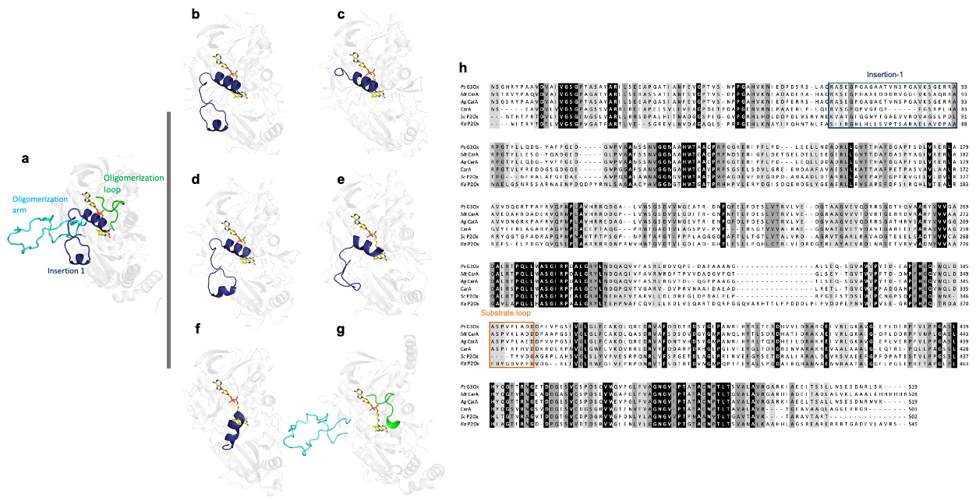

Supplementary Figure 10. Structural localization of the insertion-1 region in G3Ox and comparison to oligomerization features of P2Oxs. (a) Representation of the insertion-1 region (dark blue) in PsG3Ox and oligomerization loop (green) and arm (cyan) in TmP2Ox. Crystal structure of (b) PsG3Ox and (c) MtCarA and predicted model by alphafold of (d) AgCarA, (e) CarA, (f) ScP2Ox, (g) KaP2Ox. The insertion-1 region is colored in dark blue in panels b-f. The oligomerization arm and loop are colored in cyan and green, respectively in (g). In (h) Amino acid sequence alignment (primary sequence) of bacterial enzymes where the insertion-1 region and substrate loop is marked with a blue and orange boxes.

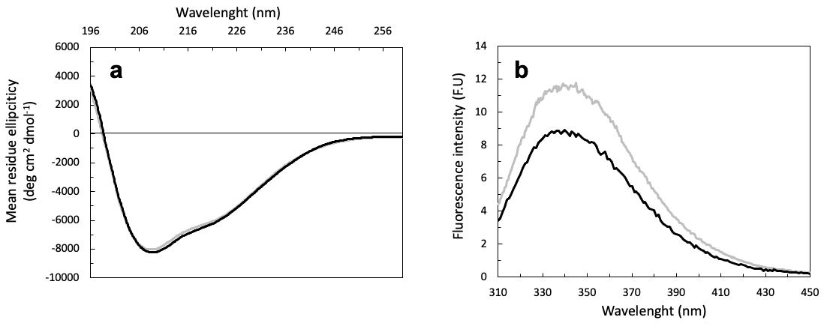
Supplementary Figure 11. The secondary and tertiary structure of PsG3Ox after deflavination. (a) Circular dichroism spectra in the far-UV show the secondary structure of the partially FAD-loaded PsG3Ox (black line) and the Apo PsG3Ox (gray line). (b) Tryptophan fluorescence emission spectra of the partially FAD-loaded PsG3Ox (black line) and the Apo preparation (gray line).

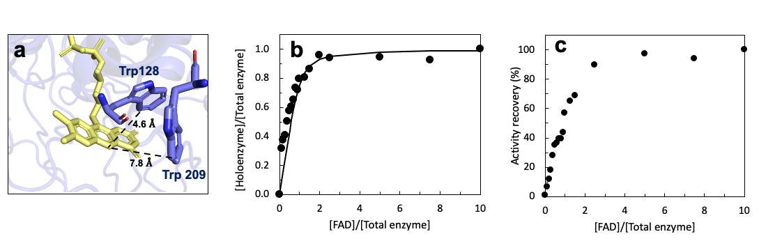
Supplementary Figure 12. In vitro flavinylation of apo wild-type PsG3Ox. (a) A highlight of the two tryptophan residues that could be quenched by the FAD attachment. Trp128 and Trp209 are located at 4.6 $Å$ and 7.8, $Å$ far from N5 of FAD, respectively. (b) Fraction of FAD-bond enzyme given by the normalized tryptophan fluorescence quenching as a function of the different ratios of FAD: Enzyme. The solid line represents the theoretical fit of the experimental data to the one binding site model providing an estimated dissociation constant, K_{D} = (2.0 ± 0.7) × 10⁻⁷ M and an affinity constant, K_{A} = (5.3 ± 1.9) × 10⁶ M⁻¹. (c) Activity recovery experiments of apo-WT PsG3Ox previously incubated with FAD in different ratios. The activity was measured using HRP-AAP/DCHBS coupled assay in 100 mM sodium phosphate buffer at pH 7.5, and the routine reaction mixture contained 1 M of D-Glc, 0.1 mM of AAP, 1 mM of DCHBS, and 8 U ml⁻¹ of HRP.
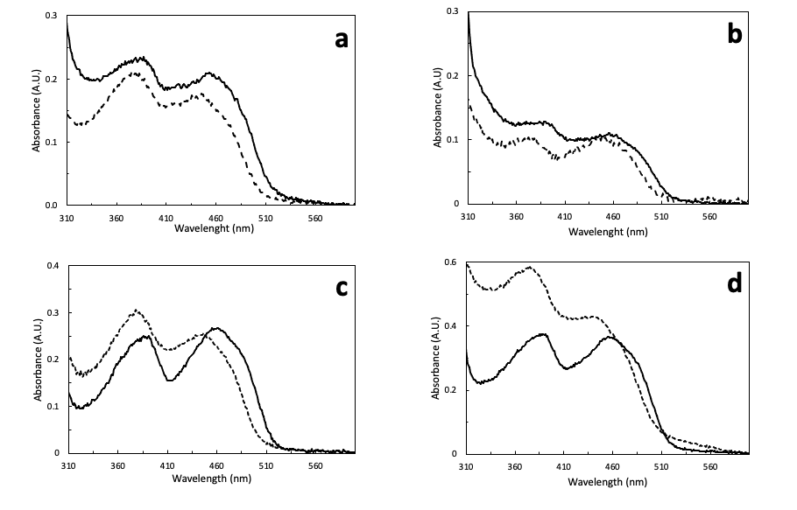
Supplementary Figure 13. FAD attachment analysis in different PsG3Ox variants. UV-Vis spectra of purified enzyme preparations of (a) A125S, (b) A126T, (c) N120C, (d) N120Y variants before (solid line) and after thermal denaturation (supernatant; dashed line) ²⁶.
.
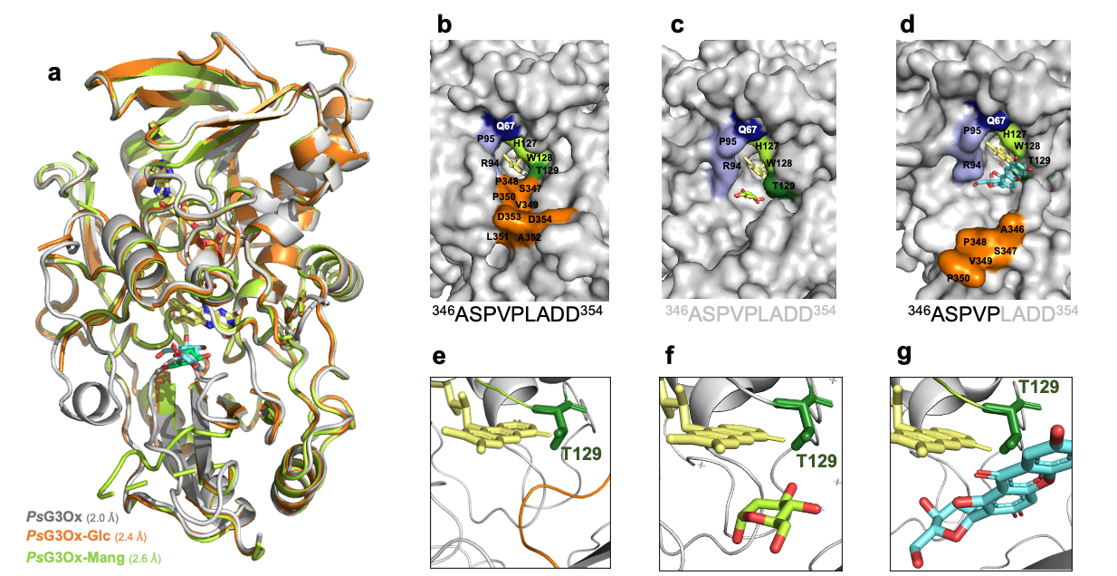
Supplementary Figure 14. X-ray crystal structures of PsG3Ox. (a) Cartoon of the structural superposition of the crystal structures of substrate-free PsG3Ox (grey) and structures in complex with D-Glc (orange) and Mang (light green). Solvent accessible surface representation of the active-site in (b) substrate-free PsG3Ox, (c) PsG3Ox-Glc and (d) PsG3Ox-Mang complex crystal structures. The residues surrounding the FAD cavity are colored as in Fig 1D. The substrate loop amino acid composition is represented below the panels’ b-d where the black letters represent the residues visible in the crystal structure and the gray ones the non-visible residues in the electron density maps. PsG3Ox active site highlighting the conformation of the residue T129 in (e) substrate-free PsG3Ox, (f) PsG3Ox-Glc and (g) PsG3Ox-Mang complexes. The FAD is shown as sticks in yellow color. The substrates D-Glc and Mang are shown as sticks coloured in green and cyan, respectively. In PsG3Ox, the residue T129 establishes hydrogen bonds with FAD^{N5} (and P348^{N}) and also interacts with FAD^{N5} when the substrate loop is in a closed conformation similarly to the T169 in TmP2Ox, (Fig. S15a,d). However, contrary to the fungal enzymes in PsG3Ox, the T129 appears to have the same configuration independently of the substrate loop conformation.
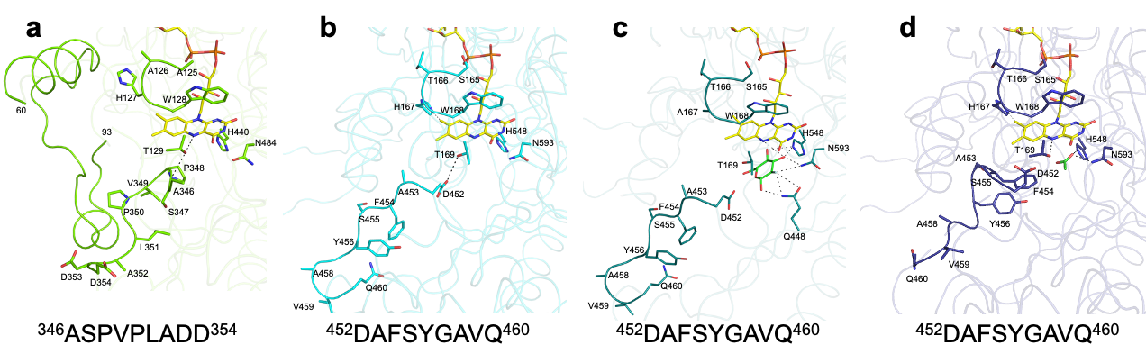
Supplementary Figure 15. Representing regions delimiting the FAD cavity in PsG3Ox and fungal T. multicolor P2Ox. (a) Cartoon representation of the insertion-1, segment ¹²⁵AAHW¹²⁸, and substrate loop in closed conformation in substrate-free PsG3Ox, in (b) T. multicolor P2Ox (substrate free; PDB 2IGK) in open conformation, in (c) T. multicolor P2Ox H167A in complex with 2-fluoro-2-deoxy-D-glucose (PDB 2IGO) that is oxidized in C3 position, shows an open conformation and in (d) T. multicolor P2Ox (with acetate, PDB 1TT0) in closed conformation of the substrate loop. The catalytic residues and residues part of the flavinylation motif and substrate loop are shown as sticks with carbon atoms colored in green, cyan, and dark blue for PsG3Ox, 2IGK, and 2IGO, respectively. The FAD is shown as sticks with carbon, nitrogen, oxygen, and phosphorous atoms in yellow, blue, red and orange, respectively. The interatomic distances are shown as black dashed lines. The substrate loop amino acid composition for POxs is below the corresponding panels. The T169 residue, in TmP2Ox, adopts different rotamer conformations and was suggested to trigger the transition between the different conformations of the substrate loop in fungal enzymes ²⁷⁻²⁹.
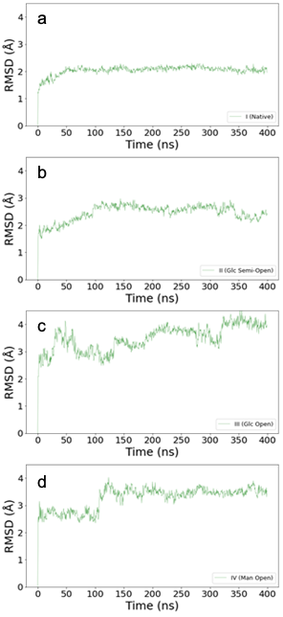

Supplementary Figure 16. RMSD (root-mean-square deviation, in Å) of Cα positions along the 400 ns conventional molecular dynamics simulations of Model I - IV (a-d) (see Material and Methods section for models’ definition). The plots show convergence of the simulation for Model I, II and IV, whereas for Model III some fluctuations are seen as a result of glucose leaving the active site after 300 ns.

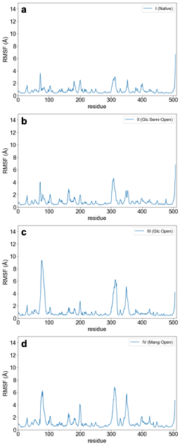

Supplementary Figure 17. RMSF (root-mean-square fluctuation, in Å) of Cα positions along the 400 ns conventional molecular dynamics simulations of Model I - IV (a-d) (see Material and Methods section for models’ definition). The plots show higher fluctuation in the open state systems, mainly in the insertion-1 (60-93), in a solvent exposed loop at the enzyme’s surface (~300-320) and in the substrate loop (346-354).

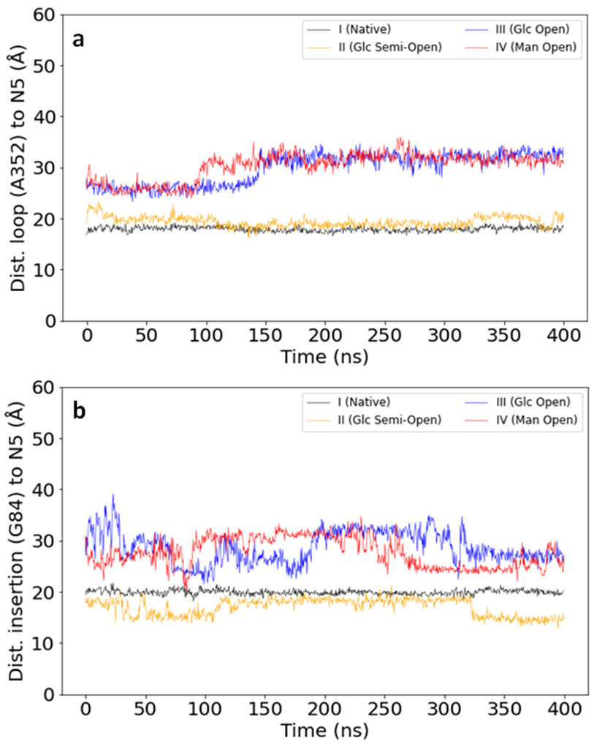

Supplementary Figure 18. Conformation of Substrate-loop (a) and Inserion1-loop (b) along the 400 ns conventional molecular dynamics simulations: Model I (gray), II (orange), III (blue) and IV (red). The distance (in Å) between the N5 atom of FAD and residue A352 was monitored along the simulation as an indication of the conformation adopted by the substrate loop while the distance between G84 and N5 was measured to provide the information about insertion-1 loop conformation. In both graphics, shorter distances relate to closed conformations while long distances suggest open conformations. The insertion loop shows more changes along the simulations. For both loops, no transitions can be observed within these simulation times for closed and semi-open systems (the loops stay as in the corresponding initial conformation). Although for the simulations with initial open models, a further opening is observed, which could be related to the substrate displacement from the active site.

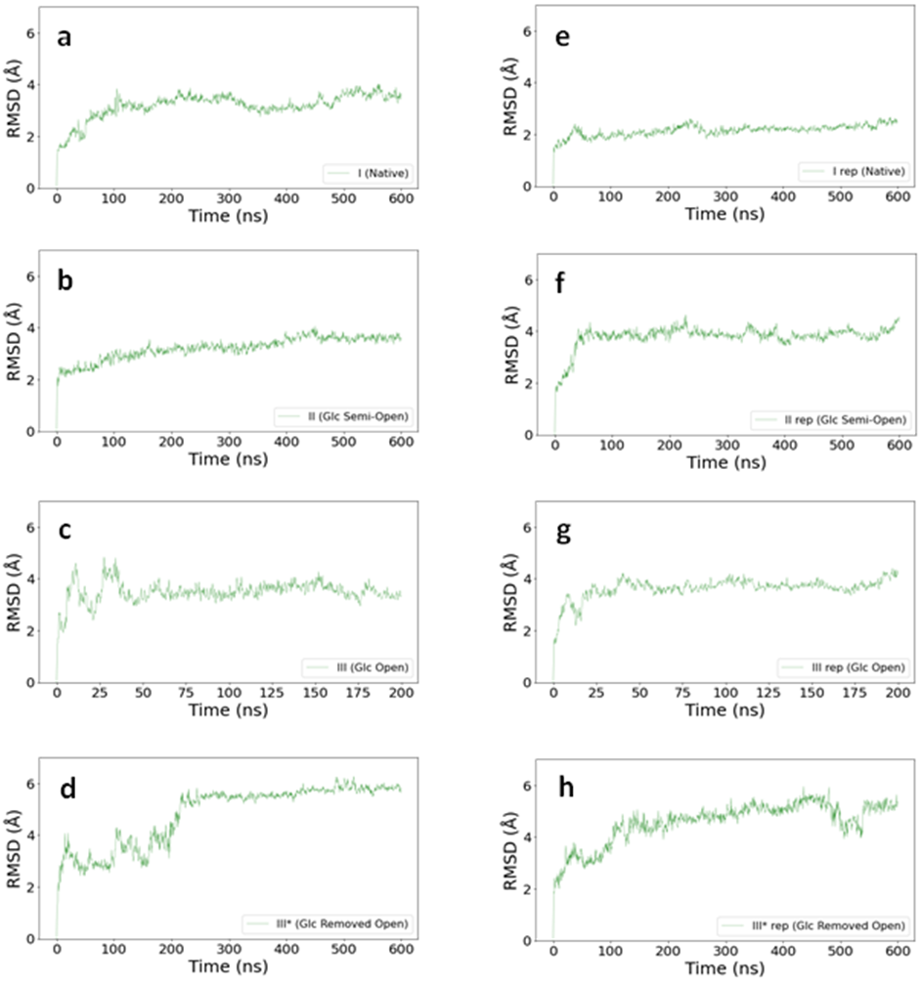
Supplementary Figure 19. RMSD of Cα positions along the GaMD simulations of Models I (a, e), II (b,f), III (c,g) and III* (d,h); see Material and Methods section for models’ definition. For each model, two simulations with different distributions of the initial velocities were run to enhance the conformational space sampled. For Model III, the simulations were stopped at 200 ns since D-Glc left the binding site (see Fig. S22). Despite being GaMDs, the graphs show relatively stable RMSD as the trajectories advance. The sudden increase in the first model III* replicate, which starts from open conformations of the loops and with D-Glc removed, corresponds to the closing of the substrate loop.

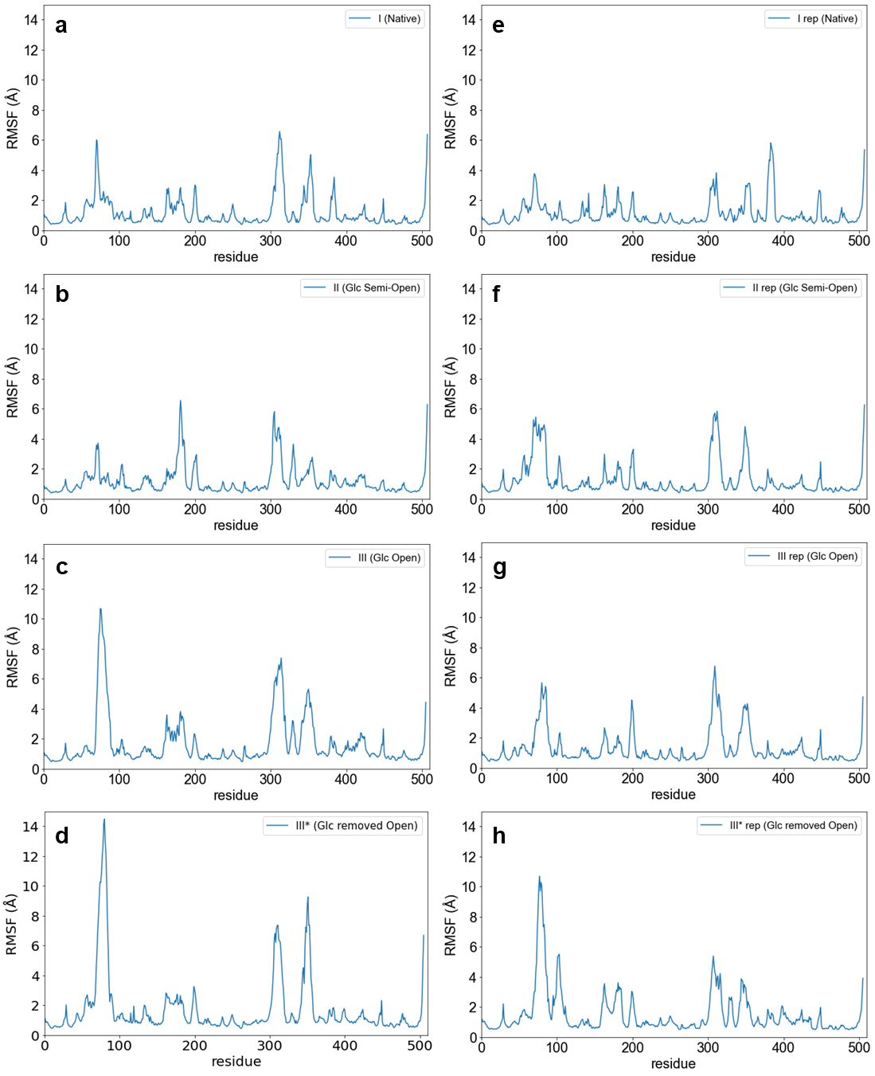
Supplementary Figure 20. RMSF of Cα positions along the 600 ns GaMD simulations of Model I (a-e), II (b-f), III (c-g) and III* (d-h) (see material and methods section for models’ definition). For each model, two simulations with different distributions of the initial velocities were run to enhance the conformational space sampled. For Model III, the simulations were stopped at 200 ns since D-Glc left the binding site. The plots show higher fluctuation in the open state systems, mainly in the insertion-1 (60-93), in a solvent exposed loop at the enzyme’s surface (~300-320) and in the substrate loop (346-354).

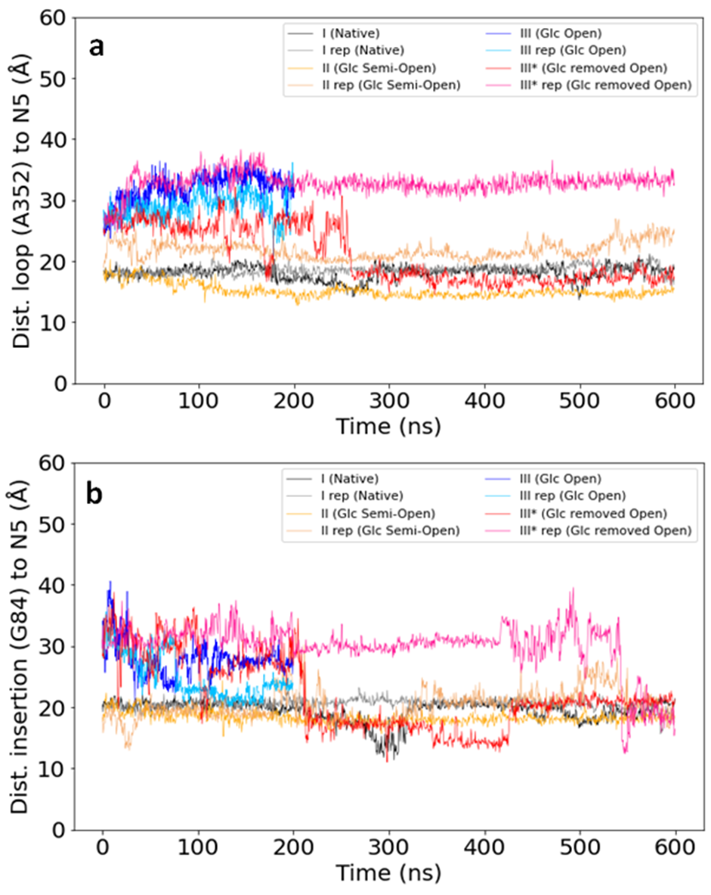
Supplementary Figure 21. Conformation of Substrate-loop (a) and Inserion1-loop (b) along the GaMD simulations. The two simulations for each model are represented: for Model I (black and gray), II (orange and brown), III (blue and light blue) and III* (red and pink), see materials and methods section for models’ definition. The distance (in Å) between the N5 atom of FAD and residue A352 was monitored along the simulation as an indication of the conformation adopted by the substrate loop while the distance between G84 and N5 was measured to provide the information about insertion-1 loop conformation. In both graphics, shorter distances relate to closed conformations while long distances suggest open conformations. For both loops, no transitions are observed within these simulation times for a closed system (the loops stay as in the corresponding initial conformation). Although for both loops in the semi-open and open system, more conformational changes are observed. For Model III the simulations were stopped at 200 ns because D-Glc left the binding site (see Fig S22).

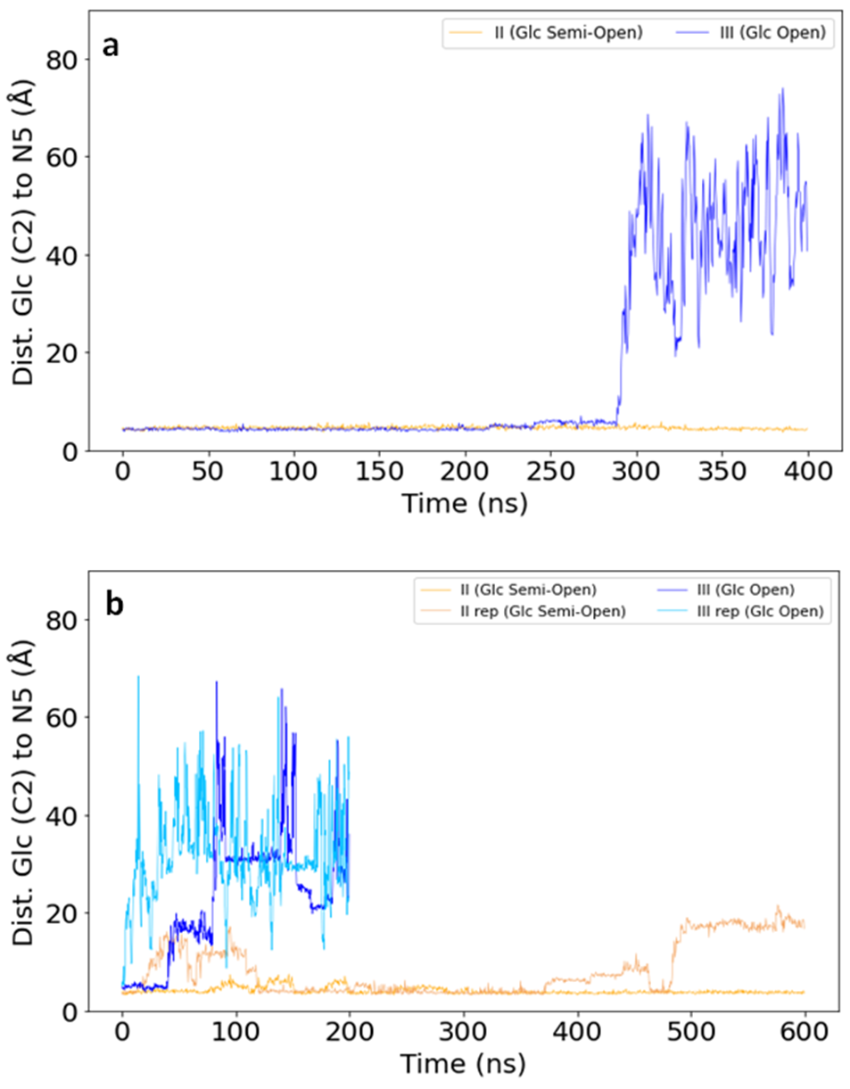
Supplementary Figure 22. Distance between the C2 of D-Glc and N5 of FAD during the cMDs (a) and GaMD (b) simulations for the model II and model III systems (see materials and methods section for models’ definition). In (b) the two simulations that were run for each model are represented (for model II in yellow and light orange; for Model III in blue and light blue).

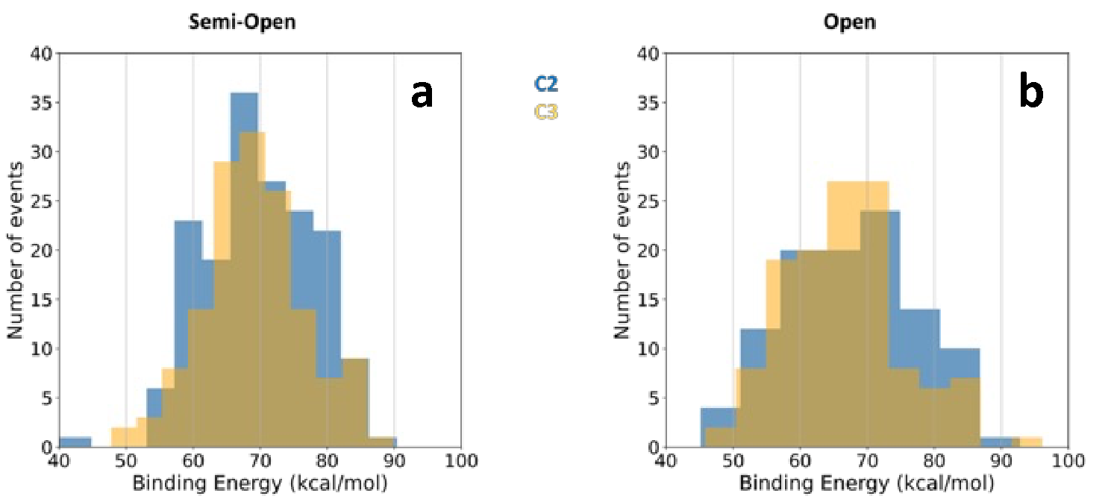
Supplementary Figure 23. Local dockings of D-glucose to wild-type PsG3Ox with a semi-open (a) and open (b) substrate loop conformations. Full histograms of D-glucose’s binding energies (in kcal/mol). Docking results were filtered as C2 and C3 binding modes or discarded, according to their catalytic distances to FAD’s N5 and H440. Data in blue and yellow represent docking results in a binding mode suitable for C2 and C3 oxidation, respectively. A higher Yasara’s binding energies correspond to better docking results ³⁰.

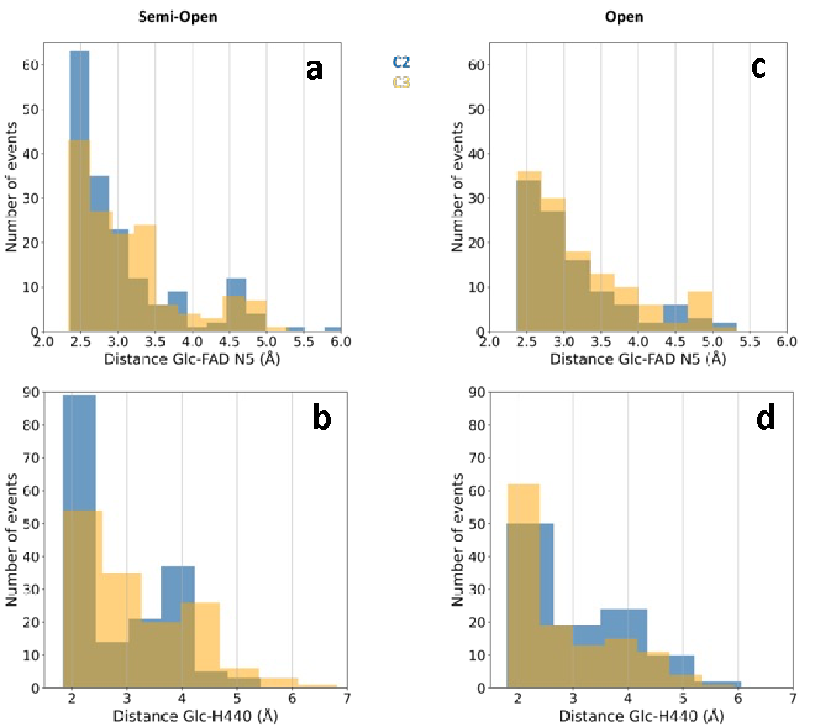
Supplementary Figure 24. Local dockings of D-glucose to wild-type PsG3Ox with a semi-open (a-b) and open (c-d) substrate loop conformations. Full histograms of the distances (in Å) between D-Glc and the FAD(N5) or H440. Docking results were filtered as C2 and C3 binding modes or discarded, according to their catalytic distances to FAD’s N5 and H440. Data in blue and yellow represent docking results in a binding mode suitable for C2 and C3 oxidation, respectively.

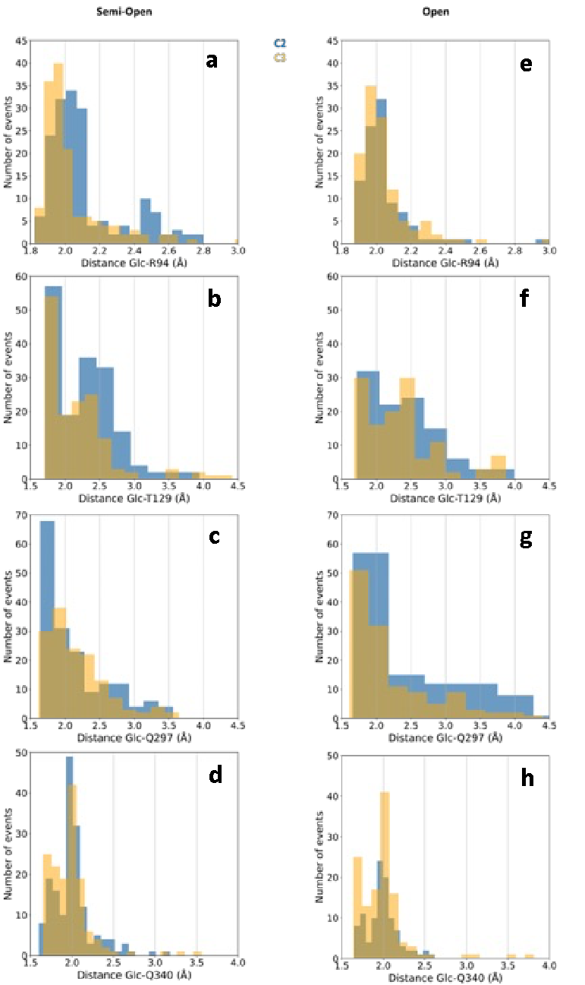
Supplementary Figure 25. Local dockings of D-Glc to wild-type PsG3Ox with semi-open (a-d) and open (e-h) substrate loop conformations. Full histograms of the distance (in Å) between D-glucose and non-catalytic interacting residues. Docking results were filtered as C2 and C3 binding modes or discarded, according to their catalytic distances to FAD’s N5 and H440. Data in blue and yellow represent docking results in a binding mode suitable for C2 and C3 oxidation, respectively.
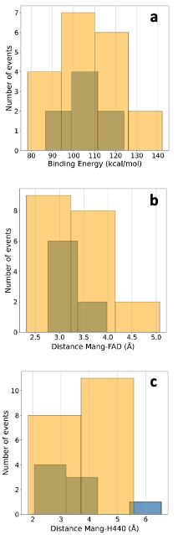
Supplementary Figure 26. Local dockings of Mang to wild-type PsG3Ox with an open substrate loop conformation. Full histograms of Mang binding energy (in kcal/mol) (a) and distance (in Å) between Mang and FAD(N5) (b) or H440 (c). Docking results were filtered as C2 and C3 binding modes or discarded, according to their catalytic distances to FAD’s N5 and H440. Data in blue and yellow represent docking results in a binding mode suitable for C2 and C3 oxidation, respectively. Higher Yasara’s binding energies correspond to better docking results³⁰.

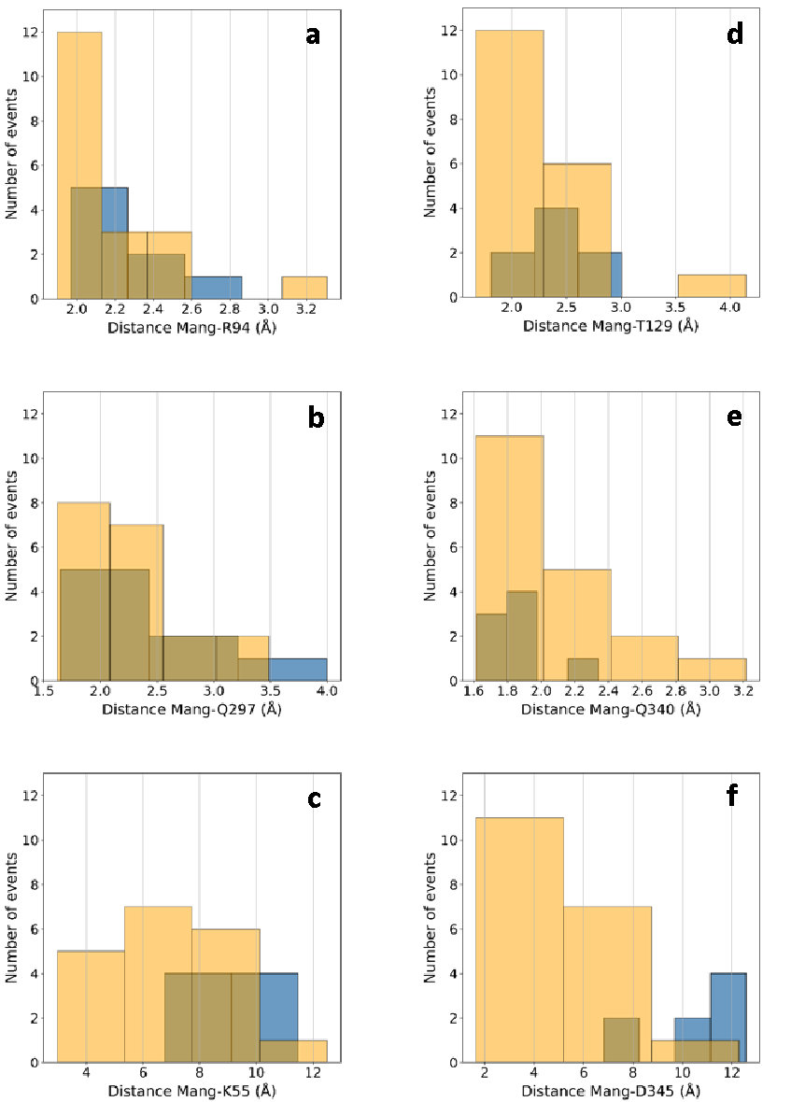
Supplementary Figure 27. Local dockings of Mang to wild-type PsG3Ox with an open substrate loop conformation. Full histograms of the distances (in Å) between Mang and the non-catalytic interacting residues (a-f). Docking results were filtered as C2 and C3 binding modes or discarded according to their catalytic distances to FAD’s N5 and H440. Data in blue and yellow represent docking results in a binding mode suitable for C2 and C3 oxidation, respectively.

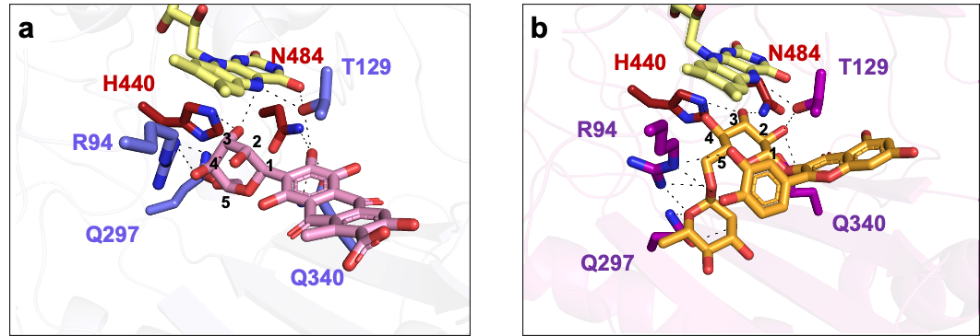
Supplementary Figure 28. Docking models highlighting the interactions of carminic acid (a), and rutin (b) with PsG3Ox. The FAD is shown as sticks colored in yellow. The catalytic residues (H440 and N484) are shown as sticks colored in dark red. All other interacting residues are shown as sticks in purple or magenta for carminic acid and rutin dockings, respectively. The carminic acid and rutin molecules are shown as sticks colored in pink and orange, respectively. The hydrogen bonds are shown as black dashed lines. Carminic acid binds in a non-catalytically competent manner: H2/C2 is relatively well oriented towards FAD^{N5}, but it is the OH3 that interacts with catalytic H440 (HO3/O3-NE: 1.82/2.78 Å; O3-HO3-NE: 160.9º), and no interaction with the catalytic residue N484 was observed. In the case of rutin, the dockings predict binding in an orientation compatible with catalysis at C3 (H3/C3-N5:2.30/3.32 Å; C3-H3-N5: 155.7º; HO3/O3-NE: 1.82/2.78 Å; HO4-NE: 2.58 Å).

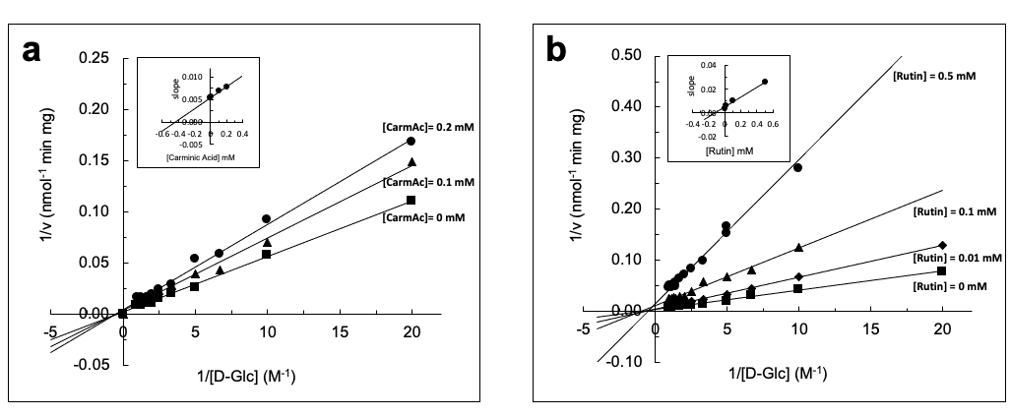
Supplementary Figure 29. Lineweaver-burk plots of PsG3Ox inhibition by (a) carminic acid and (b) rutin. The inset are the secondary plots of the slopes obtained in the Lineweaver Burk plots against inhibitor concentration. The estimated inhibition constant, K_{i}, were 0.10 ± 0.03 mM for rutin and 0.45 ± 0.02 mM for carminic acid. The activity was measured using HRP-AAP/DCHBS coupled assay in 100 mM sodium phosphate buffer at pH 7.5, 37 ºC and the routine reaction mixture contained 0-1 M of D-Glc, 0.1 mM of AAP, 1 mM of DCHBS, 8 U ml⁻¹ of HRP and 0-0.2 carminic acid or 0-0.5 mM rutin.

4. References
1. Bastian, S., Rekowski, M.J., Witte, K., Heckmann-Pohl, D.M. & Giffhorn, F. Engineering of pyranose 2-oxidase from Peniophora gigantea towards improved thermostability and catalytic efficiency. Appl Microbiol Biotechnol 67, 654-63 (2005).
2. Leitner, C., Volc, J. & Haltrich, D. Purification and characterization of pyranose oxidase from the white rot fungus Trametes multicolor. Appl Environ Microbiol 67, 3636-44 (2001).
3. Pisanelli, I. et al. Pyranose 2-oxidase from Phanerochaete chrysosporium-expression in E. coli and biochemical characterization. J Biotechnol 142, 97-106 (2009).
4. Pisanelli, I. et al. Heterologous expression and biochemical characterization of novel pyranose 2-oxidases from the ascomycetes Aspergillus nidulans and Aspergillus oryzae. Appl Microbiol Biotechnol 93, 1157-66 (2012).
5. Abrera, A.T., Chang, H.C., Kracher, D., Ludwig, R. & Haltrich, D. Characterization of pyranose oxidase variants for bioelectrocatalytic applications. Biochim Biophys Acta-Prot Proteom 1868(2020).
6. Martins, L.O. et al. Molecular and biochemical characterization of a highly stable bacterial laccase that occurs as a structural component of the Bacillus subtilis endospore coat. J Biol Chem 277, 18849-18859 (2002).
7. Fossati, P., Prencipe, L. & Berti, G. Use of 3,5-dichloro-2-hydroxybenzenesulfonic acid/4-aminophenazone chromogenic system in direct enzymic assay of uric acid in serum and urine. Clin Chem 26, 227-31 (1980).
8. Mirdita, M. et al. ColabFold: making protein folding accessible to all. Nat Meth 19, 679-682 (2022).
9. Herzog, P.L. et al. Versatile oxidase and dehydrogenase activities of bacterial pyranose 2-oxidase facilitate redox cycling with manganese peroxidase in vitro. Appl Environ Microbiol 85, 1-15 (2019).
10. Catarino, T. et al. Probing the Chemotaxis Periplasmic Sensor Domains from Geobacter sulfurreducens by Combined Resonance Raman and Molecular Dynamic Approaches: NO and CO Sensing. J Phys Chem B 114, 11251-11260 (2010).
11. Caldinelli, L., Pedotti, M., Motteran, L., Molla, G. & Pollegioni, L. FAD binding in glycine oxidase from Bacillus subtilis. Biochimie 91, 1499-508 (2009).
12. Villegas, J.M. et al. FAD binding properties of a cytosolic version of Escherichia coli NADH dehydrogenase-2. Biochim Biophys Acta 1844, 576-84 (2014).
13. Fraaije, M.W., van Den Heuvel, R.H., van Berkel, W.J. & Mattevi, A. Structural analysis of flavinylation in vanillyl-alcohol oxidase. J Biol Chem 275, 38654-8 (2000).
14. Zhang, K.K. et al. Identification and characterization of a novel bacterial pyranose 2-oxidase from the lignocellulolytic bacterium Pantoea ananatis Sd-1. Biotechnol Lett 40, 871-880 (2018).
15. Herzog, P.L. et al. Versatile oxidase and dehydrogenase activities of bacterial pyranose 2-oxidase facilitate redox cycling with manganese peroxidase in vitro. Appl Environ Microbiol 85(2019).
16. Kumano, T. et al. FAD-dependent C-glycoside-metabolizing enzymes in microorganisms: Screening, characterization, and crystal structure analysis. Proc Natl Acad Sci USA 118(2021).
17. Kostelac, A. et al. Biochemical characterization of pyranose oxidase from Streptomyces canus-towards a better understanding of pyranose oxidase homologues in bacteria. Int J Mol Sci 23(2022).
18. Schafer, A., Bieg, S., Huwig, A., Kohring, G. & Giffhorn, F. Purification by immunoaffinity chromatography, characterization, and structural analysis of a thermostable pyranose oxidase from the white rot fungus Phlebiopsis gigantea. Appl Environ Microbiol 62, 2586-92 (1996).
19. Takakura, Y. & Kuwata, S. Purification, characterization, and molecular cloning of a pyranose oxidase from the fruit body of the basidiomycete, Tricholoma matsutake. Biosci Biotechnol Biochem 67, 2598-607 (2003).
20. Bannwarth, M., Heckmann-Pohl, D., Bastian, S., Giffhorn, F. & Schulz, G.E. Reaction geometry and thermostable variant of pyranose 2-oxidase from the white-rot fungus Peniophora sp. Biochemistry 45, 6587-95 (2006).
21. Salaheddin, C. et al. Characterisation of recombinant pyranose oxidase from the cultivated mycorrhizal basidiomycete Lyophyllum shimeji (hon-shimeji). Microb Cell Fact 9, 57 (2010).
22. Ai, M.Q., Wang, F.F., Zhang, Y.Z. & Huang, F. Purification of pyranose oxidase from the white rot fungus Irpex lacteus and its cooperation with laccase in lignin degradation. Process Biochem 49, 2191-2198 (2014).
23. Sucharitakul, J., Wongnate, T. & Chaiyen, P. Kinetic isotope effects on the noncovalent flavin mutant protein of pyranose 2-oxidase reveal insights into the flavin reduction mechanism. Biochemistry 49, 3753-65 (2010).
24. Wongnate, T., Surawatanawong, P., Chuaboon, L., Lawan, N. & Chaiyen, P. The mechanism of sugar c-h bond oxidation by a flavoprotein oxidase occurs by a hydride transfer before proton abstraction. Eur J Chem 25, 4460-4471 (2019).
25. Kocourek, J., Ticha, M. & Kostir, J. The use of diphenylamine-alanine-phosphoric acid reagent in the detection and differentiation of monosaccharides and their derivatives on paper chromatograms. J Chromatogr 24, 117-24 (1966).
26. Mendes, S. et al. Characterization of a bacterial pyranose 2-oxidase from Arthrobacter siccitolerans. J. Mol. Cat. B: Enzymatic 133, 34-43 (2016).
27. Kujawa, M. et al. Structural basis for substrate binding and regioselective oxidation of monosaccharides at C3 by pyranose 2-oxidase. J Biol Chem 281, 35104-15 (2006).
28. Spadiut, O., Tan, T.C., Pisanelli, I., Haltrich, D. & Divne, C. Importance of the gating segment in the substrate-recognition loop of pyranose 2-oxidase. FEBS J 277, 2892-909 (2010).
29. Tan, T.C., Haltrich, D. & Divne, C. Regioselective control of beta-d-glucose oxidation by pyranose 2-oxidase is intimately coupled to conformational degeneracy. J Mol Biol 409, 588-600 (2011).
30. Krieger, E. & Vriend, G. YASARA View-molecular graphics for all devices-from smartphones to workstations. Bioinformatics 30, 2981-2982 (2014).

