Supplementary Information
Giant electromechanical response from defective non-ferroelectric epitaxial BaTiO₃ integrated on Si (100)
Sandeep Vura[1]*, Shubham Kumar Parate[1]*, Subhajit Pal[1,2], Upanya Khandelwal[1], Rajeev Kumar Rai[1,3], Sri Harsha Molleti[1], Vishnu Kumar[1], Rama Satya Sandilya Ventrapragada[1], Girish Patil [1], Mudit Jain[1], Ambresh Mallya[1], Majid Ahmadi[4], Bart Kooi[4,5], Sushobhan Avasthi[1], Rajeev Ranjan[6], Srinivasan Raghavan[1] , Saurabh Chandorkar[1], Pavan Nukala[1].
Author Affiliations
[1]. Center for Nano Science and Engineering, Indian Institute of Science, Bengaluru-560012, India
[2]. School of Engineering and Materials Science, Queen Mary University of London, London E1 4NS, United Kingdom
[3]. Materials Science and Engineering, University of Pennsylvania, 3231 Walnut Street, Philadelphia, 19104
[4]. Zernike Institute for Advanced Materials, University of Groningen, Groningen, 9747AG, The Netherlands
[5]. CogniGron center, University of Groningen, Groningen, 9747 AG, The Netherlands.
*indicates equal contribution
[6]. Materials Engineering, Indian Institute of Science, Bengaluru, 560012- India

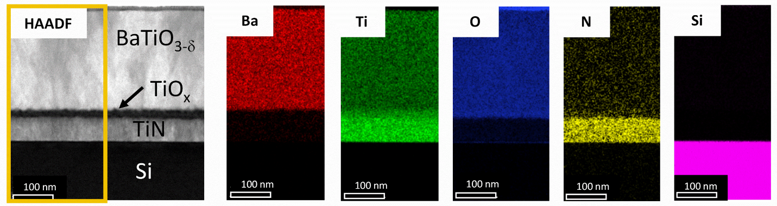
Fig S1 Chemical maps of various layers in the heterostructure: EDS map showing elemental distribution (intensities correspond to atom%) in BTO, TiN, layers, and Silicon substrate.
Note 1: Fig S1 shows the EDS map acquired on the cross-section FIB lamella of sample stack Barium Titanate (BTO) grown on Titanium Nitride (TiN) buffered Si (100). It can be seen that an additional TiO_{x} interfacial layer of thickness ~20 nm is formed between TiN and BTO.

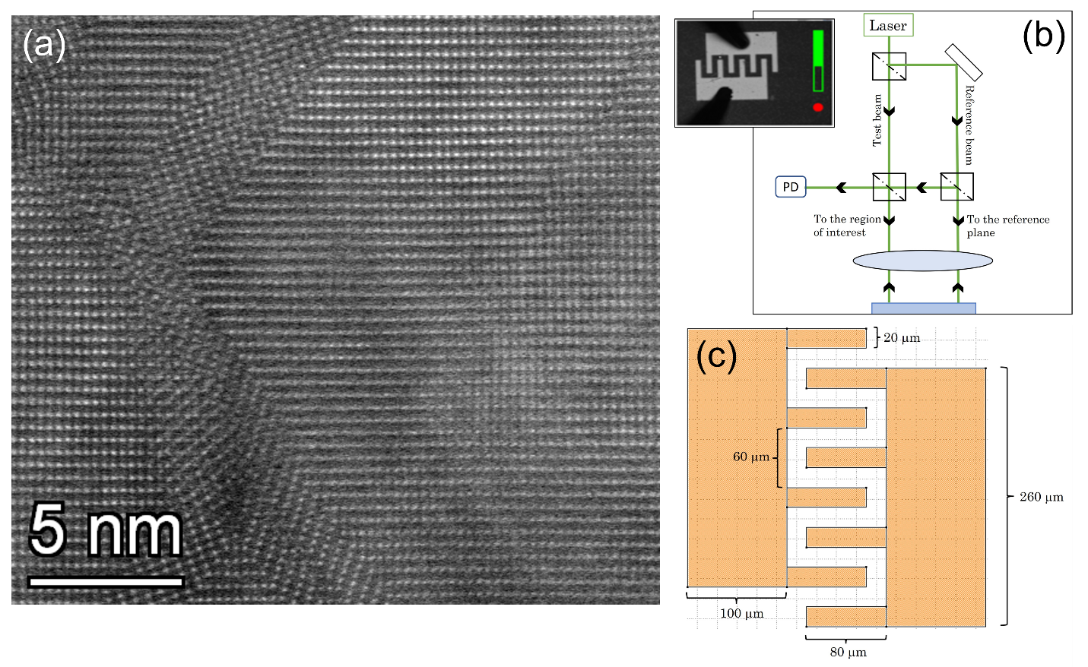
Fig S2: Defects, electromechanical measurement scheme and device structure (a) HAADF-STEM image along [110] zone axis containing domain boundaries which could be one of the contributors to MW type of relaxation mechanisms coming from the BTO layer. (b) Laser doppler vibrometer setup and optical image (inset) of Interdigitated Electrodes and (c) corresponding detailed feature dimensions of IDE.

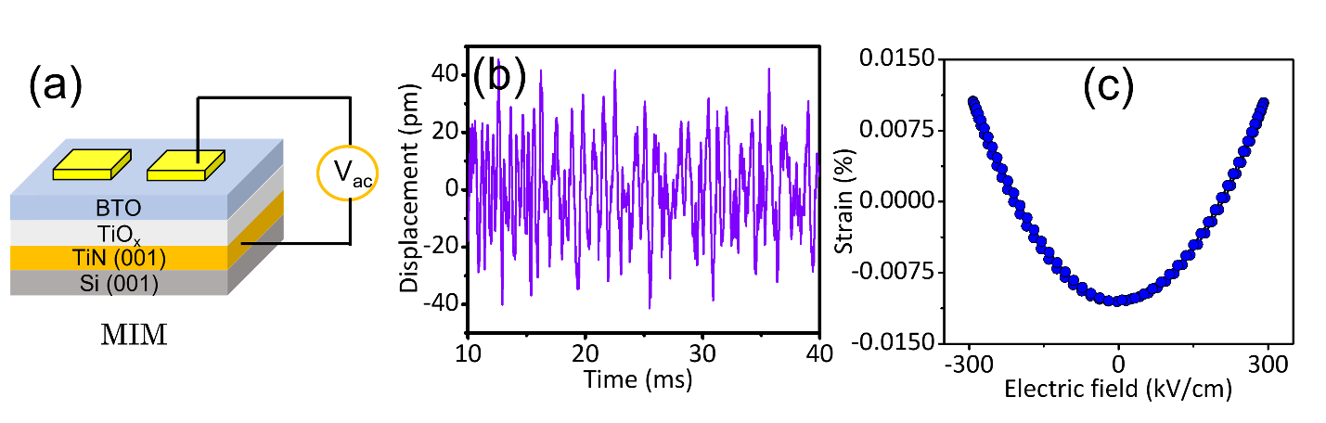
Fig S3: Electromechanical response on vertical capacitors. (a) Metal insulator metal (MIM) capacitor schematic (b) Vertical displacement as a function of time of MIM capacitor with BTO thickness 170 nm and (c) second harmonic response with a varying electric field (5 V) at 1 kHz.
Note 2: The strain response when electric field is applied in the vertical direction (on MIM vertical capacitors) is much smaller (18 pm displacement at 0.30 MV/cm field on the device) as compared to the response recorded with lateral electric field on IDE devices. This is a result of very small vertical field drop across the BTO layer and a large drop across low dielectric constant TiOx layer. As a result, in this geometry the accurate values of M₃₃ were not estimated and we concentrate rather on M₃₁

Fig S4: Large signal I-V and small signal C-V measurements. Current response as a function of time for three different voltages (a) at 1 V (b) 3 V, and (c) 5 V. (d) Magnified region from marked red enclosure in Fig (c) showing non-linear current response. (e) Dielectric loss tangent tan δ and corresponding fit obtained for equivalent circuit (f) CV measurements as a function of frequency. Notably a peak at 0V in both forward and reverse sweeps upto 10 kHz indicates non ferroelectric, yet very soft dielectric response.

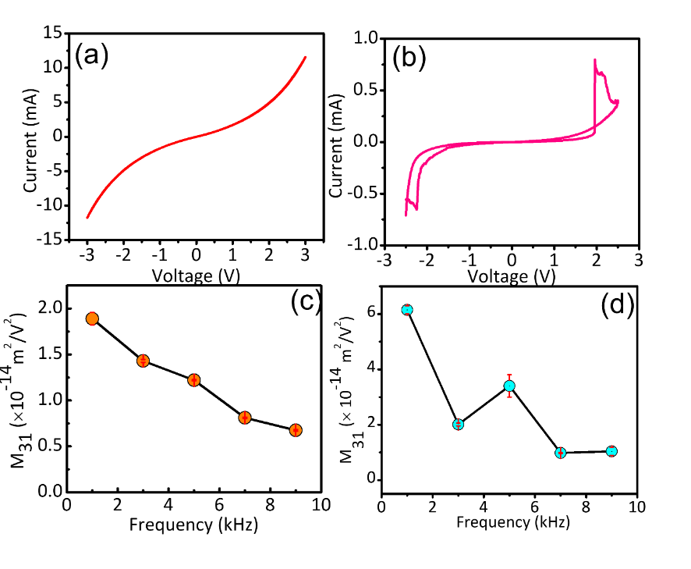
Fig S5: DC I-V characteristics of leaky devices and their electromechanical response I-V characteristics (a) and (b) from “leakier” devices showing even larger M₃₁ coefficients (c) and (d) respectively which are two and six times than the M₃₁ coefficients for the “less leaky” device at 1 kHz frequency

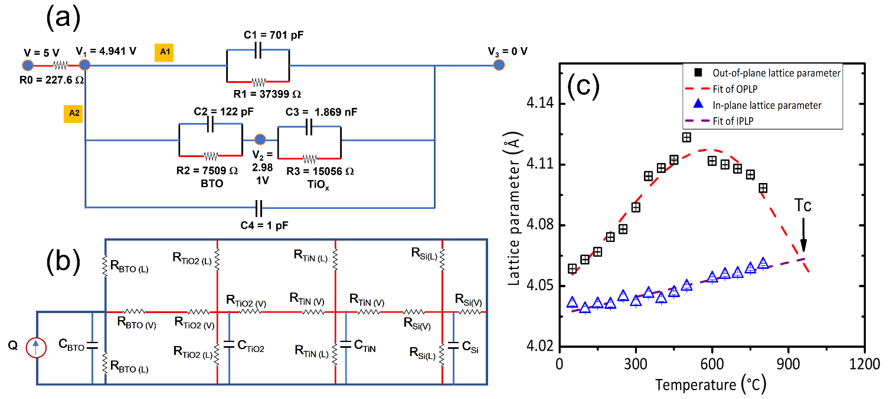
Fig S6: Impedance and thermal circuit models (a) Equivalent circuit used for fitting the impedance response including values of RC elements corresponding to lateral BTO layer (top path or A1) and A2 (bottom path) that includes vertical drop across BTO (V₁-V₂), TiO_{x}(V₂-V₃) and the MW contribution from interface obtained from Z-fit. The RC time constant of lateral BTO path is 6-7 kHz and correlates with the peak in both dielectric and electromechanical tan δ. (b) Equivalent thermal circuit model used for electrothermal simulations performed on LTspice. (L) and (V) represents lateral and vertical element respectively in each layer (c) In-situ XRD of the defective BTO/TiN/Si stack carried out to determine the coefficient of thermal expansion (reproduced¹)

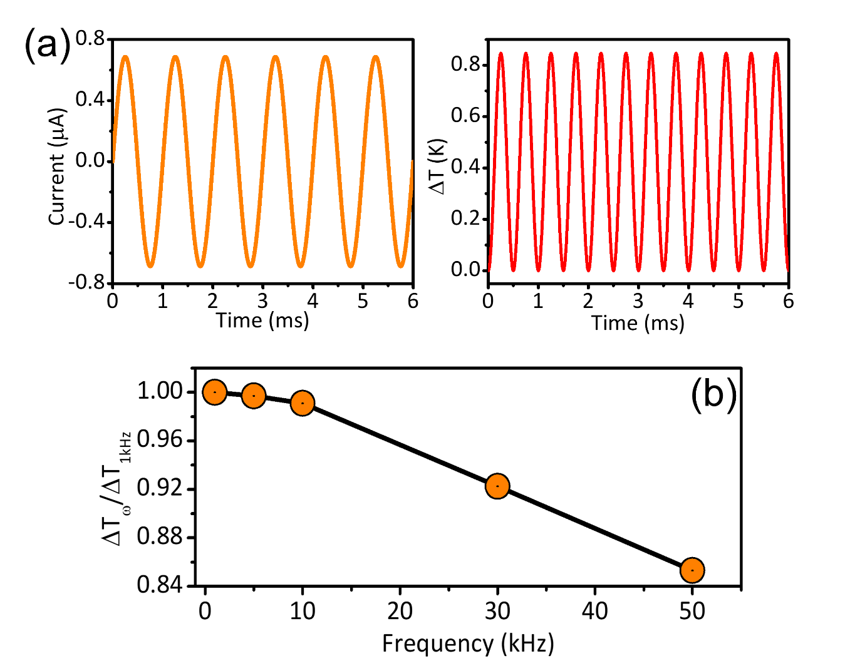
Fig S7. Results of device thermal simulations on less-leaky devices: Current waveform (from I-V measurement) used for simulating the temperature change in “less leaky” device as a function of time shown for (a) 1 kHz 5V (b) normalized temperature change as a function of frequency (ω). Maximum temperature rise is 0.8 K suggesting that Joule heating is not important in these less leaky devices for explaining the large electromechanical effect.

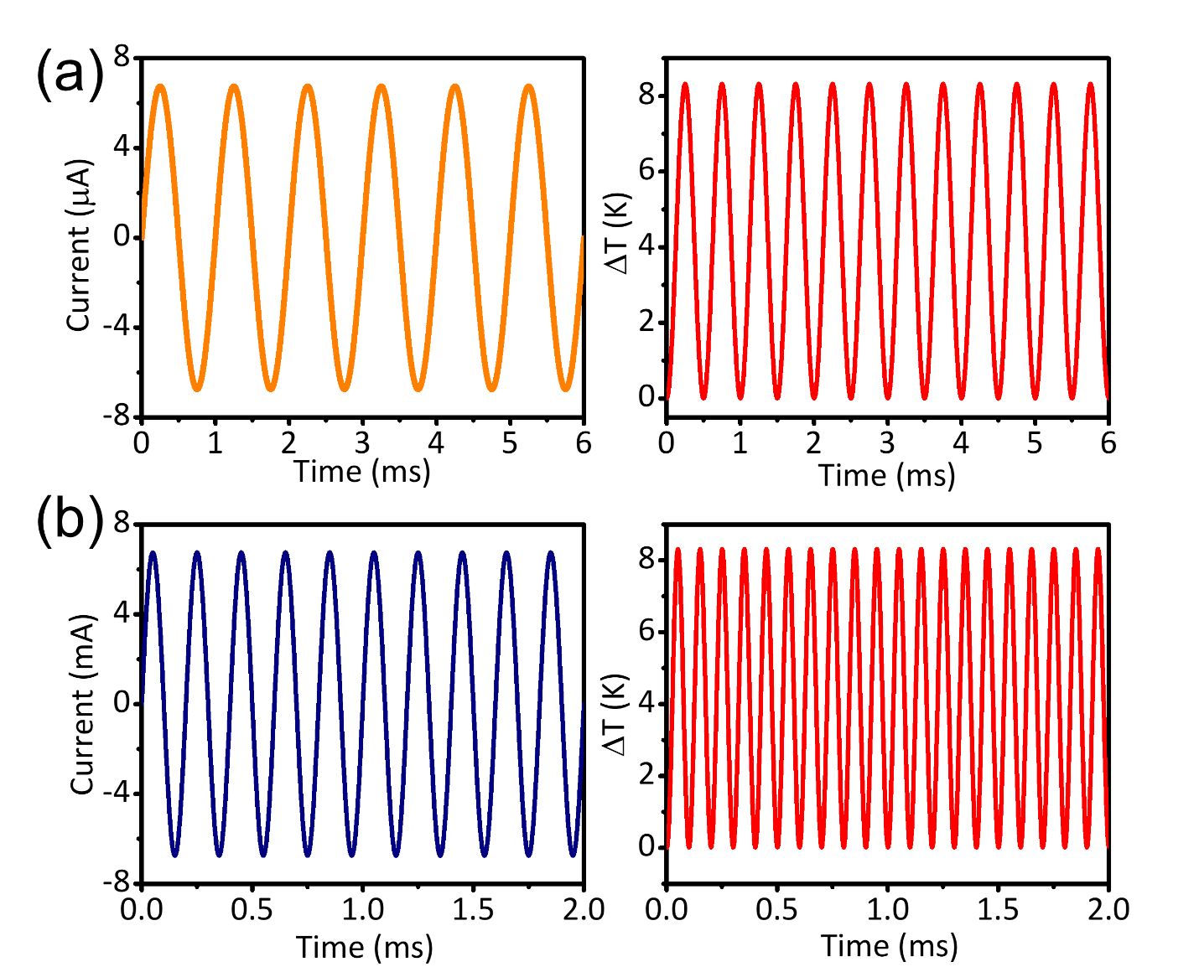
Fig S8. Thermal simulations on leaky devices: Current waveform (from I-V measurement) used for simulating the temperature rise in “leakier” device as a function of time shown for (a) 1kHz, 5V (b) 5kHz, 5V. Here we observe a maximum temperature rise of 8 K, which corresponds to a film displacement amplitude of ~60 pm. Note that the total displacement amplitude measured in this device at 1 kHz, 5 V is ~500 pm. Joule heating is still a minor part in explaining the large electromechanical effects.
References
1. Vura, S. et al. Epitaxial BaTiO 3 on Si(100) with In-Plane and Out-of-Plane Polarization Using a Single TiN Transition Layer. ACS Appl Electron Mater 3, 687–695 (2021).

