 | Dr.Preethi K Mane, has obtained her BE degree in Instrumentation Technology, in the year 1996 from Bangalore university and ME in Electronics from Bangalore university in the year 2000.She has pursued PhD in Electronics and communication Engineering from VisvesvarayaTechnological University, Karnataka, India. She has work experience of 27 years in teaching and is currently serving as Associate Professor in the department of Electronics and Instrumentation Engineering, B.M.S. College of Engineering,Bangalore-19, India.
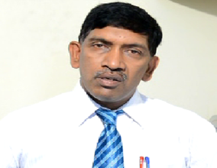 | Dr. K.Narasimha Rao, has obtained his B.Tech, M.Tech and Ph D degrees in the year 1983, 1985 and 2011 respectively. He has 32 years of teaching experience. Presently, he has retired as Professor Department Of Instrumentation Engineering, BMSCE, Bangalore-19. His research interests are in the areas of energy efficient DC Drives, Digital Signal Processing, Process Control and Biomedical Signal Processing.

