Supplementary Materials
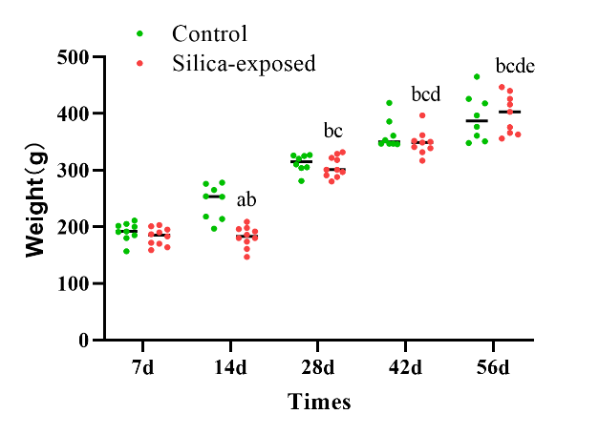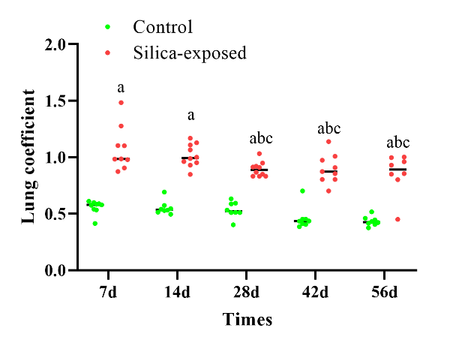 A B
Fig. S1 The body weight (A) and the lung coefficient (B) of silica-exposed and control rats. (a):P≤0.05,compared to the control group at same time points.(b): P≤0.05, compared to silica-exposed group on day 7. (c): P≤0.05,compared to silica-exposed group on day 14. (d): P≤0.05, compared to silica-exposed group on day 28. (e): P≤0.05，compared to silica-exposed group on day 42.

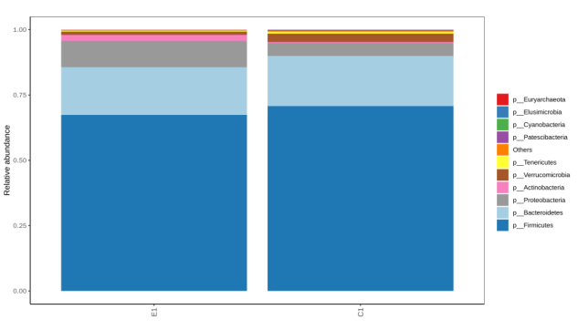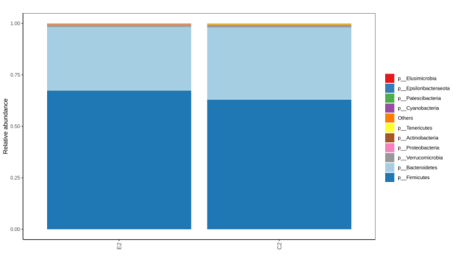
a2
a1
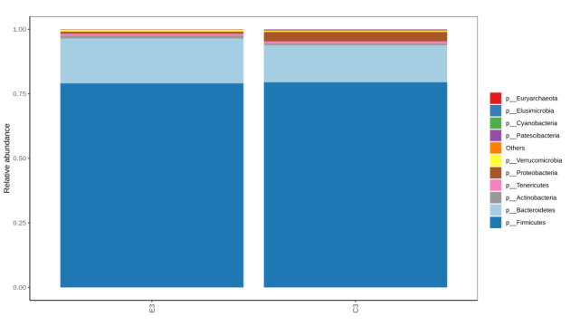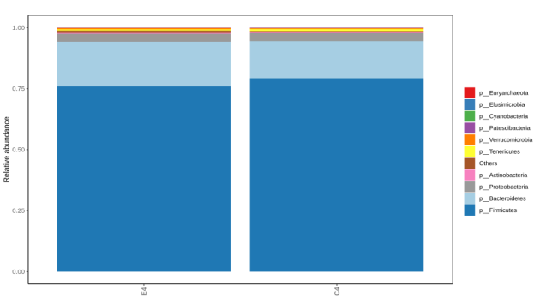
a3
a4
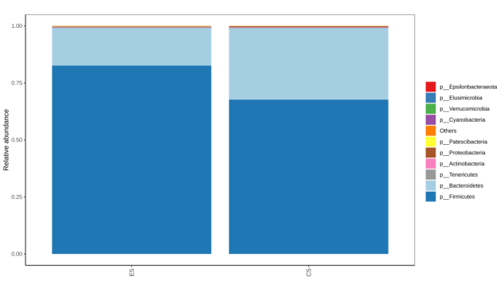
a5
A

b2
b1
b4
b3
b5
B

c4
c2
c3
c1
c5
C

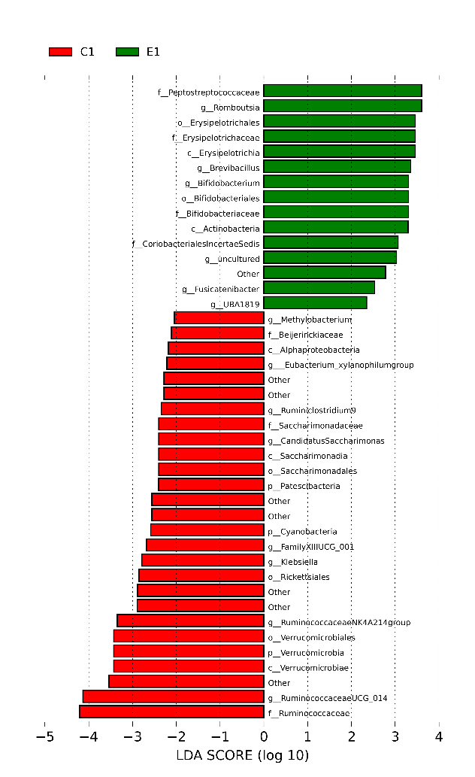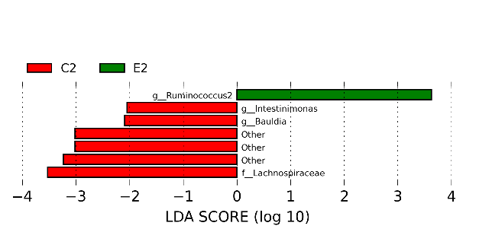
d2
d1
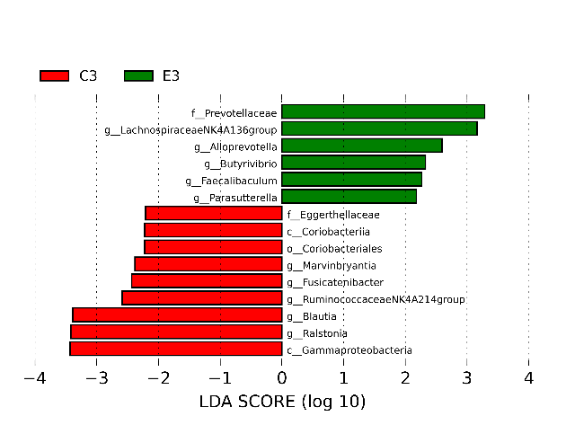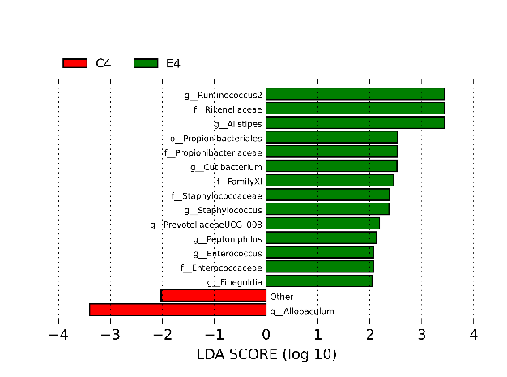
d3
d4
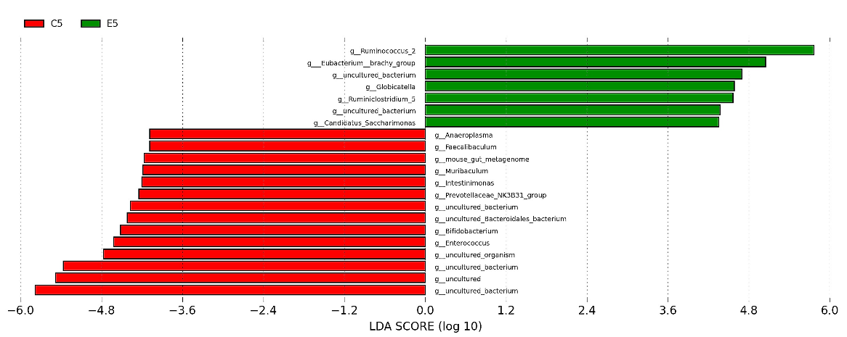
d5
D
Fig. S2 Silica exposure alters the diversity and composition of the gut microbiota. A: a1-a5: Composition and relative abundances of bacterial phyla in different groups on day 7, 14, 28, 42 and 56. B: b1-b5: Comparison of the the Chao 1 index between silica-exposed and control group on day 7, 14, 28, 42 and 56. C: c1-c5: Comparison of the the shannon index. The boxplots show median, quartile, smallest, and largest observations. D: d1-d5: Linear discriminate analysis (LDA) effect size analysis of differential gut microbiota between control and silica-exposed rats on day 7, 14, 28, 42 and 56. LDA scores>1 and significance of P≤0.05 as determined by Wilcoxon's signed-rank test.

Table S1 The differential metabolites in positive mode
Index | Compounds | Formula | VIP | p_value | FC | Type
MW0140734 | (Z)-Phenylacetaldehyde oxime;Z-Phenylacetaldoxime | C8H9NO | 2.1949 | 0.0122 | 8.1740 | up
MW0117754 | 2,2,6,6-Tetramethyl-4-piperidinone | C9H17NO | 2.2541 | 0.0026 | 5.0555 | up
MW0005453 | 5-(Diphenylphosphinyl)pentanoic acid | C17H19O3P | 2.0906 | 0.0150 | 4.5138 | up
MW0006304 | Benzyl benzoate | C14H12O2 | 1.9070 | 0.0488 | 4.1139 | up
MW0124179 | Furametpyr | C17H20ClN3O2 | 3.1310 | 0.0000 | 3.8751 | up
MEDP0588 | Ritalinic acid | C13H17NO2 | 2.0270 | 0.0292 | 3.7730 | up
MW0148216 | Deinoxanthin | C40H54O3 | 2.5567 | 0.0037 | 3.6848 | up
MW0121048 | 5-[1-(Phenylmethyl)-1H-indazol-3-yl]-2-furanmethanol | C19H16N2O2 | 2.0222 | 0.0291 | 3.5097 | up
MEDP0654 | 2-Phenylacetamide | C8H9NO | 1.9658 | 0.0316 | 3.4297 | up
MW0150864 | His Asn Tyr Lys | C25H36N8O7 | 2.2289 | 0.0067 | 3.4067 | up
MW0155851 | Pro Glu Glu Leu Lys | C27H46N6O10 | 1.5853 | 0.0324 | 3.4035 | up
MW0126549 | Silodosin | C25H32F3N3O4 | 2.3768 | 0.0074 | 3.3952 | up
MW0158430 | Tyr Gln Asn Glu | C23H32N6O10 | 1.9685 | 0.0411 | 3.2631 | up
MW0137497 | Benzoin | C14H12O2 | 2.0788 | 0.0286 | 3.1809 | up
MEDL02026 | Coniferaldehyde | C10H10O3 | 2.4318 | 0.0020 | 3.1272 | up
MW0110500 | β-Alanine, N-[2-[(3-hexylphenyl)amino]-2-oxoethyl]- | C17H26N2O3 | 2.3494 | 0.0080 | 3.1168 | up
MW0105496 | Ala-Arg | C9H19N5O3 | 1.6493 | 0.0362 | 3.0171 | up
MEDP0672 | Cyclohexylamine | C6H13N | 1.7626 | 0.0116 | 2.9097 | up
MW0058733 | PE(22:1(13Z)/22:2(13Z,16Z)) | C49H92NO8P | 1.9239 | 0.0235 | 2.8616 | up
MW0120948 | 5,6,7,8-tetrahydro-2-Quinolone | C9H11NO | 2.3174 | 0.0135 | 2.8533 | up
MW0069113 | TG(15:0/16:1(9Z)/18:1(11Z)) | C52H96O6 | 1.8252 | 0.0417 | 2.7874 | up
MW0108619 | N-Acetyl-D-phenylalanine | C11H13NO3 | 2.0617 | 0.0324 | 2.7809 | up
MW0158550 | Tyr Lys Val Glu Ile | C31H50N6O9 | 2.4426 | 0.0037 | 2.7744 | up
MW0144707 | Ala Pro Arg Lys Lys | C26H50N10O6 | 2.4115 | 0.0023 | 2.7589 | up
MW0114483 | Fumagillol | C16H26O4 | 2.6614 | 0.0008 | 2.7569 | up
MW0158969 | Val Gln Ile Asp | C20H35N5O8 | 2.4435 | 0.0062 | 2.7542 | up
MW0107732 | Leu Leu | C12H24N2O3 | 2.3141 | 0.0042 | 2.7377 | up
MW0141420 | 15(S)-15-methyl PGF2 isopropyl ester | C24H42O5 | 2.1969 | 0.0156 | 2.7335 | up
MW0146237 | Asp Pro Gln | C14H22N4O7 | 2.8264 | 0.0001 | 2.7092 | up
MW0110017 | Tributyl phosphate | C12H27O4P | 2.0828 | 0.0376 | 2.6962 | up
MW0010734 | (-)-α-Thujone | C10H16O | 2.4152 | 0.0014 | 2.6248 | up
MW0114752 | LNT | C26H45NO21 | 1.9521 | 0.0149 | 2.5658 | up
MW0107437 | Ile Glu | C11H20N2O5 | 2.6972 | 0.0006 | 2.5546 | up
MW0012748 | 19-Oxotestosterone | C19H26O3 | 2.0618 | 0.0165 | 2.4527 | up
MW0153872 | Met-Phe | C14H20N2O3S | 2.2392 | 0.0032 | 2.4421 | up
MW0139984 | Zapotin | C19H18O6 | 2.0735 | 0.0139 | 2.4351 | up
MW0144536 | Ala Gln Gln | C13H23N5O6 | 2.3896 | 0.0093 | 2.3983 | up
MW0105671 | Arg Pro | C11H21N5O3 | 1.4023 | 0.0453 | 2.3498 | up
MW0155803 | Pro Asn Val | C14H24N4O5 | 2.3236 | 0.0066 | 2.2891 | up
MW0014460 | 4-Hexen-1-ol, (E)- | C6H12O | 1.3735 | 0.0436 | 2.2465 | up
MW0014522 | 4-Methoxy-17β-estradiol | C19H26O3 | 2.0945 | 0.0246 | 2.2318 | up
MW0001302 | 1,2-Naphthoquinone | C10H6O2 | 2.2473 | 0.0082 | 2.2274 | up
MW0159134 | Val Pro Asn | C14H24N4O5 | 2.5551 | 0.0015 | 2.2043 | up
MW0137723 | Combrestatin A4 | C18H20O5 | 2.3786 | 0.0088 | 2.1967 | up
MW0110078 | Trp Phe Arg | C26H33N7O4 | 2.2166 | 0.0086 | 2.1788 | up
MW0110354 | Val Leu Lys | C17H34N4O4 | 2.4083 | 0.0069 | 2.1768 | up
MW0169405 | Lidocaine; LC-ESI-ITFT; MS2; CE | C14H22N2O | 1.3868 | 0.0438 | 2.1550 | up
MW0141502 | 16-phenyl tetranor PGF2 | C22H30O5 | 2.7095 | 0.0007 | 2.1549 | up
MW0062217 | Prostaglandin A2-biotin | C35H56N4O5S | 1.9316 | 0.0400 | 2.1251 | up
MW0149795 | Gln Pro Thr | C14H24N4O6 | 2.7656 | 0.0003 | 2.1201 | up
MW0054405 | Longicamphenylone | C14H22O | 1.3487 | 0.0491 | 2.0792 | up
MW0011871 | 1,2-Dihexanoyl-sn-glycerol | C15H28O5 | 1.3852 | 0.0454 | 2.0491 | up
MW0153005 | Lys Ile Asp Asn Glu | C25H43N7O11 | 2.2150 | 0.0073 | 2.0470 | up
MW0069243 | TG(15:0/18:1(9Z)/14:1(9Z)) | C50H92O6 | 2.0804 | 0.0146 | 2.0453 | up
MW0153603 | Met Lys Asn His Leu | C27H47N9O7S | 1.6344 | 0.0214 | 2.0391 | up
MEDP1304 | Piperidone | C9H15NO2 | 1.8211 | 0.0403 | 2.0133 | up
MEDN0848 | Indole-3-Ethanol | C10H11NO | 1.7904 | 0.0402 | 0.9338 | down
MW0108023 | Lys Thr Lys | C16H33N5O5 | 2.0533 | 0.0239 | 0.4997 | down
MEDP0065 | N-Acetyl-L-Glutamic Acid | C7H11NO5 | 1.8645 | 0.0128 | 0.4979 | down
MW0145390 | Arg Ile Glu Asp | C21H37N7O9 | 2.4957 | 0.0067 | 0.4977 | down
MEDL00352 | Glu-Val | C10H18N2O5 | 1.9520 | 0.0101 | 0.4928 | down
MW0156094 | Propan-2-yl 7-[(1R,2R,3S,5S)-2-[(3R)-3-(2,3-dihydro-1H-inden-2-yl)-3-hydroxyprop-1-enyl]-3-fluoro-5-hydroxycyclopentyl]hept-5-enoate | C27H37FO4 | 2.6427 | 0.0008 | 0.4836 | down
MW0017129 | cis-10-Nonadecenoic acid | C19H36O2 | 2.3205 | 0.0031 | 0.4772 | down
MW0146731 | Biocytin | C16H28N4O4S | 2.3161 | 0.0065 | 0.4741 | down
MW0169027 | dehydrocholic acid | C24H34O5 | 2.4271 | 0.0058 | 0.4669 | down
MW0148928 | ent-Corey PG-Lactone Diol | C15H24O4 | 2.2433 | 0.0070 | 0.4596 | down
MW0055475 | Oleoyl 3-carbacyclic phosphatidic acid | C22H41O5P | 2.7314 | 0.0002 | 0.4592 | down
MW0151464 | Ile Ile Ala | C15H29N3O4 | 1.9527 | 0.0279 | 0.4456 | down
MW0000103 | 7-Ethyl-10-(4-amino-1-piperidino)carbonyloxycamptothecin | C28H30N4O6 | 2.4177 | 0.0065 | 0.4373 | down
MW0058181 | PE(17:1(9Z)/0:0) | C22H44NO7P | 2.5285 | 0.0173 | 0.4369 | down
MW0054420 | Lubiprostone | C20H32F2O5 | 1.9982 | 0.0367 | 0.4330 | down
MW0056521 | PA(a-25:0/12:0) | C40H79O8P | 2.1182 | 0.0111 | 0.4314 | down
MEDP1681 | Leu-Gly-Leu | C14H27N3O4 | 1.8662 | 0.0291 | 0.4300 | down
MW0057458 | PC(22:0/20:3(5Z,8Z,11Z)) | C50H94NO8P | 2.3982 | 0.0281 | 0.4117 | down
MW0155088 | Phe Arg Asp | C19H28N6O6 | 2.4267 | 0.0127 | 0.3681 | down
MEDP1231 | Folic acid | C20H23N7O7 | 2.0922 | 0.0429 | 0.3428 | down
MW0152248 | Leu Asn Ile Leu Thr | C26H48N6O8 | 2.0054 | 0.0243 | 0.3397 | down
MW0143148 | 4-(3-Hydroxy-2-naphthyl)-2-oxobut-3-enoic acid | C14H10O4 | 2.4110 | 0.0112 | 0.2959 | down
MW0108648 | N-Acetyl-L-tyrosine ethyl ester | C13H17NO4 | 2.4042 | 0.0147 | 0.2934 | down
MW0017120 | Cinobufagin | C26H34O6 | 2.7060 | 0.0011 | 0.2899 | down
MW0110392 | Val-Cys | C8H16N2O3S | 2.4481 | 0.0045 | 0.2086 | down
MW0155321 | Phe Pro Tyr | C23H27N3O5 | 2.9749 | 0.0002 | 0.1749 | down
MW0150381 | Gly Ile Asn | C12H22N4O5 | 2.1290 | 0.0400 | 0.1455 | down
MW0153187 | Lys Tyr Tyr | C24H32N4O6 | 2.8002 | 0.0016 | 0.1393 | down
MW0158617 | Tyr Thr Arg Arg | C25H42N10O7 | 2.8954 | 0.0022 | 0.1154 | down

Table S2 The differential metabolites in negative mode
Index | Compounds | Formula | VIP | p_value | FC | Type
MEDN1575 | Rhapontigenin | C15H14O4 | 1.8894 | 0.0471 | 3.0085 | up
MW0143850 | 6-Hydroxytryprostatin B;Desmethyltryprostatin A | C21H25N3O3 | 1.9830 | 0.0151 | 2.8379 | up
MW0157222 | Stigmatellin X | C28H38O6 | 2.1716 | 0.0084 | 2.6770 | up
MW0143256 | 4-Aminoestra-1,3,5(10)-triene-3,17beta-diol | C18H25NO2 | 2.0550 | 0.0124 | 2.5645 | up
MW0144405 | Adynerin | C30H44O7 | 2.1754 | 0.0164 | 2.5452 | up
MW0143344 | 4-Hydroxy-3-methylbenzaldehyde | C8H8O2 | 1.8498 | 0.0133 | 2.3821 | up
MW0118655 | 2-Isopropyl-3-methoxypyrazine | C8H12N2O | 2.3828 | 0.0015 | 2.3555 | up
MEDN1039 | Indole-4-carboxaldehyde | C9H7NO | 1.8727 | 0.0386 | 2.2897 | up
MW0012276 | 13,14-dihydro Prostaglandin E1-d4 | C20H32D4O5 | 1.7979 | 0.0153 | 2.2228 | up
MEDN0232 | L-Rhamnose | C6H12O5 | 1.5953 | 0.0463 | 2.4888 | up
MW0122605 | 8-Desoxygartanin | C23H24O5 | 2.1759 | 0.0329 | 0.4656 | down
MW0114495 | Galacto-N-biose | C14H25NO11 | 2.7629 | 0.0022 | 0.4430 | down
MW0114201 | Dexpanthenol | C9H19NO4 | 2.3913 | 0.0180 | 0.4298 | down
MW0015046 | 6-Hydroxypentadecanedioic acid | C15H28O5 | 2.3471 | 0.0058 | 0.4293 | down
MW0156204 | Pterostilbene Phosphate | C16H17O6P | 2.1111 | 0.0098 | 0.4252 | down
MW0052391 | Dihydroxyfumaric acid | C4H4O6 | 2.1214 | 0.0087 | 0.3816 | down
MW0148995 | Erythronolide B | C21H38O7 | 2.7952 | 0.0003 | 0.3693 | down
MW0161530 | [(3R,4S,5S,6R)-2,4,5-trihydroxy-6-(hydroxymethyl)oxan-3-yl](E)-3-(4-hydroxyphenyl)prop-2-enoate | C15H18O8 | 2.2782 | 0.0247 | 0.3292 | down
MW0054281 | Lasalocid | C34H54O8 | 2.1460 | 0.0253 | 0.3286 | down
MW0127586 | ()-3',4'-Methylenedioxy-5,7-dimethylepicatechin | C18H18O6 | 2.4005 | 0.0169 | 0.2750 | down
MW0011282 | (3S,5R,6R,7E)-3,5,6-Trihydroxy-7-megastigmen-9-one | C13H22O4 | 2.2351 | 0.0401 | 0.0696 | down

Table S3 Pearson correlation coefficient between differential microorganisms and differential metabolites
Index | Compounds | Taxonomy | Correlation | P-value
MW0117754 | 2,2,6,6-Tetramethyl-4-piperidinone | g_Bauldia | -0.876804 | 0.000018
MW0137497 | Benzoin | g_Aggregatibacter | -0.852611 | 0.000054
MW0137497 | Benzoin | g_Ammoniphilus | -0.852611 | 0.000054
MW0137497 | Benzoin | g_Catenulispora | -0.852611 | 0.000054
MW0137497 | Benzoin | g_Coprobacillus | -0.852611 | 0.000054
MW0137497 | Benzoin | g_Flavonifractor | -0.852611 | 0.000054
MW0137497 | Benzoin | g_Fusobacterium | -0.852611 | 0.000054
MW0137497 | Benzoin | g_Imperialibacter | -0.852611 | 0.000054
MW0137497 | Benzoin | g_Sellimonas | -0.852611 | 0.000054
MW0137497 | Benzoin | g_uncultured Epsilonproteobacteria bacterium | -0.852611 | 0.000054
MW0057458 | PC(22:0/20:3(5Z,8Z,11Z)) | g_Agathobacter | -0.840760 | 0.000086
MW0055475 | Oleoyl 3-carbacyclic phosphatidic acid | g_Acholeplasmatales bacterium canine oral taxon 316 | -0.834262 | 0.000110
MW0055475 | Oleoyl 3-carbacyclic phosphatidic acid | g_uncultured Erysipelotrichia bacterium | -0.834262 | 0.000110
MW0155321 | Phe Pro Tyr | g_Saccharopolyspora rectivirgula | -0.830532 | 0.000126
MW0155321 | Phe Pro Tyr | g_Rodentibacter | -0.825548 | 0.000150
MW0145390 | Arg Ile Glu Asp | g_Saccharopolyspora rectivirgula | -0.821808 | 0.000171
MW0124179 | Furametpyr | g_Anaeroplasma | -0.819200 | 0.000187
MW0055475 | Oleoyl 3-carbacyclic phosphatidic acid | g_Elusimicrobium | -0.815668 | 0.000210
MW0155803 | Pro Asn Val | g_Aggregatibacter | -0.814528 | 0.000218
MW0155803 | Pro Asn Val | g_Ammoniphilus | -0.814528 | 0.000218
MW0155803 | Pro Asn Val | g_Catenulispora | -0.814528 | 0.000218
MW0155803 | Pro Asn Val | g_Coprobacillus | -0.814528 | 0.000218
MW0155803 | Pro Asn Val | g_Flavonifractor | -0.814528 | 0.000218
MW0155803 | Pro Asn Val | g_Fusobacterium | -0.814528 | 0.000218
MW0155803 | Pro Asn Val | g_Imperialibacter | -0.814528 | 0.000218
MW0155803 | Pro Asn Val | g__Sellimonas | -0.814528 | 0.000218
MW0155803 | Pro Asn Val | g_uncultured Epsilonproteobacteria bacterium | -0.814528 | 0.000218
MW0155803 | Pro Asn Val | g_Lachnospiraceae NK4A136 group | -0.810582 | 0.000247
MW0137497 | Benzoin | g_Bacteroides | -0.804294 | 0.000301
MW0143148 | 4-(3-Hydroxy-2-naphthyl)-2-oxobut-3-enoic acid | g_mouse gut metagenome | 0.806797 | 0.000278
MW0056521 | PA(a-25:0/12:0) | g_mouse gut metagenome | 0.810916 | 0.000244
MW0107437 | Ile Glu | g_Rodentibacter | 0.811362 | 0.000241
MW0155803 | Pro Asn Val | g_Catabacter | 0.815151 | 0.000213
MW0055475 | Oleoyl 3-carbacyclic phosphatidic acid | g_Bifidobacterium | 0.815994 | 0.000207
MW0124179 | Furametpyr | g_Ruminococcus 2 | 0.819416 | 0.000185
MW0057458 | PC(22:0/20:3(5Z,8Z,11Z)) | g_Family XIII UCG-001 | 0.820297 | 0.000180
MW0053951 | Hovenidulcigenin B | g_[Ruminococcus] gauvreauii group | 0.825955 | 0.000148
MW0153872 | Met-Phe | g_Globicatella | 0.835136 | 0.000107
MW0053951 | Hovenidulcigenin B | g_uncultured organism | 0.836524 | 0.000101
MW0056521 | PA(a-25:0/12:0) | g_uncultured bacterium | 0.837136 | 0.000099
MW0153603 | Met Lys Asn His Leu | g_DNF00809 | 0.839427 | 0.000091
MW0153187 | Lys Tyr Tyr | g_Anaeroplasma | 0.842503 | 0.000081
MW0110500 | β-Alanine,N-[2-[(3-hexylphenyl)amino]-2-oxoethyl] | g_Globicatella | 0.845452 | 0.000072
MW0155321 | Phe Pro Tyr | g_Anaeroplasma | 0.904610 | 0.000004

