Supplemental table 1. Mouse genotyping primer and identification
Mating Information | Gsk3b：fl/null/wt × fl/null/wt，  Lyz2：mut/wt × mut/wt
Remarks
Primer information：
No. | Primer Name | Sequence | Expected Band Size | Primer illustration
1 | 707956-Gsk3b-5wt-tF1 | CTTTGACTTGGGGCAACCTTA | Fl=305bp  Wt=212bp | Identification of Gsk3b
1 | 707956-Gsk3b-5wt-tR1 | GTGAATACCAGAAGACAACAGGG | Fl=305bp  Wt=212bp | Identification of Gsk3b
2 | 707956-Gsk3b-null-tF1 | TCAGAATGGTCAGGATGAAGTTGG | Fl=2055bp  Wt=1872bp  Null=768bp | Identification of Gsk3b
2 | 707956-Gsk3b-null-tR1 | TACCACAGCATGTGAGCGTCC | Fl=2055bp  Wt=1872bp  Null=768bp | Identification of Gsk3b
3 | oIMR3066 | CCCAGAAATGCCAGATTACG | Mut：~700bp | Identification of Lyz2-cre
3 | oIMR3067 | CTTGGGCTGCCAGAATTTCTC | Mut：~700bp | Identification of Lyz2-cre
4 | oIMR3067 | CTTGGGCTGCCAGAATTTCTC | Wt：~350bp | Identification of Lyz2-cre
4 | oIMR3068 | TTACAGTCGGCCAGGCTGAC | Wt：~350bp | Identification of Lyz2-cre

Description of Scheme：

Concentration of gel：2.0% |  | Electrophoretic diagram：
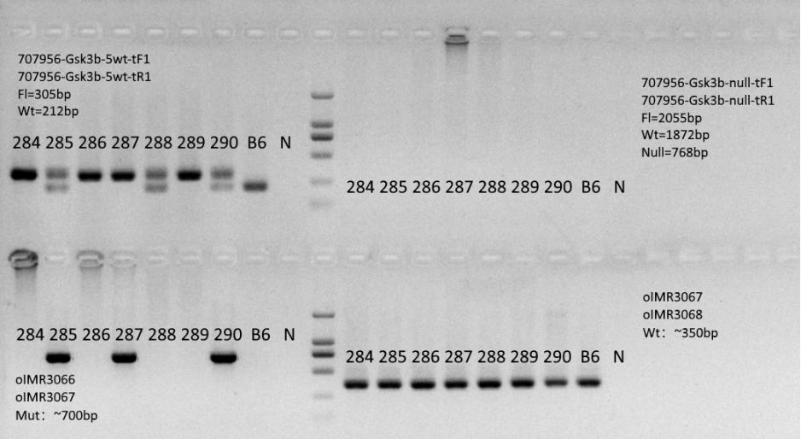
Note: B6 was the negative control，It's the B6 mouse genome DNA
N is blank control, no template control

Analysis and Conclusion：
Gsk3b：
fl/fl：284，286，287，289
fl/wt：other

Lyz2-cre：
mut/wt：285，287，290
wt/wt：other

