Supplementary Information

Factors driving dispersal and habitat use of loggerhead sea turtle post-hatchlings and its conservational implications
Marine Biology
Sara Abalo-Morla^{1*}, Rafael Muñoz Mas^{1,2}, Jesús Tomás³, Eduardo J. Belda¹

¹ Institut per a la Investigació i Gestió de Zones Costaneres (IGIC), Universitat Politècnica de València, C/Paranimf nº 1, E-46730, Gandia (Valencia), Spain.
² GRECO, Institute of Aquatic Ecology, University of Girona, 17003 Girona (Catalonia), Spain
³ Unidad de Zoología Marina, Instituto Cavanilles de Biodiversidad y Biología Evolutiva, Universitat de València, C/Catedrático José Beltrán 2, E-46980, Paterna (Valencia), Spain.

* Corresponding author
Email: saabmor@upv.es

Clutch A
Clutch B

Supplementary Information S1 Dispersal trajectories for the monitored post-hatchlings in the Mediterranean Sea in the present study. Turtle ID is shown above each map. Colors in trajectories represent the month of the year as it is shown in the inset legend
Clutch A | 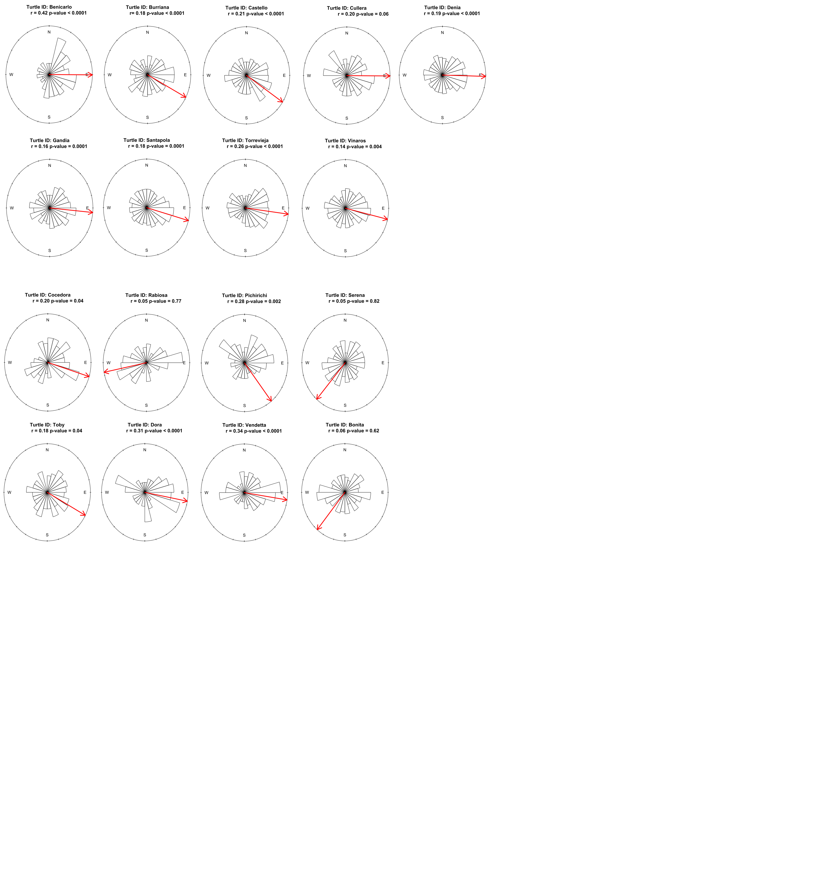
Clutch B

Supplementary Information S2 Circular plots of turtle bearing. Orientation values (white bars) and mean orientation (red arrow). Turtle ID and results of Rayleigh’s test are shown on the top of each individual’s plot. P-values < 0.05 indicate that turtles had significant and directional movement. The r value is also a measure of angular dispersion: This value can vary from 0 to 1, 0 indicating uniform dispersion and 1 indicating complete concentration of displacements in one direction

Supplementary Information S3 Distance travelled by turtles (km) and current assistance (km/h) experienced by turtles. Negative values of current assistance indicate that turtle travelled against sea current, and positive values of current assistance indicate that turtle travelled along sea currents. Turtle ID, regression line (red) and smother (dashed black line) are shown in each plot
Supplementary Information S4 Divergence of turtle’s heading and current direction (in degrees) and sea current magnitude (m/s). Turtle ID, regression line (red) and smother (dashed black line) are shown in each plot

Supplementary Information S5 Ranking of variable importance considered in the habitat suitability analysis of the present study

Supplementary Information S6 Regions of the Mediterranean Sea

Supplementary Information S7 Equation to calculate the current assisstance. Modified from Akesson & Hedenströn (2000)
$Current assistance= Mc × cos(Ht - Hc)$
where Mc is the sea current magnitude in km/h, Ht is the turtle heading and Hc is the sea current direction.

Supplementary Information S8 Equation to calculate the Eddy Kinetic Energy
$Eddy Kinetic Energy=0.5× ρ0 ×(u^{2}+v^{2} )$
where ρ₀ is a constant reference density, which is chosen to be ρ₀ = 1000 kg m⁻³ in this study, and $v$ and $u$ correspond to the sea current velocity components (Richardson, 1983; Kang & Curchitser, 2017).

