Supplementary Notes

Read mapping, filtering and variant calling
All reads were mapped to the hordeum vulgare reference genome toplevel v2 (downloaded 30.05.2019 ¹) using bwa mem (version 0.7.1 ²). Sequences were trimmed if required based on the read quality³. The sequence quality pre- and post-trimming was obtained with fastqc⁴. Aligned reads were strictly filtered by sambamba view ⁵ (version 0.6.6), while only retaining single mapped reads with a mapping quality higher than 30 and removing unpaired reads:
sambamba_v0.6.6 view -h -f bam -p -F "mapping_quality >= 30 and not (unmapped or secondary_alignment) and not ([XA]!= null or [SA]!= null)"
Duplicates were removed from the MACE and WGrS data sets with sambamba makrdup and then sorted by position (sort). Variant calling was performed with samtools mplieup and bcftools call (version 1.8⁶) with a minimum variant base quality of 30 and overall read quality of 25 for parents and pool progeny samples in one run. The SNPs and indels were called separately. Additionally, the two flags -t AD and --positions were specified. AD, the allelic depth format, generates information about the read calls for each allele and sample. The positions flag was used to restrict the pileup to sites where the parents were homozygote, variant from one another and the position was reported as variant in the ensemble⁷ variant reference database. The bcftools options -v and -m were used to generate vcf file. As described previously⁸, the proposed method is the best routine for large plant genome variant calling with superior specificity and sensitivity.

Statistical comparison of haplotypes between systems and generations
Variant calls were further processed with a custom Julia function package (https://github.com/mischn-dev/HAFcall). Position, reference, alternative allele information and read count as well as SNP quality were extracted from the vcf file for each sample. The allele frequency for each SNP related to the parental allele was calculated and stored for later use. The SNPs were linked to high-confidence genes and markers (9K iSelect Chip).
The haplotypes were used to perform gene-wise statistical comparisons of generations and systems. The results of these analyses were applied in the candidate gene selection process and gene ontology classification. Prior to the test procedure, the allele frequencies of the two samples per generation and system were merged together at the SNP level. As the SNP allele frequency distribution shape varied widely over different genes, a dynamic algorithm was applied to select the appropriate test statistic. Some genes were characterised by relatively few SNPs, some by many SNPs with 0% wtAF and yet others by mixtures of distributions. Therefore, an algorithm was developed to choose the appropriate test statistic based on the SNP allele frequency distribution pattern of the haplotype. The Mann–Whitney-U test was applied if the sample size was smaller than 30 (15 SNPs per haplotype and sample), as a proper estimate of the distribution could not be completed or if one of both test samples consisted of all zero values. If less than 15% of all values were zero or one test sample did not have any zero AF entries, a generalised linear model, based on a negative binomial distribution, was used to test the statistical significance. The largest fraction of genes was characterised by a zero-inflated, negative binomial distribution. These genes were analysed with the pscl R package⁹ implementation in Julia if less than 75% of all genes had a wtAF of 0%. Lastly, if the number of genes with no wtAF detected exceeded 75%, a zero-inflated Poisson-based linear model was applied. Pscl package calculates two test statistics for both Poisson/negative binomial and zero-inflated statistics, separately. Therefore, both p values were extracted and saved in the statistics summary table together with the information of the used test statistic, the average HAF and variation, read depth, SNP and zero value count. Selection of significant candidate genes and GO was based on p values of < 0.05 for the negative binomial distribution and an additional filter based on the zero-inflated distribution, if calculated (p < 0.05).

Data yields of the three different sequencing methods
Genotyping by sequencing was performed by LGC Genomics GmbH. A total of 20 million raw paired-end reads with an average length of 145 bp were obtained per sample. These data were trimmed prior to alignment by applying a sliding window approach with the setting 30:15. Additionally, the first 15 bases were removed and the following bases needed to exceed a quality of 30 phred score. MACE was performed by GenXPro GmbH, which generated an average of 8 million reads per sample with a sequencing read length ranging from 17 to 68 bp. The rather short reads were trimmed before alignment by removing the 10 bp on the head of each read and omitting all reads shorter than 40 bp. WGrS steps were performed by Novogene (UK) Company Limited (Cambridge, UK), which generated 400 million high-quality paired-end reads with an average length of 150 bp per sample. Quality adjustment was not necessary, as the read quality was sufficiently high for processing.

Grain yield measurements
The yield of the conventional population ranged from 0.67 to 1.2 times of the average yield of the first 3 years (43 to 77 dt/ha). The organic population yield ranged from 0.6 to 1.4 times until 2015 (27 to 59 dt/ha). The years 2007 and 2016 were characterised by massive yield reductions in the organic system of 41% and 31%, respectively, as compared to the previous years. In both years, mild and wet periods were observed during the crop development and anthesis stages. The yield reduction to 0.89 in 2016 was followed by three extraordinarily dry years, which reduced the yield ratio to an absolute minimum of the entire experimental period in 2019 (0.48 times; 20.53 dt/ha). As compared with the organic system, the yield levels in the conventional system recovered rather quickly after 2016 (yield reduction of 27% in 2016). In 2017, the ratio decreased to 0.64 times (41 dt/ha), followed by an increase to 0.92 times (59 dt/ha) in the dry year of 2018 (Supplementary Figure 5).

2 Supplementary Tables

Supplementary Table 1. Variation between samples of the same population and generation. Two samples per combination were sequenced and the variation was calculated by a negative binomial distribution in a generalised linear model, based on the gene-based haplotype frequencies. Values of < 0.05 are assumed to highlight a distinct variation between the two tested samples
 | Organic environment | Conventional environment
F3 | 0.706012304 | 0.706012304
F12 | 1.79E-29*** | 5.56E-11***
F16 | 0.003433514** | 0.159250979
F22 | 0.078228736 | 0.675195917
F23 | 4.09E-35*** | 0.844952478

Supplementary Table 2. Validation of genetic random drift of the observed allele frequencies of 34,237 haplotypes. The median allele frequency of 1,000 replicates of drift simulation was tested with a negative binomial linear model against the actual observed allele frequencies of genes for each generation. This test was used to check if the simulated and actual data were equal and, if so, the observations were based on random drift only. Values of < 0.001 are assumed to highlight a distinct variation between the simulated and actual allele frequencies, indicating that the genetic drift did not have the power to explain the majority of observed allele frequency changes over the generations. A – The p-value reports the difference between the organic and conventional against the drift simulated population for each generation separately. The drift allele frequency value of each corresponding haplotype is calculated as median value over the 1,000 iterations. Low p-values indicate high divergence between the drift and the real population sample. Next to the p-values, the average genome-wide wild type allele frequency values are reported in percent for organic, conventional and drift population. Drift simulation was calculated for the following generations based on the BC₂F₃ gene-haplotypes allele frequency
A |  |  | Average gwAF [%]
 | Organic environment | Conventional environment | organic | conventional | simulated drift
F3 | 1 | 1 | 10.0511 | 10.0511 | 10.0511
F12 | 9.61E-92 | 3.13E-34 | 8.9374 | 8.3219 | 10.0538
F16 | 3.09E-27 | 4.62E-71 | 9.0923 | 7.0674 | 10.0539
F22 | 0.000114009 | 2.13E-51 | 9.4368 | 7.1864 | 10.0550
F23 | 1.99E-38 | 1.29E-54 | 10.5314 | 6.9319 | 10.0554

Supplementary Table 3: Overview of genes with significant changes in allele frequency as compared to the F₃ generation (p < 0.001). The first column differentiates major blocks, the second column the generations and the third column the count of gene data of the conventional and organic environments. Number of genes with variations as compared to F3 - all genes with significant variation (p < 0.001) as compared to the initial generation. Wild type alleles up-selected as compared to F3 – the previously identified genes with a significantly higher wild type allele frequency as compared to F3. Cultivar allele up-selected as compared to F3 was the same as above, but for the cultivar allele frequency. 0% wild type AF (first block) – observed genes with no evidence of wild type allele frequency. 0% wild type AF (second block) – the count of genes with no wild type alleles for more than one generation, including generations F₁₂, F₁₆, F₂₂ and F₂₃.
 |  | Count of genes
 | Generations | Conventional environment | Organic environment
Count of genes variant to F3 | Total number of genes | 34343 | 34343
Count of genes variant to F3 | F12 | 22308 | 20834
Count of genes variant to F3 | F16 | 22046 | 21598
Count of genes variant to F3 | F22 | 22940 | 21839
Count of genes variant to F3 | F23 | 22240 | 22773
Wild type allele up-selected to F3 | F12 | 9179 | 9566
Wild type allele up-selected to F3 | F16 | 7548 | 10361
Wild type allele up-selected to F3 | F22 | 8115 | 9658
Wild type allele up-selected to F3 | F23 | 7115 | 10721
Cultivar allele up-selected to F3 | F12 | 13128 | 11268
Cultivar allele up-selected to F3 | F16 | 14498 | 11235
Cultivar allele up-selected to F3 | F22 | 14824 | 12180
Cultivar allele up-selected to F3 | F23 | 15124 | 12052
0% wild type AF | F12 | 1857 | 442
0% wild type AF | F16 | 2105 | 728
0% wild type AF | F22 | 2318 | 622
0% wild type AF | F23 | 3066 | 912
0% wild type AF | All generations from F12-F23 | 524 | 127
0% wild type AF | All generations from F16-F23 | 806 | 188
0% wild type AF | All generations from F22-F23 | 1379 | 376

Supplementary Table 4: Measurement of root related traits in hydroponic and field environment. All traits with a significant variation (p < 0.05) between the organic and conventional environment are included in this list. Besides the mean difference (positive values are related to higher values in the organic population), The upper and lower 95% limit of the confidence interval as well as the standard deviation and the p value reported. The table is split for field and hydroponic measurements. Empty fields indicate the trait was only measured in one experiment
 | Hydroponics |  |  |  |  |  | Field
 |  | Confidence interval |  | Standard deviation |  |  |  | Confidence interval |  | Standard deviation
Trait | Difference* | lower | upper | Convent. | Organic | p value | Difference* | lower | upper | Organic | Convent. | p value
Aerenchyma area [µm²] | -0.011497719 | -0.0143035 | -0.00869 | 0.004136 | 0.003054 | 3.12E-14 | -0.0542414 | -0.0927 | -0.0157779 | 0.109941 | 0.098524 | 0.001849
Average late metaxylem area [mm] | -0.001184939 | -0.0016712 | -0.0007 | 0.001286 | 0.00115 | 8.86E-09
cortical cell area [mm²] |  |  |  |  |  |  | -0.0654444 | -0.11341 | -0.0174789 | 0.138408 | 0.123134 | 0.002813
Late metaxylem area [mm²] | -1.250716901 | -1.751392 | -0.75004 | 0.935752 | 0.899866 | 3.69E-09 | 0.41661513 | 0.128173 | 0.7050568 | 0.733038 | 0.857624 | 0.001342
Ratio length per volume | 228.0383594 | 99.6565744 | 356.4201 | 187.0543 | 455.4954 | 4.22E-05 | 42.6210091 | 18.87541 | 66.366606 | 52.98558 | 77.17192 | 3.46E-05
Root angle [°] |  |  |  |  |  |  | -4.1004947 | -7.2792 | -0.9217868 | 6.915353 | 10.59973 | 0.005417
Root average diameter [mm] | -0.081205593 | -0.1285217 | -0.03389 | 0.09956 | 0.11787 | 8.19E-05 | -0.0907452 | -0.16308 | -0.0184123 | 0.197403 | 0.202749 | 0.007315
Root cross section [mm²] | -0.054181142 | -0.1012553 | -0.00711 | 0.111222 | 0.121031 | 0.016805 | -0.1287126 | -0.21254 | -0.0448809 | 0.237136 | 0.227227 | 0.000553
Root length [mm] | 316.5351432 | 35.4131221 | 597.6572 | 597.0236 | 883.1833 | 0.020343
Root mass density [g/cm³] | -0.036932381 | -0.0736953 | -0.00017 | 0.106157 | 0.078121 | 0.048473 | 0.06535766 | 0.009391 | 0.1213247 | 0.116963 | 0.18788 | 0.014764
Root surface area [cm] | -0.139604476 | -0.2171352 | -0.06207 | 0.245599 | 0.15429 | 3.18E-05
Root tip number [1/plant] |  |  |  |  |  |  | 165.889829 | 19.04341 | 312.73625 | 357.1448 | 440.1057 | 0.019798
Stele area [mm] | -0.018415166 | -0.0359321 | -0.0009 | 0.044389 | 0.043046 | 0.035124
Tiller number [1/plant] | -1.388788142 | -2.5013038 | -0.27627 | 2.651002 | 2.588242 | 0.007686
Plant height [cm] | -7.350427168 | -12.251316 | -2.44954 | 7.186694 | 7.570277 | 0.000781
Total cortical area [mm²] | -0.035542984 | -0.0685089 | -0.00258 | 0.078625 | 0.087294 | 0.028977 | -0.1200043 | -0.19235 | -0.0476626 | 0.209659 | 0.186318 | 0.000154
Vascular bundle area [mm²] | -0.051890668 | -0.0983379 | -0.00544 | 0.109936 | 0.119866 | 0.021732
 | * Organic always as first value - negative values are related to smaller in organic

Supplementary Table 5. The allele frequency of the 3rd and 23rd generation for selected QTL regions identified by meta-analysis. QTL studies related to fungal resistance genes^{10–13}, grain yield^{14–17}, nutrient uptake and translocation ^{18,19}, upper body yield physiology, such as flowering, dormancy or dwarfing genes^{18,20–29}, root associated traits^{30–32} and drought resistance^{18,33–35} were identified and classified by colour. Besides the QTL name, the position, map source, category, reference publication of the QTL, actual trait and crossing background are reported. This information is linked to the wild type allele frequency of the F₃ and the F₂₃ generations of both the organic and conventional systems for the region of the QTL. In general, a specified QTL region was regarded as relevant and listed in the table if a significant variation of the generations or environments was observed in the pooled sample data.
[See the Excel file]

Supplementary Table 6. Identified candidate genes related to the QTL region of Table 3. Besides the associated QTL, the structural variation observed on amino acid and / or DNA level are reported as well as the function of this gene, the gene name in the reference, the wild type allele frequency for the 23rd generation in conventional (wtAFcon F23) and organic system are shown. Furthermore, the wild type allele frequency of the third generation, the SNP count and read count of the haplotype and the information of preliminary stop codons are reported.
[See the Excel file]

Supplementary Table 7: Field experiment trail layout (A) and treatment (B) of organically and conventionally farmed environments. A – Crop rotation of organic and conventional farming. The spring barley populations of interest are illustrated in blue and rotate to the right in their blocks in the next year. The conventional farming system consists of a three-crop rotation, the organic farming system of seven crops. The barley populations always remained in their row, while the conventional population rotates in the first to third column, and the organic population in the fourth to tenth column. B – treatments in both environments; [WW – winter wheat, SB – spring barley, WRa – winter rape seed, Pot – Potato, AB – common bean, WR – winter rye, OAT – spring oat]
 | A
 |  |  | conventional |  |  |  |  |  |  |  |  |  | organic
 |  |  | 3 m border |  |  |  |  |  |  |  |  |  | 3 m border
 |  |  | WRa |  |  | WW |  | SB |  |  |  |  | AB | WRa |  | SB |  |  | Oat |  | WR | WW | Pot
 |  |  | 9 m border |  |  |  |  |  |  |  |  |  | 9 m border
 |  |  | SB |  |  | WRa |  | WW |  |  |  |  | WR | Pot |  | Oat |  |  | AB |  | WW | SB | WRa
 |  |  | 9 m border |  |  |  |  |  |  |  |  |  | 9 m border
 |  |  | WW |  |  | SB P1 |  | WRa |  |  |  |  | SB | Oat |  | WRa |  |  | WR |  | Pot | AB | WW
 |  |  | 9 m border |  |  |  |  |  |  |  |  |  | 9 m border
 |  |  | WRa |  |  | WW |  | SB |  |  |  |  | Pot | AB |  | WR |  |  | SB P1 |  | WRa | WW | Oat
 |  |  | 3 m border |  |  |  |  |  |  |  |  |  | 3 m border
 |  |  |  |  |  |  |  |  |  |  |  |  |  |  |  |  |  |  |  |  |  |  | 9 m
 |  |  |  |  |  |  |  |  |  |  | Environment
 |  | B |  |  |  |  |  |  |  |  | Organic |  |  |  |  |  |  | Conventional
 |  | Fertilizer |  |  |  | Type |  |  |  |  | Manure |  |  |  |  |  |  | Minerals
 |  |  |  |  |  | Times of Application |  |  |  |  | once per year for Potato and Rape seed |  |  |  |  |  |  | Booting and Flowering Stage
 |  |  |  |  |  | Amount added |  |  |  |  | 200 dt/ha – 156kg N, 78 kg P2O5, 374 kg K2O, 36 KG MgO,* |  |  |  |  |  |  | 80 – 100 kg N by calcium ammonium nitrate*
 |  | Growth Control |  |  |  | Seed Treatment |  |  |  |  | Seeds coated for sawing |  |  |  |  |  |  | Seeds coated for sawing
 |  |  |  |  |  | Growth Regulation |  |  |  |  | none |  |  |  |  |  |  | on demand²
 |  |  |  |  |  | Fungicide Treatment |  |  |  |  | none |  |  |  |  |  |  | on demand²
 |  |  |  |  |  | Competition Control |  |  |  |  | groom between rows |  |  |  |  |  |  | Herbicide on demand²
 |  | System Managed |  |  |  | Crop Rotation |  |  |  |  | Rape Seed – Winter Rye – Winter Wheat – Acre Beans – Oat – Spring Barley – Potato |  |  |  |  |  |  | Rape Seed – Winter Wheat – Srping Barley
 |  |  |  |  |  | Soil Balance |  |  |  |  | pH, Nmin, Pmin, organic matter |  |  |  |  |  |  | pH, Nmin, Pmin, organic matter
 |  |  |  |  |  | pH Adjustment |  |  |  |  | lime to pH of 7 |  |  |  |  |  |  | lime to pH of 7
 |  |  |  |  |  | * – Phosphate fertilization was not required due to high saturation level of the soil
 |  |  |  |  |  | 2 - only products with a valid registration certificate of the year of use were utilized

3 Supplementary Figures

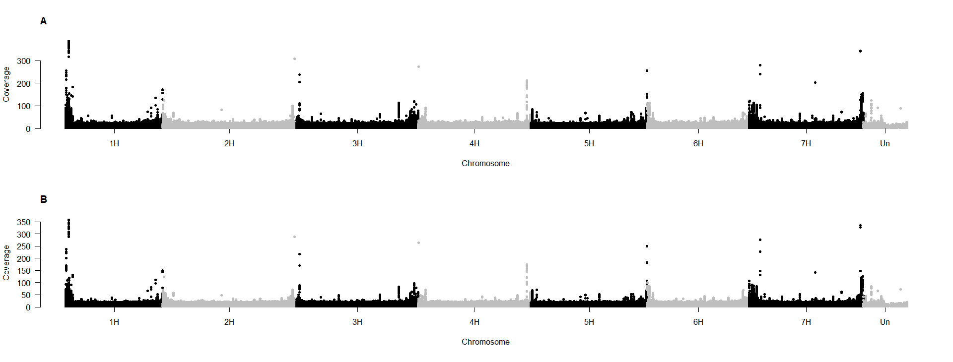Supplementary Figure 1: The genome wide coverage per SNP for two representative samples collected (A, B). Each dot represents one identified SNP between the two parents. The y-axis represents the read count per SNP, while the x-axis illustrated the chronological position on the genome.
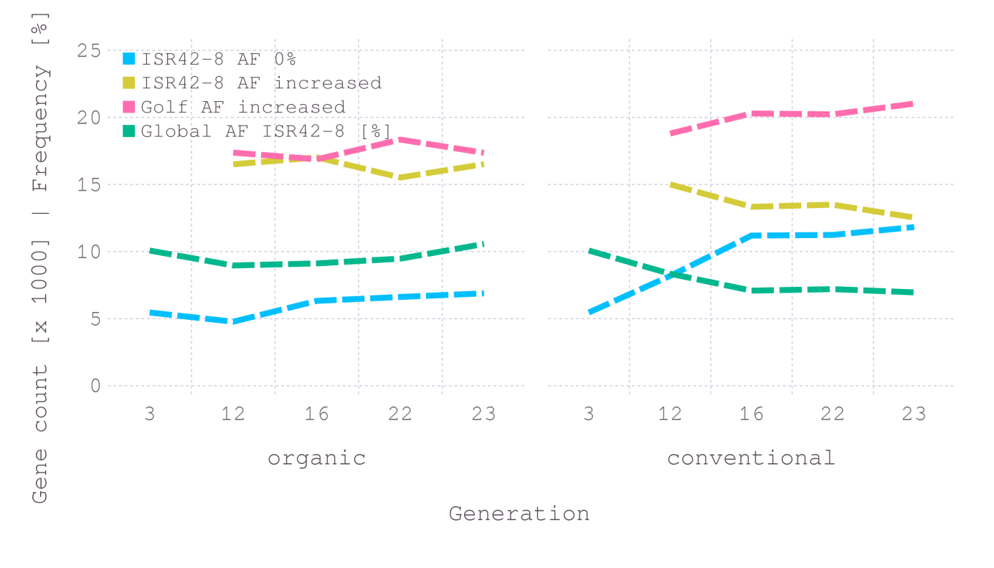
Supplementary Fig. 2. Genome-wide overview of the allele frequency evolution over the generations as well as the count of positive selected wild type and cultivar alleles. The x-axis shows the generations of the organic and conventional systems. The y-axis presents the gene count (multiplied by 1,000) and the allele frequency in %. The blue line highlights the count of genes for which no ISR42-8 alleles was observed in the population. AF is an acronym for allele frequency. ISR42-8 is the wild type, while Golf is the cultivar parent. The green line represents the genome-wide wild type allele frequency for each generation. The yellow line indicates the count of genes for which the wild type allele frequency has increased in the population, as compared to the F₃. The red line represents the same information for the cultivar alleles in the population.
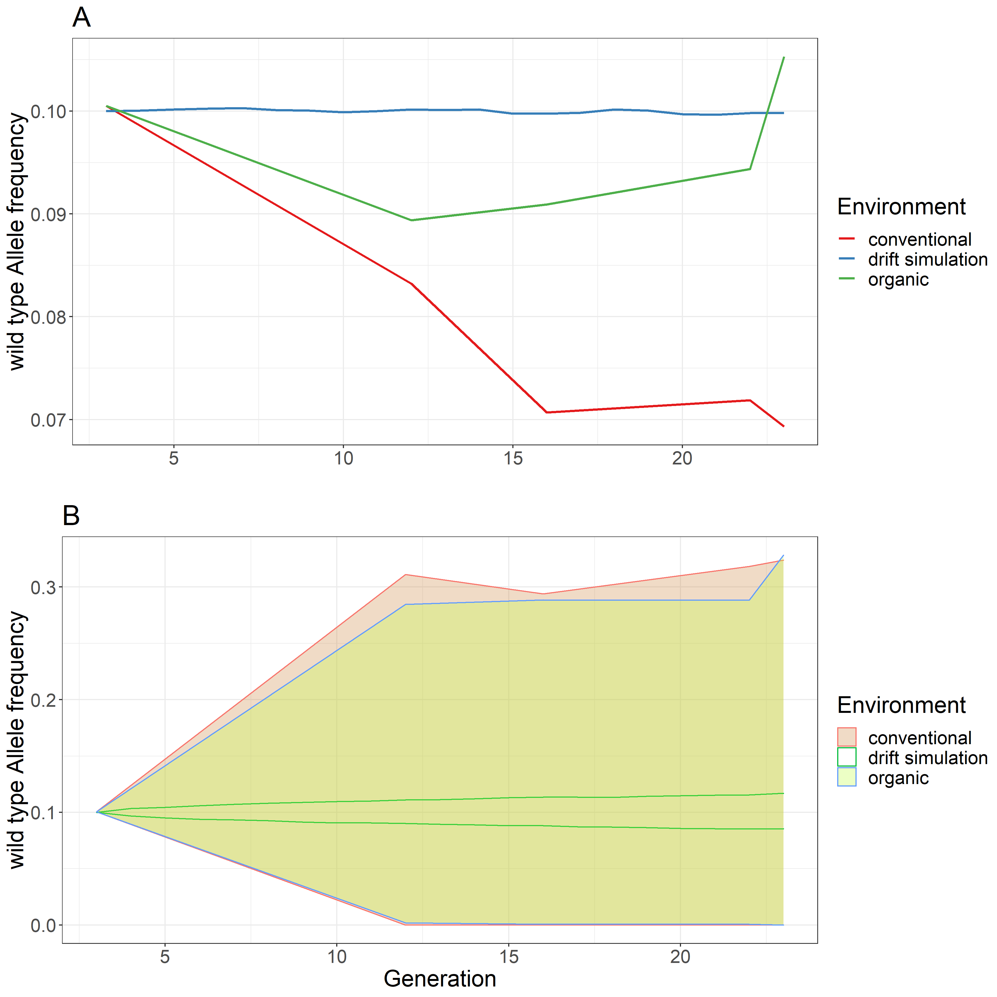
Supplementary Fig. 3: Effect size estimation of genetic drift, compared to the allele frequency evolution in the organic and conventional population over all generations. A – the average genome wide wild type allele frequency value (y-axis) against the generations (x-axis). The conventional, organic and drift are indicated by different colours. B – the 95% confidence interval of the gene-based haplotypes for conventional and organic populations. Additionally, the confidence interval of the drift is plotted and compared against both field experiment-based environments. The drift as single factor showed a 10 times smaller effect on the allele frequency variation compared to the conventional and organic population. The conventional and organic lines and areas are the result of the real data, while the drift line is the result of a simulation.

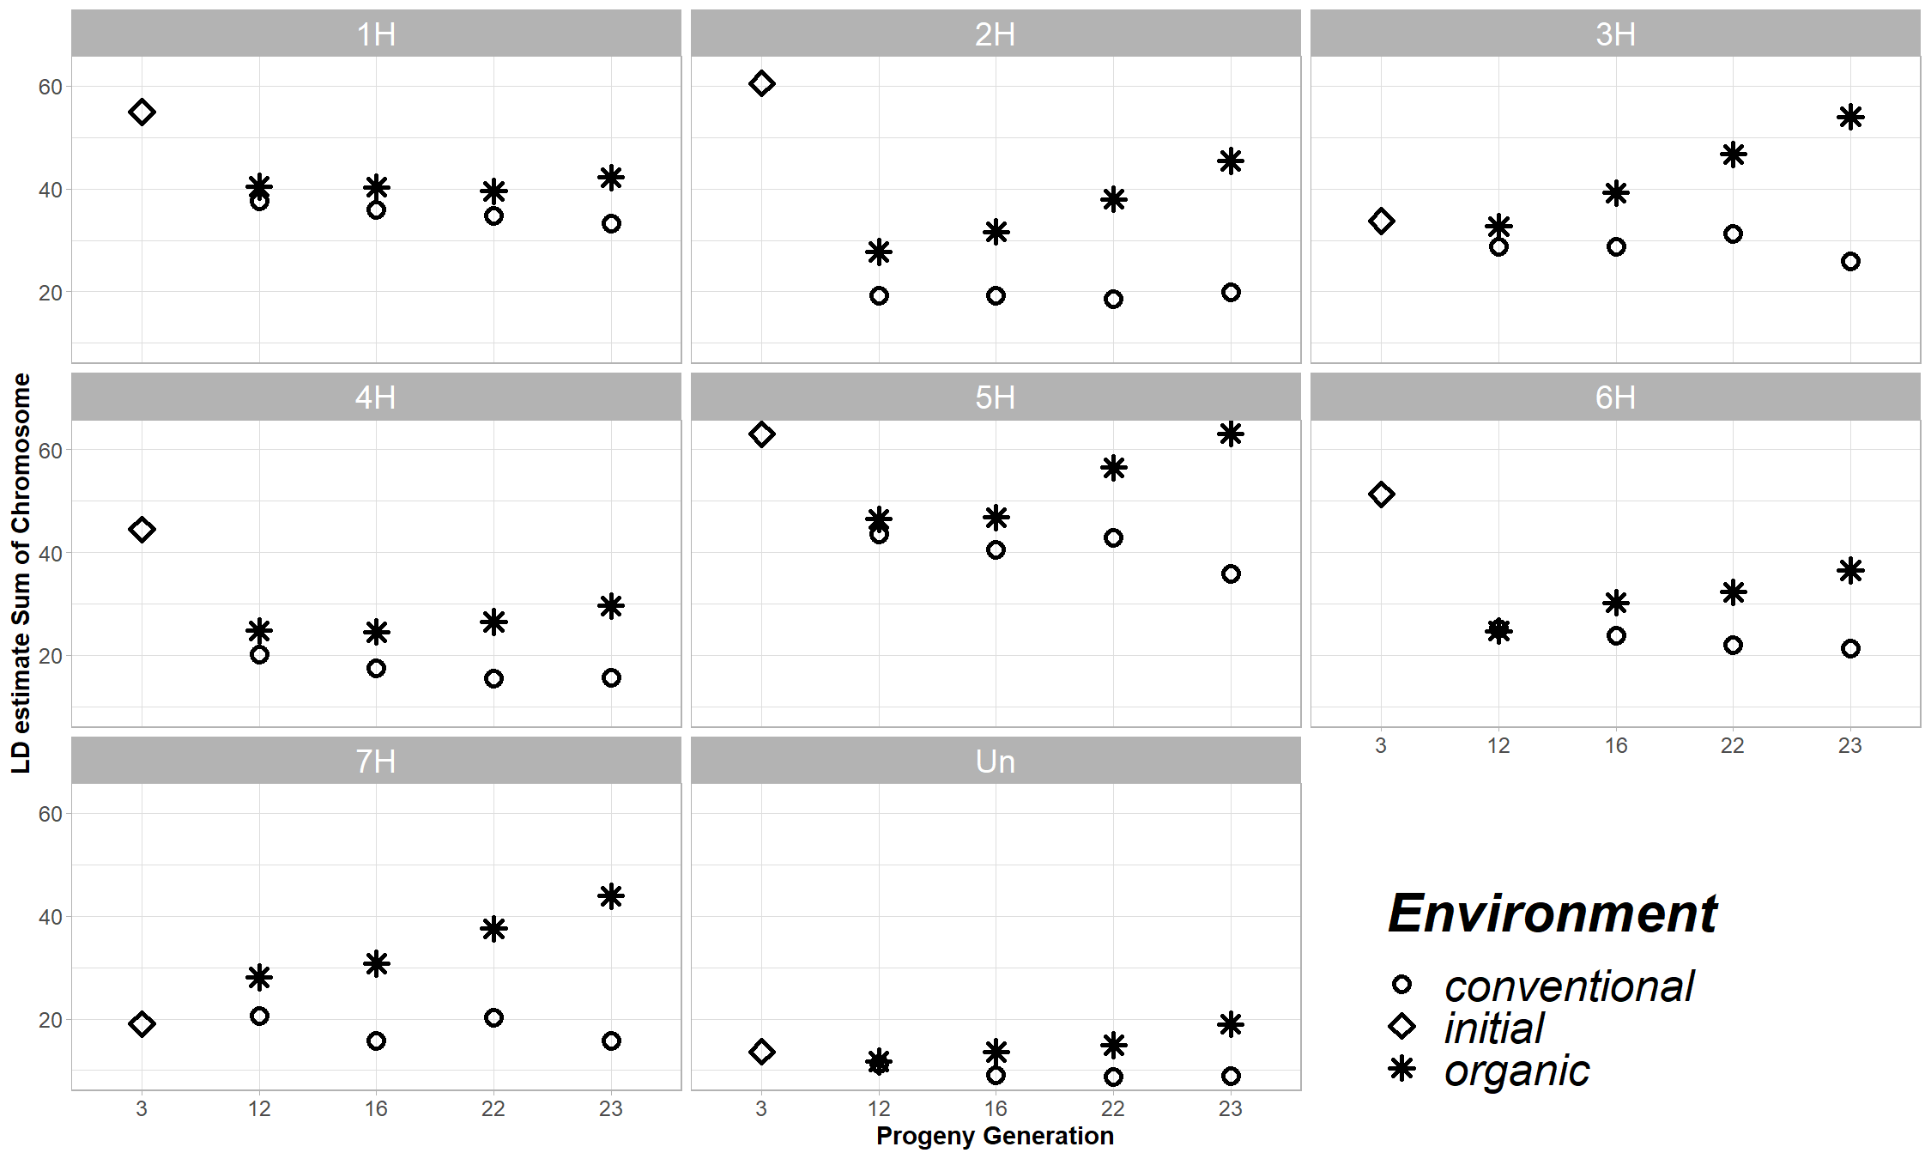 Supplementary Fig. 4. Genetic map length per each chromosome for the conventional, organic and initial populations. The chromosome-wise sum of LD is facetted for chromosomes and plotted against the generation (x-axis). A high value is associated with high variability. Decreasing values indicate reduced variability, as observed for the conventional system.
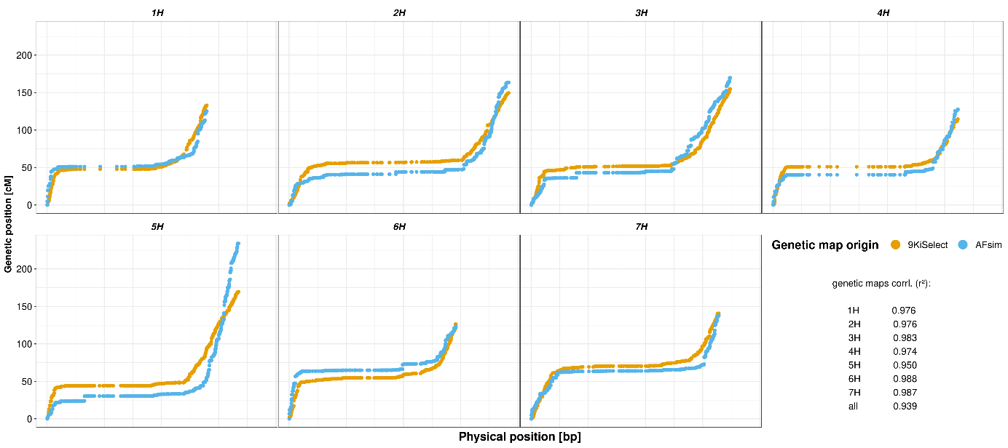
Supplementary Figure 4: Comparison of the genetic to physical position of the 9KiSelect consensus map (yellow) and an estimated genetic map by the allele frequency variations (blue, AFsim). The genetic distance compared to the physical distance to investigate the recombination event likelihood. The genetic position (y-axis) is plotted against the physical position (x-axis). Based the genetic position of the 9KiSelect chip, a F4 population of 4,000 individuals was simulated using AlphaSimR for 3,999 markers. For each marker, the allele frequency was calculated and subsequently D’ and the genetic map calculated based on the physical distance and the allele frequency variation of neighbouring markers. Without the utilization of haplotype information, the correlation of the estimated to real genetic map is greater 0.93. The Pearson correlation of both genetic maps for each chromosome is presented in the bottom right of the plot.

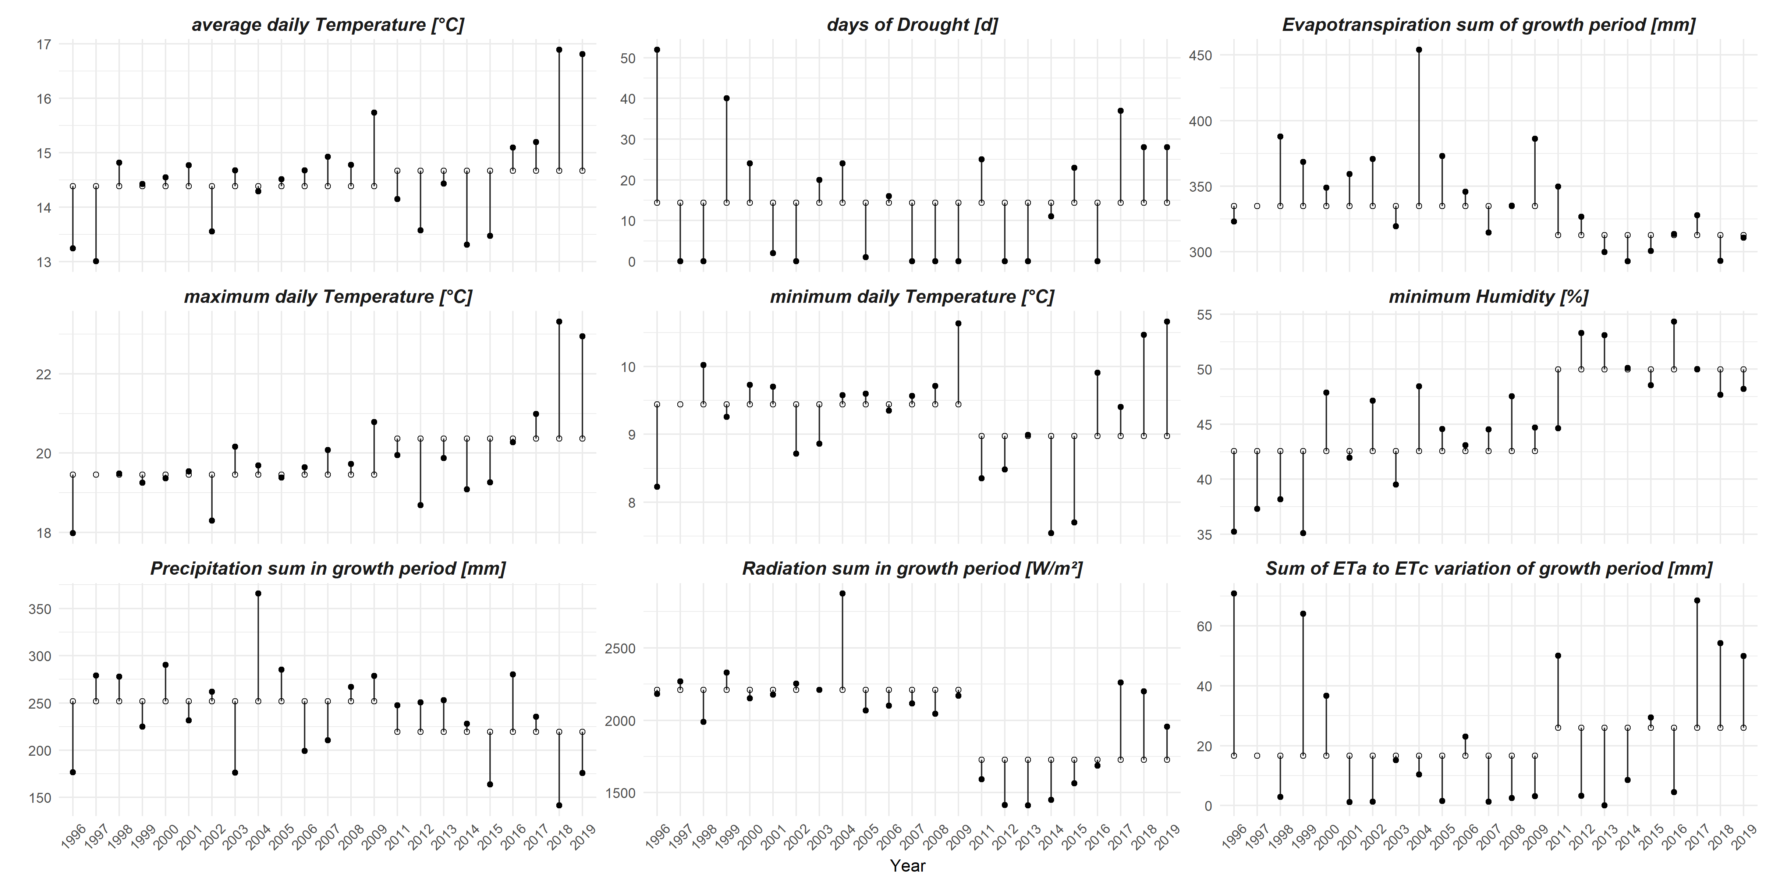Supplementary Figure 6: Summary statistics of annual weather-related values. Nine windows for the most relevant weather characteristics are illustrated. While the y-axis reports the value in the unit given in the sub figure title, the x-axis reports the years. Filled dots indicate the values of the year, while the empty dots present the mean over the period (serval year). As two different weather stations were used in the duration of the experiment, the measurements taken from these deviate little from each other. To overcome this, the over annual average values (white dots) were calculated for each station separately. The black line between the filled black and the white dot is the annual deviation from the over annual mean. For each of the nine windows, either the mean (temperatures, humidity) or the sum (drought, evapotranspiration, precipitation, radiation, Eta to ETc ratio) over the reported trait is presented.
A
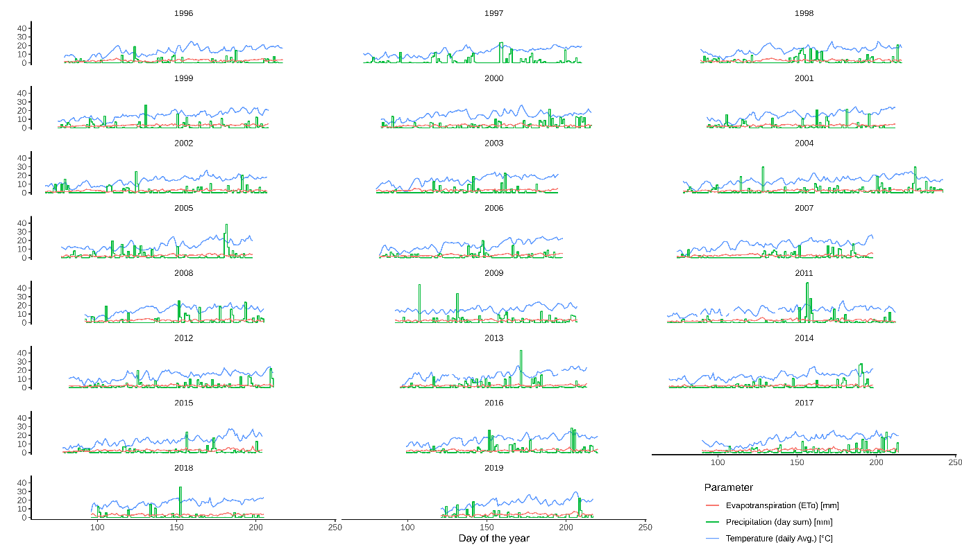
B
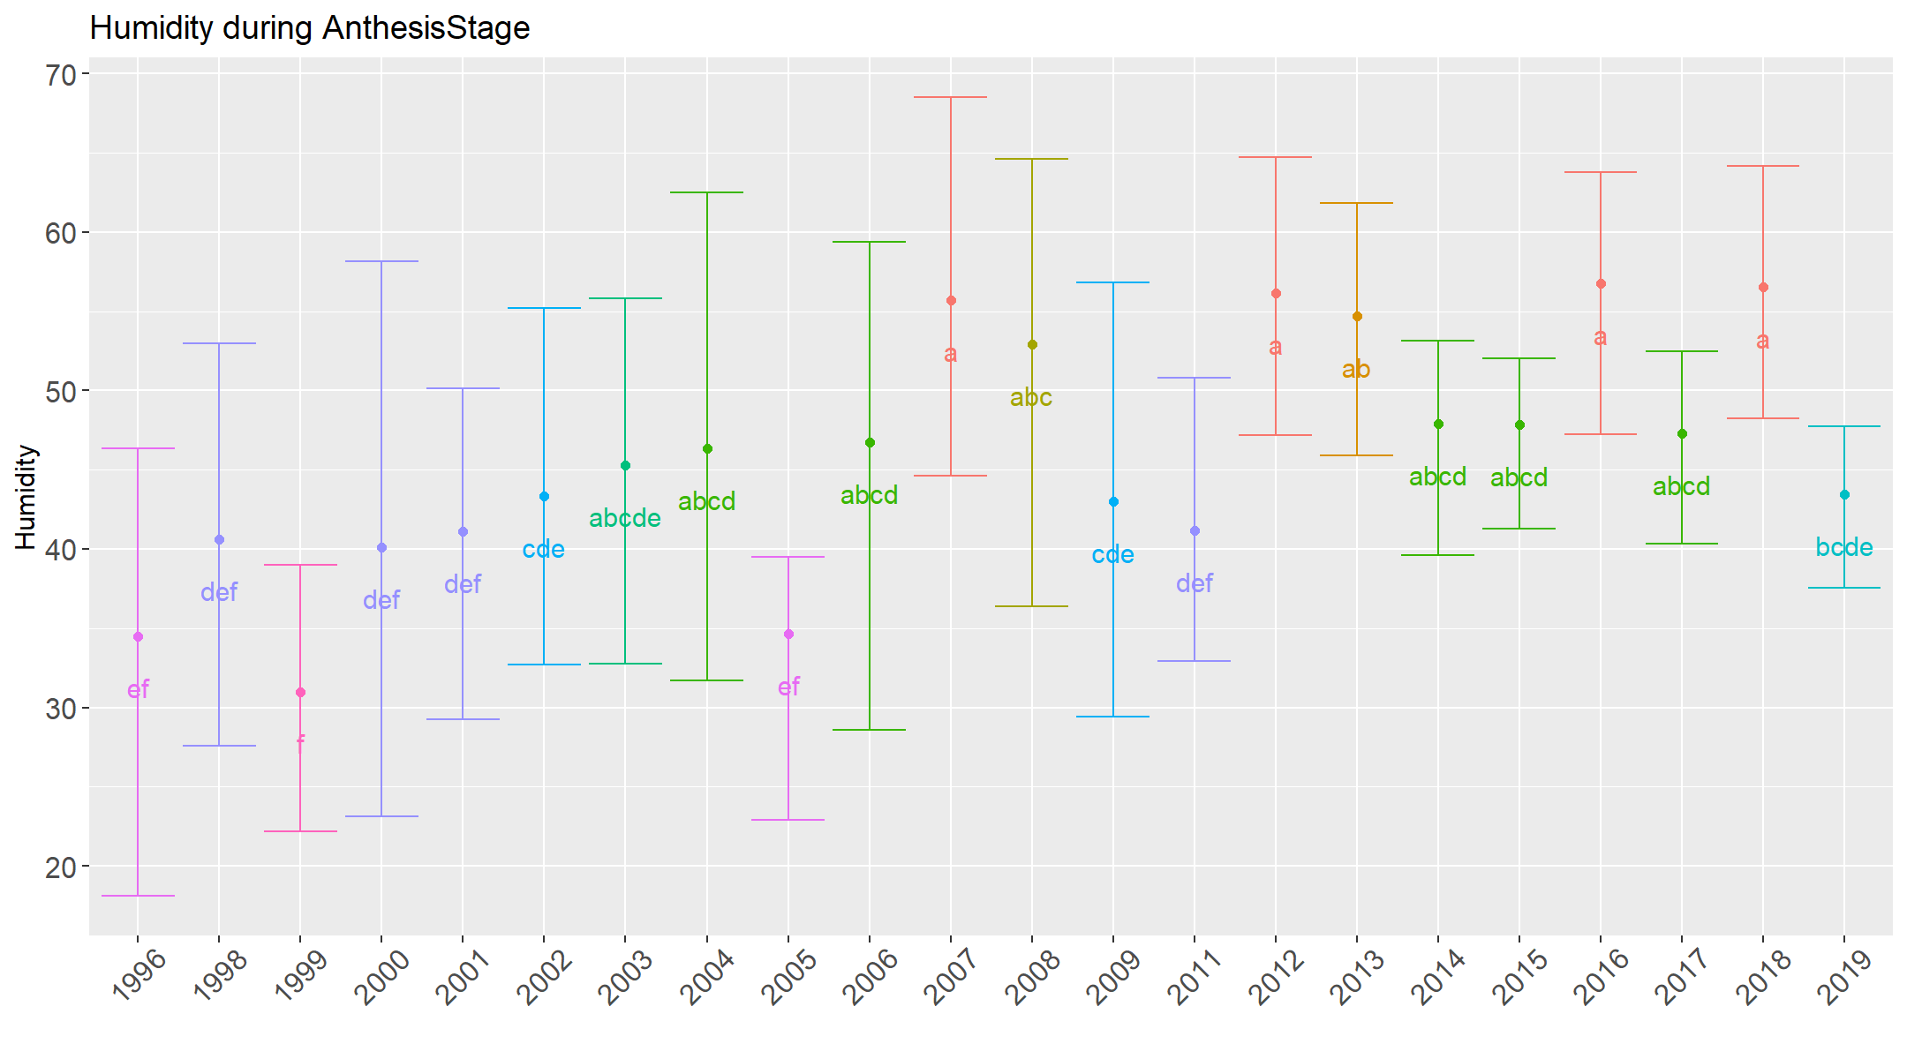
Supplementary Figure 7: Annual vegetation period weather. A - The average daily temperature in °C (blue), daily sum of evapotranspiration (magenta) and precipitation (green) in millimetres (y-axis) for each day of the growing season in days of the year (x-axis), starting by sawing date to end with the harvest date. B – the measured daily minimal humidity during the anthesis stage. Years are clustered by letters according to their intersection of humidity levels during this developmental stage. High humidity levels were associated with increased potential for fungal attack of the canopy.

Supplementary Figure 8: Annual grain yield of conventional (A) and organic (B) populations. While the left y-axis is associated to the red, green and purple lines of relative yield, the right y-axis presents the actual deci tones pre hectar yield for the bars. The purple line is the annual yield compared to the mean yield of the first three years (of the population – 1999 [F4] to 2001 [F6]). The red and green line are relative yield compared to the average spring barley grain yield in Germany (red)³⁶ and North Rhine Westphalia (State, green)³⁷. This ratio is based on the direct relation of seasonal values. Light green bars indicate the year for which pool sequencing was performed (2007 as well), and dark blue bar indicate the years with distinct yield decrease.

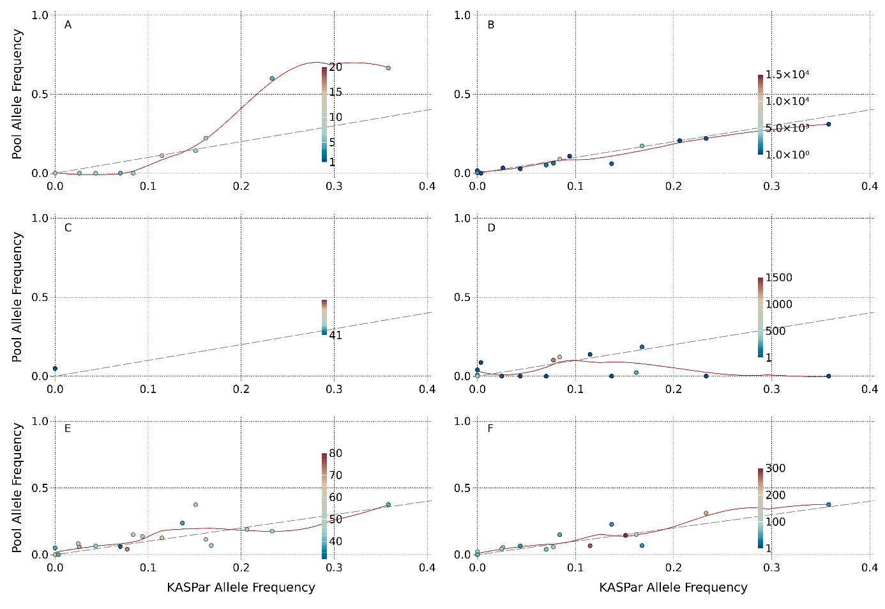Supplementary Figure 9: The correlation of pool obtained allele frequency for three tested sequencing strategies (WGrS, GBS, MACE). Three different methods were compared on their accuracy for pool sequencing of large pools. A – SNP-based pool AF compared to the KASP assay detected allele frequency for WGrS. B – Gene haplotype-based pool AF compared to KASP assay for WGrS. C – SNP-based pool AF to KASP for GBS. D - Gene haplotype-based pool AF compared to KASP assay for GBS. E – SNP-based pool AF to KASP for MACE RNAseq. F - Gene haplotype-based pool AF compared to KASP assay for MACE RNAseq. The dotted line indicates the optimal match of individual (KASP assay) and pool sequencing. Each point represents a single locus – for A, C and E, a locus is a SNP; for B, D and F, a locus is a gene, related to a KASP marker. The colour of the points presents the read coverage of the locus. The red line is a regression through all points.

References:
1. Mayer, K. F. X. et al. A physical, genetic and functional sequence assembly of the barley genome. Nature 491, 711–716 (2012).
2. Li, H. Aligning sequence reads, clone sequences and assembly contigs with BWA-MEM. 00, 1–3 (2013).
3. Bolger, A. M., Lohse, M. & Usadel, B. Trimmomatic: A flexible trimmer for Illumina sequence data. Bioinformatics 30, 2114–2120 (2014).
4. Andrews, S. FastQC - A quality control tool for high throughput sequence data. Babraham Bioinforma. http://www.bioinformatics.babraham.ac.uk/projects/ (2010).
5. Tarasov, A., Vilella, A. J., Cuppen, E., Nijman, I. J. & Prins, P. Sambamba: Fast processing of NGS alignment formats. Bioinformatics 31, 2032–2034 (2015).
6. Li, H. et al. The Sequence Alignment/Map format and SAMtools. Bioinformatics 25, 2078–2079 (2009).
7. Cunningham, F. et al. Ensembl 2019. Nucleic Acids Res. 47, D745–D751 (2019).
8. Yao, Z. et al. Evaluation of variant calling tools for large plant genome re-sequencing. BMC Bioinformatics 21, 360 (2020).
9. Jackman, S., Tahk, A., Zeileis, A., Maimone, C. & Fearon, J. Political Science Computational Laboratory, Stanford University: Package ‘ pscl ’. http://pscl.stanford.edu/ (2013).
10. Von Korff, M., Wang, H., Léon, J. & Pillen, K. AB-QTL analysis in spring barley. I. Detection of resistance genes against powdery mildew, leaf rust and scald introgressed from wild barley. Theor. Appl. Genet. 111, 583–590 (2005).
11. Bedawy, I. M. A., Dehne, H. W., Léon, J. & Naz, A. A. Mining the global diversity of barley for Fusarium resistance using leaf and spike inoculations. Euphytica 214, (2018).
12. Lüpken, T. et al. High-resolution mapping of the barley Ryd3 locus controlling tolerance to BYDV. Mol. Breed. 33, 477–488 (2014).
13. Dragan, P. et al. Genetic Fine Mapping of a Novel Leaf Rust Resistance Gene and a Barley Yellow Dwarf Virus Tolerance (BYDV) Introgressed from Hordeum bulbosum by the Use of the 9K iSelect Chip. in Advance in Barley Sciences 269–284 (Springer Netherlands, 2013). doi:10.1007/978-94-007-4682-4_23.
14. Schmalenbach, I., March, T. J., Pillen, K., Bringezu, T. & Waugh, R. High-resolution genotyping of wild barley introgression lines and fine-mapping of the threshability locus thresh-1 using the illumina goldengate assay. G3 Genes, Genomes, Genet. 1, 187–196 (2011).
15. Liller, C. B. et al. Fine mapping of a major QTL for awn length in barley using a multiparent mapping population. Theor. Appl. Genet. 130, 269–281 (2017).
16. Komatsuda, T., Maxim, P., Senthil, N. & Mano, Y. High-density AFLP map of nonbrittle rachis 1 (btr1) and 2 (btr2) genes in barley (Hordeum vulgare L.). Theor. Appl. Genet. 109, 986–995 (2004).
17. Watt, C., Zhou, G., McFawn, L. A., Chalmers, K. J. & Li, C. Fine mapping of qGL5H, a major grain length locus in barley (Hordeum vulgare L.). Theor. Appl. Genet. 132, 883–893 (2019).
18. Barley Gene Function Annotation. https://webblast.ipk-gatersleben.de/barley_ibsc/downloads/.
19. Takahashi, R., Bashir, K., Ishimaru, Y., Nishizawa, N. K. & Nakanishi, H. Takahashi ('12) - The role of heavy-metal ATPases, HMAs, in zinc. 1605–1607 (2012).
20. Marzec, M. & Alqudah, A. M. Key hormonal components regulate agronomically important traits in barley. Int. J. Mol. Sci. 19, 1–12 (2018).
21. Sato, K. et al. Alanine aminotransferase controls seed dormancy in barley. Nat. Commun. 7, 1–9 (2016).
22. Alqudah, A. M., Koppolu, R., Wolde, G. M., Graner, A. & Schnurbusch, T. The genetic architecture of barley plant stature. Front. Genet. 7, 117 (2016).
23. Mulki, M. A., Bi, X. & von Korff, M. Flowering locus T3 controls spikelet initiation but not floral development. Plant Physiol. 178, 1170–1186 (2018).
24. Guan, J. C. et al. Diverse roles of strigolactone signaling in maize architecture and the uncoupling of a branching-specific subnetwork. Plant Physiol. 160, 1303–1317 (2012).
25. Xu, Y. et al. Characterization of the sdw1 semi-dwarf gene in barley. BMC Plant Biol. 17, 1–10 (2017).
26. Itoh, H. et al. A rice semi-dwarf gene, Tan-Ginbozu (D35), encodes the gibberellin biosynthesis enzyme, ent-kaurene oxidase. Plant Mol. Biol. 54, 533–547 (2004).
27. Wang, G. et al. Association of barley photoperiod and vernalization genes with QTLs for flowering time and agronomic traits in a BC2DH population and a set of wild barley introgression lines. Theor. Appl. Genet. 120, 1559–1574 (2010).
28. Afsharyan, N. P., Sannemann, W., Léon, J. & Ballvora, A. Effect of epistasis and environment on flowering time in barley reveals a novel flowering-delaying QTL allele. J. Exp. Bot. 71, 893–906 (2020).
29. Yan, L. et al. The Wheat VRN2 Gene Is a Flowering Repressor Down-Regulated by Vernalization. Science (80-. ). 303, 1640–1644 (2004).
30. Naz, A. A., Arifuzzaman, M., Muzammil, S., Pillen, K. & Léon, J. Wild barley introgression lines revealed novel QTL alleles for root and related shoot traits in the cultivated barley (Hordeum vulgare L.). BMC Genet. 15, 1–12 (2014).
31. Reinert, S., Kortz, A., Léon, J. & Naz, A. A. Genome-wide association mapping in the global diversity set reveals new QTL controlling root system and related shoot variation in barley. Front. Plant Sci. 7, (2016).
32. Oyiga, B. C. et al. Genetic components of root architecture and anatomy adjustments to water-deficit stress in spring barley. Plant Cell Environ. 43, 692–711 (2020).
33. Muzammil, S. et al. An Ancestral Allele of Pyrroline-5-carboxylate synthase1 Promotes Proline Accumulation and Drought Adaptation in Cultivated Barley. Plant Physiol. 178, 771–782 (2018).
34. Honsdorf, N., March, T. J., Berger, B., Tester, M. & Pillen, K. High-throughput phenotyping to detect drought tolerance QTL in wild barley introgression lines. PLoS One 9, (2014).
35. Mohammed, K. A. H. & Léon, J. Improving crop varieties of spring barley for drought and heat tolerance with AB-QTL-analysis. Diss. Univ. Bonn 150 (2004).
36. Proplanta. Spring Barley Yield Nordrhein Westfalen. https://de.statista.com/statistik/daten/studie/262 (2020).
37. Statista. Spring Barley Yield Germany. https://www.proplanta.de/Maps/Sommergerste+Statist (2020).

